COMMANDS IN LINUX OPERATING SYSTEM
mkdir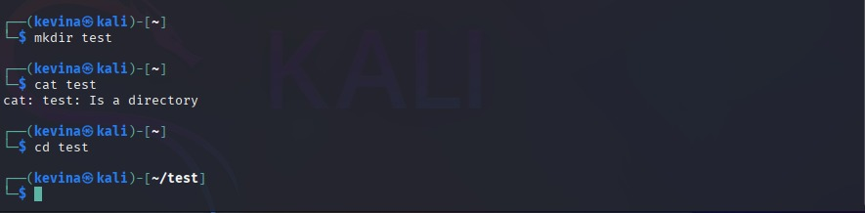uptime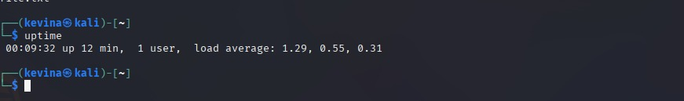cd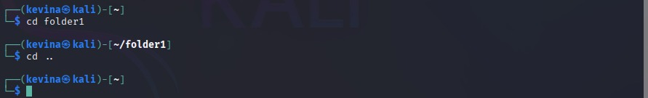cp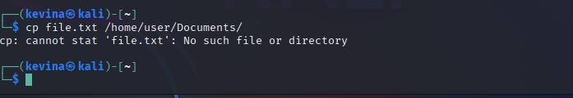users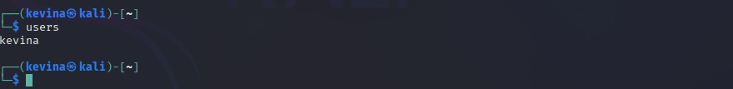wget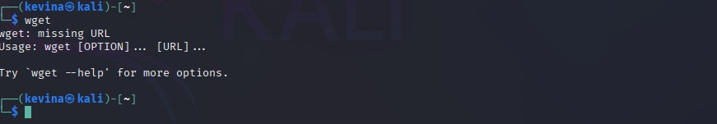tail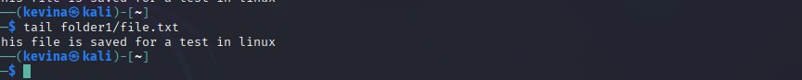
history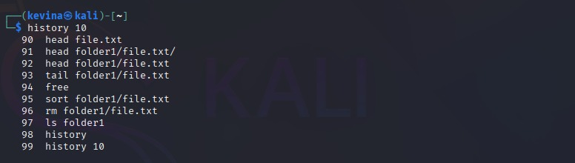rm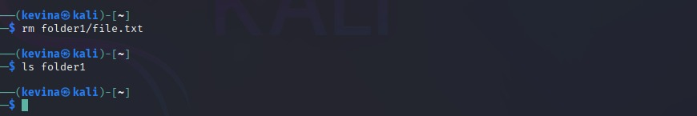sort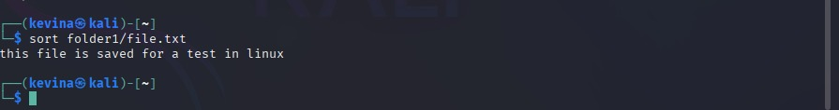free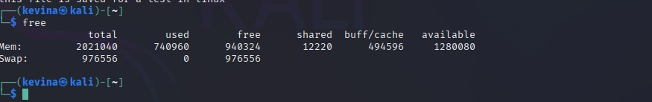touch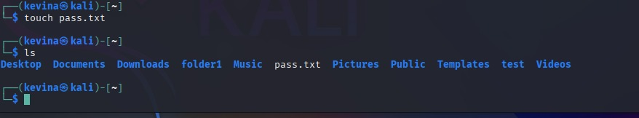head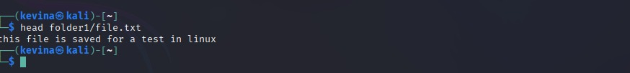
tree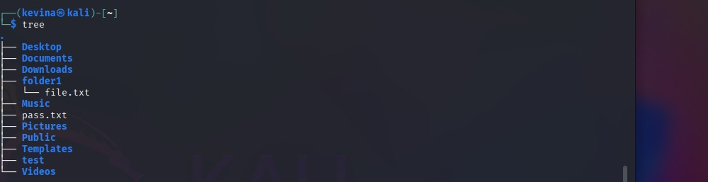pwd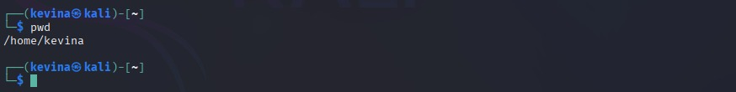cat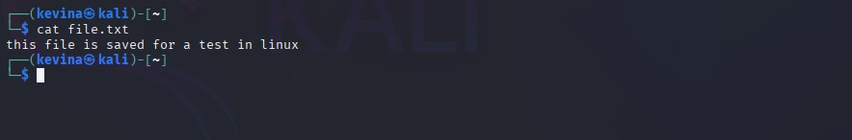mv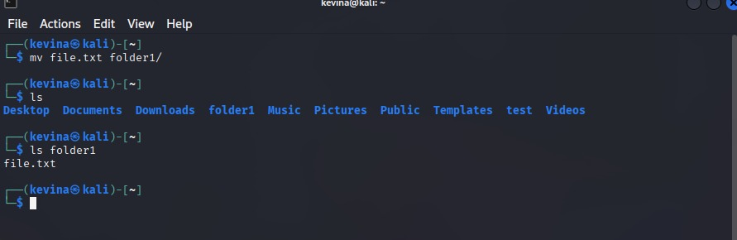
ls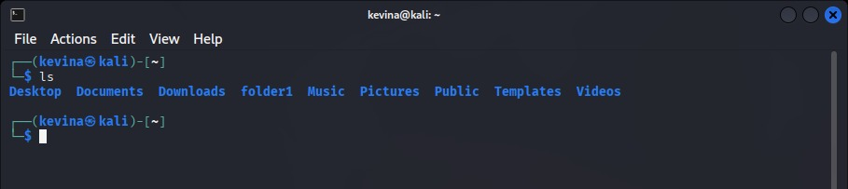

date
