**the problem**

How Do You Know What Your Items Are Worth?

Do you the item? Or Check

|  |  |  |  |
| --- | --- | --- | --- |
| Common Items And Results | | | |
|  | **Ipad 2 - 16GB** | **Apple iPhone 5s 32GB** | **Harry Potter and the Chamber of Secrets DVD** |
|  | ipda.png | http://inwallspeakers1.com/wp-content/uploads/2015/03/Iphone-5-Transparent-Background.png | http://i.ebayimg.com/04/!!eBk0o!!WM~$(KGrHqMOKikE0sRpwCY,BNQ)G+WOVQ~~_32.JPG |
| **eBay Results** | **1,882** | **1,230** | **738** |
| **Google Results** | **154,000** | **13,800,000** | **471,000** |
| **Price Ranges** | **$1 - $499.99** | **$1 - $1,149.95** | **$2.50 - $125** |

What's the best price to sell your item for?

And was born...

Many people struggle to accurately price items

No way to determine the most optimal price

One can spend hours comparing prices

Too many resources for item pricing

So.. What does  do?

* Uses live and stored data
* Attempts to organize the mess of outputted data
* Provides a price suggestion based on the live and past data on
* Gets the user closer to finding the optimal selling price and conditions for their item

**the output**

* Commons
  + Collection of commonly relatable adjectives
  + Each common links to Max, Min, Avg Prices
  + Types
    - Condition, Title, Listing Type, Selling State, Shipping, Top Rated, Product Id
* Graphs
  + Displays common collections over graphical output
  + Simple bar charts for rapid comparisons
* Removed Items
  + Shows removed item based on item matching algorithm
* All Items
  + Shows all of the items used in the price comparisons
  + Can double check the references
* Refine
  + Helps the user refine their search for better results

**configuration**

Application can be custom configured

|  |  |
| --- | --- |
| Configuration | Definition |
| Entries Per Page | The number of items to get from eBay per API call where 100 is the maximum number |
| Pages Per Search | The number of calls to make to eBay during one search, as search the total results would be (entries per page * pages per search) |
| Enable Recent Search | Simply determines if the application should remember and store the search keywords |
| Enable Local Results | Determines if the application should pull any related items from its local database and add it to your price consideration |
| Enable Tag Collection | Allows the application to store tags that it considers as a background process that runs with the search functionality. |
| Enable Title Matching | Allows the search to remove returned eBay items using the results from the matching algorithm. |
| Title Matching Tolerance | Determines what level of match an item must make in order to be considered in the results. |



Application Configured With

|  |  |
| --- | --- |
| Configuration | Definition |
| endpoint | The endpoint for the Finding Service, which should never have to change unless eBay changes their API |
| version | Once again, this is corrected by eBay and using the standard value will not make a difference |
| appid | This is the application id provided by the eBay developers program |
| devid | This is the developer id provided by the eBay developers program |
| certid | This is the certificate id provided by the eBay developers program |
| globalid | Is default to United states but can be changed to get results from other countries |

**the output screen**

Search Tabs



Individual Item Results

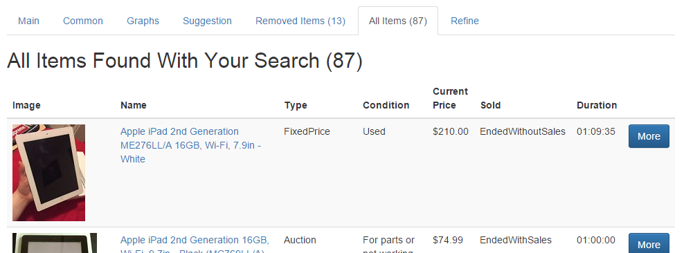

Condition Common Pricing

