**data flow diagram**

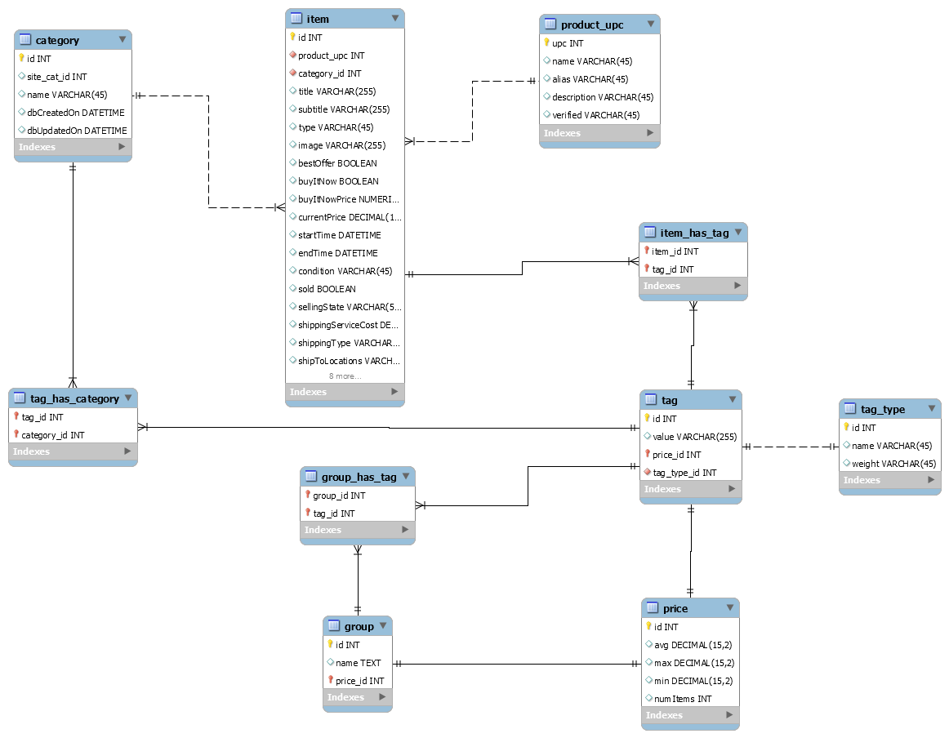

**custom library structure**

**Fork**

* Provides concurrent and background data processes
* Takes in URLs and sends requests in the desired manner

**Linker**

* Links any data object with its data based relationships
* Example: item to tag

**Parser**

* Takes eBay XML output and turns into meaningful data that the system can use
* Breaks down data into a wide range of sub categories

**Query Builder**

* Turns keywords into fully qualified URL string

**Store**

* Saves advanced data types into the database

**how does it work?**

 uses the http://developer.ebay.com/DevZone/finding/assets/eBayDevLogo_sm.gif to utilize their Finding API

The Finding API provides URLs for collecting item data

Structuring well formed URLs allows  to collect the perfect amount of data

The data received is processed by a custom library to make sense of the XML output

 can output the parsed data to help the end user find the optimal pricing for any given item

**the matching algorithm?**

Hard to determine what the item of interest is

Need to analyze item data to determine which items are the same

Tags - Single keyword that represents a small piece of the item

1. Break Down The Title String
2. Calculate The "Weighted Tag Score" For Each Tag
   1. WTS = ( Number Of Single Tag Occurrences /

Number Of Total Non Unique Tags)

1. Calculate The "Total Item Rating" For Each Item
   1. TIR = ( WTSTag1 + WTSTag2 + ... + WTSTagN ),

n = Total Number Of Tags Linked To Item

1. Organize Items By Total Item Rating

**the matching algorithm example**

End User Searches For "bat man gloves"

**The Matching Index**

{bat, 5}, {man, 6}, {gloves, 4},

{red, 3}, {hat, 1}, {Christmas, 1}, {dog, 1}, {oven, 1}, {mitt, 1}

Item Results:

* bat man gloves red
* bat man gloves red Christmas
* bat man gloves red

**Total Non unique Tags:** 23

5+6+4+3+1+1+1+1+1

* bat man gloves
* bat man hat

**Applying The Matching Algorithm**

bat: 5/23, man: 5/23, gloves: 4/23, red: 3/23,

hat: 1/23, Christmas: 1/23, oven: 1/23, mitt: 1/23

* dog man oven mitt

**Total Item Ratings**  
bat man gloves red 5/23+6/23+4/23+3/23 = **18/23**

bat man gloves red Christmas  5/23+6/23+4/23+3/23 = **18/23**

bat man gloves red 5/23+6/23+4/23+3/23 = **18/23**

bat man gloves  5/23+6/23+4/23 = **15/23**

bat man hat  5/23+6/23 = **11/23**

dog man oven mitt 6/23 = **6/23**