**MTG-Card-Generator**

Users are able to search for list of cards with the same text in the search item. The user is able to return card information such as rarity, included set card was released in, and the card’s text description.

**Screenshots**

Login Screen/Landing Page:

[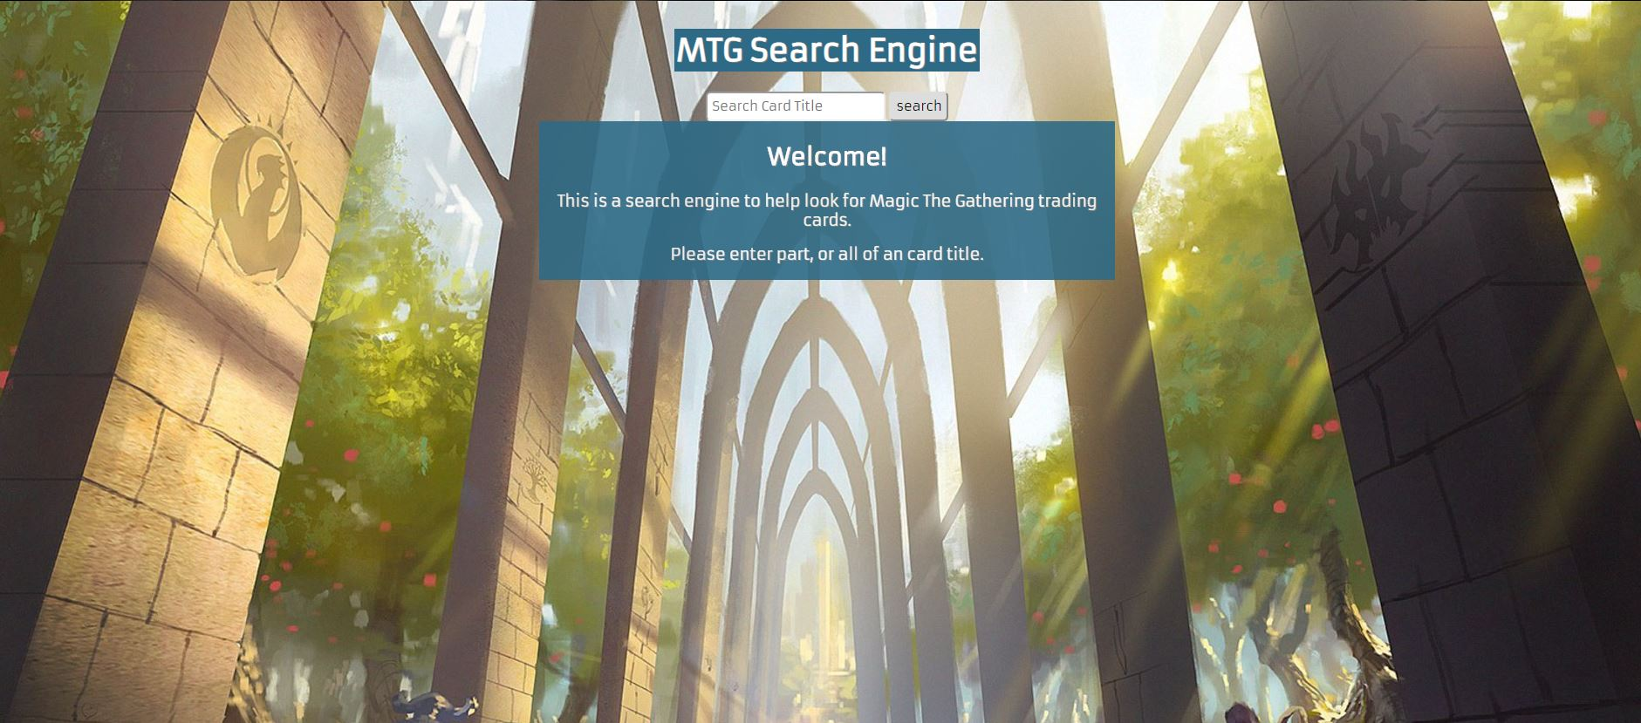](https://github.com/thinkful-c11/book-thing.io/blob/master/screenshots/login.png)

Results page:

[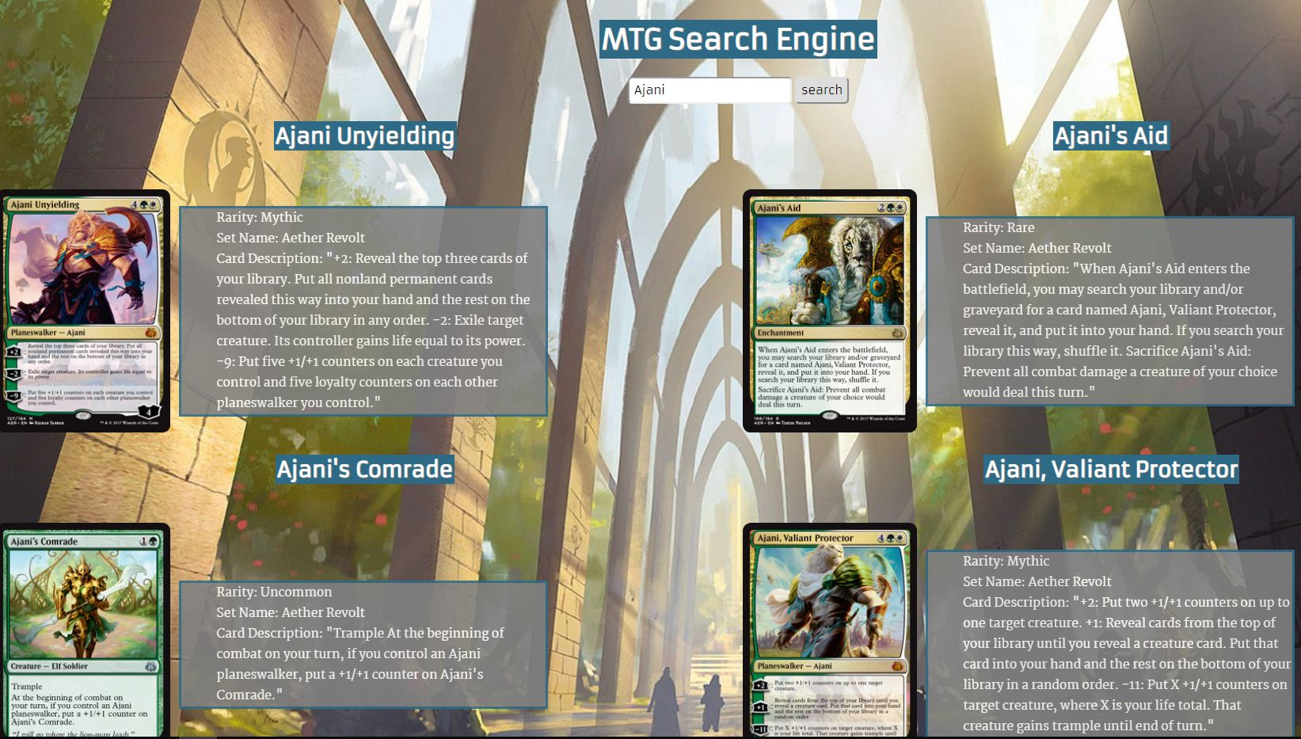](https://github.com/thinkful-c11/book-thing.io/blob/master/screenshots/recommendations.png)

**Built With**

**Front-End**

* Javascript
* HTML
* CSS
* jQuery Library

**Features**

* Search for cards with similar title

**Demo**

* [Live Demo](https://kevinakadamian19.github.io/MTG-Card-Generator/)

**API**

* <https://docs.magicthegathering.io/>