Wagering on Races: A Study on How to Increase Payouts

Datasets for this study were obtained from the biggest betting exchange worldwide: Betfair (TheGuardian.com). Betfair started its operationgs in 2000, with a steady growth that allowed the purchasing of England’s biggest horseracing publishing company, Timeform, in 2006. In 2009, Betfair purchased the TVG Network in the United States, which allowed for Betfair to offer wagering services in 31 of the States. Betfair also reached a deal in 2009 with the New York Racing Association, which allowed for Betfair to offer wagering and exchanges on Aqueduct’s thoroughbreeding races (ThoroughbredTimes.com). More recently in 2015, Betfair merged with the biggest bookmaker in Ireland, Paddy Power, which cemented Betfair as the biggest betting exchange operating across the globe. Although public access to archived data only extends back to 2007, the dataset Betfair holds on sport gamblings far surpass those offered by any other research firm or corporate entity such as ESPN. Therefore, our datasets for this research topic are exclusively gathered from Betfair.

Betfair offers an up-to-the-minute database via their API. However, this requires an active account. For our purposes, we require historical data rather than the latest data. Betfair provides previous days’ racing data freely through its public website at the following link: https://promo.betfair.com/betfairsp/prices/index.php. These .csv files date back to 2007 with data from horse racing in multiple countries, to include the United Kingdom, Ireland, Australia, the United States of America, and South Africa. Collecting the off of their server was a trivial task with web-browser plug-in tools such as “DownloadThemAll”, which scrapes a server and downloads all dependent files from a public site.

Each .csv file provided by Betfair has a patterned name of their ‘exchange-price-location-winnings-date’. The files are formatted the same way internally. Each file represents the days’ worth of races (times based out of Gibraltar). Attributes in these files include the ‘Event ID’, ‘Name of Runner (horse)’, ‘Win/Lose (or ‘Place’; effectively 1st place, 2nd place, or loss), ‘Starting Price’ on wagers, and amount that each wager sways up to the time of the race as well as the amount of trading through the Betfair exchange.

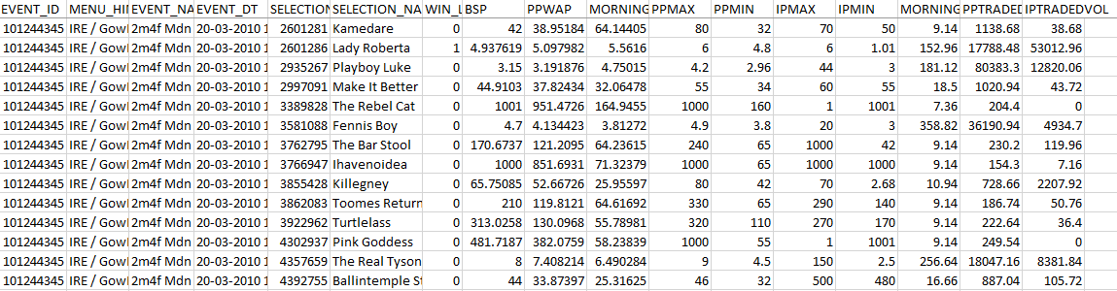
Figure 1 - Bitfair CSV File for a sample event.

In thanks to the same attributes being present across all of the files, merging the files is also a trivial process. In Windows, the command line shell allows for a simple argument of “[directory] copy *.csv mergedFileName.csv” (AnalystCave.com). A Python script would require a File I/O function which itself would still be trivial (fout, for loop, write).

We have over 22,500 data sets gathered from Betfair, with an average of 120 rows of data per set. The datasets offered by Betfair gives us two minor hurdles. Their horseracing data mixes in their dog racing data. Fortunately, greyhound race results are aptly named ‘greyhound’ as part of their filename and can easily be sorted out. The second issue comes in the form of poorly kept records; some races do not have betting data included. Without the starting wagers, we do not have a way in which to calculate odds and favors. Some datasets also exclude the list of winners and losers, which also hinders us from calculating final payouts based on wins. Therefore, whenever we complete our data analysis in R, we will need to exclude entire ‘Event ID’ sets that do not have either a complete set of betting data or winners.

In order to answer our hypotheses regarding an overall favored horse’s likelihood to win its given race, we should have enough data points to provide a good probability model fitting a binomial distribution, since we are just measuring the win/loss (two-outcome) event per race. With over 22,500 datasets based on daily events, each file contains an average of four events, meaning that our dataset for this probability model will have about 90,000 data points. Although we have a large number of data points, a simple binomial distribution curve may be the best way to visualize this data. Since our hypothesis is meant to provide insight into our big question of ‘how to increase payouts from horse racing bets’, the normalized probability distribution should be directly proportional to the payout odds. This same methodology would address our additional hypothesis in which we wish to see if we receive a better payout by betting on a horse favored in second to the top favored horse.

To address our third hypothesis on a ‘window of odds’, we will need to create an artificial bracket of odds. For example, a horse favored 1-1 to 5-1 are all grouped in the same bracket, then 6-1 to 10-1 are grouped in a different bracket, and so on and so forth. This creates a sliding bracket (window) of odds. Then in R, we can compare how many horses won per each window, with an accompanying bar graph for each betting window. We will then create a correlated graph showing the payout for each bracket according to their winning probabilities. This can be a dynamic graph that is generated in Tableau so that the user can switch between each graph (Tableau.com), overlay the graphs, or generate their own brackets and graphs using our data (as opposed to viewing our pre-made graphs).

