1. Newton Raphson

$$f\left(x\right)= \left(sin\left(x\right)+cos\left(1+x^{2}\right)- 1\right)$$

$$f^{'\left(x\right)}= \left(cos\left(x\right)-sin\left(1+x^{2}\right)*2*x\right)$$

$$x_{i+1}=x_{i}-\frac{f\left(x\right)}{f^{'}\left(x\right)}$$

Elegimos un $x_{0}=0$

$$x_{i+1}=x_{i}-\frac{f\left(x_{i}\right)}{f^{'}\left(x_{i}\right)}$$

$$x_{i+1}=x_{i}-\frac{sin\left(x_{i}\right)+cos\left(1+x_{i}^{2}\right)- 1}{cos\left(x_{i}\right)-sin\left(1+x_{i}^{2}\right)*2*x_{i}}$$

$$x_{1}=0-\frac{sin\left(0\right)+cos\left(1+0^{2}\right)- 1}{ cos\left(0\right)-sin\left(1+0^{2}\right)*2*0}=0.50034$$

$$x_{2}=0.05-\frac{sin\left(0.05\right)+cos\left(1+{0.05}^{2}\right)- 1}{ cos\left(0.05\right)-sin\left(1+{0.05}^{2}\right)*2*0.05}=-2.3379$$

$$x_{3}=0.50034-\frac{sin\left(0.50034\right)+cos\left(1+{0.50034}^{2}\right)- 1}{ cos\left(0.50034\right)-sin\left(1+{0.50034}^{2}\right)*2*0.50034}=2.3874$$

$$x_{4}=-2.3379-\frac{sin\left(-2.3379\right)+cos\left(1±{2.3379}^{2}\right)- 1}{ cos\left(-2.3379\right)-sin\left(1±{2.3379}^{2}\right)*2*-2.3379}=2.6126$$

$$x_{5}=2.3874-\frac{sin\left(2.3874\right)+cos\left(1+{2.3874}^{2}\right)- 1}{ cos\left(2.3874\right)-sin\left(1+{2.3874}^{2}\right)*2*2.3874}=2.5359$$

$$x_{6}=2.6126-\frac{sin\left(2.6126\right)+cos\left(1+{2.6126}^{2}\right)- 1}{ cos\left(2.6126\right)-sin\left(1+{2.6126}^{2}\right)*2*2.6126}=2.5322$$

$$x_{7}=2.5359-\frac{sin\left(2.5359\right)+cos\left(1+{2.5359}^{2}\right)- 1}{ cos\left(2.5359\right)-sin\left(1+{2.5359}^{2}\right)*2*2.5359}=2.5322$$

En 7 iteraciones la raíz es $x_{7}=$ 2.5322

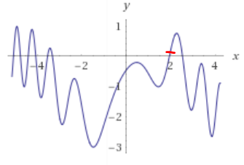

1. Runge kutta orden 4

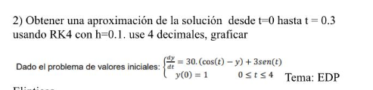

$$\frac{dy}{dt}=30\left(\cos\left(t\right)-y\right)+3sen\left(t\right)$$

$$k_{1}= f\left(t_{i},y_{i}\right)$$

$$k_{1}=30\left(\cos\left(t_{i}\right)-y_{i}\right)+3sen\left(t_{i}\right)$$

$k_{2}=f\left(t_{i}+\left(\frac{h}{2}\right),y_{i}+\left(\frac{h}{2}\right)*k_{1}\right)$

$$k_{2}=30\left(\cos\left(t_{i}+\left(\frac{h}{2}\right)\right)-\left(y_{i}+\left(\frac{h}{2}\right)*k_{1}\right)\right)+3sen\left(t_{i}+\left(\frac{h}{2}\right)\right)$$

$$k_{3}= f\left(t_{i}+\left(\frac{h}{2}\right),y_{i}+\left(\frac{h}{2}\right)*k_{2}\right)$$

$$K_{3}=30\left(\cos\left(t_{i}+\left(\frac{h}{2}\right)\right)-{(y}_{i}+\left(\frac{h}{2}\right)*k_{2} )\right)+3sen\left(t_{i}+\left(\frac{h}{2}\right)\right)$$

$$k_{4}=f\left(t_{i}+h,y_{i}+h*k_{3}\right)$$

$$k_{4}=30\left(\cos\left(t_{i}+h\right)-\left(y_{i}+h*k_{3}\right)\right)+3sen\left(t_{i}+h\right)$$

$$y_{i+1}=y_{i}+\left(\frac{h}{6}\right)*\left(k_{1}+2*k_{2}+2*k_{3}+k_{4}\right)$$

$$k_{1}= 30\left(\cos\left(0 \right)-1\right)+3sen\left(0\right)=0$$

$$k_{2}= 30\left(\cos\left(0+\left(\frac{0.1}{2}\right)\right)-\left(1+\left(\frac{0.1}{2}\right)*0 \right)\right)+3sen\left(0+\left(\frac{0.1}{2}\right)\right)=0.11245$$

$$k_{3}= 30\left(\cos\left(0+\left(\frac{0.1}{2}\right)\right)-\left(1+\left(\frac{0.1}{2}\right)*0.11245 \right)\right)+3sen\left(0+\left(\frac{0.1}{2}\right)\right)=-0.056223$$

$$k_{4}= 30\left(\cos\left(0+0.1\right)-\left(1+0.1*-0.056223\right)\right)+3sen\left(0+0.1\right)=0.31829$$

$$y_{1}=1+\left(\frac{0.1}{6}\right)*\left(0+2*0.11245+2*-0.056223+0.31829\right)=1.0072$$

$$k_{1}= 30\left(\cos\left(0.1 \right)-1.0072\right)+3sen\left(0.1\right)=-0.065744$$

$$k_{2}= 30\left(\cos\left(0.1+\left(\frac{0.1}{2}\right)\right)-\left(1.0072+\left(\frac{0.1}{2}\right)*-0.065744 \right)\right)+3sen\left(0.1+\left(\frac{0.1}{2}\right)\right)=-0.0053065$$

$$k_{3}= 30\left(\cos\left(0.1+\left(\frac{0.1}{2}\right)\right)-\left(1.0072+\left(\frac{0.1}{2}\right)*-0.0053065 \right)\right)+3sen\left(0.1+\left(\frac{0.1}{2}\right)\right)=-0.095963$$

$$k_{4}= 30\left(\cos\left(0.1+0.1\right)-\left(1.0072+0.1*-0.095963\right)\right)+3sen\left(0.1+0.1\right)=0.070525$$

$$y_{2}=1.0072+\left(\frac{0.1}{6}\right)*\left(-0.065744+2*-0.0053065+2*-0.095963+0.070525\right)=1.0039$$

$$k_{1}= 30\left(\cos\left(0.2 \right)-1.0039\right)+3sen\left(0.2\right)=-0.11848$$

$$k_{2}= 30\left(\cos\left(0.2+\left(\frac{0.1}{2}\right)\right)-\left(1.0039+\left(\frac{0.1}{2}\right)*-0.11848 \right)\right)+3sen\left(0.2+\left(\frac{0.1}{2}\right)\right)=-0.12918$$

$$k_{3}= 30\left(\cos\left(0.2+\left(\frac{0.1}{2}\right)\right)-\left(1.0039+\left(\frac{0.1}{2}\right)*-0.12918 \right)\right)+3sen\left(0.2+\left(\frac{0.1}{2}\right)\right)=-0.11314$$

$$k_{4}= 30\left(\cos\left(0.2+0.1\right)-\left(1.0039+0.1*-0.11314\right)\right)+3sen\left(0.2+0.1\right)=-0.2304$$

$$y_{3}=1.0039+\left(\frac{0.1}{6}\right)*\left(-0.11848+2*-0.12918+2*-0.11314-0.23042\right)=0.9899$$

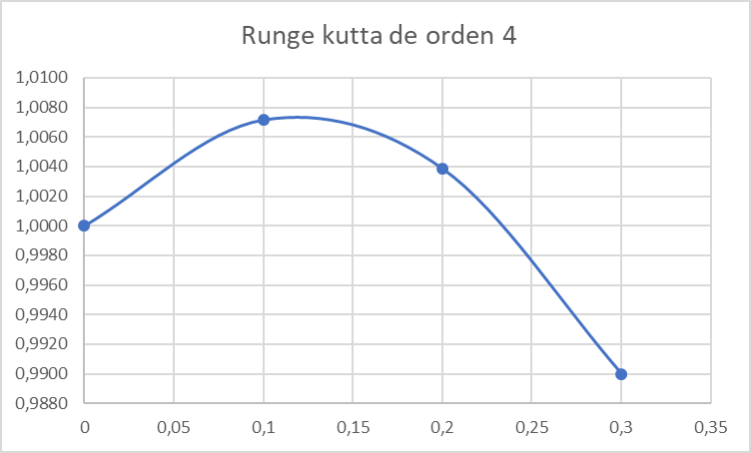

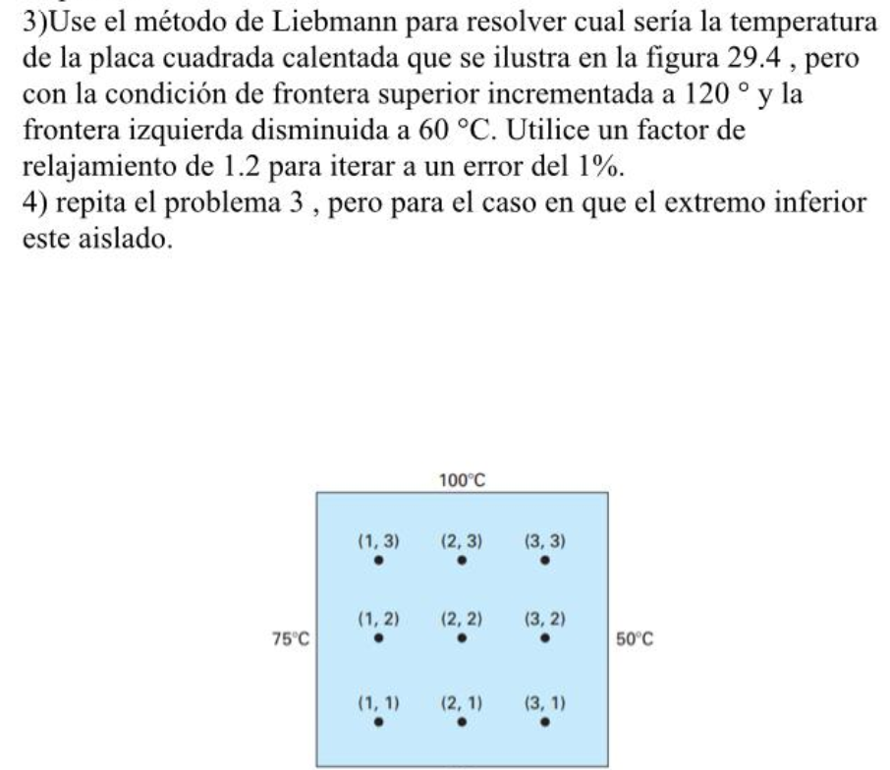

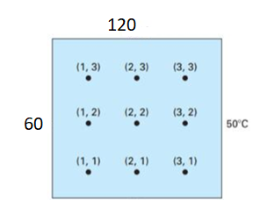

$$T_{i,j}=\frac{ T_{i+1,j}+ T_{i-1,j}+ T_{i,j+1}+T_{i,j-1}}{4}$$

$T_{i,j}^{nuevo}= {λ*T}_{i,j}^{nuevo}+\left(1+λ\right)*T_{i,j}^{anterior}$

$\left|ε_{a}\right|=\frac{\left|T_{i,j}^{nuevo}- T_{i,j}^{anterior}\right|}{\left|T_{i,j}^{nuevo}\right|}<ε_{s}$

Para $i=1$

$j=1$

$$T_{1,1}=\frac{ T_{1+1,1}+ T_{1-1,1}+ T_{1,1+1}+T_{1,1-1}}{4}$$

$$T_{1,1}=\frac{ T_{2,1}+ T_{0,1}+ T_{1,2}+T_{1,0}}{4}$$

$$T_{1,1}=\frac{T_{1+1,1}+ T_{1-1,1}+ T_{1,1+1}+T_{1,1-1}}{4}$$

$$\frac{0+ 60+ 0+0}{4}=15$$

$$T_{1,1}^{nuevo}= 1.2*T_{1,1}^{nuevo}+\left(1+1.2\right)*T_{1,1}^{anterior}=18$$

$$\left|e_{a}\right|=\frac{\left|18 - 0 \right|}{\left|18 \right|}<0.01=1<0.01$$

$$T_{2,1}=\frac{T_{2+1,1}+ T_{2-1,1}+ T_{2,1+1}+T_{2,1-1}}{4}$$

$$\frac{0+ 18+ 0+0}{4}=4.5$$

$$T_{2,1}^{nuevo}= 1.2*T_{2,1}^{nuevo}+\left(1+1.2\right)*T_{2,1}^{anterior}=5.4$$

$$\left|e_{a}\right|=\frac{\left|5.4 - 0 \right|}{\left|5.4 \right|}<0.01=1<0.01$$

$$T_{3,1}=\frac{T_{3+1,1}+ T_{3-1,1}+ T_{3,1+1}+T_{3,1-1}}{4}$$

$$\frac{50+ 5.4+ 0+0}{4}=13.85$$

$$T_{3,1}^{nuevo}= 1.2*T_{3,1}^{nuevo}+\left(1+1.2\right)*T_{3,1}^{anterior}=16.62$$

$$\left|e_{a}\right|=\frac{\left|16.62 - 0 \right|}{\left|16.62 \right|}<0.01=1<0.01$$

$$T_{1,2}=\frac{T_{1+1,2}+ T_{1-1,2}+ T_{1,2+1}+T_{1,2-1}}{4}$$

$$\frac{0+ 60+ 0+18}{4}=19.5$$

$$T_{1,2}^{nuevo}= 1.2*T_{1,2}^{nuevo}+\left(1+1.2\right)*T_{1,2}^{anterior}=23.4$$

$$\left|e_{a}\right|=\frac{\left|23.4 - 0 \right|}{\left|23.4 \right|}<0.01=1<0.01$$

$$T_{2,2}=\frac{T_{2+1,2}+ T_{2-1,2}+ T_{2,2+1}+T_{2,2-1}}{4}$$

$$\frac{0+ 23.4+ 0+5.4}{4}=7.2$$

$$T_{2,2}^{nuevo}= 1.2*T_{2,2}^{nuevo}+\left(1+1.2\right)*T_{2,2}^{anterior}=8.64$$

$$\left|e_{a}\right|=\frac{\left|8.64 - 0 \right|}{\left|8.64 \right|}<0.01=1<0.01$$

$$T_{3,2}=\frac{T_{3+1,2}+ T_{3-1,2}+ T_{3,2+1}+T_{3,2-1}}{4}$$

$$\frac{50+ 8.64+ 0+16.62}{4}=18.815$$

$$T_{3,2}^{nuevo}= 1.2*T_{3,2}^{nuevo}+\left(1+1.2\right)*T_{3,2}^{anterior}=22.578$$

$$\left|e_{a}\right|=\frac{\left|22.578 - 0 \right|}{\left|22.578 \right|}<0.01=1<0.01$$

$$T_{1,3}=\frac{T_{1+1,3}+ T_{1-1,3}+ T_{1,3+1}+T_{1,3-1}}{4}$$

$$\frac{0+ 60+ 120+23.4}{4}=50.85$$

$$T_{1,3}^{nuevo}= 1.2*T_{1,3}^{nuevo}+\left(1+1.2\right)*T_{1,3}^{anterior}=61.02$$

$$\left|e_{a}\right|=\frac{\left|61.02 - 0 \right|}{\left|61.02 \right|}<0.01=1<0.01$$

$$T_{2,3}=\frac{T_{2+1,3}+ T_{2-1,3}+ T_{2,3+1}+T_{2,3-1}}{4}$$

$$\frac{0+ 61.02+ 120+8.64}{4}=47.415$$

$$T_{2,3}^{nuevo}= 1.2*T_{2,3}^{nuevo}+\left(1+1.2\right)*T_{2,3}^{anterior}=56.898$$

$$\left|e_{a}\right|=\frac{\left|56.898 - 0 \right|}{\left|56.898 \right|}<0.01=1<0.01$$

$$T_{3,3}=\frac{T_{3+1,3}+ T_{3-1,3}+ T_{3,3+1}+T_{3,3-1}}{4}$$

$$\frac{50+ 56.898+ 120+22.578}{4}=62.369$$

$$T_{3,3}^{nuevo}= 1.2*T_{3,3}^{nuevo}+\left(1+1.2\right)*T_{3,3}^{anterior}=74.8428$$

$$\left|e_{a}\right|=\frac{\left|74.8428 - 0 \right|}{\left|74.8428 \right|}<0.01=1<0.01$$

$$T_{1,1}=\frac{T_{1+1,1}+ T_{1-1,1}+ T_{1,1+1}+T_{1,1-1}}{4}$$

$$\frac{5.4+ 60+ 23.4+0}{4}=22.2$$

$$T_{1,1}^{nuevo}= 1.2*T_{1,1}^{nuevo}+\left(1+1.2\right)*T_{1,1}^{anterior}=23.04$$

$$\left|e_{a}\right|=\frac{\left|23.04 - 18 \right|}{\left|23.04 \right|}<0.01=0.21875<0.01$$

$$T_{2,1}=\frac{T_{2+1,1}+ T_{2-1,1}+ T_{2,1+1}+T_{2,1-1}}{4}$$

$$\frac{16.62+ 23.04+ 8.64+0}{4}=12.075$$

$$T_{2,1}^{nuevo}= 1.2*T_{2,1}^{nuevo}+\left(1+1.2\right)*T_{2,1}^{anterior}=13.41$$

$$\left|e_{a}\right|=\frac{\left|13.41 - 5.4 \right|}{\left|13.41 \right|}<0.01=0.59732<0.01$$

$$T_{3,1}=\frac{T_{3+1,1}+ T_{3-1,1}+ T_{3,1+1}+T_{3,1-1}}{4}$$

$$\frac{50+ 13.41+ 22.578+0}{4}=21.497$$

$$T_{3,1}^{nuevo}= 1.2*T_{3,1}^{nuevo}+\left(1+1.2\right)*T_{3,1}^{anterior}=22.4724$$

$$\left|e_{a}\right|=\frac{\left|22.4724 - 16.62 \right|}{\left|22.4724 \right|}<0.01=0.26043<0.01$$

$$T_{1,2}=\frac{T_{1+1,2}+ T_{1-1,2}+ T_{1,2+1}+T_{1,2-1}}{4}$$

$$\frac{8.64+ 60+ 61.02+23.04}{4}=38.175$$

$$T_{1,2}^{nuevo}= 1.2*T_{1,2}^{nuevo}+\left(1+1.2\right)*T_{1,2}^{anterior}=41.13$$

$$\left|e_{a}\right|=\frac{\left|41.13 - 23.4 \right|}{\left|41.13 \right|}<0.01=0.43107<0.01$$

$$T_{2,2}=\frac{T_{2+1,2}+ T_{2-1,2}+ T_{2,2+1}+T_{2,2-1}}{4}$$

$$\frac{22.578+ 41.13+ 56.898+13.41}{4}=33.504$$

$$T_{2,2}^{nuevo}= 1.2*T_{2,2}^{nuevo}+\left(1+1.2\right)*T_{2,2}^{anterior}=38.4768$$

$$\left|e_{a}\right|=\frac{\left|38.4768 - 8.64 \right|}{\left|38.4768 \right|}<0.01=0.77545<0.01$$

$$T_{3,2}=\frac{T_{3+1,2}+ T_{3-1,2}+ T_{3,2+1}+T_{3,2-1}}{4}$$

$$\frac{50+ 38.4768+ 74.8428+22.4724}{4}=46.448$$

$$T_{3,2}^{nuevo}= 1.2*T_{3,2}^{nuevo}+\left(1+1.2\right)*T_{3,2}^{anterior}=51.222$$

$$\left|e_{a}\right|=\frac{\left|51.222 - 22.578 \right|}{\left|51.222 \right|}<0.01=0.55921<0.01$$

$$T_{1,3}=\frac{T_{1+1,3}+ T_{1-1,3}+ T_{1,3+1}+T_{1,3-1}}{4}$$

$$\frac{56.898+ 60+ 120+41.13}{4}=69.507$$

$$T_{1,3}^{nuevo}= 1.2*T_{1,3}^{nuevo}+\left(1+1.2\right)*T_{1,3}^{anterior}=71.2044$$

$$\left|e_{a}\right|=\frac{\left|71.2044 - 61.02 \right|}{\left|71.2044 \right|}<0.01=0.14303<0.01$$

$$T_{2,3}=\frac{T_{2+1,3}+ T_{2-1,3}+ T_{2,3+1}+T_{2,3-1}}{4}$$

$$\frac{74.8428+ 71.2044+ 120+38.4768}{4}=76.131$$

$$T_{2,3}^{nuevo}= 1.2*T_{2,3}^{nuevo}+\left(1+1.2\right)*T_{2,3}^{anterior}=79.9776$$

$$\left|e_{a}\right|=\frac{\left|79.9776 - 56.898 \right|}{\left|79.9776 \right|}<0.01=0.28858<0.01$$

$$T_{3,3}=\frac{T_{3+1,3}+ T_{3-1,3}+ T_{3,3+1}+T_{3,3-1}}{4}$$

$$\frac{50+ 79.9776+ 120+51.222}{4}=75.2999$$

$$T_{3,3}^{nuevo}= 1.2*T_{3,3}^{nuevo}+\left(1+1.2\right)*T_{3,3}^{anterior}=75.3913$$

$$\left|e_{a}\right|=\frac{\left|75.3913 - 74.8428 \right|}{\left|75.3913 \right|}<0.01=0.0072756<0.01$$

71.2044 79.9776 75.3913

41.1300 38.4768 51.2220

23.0400 13.4100 22.4724

b. Aislado



La matriz de coeficientes P es

|  |  |  |  |  |  |  |  |  |  |  |  |
| --- | --- | --- | --- | --- | --- | --- | --- | --- | --- | --- | --- |
| 4 | -1 | 0 | -2 | 0 | 0 | 0 | 0 | 0 | 0 | 0 | 0 |
| -1 | 4 | -1 | 0 | -2 | 0 | 0 | 0 | 0 | 0 | 0 | 0 |
| 0 | -1 | 4 | 0 | 0 | -2 | 0 | 0 | 0 | 0 | 0 | 0 |
| -1 | 0 | 0 | 4 | -1 | 0 | -1 | 0 | 0 | 0 | 0 | 0 |
| 0 | -1 | 0 | -1 | 4 | -1 | 0 | -1 | 0 | 0 | 0 | 0 |
| 0 | 0 | -1 | 0 | -1 | 4 | 0 | 0 | -1 | 0 | 0 | 0 |
| 0 | 0 | 0 | -1 | 0 | 0 | 4 | -1 | 0 | -1 | 0 | 0 |
| 0 | 0 | 0 | 0 | -1 | 0 | -1 | 4 | -1 | 0 | -1 | 0 |
| 0 | 0 | 0 | 0 | 0 | -1 | 0 | -1 | 4 | 0 | 0 | -1 |
| 0 | 0 | 0 | 0 | 0 | 0 | -1 | 0 | 0 | 4 | -1 | 0 |
| 0 | 0 | 0 | 0 | 0 | 0 | 0 | -1 | 0 | -1 | 4 | -1 |
| 0 | 0 | 0 | 0 | 0 | 0 | 0 | 0 | -1 | 0 | -1 | 4 |

El vector

T=

|  |
| --- |
| 60 |
| 0 |
| 50 |
| 60 |
| 0 |
| 50 |
| 60 |
| 0 |
| 50 |
| 180 |
| 120 |
| 170 |

Resolviendo el sistema

*T*10 = 63.059 *T*20 = 62.825 *T*30 = 58.110

*T*11 = 64.705 *T*21 = 65.066 *T*31 = 59.808

*T*12 = 70.694 *T*22 = 72.926 *T*32 = 66.055

*T*13 = 85.146 *T*23 = 89.890 *T*33 = 81.486