**GitHub Link:** [**https://github.com/kevinausrain/reinforment-learning-work**](https://github.com/kevinausrain/reinforment-learning-work)

To run environment in Box2D on macOS, the following package are required for enable 2D graphic:

brew install gcc@9

brew install swig

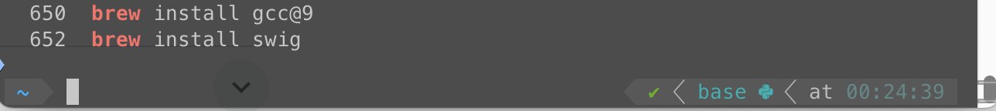

And following python packages are required for Box2D through “pip install”:

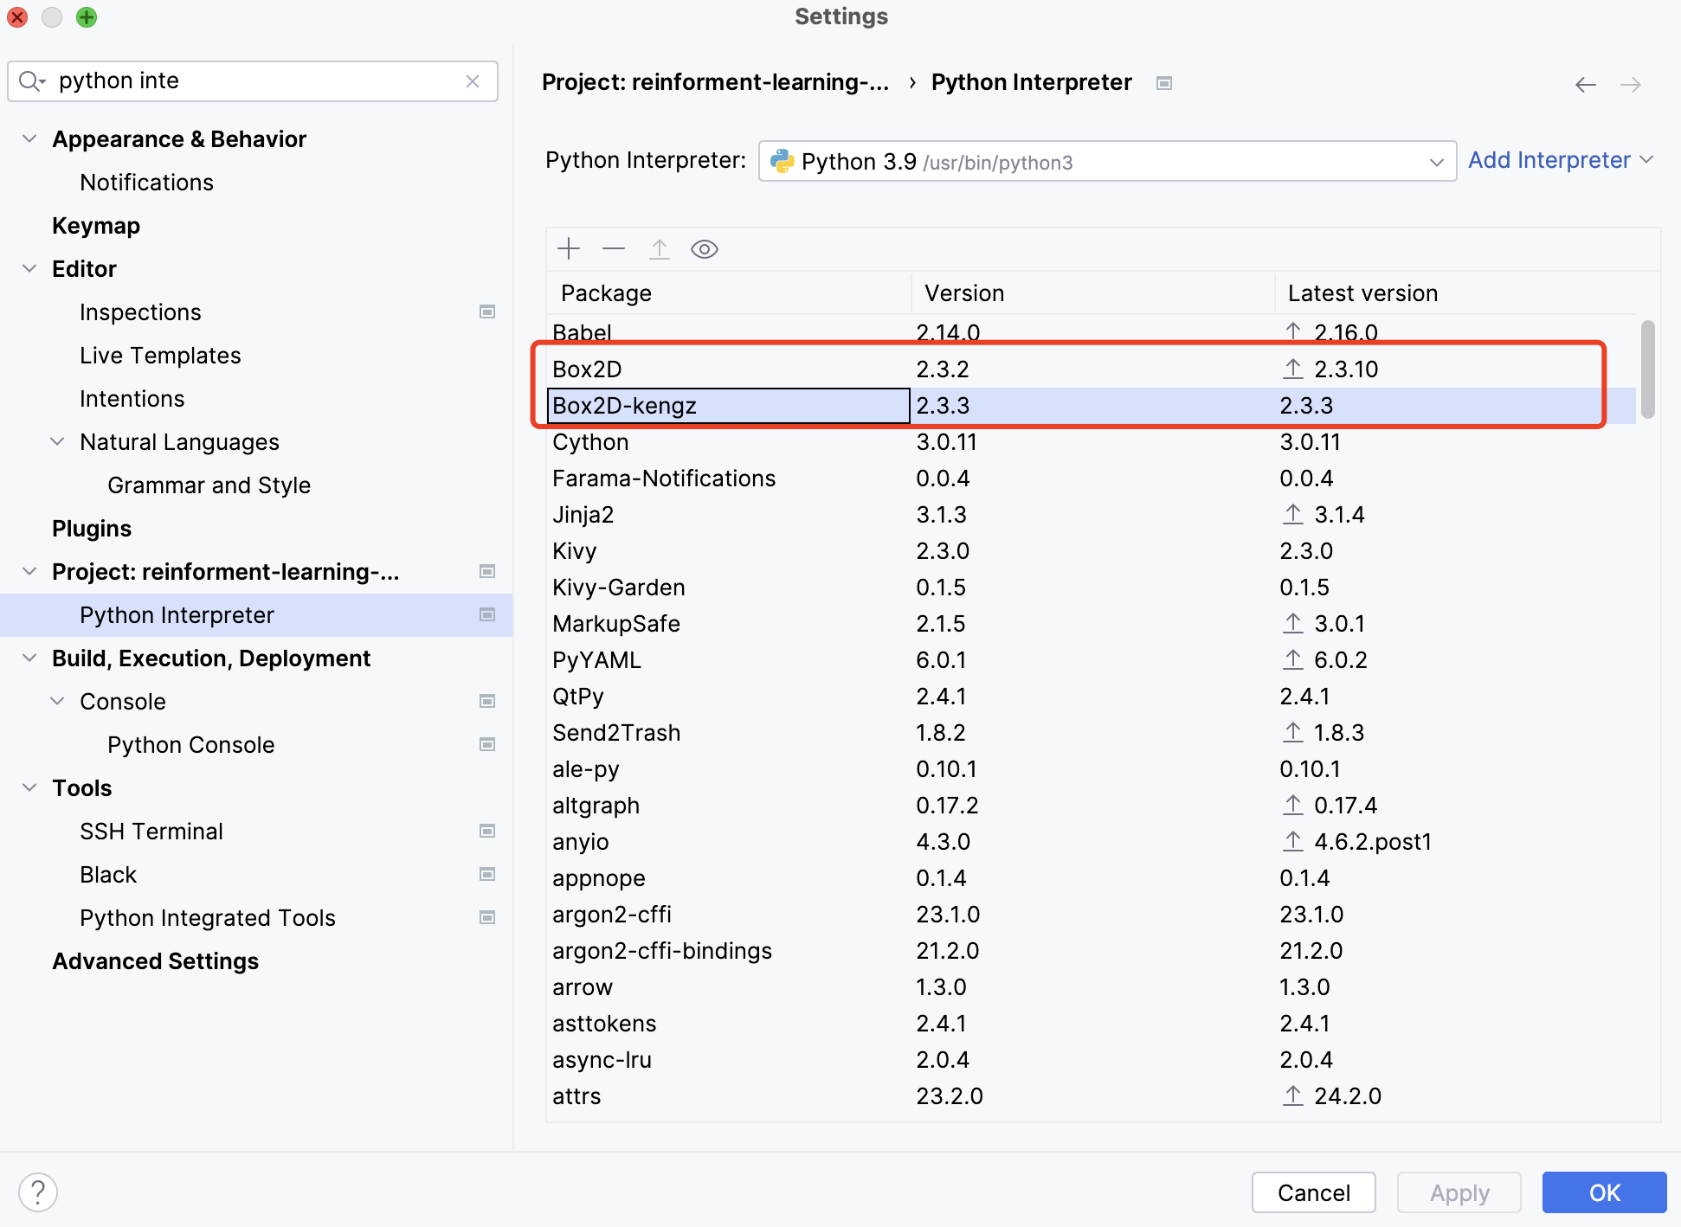

And following python packages are required for Atari through “pip install”:

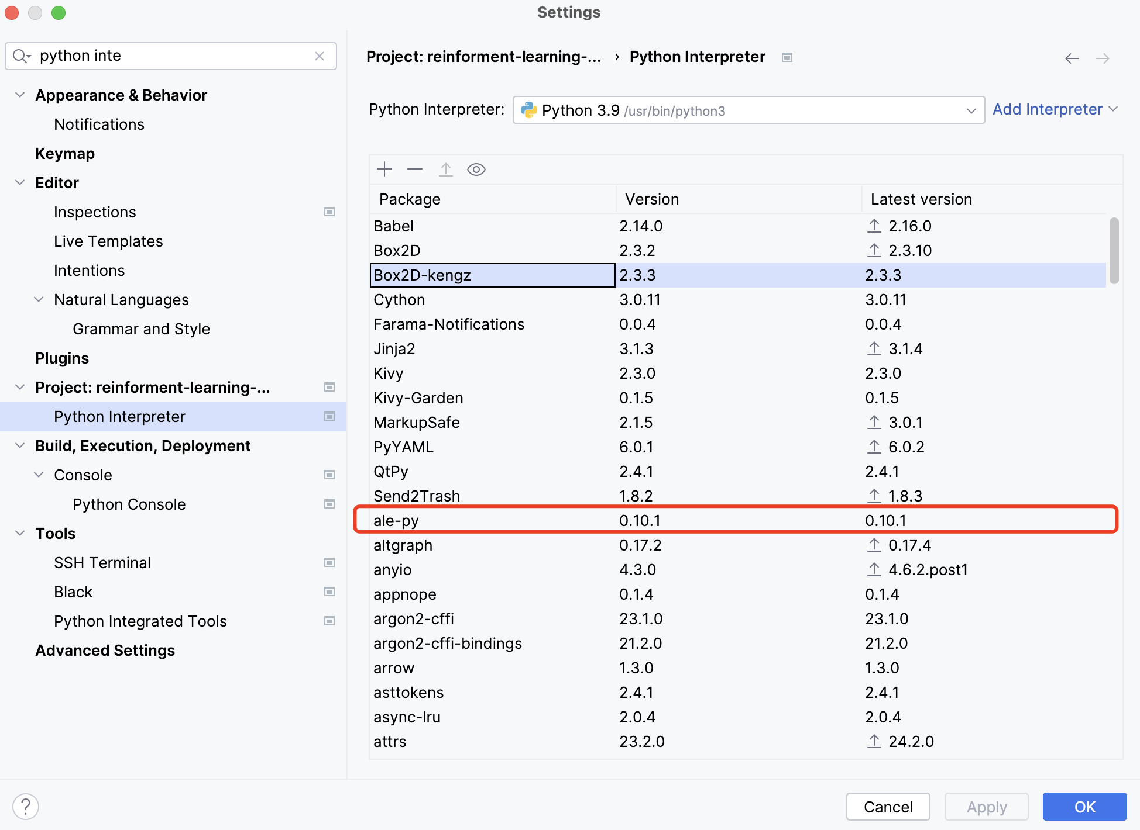

Following are main code files:

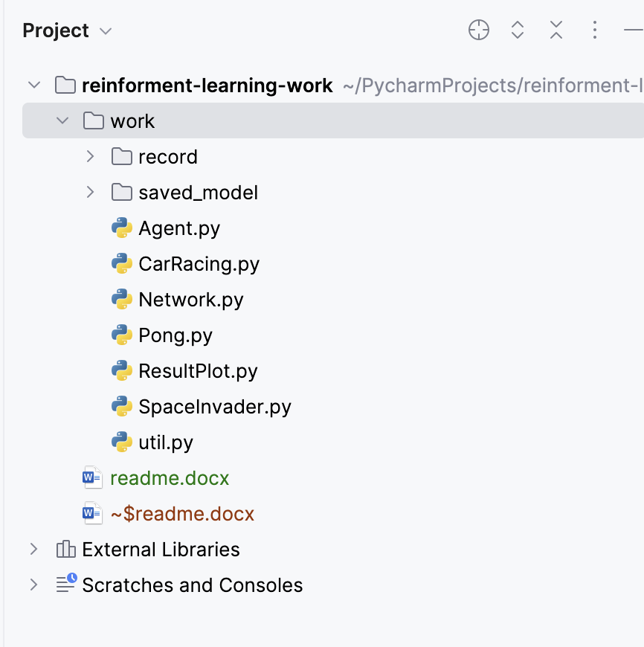

Agent.py implements three algorithms: DQN, REINFORCE and Actor-Critic. The core implementation code in agent.py is mainly based on implementation code from Practicals with only minor updates (such as adding the function of writing training information into text file), so it is easy to read and understand.

CarRacing.py, Pong.py and SpaceInvader.py are files to initialize, train and evaluate agents by calling classes in Agent.py for three games respectively.

ResultPlot.py is to use matplotlib to visualize training outcome by figures

Util.py includes some tool functions for other files, such as image pre-process and text formation.

Training information text files and trained models are saved in “record” and “saved_model” directories respectively.

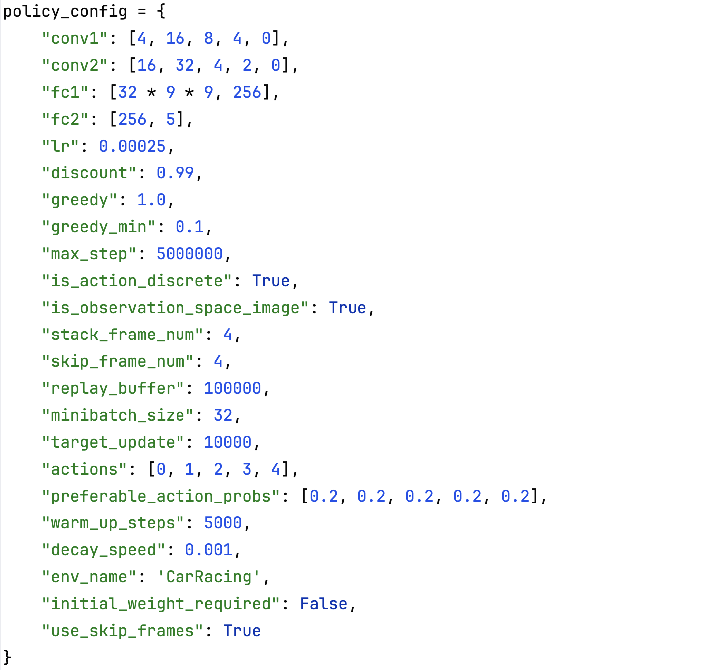

In CarRacing.py, Pong.py and SpaceInvader.py, core parameters for agent are given in dictionary, such as:

1. network structure
2. learning rate
3. gamma (discount)
4. epsilon (e-greedy)
5. epsilon min (minimum value of epsilon after continuous decay)
6. decay speed (how much to reduce epsilon after each step)
7. max steps
8. stack frame num (how many consecutive frames are regarded as one state)
9. skip frame num (how many consecutive frames are given the same action of first frame every, for example, frame 1-4 given action of frame 1, frame 5-8 given action of frame 5 and so on)
10. use skip frame (if skipping frame trick is used, True of False)
11. replay buffer (size of experience replay buffer)
12. minibatch size (batch size for DQN)
13. target update (interval of steps for target Q-net sync to Q-net)
14. preferable action probs (when explore with greedy, the probability distribution of actions)
15. initial weight required (whether weights of network require to be randomly initialized)

In CarRacing.py, Pong.py and SpaceInvader.py, there are three methods to train and evaluate three algorithms:

1. solve_by_dqn(): train and evaluate with DQN, parameters:
2. train_required: True for training model, False for directly evaluate model
3. model_name: can work with train_required=False to load already trained model to directly evaluate, or work with train_required=True so that training can continue based on previously trained model instead of nothing
4. greedy: define epsilon, this is useful when start to train from previously trained model, in this case, suppose previous model has already been trained for 500,000 steps, then then greedy can be set to 0.5 instead of 1.0 for training from nothing
5. decay_speed: as it explained in previous paragraph
6. preferable_action_probs: as it explained in previous paragraph

Also, you can add more parameters to be editable into function call if necessary

1. solve_by_reinforce(): train and evaluate with REINFORCE, parameters with the same name are similar with those for solve_by_dqn()
2. solve_by_actor_critic(): train and evaluate with Actor-Critic, parameters with the same name are similar with those for solve_by_dqn()

As training requires incredible amount of time, environments for three games are all executed with graphic interface disabled.