­



**NAMA : KEVIN AVICENNA WIDIARTO**

**NIM : L200200183**

**Modul : 6**

**Praktikum Algoritma Struktur Data**

**MODUL 7**

No 1

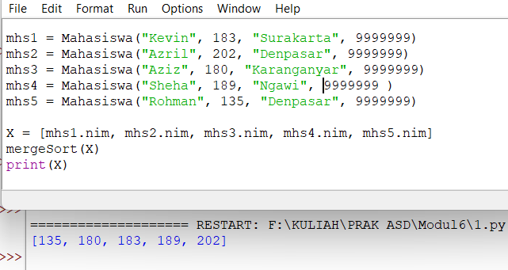

No 2

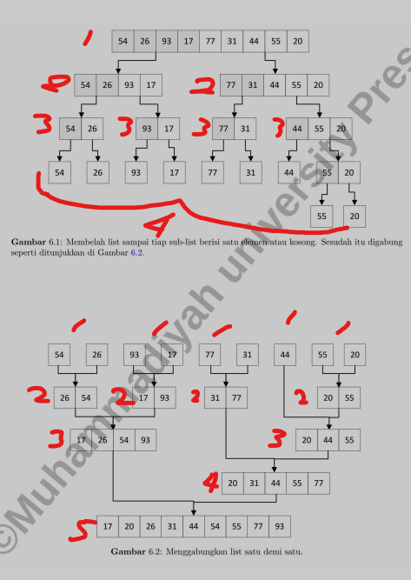

No 3

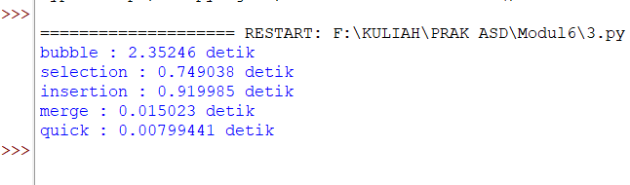

No 4

L = [80, 7, 24, 16, 43, 91, 35, 2, 19, 72],

MergeSort

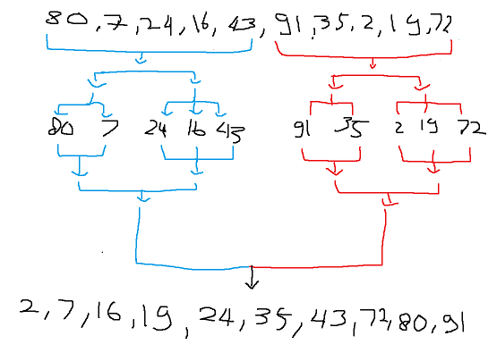

QuickSort

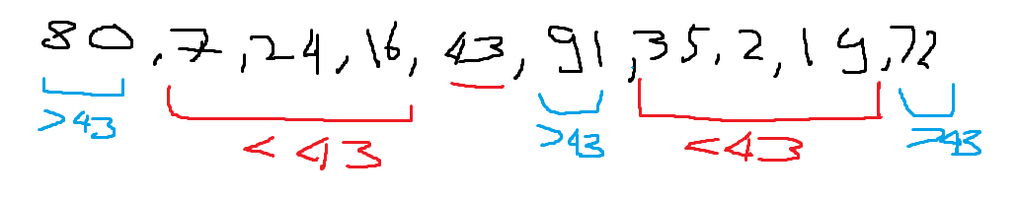

No 5

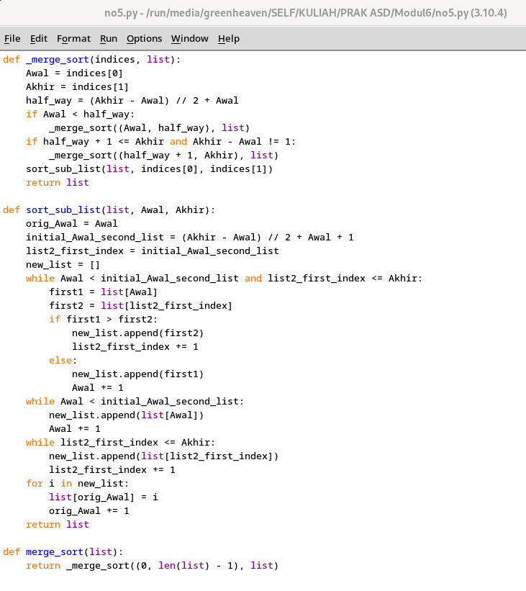

No 6

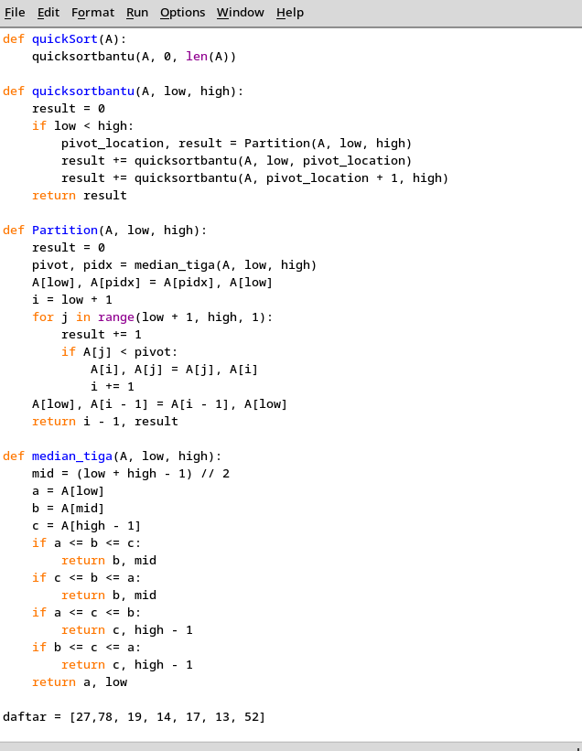

No 7

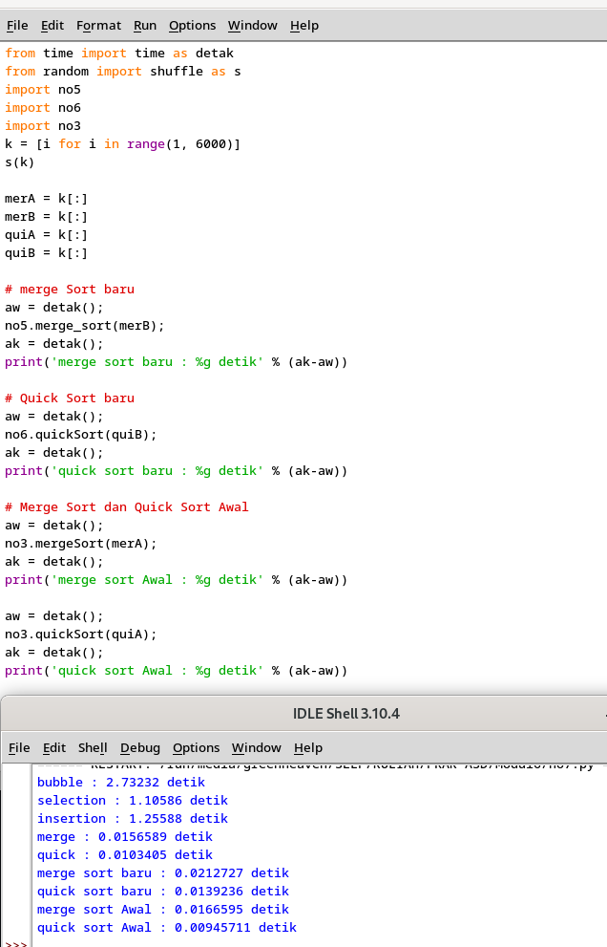

No 8

