**Debugging Life: The South**

**Paw Way**

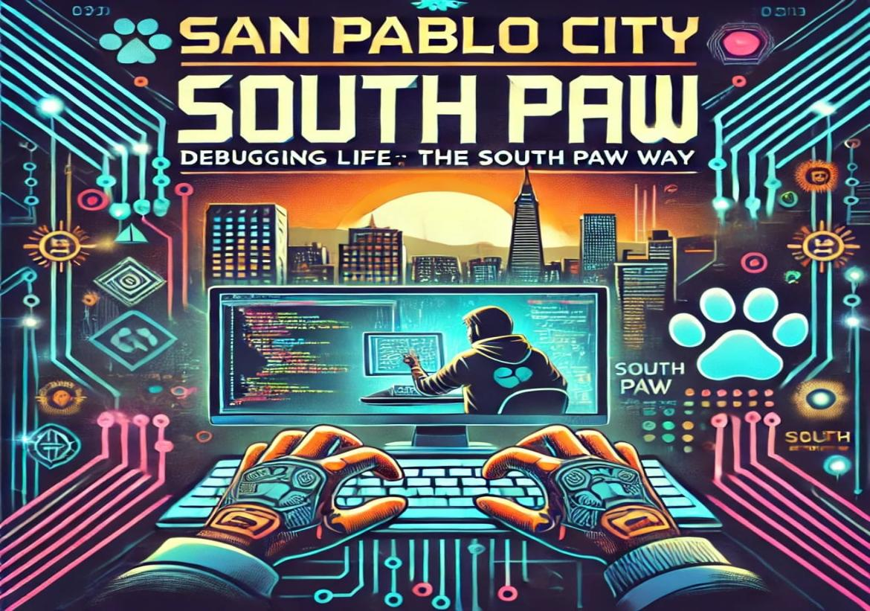

**LOGO Description:**

The logo combines two key ideas: the technical process of "debugging" from IT and the metaphorical reference to "life." Debugging is a systematic approach to identifying and fixing errors, often requiring critical thinking, persistence, and creativity traits essential in both IT and life. "South Paw" adds a layer of uniqueness, representing an unconventional or adaptive approach to tackling challenges, much like a left-handed fighter in a right-handed world.

**Ratoinale:**

**Debugging Life:** Life, like code, is prone to "bugs"—unexpected problems, setbacks, or inefficiencies. This phrase suggests that with the right mindset and tools, these issues can be resolved, optimized, and turned into opportunities for growth.

**The South Paw Way:** The term "South Paw" evokes an image of resourcefulness, adaptability, and standing out in a predominantly right-handed world. It aligns with the IT culture of innovation and resilience, symbolizing a non-traditional, bold approach to problem-solving.

**Connection to IT and Life**

This title resonates with IT professionals, developers, and freelancers who often apply technical skills to real-world challenges. It bridges the gap between the logical and emotional aspects of life, appealing to individuals who value creative thinking, perseverance, and the ability to adapt when facing personal and professional "bugs."

**Target Audience**

IT Professionals and Developers: Those who see parallels between debugging code and solving life’s problems.

Freelancers and Entrepreneurs: Individuals looking for inspiration on navigating the uncertainties of independent work.

General Readers: Anyone drawn to self-improvement, unique perspectives, and relatable metaphors.

**Tone and Style**

The title suggests a book, blog, or presentation that is both practical and inspirational. It promises a blend of technical wisdom, personal anecdotes, and actionable advice delivered with a touch of creativity and individuality.

**Mission Statement**

To empower individuals to approach life’s challenges with the mindset of a debugger: identifying problems, creating innovative solutions, and adapting to unique circumstances. By embracing the resilience and resourcefulness of "The South Paw Way," we inspire creativity, unconventional thinking, and the courage to navigate both personal and professional obstacles.

**Vision Statement**

To become a transformative guide for individuals seeking clarity, growth, and empowerment in a rapidly evolving world. Debugging Life: The South Paw Way envisions a future where everyone can master the art of turning setbacks into opportunities, combining technical insight with emotional resilience to create meaningful and impactful lives.

**Objectives:**

1. **Promote Problem-Solving Skills**

Encourage individuals to adopt a structured, analytical approach to identifying and addressing life’s challenges, inspired by debugging principles used in IT.

1. **Foster Adaptability and Resilience**

Advocate for the importance of flexibility and resourcefulness, embracing the "South Paw Way" to thrive in unconventional or adverse circumstances.

1. **Inspire Personal and Professional Growth**

Provide tools, strategies, and insights to help individuals optimize their lives, improve decision-making, and overcome setbacks effectively.

1. **Bridge Technical and Emotional Perspectives**

Demonstrate how technical concepts like debugging can offer profound life lessons, building connections between logical thinking and personal development.

1. **Create a Supportive Community**

Build a community of like-minded individuals who share stories, ideas, and experiences about turning life’s "bugs" into opportunities for learning and improvement.

1. **Promote Lifelong Learning**

Encourage continuous development of skills and knowledge, both technical and personal, to stay ahead in a constantly changing world.

**SWOT Analysis**

|  |  |
| --- | --- |
| **Strengths** | **Weakness** |
| · **Unique Concept:** Combines IT principles (debugging) with life skills, offering a fresh, relatable approach to self-improvement.  · **Broad Appeal:** Targets diverse audiences, including tech professionals, freelancers, and personal growth enthusiasts.  · **Inspirational Messaging:** Aligns with popular themes of resilience, adaptability, and problem-solving, fostering strong emotional connections.  · **Creative Branding:** The "South Paw" concept signifies individuality and unconventional methods, making it memorable and distinctive.  · **Versatility:** Can be adapted into multiple formats (book, blog, workshop, or online course) to reach various demographics. | · **Niche Interpretation:** The IT metaphor might limit initial understanding or interest from non-technical audiences.  · **Potential Overlap:** May face competition with existing self-help content using similar problem-solving frameworks.  · **Clarity of Message:** Requires careful balance between technical terminology and general applicability to avoid alienating readers unfamiliar with IT concepts.  · **Resource Intensive:** Development of high-quality content (books, online courses, community platforms) requires significant time and effort. |
| **Opportunities** | **Threats** |
| · **Growing Interest in Self-Improvement:** Rising global focus on personal development and resilience creates a ready market for such content.  · **IT Professionals' Demand:** Tech professionals seeking relatable, niche content can become a core audience.  · **Expanding Platforms:** Opportunities to share the concept through social media, podcasts, webinars, and YouTube for greater visibility.  · **Partnerships and Collaboration:** Collaborate with tech influencers, mental health advocates, and corporate training programs to increase reach.  · **Global Adaptation:** The theme’s universality can appeal across cultural and geographic boundaries with minimal localization. | · **Saturation of Self-Help Market:** Competing for attention in a crowded field of self-improvement and productivity resources.  · **Misinterpretation of Concept:** Audiences may perceive it as overly technical, limiting its adoption by general readers.  · **Shifting Trends:** As trends in self-help content evolve, maintaining relevance may require ongoing updates and adjustments.  · **Economic Factors:** Economic downturns or budget constraints might impact consumer spending on non-essential resources like self-help materials. |

Financial Section

1. Capital

* Sources: Sole Proprietorship
* Starting Fund: ₱50,000

2. Assets

* Equipment:
* Laptop or Desktop for content creation – ₱30,000
* Microphone and Webcam for online courses – ₱5,000
* Graphic Design Software Subscription – ₱3,000
* Learning Platform (e.g., Teachable/Thinkific Subscription) – ₱5,000/year
* Content Development:
* Professional Editing and Proofreading – ₱10,000
* Cover Design for the book – ₱5,000

3. Liabilities

* Employee Wages (Freelance):
* Virtual Assistant and Marketing Support – ₱10,000/month

4. Operational Expenses

* Monthly Expenses:
* Website Hosting and Maintenance – ₱1,000
* Social Media and Digital Marketing Ads – ₱3,000
* Miscellaneous (Internet, Subscriptions) – ₱1,000

5. Income Statement

* Monthly Income:
* Estimated Sales of Books (100 copies @ ₱500 each) – ₱50,000
* Enrollment in Online Courses (50 students @ ₱1,000) – ₱50,000
* Sponsorship Deals – ₱10,000
* Total Monthly Income: ₱110,000
* A Year’s Income (12 Months):
* Estimated Book Sales (1,200 copies) – ₱600,000
* Online Courses Enrollment (600 students) – ₱600,000
* Sponsorship Deals – ₱120,000
* Total Yearly Income: ₱1,320,000
* Expenses:
* Content Creation and Initial Investments – ₱48,000
* Marketing and Operational Costs (12 Months) – ₱60,000
* Freelance Wages (12 Months) – ₱120,000
* Total Yearly Expenses: ₱228,000
* Projected Net Income (1 Year): ₱1,092,000

**Richmond D. Besmonte**

**Email: [richmondbesmonte0@gmail.com](mailto:kleindarelle@gmail.com)**

**Mobile Number: 09211574452**

**Date of Birth: April 30, 2002**

**Place of Birth: Calamba, Laguna**

**Civil Status: Single**

**Citizenship: Filipino**

**Jade Kevin Balocos**

**Email: [Kevinbalocos@gmail.com](mailto:kleindarelle@gmail.com)**

**Mobile Number: 09054651578**

**Date of Birth: August, 16, 2003**

**Place of Birth: San Pablo City, Laguna**

**Civil Status: Single**

**Citizenship: Filipino**

**Jason Adrian A. Platino**

**Email: [jasonPlatino798@gmail.com](mailto:kleindarelle@gmail.com)**

**Mobile Number: 09368986003**

**Date of Birth: November 20, 2000**

**Place of Birth: San Pablo City, Laguna**

**Civil Status: Single**

**Citizenship: Filipino**

