Class5.R

Kevin Banh

2019-10-17

#Class5 Data Visualization   
x <- rnorm(1000)  
  
#fml  
mean(x)

## [1] -0.02717027

sd(x)

## [1] 0.9839939

summary(x)

## Min. 1st Qu. Median Mean 3rd Qu. Max.   
## -3.25326 -0.70997 -0.05051 -0.02717 0.63877 3.25164

boxplot(x)

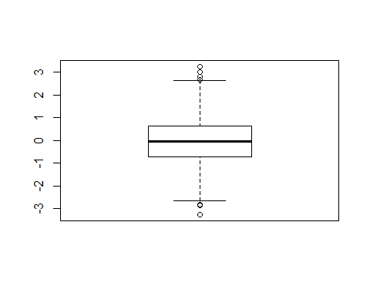

hist(x)  
rug(x)

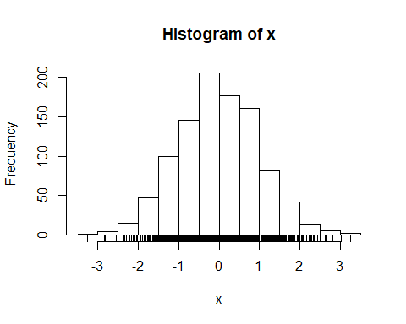

weight <- read.table("bimm143_05_rstats/weight_chart.txt", header=TRUE)  
weight

## Age Weight  
## 1 0 3.6  
## 2 1 4.4  
## 3 2 5.2  
## 4 3 6.0  
## 5 4 6.6  
## 6 5 7.2  
## 7 6 7.8  
## 8 7 8.4  
## 9 8 8.8  
## 10 9 9.2

plot(weight$Age, weight$Weight)

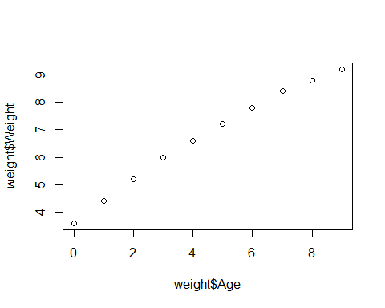

plot(weight$Age, weight$Weight, pch=15)

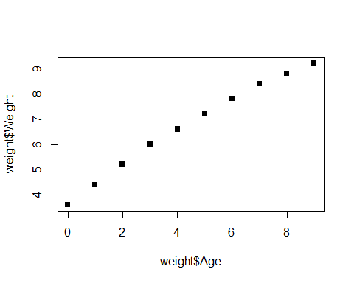

plot(weight$Age, weight$Weight, pch=15, cex=1.5)

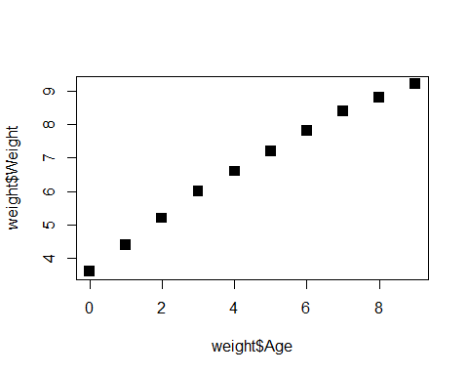

plot(weight$Age, weight$Weight, lwd=2)

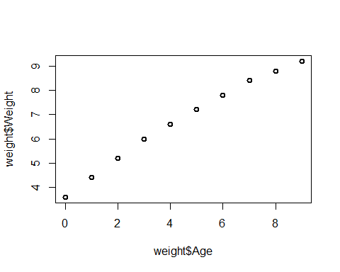

plot(weight$Age, weight$Weight, ylim=c(2,10))

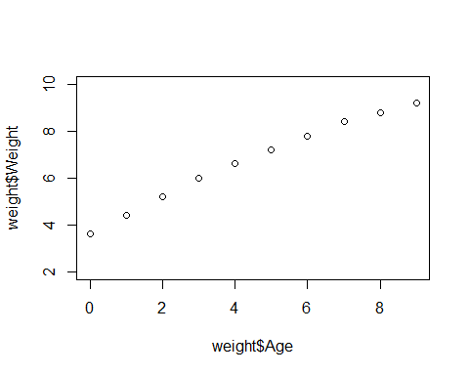

plot(weight$Age, weight$Weight, xlab= "Age(months)")

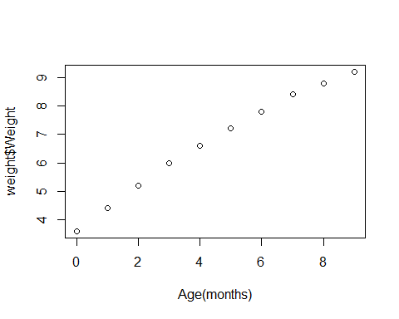

plot(weight$Age, weight$Weight, ylab = "Weight(kg)")

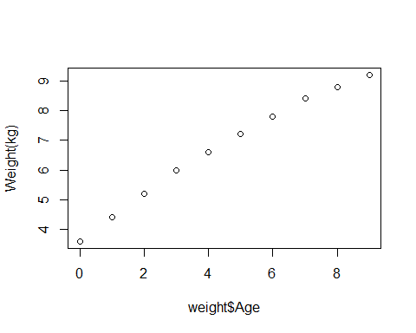

plot(weight$Age, weight$Weight, main = "OwO")

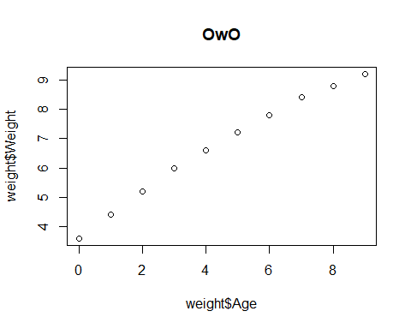

plot(weight$Age, weight$Weight, xlab = "Age(months)", ylab = "Weight(kg)", main = "OwO", lwd = 2, col= "blue", pch=15, typ="o", cex=1.5)

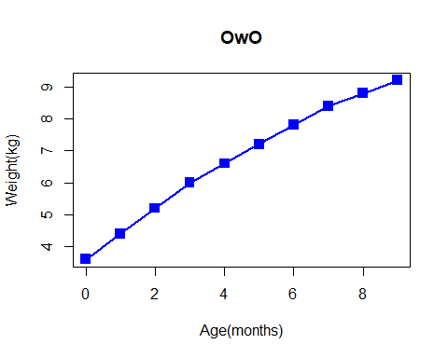

mouse <- read.table("bimm143_05_rstats/feature_counts.txt", sep="\t", header = TRUE)  
barplot(mouse$Count)

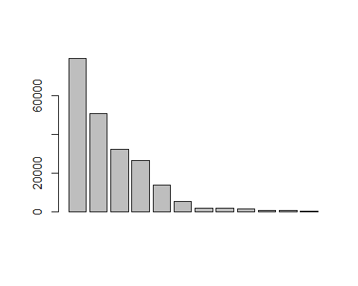

barplot(mouse$Count, horiz = TRUE, names.arg = mouse$Feature)  
barplot(mouse$Count, horiz = TRUE, names.arg = mouse$Feature,)

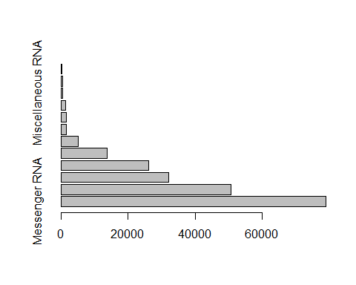

read.delim("bimm143_05_rstats/weight_chart.txt")

## Age Weight  
## 1 0 3.6  
## 2 1 4.4  
## 3 2 5.2  
## 4 3 6.0  
## 5 4 6.6  
## 6 5 7.2  
## 7 6 7.8  
## 8 7 8.4  
## 9 8 8.8  
## 10 9 9.2

par(mar=c(5,11,2,2))  
barplot(mouse$Count, horiz = TRUE, names.arg = mouse$Feature, main="OwO", las=1)

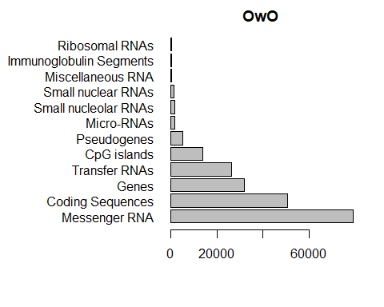

OwO <- read.delim("bimm143_05_rstats/male_female_counts.txt")  
barplot(OwO$Count, names.arg = OwO$Sample, col = rainbow(nrow(OwO)), las=2, ylab = "OwO")

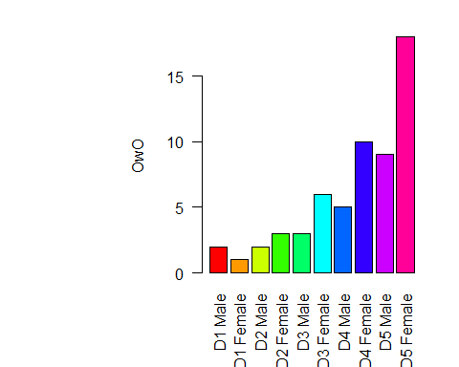

barplot(OwO$Count, names.arg = OwO$Sample, col = c("blue2", "red2"), las=2, ylab = "OwO")

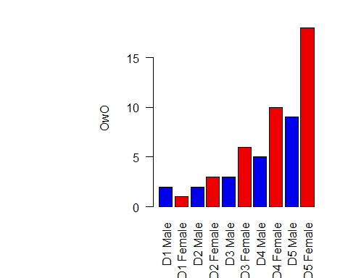

genes <- read.delim("bimm143_05_rstats/up_down_expression.txt")  
nrow(genes)

## [1] 5196

table(genes$State)

##   
## down unchanging up   
## 72 4997 127