Form 4: Assignment Brief - FETAC

Course: | Computer Science 1A | Module: | Computer Programming C20013
Assignment: | Assignment 1 | Tutor: | Pat McDonnell
Date of Issue: | 5th November 2014 | Submission Date: | 19th November 2014

Tutor: Learner:
Pat McDonnell

Assignment Description:
This assignment is designed to demonstrate the use of for loops, while loops and if statements. Students are required to submit their work in Google Classroom on the due date and present accompanying documentation in the form of a written report.

Brief/Task:

- You are required to write a program (java class) for entering Leaving Cert grades for two students and calculating the points each achieved.
- The user should be asked to enter each student’s name and enter seven grades for each student. Use a loop, which will execute seven times, to take in the grades.
- Use a while loop for one student and a for loop for the other student.
- Use the best six grades. The lowest grade must be not used in the point’s calculation.
- Calculate the number of points achieved by each student.
(Use the following web site as a guide to point’s calculation
http://www2.cao.ie/app_scoring/lcegrid.htm)
- Tell the user the highest and lowest and average number of points for each student.
- Tell the user the name of the student that got the highest points scored or if both students got the same points score.

Guidance:
See notes on Google Classroom and class notes.
The written report should include all relevant documentation including; an Introduction, a Program Walkthrough, a Test Bed and finally a Conclusion and Evaluation.

Assignment Criteria: (Candidate Marking Sheet Attached)

A Pass grade is achieved by meeting all the requirements defined in the assignment criteria. 50%

In order to achieve a Merit a student must achieve a minimum of 65%

In order to achieve a Distinction a student must achieve a minimum of 80%

When handing up work please ensure you:
- attach this form to your assignment
- sign the back of this form confirming that the work submitted is your own

Form 4A: Assignment Report – FETAC

Course: | Computer Science 1A | Module: | Computer Programming C20013
Assignment: | Assignment 1 | Tutor: | Pat McDonnell
Date of Issue: | 5th November 2014 | Submission Date: | 19th November 2014

Learner Name: KEVIN DONOVAN (Print name) Date of submission:

Learner Signature: ________________________ (By signing here I confirm that all of this work is entirely my own)

Learner’s Comment: (Did you understand the brief? Did you develop new skills? How did the brief challenge you ? Were the guidelines clear?)

I thought the brief and guidelines were extremely clear. I feel a gained invaluable Java Programming knowledge. The challenges of troubleshooting my problems as I progressed through the assignment was tough but I’m happy I was able to overcome them.

Tutor Feedback: (Were the assessment criteria met? Strong / Weak points in assignment? How does this learner progress to the next level? )

Grade: Tutor signature: Date:

Learner signature:

Reason (s) for Referral:

Action (s) required to pass the assignment:

Resubmission date:

(Please print on reverse of Form 4.)

Student Name: KEVIN DONOVAN

Computer Programming Assignment 1
30% of total Module mark
Assessment Criteria | Maximum  Marks | Marks  awarded
• clearly documented program code :  ( Fully commented)  • excellent screen layout :  - Spacing -5  - Prompting -5  - Look -5 | 15  15
• effective code layout :  • accurate programming (syntactically and  semantically) :  - syntactically - 15  - semantically - 15 | 15  30
• appropriate testing:  - 7.5 test bed  - 7.5 tested program | 15
Total Marks | 90

Pass  50 – 64% | Merit  65 – 79% | Distinction  80 – 100%

Guidance on Assignment 1

Introduction
Explain what the program is to do and how you are going to do the program, e.g. using for loops , while loops to validate the data etc.

Steps

Program Walkthrough
You must include screen shots in this section.

Test Bed
Scenario | Data Entered | Expected Result | Actual Result

Conclusion/Evaluation
- Does the program work?
- If not what problems did you have.
- What did you find difficult or tricky with the assignment.
- How do your test bed results match? Would you do anything differently if you were to start again or had more time?
- What could be done to make the program better?
- Are you happy with the end result?

Introduction:
This program utilises both the knowledge of while loops and for loops in Java Programming.

Using JCreator we were told to create a program that emulated a Leaving Certificate Points Calculator. It took in 7 grades from two Students. It then calculated both student’s highest, lowest, average and the total points they got.

After that it then told both students which of them got the higher points total.

Program Walkthrough:
1: Using JCreator, we first ran the Program. Which brought up this screen, prompting the user to enter their name
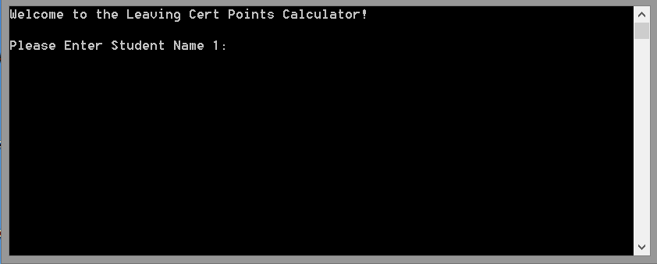

2: I’ll enter my own name, once done the program provides the user with a welcome message, along with a prompt to enter the first of 7 grades it will take in.

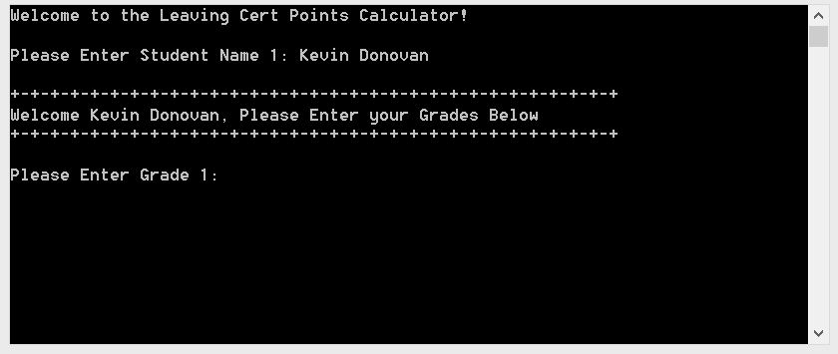

3: So I enter Grade 1…….
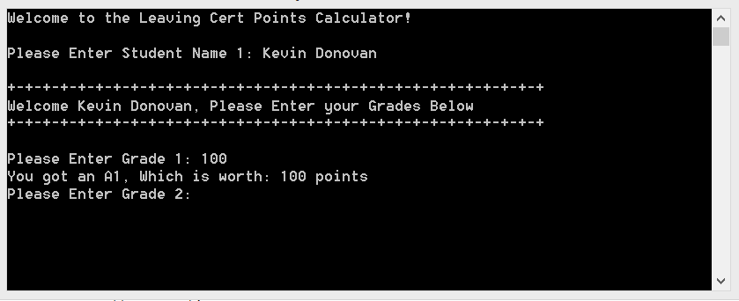

5: It then prompts me for Grades 2,3,4….etc up to 7, so for testing purposes I cycle through the grades as far as I can (In this case 7). It then prompts the second user for their name

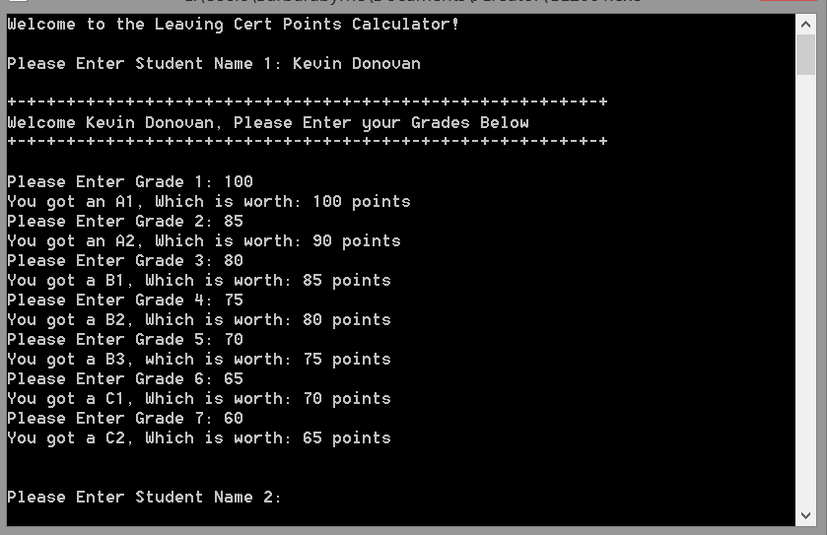

5: The second user’s name will be Devon Konovan, again the program prompts the second user for their 7 grades, starting with 1.

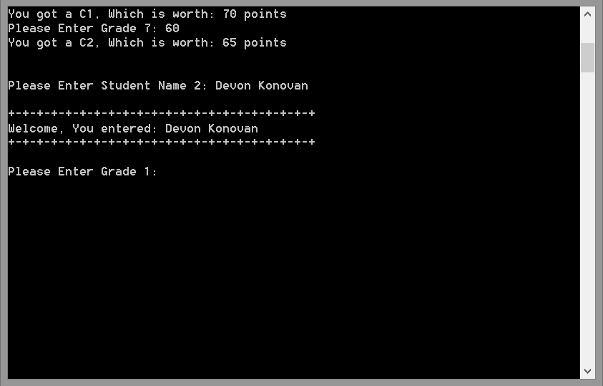

6: Devon sadly didn’t do as good as me in his Leaving Cert, but he enters his 7
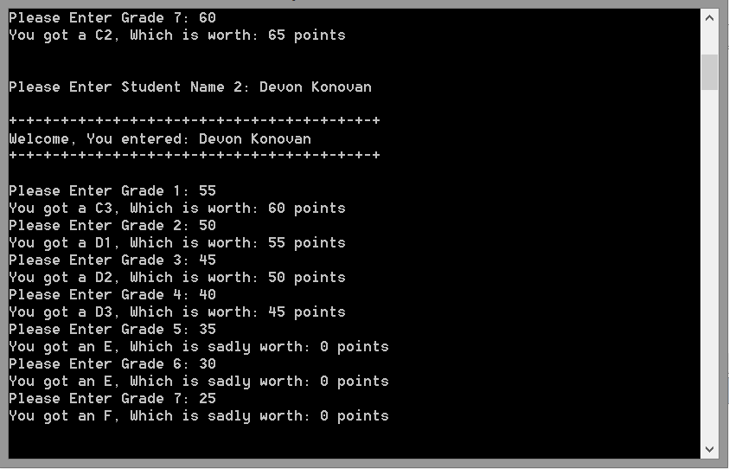

7: Once both Students have entered their grades it then shows the final results

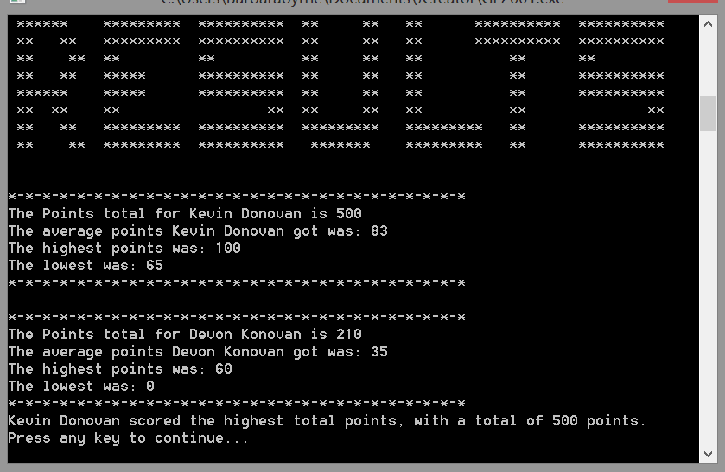

8: In the off chance both students get the same points totals, it will show this
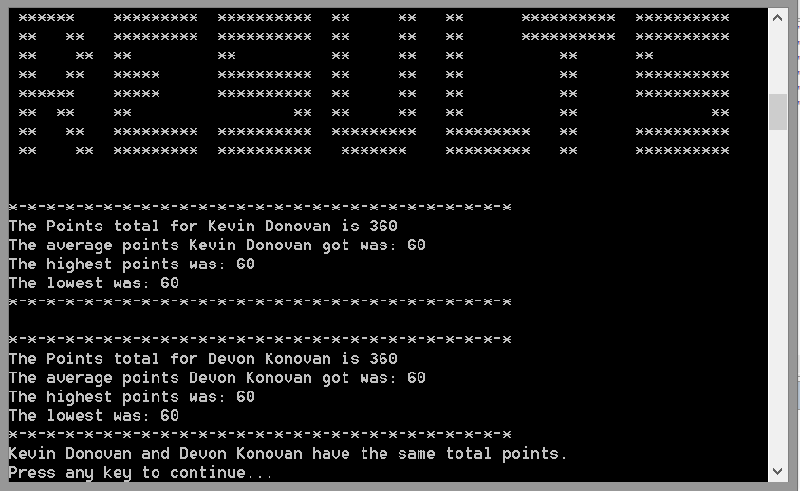

As you can see, the points total, average, highest and lowest were all shown. And that ends my Program Walkthrough!!

Test Bed

Scenario | Data Entered | Expected Result | Actual Result
Please Enter Student Name 1 | Kevin Donovan | Welcome Kevin Donovan, Please Enter your Grades Below | Welcome Kevin Donovan, Please Enter your Grades Below
Please Enter Grade 1 | 64 | You got a C2, Which is worth: 65 points | You got a C2, Which is worth: 65  points
Please Enter Student Name 2 | John Barnes | Welcome John Barnes, Please Enter your Grades Below | Welcome John Barnes, Please Enter your Grades Below
Please Enter Grade 1 | 99 | You got an A1, Which is worth: 100 points | You got an A1, Which is worth: 100 points

Conclusion and Evaluation

Initially I did find the assignment rather daunting and challenging, I found it hard to get to grips with the intricacies of Java programming, but I found I grew in confidence once I looked over notes and got the initial prompts working

If I’m honest and had more time I’d have added more aesthetically pleasing things to my program, much like the huge RESULTS when the final results are printed out.

I would also have like to split the names up, so for example when you enter “Kevin Donovan” it prints out only the first name, but that’s just my personal preference

Overall I’m delighted with my program, It works well and without fault and the work to get it there paid off. It follows the guidelines set and in my opinion looks good and is written well.

