Form 4: Assignment Brief - FETAC

Course: | Computer Science 1A | Module: | Computer Programming C20013
Assignment: | Assignment 2 | Tutor: | Pat McDonnell
Date of Issue: | 3rd March 2015 | Submission Date: | 24th March 2015

Tutor: Learner:
Pat McDonnell

Assignment Description:
This assignment is designed to demonstrate the use of for loops and arrays. Students are required to submit their work in Google Classroom on the due date and present accompanying documentation in the form of a written report.

Brief/Task:

- You are required to write a program (java class) to create a system for a supermarket running a loyalty card scheme.
- Hard code 5 gifts that the supermarket offer and the points the gifts cost. (These must all be stored in arrays.)
- Hard code the users for the system. Each user will have a name, pin and points. (These must all be stored in arrays.)
- The user will be asked to log in. Once they log in they will have a menu with options to View Gifts, Buy Gifts, Add Points, Change Pin and Exit. The menu should loop until the user chooses to Exit. (The PIN cannot be a PIN that is already in use.)
- When the user buys a gift the amount of points the gift cost must be deducted from the users points.
- The user will not be allowed to purchase a gift if the gift costs more points than they have. The user points held in the array must be updated. When the user adds points the points in the array must also be updated.
- All inputs must be validated for error checking.

Guidance:
See notes on Google Classroom and class notes.
The written report should include all relevant documentation including; an Introduction, a Program Walkthrough, a Test Bed and finally a Conclusion and Evaluation.

Assignment Criteria: (Candidate Marking Sheet Attached)

A Pass grade is achieved by meeting all the requirements defined in the assignment criteria. 50%

In order to achieve a Merit a student must achieve a minimum of 65%

In order to achieve a Distinction a student must achieve a minimum of 80%

Form 4A: Assignment Report – FETAC

Course: | Computer Science 1A | Module: | Computer Programming C20013
Assignment: | Assignment 2 | Tutor: | Pat McDonnell
Date of Issue: | 3rd March 2015 | Submission Date: | 24th March 2015

Learner Name: _____________________________ (Print name) Date of submission:

Learner Signature: ________________________ (By signing here I confirm that all of this work is entirely my own)

Learner’s Comment: (Did you understand the brief? Did you develop new skills? How did the brief challenge you ? Were the guidelines clear?)

Tutor Feedback: (Were the assessment criteria met? Strong / Weak points in assignment? How does this learner progress to the next level? )

Grade: Tutor signature: Date:

Learner signature:

Reason (s) for Referral:

Action (s) required to pass the assignment:

Resubmission date:

(Please print on reverse of Form 4.)

Student Name: Kevin Donovan

Computer Programming Assignment 2
30% of total Module mark
Assessment Criteria | Maximum  Marks | Marks  awarded
• clearly documented program code :  ( Fully commented)  • excellent screen layout :  - Spacing -5  - Prompting -5  - Look -5 | 15  15
• effective code layout :  • accurate programming (syntactically and  semantically) :  - syntactically - 15  - semantically - 15 | 15  30
• appropriate testing:  - 7.5 test bed  - 7.5 tested program | 15
Total Marks | 90

Pass  50 – 64% | Merit  65 – 79% | Distinction  80 – 100%

Guidance on Assignment 2

Introduction
Explain what the program is to do and how you are going to do the program, e.g. using for loops , while loops to validate the data etc.

Steps

Program Walkthrough
You must include screen shots in this section.

Test Bed
Scenario | Data Entered | Expected Result | Actual Result

Conclusion/Evaluation
- Does the program work?
- If not what problems did you have.
- What did you find difficult or tricky with the assignment.
- How do your test bed results match? Would you do anything differently if you were to start again or had more time?
- What could be done to make the program better?
- Are you happy with the end result?

Introduction

This assignment is designed to demonstrate the use of for loops and arrays. We were required to write a program (java class) to create a system for a supermarket running a loyalty card scheme.

We were asked to hard code 5 gifts that the supermarket offer and the points the gifts cost. (These must all be stored in arrays.) We were also asked to hard code the users for the system. Each user will have a name, pin and points. (These must all be stored in arrays.)

The user will be asked to log in. Once they log in they will have a menu with options to View Gifts, Buy Gifts, Add Points, Change Pin and Exit.

The menu should loop until the user chooses to Exit. When the user buys a gift the amount of points the gift cost must be deducted from the users points. The user will not be allowed to purchase a gift if the gift costs more points than they have. The user points held in the array must be updated. When the user adds points the points in the array must also be updated.
All inputs we make must be validated for error checking.

Steps

- Import Java Scanner
- Start of the class
- Start of the main
- Scanner input
- Declare ints
- Declare Strings
- Welcome Greeting and Login/Exit Prompting
- Start While loop to Error Check to see if the user chooses 1-2
- Re-prompt the user to make a choice
- Start of Count
- Start of if statment (when they run out of attempts)
- else startment to exit the program
- End of while
- While loop to take in username and password
- Prompt user for username and password
- start another count for error checking
- for loop to go through each array and check the vailidity of the username and password
- change the value of the flag to stop the while loop
- reprompt if username or pincode is incorrect
- end while loop
- prompt user for their choice 1-5
- take in their choice as a string (user_input)
- change user_input into an integer choice (choice = Integer.parseInt(user_input);)
- check the number entered is 1-5
- while loop to keep the menu appearing
- for loop to print out the gifts and their prices (System.out.print(gifts[i]+" "+giftcost[i]+"\n");)
- validate the gift purchase only contains digits
- take gift choice as a string (user_input)
- check if balance is enough and reprompt if not
- if so, show reamaining points on screen
- if chosen, ask the user how many points they wish to add to their given account
- check the add points only contains digits, if incorrect, reprompt
- if chosen, ask the user to enter a new pin
- check newpin only contains digits
- take in user input as string, and then to an int
- prompt the user “Pin has been changed to:........”
- re prompt user the menu
- check if numbers are 1-5
- Print out final greeting
- End main
- End Class

Program Walkthrough

1. When the program is ran, the main Login/Exit Menu comes up

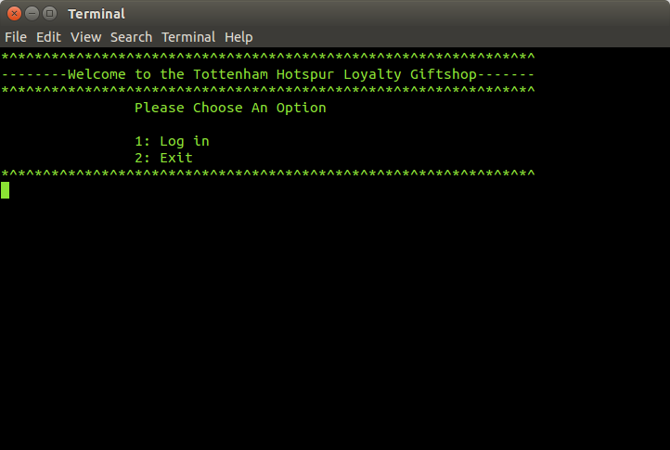

2: We hit 1 to Login and we are prompted for the username and password

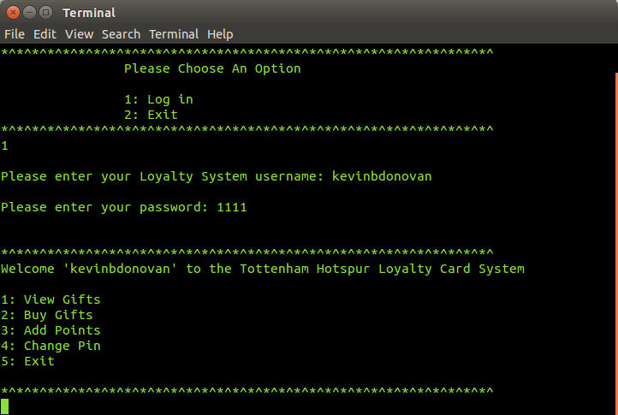

3. I think we'll buy something!
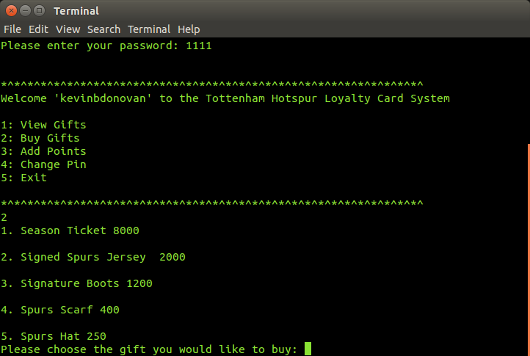

4. We'll buy the signed jersey:

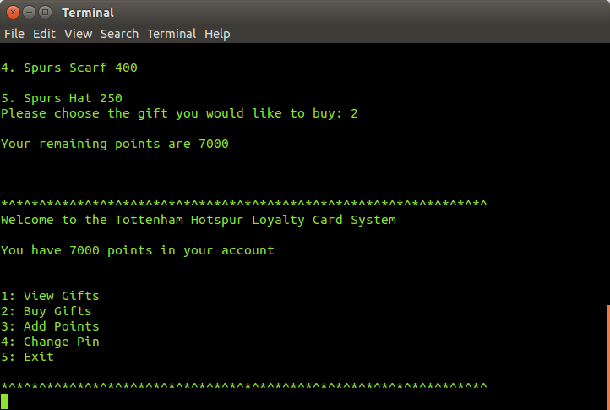

5. Here's the add points working
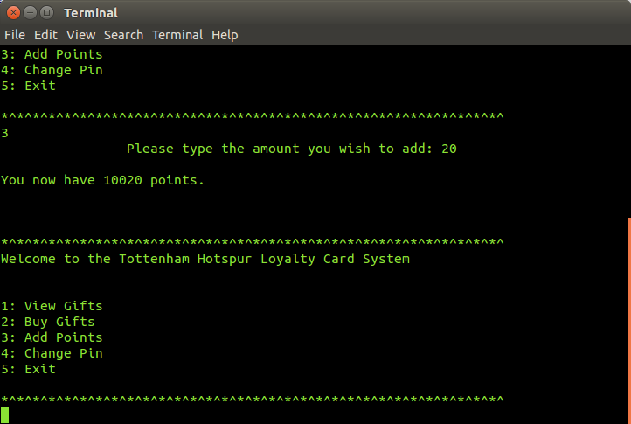

6: Here's the pin change

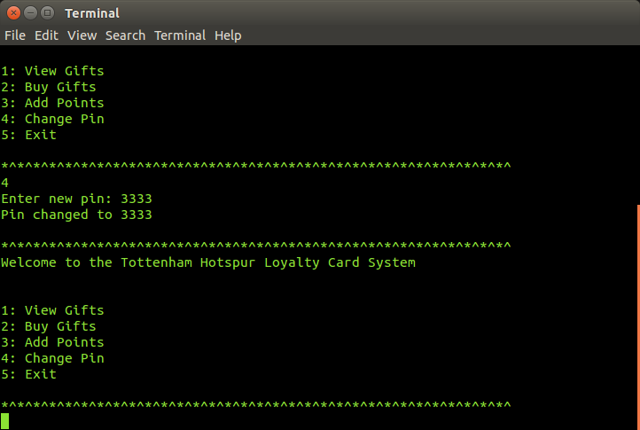

Test Bed:

Scenario | Data Entered | Expected Result | Actual Result
Please enter your Loyalty System username | kevinbdonovan | Welcome 'kevinbdonovan' to the Tottenham Hotspur Loyalty Card System | Welcome 'kevinbdonovan' to the Tottenham Hotspur Loyalty Card System
Please enter your Loyalty System username | harrykane | Welcome harrykane' to the Tottenham Hotspur Loyalty Card System | Welcome harrykane' to the Tottenham Hotspur Loyalty Card System
Please enter your Loyalty System username | nabilbentaleb | Welcome 'nabilbentaleb' to the Tottenham Hotspur Loyalty Card System | Welcome 'nabilbentaleb' to the Tottenham Hotspur Loyalty Card System
Please enter your Loyalty System username | ryanmason | Welcome 'ryanmason' to the Tottenham Hotspur Loyalty Card System | Welcome 'ryanmason' to the Tottenham Hotspur Loyalty Card System
Please enter your Loyalty System username | fiabyrne | Welcome 'fiabyrne' to the Tottenham Hotspur Loyalty Card System | Welcome 'fiabyrne' to the Tottenham Hotspur Loyalty Card System
Gift Menu | 1 | View Gift Option | View Gift came up
Gift Menu | 2 | Buy Gift Menu and prompt | Buy Gift Menu and prompt
Gift Menu | 3 | Points add Menu | Points add menu
Gift Menu | 4 | Pin Change | Pin Change
Gift Menu | 5 | Exit | Exit
Buy Gift Menu and prompt | 2 | Your Remaining points are 7000 | Your Remaining points are 7000
Points Add | 20 | You now have 10020 points | You now have 10020 points
Pin Change | 3333 | Your new pin is 3333 | Your new pin is 3333

Conclusion/Evaluation
- Does the program work?
The program work well, albeit with some glitches and a really annoying bug I just cant understand or fix. It looks well and the code is fine and well written, but again I think the bug ruins it, it's something to do with where I put my while loops and what's inside them.
- If not what problems did you have.
The problem is that when you compile the program and run it, you can login, but the exit doesn't work properly, and when you do login if you choose an option, say Buy Gift-2, even though the menu is looped no matter what choice you make it will always loop to the choice you made first (This really frustrated me) so if I chose 4 to change my pin, it would just show the buy gift menu again
- What did you find difficult or tricky with the assignment.
The challenges I faced I really found frustrating, I changed my code around to fix an issue, and ended up breaking it and I found that to be really trying of my time and patience.
- How do your test bed results match? Would you do anything differently if you were to start again or had more time?
My test bed results were fine, once I started up the program each time I had to run a certain option, if I had more time I'd try to solve my problem in order to make the code run perfectly, If I had time to start again I'd try to approach the code from a different angle so I wouldn't make a mistake
- What could be done to make the program better?
Linking it with an access database would make the code easier to write, less arrays etc. And if such a feat could be possible it would make it easier to add options and users etc
- Are you happy with the end result?
Overall I am happy with the work I put in and the things I've learned, but sadly I'm not 100% happy with the end product, honestly I could have done alot better and would have loved to fix the bug that will probably haunt me for the rest of my life. It has made me more cautious of mistakes and bugs, and when I go into second year of this course I hope to improve my coding knowledge and make less mistakes, the lesson I have learned from this assignment will do me well for my education in the college, despite making it difficult to take now.

