

**KABARAK UNIVERSITY**

**SCHOOL OF COMPUTER SCIENCE AND BIOINFORMATICS**

**DEPARTMENT OF COMPUTER SCIENCE AND IT**

PROJECT PROPOSAL/RESEARCH PROJECT II

PROJECT PROPOSAL TITLE**: MKULIMA TRANSPORT SYSTEM**

**A Project Report Documentation Submitted in The Department of Computer Science and IT in partial fulfillment of the degree of Computer Science**.

**KIPLANGAT KEVIN INTE/M/O150/01/22**

**SUPERVISOR: MR. CLEOPHAS MOCHOGE**

# **DECLARATION**

**This is to assert that this research proposal has been carried out by me under the supervision of Mr. Cleophas Mochoge**

**KIPLANGAT KEVIN**

**SIGN: ___________________________________________DATE: _____________________**

# **DEDICATION**

This proposal is my original work and has not been presented for a degree or any purpose in any other institution.

This proposal has been submitted for examination with my approval as University Supervisor.

**MR. CLEOPHAS MOCHOGE**

**………………………............. ................................................**

**Signature Date**

# **ACKNOWLEDGEMENT**

My sincerest gratitude goes to the Almighty God for the strength, good health and protection he has given me. We do recognize our parents and siblings who supported us financially and morally throughout our studies. I would also wish to acknowledge Kabarak University for the training opportunity in their institution. Without forgetting my supervisor Mr. Cleophas Mochoge for his good guidance, motivation and teaching in all the areas that we got difficulties. I would also wish to appreciate the good working environment, idea sharing and supportive work from my fellow classmates and friends.

ABSTRACT

Many farmers nowadays find a hard time to control and distribute their goods within the company for transportation to various places. The lack of access to reliable, affordable, and efficient transport services not only limits their ability to sell produce at fair prices but also contributes to high post-harvest losses, reduced income for farmers, and increased food prices for consumers. The existing transport solutions are often not tailored to the specific needs of farmers, such as the requirement for vehicles that can handle perishable goods under controlled conditions, or the flexibility needed to service rural areas with poor infrastructure, hence there is a critical need for a dedicated transport system that can bridge the gap between farmers and markets, enhancing the agricultural supply chain's efficiency and sustainability. Mkulima transport system is a system that is meant to solve the tedious manual approach that is used by the company in assigning goods or items to various vehicles and drivers. The system is meant to act as a go between the farmers and the company to ensure efficiency in the service delivery. The farmers are supposed to be registered in the company’s system, if the farmers have enough goods to be transported by a single vehicle the farmer is registered as an individual, if the farmer cannot be able to fill at least one vehicle then they are placed in a group of at least five and then registered as one entity. The vehicles are registered in the company with different carrying capacities and once the weight of the luggage is placed on the system the system is able to identify what type of vehicle to be used to carry the luggage. The system also incorporates the expenses in the company which will be used to calculate the companies’ profits during the company’s audit. This system will really help the company in easing transportation hence improving and encouraging more farmers to have easy transportation of goods and it will also make it way easier for the flow of various activities involving transportation to be easier.

Table of Contents

**DECLARATION** ii

**DEDICATION** iii

**ACKNOWLEDGEMENT** iv

**CHAPTER ONE** 1

**INTRODUCTION** 1

**1.0** **Introduction** 1

**1.1 Background of the Study** 1

**1.2 Problem Statement** 1

**1.3. Objectives** 2

**1.3.1 General objective** 2

**1.3.2 Specific objectives**. 2

**1.5 Significance of the study** 3

**1.6 Scope and limitation of the study** 3

**1.6.1 Scope of the study** 3

**CHAPTER TWO** 4

**LITERATURE REVIEW** 4

**2.1 Theoretical Review** 4

**2.2 Review of objective one**. 4

**2.2.1 Features of the system** 5

**2.3 Review of objective two.** 5

**2.4 Review of objective three.** 6

**2.5 Concept map** 6

**CHAPTER THREE:** 7

**RESEARCH METHODOLOGY** 7

**3.1 Overview** 7

**3.1.1 Agile Software Development Life Cycle** 8

**3.2 Research Design** 9

**3.3 Data Collection Methods** 12

**3.3.1**  **Questionnaires** 12

**3.3.2 Interviews** 13

**3.4 Research Ethics** 13

**CHAPTER FOUR** 14

**SYSTEM IMPLEMENTATION AND DEPLOYMENT** 14

**4.1 Introduction.** 14

**4.2 System Architecture.** 14

**4.3 Front end development.** 14

**4.3.1 HTML** 15

**4.3.2 CSS** 15

**4.4 User Interface Design** 16

**4.5 Back-end development** 17

**4.6 System Testing** 20

**4.6.1 Unit Testing.** 20

**4.6.2 Integration Testing.** 20

**CHAPTER FIVE** 21

**CONCLUSION AND RECOMMENDATION** 21

**5.1 Achievements** 21

**5.2 Conclusion** 21

**5.3 Challenges** 21

**5.4 Recommendations** 21

**REFERENCES** 22

**LIST OF APPENDICES** 23

**APPENDIX 1: BUDGET** 23

# **CHAPTER ONE**

# **INTRODUCTION**

# **Introduction**

Transportation has become an important factor in modern society hence the need to have an easy transportation system. This system is meant to solve the tedious manual approach that is used by the companies to provide transport to the farmers.

# **1.1 Background of the Study**

The Mkulima transport System is a system aimed at ensuring that farmers have an easy time finding transportation. Its aim is to ensure a smooth and comfortable way to get a vehicle for transportation. Farmers in various regions face significant challenges in transporting their goods to markets, processing facilities, and distribution centers.

Most farmers live in rural areas where their infrastructure is poor. The roads that they use to transport their goods are very bad hence making their transportation to markets tough. The farmers also live far away from easily reach of transportation companies and they really struggle to get transport for their goods in time hence the need for a transportation company.

Farmers have a central importance in the modern society hence the need to have an online transportation system which will ease the transport of their goods. The farmers have a central importance to the quality of life with considerable economic, social, cultural and personal significance. The focus of this research project is basically easing the tiresome work of logistics inside transportation companies and to the farmers.

Most farmers choose to find transport companies who can meet their transport needs whenever they want. The fee for transportation can also be calculated based on the distance and the vehicle used by the farmer hence making the transport fee to be very transparent to the farmer.

# **1.2 Problem Statement**

Over the years, the farmers have a problem in finding transportation for their farm produce and other goods.

The issues that have made transportation difficult include;

* 1. Companies have a difficult time in assigning different drivers to different vehicles.
  2. Farmers have a hard time in finding transport companies which are able to assist them to transport their goods.
  3. The farmers also find it hard to get transport because of the poor infrastructure of the roads.

# 

# **1.3. Objectives**

The objectives of this system are to develop a software application that allows a transportation company to hire drivers and to allocate them to different vehicles.

The system is used by the admin to place the records or information about the hired vehicles and the farmer’s details to the system for easy follow up on how the goods are being moved.

After the system has been designed, it will be tested for its functionality.

# **1.3.1 General objective**

The main objective of this system is to make available a system that is able to contain information about all drivers of the company, all the vehicles the company owns, the farmers who have been registered on the system and the revenue which have been collected on certain duration of time.

The system should also show jobs which have been scheduled to be done.

# **1.3.2 Specific objectives**.

From the above-mentioned objective and general objective, the following are the specific objectives that the project has undertaken:

1. To develop a user-friendly mkulima transport system that can solve users’ needs of looking for a transport company and for general use of the developed system.
2. To design a system that can satisfy the users in terms of interaction and also how well the steps are made easier by the system during navigation.
3. To deploy the best online system available that will be a great step for a business person involved in transportation and easy access to the customers.

**1.4 Research questions**

Mkulima transport system tends to answer the following research questions:

1. What difference will courier transport system bring on the advisement of the transport system in the available market with a number of other systems developed trying to solve the same problem?
2. How does this system go about the problem of attracting users of the system, where most are companies in need of the system, prefer searching for transportation the usual way?
3. How will this system make its way to be a platform that will be easily available to the user, which are the companies, easy to use and also easy for them to use when advertising their company?

# **1.5 Significance of the study**

The development of this project come about to solve the problem facing most transport companies and how to help farmers in need of transportation hence ease of tiresome work of looking for a company tirelessly. The following are the significance of the project:

1. The project brings together farmers available in a vast area in need of transportation hence solving the problem of time wasted by the farmer walking around the area to look for a vehicle to hire.
2. This system also helps farmers in transporting their goods smoothly and swiftly without them struggling with a lot of logistics.
3. The project benefits the owner of the company because they can remotely allocate drivers to different jobs and vehicles and can manage the company remotely.

# **1.6 Scope and limitation of the study**

# **1.6.1 Scope of the study**

Mkulima transport project contains variety of services it has to offer including;

1. Advertisement of the transport company available for the farmers.
2. It allows for the registration of the drivers and farmers to keep track of the jobs allocated to them.
3. It allows the company to monitor their revenue and the profits they and this will show how to improve the company.

# **CHAPTER TWO**

# **LITERATURE REVIEW**

A literature review on a transport system for farmers transporting their goods focuses on examining existing research findings, analyses, and case studies related to agricultural logistics, farmer-centric transportation solutions, and innovative models for enhancing the efficiency of the agricultural supply chain. This review will highlight key themes, challenges, and solutions that have been identified in the context of developing and implementing transport systems dedicated to supporting farmers.

# **2.1 Theoretical Review**

Vukan R. Vuchic (2005) in “Urban Transit: Operations, Planning, and Economics" provides a comprehensive overview of urban transit systems, including planning and operational perspectives, which could be foundational for understanding how to design and implement dedicated transport systems.

William R. Black (2010) in "Sustainable Transportation: Problems and Solutions" focuses on creating transportation systems that are environmentally friendly, economically viable, and socially equitable, which is crucial for the sustainability aspect of dedicated transport systems.

Shyam Sundar et al., (2017) in "Transportation and post-harvest losses in developing countries: a review of the literature" examines the relationship between transportation systems and post-harvest losses in developing countries, emphasizing the need for improved transportation infrastructure and logistics management.

Levinson, D.M., & Krizek, K.J. (2008). "Place Rank: Valuing Spatial Interactions." Focuses on transportation practice which aims to move people and goods safely and eﬃciently. The barometers used to measure eﬃciency attributes include hours of delay, speed of traﬃc and number of cars in congestion.

Cervero, R., & Kockelman, K. (1997). "Travel demand and the 3Ds: Density, diversity, and design." This paper tests this proposition by examining how the ‘3Ds’ affect trip rates and mode choice of residents in the San Francisco Bay Area. The built environment is thought to influence travel demand along three principal dimensions —density, diversity, and design.

# **2.2 Review of objective one**.

Objective one is to develop a user friendly Mkulima transport system that can solve users’ needs of looking for transport and for general use of the developed system. The users of the system are able to surf through the system with ease, the steps are simple and easy to follow, and every module on the system will be connected to each other for easy navigation on the system. The system contains the bellow mentioned features.

# **2.2.1 Features of the system**

The system will be made of the following parts:

1. **Login Module:** This is used to authenticate and authorize valid users to access systems components according to their respective levels and roles.
2. **Staff module:** This interface is used by the company staff to allocate jobs available and the vehicles and also to check the progress of each staff and they are also able to get information such as the location and contacts of the farmer.
3. **Admin module**: This interface is used by the admin of the company, they are required by the system to provide relevant information for registration and when registered they will be able to update the information about the transport details this includes some information about the locations of where the goods are being delivered, the contact information for easy communication with the farmers and also upload images of the goods being transported.
4. **Database module**; as the name suggested it contains all the information about the logins credentials, admin and user’s credentials also stores the images uploaded by the admin. It will act as the storage for all the information.

# **2.3 Review of objective two.**

The second objective that the system is seeking to achieve is to design a system that can satisfy the company in terms of interaction and also how well the steps are made easier by the system during navigation.

The system is able to portray steps and information needed by the user. It has a navigation bar that helps the user navigate easily on the system by just going direct to the intended page the user wants to view hence making navigation on the platform easier, it also contains pictorials that relate to the system to assure the user that they are on the correct page on the platform.

# **2.4 Review of objective three.**

The third and final objective of the system is to deploy the best online system available that will be a great step for a business person involved in transportation, hence a platform that is ready to advertise the business.

The system is one of a kind on the market it will be able to commercialize and advertise businesses of transportation by being able to make it easier for the transport company to be identified by farmers in the shortest time possible.

# **2.5 Concept map**

The below diagram shows how the variables in the system are connected to each other, by showing all the modules on the system.

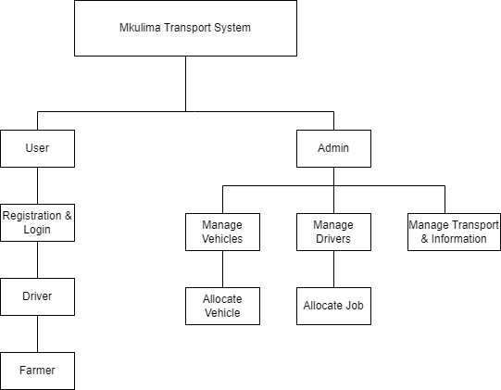

**Figure 2.5: concept map**

# 

# **CHAPTER THREE:**

# **RESEARCH METHODOLOGY**

# **3.1 Overview**

A software development methodology is a framework that is used to structure, plan, and control the process of developing an information system, this includes the pre-definition of specific deliverables and artefact’s that are created and completed by a project team to develop or maintain an application. A wide variety of such frameworks have evolved over the years, each with its own recognized strengths and weakness. One software development methodology framework is not necessarily suitable for use by all projects. Each of the available methodology frameworks are best suited to specific kinds of projects, based on various technical, organizational, project and team considerations. System development life cycle is a process of developing software on the basis of the requirement of the end user to develop efficient and good quality software. It is necessary to follow a particular procedure. The sequence of phases that must be followed to develop good quality software is known as SDLC (System Development Life Cycle). Mkulima Transport system will be developed using the Agile method of system development. The steps are explained below.

# **3.1.1 Agile Software Development Life Cycle**

The process itself is divided into different phases, depending on the IT project or other product development requirements.

Requirements gathering and documentation

System Design

Implementation

Testing

Deployment

Maintenance

**Figure 3.1.1: Agile model.**

1. **Requirements gathering and documentation**

This is a phase where the developer understands and defines the problem that’s to be solved in this case the house renting problem. Specifications of the inputs and outputs are clearly defined. The development team methodically gathers project requirements. Users give the analyst their expectations then the analyst gathers what is required to achieve the goal. Well- documented requirements serve a foundation and guarantee a smooth software development process.

1. **System Design**

Using the output from the previous stage, the team proceeds to work on the system’s design, including the software and hardware architecture, database tables and user interface mockups.

1. **Implementation**

Is the operations phase. This is the final stage of the software development life cycle that covers the software deployment to a live environment. It also includes maintenance of the subsequent support of the product to ensure it is functioning properly at all times.

1. **Testing**

During this stage, the testing and quality control team performs all testing activities including functional, system and acceptance testing to find bugs, errors or flaws. Testers also make sure that the product is built as per the requirements specification and that it functions as required. Any bugs found in the software means that the development team needs to go back to the coding stage to fix them.

1. **Deployment**

The system is deployed in this phase and put into use.

1. **Maintenance**

The software is maintained to ensure that it continues to meet the customer’s needs and expectations.

# **3.2 Research Design**

This is the process of defining the architecture, components, modules, interfaces, and data for a system to satisfy specified requirements. Systems design could be seen as the application of system theory to product development. There is some overlap with the disciplines of system analysis, system architecture and systems engineering. Tools and techniques to be used:

1. **Data Flow Diagram (DFDs)**

* DFDs will be used to analyze the data by providing a complete model of the information system. This shows the view of the system focusing on the data source, processes involved and its destination.

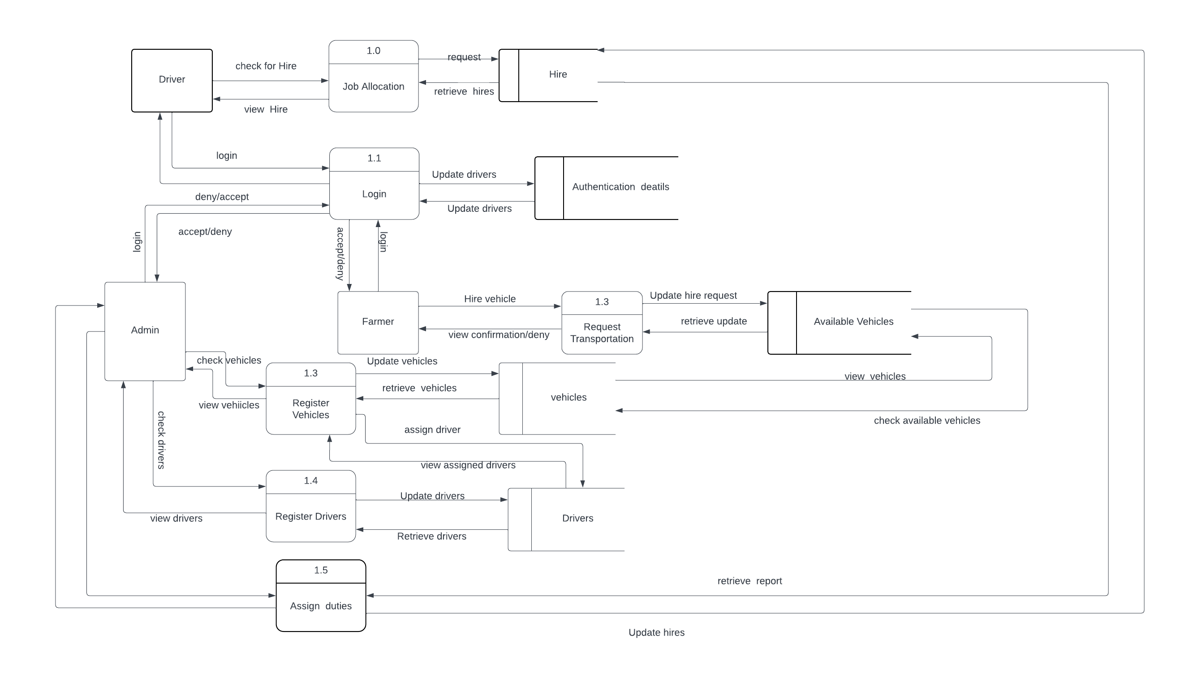

**Figure 3.2 a. Mkulima Trasport Data Flow diagram.**

1. **Use Case Diagram**

* This is part of the system design where there are interactions between the system and its actors. Mkulima Transport system focuses on the interactions between the company the drivers and the farmer.

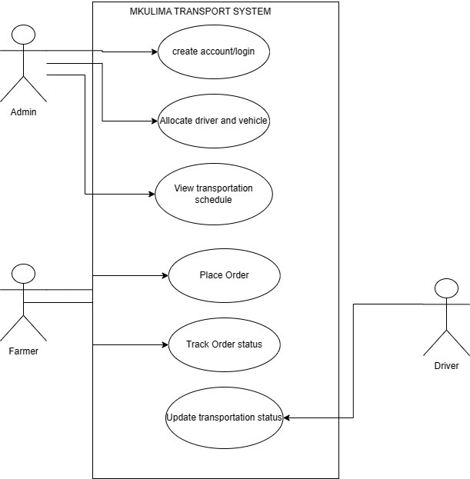

**Figure 3.2 b. Use Case diagram.**

**iii. Context diagram**

* The below diagram shows how the variables in the system are connected to each other, by showing all the modules on the system.

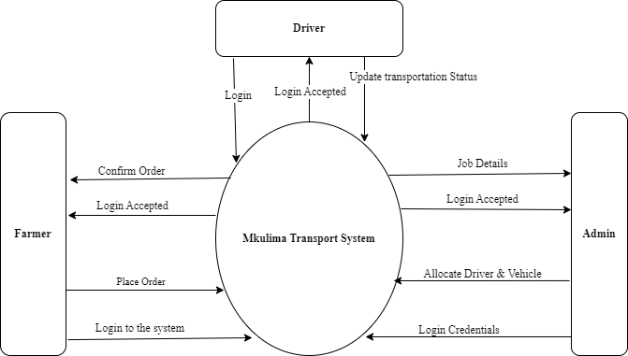

**Figure 3.2 c. Context diagram.**

##### Hardware Tools needed include:

1. A laptop.
2. External storage device for back up moving of files.

# **3.3 Data Collection Methods**

These are methods that are used to collect data in relation to the system requirements. Some of the methods used to collect data for this project include:

# **3.3.1 Questionnaires**

This is a means of eliciting the feelings, beliefs, experience and perception of some individuals. This is achieved by designing concise questions to yield specific information about a certain topic. Therefore, the questionnaires will be used to get the system requirements from the clients of the system. The approximated number of responses needed to do this is 20-30 responses from the sample of farmers in each place identified for the questionnaire. Using this method helped in getting more views from the possible users of the system on how they are currently searching for transportation and which methods they are using to possibly ease up the house searching challenge.

The advantages of using questionnaires are that it enables in getting different answers, it also helps in reaching out to so many possible clients of the system.

# **3.3.2 Interviews**

This is a direct face to face attempt to obtain reliable and valid information in the form of verbal responses from one or more responses. An interview is carried out with some of the farmers or the people who have already used a transport company before. They explain on how they get to secure a transport company they already have and also methods they used.

# **3.4 Research Ethics**

To avoid any illegal issues during the research requirements gathering the following research ethics are followed;

1. Ensure no duplication of other researcher’s projects.
2. To avoid interfering with our subject’s privacy we should announce our visit early to inform them of our intensions in their homes.
3. To ensure good relation with the participants, at the end of the research we should pay them a token of thanks for their kindness.
4. No one should be forced to provide information; it should be out of their own consent.
5. We should ensure them that information they provide is strictly confidential and won’t be traced back to them.

# **CHAPTER FOUR**

# **SYSTEM IMPLEMENTATION AND DEPLOYMENT**

# **4.1 Introduction.**

This chapter emphasizes on the actual system implementation. It introduces the functionality of the proposed system, how the system works and under what condition. The system was transformed from user requirement into a workable product. The purpose of system implementation was to make sure that the correct application is delivered to the end user. Besides that, this chapter also deals with how the testing was done to confirm that user requirements were met.

# **4.2 System Architecture.**

The proposed system is accessed via a browser when a user is connected to the internet. The following are the steps involved while interacting with the system

1. First the admin accesses the home page view the scheduled jobs.
2. In order to schedule a job, there should be an available vehicle and available driver.
3. After scheduling a job, the driver and the farmer are both notified that the job is ongoing and the date and time that the goods is expected to reach the farmer.
4. Administrator will be able to manage the whole system by checking if there are pending jobs or if everything is in order.
5. The admin is able to add drivers in the system, vehicles and also schedule more jobs for the available drivers.
6. After completion the admin logout of the system.

# **4.3 Front end development.**

The front end of the system is the part a user sees and directly interacts with their web browsers.

To make the project interactive and be able to attract more clients the best Languages software production was used. We used the following languages in developing the front end of the proposed system.

1. Hypertext markup language (HTML)
2. Cascading style sheet (CSS)

# **4.3.1 HTML**

We used HTML to build the front end of the system, this is where users interact with the system, because it provides elements and contents of logic and instructions on how they must appear on a web page browser. The following are the screenshots of how the front end code using visual studio.

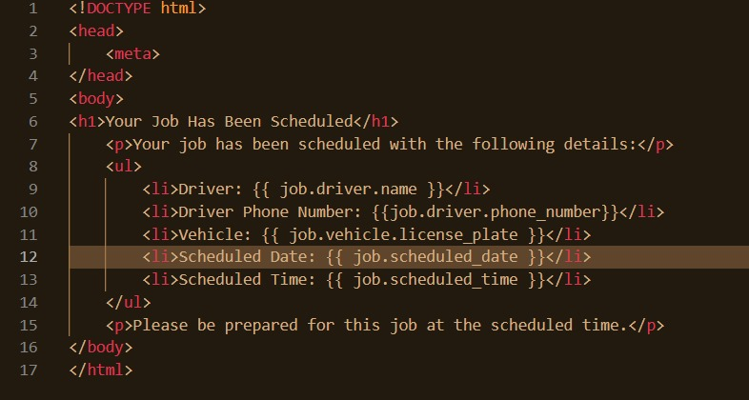

**Figure 4.3.1 HTML Code Extract.**

# **4.3.2 CSS**

CSS complements HTML by providing a look and feel to web pages. We used CSS to control the layout of the page. CSS sets the color, fonts and background images. Here is an example of a code extract.

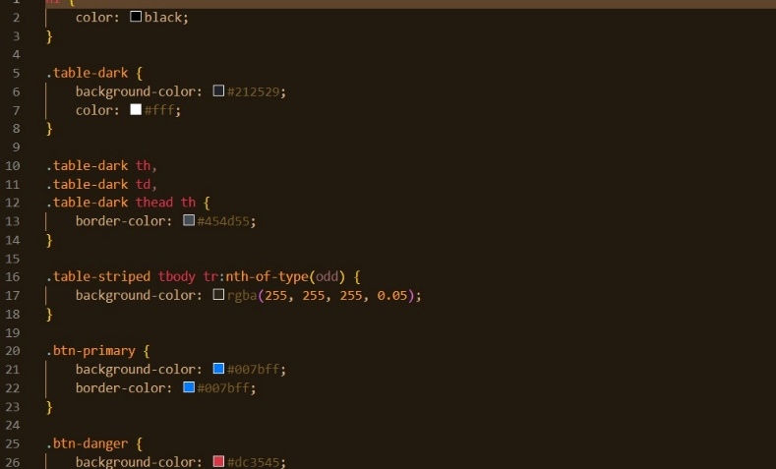

**Figure 4.3.2. CSS Code Extract.**

# **4.4 User Interface Design**

Physical design is intended to describe physically the design specifications for the user interface of various modules of the system. The system consists of several subsystems which are interconnected together to attain a specific goal. The following is a screenshot samples:

1. Login page: The login page for the admin that allows access to the system of the Mkulima Transport.

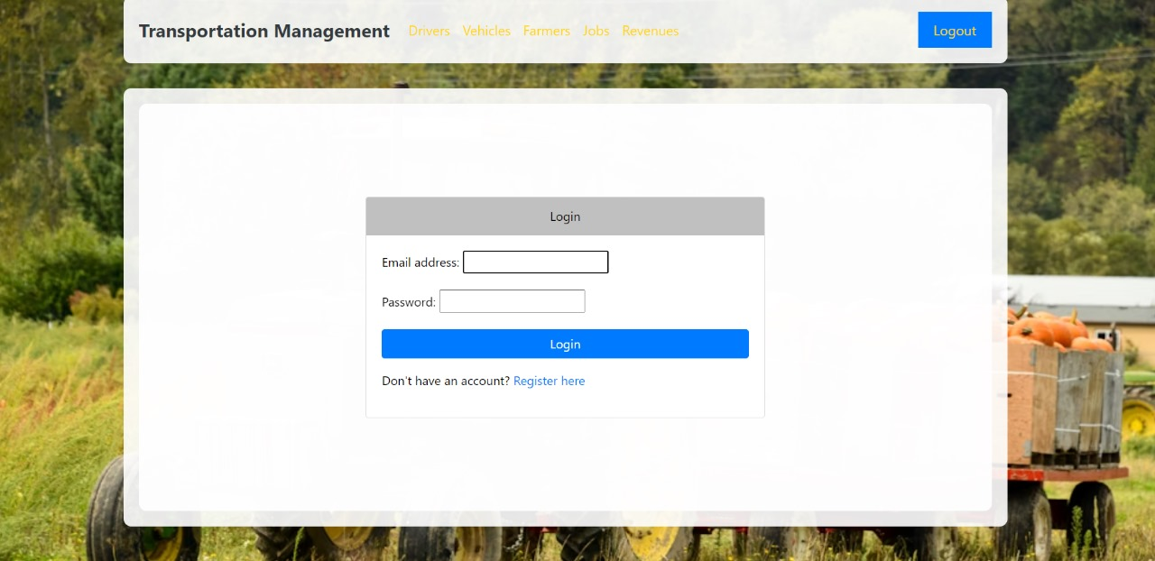

**Figure 4.4 a: log in page interface.**

1. Sign Up form: This is the page where the admin registers a new account in the system register.

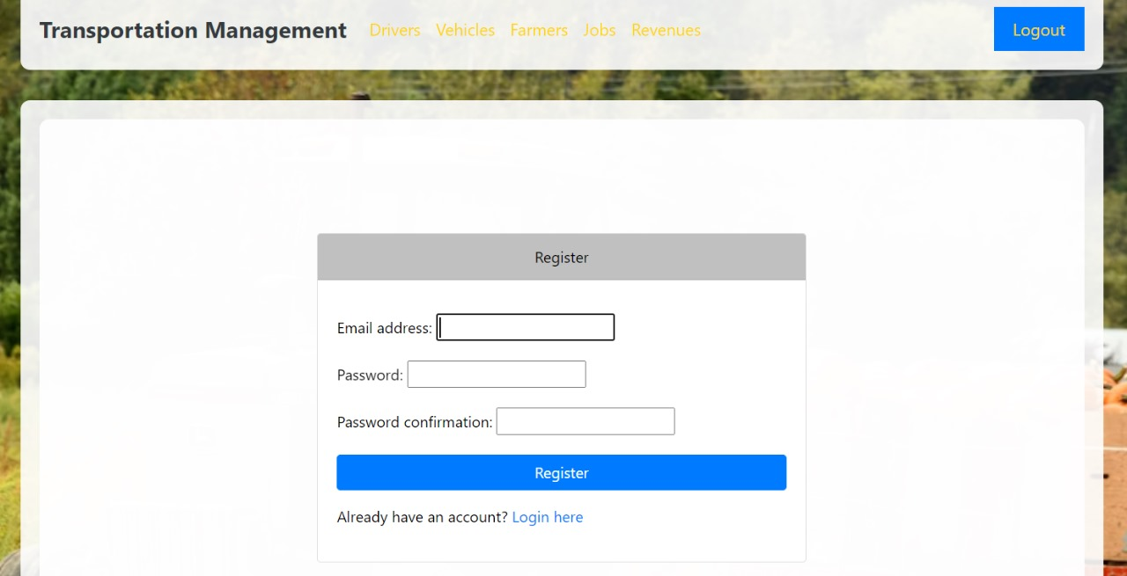

**Figure 4.4** b:  **Sign up form.**

1. Admin dashboard: This page contains a summary of most activities taking place in the system, it is also where the admin controls the user pages on the web browser Example: drivers’ details, farmers details, jobs and the reveue received in every job done.

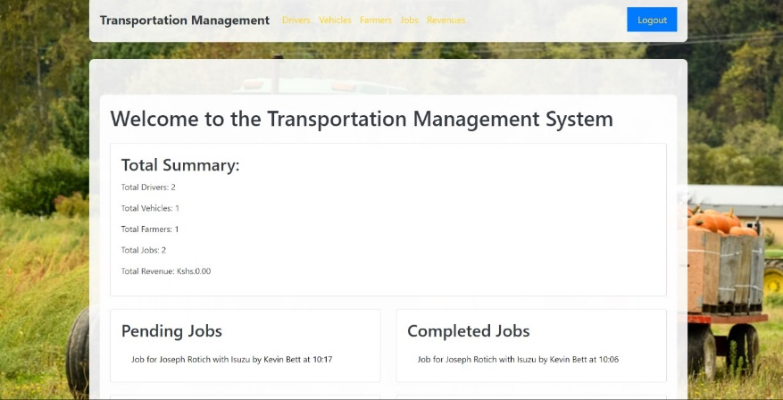

**Figure 4.4** c:  **Admin dashboard.**

# **4.5 Back-end development**

In the Mkulima transport system, the backend development involves the crucial "behind the scenes" operations that users do not interact with directly. We have employed the Django Framework to manage the system's data and functionality, leveraging its powerful features for efficient development and data handling.

#### **Django Models**

Our system uses Django models to define and manage the data structure. Django models provide a high-level abstraction for interacting with the database using Python classes. Each model class corresponds to a database table, with class attributes representing columns and their data types.

Django’s ORM (Object-Relational Mapping) handles the translation between Python objects and SQL queries, allowing us to work with high-level data structures while Django manages the underlying database interactions. Models define fields that capture the attributes of entities, such as vehicle_id, driver_name, or delivery_date, and manage relationships between different entities, including one-to-one, one-to-many, and many-to-many relationships. This setup ensures efficient data management and integrity.

Normalization of data, which involves organizing data to minimize redundancy and improve data integrity, is handled by Django’s ORM. This process ensures that the database remains flexible, adaptable, and scalable.

#### **Database: SQLite**

For the Mkulima transport system, we use SQLite as our database. SQLite is a lightweight, file-based database engine that is integrated directly with Django. It is easy to set up and does not require a separate server process, making it ideal for development and testing environments. SQLite provides a simple yet powerful way to store and manage data for the application.

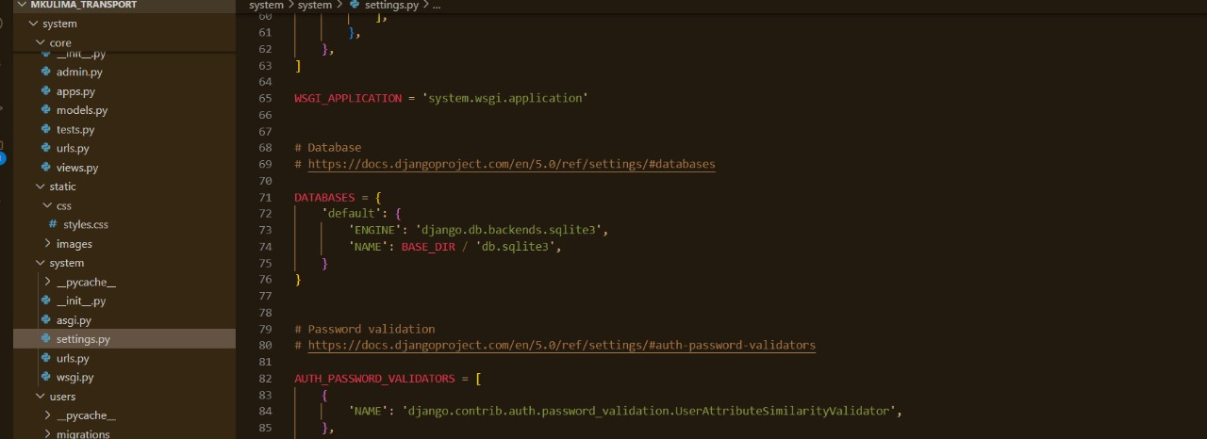

**Figure 4.5.1**. A. SQLite3

#### **Web Server: Django’s Built-in Server**

During the development and testing phases of the Mkulima transport system, we use Django’s built-in web server. Django’s development server is a lightweight server that comes with the Django framework and allows for rapid testing and debugging. It provides an easy way to run and test the application locally, ensuring that all components function correctly before deployment.

Back-end development can be described as the “behind the scenes” parts of the system that the user does not interact with directly. We used Django Framework in designing the back-end part of the system. It is considered as the storage of the system. All data from the system is stored on the database.

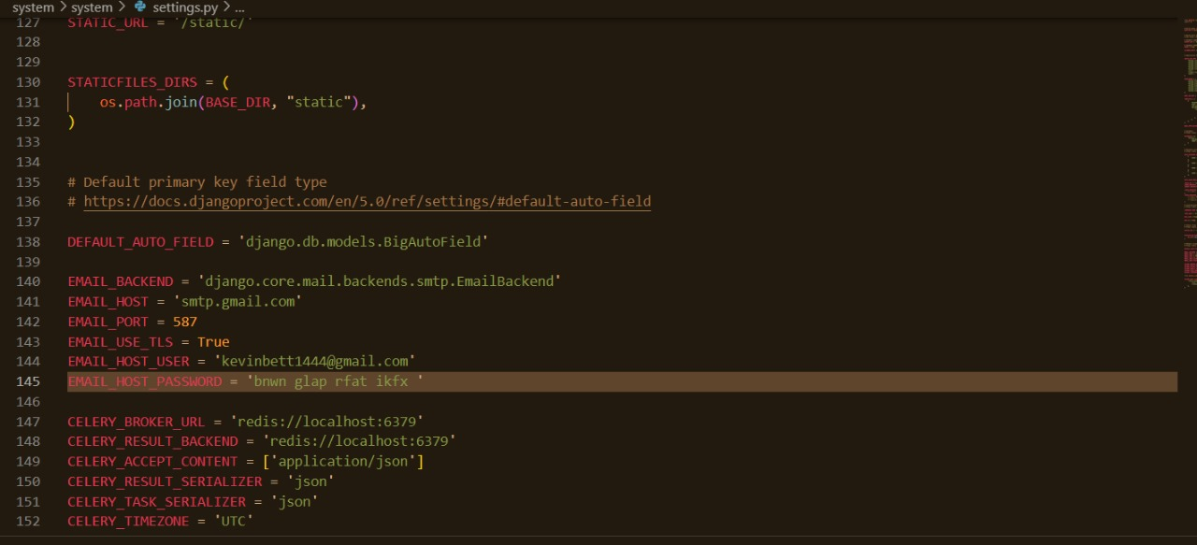

**Figure 4.5.1**. B. Django’s Server

# **4.6 System Testing**

Testing was done after the system was put in place. Unit Testing and integration testing was done to verify that the system works correctly component by component and as a whole.

# **4.6.1 Unit Testing.**

Unit testing was carried out on individual components of the system to ensure that they are fully functional. This was done by examining each unit, for example scheduling a jo. It was checked to ensure that it functions as required and that it adds the driver and farmers details and also ensured that this data is sent to the database. The success of each individual unit gave us the go ahead to carryout integration testing. All identified errors were dealt with.

# **4.6.2 Integration Testing.**

Integration testing after different modules had been put together to make a complete system. Integration was aimed at ensuring that modules are compatible and they can be integrated to form a complete working system.

# **CHAPTER FIVE**

# **CONCLUSION AND RECOMMENDATION**

# **5.1 Achievements**

Basing on our objectives we were able to meet a number of goals during development process of the system. The following is specific objectives that were met:

1. We developed a system that allows faster admin registration.
2. The system ensures easy scheduling of jobs to farmers.
3. The system helps the admin to draw reasonable conclusions and make the right decisions.

# **5.2 Conclusion**

The Mkulima Transport system has been developed with a graphical user interface that is simple for use and is therefore going to simplify the entire event management processes. It is concluded that the objectives of the research were met and the system developed functions correctly.

# **5.3 Challenges**

Upon completion, the following challenges were encountered:

1. Finance to acquire research materials gave as a difficulty.
2. Developing the project needed internet a lot which was not available all the time.
3. During the requirement research we encountered problems with some of the research participants who gave wrong responses.
4. Due to the magnitude of the project, it needed extra time which was not available hence we had to go an extra mile.

# **5.4 Recommendations**

In order to reverse the risks/problems involved in the project and realize improvements in succeeding developments, I would like to make the following recommendations:

1. Reduction in strictness of the Time deadlines
2. Compelling some institutions to pave way for the students to develop
3. Project finances to the students
4. Provide necessary skills for project development

**REFERENCES**

Brown, Laura R. “Urban Transit Efficiency: A Comparative Study.*” Journal of Transport Studies, vol. 15, no. 3, 2021, pp. 45-67.*

Cervero, R., & Kockelman, K. (1997). "Travel demand and the 3Ds: Density, diversity, and design." *Transportation Research Part D: Transport and Environment, 2(3), PP 199-219.*

Levinson, D.M., & Krizek, K.J. (2008). "Place Rank: Valuing Spatial Interactions. “*Networks and Spatial Economics Geography Compass, Vol.2(6), PP 1903-1929.*

Shyam Sundar, Eugenia M. Pricop, Octavian Baston, Octavian Barna (2017) in "Transportation and post-harvest losses in developing countries: a review of the literature*". Journal of International Scientific Publications, Agriculture and Food.*

Vuchic, V.R. (2005). "Integration of Transit Services, Operations, and Management in Urban Areas*." Transportation Research Record: Journal of the Transportation Research Board, No. 1896, Transportation Research Board of the National Academies, Washington, D.C., 2005, pp. 49-56.*

William R. BLACK, (2010) – Problems and Solutions for sustainable transport*.* “*Journal of Education and Research, The Guilford Press, 299 pages, ISBN: 1606234854”*

**LIST OF APPENDICES**

**APPENDIX 1: BUDGET**

|  |  |  |  |  |
| --- | --- | --- | --- | --- |
| **Item** | **Description** | **Quantity** | | **Price** |
| Desktop Computer | Core i5 Processor (2.6 GHz or more), RAM (8Gb or more, 500Gb Hard Disk | 1 | | 40,000/= |
| Operating System | Windows 10 Pro | 1 | | 10,000/= |
| Database Management | XAMP | 1 | | Free/Open source |
| Internet | Safaricom Home Faiba | 1 | | 3,000 |
| **Total** |  |  | **53,000** | |

**APPENDIX 2: PROJECT SCHEDULE**

|  |  |  |  |  |  |  |  |
| --- | --- | --- | --- | --- | --- | --- | --- |
| month | JANUARY | FEBRUARY | MARCH | APRIL | MAY | JUNE | JULY |
| Requirements gathering and documentation |  |  |  |  |  |  |  |
| System design |  |  |  |  |  |  |  |
| Implementation |  |  |  |  |  |  |  |
| Testing |  |  |  |  |  |  |  |
| Deployment |  |  |  |  |  |  |  |
| Maintenance |  |  |  |  |  |  |  |