Analysis Human and Computer Interaction Between Traveloka dan Tiket.com Website

Celina Josephine  
Computer Science Department  
Bina Nusantara UniversityJakarta, Indonesia  
[celina.josephine@binus.ac.id](mailto:celina.josephine@binus.ac.id)

Christian Nathanael Pranata  
Computer Science Department

Bina Nusantara UniversityJakarta, Indonesia  
[christian.pranata001@binus.ac.id](mailto:christian.pranata001@binus.ac.id)

Kevin  
Computer Science Department  
Bina Nusantara UniversityJakarta, Indonesia  
[kevin093@binus.ac.id](mailto:kevin093@binus.ac.id)

*Abstract*— Traveloka is an online travel platform that was founded in 2012. Meanwhile, Tiket.com is an online travel agency company that was founded in August 2011. In this century, technology has developed so rapidly that many online applications have emerged, such as online ticket booking applications. Various applications compete to attract users, one of which is through User Interface and User Experience. In this study we compare UI & UX between Tiket.com and Traveloka as the same type of application through about fifty survey results using SUS method and Questionnaire. With that method of research, it’s proven that Tiket.com and Traveloka website has a similar score about 63. That result means that both of website needs many improvements in the fields of UI and UX design of applications.

Keywords— user experience evaluation, online travel booking, system usability scale, website, application.

# Introduction

In this Era, technology is developing very rapidly and human life is inseparable from the use of computers, such as mobile applications and website. Technology utilization can increase user effectiveness and efficiency. The application's user interface is one of the factors that affect user interest. This interface includes UI (User Interface) and UX (User Experience). UI & UX is a branch of Human Computer Interaction that studies how humans interact with computer programs, and how to design user-friendly application displays.

User Interface (UI) is anything a user may interact with to use a digital product or service, in this case it affect the appearance of an application. While User Experience (UX) evolved as a result of UI improvements that focus more on user interaction. Good User Interface indispensable to identify the target audience for user interface design, it can also boost productivity and be readily used. Bad User Interface caused uncertainty in using it.

The interface on the website has a big impact on user interest in using the application. Forrester Consulting conducted a study that found that computer use is declining. About half of users will avoid using an app or website or look for simpler alternatives if they are uncomfortable with the UI/UX. And about 38% of users will stop using a website if they think the layout is unattractive. Therefore, for the convenience of the user, an application must have good UI and UX.

In this research, authors will adopted System Usability Scale Method to compare between Traveloka and Tiket.com website. SUS were used to measure the usability of both of the websites in terms of interactiveness, convenience, and ease of use through a survey that will be conducted on at least 50 respondents.

# Study Literature

In the process of developing a User Interface (UI) and User Experience (UX), a combination of skills, tools, and processes are needed. The first things that are needed for developing UI and UX is research and analysis. This thing is important to conduct user research to understand what target users’ behaviour and what they need. A successful UI and UX design require a variety of design tools. Wireframes, prototypes, and mock-ups can be created using the features offered by these technologies. Interaction design skills is one aspect that is important to create a good and interactive design. Many enterprises demand an interactive one to make their application user-friendly and stand out among users. UI and UX design are also constantly evolving so it was an obligation for developers to stay up to date with new design trends and adjust the development for applications of what users needed.

The growth of information technology and communication (ICT) leads people to use online applications for all their needs, including travel booking. [2] And the interface and user comfort are important to develop an application. In ticket booking websites or applications it is proven that user experience and customer satisfaction play an important role in increasing customer loyalty in the travel and tourism industry. An inappropriate interface made users easily leave the application that was already built. It does not rule out the possibility that they will abandon the previous application if they find another one more appealing. [10] Some shows that factors such as price, location, cleanliness, quality of information and interactive services influence user perceptions and customer satisfaction. The fact that the interface of an application must be designed with user-friendly services, attractive, easy to use and as user needed. When the application is designed simpler and practical, the application will be liked or frequently used by users.

So, in this case, User Experience Evaluations are needed to create an attractive application or website that can increase user satisfaction and loyalty. User Experience Evaluation is a key factor to determine the quality of a product, also defined by ISO as a user’s perceptions resulting from use of products. Research shows that an integrated and data-driven User Experience evaluation method is important to confirm the results of UX research. With the evaluation of user experience, users cand find out the experience of users get when they are using an application, such as online travel booking, to improve the services for users when they are ordering ticket. [29]

This literature review provides a view of the comparison method that used in User Experience Evaluation. There are several possible solutions to the aforementioned issues. This solution is based on previous studies that looked at how users viewed two websites that looked similar but had different features and appearances. There are some methods, which are as follows. First, user testing which is a method that is used for identifying issues that exist on websites and software applications. There is another alternative method that can be used to identify usability issues, that is the Heuristic Method. Both of these methods are used to find out what are the weaknesses in the application. [4]

Through a variety of methods, including surveys, questionnaires, and interviews, usability evaluations are carried out to determine user satisfaction levels while utilizing an application. Another method, named System Usability Scale (SUS), was used to analyze the usability of a website or application. SUS is a common scale to get feedback from users, to know whether the application is suitable for users’ needs.[2] It will consist of some mixed positive and negative statements about all aspects of the usability of online travel booking websites. [6]

According to Nielsen global e-commerce report (2017),

8% of all online purchases made globally were for fashion products, followed by 55% on average for travel-related items or services, 50% for books, music, and stationary, 43% for IT and mobile, and 41% for event tickets. [30]. A study by Law and Hsu in China (2015) said that most users see some inconsistencies between the website's information and their demands. In China, people frequently use websites to find information for business or travel purposes. Therefore, websites should offer content that fits with users' needs. [3]

Research is conducted to compare both applications whether smart tourism technologies can influence the user loyalty, also find out whether smart tourism technologies, user satisfaction and user experiences affect users’ loyalty. [16] However, studying interesting UI/UX design concepts can also be learned through experts who then it is possible for us to improvise the UI/UX design knowledge that we get, to make the appearance of the online booking service application/website attractive, clear, practical, efficient, easy to understand for the user.

So, it can be concluded that the interface and user experience are very important in the development of applications and websites. There are several ways to make it better that can help it grow, such as the method that has been collected above, or comparing between the two applications [7]. In this case we compared two popular online travel booking websites, Traveloka and Tiket.com using System Usability Scale Method.

# Research Method

The Methodology that are used in this research consisted of two, Questionnaire and SUS (System Usability Scale). These are the collection of methods that are suitable for use in this research.

1. SUS (System Usability Scale)

System Usability Scale (SUS) is a simple, 10-item Likert scale questionnaire that provides an at-a glance look at the ease of use. User evaluation must result in a positive user experience and improved product usability. Understanding usability will increase user satisfaction.

System usability scale is a common scale for measuring usability feedback from users. It was created by John Broke in 1986 to measure the usability of electronic office systems. However, it is now used to assess how easy or difficult it is to use a wide range of web or technology-based applications to improve them. SUS called as quick and dirty scale since it is measuring usability quickly with limited respondents. SUS ia a very easy scale to administer to respondents, it can be used on small sample sizes with reliable results. This method also valid and can effectively differentiate between usable and unusable systems.

The questionnaire consisted of some mixed positive and negative statements, which represent all of the aspects usability. Respondents must rank the measure of their adjustment using a Likert scale, where the lowest number is strongly disagree and the highest number is strongly agree.

After collect the data from respondents, it should be calculated with these formula:

It calculates by the odd-numbered and even-numbered questions. And then multiply the sum by 2.5 to get the final score. From the research, SUS score above 68 was considered as above average and if the result is below 68, it means below the average. The questions are mix of negative and positive items and had total ten questionnaire. The collected data was processed based on the guidance of SUS Scoring to evaluate which online travel booking application is better, both Traveloka and Tiket.com.

Analyzing research data using SUS and Questionnaire begins by identifying the value of each answer written by the respondents. An each value of the answer is processed based of the SUS to become an indicator of the quality of user acceptance for the interface and user experience design.

Details of the default questions in this study are shown in table below.

TABLE I.SYSTEM USABILITY SCALE TESTING INSTRUMENTS

|  |  |
| --- | --- |
| No | Inquiry |
| General Questionnaire | |
| 1. | Design interface is the most important in website. |
| 2. | A website with a simple and simple layout is better than a website with a complex layout and has complicated ornaments. |
| 3. | I will close the website if the website loads for more than 3 seconds. |
| 4. | Customer Service or Contact Us is an important thing in a website. |
| 5. | A step-by-step guide to using the website is useful for users who are using the website for the first time. |
| SUS Questions (Traveloka and Tiket.com) | |
| 1. | I often visit the website. |
| 2. | The appearance of the website is too complicated and complex (loads unnecessary things). |
| 3. | In my opinion, the appearance of the Traveloka website is easy to navigate. |
| 4. | I need technical assistance from other people / instructions to explore the website. |
| 5. | In my opinion, the functions and features on Traveloka are well designed and prepared. |
| 6. | I think there are too many mistakes on the website. |
| 7. | I feel comfortable when using the website. |
| 8. | I should familiarize myself before using this website. |
| 9. | I need to learn many things before using the website. |
| 10. | I feel confused to booking ticket in this application. |

After the respondent fills in the questions above, the calculation is carried out as follows:

1. For each odd numbered question, the score is deducted by 1 from the original score.
2. For each even numbered question is 5 minus the value obtained from the respondent.
3. Add up these new values (subtract 1 and add 5) then multiply the result by 2.5.
4. Add up all the final scores and divide by the number of respondents.
5. Will generate a number 0-100

The numbers obtained can be converted into predetermined categories, whether Acceptable (A, B, C, D) or Not Acceptable (F).

1. Questionnaire

Questionnaire is a research method where the researchers collect and analyze data to a certain group of people. It can be quantitative or qualitative information. This method are commonly used in market research, such as social, health, or sciences. There are two questionnaire methods, self-administered and researcher-administered. Self-administered questionnaires are more common because it easier to implement and inexpensive, but researcher-administered questionnaires allow deeper insights.

TABLE II. QUESTIONNAIRE

|  |  |
| --- | --- |
| 1. | What are the features that must be had on a ticket booking website? |
| 2. | What are the weakness from the website? |

In this study, we used some questionnaire in the survey, to know which are the features that should be available in online booking applications and what is the weakness from Traveloka and Tiket.com application.

# Result

## Research Respondents

About fifty-three valid respondents were selected from Jakarta, Indonesia. For these surveys, the researchers use two criteria of respondents in this study. The first one is the respondents that using internet and apprehend using mobile and website technology. The second one is the respondents that have experience with online travel booking application. For the questionnaire, we used Google Form platform to collect the answers of respondents easily.

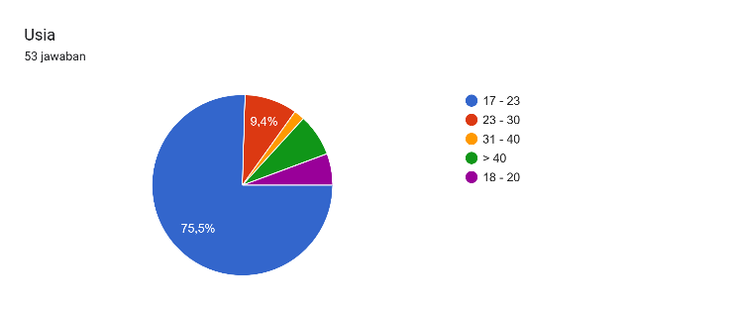

From the survey, about 75.5% respondents are 17-23 years old, 9.4% respondents are 24 – 30 years old, 1.9% respondents

are 31 – 40 years old, and the rest of them are more than 40 years old.

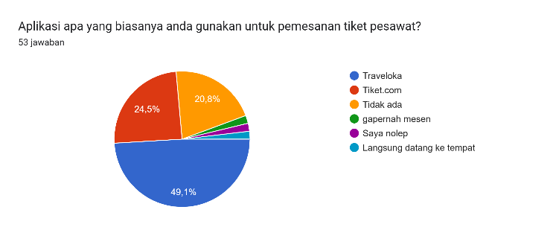

Majority of respondents, about 49,1%, use Traveloka as their usual online ticket booking application.

About 24,5% use Tiket.com for booking ticket and rest of them never use this application.

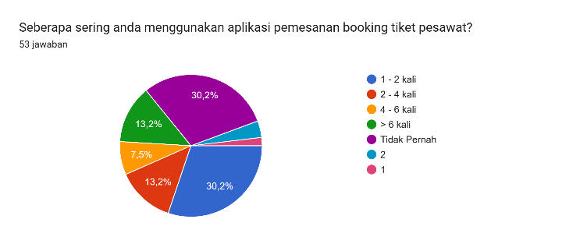

This diagram shows that there are different frequency of the respondents that are using booking online ticket applications. About total 35.9% have only ever used the application 1-2 times and 30.2% respondents never used. There are 13.2% respondents that used 2 – 4 times, and 7.5% used this application 4 – 6 times, and the rest of them used more than 6 times.

|  |  |  |  |
| --- | --- | --- | --- |
| Classification |  | Number | Percentage (%) |
| Age | 17 – 23  23 – 30  31 – 40  > 40 | 43  5  1  4 | 81.1  9.43  1.8  7.5 |
| Applications | Traveloka  Tiket.com  Never | 26  13  14 | 49.1  24.5  26.4 |
| Frequency | 1 – 2  2 – 4  4 – 6  >6  Never | 18  7  4  7  16 | 34.6  13.4  7.7  13.5  30.8 |
| Total |  |  | 100 |

## System Usability Scale Testing

All the respondents were asked to use Tiket.com and Traveloka’s website to run all the functions of application and design then fill out the form. These are the results of SUS test from respondents.

TABLE III. TRAVELOKA RESULT

|  |  |  |  |  |  |  |  |
| --- | --- | --- | --- | --- | --- | --- | --- |
| No. | Score | | | | | Mean | SUS Score |
| 1 | 2 | 3 | 4 | 5 |
| Q1 | 2 | 10 | 11 | 7 | 4 | 4.29 | 3.29 |
| Q2 | 9 | 14 | 9 | 1 | 1 | 2.14 | 2.86 |
| Q3 | 2 | 7 | 12 | 13 | 3 | 3.21 | 2.21 |
| Q4 | 13 | 13 | 6 | 3 | 1 | 2.11 | 2.89 |
| Q5 | 0 | 4 | 14 | 14 | 5 | 3.702 | 2.702 |
| Q6 | 5 | 13 | 11 | 3 | 3 | 2.6 | 2.4 |
| Q7 | 3 | 5 | 13 | 12 | 4 | 3.24 | 2.24 |
| Q8 | 5 | 12 | 7 | 7 | 3 | 2.73 | 2.27 |
| Q9 | 6 | 10 | 8 | 7 | 4 | 2.8 | 1.8 |
| Q10 | 12 | 11 | 8 | 5 | 1 | 2.24 | 2.76 |
| Total | | | | | | 2.84 | 25.422 |

SUS Score = 2.5 x 25.422 = 63.55

TABLE IV. TIKET.COM RESULT

|  |  |  |  |  |  |  |  |
| --- | --- | --- | --- | --- | --- | --- | --- |
| No. | Score | | | | | Mean | SUS Score |
| 1 | 2 | 3 | 4 | 5 |
| Q1 | 6 | 7 | 12 | 7 | 5 | 2.94 | 1.94 |
| Q2 | 17 | 10 | 4 | 1 | 1 | 1.75 | 3.25 |
| Q3 | 0 | 4 | 12 | 13 | 6 | 3.6 | 2.6 |
| Q4 | 11 | 10 | 6 | 7 | 2 | 2.41 | 2.59 |
| Q5 | 2 | 7 | 13 | 8 | 6 | 3.25 | 2.25 |
| Q6 | 17 | 5 | 4 | 4 | 2 | 2.09 | 2.91 |
| Q7 | 1 | 7 | 14 | 11 | 3 | 3.5 | 2.5 |
| Q8 | 10 | 9 | 5 | 1 | 2 | 2.1 | 2.9 |
| Q9 | 1 | 4 | 8 | 12 | 12 | 3.81 | 2.81 |
| Q10 | 2 | 6 | 10 | 8 | 7 | 3.36 | 1.64 |
| Total | | | | | | 2.88 | 25.39 |

SUS Score = 2.5 x 25.39 = 63.47

The result of SUS value from about respondents for Traveloka was 63.55. Meanwhile result of SUS value for Tiket.com was 63.47. These obtained from the evaluation results that user acceptance based on the acceptability range grade scale, category, and ratings from respondents. There was just a slight difference between Traveloka’s SUS Score and Tiket.com’s SUS Score. It means both of them have similar app ratings in features and design.

The average SUS score from most number of studies is 68, so if the SUS score is above 68, it will be considered above average. And for scores below 68 are below average. From this case, both of website get about sixty-three. It means Tiket.com and Traveloka’s website have acceptability ranges in the “D” category and get an adjective rating level between “OK” and “Good” category. The evaluation results of the interface on Traveloka and Tiket.com website have a good acceptance and good usability on online ticket booking application.

## Questionnaire

Each respondent who has filled out the survey of SUS questionnaire will be directed to fill out the questionnaire. In this part, there is only 2 questions. First about what are the features that should be had on online ticket booking application.

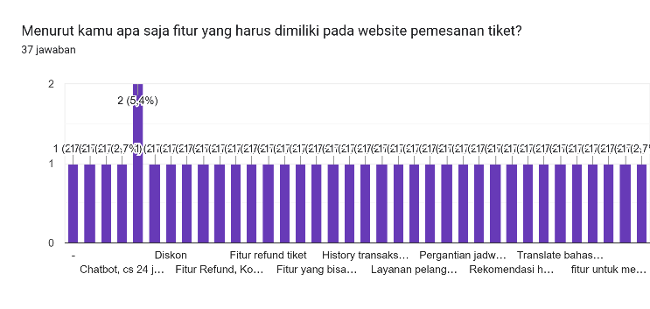

There are lots answers for this question, including chatbot features, discounts, refund, transaction history, reschedule, comparison between website prices, tracking plane location, complain, automatic payment check, and responsive customer services.

The next questions is about the weakness of Traveloka’s website. Such as too many ornaments, high complexity of interface layout, untidy interface, there are errors in some features, not easily to understand for new users, too many features that made the new users confused, too many ads, guidebook for user, there are less discount for users.

With the same questions, here are the answers for Tiket.com websites, more creative for the website’s interface, need user’s guide, this website already has a simple and aesthetic appearance, need more information in the home page of website, the button size is too big and not to appropriate for website, and sometimes the prices are not invalid.

# Conclusion

SUS has proved to be a valuable evaluation tool, being robust and reliable. This research aims to compare online travel booking application’s interface and features, to know which one is better. This study using system usability scale and questionnaire for collect the data. The final respondents for this research contained 53 data, including respondents who have never used the online ticket booking application and respondents who often used the online ticket booking.

The SUS questionnaire consisted of a set of positive and negative statements that covered various aspects of usability. The respondents ranked their agreement with each statement on a Likert scale. This score result of SUS is 63.55 for Traveloka and 63.47 for Tiket.com that means the website has “OK” or “Good” category. This score result of SUS is below 68 (average), which means there’s a lot of components of website that must be improved. From the questionnaire result, we know the things and what the user wants that makes user is comfortable using the website. Also, what makes user uncomfortable in using the website. So the researcher know what needs to be improved and doesn’t appropriate with user’s need.

##### References

1. A.A. Istri Ita Paramitha, Gede Rasben Dantes, Gede Indrawan. 2018. The Evaluation of Web Based Academic Progress Information System Using Heuristic Evaluation and User Experience Questionnaire (UEQ).
2. Nur Ani, Handrie Noprisson, Nazlena Mohamad Ali. 2019. MEASURING USABILITY AND PURCHASE INTENTION FOR ONLINE TRAVEL BOOKING: A CASE STUDY. Int. Rev. Appl. Sci. Eng. 10 (2019) 2, 165–171
3. Fransisca Andreani, Gabriella Winata, Eunike Halim. 2018. GAP ANALYSIS OF TRAVELOKA.COM: HOTEL CONSUMERS’ EXPECTATIONS AND PERCEPTIONS OF THE WEBSITE. JMK, VOL. 20, NO. 1, 31–37.
4. Maguire, Martin, and Paul Isherwood. 2019. “A Comparison of User Testing and Heuristic Evaluation Methods for Identifying Website Usability Problems”. figshare. https://hdl.handle.net/2134/36466
5. Ingrid Pettersson, Florian Lachner, Anna-Katharina Frison, Andreas Riener, Andreas Butz. 2018. A Bermuda Triangle? A Review of Method Application and Triangulation in User Experience Evaluation. Paper No : 461. 1-16. <https://doi.org/10.1145/3173574.3174035>
6. Ignacio Díaz-Oreiro, Gustavo López, Luis Quesada, Luis A. 2019. Guerrero. Standardized Questionnaires for User Experience Evaluation: A Systematic Literature Review. 31(1), 14; https://doi.org/10.3390/proceedings2019031014
7. Ignacio Díaz-Oreiro, Gustavo López, Luis Quesada, Luis A. Guerrero. 2019. User Experience Comparison of Intelligent Personal Assistants: Alexa, Google Assistant, Siri and Cortana. Proceedings 2019, 31(1), 51; https://doi.org/10.3390/proceedings2019031051R. Nicole, “Title of paper with only first word capitalized,” J. Name Stand. Abbrev., in press.
8. Leon A. Abdillah. 2020. FinTech E-Commerce Payment Application User Experience Analysis during COVID-19 Pandemic. Page : 1 – 14. https://doi.org/10.15294/sji.v7i2.26056.
9. Komang Candra Brata, Adam Hendra Brata. 2020. User experience improvement of Japanese language mobile learning application through mental model and A/B testing. Vol. 10, No. 3, June 2020, pp. 2659~2667.
10. Dharmayanti, A. M. Bachtiar and A. P. Wibawa. 2018. Analysis of User Interface and User Experience on Comrades Application. doi:10.1088/1757-899X/407/1/012127
11. Rahawarin, M. Furqon, Salim, and R. Ahmad, Comparative analysis of Pegipegi.com and Tiket.com website quality using the Webqual 4.0 method for end user satisfaction, vol. 8, no. 9, 2020.
12. L. Maharani, Systematic Literature Review : Evaluate User Systematic Literature Review : Evaluate User Experience On the Ticket Booking Application, 2021.
13. Nadya Paramitha Putri, Andry Alamsyah, and Sri Widiyanesti, “Fulfillment and Responsiveness on Online Travel Agencies Using Multiclass Classification,” International Conference on Information and Communication Technology, Jun. 2020, doi: https://doi.org/10.1109/icoict49345.2020.9166457.
14. Dina Ayu Musfikasari, Evaluasi Perbandingan Scoring Proposed Value dan Perceived Value Berdasarkan Model UX Honeycomb (Studi Kasus: Traveloka, Tiket.com, Dan Pegi-Pegi), Aug. 2018.
15. I. Pettersson, A. K. Frison, A. Riener, A. Butz, and F. Lachner, “A bermuda triangle? - A review of method application and triangulation in user experience evaluation,” in Conference on Human Factors in Computing Systems - Proceedings, 2018.
16. Safitri, Liza Ria and Abdurrahman, Agus, THE EFFECT OF SMART TOURISM TECHNOLOGIES, MEMORABLE TOURISM EXPERIENCES, AND TOURIST SATISFACTIONS ON TRAVELLER LOYALTY (STUDY ON TRAVELLER USERS OF THE TIKET.COM APP), vol. 16, no. 1, pp. 153–172, 2023, doi: https://doi.org/10.21107/pamator.v16i1.19558.
17. W. Takashi Nakamura, E. Harada Teixeira de Oliveira, and T. Conte, “Usability and User Experience Evaluation of Learning Management Systems - A Systematic Mapping Study,” Proceedings of the 19th International Conference on Enterprise Information Systems, 2017, doi: https://doi.org/10.5220/0006363100970108.
18. The Universal Access Handbook, C Stepanidis (ed), CRC Press, 2009
19. ICEC '05: Proceedings of the 7th international conference on Electronic commerce August 2005, Pages 319–326
20. Ravi Chandra Chaitanya Guntupali. User Interface Design - Method and Qualities of a Good User Interface.
21. https://www.diva-portal.org/smash/get/diva2:215020/FULLTEXT01.pdf
22. Feyza Gündüz, Al-Sakib Khan Pathan. 2012. Usability Improvements for Touch-Screen Mobile Flight Booking Application: A Case Study. <https://doi.org/10.1109/ACSAT.2012.9>
23. Josh Dehlinger and Jeremy Dixon, Department of Computer and Information Sciences Towson University
24. Al‐hawari, M.A. and Mouakket, S. (2012), "Do offline factors trigger customers' appetite for online continual usage? A study of online reservation in the airline industry", Asia Pacific Journal of Marketing and Logistics, Vol. 24 No. 4, pages 640-657. https://doi.org/10.1108/13555851211259061
25. Schaarschmidt, M. and Höber, B. (2017), "Digital booking services: comparing online with phone reservation services", Journal of Services Marketing, Vol. 31 No. 7, pages 704-719. https://doi.org/10.1108/JSM-04-2016-0145
26. International Journal of Applied Engineering Research ISSN 0973-4562 Volume 12, Number 20 (2017) pages 9931-9935 © Research India Publications. http://www.ripublication.com
27. Tourism Management Vol. 35, april 2013, pages 23-31.
28. Michael A. Rupp & Andrew J. Wismer HP Inc. 2021. Too Much of a Good Thing is Just About Right: Using Penalty Analysis to Evaluate the Impact of Key Travel on Notebook Keyboard User Experience.
29. Lisa Maharani. Yusuf Durachman, Suci Ratnawati. 2021. Systematic Literature Review Method for Evaluation of User Experience on Ticket Booking Applications.
30. Azham Hussain, Rahma Fitria. 2018. Mobile Flight and Hotel Booking Application: A Heuristic and UX Test. e-ISSN: 2289-8131 Vol. 10 No. 1-11.