Design Specifications (Appearance)

As a computer programmer, the whole design is up to you and you alone. You often might find some nuisances when using programs designed by other programmers or companies. However, this time, we get to design the program based on how we want it to run. The well renowned phrase, “The world is my oyster” now becomes “The compiler is my oyster” - and we, as products of a degree course in Computer Science must use that compiler to design our program in whatever way suits.

With the brief introduction out of the way, I shall now talk about the appearance of the application. At the very beginning I shall be honest in saying that I did not have any idea as to how this application would look. Then piecing together bits of information I finally arrived at one design plan.

Once the program is launched, the user is greeted with the basic design of the program. (See screenshot below).

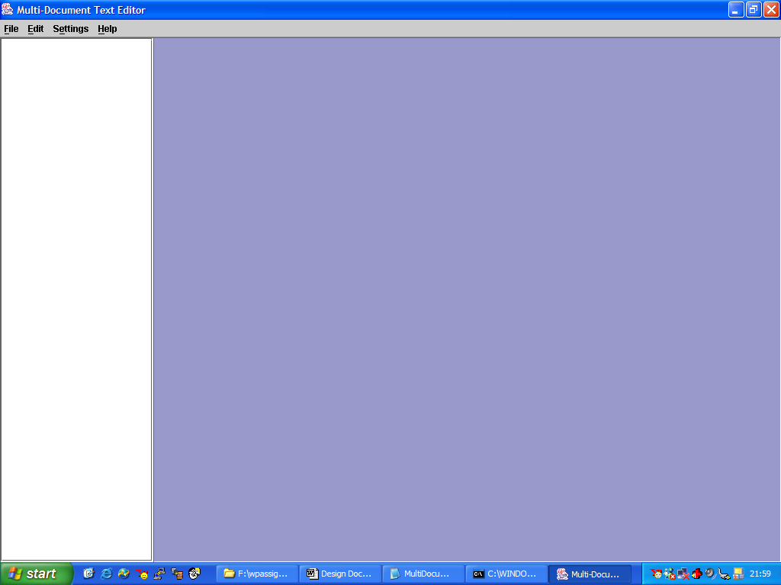
Application Basic Design

In essence, the application’s underlying class is the JFrame which incorporates a JMenuBar as shown. Added to the content of the JFrame we have a JSplitPane – which gives us great options and scope as to how the overall application will be developed (Seen later). To the right-component of the JSplitPane is a JDesktopPane. To the left-component is a JScrollPane which contains a JList. That concludes the fundamental design of application.

However, there is something else, which is dynamically created while the application is running – This is the JInternalFrame which will eventually hold an open document for editing. I say eventually because it isn’t actually the JInternalFrame that holds the content of a file. No, the JInternalFrame, while providing very useful functionality, does not hold the contents of a file. This is done by a JEditorPane which is added to the content of every JInternalFrame dynamically created. NOTE – The JEditorPane incorporates a JList.

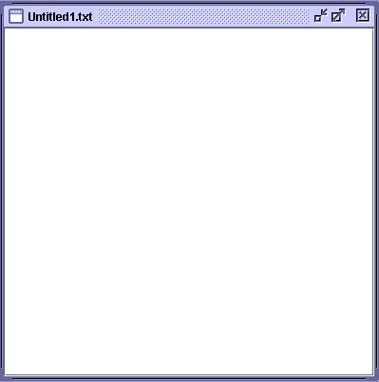
JInternalFrame

If you find reading a bit laborious, then please take a look at the basic hierarchical diagram below, which reiterates what I have previously written in the previous paragraphs.

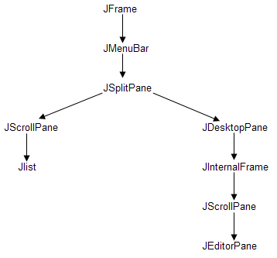
Design Hierarchy

The actual appearance of the application was constant and never changed throughout the whole coding process. I never once strayed off the idea of this as I felt this was definitely the way that would cause least hassle for people using the program. i.e. – It was neither too extravagant, nor too ‘dusty’.

Design Specifications (Coding)

My initial thoughts on how to code the application, as it turns out did change, but I shall go through my initial views anyway. I originally had the ‘launch-pad’ class, MultiDocuments.class which extended JFrame and created a KBEditorPane and KBMenuFrame. These two classes were added to the content of the JFrame. The KBEditorPane created a KBDesktop, (which actually had no functionality). The KBDesktop class, in turn created a KBDocumentFrame object.

I eventually ended up using five different classes (one made by an outside user), and I will now take you through the general coding ideas behind each class.

MultiDocuments.class
This is the ‘launch-pad’ of the application. It simply creates an instance of the KBEditorPane class which is the central piece of the application.

KBEditorPane.class
There are a number of principles behind this class:
- Creates a menu-bar, and an associated ActionListener for the application. Each menu-item has specific functionality.
- Uses a WindowListener to provide functionality for various window operations
- Uses a JList in co-operation with a vector (explained later on).
- Incorporates an error handler. Any function that causes an error can send a string (an explanation of the error ) to the handler.
- Incorporates a save handler. This acts as a central point in the saving process, and performs simple checks. Eg Checking if the user is attempting to overwrite a file

KBDocumentFrame.class
I have tried to keep the document frame as close to an independent object as I could. The object provides many accessor / mutator functions which can alter certain private member boolean variables of the object such as; whether it is a default document or not, or whether it has been modified or not.
The document implements two different listeners; InternalFrameListener providing functionality for window operations on the frame, and a DocumentListener providing functionality for operations that alter the text content of the document frame.
The document receives a file name, and file path as parameters. Using the file path it will input data from the file itself.

KBWindowAdapter.class
This class is added to the KBEditorPane and defines functionality for MS Windows operations on the application.

Major Components

This section will take you through the major components used in the application and why I felt they were particularly useful to the application as a whole.

Use of a JFrame:
The underlying, and fundamental component of the application is a JFrame object. This particular object was chosen because of its ease of use. While in itself as its own class not providing too much functionality, it is at the base of a long hierarchical list of extended classes, thereby providing lots of various functions.
- Once created, the frame can easily be resized
- It has good compatibility with the various ‘listeners’
- It is especially useful when dealing with ‘Window’ functions, as it is eventually extended from the java.awt.Window class
- Other classes can easily be added to the content of the frame

Use of a JMenuBar:
This class is simply used to provide ease of use for the end-user. No-one wants to be using various combinations of keyboard buttons to access functions of the application. So, while tuning into the fact that most end-users will be familiar with the MS Windows environment, I decided to add a JMenuBar to the application.

Use of a JSplitPane:
In essence there are two main parts to the content of the JFrame. Consequently, these just happen to be the two components of the JSplitPane which I feel are needed. Simply, the right-component of the JSplitPane will contain the JinternalFrames that are created. The left-component of the JSplitPane will contain a list of documents that are open. These will be represented by the file name of the documents that are open. The list will allow for the user to click on a file name and its corresponding JInternalFrame on the right-component of the JSplitPane will be made visible.

Use of a JList / Vector:
These two components should not be taken lightly as they, for me, are definitely the most important piece in the big jigsaw this application throws at us. Think of them as a giant cog, or an engine that drives the application to make it run smoothly. Once they are working in direct correlation, it should be easy to go on and complete the application without any major passing difficulties.
The JList will store the file names of each document that is open. The vector will store a string representation of each JInternalFrame created in the application. The index values of the JList and the vector will be in direct correlation with each other - whatever JInternalFrame is selected, its corresponding index value in the JList will be highlighted, and vice versa.

Use of a JInternalFrame:
The JInternalFrame is extremely useful for a number of reasons:
- It creates a new window within the parent window
- Like the JFrame, provides very good functionality for basic window functions
- It is compatible with many types of ‘listeners’
- It is easily sizeable
In truth, the JInternalFrame was needed so as to adhere to my overall design specification.

Use of a JEditorPane:
The JEditorPane is where the editing takes place. The editor allows for easy addition of file content to it. It is also compatible with a ‘document listener’. Once a ‘Document’ object is connected to the content of the JEditorPane, modifications of the content are easily detected. This can be useful for saving recently modified documents.

Major Design Changes

Obviously the initial thoughts of how to code the application had to be changed. The whole concept as I provided originally just seemed dead and pointless. It had no defining structure and simply portrayed the designer as a first year programmer. Thankfully, I am not one of those people and I am able to stand on a pedestal and make huge design changes without the fear of ruining the whole application, and having to restart the coding process.

The first major design change was to combine three classes into one. The KBDesktop, KBMenuFrame, and KBEditorPane all combined under the one name of KBEditorPane. I felt this would provide far easier functionality – especially regarding the combination of the menu and the main editor. Another class was then created, KBWindowAdapter to provide functionality for simple MS Windows functions, such as closing the application.

The second major design decision regarded the use of vectors. Originally, there were three vectors in use; one for the open documents, for the file names, and one for the file paths. The vectors for file names, and file paths could easily be removed by introducing accessor functions into each KBDocumentFrame class. The accessor functions would return the file name, and path of that particular document.

Thank You.

