Dissecting the soaptest Switchyard example
Kevin Boone, July 2017

This document explains how the simple soaptest Switchyard example works. It isn't intended to be a tutorial on how to create the application using, for example, JBDS tooling; rather it shows how the various elements of the application, as specified in the switchyard.xml file, are interconnected.

Overview
The diagram below shows the application in outline. It implements a SOAP webservice in Java code, which passes data to a Camel route, which in turn produces a message to a JMS message queue. No significant processing occurs at any stage -- the purpose of the example is to show how Switchyard components, services, and gateways work together.
HTTP client
SOAP
webservice
Camel route
JMS message
broker
Switchyard application

Development and testing
soaptest was created using JBoss Developer Studio (JBDS) version 9.1, and tested using JBoss Fuse 6.3, running on JBoss EAP 6.4.

The switchyard.xml file
The diagram below shows how switchyard.xml is represented graphically in JBDS, annotated to show some of the relationships between the elements.

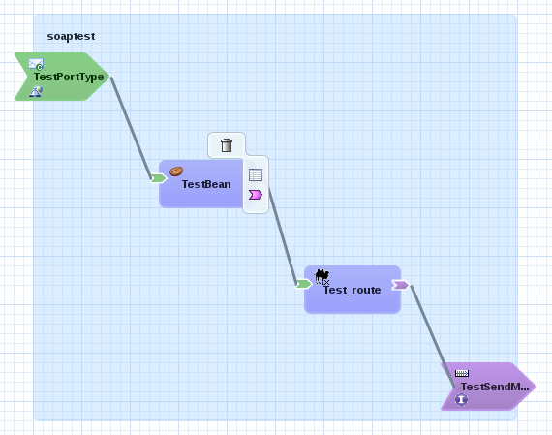
Get this input gateway by “promoting” the interface of TestBean and providing a WSDL interface
Get this output gateway by “promoting” the reference from Test_route and providing a Java interface
The Java component TestBean implements the service Test
The Camel component Test_route implements the service TestRoute, which is referenced by TestBean
This is a JMS binding, i.e., output to a JMS queue
A WSDL interface, specifed by Test.wsdl
A SOAP/HTTP binding, with context root /soaptest
These lines between components and services look like data flows, but are actually references. In practice, they often do give an idea of data flow

The TestBean component

TestBean is a Java class, specified by an interface Test. It will be exposed as a SOAP-based webservice, specified by a WSDL file.
TestBean takes an object of class TestIn as input, a returns an object of class TestOut. These objects are converted to and from XML using JAXB, as controlled by the Switchyard transformer specification. In switchyard.xml we have (among others):
<transform:transform.jaxb
from="java:com.example.switchyard.soaptest.TestOut"
to="{urn:com.example.switchyard:soaptest:1.0}testOut"
contextPath="com.example.switchyard.soaptest"/>

That is, we will use JAXB to transform the object TestOut to an an XML element <testOut> in the specified namespace. This transformation is largely automatic -- JAXB defaults are used for the mappings between Java property names and XML elements. All that is necessary to make this happen is to add the necessary JAXB annotations to the TestIn and TestOut classes:

@XmlRootElement(name ="testIn")
public class TestIn {

The TestPortType input gateway
This gateway is obtained by “promoting” the interface (green arrow in JBDS) on TestBean. As part of the promotion we specify an interface, which is of type WSDL in this case, as this gateway will have a SOAP binding. It is the use of WSDL that has led to the name “TestPortType” -- this is actually the name of a <wsdl:portType> definition in the WSDL.
The JBDS tooling can create the WSDL file from the Java interface (Test) and its associated classes. There are various options that can be applied to this generation, not all of which work -- that is, not all options result in a WSDL file that is compatible with automatic JAXB transformation. In particular, selecting “wrapped” SOAP messages, which is the default, is problematic.
Note that the interface is distinct from the binding -- creating the WSDL interface does not, by iteself, create an HTTP endpoint in the application server. We need a SOAP binding for that.

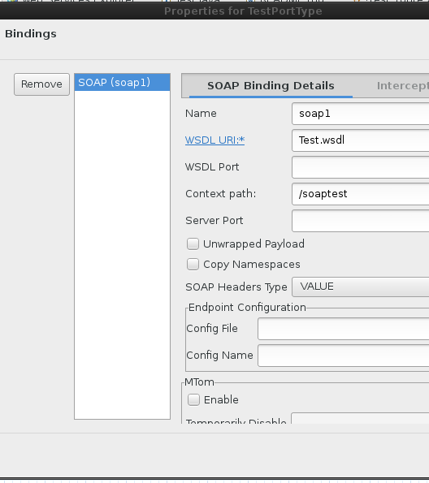

The binding specifies the WSDL file, and the web context root for the application server
-- /soaptest in this case. The full URL of the service will be made from the context root, and the name of the service corresponding to the TestBean component. The service name is
Test, as can be seen from switchyard.xml:

<sca:component name="TestBean">
<bean:implementation.bean
class="com.example.switchyard.soaptest.TestBean"/>
<sca:service name="Test">

So the full URL of this service will be

/soaptest/Test

The Test_route camel component
Switchyard allows for components to be implement as ordinary Camel routes, specified in Java or XML DSL. In this example we have the XML definition in the file test_route.xml. The route doesnt't do anything useful: the complete definition is as follows:

<route id="_route1">
<from id="_from1" uri="switchyard://TestRoute" />
<log id="_log1" message="TestRoute - message received: ${body}" />
<to uri="switchyard://TestSendMessage"/>
</route>

Note that the “from” and “to” endpoints are both Switchyard endpoints. The “to” endpoint refers to the TestSendMessage gateway (see below). The “from” endpoint is a reference to the service that the Camel route implements; that is, in effect, a reference to itself. The input to the Camel route will be a method call from the Java code in TestBean, but that isn't something that can be specified in the Camel route -- the reference to the route itself creates a free-floating consumer that will accept messages from any other component that holds a reference to this service.

Invoking the Camel route from the Java class TestBean
We use CDI annotations in the TestBean to create a reference to the Camel route. Note that the Camel route has a Java interface -- TestRoute, which specifies a single method doMessage(String). The name of the method is arbitrary, because Camel accepts message bodies as input, not formal parameters. However, we need something for the Java code to call.
The CDI annotations are as follows:
@Inject
@Reference("TestRoute")
private TestRoute _testRoute;

This creates a reference to the service TestRoute (implemented by test_route.xml). Note that nothing in the application actually implements the interface TestRoute -- the implementation is a dynamically-generated proxy. When we call the interface's only method:
_testRoute.doMessage (...);
the argument is converted to a Camel exchange and passed into the route.

The TestSendMessage gateway

The output gateway TestSendMessage is actually a “promoted” reference. it is obtained in JBDS by selecting the reference (purple arrow) on Test_route, and promoting it. As part of the promotion we provide a new interface, which can be Java or something else. In this simple example, the interface is irrelevant, and JMS does not take arguments, and the provider of data will be a Camel route. However, Switchyard requires all service to have interfaces.

The gateway has a binding (connection) using JMS. The properties of this binding are shown in the following diagram:

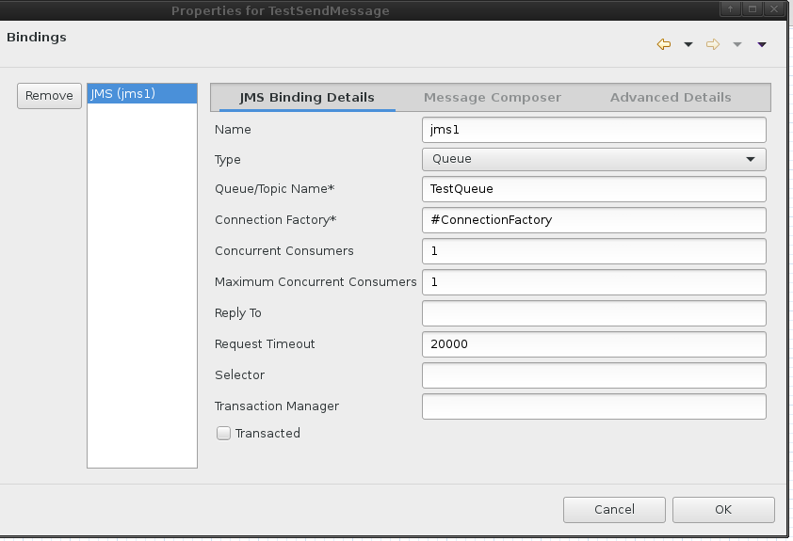
The name of the queue and the connection factory are dependent on the platform, but Switchyard does some magic to try to find compatible references on the various supported platforms. On EAP, the name TestQueue refers to the <entry> element in a jms-queue definition in the configuration file (without the java:/ prefix:

<jms-queue name="AnythingAtAll">
<entry name="java:/TestQueue"/>
<durable>true</durable>
</jms-queue>

The “#” sign at the beginning of “#ConnectionFactory” is common notation in Spring or Blueprint XML for an object in the Spring/Blueprint registry. On Karaf we would typically use a <bean> definition to provide an object based on the particular JMS client runtime. On EAP, this token refers to a connectionfactory definition in the configuration file:
<jms-connection-factories
<connection-factory name="InVmConnectionFactory">
<connectors>
<connector-ref connector-name="in-vm"/>
</connectors>
<entries>
<entry name="java:/ConnectionFactory"/>
...

(This connection factory name is provided by default in standalone-full.xml.) The effect of the JMS binding is that any invocation of the TestSendMessage gateway will result in the message body being posted to the specified JMS queue. Some data conversion might be required, but this is transparent in this simple example.

