RDBMS Final Term Project

Shikha Pandey

# Hepatitis B

# Hepatitis B cases among continents and regions

# Boxplot for Hepatitis B cases by all continents  
HepatitisB %>% filter(Continent != "#N/A") %>% ggplot(aes(x = Continent, y = Incidence, fill = Continent)) + geom_boxplot(alpha = 0.4) + labs(title = 'Hepatitis B cases for all Continents', x = 'Continents', y = 'Incidents') + theme(legend.position = "none")

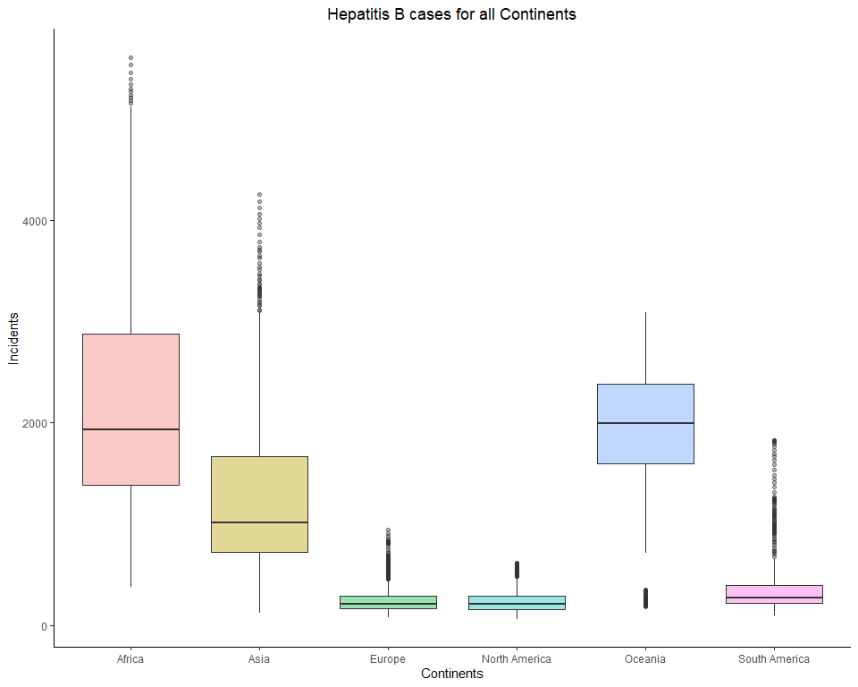

# Barplot for Hepatitis B cases by all continents  
HepatitisB %>% filter(Continent != "#N/A") %>% ggplot(aes(x = Continent, y = Incidence, fill = Continent)) + geom_bar(stat = "identity", width = 0.5, alpha = 0.6) + labs(title = 'Hepatitis B cases for all Continents', x = 'Continents', y = 'Incidents') + theme(legend.position = "none")

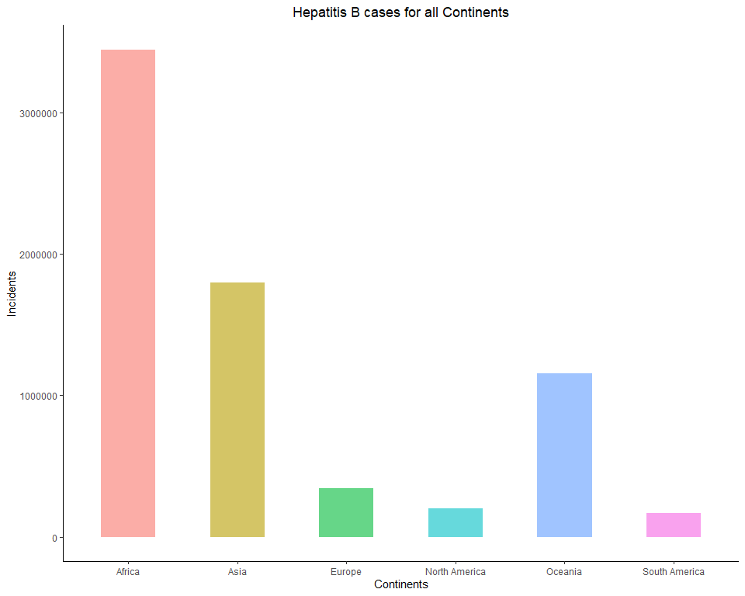

# Barplot for HepatitisB cases by all regions  
HepatitisB$Region <- factor(HepatitisB$Region, levels=unique(HepatitisB$Region[order(HepatitisB$Continent,HepatitisB$Region)]), ordered=TRUE)  
  
HepatitisB %>% filter(Region != "#N/A") %>% ggplot(aes(x = Region, y = Incidence, fill = Continent)) + geom_bar(stat = "identity", width = 0.5, alpha = 0.6) + labs(title = 'HepatitisB cases for all Regions', x = 'Regions', y = 'Incidents') + theme(axis.text.x = element_text(angle = 65, hjust = 1.1))

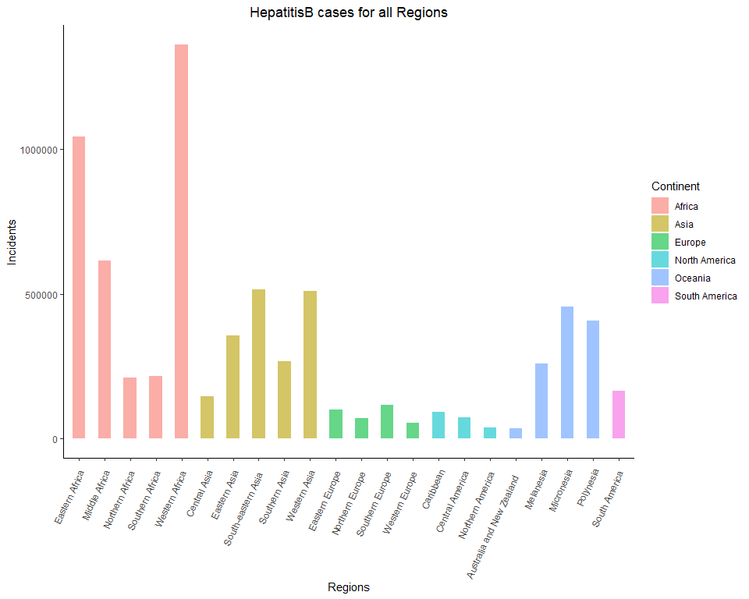

# Hepatitis B cases in continents each year by countries

# Barplot for Hepatitis B cases in Asia by Country  
HepatitisB %>% filter(Continent == "Asia") %>% ggplot(aes(x = Year, y = Incidence, fill=Country)) + geom_bar(stat="identity", width = 0.5, alpha=0.6) + labs(title = 'Hepatitis B cases for countries in Asia', x= 'Year', y = 'Incidents')

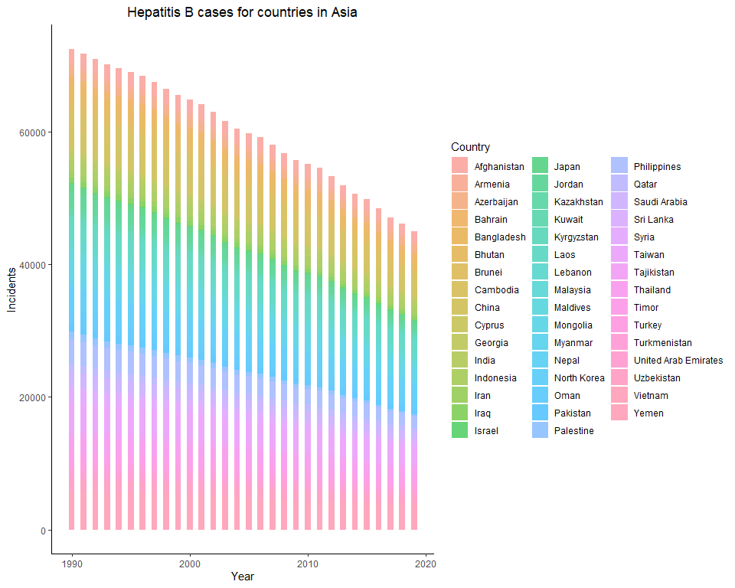

# Barplot for Hepatitis B cases in Africa by Country  
HepatitisB %>% filter(Continent == "Africa") %>% ggplot(aes(x = Year, y = Incidence, fill=Country)) + geom_bar(stat="identity", width = 0.5, alpha=0.6) + labs(title = 'Hepatitis B cases for countries in Africa', x= 'Year', y = 'Incidents')

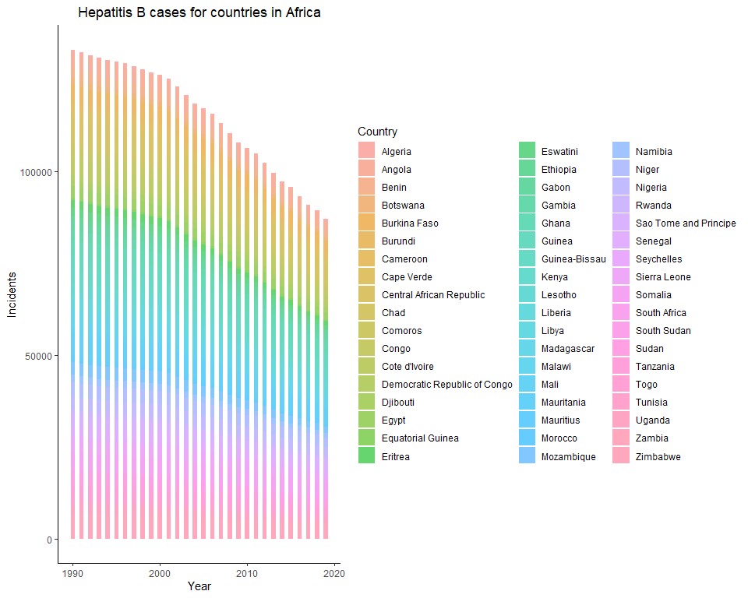

# Barplot for Hepatitis B cases in Europe by Country  
HepatitisB %>% filter(Continent == "Europe") %>% ggplot(aes(x = Year, y = Incidence, fill=Country)) + geom_bar(stat="identity", width = 0.5, alpha=0.6) + labs(title = 'Hepatitis B cases for countries in Europe', x= 'Year', y = 'Incidents')

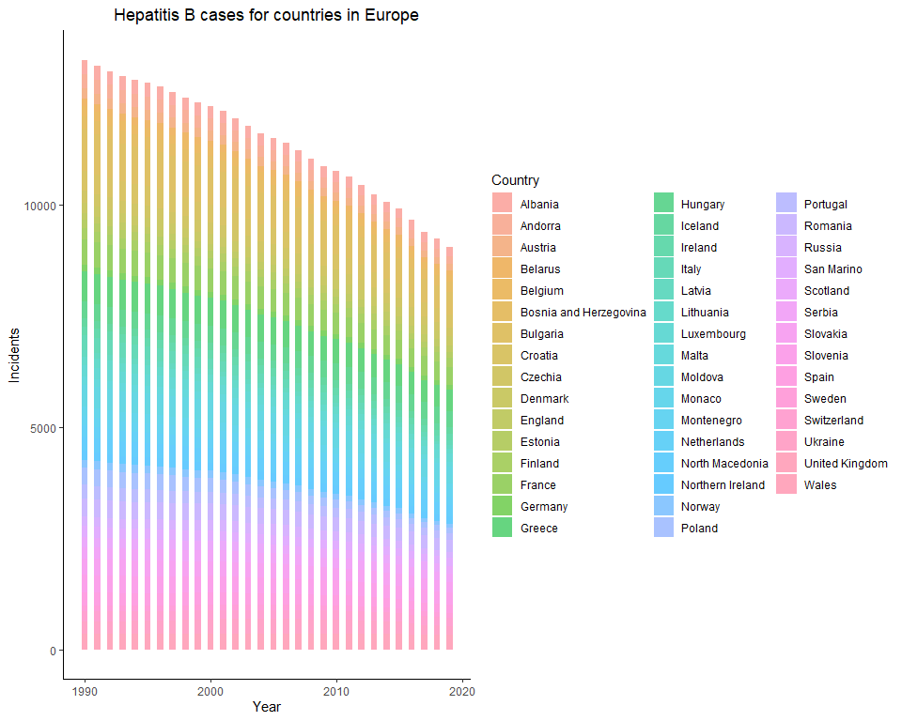

# Barplot for Hepatitis B cases in North America by Country  
HepatitisB %>% filter(Continent == "North America") %>% ggplot(aes(x = Year, y = Incidence, fill=Country)) + geom_bar(stat="identity", width = 0.5, alpha=0.6) + labs(title = 'Hepatitis B cases for countries in North America', x= 'Year', y = 'Incidents')

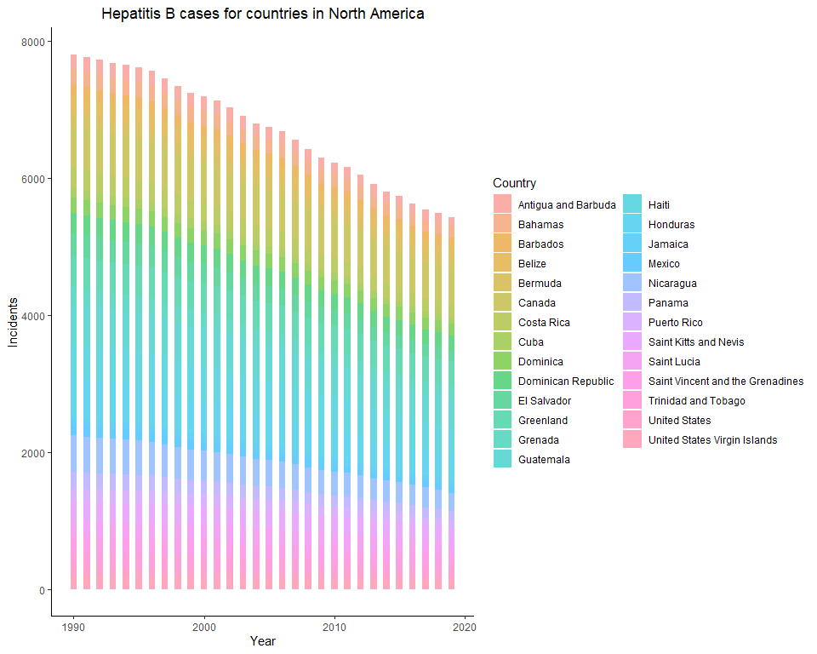

# Barplot for Hepatitis B cases in South America by Country  
HepatitisB %>% filter(Continent == "South America") %>% ggplot(aes(x = Year, y = Incidence, fill=Country)) + geom_bar(stat="identity", width = 0.5, alpha=0.6) + labs(title = 'Hepatitis B cases for countries in South America', x= 'Year', y = 'Incidents')

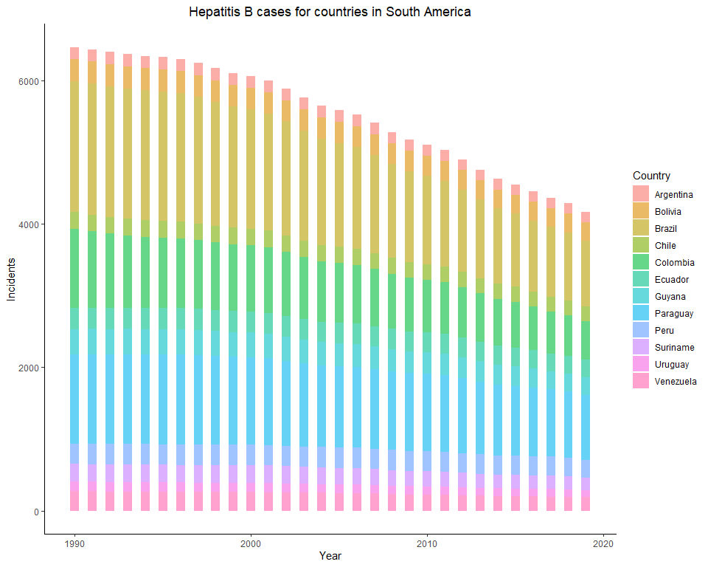

# Barplot for Hepatitis B cases in Oceania by Country  
HepatitisB %>% filter(Continent == "Oceania") %>% ggplot(aes(x = Year, y = Incidence, fill=Country)) + geom_bar(stat="identity", width = 0.5, alpha=0.6) + labs(title = 'Hepatitis B cases for countries in Oceania', x= 'Year', y = 'Incidents')

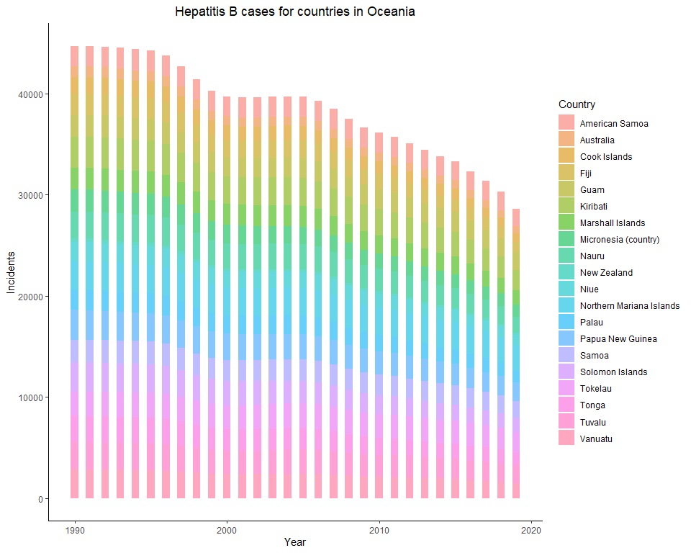

# Hepatitis B cases in SELECT top countries within each continent

# Boxplot for Hepatitis B cases in SELECT countries in Asia  
HepatitisB %>% filter(Continent == "Asia" & Country %in% c("Taiwan","North Korea","Philippines","Vietnam","Laos","Cambodia","China","Yemen","Mongolia","Afganistan")) %>% ggplot(aes(x = Year, y = Incidence, fill=Country)) + geom_boxplot(alpha=0.4) + labs(title = 'Hepatitis B for countries with most cases in Asia', x= 'Year', y = 'Incidents')

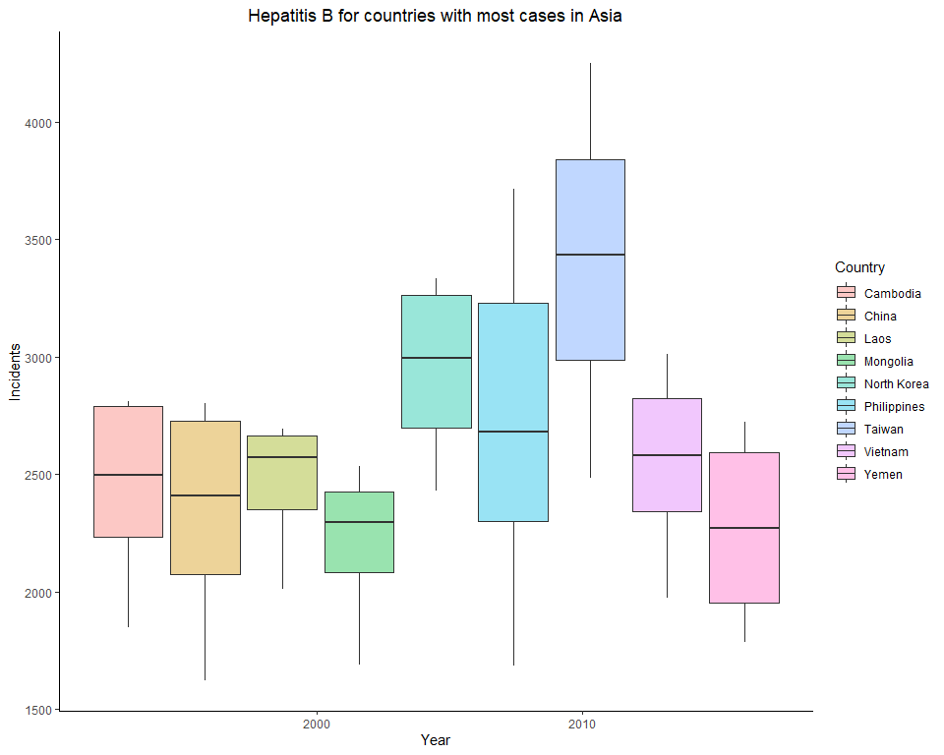

# Boxplot for Hepatitis B cases in SELECT countries in Africa  
HepatitisB %>% filter(Continent == "Africa" & Country %in% c("Mauritania","Somalia","Central African Republic","Angola","Ghana","Burkina Faso","Niger","Guinea","Guinea-Bissau")) %>% ggplot(aes(x = Year, y = Incidence, fill=Country)) + geom_boxplot(alpha=0.4) + labs(title = 'Hepatitis B for countries with most cases in Africa', x= 'Year', y = 'Incidents')

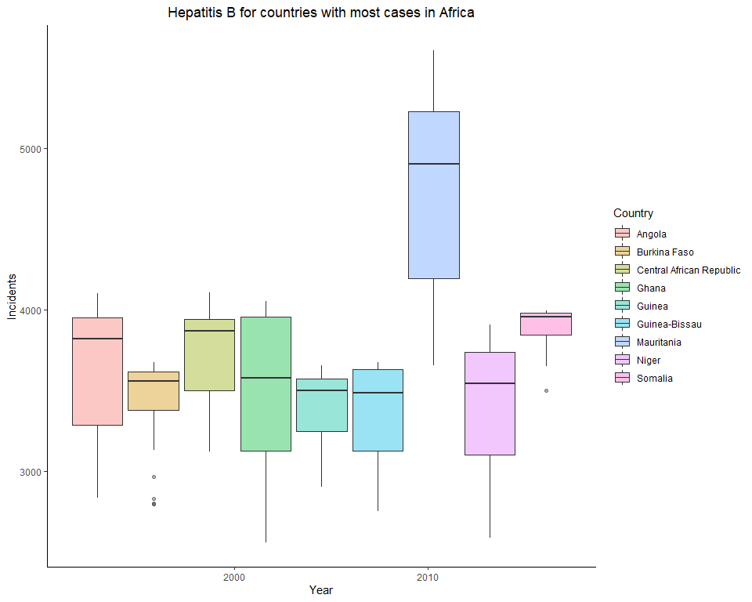

# Boxplot for Hepatitis B cases in SELECT countries in Europe  
HepatitisB %>% filter(Continent == "Europe" & Country %in% c("Bulgaria","Greece","France","Moldova","Croatia","Hungary","Slovenia","Romania","Slovakia", "North Macedonia")) %>% ggplot(aes(x = Year, y = Incidence, fill=Country)) + geom_boxplot(alpha=0.4) + labs(title = 'Hepatitis B for countries with most cases in Europe', x= 'Year', y = 'Incidents')

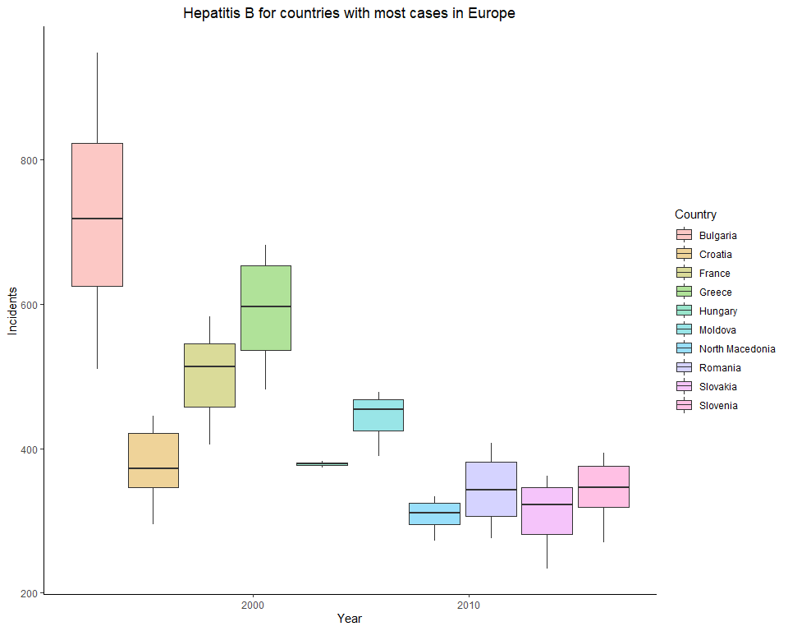

# Boxplot for Hepatitis B cases in SELECT countries in North America  
HepatitisB %>% filter(Continent == "North America" & Country %in% c("Canada","Guatemala","Haiti","Honduras","Greenland","Nicragua")) %>% ggplot(aes(x = Year, y = Incidence, fill=Country)) + geom_boxplot(alpha=0.4) + labs(title = 'Hepatitis B for countries with most cases in North America', x= 'Year', y = 'Incidents')

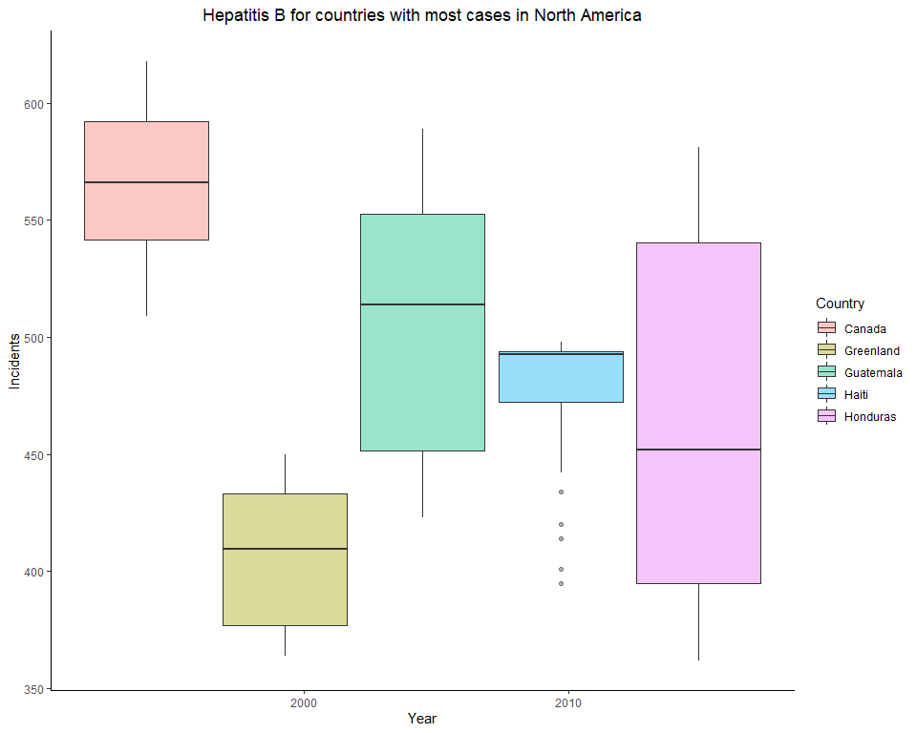

# Boxplot for Hepatitis B cases in SELECT countries in South America  
HepatitisB %>% filter(Continent == "South America" & Country %in% c("Brazil","Paraguay","Columbia","Guyana","Bolivia","Ecuador")) %>% ggplot(aes(x = Year, y = Incidence, fill=Country)) + geom_boxplot(alpha=0.4) + labs(title = 'Hepatitis B for countries with most cases in South America', x= 'Year', y = 'Incidents')

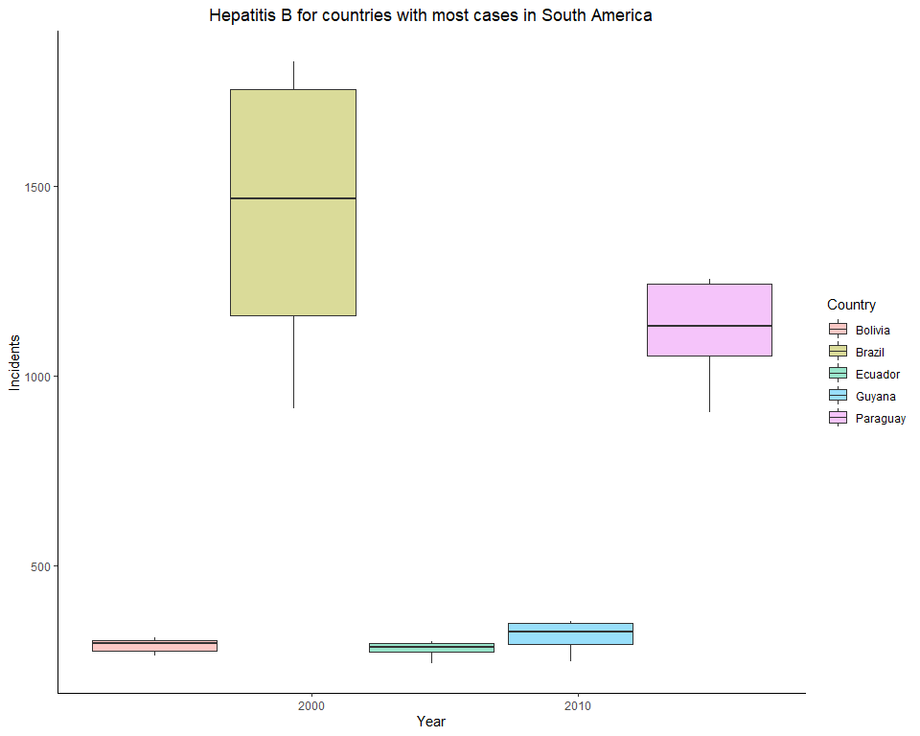

# Boxplot for Hepatitis B cases in SELECT countries in Oceania  
HepatitisB %>% filter(Continent == "Oceania" & Country %in% c("Northern Mariana Islands","Kiribati","Papua New Guinea","Nauru","Tokelau","Tuvalu","Vanuatu")) %>% ggplot(aes(x = Year, y = Incidence, fill=Country)) + geom_boxplot(alpha=0.4) + labs(title = 'Hepatitis B for countries with most cases in Oceania', x= 'Year', y = 'Incidents')

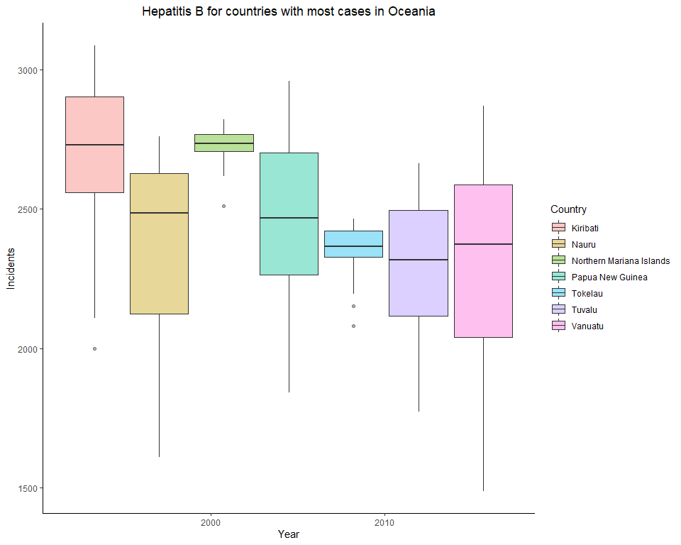

# Polio

# Polio cases among continents and regions

# Barplot for Polio cases by all continents  
Polio %>% filter(Continent != "#N/A") %>% ggplot(aes(x = Continent, y = Incidence, fill=Continent)) + geom_bar(stat="identity", width = 0.5, alpha=0.6) + labs(title = 'Polio cases for all Continents', x= 'Continents', y = 'Incidents') + theme(legend.position="none")

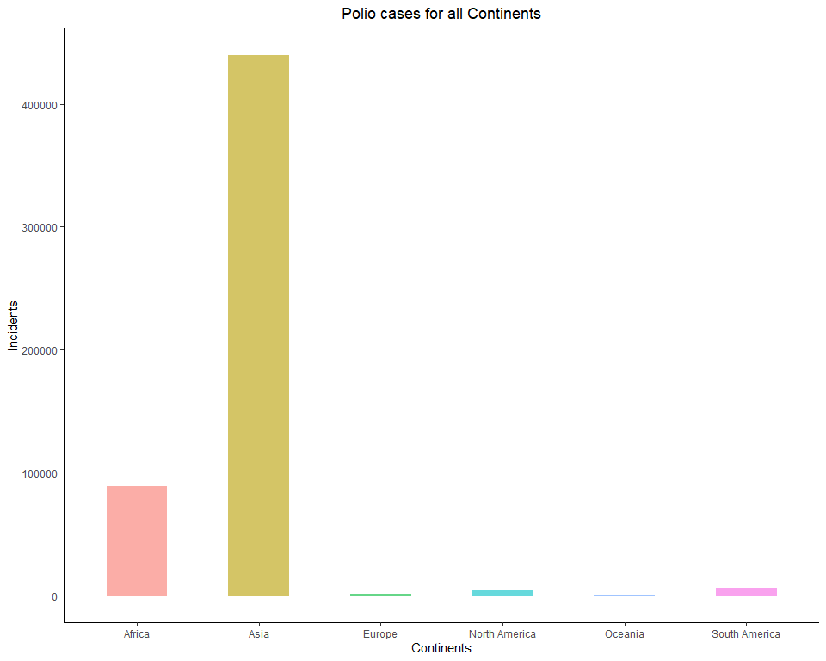

# Barplot for Polio cases by all regions  
Polio$Region <- factor(Polio$Region, levels=unique(Polio$Region[order(Polio$Continent,Polio$Region)]), ordered=TRUE)  
  
Polio %>% filter(Region != "#N/A") %>% ggplot(aes(x = Region, y = Incidence, fill = Continent)) + geom_bar(stat = "identity", width = 0.5, alpha = 0.6) + labs(title = 'Polio cases for all Regions', x = 'Regions', y = 'Incidents') + theme(axis.text.x = element_text(angle = 65, hjust = 1.1))

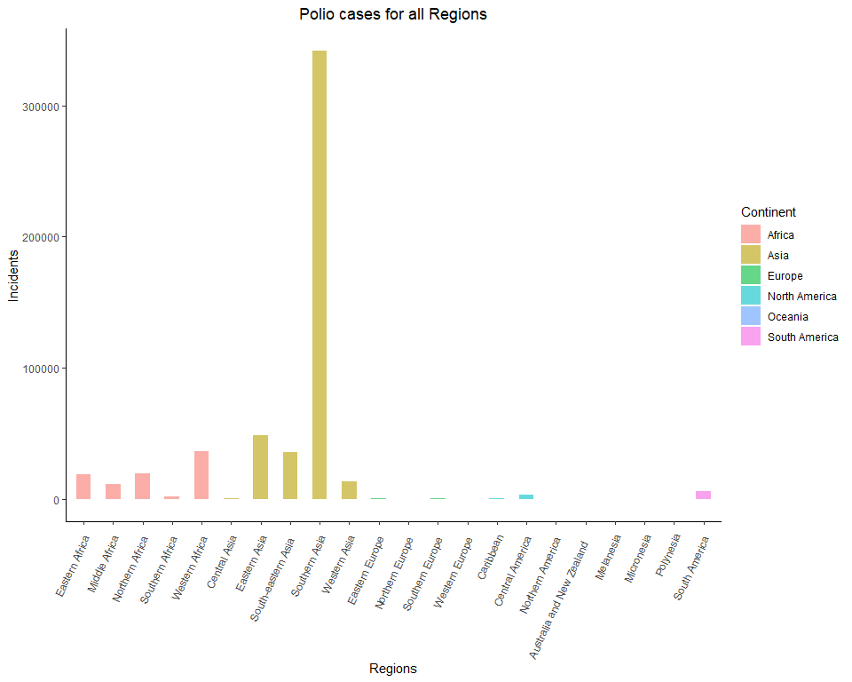

# Polio cases in continents each year by countries

# Barplot for Polio cases in Asia by Country  
Polio %>% filter(Continent == "Asia") %>% ggplot(aes(x = Year, y = Incidence, fill=Country)) + geom_bar(stat="identity", width = 0.5, alpha=0.6) + labs(title = 'Polio cases for countries in Asia', x= 'Year', y = 'Incidents')

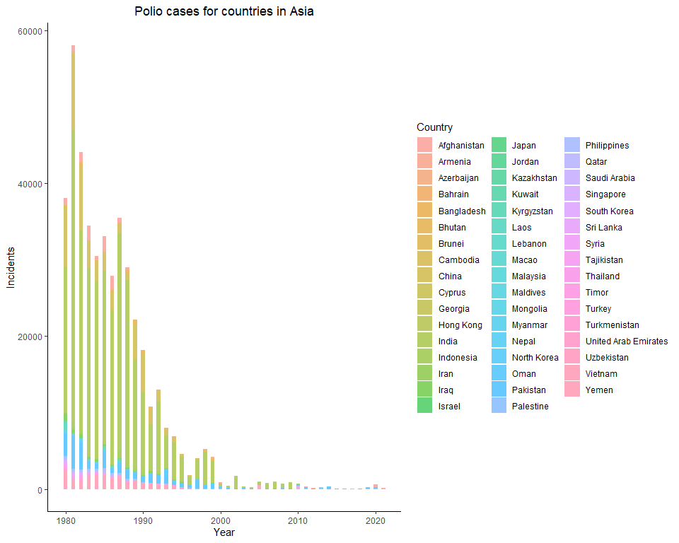

# Barplot for Polio cases in Africa by Country  
Polio %>% filter(Continent == "Africa") %>% ggplot(aes(x = Year, y = Incidence, fill=Country)) + geom_bar(stat="identity", width = 0.5, alpha=0.6) + labs(title = 'Polio cases for countries in Africa', x= 'Year', y = 'Incidents')

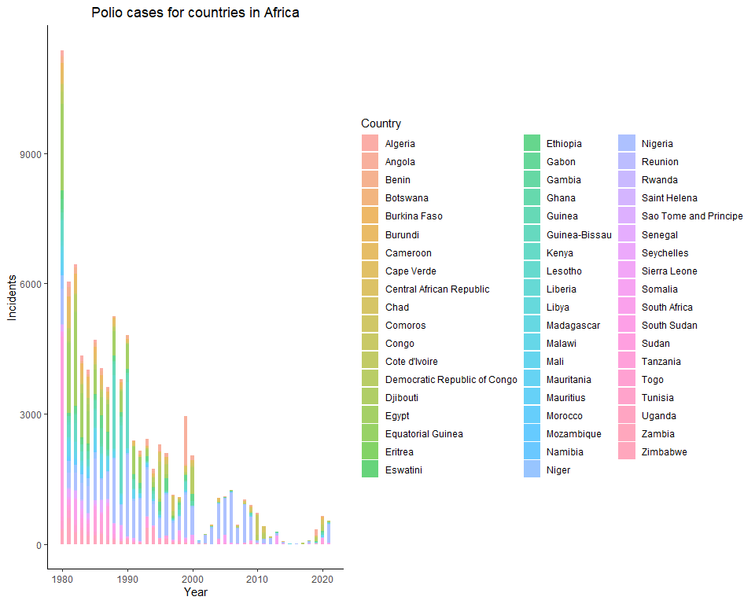

# Barplot for Polio cases in Europe by Country  
Polio %>% filter(Continent == "Europe") %>% ggplot(aes(x = Year, y = Incidence, fill=Country)) + geom_bar(stat="identity", width = 0.5, alpha=0.6) + labs(title = 'Polio cases for countries in Europe', x= 'Year', y = 'Incidents')

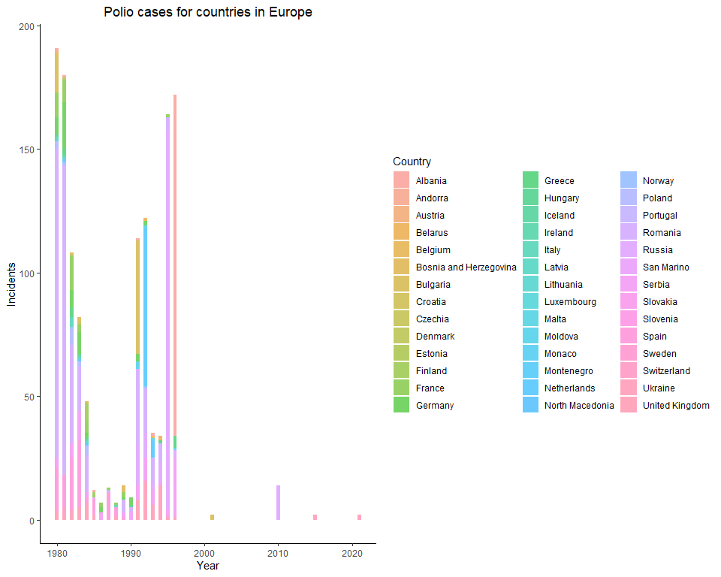

# Barplot for Polio cases in North America by Country  
Polio %>% filter(Continent == "North America") %>% ggplot(aes(x = Year, y = Incidence, fill=Country)) + geom_bar(stat="identity", width = 0.5, alpha=0.6) + labs(title = 'Polio cases for countries in North America', x= 'Year', y = 'Incidents')

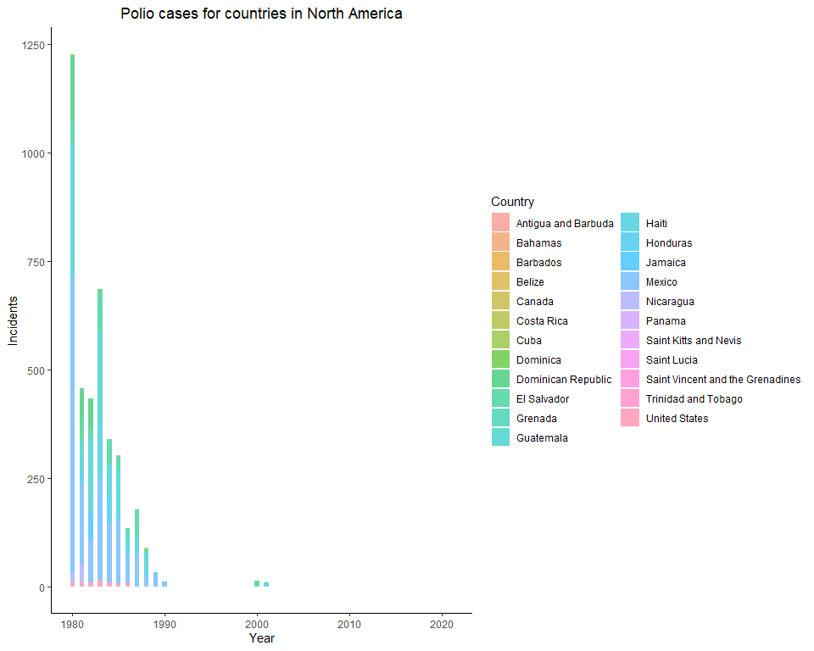

# Barplot for Polio cases in South America by Country  
Polio %>% filter(Continent == "South America") %>% ggplot(aes(x = Year, y = Incidence, fill=Country)) + geom_bar(stat="identity", width = 0.5, alpha=0.6) + labs(title = 'Polio cases for countries in South America', x= 'Year', y = 'Incidents')

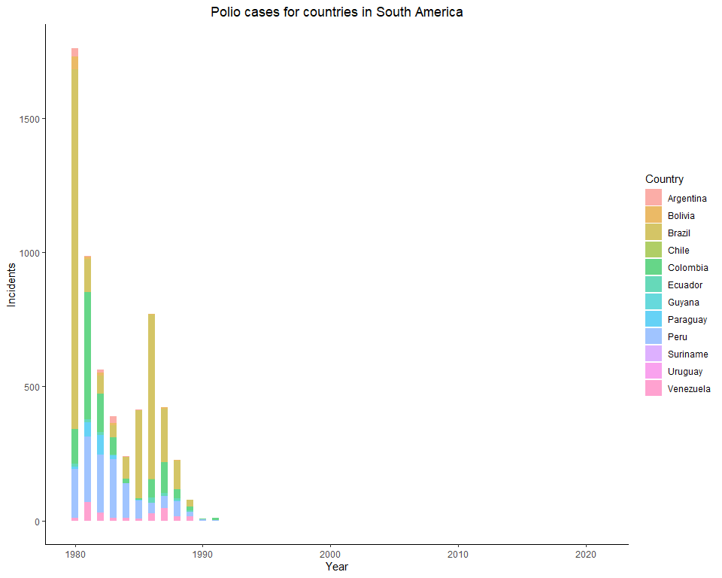

# Barplot for Polio cases in Oceania by Country  
Polio %>% filter(Continent == "Oceania") %>% ggplot(aes(x = Year, y = Incidence, fill=Country)) + geom_bar(stat="identity", width = 0.5, alpha=0.6) + labs(title = 'Polio cases for countries in Oceania', x= 'Year', y = 'Incidents')

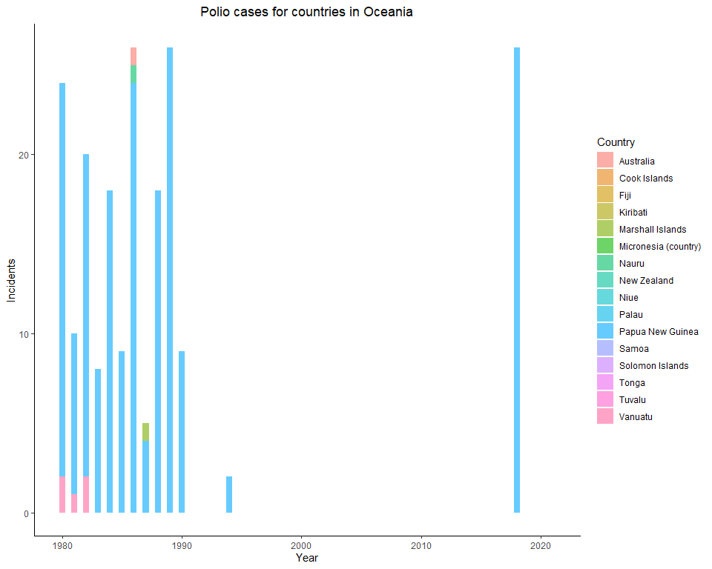

# Polio cases in SELECT top countries within each continent

# Boxplot for Polio cases in SELECT countries in Asia  
Polio %>% filter(Continent == "Asia" & Country %in% c("India","China","Pakistan","Vietnam","Afganistan")) %>% ggplot(aes(x = Year, y = Incidence, fill=Country)) + geom_boxplot(alpha=0.4) + labs(title = 'Polio for countries with most cases in Asia', x= 'Year', y = 'Incidents')

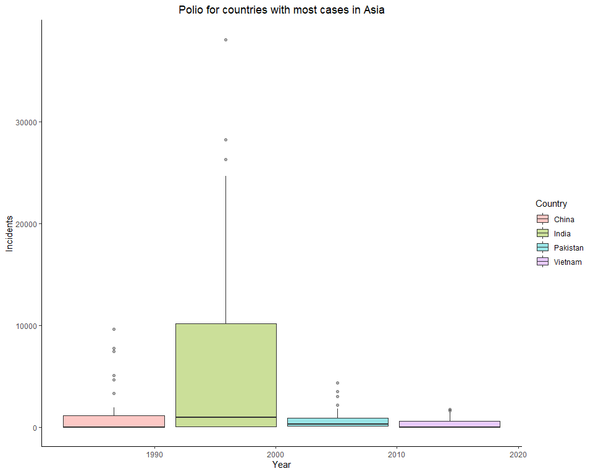

# Boxplot for Polio cases in SELECT countries in Africa  
Polio %>% filter(Continent == "Africa" & Country %in% c("Nigeria","Egypt","Kenya","Sudan","Democratic Republic of Congo","Ehiopia","Zambia")) %>% ggplot(aes(x = Year, y = Incidence, fill=Country)) + geom_boxplot(outlier.shape=NA, alpha=0.4) + coord_cartesian(ylim=c(0, 1700)) + labs(title = 'Polio for countries with most cases in Africa', x= 'Year', y = 'Incidents')

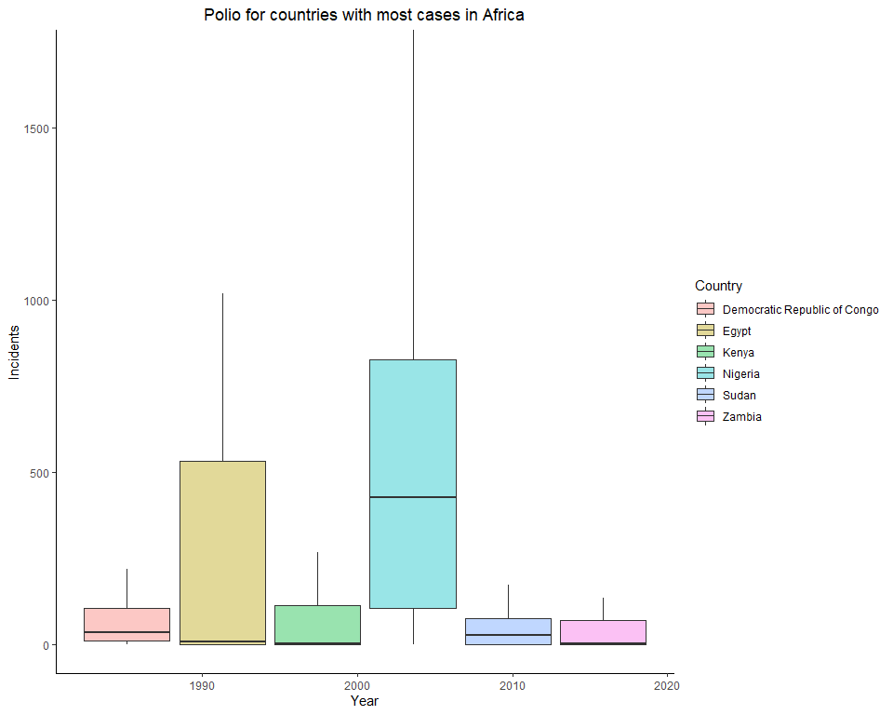

# Boxplot for Polio cases in SELECT countries in Europe  
Polio %>% filter(Continent == "Europe" & Country %in% c("Romania","Serbia","France","Ukraine")) %>% ggplot(aes(x = Year, y = Incidence, fill=Country)) + geom_boxplot(outlier.shape=NA, alpha=0.4) + coord_cartesian(ylim=c(0, 10)) + labs(title = 'Polio for countries with most cases in Europe', x= 'Year', y = 'Incidents')

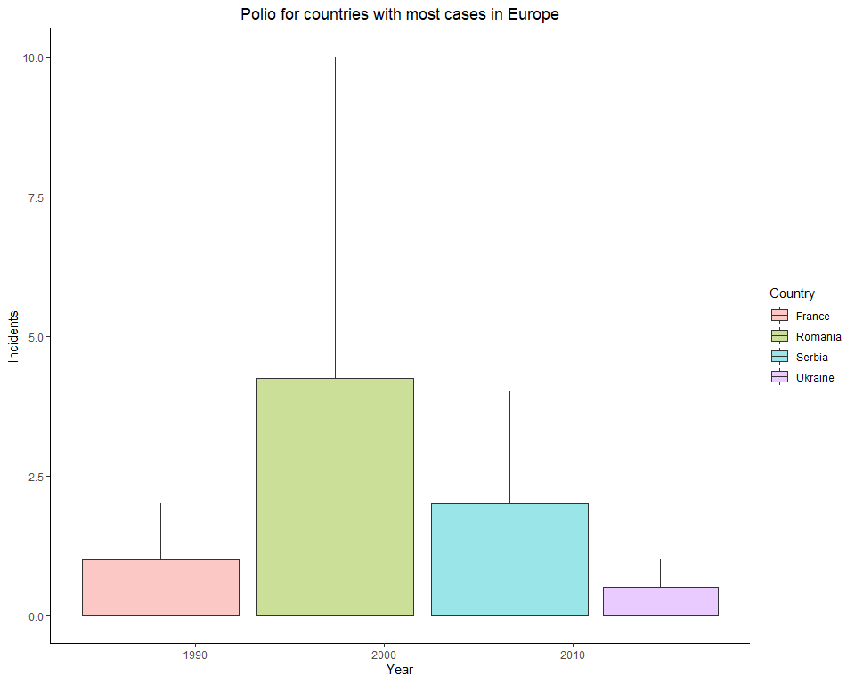

# Boxplot for Polio cases in SELECT countries in North America  
Polio %>% filter(Continent == "North America" & Country %in% c("Mexico","Guatemala","Haiti")) %>% ggplot(aes(x = Year, y = Incidence, fill=Country)) + geom_boxplot(outlier.shape=NA, alpha=0.4) + coord_cartesian(ylim=c(0, 7.5)) + labs(title = 'Polio for countries with most cases in North America', x= 'Year', y = 'Incidents')

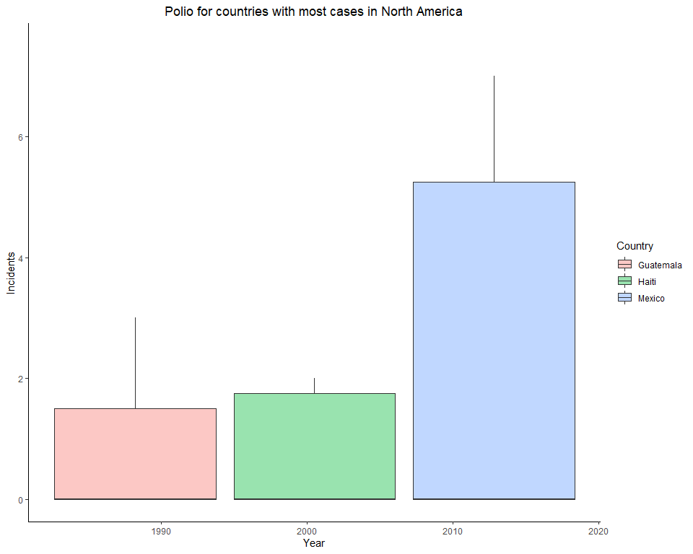

# !!!! BRAZIL doesn't show up !!!!  
# Boxplot for Polio cases in SELECT countries in South America  
Polio %>% filter(Continent == "South America" & Country %in% c("Brazil","Peru","Colombia")) %>% ggplot(aes(x = Year, y = Incidence, fill=Country)) + geom_boxplot(outlier.shape=NA, alpha=0.4) + coord_cartesian(ylim=c(0,8)) + labs(title = 'Polio for countries with most cases in South America', x= 'Year', y = 'Incidents')

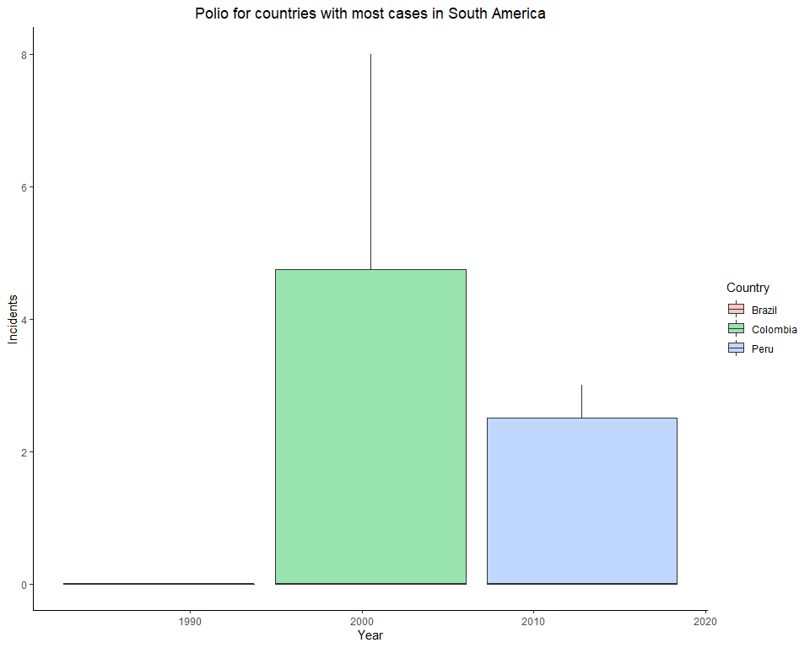

# Boxplot for Polio cases in SELECT countries in Oceania  
Polio %>% filter(Continent == "Oceania" & Country %in% c("Papua New Guinea","Vanuatu")) %>% ggplot(aes(x = Year, y = Incidence, fill=Country)) + geom_boxplot(outlier.shape=NA, alpha=0.4) + coord_cartesian(ylim=c(0,8)) + labs(title = 'Polio for countries with most cases in Oceania', x= 'Year', y = 'Incidents')

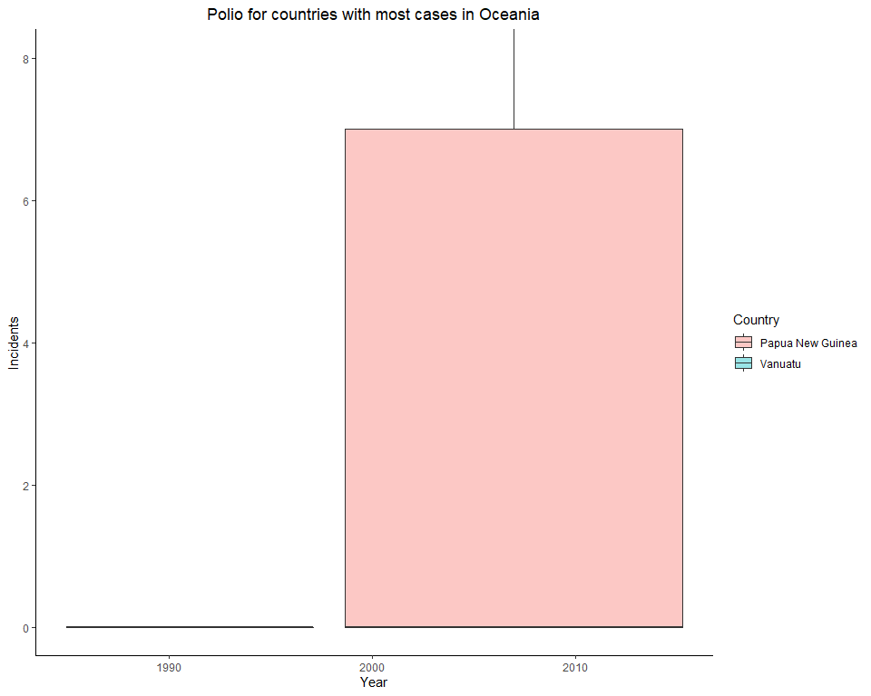

# Measles

# Measles cases among continents and regions

# Barplot for Measles cases by all continents  
Measles %>% filter(Continent != "#N/A") %>% ggplot(aes(x = Continent, y = Incidence, fill=Continent)) + geom_bar(stat="identity", width = 0.5, alpha = 0.6) + labs(title = 'Measles cases for all Continents', x= 'Continents', y = 'Incidents') + theme(legend.position="none")

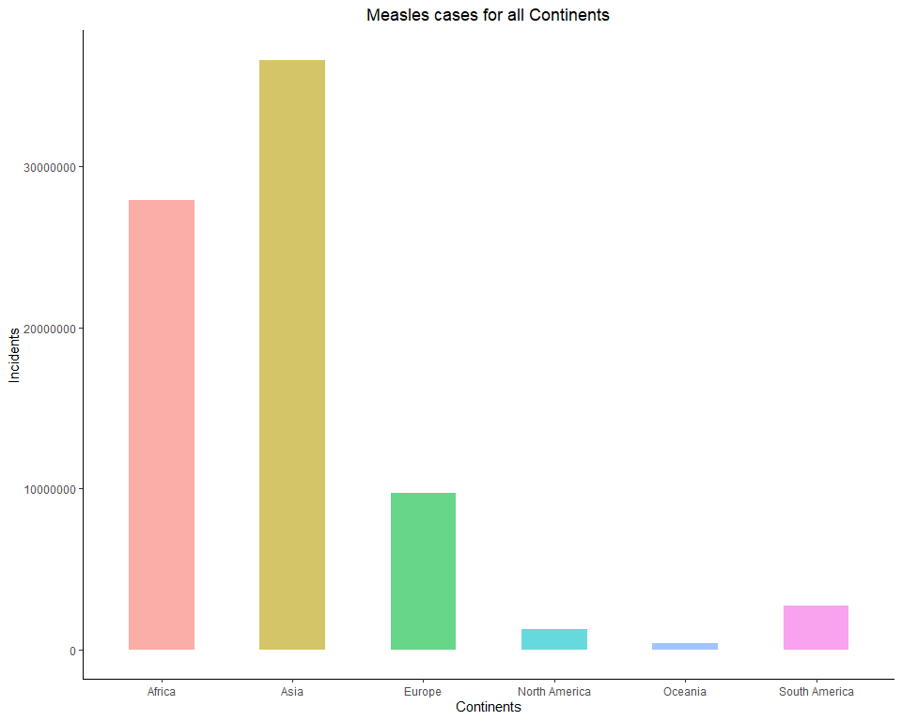

# Barplot for Measles cases by all regions  
Measles$Region <- factor(Measles$Region, levels=unique(Measles$Region[order(Measles$Continent,Measles$Region)]), ordered=TRUE)  
  
Measles %>% filter(Region != "#N/A") %>% ggplot(aes(x = Region, y = Incidence, fill = Continent)) + geom_bar(stat = "identity", width = 0.5, alpha = 0.6) + labs(title = 'Measles cases for all Regions', x = 'Regions', y = 'Incidents') + theme(axis.text.x = element_text(angle = 65, hjust = 1.1))

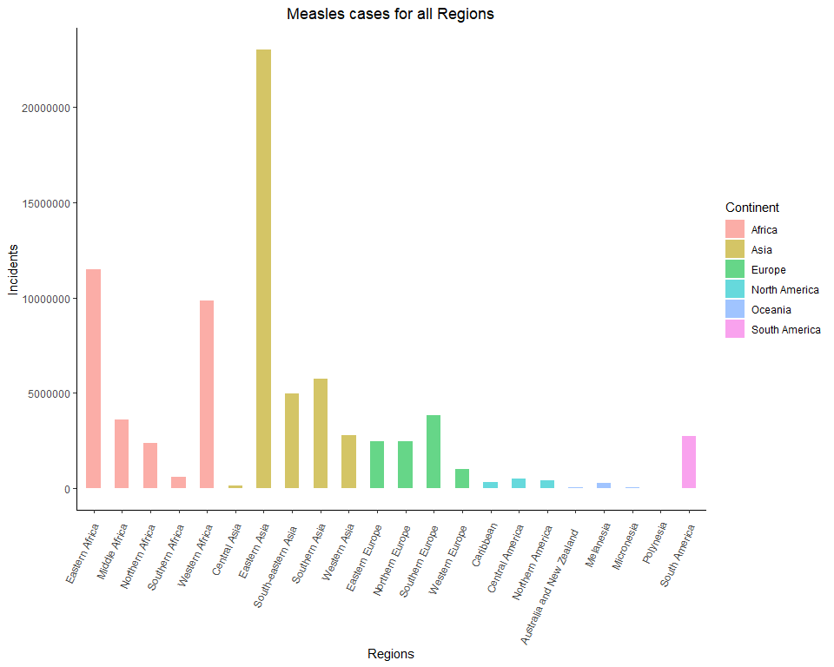

# Measles cases in continents each year by countries

# Barplot for Measles cases in Asia by Country  
Measles %>% filter(Continent == "Asia") %>% ggplot(aes(x = Year, y = Incidence, fill = Country)) + geom_bar(stat = "identity", width = 0.5, alpha = 0.6) + labs(title = 'Measles cases for countries in Asia', x = 'Year', y = 'Incidents')

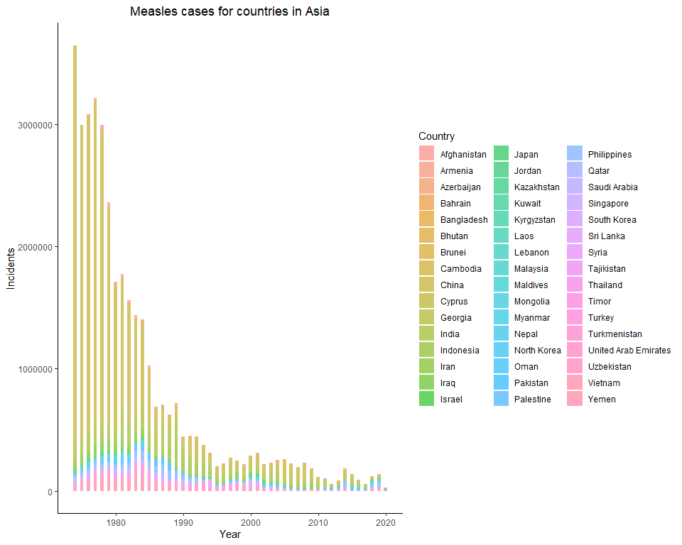

# Barplot for Measles cases in Africa by Country  
Measles %>% filter(Continent == "Africa") %>% ggplot(aes(x = Year, y = Incidence, fill = Country)) + geom_bar(stat ="identity", width = 0.5, alpha = 0.6) + labs(title = 'Measles cases for countries in Africa', x = 'Year', y = 'Incidents')

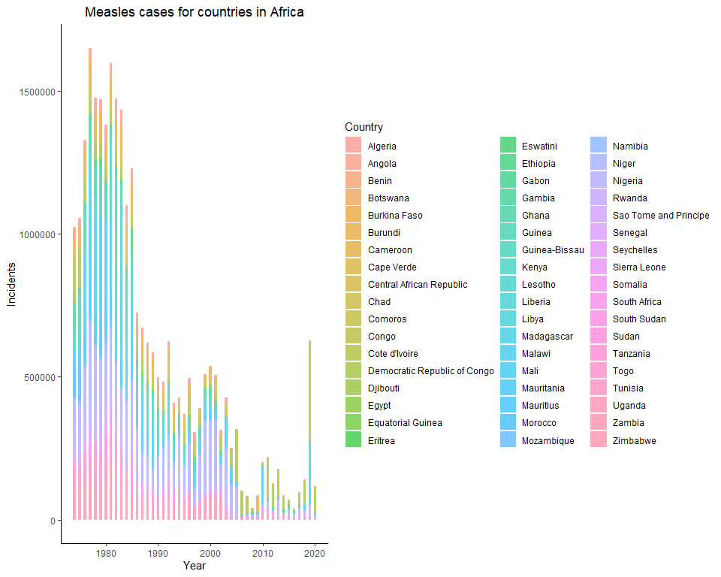

# Barplot for Measles cases in Europe by Country  
Measles %>% filter(Continent == "Europe") %>% ggplot(aes(x = Year, y = Incidence, fill = Country)) + geom_bar(stat = "identity", width = 0.5, alpha = 0.6) + labs(title = 'Measles cases for countries in Europe', x = 'Year', y = 'Incidents')

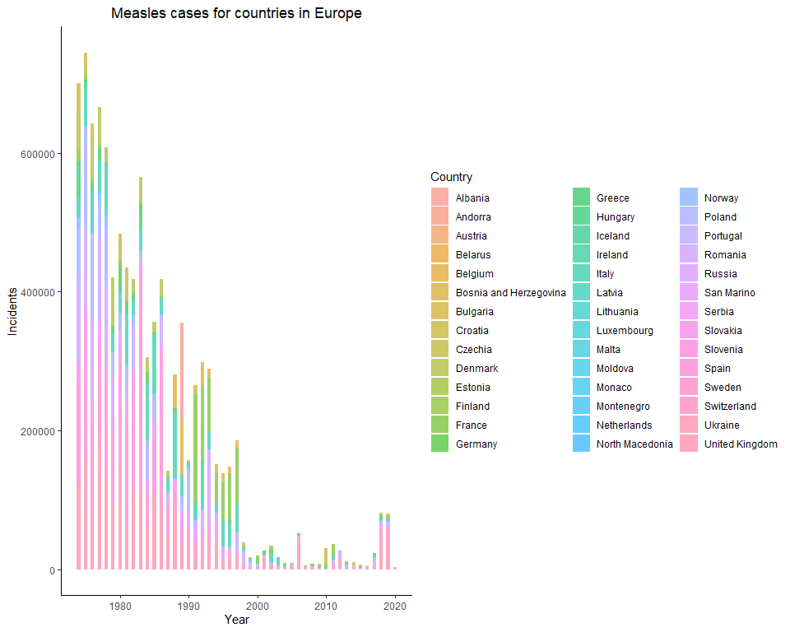

# Barplot for Measles cases in North America by Country  
Measles %>% filter(Continent == "North America") %>% ggplot(aes(x = Year, y = Incidence, fill = Country)) + geom_bar(stat = "identity", width = 0.5, alpha = 0.6) + labs(title = 'Measles cases for countries in North America', x = 'Year', y = 'Incidents')

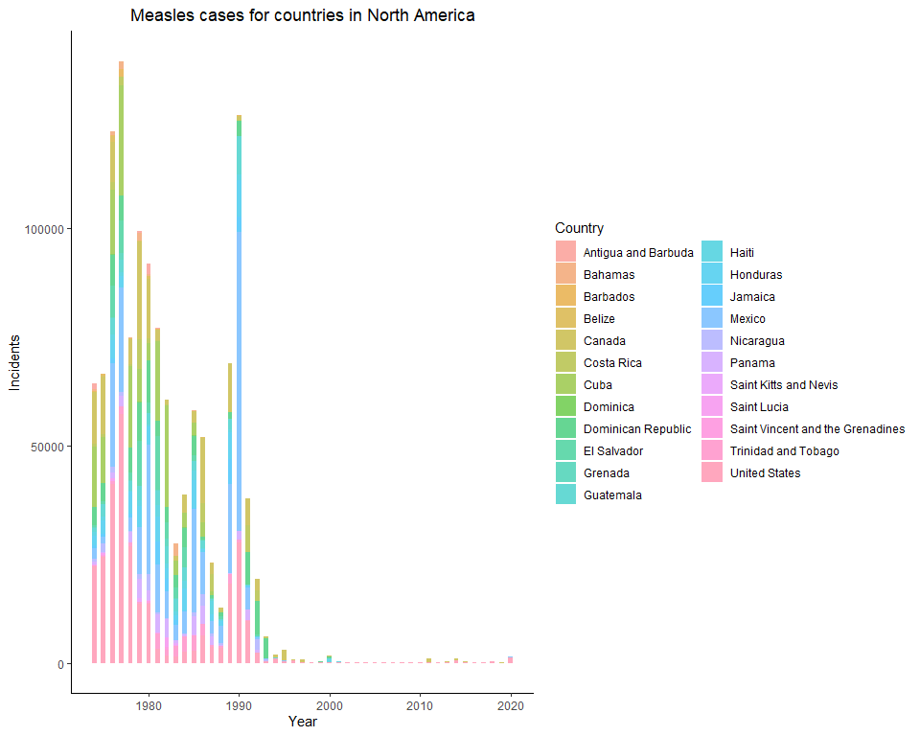

# Barplot for Measles cases in South America by Country  
Measles %>% filter(Continent == "South America") %>% ggplot(aes(x = Year, y = Incidence, fill = Country)) + geom_bar(stat = "identity", width = 0.5, alpha = 0.6) + labs(title = 'Measles cases for countries in South America', x = 'Year', y = 'Incidents')

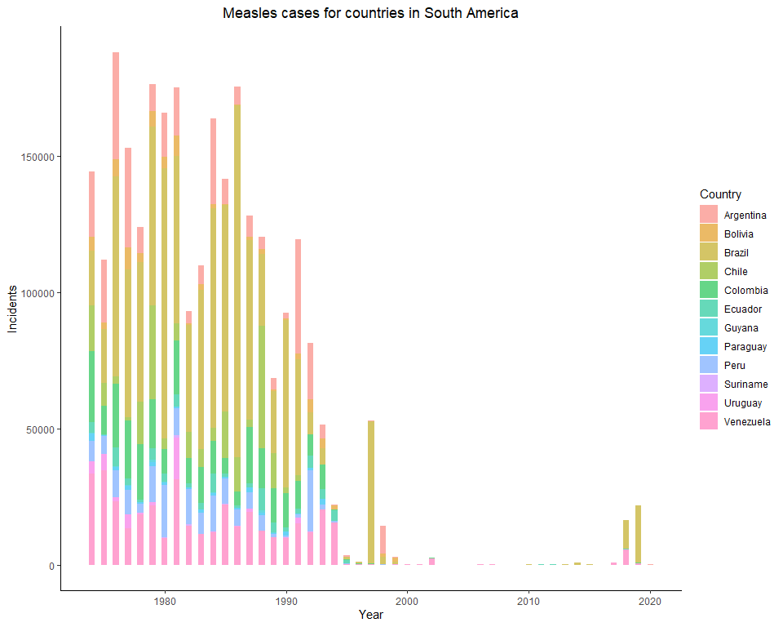

# Barplot for Measles cases in Oceania by Country  
Measles %>% filter(Continent == "Oceania") %>% ggplot(aes(x = Year, y = Incidence, fill = Country)) + geom_bar(stat = "identity", width = 0.5, alpha = 0.6) + labs(title = 'Measles cases for countries in Oceania', x = 'Year', y = 'Incidents')

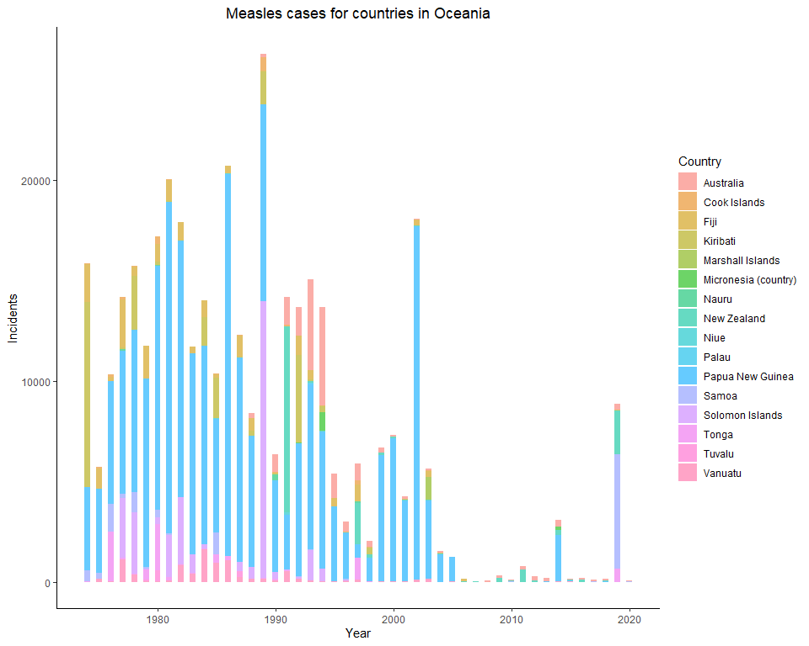

# Measles cases in SELECT top countries within each continent

# Boxplot for Measles cases in SELECT countries in Asia  
Measles %>% filter(Continent == "Asia" & Country %in% c("China","India")) %>% ggplot(aes(x = Year, y = Incidence, fill = Country)) + geom_boxplot(outlier.shape = NA, alpha = 0.4) + coord_cartesian(ylim = c(0,15000)) + labs(title = 'Measles for countries with most cases in Asia', x = 'Year', y = 'Incidents')

# Boxplot for Measles cases in SELECT countries in Africa  
Measles %>% filter(Continent == "Africa" & Country %in% c("Nigeria","Malawi","Kenya","Democratic Republic of Congo")) %>% ggplot(aes(x = Year, y = Incidence, fill = Country)) + geom_boxplot(outlier.shape = NA, alpha = 0.4) + coord_cartesian(ylim = c(0,200000)) + labs(title = 'Measles for countries with most cases in Africa', x = 'Year', y = 'Incidents')

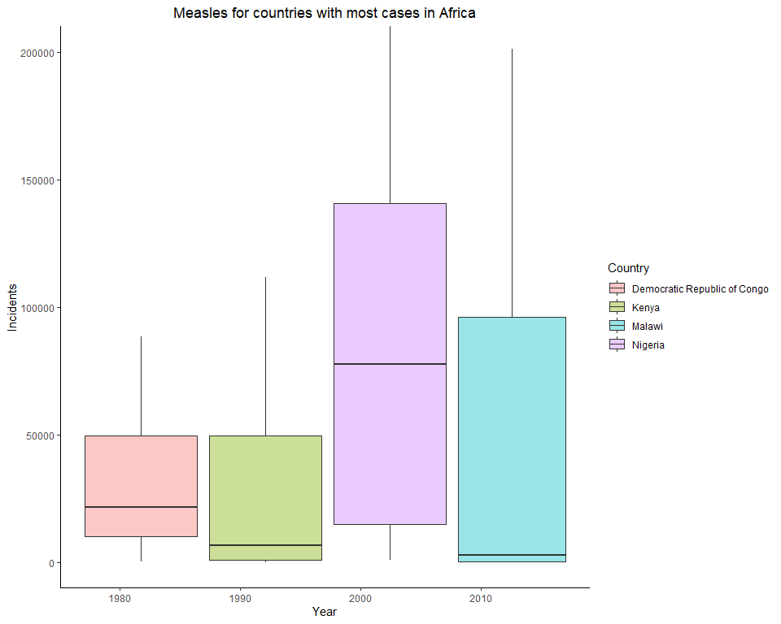

# Boxplot for Measles cases in SELECT countries in Europe  
Measles %>% filter(Continent == "Europe" & Country %in% c("Sapin","United Kingdom","Italy","Romania","Poland")) %>% ggplot(aes(x = Year, y = Incidence, fill = Country)) + geom_boxplot(outlier.shape = NA, alpha = 0.4) + coord_cartesian(ylim = c(0,150000)) + labs(title = 'Measles for countries with most cases in Europe', x = 'Year', y = 'Incidents')

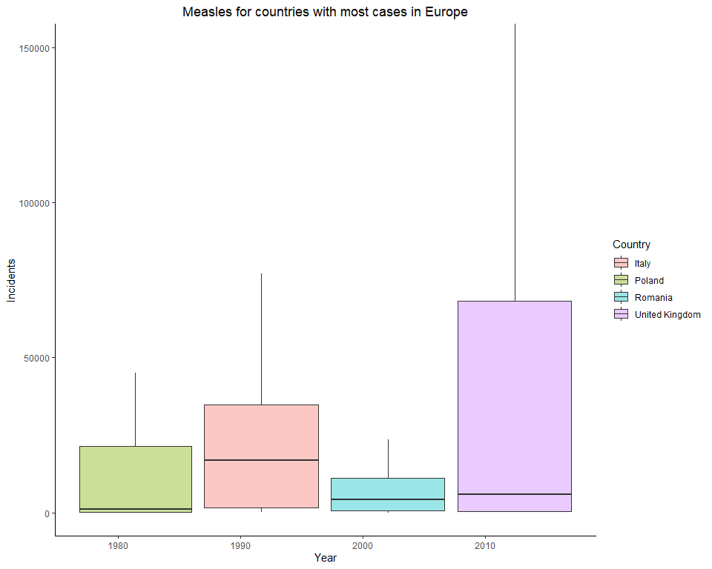

# Boxplot for Measles cases in SELECT countries in North America  
Measles %>% filter(Continent == "North America" & Country %in% c("United States","Mexico","Cuba","Canada","Dominican Republic")) %>% ggplot(aes(x = Year, y = Incidence, fill = Country)) + geom_boxplot(outlier.shape = NA, alpha = 0.4) + coord_cartesian(ylim = c(0,10000)) + labs(title = 'Measles for countries with most cases in North America', x = 'Year', y = 'Incidents')

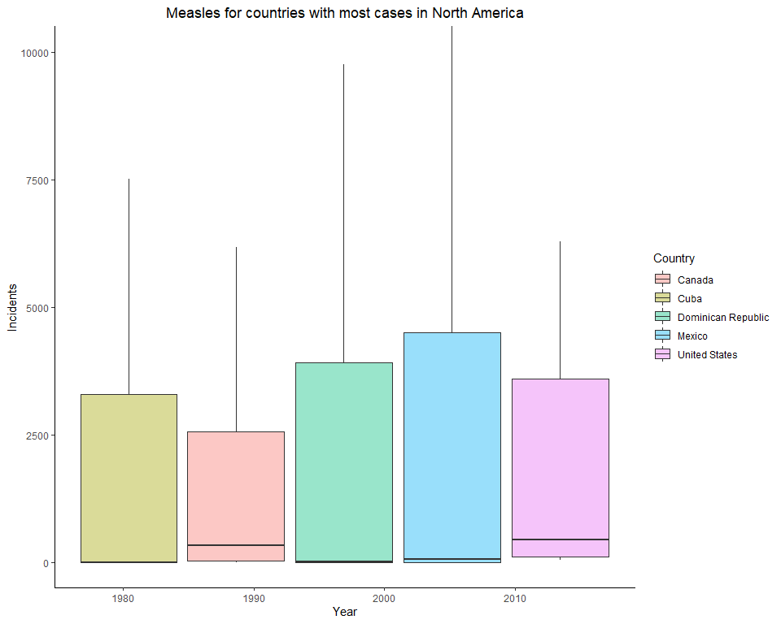

# Boxplot for Measles cases in SELECT countries in South America  
Measles %>% filter(Continent == "South America" & Country %in% c("Brazil","Venezuela","Argentina","Colombia")) %>% ggplot(aes(x = Year, y = Incidence, fill = Country)) + geom_boxplot(outlier.shape = NA, alpha = 0.4) + coord_cartesian(ylim = c(0,125000)) + labs(title = 'Measles for countries with most cases in South America', x = 'Year', y = 'Incidents')

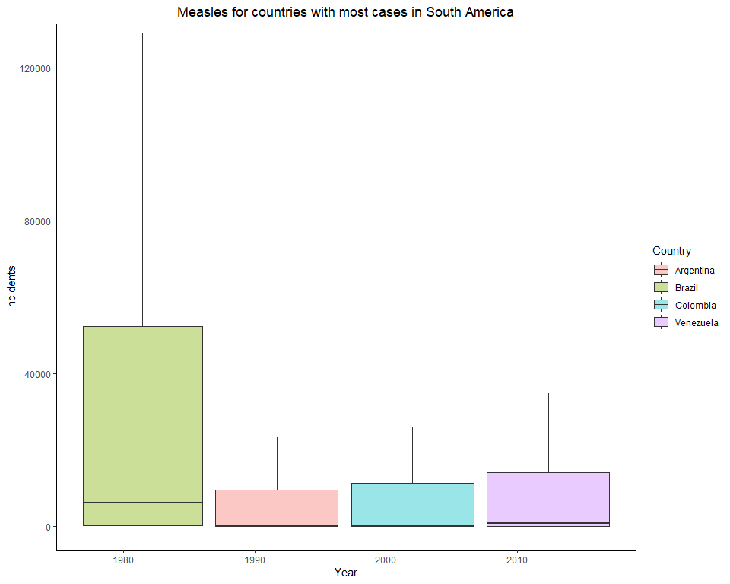

# Boxplot for Measles cases in SELECT countries in Oceania  
Measles %>% filter(Continent == "Oceania" & Country %in% c("Papua New Guinea","Solomon Islands","Kiribati")) %>% ggplot(aes(x = Year, y = Incidence, fill = Country)) + geom_boxplot(outlier.shape = NA, alpha = 0.4) + coord_cartesian(ylim = c(0,15000)) + labs(title = 'Measles for countries with most cases in Oceania', x = 'Year', y = 'Incidents')

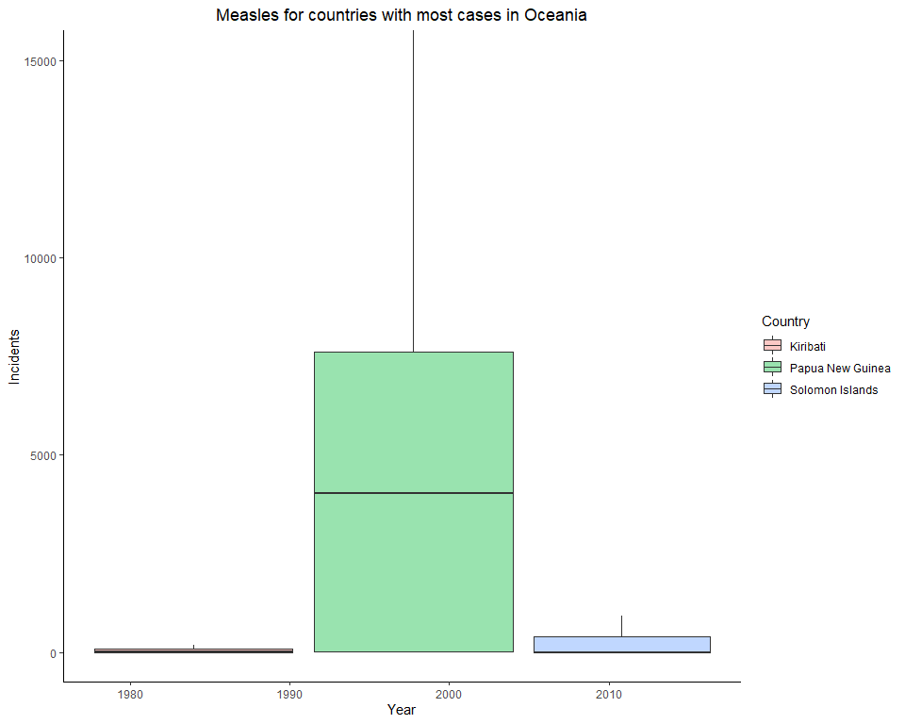

# Tuberculosis

# Tuberculosis cases among continents and regions

# Boxplot for Tuberculosis cases by all continents  
Tuberculosis %>% filter(Continent != "#N/A") %>% ggplot(aes(x = Continent, y = Incidence, fill = Continent)) + geom_boxplot(alpha = 0.4) + labs(title = 'Tuberculosis cases for all Continents', x = 'Continents', y = 'Incidents') + theme(legend.position ="none")

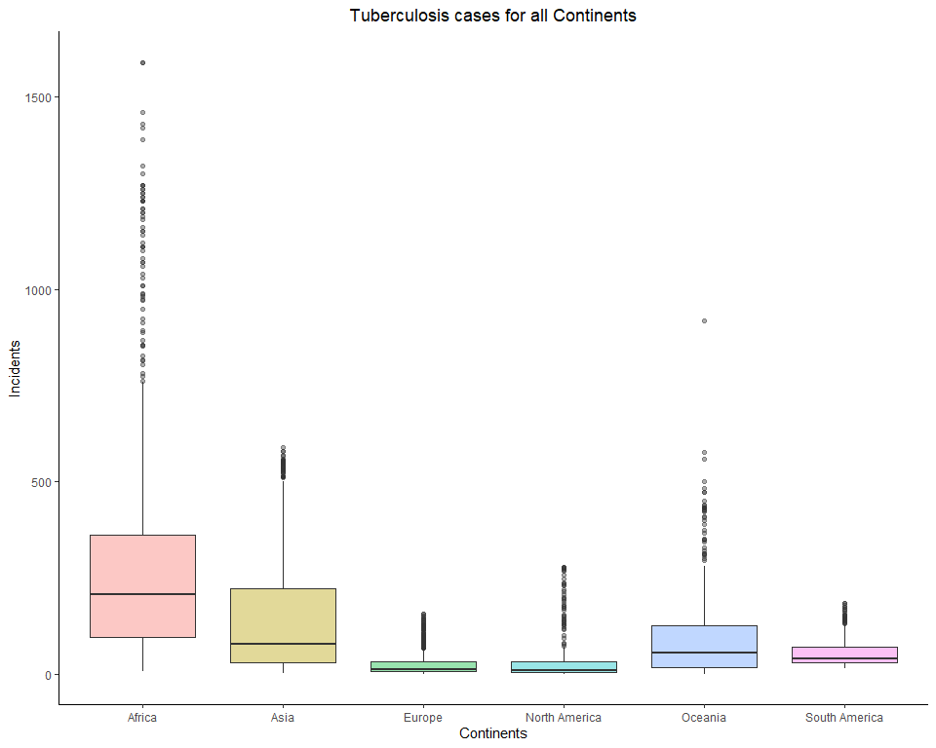

# Barplot for Tuberculosis cases by all continents  
Tuberculosis %>% filter(Continent != "#N/A") %>% ggplot(aes(x = Continent, y = Incidence, fill = Continent)) + geom_bar(stat = "identity", width = 0.5, alpha = 0.6) + labs(title = 'Tuberculosis cases for all Continents', x = 'Continents', y = 'Incidents') + theme(legend.position = "none")

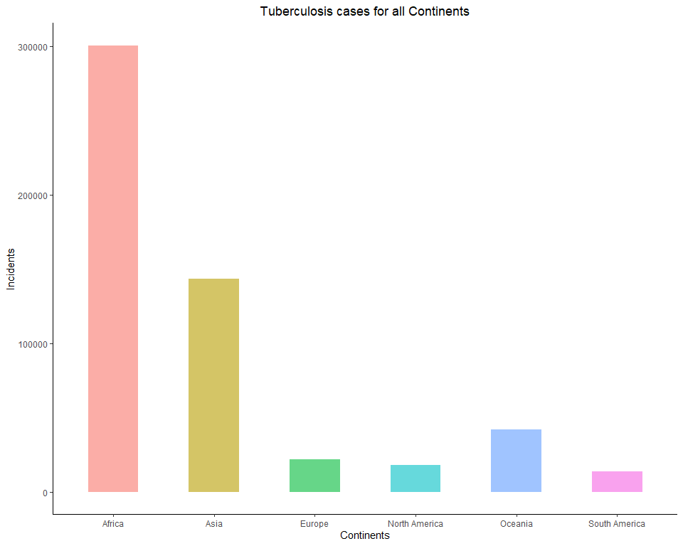

# Barplot for Tuberculosis cases by all regions  
Tuberculosis$Region <- factor(Tuberculosis$Region, levels=unique(Tuberculosis$Region[order(Tuberculosis$Continent,Tuberculosis$Region)]), ordered=TRUE)  
  
Tuberculosis %>% filter(Region != "#N/A") %>% ggplot(aes(x = Region, y = Incidence, fill = Continent)) + geom_bar(stat = "identity", width = 0.5, alpha = 0.6) + labs(title = 'Tuberculosis cases for all Regions', x = 'Regions', y = 'Incidents') + theme(axis.text.x = element_text(angle = 65, hjust = 1.1))

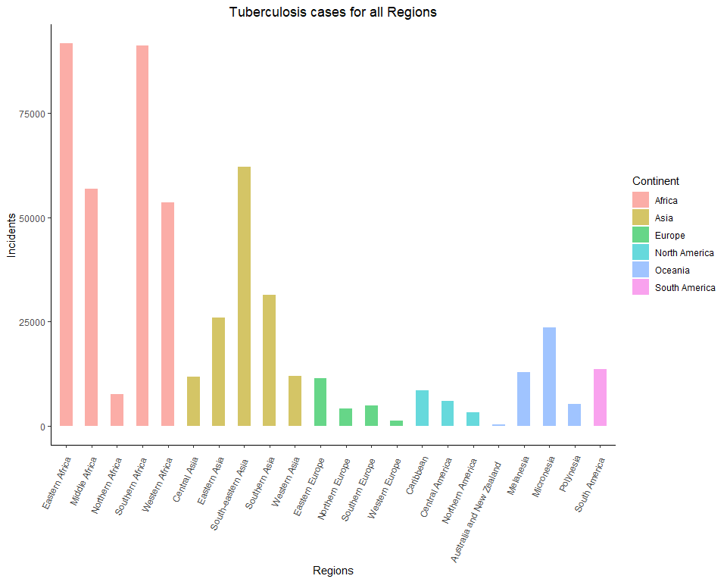

# Tuberculosis cases in continents each year by countries

# Barplot for Tuberculosis cases in Asia by Country  
Tuberculosis %>% filter(Continent == "Asia") %>% ggplot(aes(x = Year, y = Incidence, fill=Country)) + geom_bar(stat="identity", width = 0.5, alpha = 0.6) + labs(title = 'Tuberculosis cases for countries in Asia', x= 'Year', y = 'Incidents')

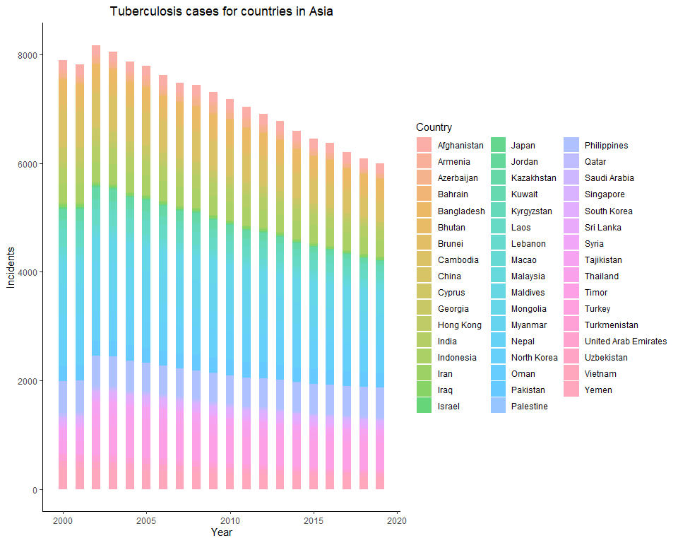

# Barplot for Tuberculosis cases in Africa by Country  
Tuberculosis %>% filter(Continent == "Africa") %>% ggplot(aes(x = Year, y = Incidence, fill=Country)) + geom_bar(stat="identity", width = 0.5, alpha = 0.6) + labs(title = 'Tuberculosis cases for countries in Africa', x= 'Year', y = 'Incidents')

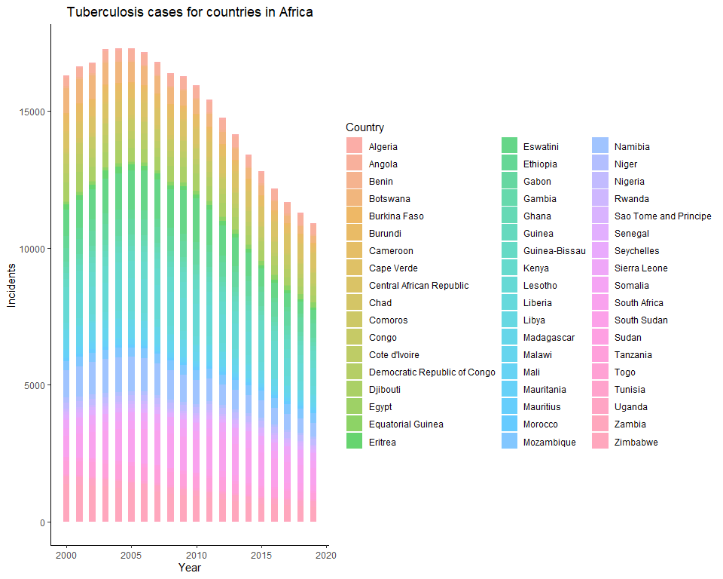

# Barplot for Tuberculosis cases in Europe by Country  
Tuberculosis %>% filter(Continent == "Europe") %>% ggplot(aes(x = Year, y = Incidence, fill=Country)) + geom_bar(stat="identity", width = 0.5, alpha = 0.6) + labs(title = 'Tuberculosis cases for countries in Europe', x= 'Year', y = 'Incidents')

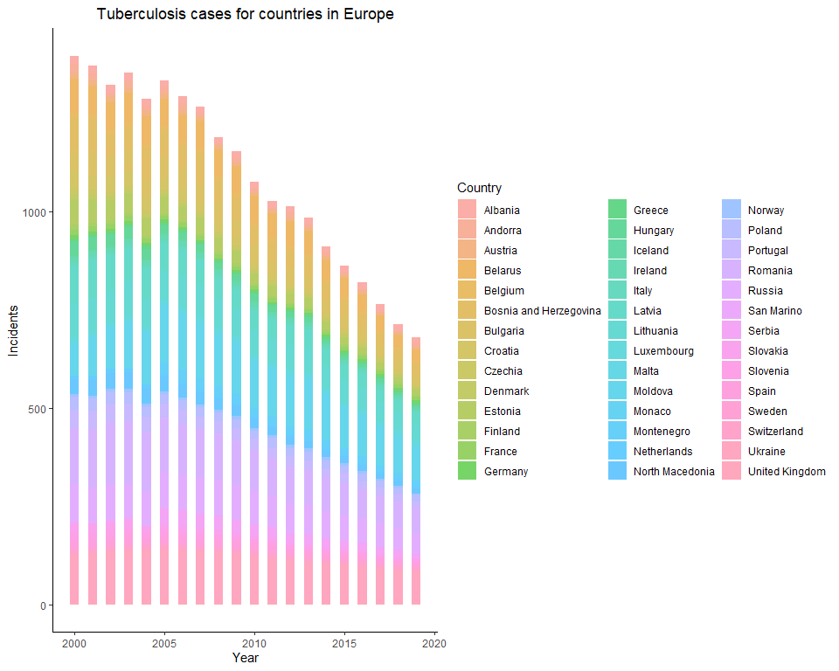

# Barplot for Tuberculosis cases in North America by Country  
Tuberculosis %>% filter(Continent == "North America") %>% ggplot(aes(x = Year, y = Incidence, fill=Country)) + geom_bar(stat="identity", width = 0.5, alpha = 0.6) + labs(title = 'Tuberculosis cases for countries in North America', x= 'Year', y = 'Incidents')

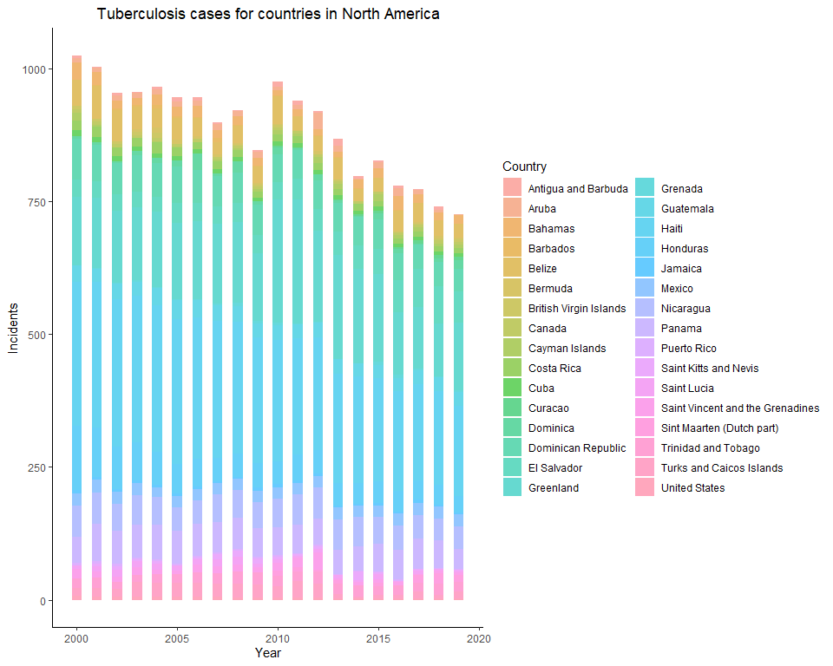

# Barplot for Tuberculosis cases in South America by Country  
Tuberculosis %>% filter(Continent == "South America") %>% ggplot(aes(x = Year, y = Incidence, fill=Country)) + geom_bar(stat="identity", width = 0.5, alpha = 0.6) + labs(title = 'Tuberculosis cases for countries in South America', x= 'Year', y = 'Incidents')

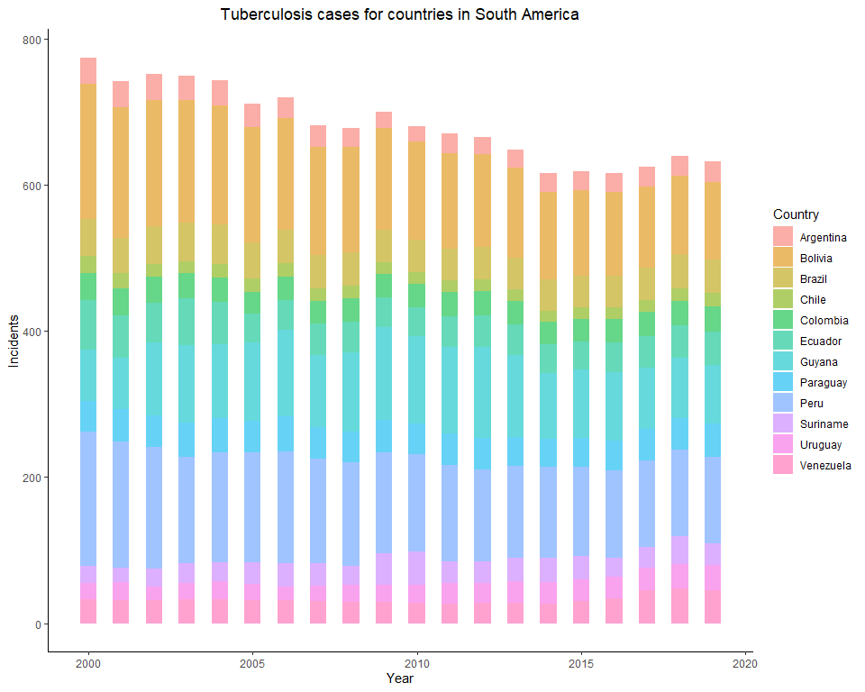

# Barplot for Tuberculosis cases in Oceania by Country  
Tuberculosis %>% filter(Continent == "Oceania") %>% ggplot(aes(x = Year, y = Incidence, fill=Country)) + geom_bar(stat="identity", width = 0.5, alpha = 0.6) + labs(title = 'Tuberculosis cases for countries in Oceania', x= 'Year', y = 'Incidents')

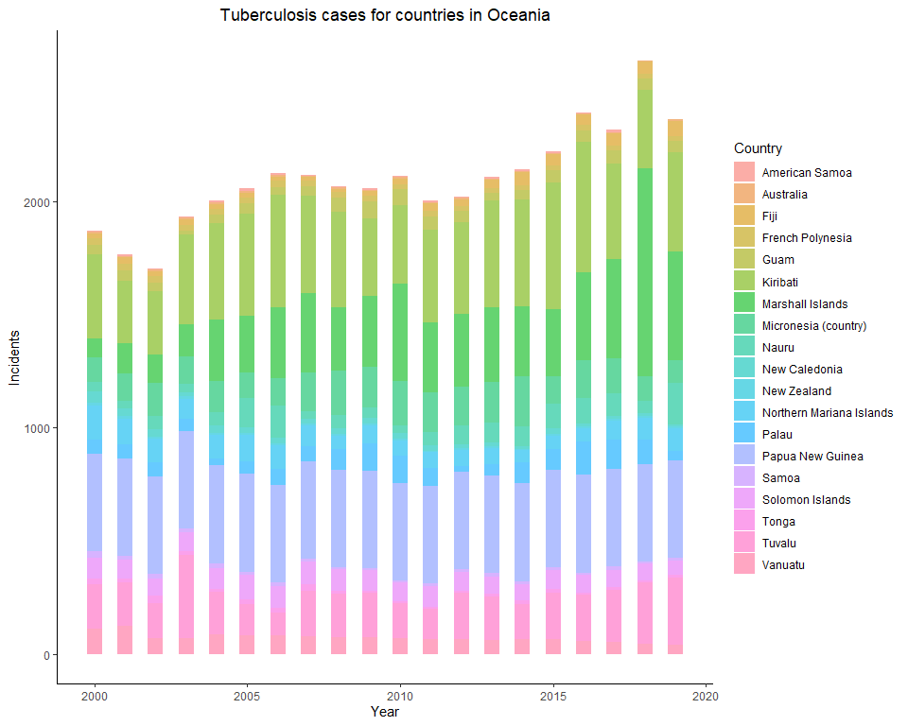

# Tuberculosis cases in SELECT top countries within each continent

# Boxplot for Tuberculosis cases in SELECT countries in Asia  
Tuberculosis %>% filter(Continent == "Asia" & Country %in% c("Philippines","Myanmar")) %>% ggplot(aes(x = Year, y = Incidence, fill = Country)) + geom_boxplot(outlier.shape = NA, alpha = 0.4) + coord_cartesian(ylim = c(300,600)) + labs(title = 'Tuberculosis for countries with most cases in Asia', x = 'Year', y = 'Incidents')

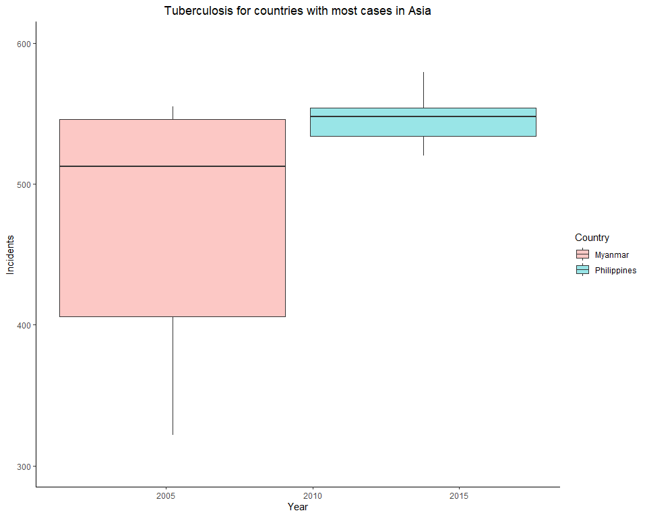

# Boxplot for Tuberculosis cases in SELECT countries in Africa  
Tuberculosis %>% filter(Continent == "Africa" & Country %in% c("Eswatini","South Africa","Lesotho","Namibia")) %>% ggplot(aes(x = Year, y = Incidence, fill = Country)) + geom_boxplot(outlier.shape = NA, alpha = 0.4) + coord_cartesian(ylim = c(0,2000)) + labs(title = 'Tuberculosis for countries with most cases in Africa', x = 'Year', y = 'Incidents')

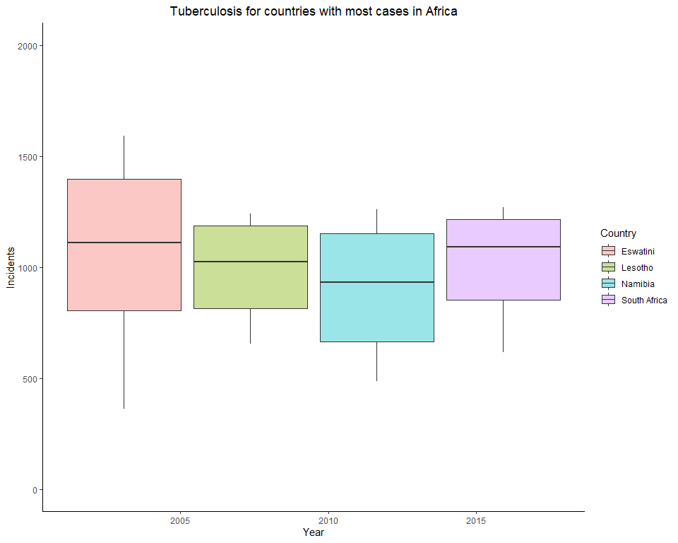

# Boxplot for Tuberculosis cases in SELECT countries in Europe  
Tuberculosis %>% filter(Continent == "Europe" & Country %in% c("Moldova","Romania","Ukraine","Russia")) %>% ggplot(aes(x = Year, y = Incidence, fill = Country)) + geom_boxplot(outlier.shape = NA, alpha = 0.4) + coord_cartesian(ylim = c(0,200)) + labs(title = 'Tuberculosis for countries with most cases in Europe', x = 'Year', y = 'Incidents')

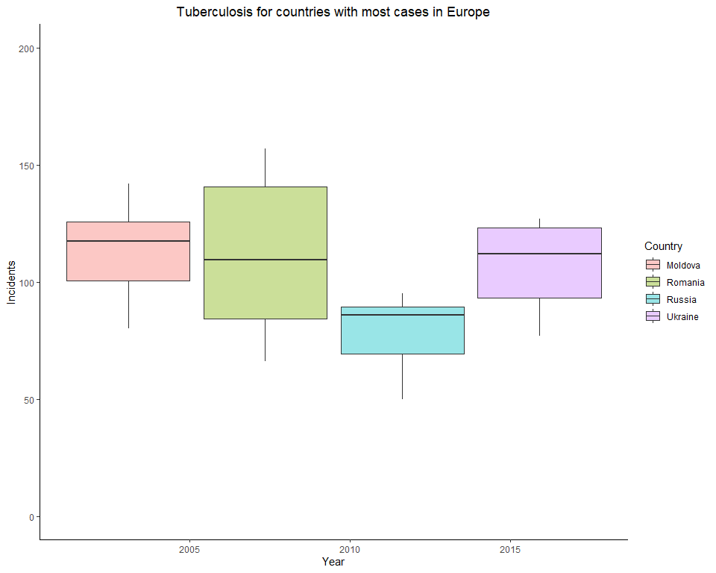

# Boxplot for Tuberculosis cases in SELECT countries in North America  
Tuberculosis %>% filter(Continent == "North America" & Country %in% c("Haiti","Greenland","Dominican Republic")) %>% ggplot(aes(x = Year, y = Incidence, fill = Country)) + geom_boxplot(outlier.shape = NA, alpha = 0.4) + coord_cartesian(ylim = c(0,400)) + labs(title = 'Tuberculosis for countries with most cases in North America', x = 'Year', y = 'Incidents')

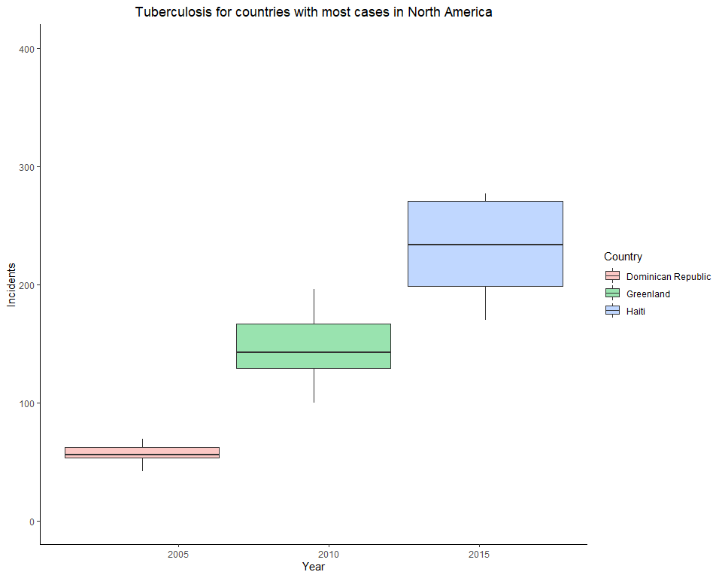

# Boxplot for Tuberculosis cases in SELECT countries in South America  
Tuberculosis %>% filter(Continent == "South America" & Country %in% c("Bolivia","Peru","Guyana")) %>% ggplot(aes(x = Year, y = Incidence, fill = Country)) + geom_boxplot(outlier.shape = NA, alpha = 0.4) + coord_cartesian(ylim = c(70,200)) + labs(title = 'Tuberculosis for countries with most cases in South America', x = 'Year', y = 'Incidents')

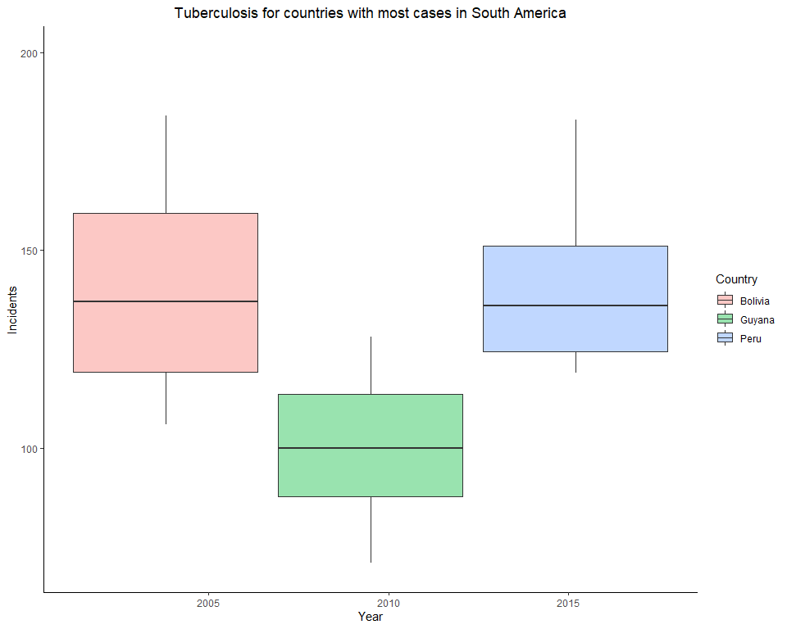

# !!!!!! Papua New Guinea DOESNT SHOW UP on boxplot !!!!!!!  
# Boxplot for Tuberculosis cases in SELECT countries in Oceania  
Tuberculosis %>% filter(Continent == "Oceania" & Country %in% c("Papua New Guinea","Kiribati","Marshall Islands")) %>% ggplot(aes(x = Year, y = Incidence, fill = Country)) + geom_boxplot(outlier.shape = NA, alpha = 0.4) + coord_cartesian(ylim = c(70,650)) + labs(title = 'Tuberculosis for countries with most cases in Oceania', x = 'Year', y = 'Incidents')

