**Assignment 3**

Question 1

1. Summary statistics on mean, standard deviation, skewness and kurtosis for monthly CSI 300 index returns:

1. Histogram for CSI 300 monthly returns:

Code illustration: First change the date type to Stata date type. We then use bysort and max to find the last trading day of the month and keep it. Use xset and l1.closing_index to derive the lagged closing price and finally derive the monthly return. Then use sum and sktest to get mean, standard deviation, skewness, and kurtosis. Finally, we draw the histogram.

1. We use Shapiro-Wilk test to test normality.

From the statistic result p-value is smaller than 0.05, so we can conclude that returns of the CSI 300 index **do not follow** a normal distribution at 95% confidence level.

Question 2

Replicate Table 2:

|  |  |  |  |  |
| --- | --- | --- | --- | --- |
| Group | $$α_{p}$$ | $$β_{p}$$ | R-squared | Obs. |
| 1 | -0.00130  (0.00064) | 0.80030  (0.02028) | 0.9397 | 102 |
| 2 | 0.00003  (0.00053) | 0.88093  (0.01671) | 0.9653 | 102 |
| 3 | 0.00019  (0.00044) | 0.89602  (0.01388) | 0.9766 | 102 |
| 4 | 0.00048  (0.00043) | 0.94554  (0.01377) | 0.9792 | 102 |
| 5 | -0.00010  (0.00033) | 1.00225  (0.01039) | 0.9894 | 102 |
| 6 | -4.698e-06  (0.00039) | 1.04889  (0.01254) | 0.9859 | 102 |
| 7 | -0.00025  (0.00036) | 1.03807  (0.01145) | 0.9880 | 102 |
| 8 | -0.00005  (0.00047) | 1.10153  (0.01479) | 0.9823 | 102 |
| 9 | 0.00022  (0.00044) | 1.08865  (0.01414) | 0.9834 | 102 |
| 10 | -0.00095  (0.00057) | 1.15058  (0.01799) | 0.9761 | 102 |

Replicate Table 3:

$$r_{p,t}-r_{f,t}=γ_{0}+γ_{1}β_{p}+ε_{p}$$

|  |  |  |  |  |  |
| --- | --- | --- | --- | --- | --- |
|  | $$γ_{0}$$ | $$γ_{1}$$ | $$R^{2}$$ | F-statistic | $$P$$ |
| Coefficient | -0.0010176 | 0.0025944 | 0.3929 | 5.18 | 0.0524 |
| t-statistic | -0.89 | 2.28 |

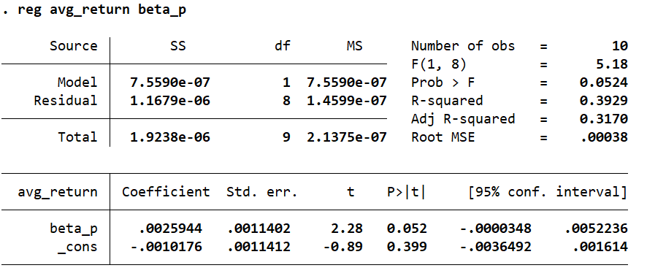

Code illustration: We first process the raw data, keep the data that are in the mainboard, which means to keep the market type 1, 4, 64. Then we use bysort to get the market return of each week. Then we merge the risk-free data into it and derive the market premium and stock premium. Second, we process the period 1 data from 2017 week 1 to 2018 week 52. We use bysort to get the beta of each stock. Third we process the period 2 data. We merge the beta derive from period 1 and use bysort and xtile to construct ten portfolios. Then derive the average return for each group at each week. Then run the regression for each group. Finally, we process the period 3 data. We merge the beta from period 1 and divide then into ten groups, calculate the average return of the whole period 3 and merge the beta we get in period 2 and finally we run the regression and output the result.