**Assignment 4**

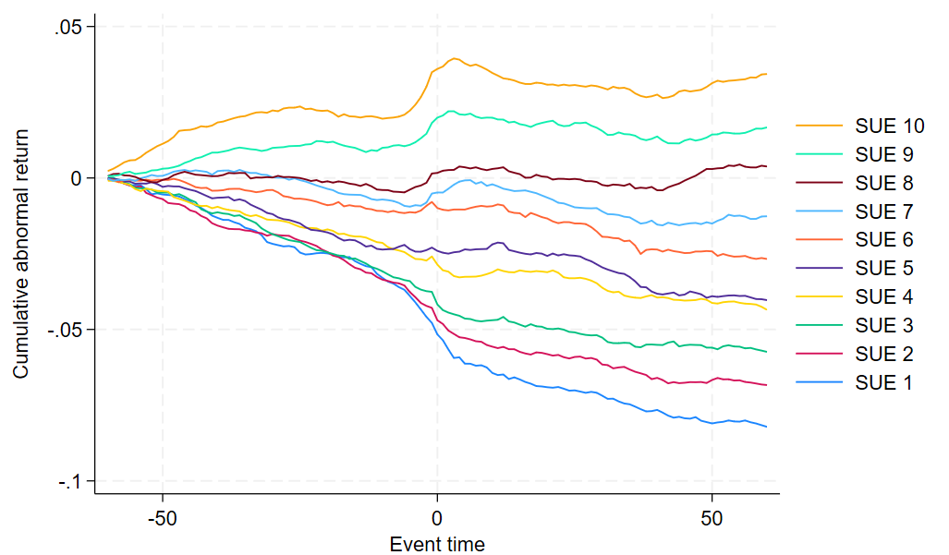

From the figure we can find that Earnings Announcement Drift (PEAD) phenomena exist

in China’s A-share markets. PEAD manifests itself as a sustained trend of stock returns that

continue to rise or fall for a period of time after the announcement date following an earnings

announcement.

**Code illustration**

We first processed the individual stock return and market return data. We only keep the SSE A share market’s market return. Then we processed the EPS data, after dropping the parent statement, ST PT and financial companies we start to select the data are in half year. Using xtset to set the panel data, and generate the half year EPS and unexpected earnings (UE). We then keep the data between 5th and 95th decile starting from 2016h1. Then we processed the announcement data, select the data of half year and annual, we reshape it to a wide data set. We then merge all the data together, and using forvalues to processed data in each half year time from 2016h1 to 2022h2. Finally we merge the data together and using xtline to draw the graph.