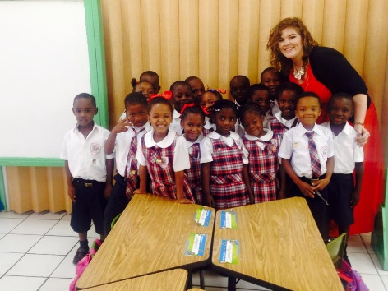Brianna Watt

briannaw1993@outlook.com

189 Patterson Run Road Waynesburg, PA 15370

724-833-6408

Find me on Linkedin.

**Proffesional Summary**

Energetic and passionate educator ready to start my career. My college career provided me with a variety of opportunities in regular education and special education classrooms. I have also been a part of community service and volunteer work, as well as mission trips. Volunteer work has allowed me to grow as a person, as well as develop crucial critical thinking and social skills that will help me be the best I can be for students in your school.

**Education**

Waynesburg University, Waynesburg PA

*Bachelor of Arts:* Early Childhood/ Special Education

Graduation: May 2016

Experience

Bobtown Elementary | Bobtown, PA

Internship and Student Teaching September 2015 – April 2016

* Internship was in first grade classroom during the fall semester.
* Student teaching was in a first grade classroom and an inclusive learning support classroom for grades K-3 for six weeks each during the spring semester.

Nanny’s Daycare

| Waynesburg, PA

Teacher Assistant August 2013 – Present

* Assisted the preschool teacher in providing a safe and educational environment.
* Engaged with children on an individual basis in a pleasant manner.
* Sanitized toys and play equipment each day to maintain safety and cleanliness.
* Developed and maintained professional relationships with students’ parents.

Babysitter

| Waynesburg, PA

Babysitter August 2013 – Present

* Cared for and tutored for two family's children throughout the year providing educational activities and crafts, as well as assisting with homework throughout the school year.

.

Skills

• Tutoring experience

• Strong collaborator

• Critical thinking

• Experience with special-needs students through observations and service experience

• Positive outlook

• Open to new experiences

• Fast learner

• Enthusiastic

Service

Habitat for Humanity

* Greene County Habitat for Humanity Volunteer.
* Mission Trips to Concord, North Carolina (Spring Break: 2013 and 2014)

Special Olympics

* Training Coordinator (2013- Present)
* Bocce Ball Coach (2015- Present)
* Basketball Coach(2015- Present)

St. Anne's Soup Kitchen (2014- Present)

Mission Trips to Nassau, Bahamas through the Education Department

* Worked in an orphanage
* Worked in Elementary schools by teaching math and reading to first and second graders, as well as bringing materials and books to classrooms.

(Winter Break: 2014, 2015)

Relay for Life

* Worked with our college chapter to raise money and awareness. (2014-2015)

References

**Mrs. Dena Bierer**-

First grade teacher, Bobtown Elementary

304 Grant Street, Bobtown PA 15315

724-322-6774

**Mrs. Amanda Law**-

Learning Support (K-2) teacher, Bobtown Elementary

304 Grant Street, Bobtown PA 15315

724- 984-1245

**Mr. Frank Pazzynski**-

Education professor, Waynesburg University

51 W College St, Waynesburg, PA 15370

724-833-5618