MARGO WUNDER

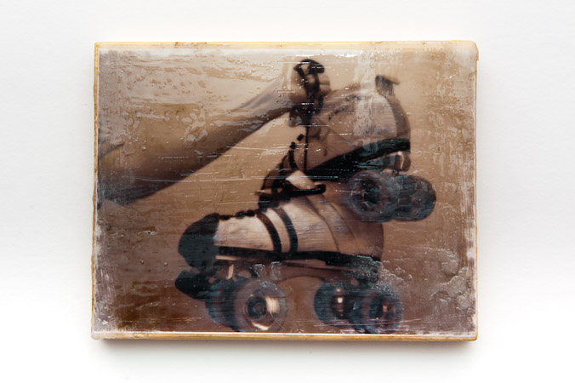

805 WHARTON STREET

PHILADELPHIA, PA. 19147

wunder700@gmail.com
215.888.9622

Award-winning artist and art educator, advocate and mentor for all students- I impart my extensive knowledge of art history, art criticism, art production, and aesthetics as the foundation upon which each student will build mastery, understanding, and appreciation of their craft.
- CERTIFICATION
Instructional I Art K-1

EDUCATION

Moore College of Art & Design, Philadelphia, Pa. 2011
Teaching Certification Program with a focus on special populations
STEDI Substitute teaching course 2010 (Emergency Permit: Day-to-Day Substitute All
Instructional Areas PK-12)
The University of the Arts, Philadelphia, Pa. MFA, Sculpture 1999
Ohio Wesleyan University, Delaware, Oh. 1992
BFA Cum Laude, Sculpture and Painting majors. Italian Minor
The Shipley School, Bryn Mawr, Pa.1988, With Honors

ACCOMPLISHMENTS
Universal Daroff Game Changer Award 2013
Coming into the building and making a change
UCDS Art Club Coach Award 2013
Dick Blick Wishlist 2013
Grant received for K-8 art supplies

RELATED PROFESSIONAL EXPERIENCE

Fleisher Art Memorial, September 2012- Present
Sculpture instructor, Children and Youth Program, teaching students with a wide
range of learning needs and cultural backgrounds, focusing on hand building, glazing,
and wheel throwing techniques,
Universal Daroff Charter School, August 2012- Present
K-8 and Life Skills Art Instructor. founder of Community Art Club, Open Studio Club, and
1st-8th grade Sketch Clubs. Advocated for and organized free field trips for students to
the Barnes museum, Philadelphia Museum of Art, and Philadelphia’s Magic Gardens,
spearheaded and organized The UCDS school-wide art exhibition off site with self-made
community partner Saint Matthews Manor
William Meredith Elementary, Philadelphia School District, December 2010 - 2012
Substitute teacher teaching grades K-8, art, literacy, mathematics, social studies, science,
physical education, music, and technology. As such, I expanded my repertoire of situational
teaching styles and honed my classroom management skills
Philadelphia Museum of Art, Philadelphia, Pa. November 2010 - December 2010
Volunteer assistant for preschool art classes, assisting in tours of the museum galleries
and hands-on art activities
William Meredith Elementary School, Philadelphia, Pa. September 2009 - December 2010
Supportive Services Assistant helping to educate elementary school students in the second
Grade, offering literacy and mathmatics support.
The Inglis House, Philadelphia, Pa. April 1997- January 1998
Volunteer painting instructor for recreational therapy in a wheelchair community,
where as a musician, I also organized free performances for the residents.

PROFESSIONAL AFFILIATIONS

NAEA
PAEP
Potters’ Guild

- PRESENTATIONS

Wunder, Margo (2014) Encorporating technology and Story Telling in the Classroom, presented
at Universal Daroff Charter School
Wunder, Margo (2014) Teaching as a Facilitator- Student Driven Criticism, Presented at Universal
Daroff Charter School

- SKILLS

Experience and proficiency working in wood and clay, as well as with fibers, metal, and other three
dimensional media.
Experience and proficiency working with a wide variety of painting media, charcoal, pencil, pastel,
Pen and ink, encaustic, printmaking, and other two dimensional media.
Interpersonal skills, working cross-curricularly and collaborating with peers, engaging
students in peer sharing and cooperative learning
demonstrate a knowledge of students and pedagogy
Experience teaching students with disabilities
Experience teaching students with a wide variety of learning abilities and needs from varied socio-
economic and cultural backgrounds
Experience teaching students ages PreK- 21 years
Use of technology in the classroom and as one of many means of communication with family and
community members via social networking and web pages.

RECENT EXHIBITIONS

2013 Fleisher Art Memorial, 115th Annual Faculty Exhibition, Group Exhibition, Philadelphia, PA.
2007 Hopkins House Gallery of Contemporary Art, Domestic Blisster, Group Exhibition,
Haddon Township, NJ.
2005 Rosenwald Wolf Gallery, SUMFA 10, Group Exhibition. Philadelphia, PA.
2003 Artforms, Birth, Group Exhibition. Manayunk,Pa.
2001 Artforms, Body Manipulations. Group Exhibition. Manayunk, Pa.
2001 University Art Gallery, Obsession. Group Exhibition. La Jolla, Ca.
2000 Philadelphia Art Alliance, Performance Process Repitition. Group Exhibition.
Philadelphia, Pa.
1999 Rosenwald Wolf Gallery, MFA Group Exhibition. Philadelphia, Pa.
1999 New Arts Salon, Unveiled. Solo Exhibition. Philadelphia, Pa.
1999 Oberon, Recent Works. Solo Exhibition. Philadelphia, Pa.
1999 New Arts Salon, Dialogues. Group Exhibition. Philadelphia, Pa.
1999 Body Graphics Gallery, Weft. Solo Exhibition. Pennsauken, NJ.

- BIBLIOGRAPHY

Meals, Caitlin. Left of Center, The South Philly Review. August 2007.
Bratten, Dawna. A Procession of Obsessions, Village News Pp 15A-23A, Wednesday, July 11 2001.
Kendricks, Neil. Obsessions at the University Art Gallery, UC San diego, Artweek. April 2001.
Rosenholtz, Ellen. Philadelphia, Art News. September, 2000.
Barrientos, Tanya. Nurturing Art and Creativity, The Philadelphia Inquirer. PD1, August 14, 1996.

