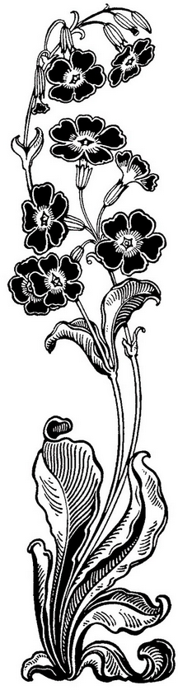 | Professional Profile  Eager to bring the love of art into the classroom, inspire students to find creativity in themselves, and encourage self-esteem and cross-curriculum learning  - Hold Bachelor’s degree in Art Education  - Enthusiastic about sparking a love for learning in all students  - Dedicated, goal-driven, flexible  - Skilled in lesson planning, curriculum development, technology, and team teaching  Education, Honors, and Certifications  Bachelor of Arts – Art Education  Washington and Jefferson College, Washington, PA 2012  Alpha Lambda Delta Honors Society  Scholar of Art Award – 2012  Certifications  PA State Art Education, 2012  Key Qualifications  Certified in Art (K-12)  Planning and instructing art lessons, design and implementing behavior plans, evaluate students, and reevaluating each to make improvements  Integrating different learning modalities to reach all students.  Differentiating lessons for different physical and mental ability and English language learners  Incorporating outside materials and resources for a diverse and interesting learning environment  Experienced Educator  Experienced with grades K-12, as well as students from different economic and ethnic backgrounds  Currently develops curriculum for students grades K-5 that utilizes all subject areas  Employment  Professional Development in Education  - YMCA Kindergarten Teacher/ Group Supervisor, January 2013 – present McKnight Elementary School, Pittsburgh, PA  - YMCA Camp Kon-O-Kwee Spencer – Unit Leader Summer 2009-present  Fombell, PA  - YMCA Camp Kon-O-Kwee Spencer – Program Specialist 2012-2013  - Student Teaching – February – May 2012  Trinity High School, Washington, PA  Professional References  - Charlotte Deer – Camp Spencer Director – cdeer@ymcapgh.org -  - Dr. John Lambertson – Art Department Chair, W&J College – jlamberston@washjeff.edu  - Michelle Gephardt – Child Care Director, Baierl Family YMCA – mgephardt@ymcapgh.org  - Sherry Knight – Art Teacher, Trinity High School – knights@trinitypride.org

