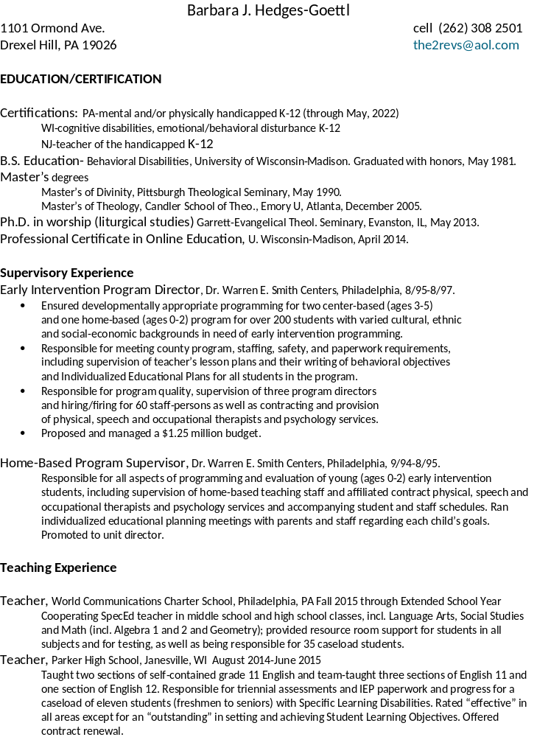

Special Ed Teacher, Melvin H. Krepps Middle School, E. Windsor, NJ 9/87-6/88.
Responsible for all aspects of self-contained and mainstream programming for eight students with learning disabilities-neurological impairment. Evaluated student’s skills in areas of reading and math. Was responsible for holding team/parent meetings to develop Individualized Educational Plans.

Special Ed teacher, (long-term sub), Colonial-Northampton Intermediate Unit,
Saucon Valley Middle School, Hellertown, PA 3/85-5/85
Taught learning disabled (neurologically impaired) middle school students in learning support and self-
contained classes for all subjects

Liberty High School, Bethlehem, PA 10/85-6/86.
Was responsible for all aspects of self-contained programming for six students with severe mental retardation, including development of Individualized Educational Plans and educational assessments of students in the program. Supervised a full-time aide and a floating aide.

Tutor, San Diego Learning Center, San Diego, CA 7/81-12/81.
Worked one-on-one tutoring students of varying ages and abilities in reading using the Bannatyne color-coded phonics system, as well as in math.

Learning Lab Teacher, Cerro Coso Community College, Ridgecrest, CA 3/82-5/83.
Worked with international and learning disabled students on basic math and English skills.

Other Experience
Pastor, First Presbyterian Church-Malvern, Arkansas; Kensington Presbyterian Parish and Falls of the Schuylkill
Church, Philadelphia and Norris Lake Presbyterian Church, GA, 12/89-8/04.
Responsible for all aspects of church programming, including planning, budgeting, running meetings and managing volunteers and paid staff.

