D3

Shapes + text

<!-- Rectangle (x and y specify the coordinates of the upper-left corner -->

<rect x="0" y="0" width="50" height="50" fill="blue" />

<!-- Circle: cx and cy specify the coordinates of the center and r the radius -->

<circle cx="85" cy="25" r="25" fill="green" />

<!-- Ellipse: rx and ry specify separate radius values -->

<ellipse cx="145" cy="25" rx="15" ry="25" fill="purple" />

<!-- Line: x1,y1 and x2,y2 specify the coordinates of the ends of the line -->

<line x1="185" y1="5" x2="230" y2="40" stroke="gray" stroke-width="5" />

<!-- Text: x specifies the position of the left edge and y specifies the vertical position of the baseline -->

<text x="260" y="25" fill="red">SVG Text</text>

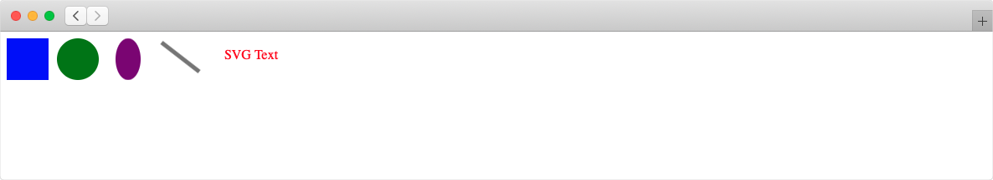

select(), eg. select('body') selects first elemnt that matches tag, also selectAll()

append(), eg. .append('p'), adds p as last child of parent element

|  |  |  |
| --- | --- | --- |
| High | Medium | Low |
| * Mobile compatibility * Inadequate testing * Inaccurate estimations | * Scope too wide * Poor quality code/design * Tight deadlines * Lack of experience/technical knowledge | * Security risks   + Cloud computing   + Insecure API * Performance of the matching algorithm |