# CPSC 436V, Foundations 2 Answer Template

Out: Thu Jan 27 2022. Due: Fri Feb 4 2022, 6pm   
Submit through Gradescope, as a file in PDF format, following [this googledoc](https://docs.google.com/document/d/1uKTPPt5VblsI3wiz4szrrbgCgCAm2YCBjqaUgSgHL9U/edit?usp=sharing) answer template.

Make a copy of this document by navigating on the toolbar: “File” > “Make a copy”

Administrative overhead penalty of up to 20% will be imposed if additional processing work is required to handle your assignment, such as: did not follow answer template, unreadable file loaded into Gradescope, etc.

### **0 [Name & Student Number]**

Kevin Cai - 41146127

### **1 Generate: Two Numbers (3%)**

Sketch three different ways to show the two numbers: **8** and **23**, with each sketch using a different combination of marks and channels. Write down the marks and channels used in each of your sketches. Provide names of group members if you worked together on this question during class.

**Group members:**

Carmen L

**1a.**

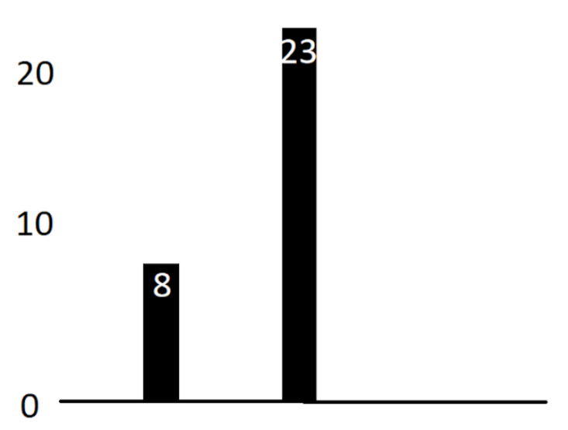

Visual channels used:

* **1D Length**

Marks used:

* Line

**1b.**

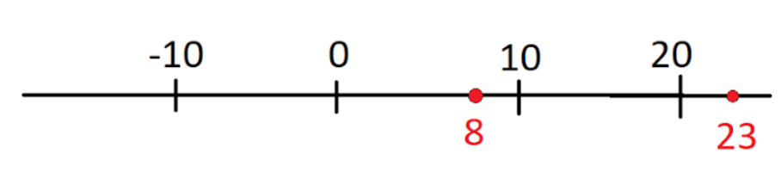

Visual channels used:

* **Position on common scale (horizontal)**

Marks used:

* Point

**1c.**

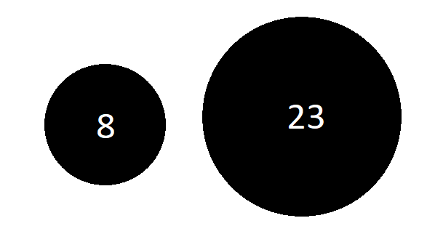

Visual channels used:

* **Area**

Marks used:

* Point

*Rubric: 1% each example, .5% sketch and .5% mark/channel analysis*

### **2 Decode: Name Those Channels (5%)**

For each example below, state which visual channels are used for which attributes. Add more rows to tables as you need or delete unneeded rows.

**2.1 Inconvenient truth**

|  |  |
| --- | --- |
| **Channel** | **Attribute** |
| Position on common scale (horizontal) | Time |
| Position on common scale (vertical) | Value of CO2 concentration and temperature |
| Color | Category of CO2 concentration or temperature |
|  |  |
|  |  |
|  |  |

**2.2 Tax rates**

|  |  |
| --- | --- |
| **Channel** | **Attribute** |
| Position on common scale (horizontal) | Effective tax rate |
| Color | Effective tax rate quantiles |
| Area | Company market cap |
|  |  |
|  |  |
|  |  |

**2.3 Alpen Forest Fires**

|  |  |
| --- | --- |
| **Channel** | **Attribute** |
| Position on common scale (horizontal) | Time |
| Area | Hectares of burned forests |
|  |  |
|  |  |
|  |  |
|  |  |

**2.4 More Alpen Forest Fires**

|  |  |
| --- | --- |
| **Channel** | **Attribute** |
| Tile/angle | Month of the year |
| Length(1D size) | Number of fires |
| Color | Cause of fire |
|  |  |
|  |  |
|  |  |

**2.5 Netherlands Commuters**

|  |  |
| --- | --- |
| **Channel** | **Attribute** |
| Color | Amount of traffic |
| Length(1D size) – Height of light rays | Amount of traffic |
| Position (horizontal) | Geographic location |
| Position (vertical) | Geographic location |
|  |  |
|  |  |

*Rubric: 1% each****,*** *.75% channel; .25% attribute.*

### **3 Decode: Name Those Marks (7%)**

For each example below, state which type of mark(s) are used (point, line, interlocking area), for which item(s). Add more rows to tables as you need or delete unneeded rows.

**3.1 Shooting Media Coverage**

|  |  |
| --- | --- |
| **Mark** | **Item** |
| Line | Number of shootings |
| Line | Average number of words in NYT coverage |
|  |  |
|  |  |
|  |  |
|  |  |

**3.2 Sunsquatch**

|  |  |
| --- | --- |
| **Mark** | **Item** |
| Point | Bigfoot sightings |
| Interlocking area | Path of solar eclipse |
| Interlocking area | US states |
|  |  |
|  |  |
|  |  |

**3.3 UFC Fights**

|  |  |
| --- | --- |
| **Mark** | **Item** |
| Point | UFC fight result |
|  |  |
|  |  |
|  |  |
|  |  |
|  |  |

**3.4 Yet More Alpen Forest Fires**

|  |  |
| --- | --- |
| **Mark** | **Item** |
| Interlocking area | Regions in Switzerland |
|  |  |
|  |  |
|  |  |
|  |  |
|  |  |

**3.5 Tax Rates**

|  |  |
| --- | --- |
| **Mark** | **Item** |
| Point | S&P 500 companies |
|  |  |
|  |  |
|  |  |
|  |  |
|  |  |

**3.6 Alpen Forest Fires**

|  |  |
| --- | --- |
| **Mark** | **Item** |
| Point | Year |
|  |  |
|  |  |
|  |  |
|  |  |
|  |  |

**3.7 More Alpen Forest Fires**

|  |  |
| --- | --- |
| **Mark** | **Item** |
| Line | Month |
|  |  |
|  |  |
|  |  |
|  |  |
|  |  |

### *Rubric: 1% each; .75% mark, .25% item.*

### **4 Decode: Marks & Channels (40%)**

For each of the 5 charts following, you will identify data **items** and the **marks** used to encode them, and data **attributes** and the **channels** used to encode them. Add or delete bullet points as needed.

**4.1 Income**

Visual channels used:

* Channel **position on common scale (horizontal)** encodes attribute **annual income**
* Channel **color** encodes attribute **profession**

Marks used:

* Mark of type **point** encodes item **professional worker**

**4.2 Ukko**

Visual channels used:

* Channel **color(hue)** encodes attribute **predicted change**
* Channel **angle/tilt** encodes attribute **predicted change**
* Channel **length(height of each bar)** encodes attribute **predicted wind speed**
* Channel **color(luminance)** encodes attribute **predictive skill of model**
* Channel **length(height of icon)** encodes attribute **strength of installed wind power**
* Channel **horizontal/vertical position** encodes attribute **geographic location**

Marks used:

* Mark of type **point(bars)** encodes item **predicted wind speed**
* Mark of type **interlocking area** encodes item **countries in central America**
* Mark of type **point(propellers)** encodes item **installed wind power**

**4.3 Draft**

Visual channels used:

* Channel **color** encodes attribute **replacement VORP comparison**
* Channel **horizontal position** encodes attribute **time**
* Channel **vertical position** encodes attribute **actual value**

Marks used:

* Mark of type **point** encodes item **NBA** **player**

**4.4 Disease**

Visual channels used:

* Channel **color** encodes attribute **type of disease**
* Channel **area** encodes attribute **number of genes associated with disease**

Marks used:

* Mark of type **point** encodes item **disease**
* Mark of type **connection** encodes item **related disease**

**4.5 Entitlements**

Visual channels used:

* Channel **color** encodes attribute **percentage of income from gov benefits**
* Channel **horizontal/vertical position** encodes attribute **geographic area**

Marks used:

* Mark of type **interlocking area** encodes item **US counties and states**

*Rubric: 8% each*

### **5 Generate: Table Alternatives (24%)**

Spacing text for document header outline

**5.1. Table A (Left), Sketch 1**

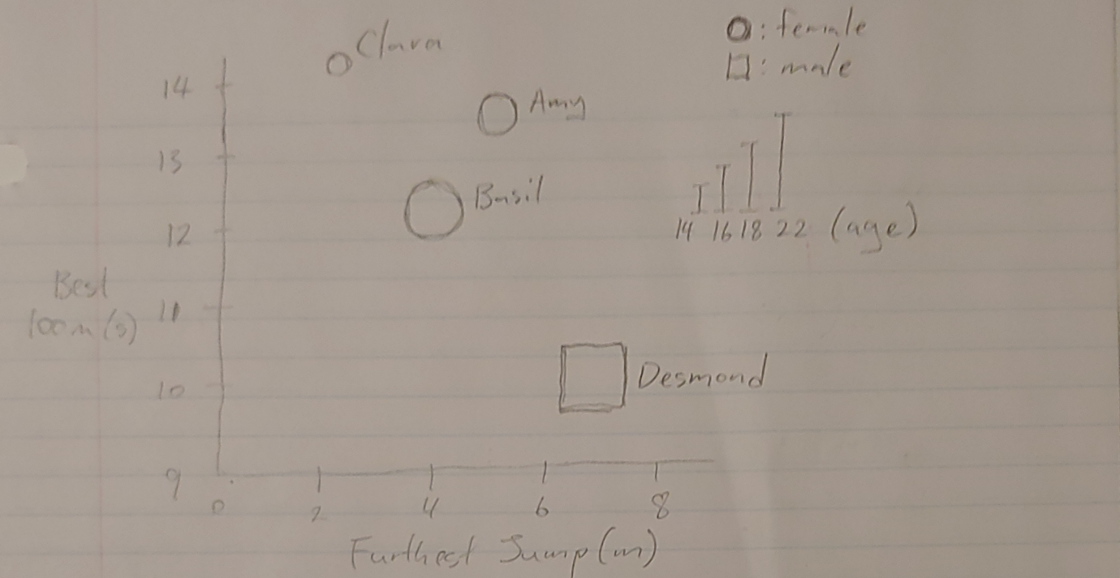

Analysis:

- Expressiveness and effectiveness of attribute types and channel choices: I think using the 1D height of shapes to represent age isn’t very effective, since people will tend to decode area instead of height. Plotting Best 100m Time vs. Furthest Jump Distance is also not very effective because it implies some sort of correlation between the two variables. Using circles and squares to differentiate between male and female also lacks pop out distinguishability.

- Semantics of attributes: The chart gives information about the age, gender, best 100m race time and the furthest jump distance of Amy, Basil, Clara and Desmond.

- Information density: This graph is quite dense as all information is compressed into one graph and the channels include 1D length, shape, and both horizontal and vertical position.

**5.2. Table B (Right), Sketch 1**

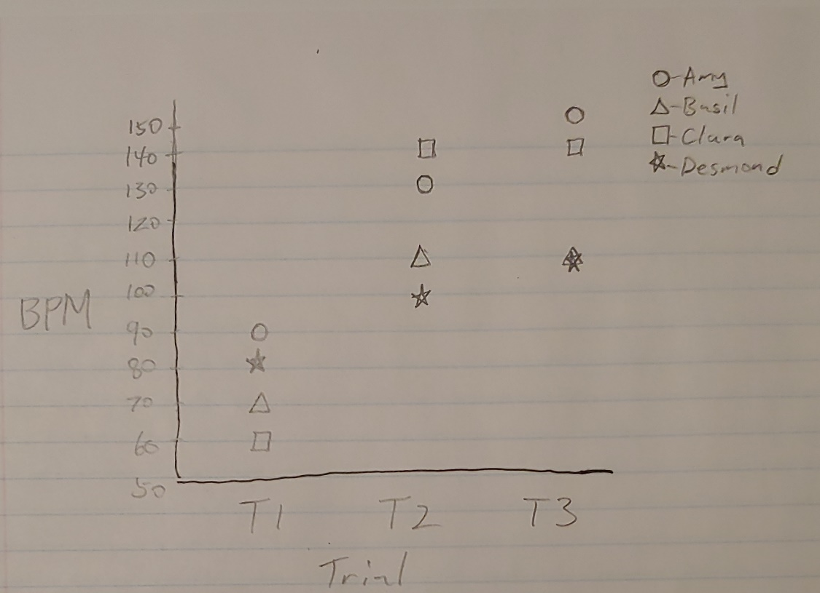

Analysis:

- Expressiveness and effectiveness of attribute types and channel choices: Using shape to distinguish between people is one of the methods with lower effectiveness. There is also overlap between Desmond and Clara in trial 3, even though their values differ by 1, but that difference is hard to read.

- Semantics of attributes: This chart gives the heart beats per minute measured in 3 trials for Amy, Basil, Clara and Desmond.

- Information density: The information isn’t too dense, but it can be hard to read because two points overlap.

**5.3. Table A (Left), Sketch 2**

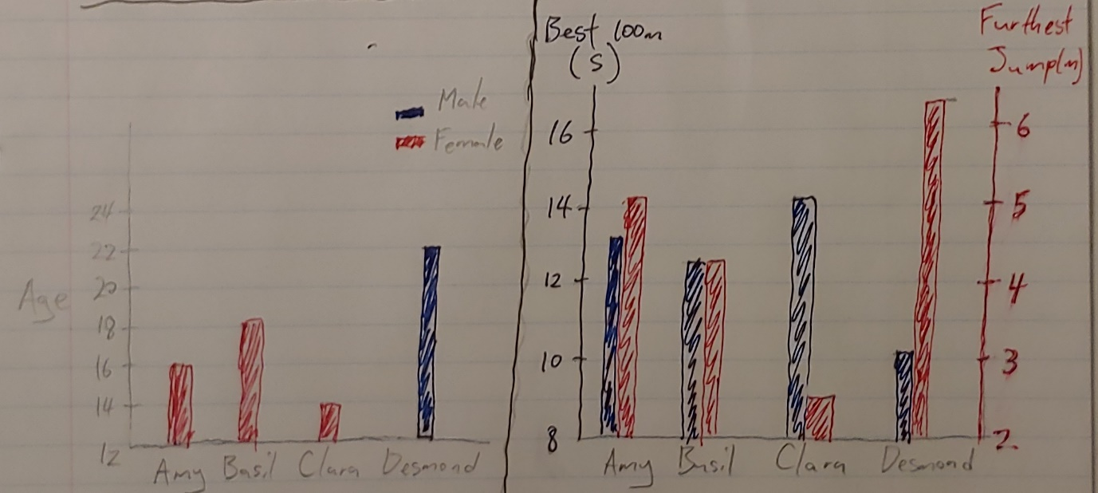

Analysis:

- Expressiveness and effectiveness of attribute types and channel choices: The separation of the data into two graphs makes the presentation more effective. Instead of using the shape and height of point marks to show age and gender, the use of color and length of line marks provide higher accuracy. Sketch 1 also plotted Best 100m vs Furthest Jump, which implies correlation when there isn’t necessarily any so the right chart above shows a more effective presentation of the data.

- Semantics of attributes: The first chart displays the age and gender of 4 people and the second chart displays the juxtaposition of their best 100m race time and their furthest jump distance.

- Information density: The information density is much lower compared to sketch 1, which compresses all the data into a single view.

**5.4. Table B (Right), Sketch 2**

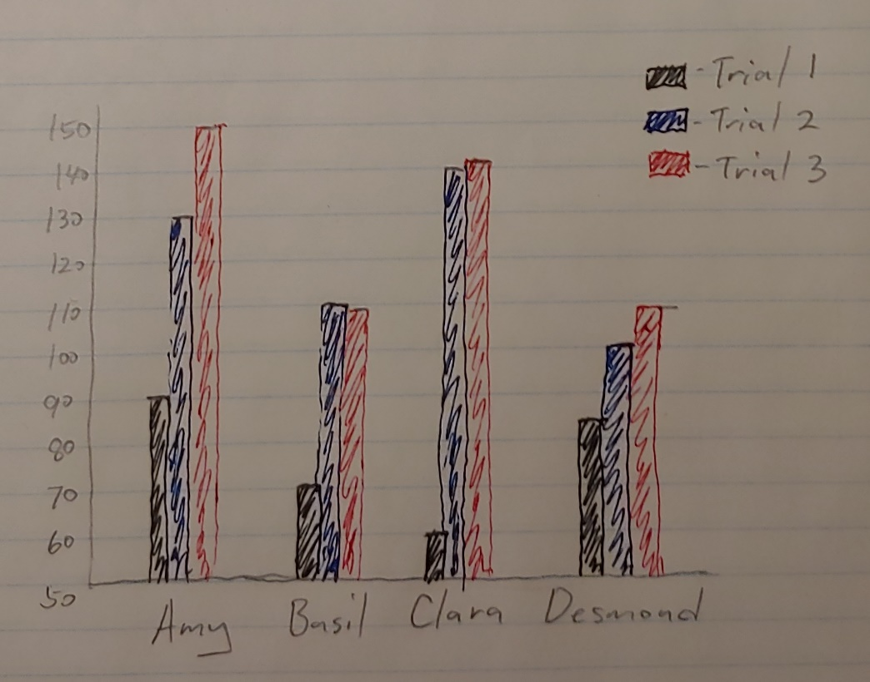

Analysis:

- Expressiveness and effectiveness of attribute types and channel choices: Using color instead of shape to identify categorical attributes is more accurate. Grouping by person instead of by trial is also more effective in presenting the change in BPM of each individual.

- Semantics of attributes: This chart gives the heart beats per minute measured in 3 trials for 4 people.

- Information density: The information density is technically the same as sketch 1 because all of the same data is shown but it feels less dense because there is no overlapping present.

*Rubric: 6% each table: 3% sketch & 3% analysis.*

### **6 Redesign: New Zealand Table (21%)**

Answer the following questions:

##### **6.1** Describe the data abstraction in the abstract language covered in this class (dataset type, attribute types, number of levels for categorical attributes, ranges for quantitative attributes).

This graph uses the geometric dataset type to encode quantitative attributes that range from 1% to 33%.

##### **6.2** How is this data visually encoded (in terms of marks/channels)?

Marks: line marks encode political issues

Channels:

-horizontal position encodes time

-length(diameter of circles) encodes for percentage of concern

-color encodes for categories of issues

##### **6.3** If the numeric labels were not visible, would you be able to decode the data precisely? Why?

No, because the presentation of the data in the chart is misleading. The overlapping circles makes it look like the comparisons are based on area rather than diameter, which I would’ve mistaken if the labels were not visible.

##### **6.4 Develop one better alternative design to visualize this data**. Show it with a sketch. Provide a brief rationale for why it is better in terms of a task that is poorly supported by their design. Make sure to use {action,target} pairs to describe the task abstractly.

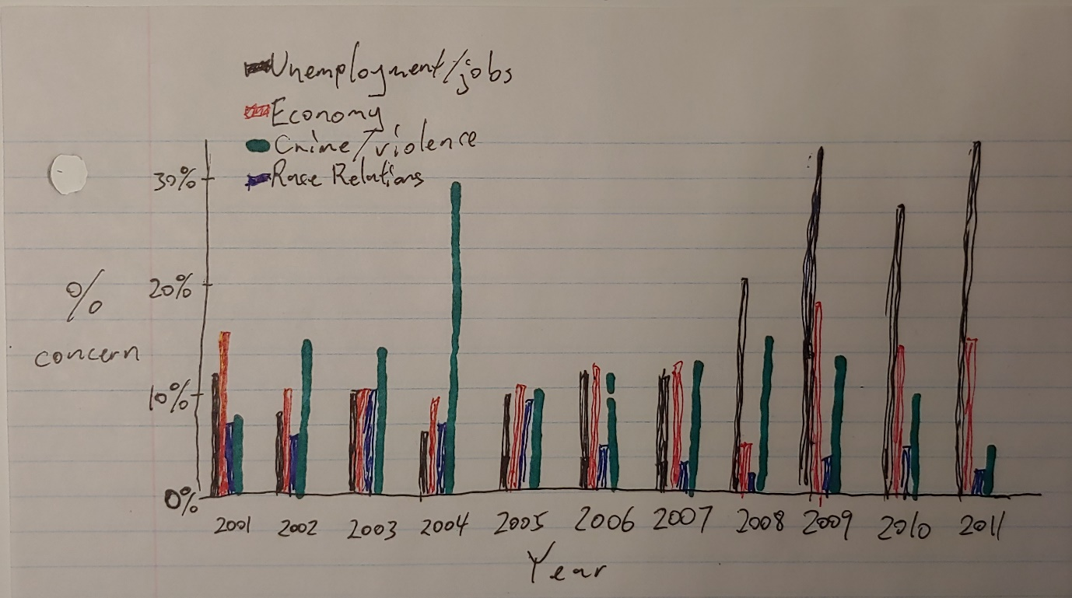

{compare, correlation} The original image splits the data into two sets and presents it in two separate views. My visualization displays all the information in one view, which makes it easier to compare in different sets, like economy and crime/violence.

*Rubric: 5% 6.1, 5% 6.2, 1% 6.3, 5% 6.4 sketch, 5% 6.4 explanation*