

國家太空中心
衛星多重任務及星系操作系統整合軟體
PRM/TOFA/MPSS操作規則文件

(第1版)

文件編號：05
Submitted by: |  |  | 
ACS 專案經理 彭一盟
Authenticated by:
NSPO操控組組長 楊善國

TABLE OF CONTENTS

Lanham, MD 20706-4417

1. FORMOSAT-5 Scheduling Rules 4
2. Scheduling Rules Key Terms and Concepts 4
2.1 Scheduling Terms 4
2.2 Scheduling Example 5
2.3 Rule Types 6
3. Scheduling Resources 7
3.1 Satellite Resource 7
3.1.1 Global Satellite Resources 7
3.1.2 Satellite Parameter Set Data 9
3.2 Site Resources 12
3.2.1 Global Site Resources 12
3.2.2 Site Parameter Set Data 12
3.3 Unavailable Time Ranges 12
4. FORMOSAT-5 Activities 13
4.1 FORMOSAT-5 Activity Types 13
4.1.1 Spacecraft Maneuver 13
4.1.2 RSI Imaging 14
4.1.3 Delete 15
4.1.4 AIP Playback 15
4.1.5 AIP Procedure 15
4.1.6 Real Time Command Procedure 16
4.1.7 Miscellaneous Memory Procedure 16
4.1.8 Uplink 16
4.1.9 X-Band Crossover 16
4.1.10 Monitoring (SOH) 17
4.2 FORMOSAT-5 Activity Definitions 17
4.2.1 Maneuver Activity 17
4.2.2 RSI Record Activity 17
4.2.3 RSI Playback Activity 18
4.2.4 RSI DDT Activity 20
4.2.5 Delete Activity 21
4.2.6 AIP Playback Activity 21
4.2.7 AIP Procedure Activity 21
4.2.8 Real-Time Activity 22
4.2.9 Miscellaneous Memory Activity 22
4.2.10 Uplink Activity 22
4.2.11 X-Band Crossover Activity 22
4.2.12 Spacecraft Monitoring Activity 23
4.3 Activity Scheduling Rules 23
5. FORMOSAT-7 Activities 23
5.1 FORMOSAT-7 Activity Types 23
5.1.1 Payload Playback 24
5.1.2 Back Orbit State of Health 24
5.1.3 TBB Operations 24
5.1.4 Spacecraft Maneuver 24
5.1.5 Real Time Command Procedure 24
5.1.6 Miscellaneous Command Procedure 24
5.1.7 Uplink 24
5.1.8 Monitoring (SOH) 25
5.2 FORMOSAT-7 Activity Definitions 25
5.2.1 Payload Playback 25
5.2.2 Back Orbit State of Health 25
5.2.3 TBB Operations 25
5.2.4 Spacecraft Maneuver 25
5.2.5 Real-Time Command Procedure 25
5.2.6 Miscellaneous Command Procedure 25
5.2.7 Uplink 25
5.2.8 Monitoring 25
6. Contact Scheduling Rules 25
6.1.1 X-Band Station Contacts 25
6.1.2 S-Band Station Contacts 25
6.1.3 General Contact Rules 26
7. Resource Scheduling Rules 27
7.1 Solid State Recorder Rules 27
7.2 Duty Cycle Rules 27
7.3 S-Band Transmitter Rules 27
7.4 Resource Allocation Rules 27
8. Branch Scheduling Rules 28
9. Branch Merging Rules 29
10. Service Rules 31
Appendix A Internal Activity Structure 1

FORMOSAT-5 Scheduling Rules
This document describes the rules that shall be implemented in the FORMOSAT-5 Mission Planning Function (MPSS). This document is organized into two sections, Section 2 describes key terms and concepts about the application of the scheduling rules. Section 3 provides the rules that shall be contained within the FORMOSAT-5 implementation.

Scheduling Rules Key Terms and Concepts

Scheduling Terms
ActivityType refers to the class (type) of an activity request, activity request list or activity. There are a fixed number of predefined activity types in the MPSS.

Activity Requests specify the activities to generate for resources over a given session or scheduling period. Activity Requests may be specified by the Mission Planner within an Activity Request List or shall be contained within the instrument Mission Timelines.

Activity Request Lists are lists of activity requests of a single activity type. Activity Request Lists (ARLs) are assigned to the satellites on a session-by-session basis.

Activities are the objects that get placed on the schedule during scheduling. Activities may be either scheduled or unscheduled. Scheduled activities are activities that have had their requirements satisfied (have been placed on the schedule). Unscheduled activities have not had their requirements met (have not been placed on the schedule), this does not mean that the requirements for the unscheduled activity cannot be met.

Advisory are brought to the attention of the mission planner during schedule validation. Advisories are instances of ‘soft’ scheduling rules being bent. An advisory tends to indicate that some preference is being broken, such as a contact being too close to another contact. Also see violation.

Branch refers to a session that does not belong to the nominal schedule. A branch can be thought of as a ‘what-if’ session, where scheduling may be done without interfering with the nominal schedule. Branches differ from sessions by being able to overlap sessions and other branches in time.

Contact refers to when a satellite and a site are communicating. FORMOSAT-5 scheduling shall utilize both X-Band and S-Band contacts. The type of the contact is dependent on the ground site type.

Global Data refers to the static attributes of a resource. The name of a satellite is an example of global data.

Mission Planner refers to the person who actually performs the planning of the mission.

Nominal Schedule is the contiguous set of sessions that define the desired operational schedule.

Parameter Set Data refers to the dynamic attributes of a resource. The ordered list of preferred sites for a satellite to have contacts with is Parameter Set Data.

Parameter Sets are instances of all of the dynamic resource attributes and rule parameters in the system.

Potential Contacts refer to the times when a satellite is in view of a site, but the two are not communicating.

Resource refers to an instance of a resource type. Resources are allocated during scheduling for use by activities. The FORMOSAT-5 satellite and the ground sites are resources. Resources tend to be physical objects.

Resource Type refers to a predefined type of resource. Examples of resource types are satellites and sites. An instance of a resource type is called a resource.

Rules represent constraints that are considered during the scheduling process. When user-specified activities are under consideration for scheduling, each rule is examined for relevance and applied. The following example is a simplified abstraction that demonstrates the input and output of the scheduling process.

Scheduler refers to the software that schedules the FORMOSAT-5 activities and manages the system’s resources. The scheduler is invoked by the mission planner who is the individual responsible for generating FORMOSAT-5 schedules.

Service Rules refers to the set of rules that keep the MPS processes from reading or writing data that another process is currently manipulating.

Session refers to the object that defines a parameter set, a time period over which to schedule, a set of resources and their associated ARLs. Sessions cannot overlap in time or have gaps between one another.

Unavailability Period refers to the window of time when a resource may not be allocated to an activity.

Violations are brought to the attention of the mission planner during schedule validation. Violations are instances of ‘hard’ scheduling rules being broken. A violation tends to indicate that something impossible is scheduled to happen, such as an activity (i.e. an uplink) is using a resource (i.e. an ground site), which does not exist in the database. Also see advisory.

Scheduling Example
For the purposes of this example assume that the rulebase consists of the following rules:
- The MPSS shall attempt to schedule as many activities as possible during the same contact.
- The MPSS shall attempt to schedule activities during the earliest available time period.
And it is further assumed that:
- It is desired to schedule two activities (Activity A and B). Neither of these activities have common resource requirements and it is desired that they both be scheduled during the same time window.
- There are three contacts where Activities A and B may be potentially scheduled:
  - Contact_1 which occurs early in the activity’s requested time window.
  - Contact_2 whose Rise is within 20 minutes of Contact_1’s fade.
  - Contact_3 which occurs during the succeeding revolution.

In this example, Activities A and B would be scheduled during Contact_1, for the following reasons:
- Activity A is scheduled for Contact_1 by Rules 1 and 2.
- Activity B is scheduled for Contact_1 by Rules 1 and 2.
To further describe the operation of the rulebase, the above scenario is modified in the following manner.

The addition of the following rules:
- The MPSS shall not schedule any activities concurrently which require the same mutually exclusive resources.
- The MPSS shall assign contacts to higher priority activities before lower priority activities.
Activities A and B both require the same resource and Activity A has a higher priority than Activity B.

In this example Activity A would be scheduled for Contact_1 and Activity B would be scheduled for Contact_3, for the following reasons:
- Activity A is scheduled for Contact_1 by Rules 1, 2, and 4.
- Activity B is scheduled for Contact_2 by Rules 1, 2, 3 and 4.

Rule Types
There are two types of rules within the MPSS, physical rules and preferences. A physical rule is a constraint that is physically impossible to violate. Examples of physical rules include:
- It is impossible for an MMC to take more passes than it has FEPs.
- It is impossible for a site/antenna to simultaneously take a contact from two spacecraft.
A preference is a rule that describes a desired mode of operation. Examples of preferences include:
- Activity A has a higher priority than Activity B.
- There shall be a minimum turnaround period of 10 minutes between contacts at the same site.

The use of physical rules and preferences provides flexibility to the MPSS scheduling environment. All schedules generated by automated scheduling shall be free of conflicts as described by the physical rules and preferences contained within the rulebase. However, during manual scheduling operations, the planner can schedule an activity that violates a preference constraint. Violations of physical rules shall always be rejected by the schedule editor.

Scheduling Resources
The following section describes the resource types that exist within the Mission Planning Function (MPSS). Scheduling resources are instances of resource types that are managed through the MPSS Resource Configuration utility.

Typical scheduling resources include satellites, objects of the satellite such as solid state recorder, transmitters, etc., and sites.

The following tables identify and describe the scheduling resources for the FORMOSAT-5 project. The table columns include:
- Field Name column is a very brief description of the resource attribute.
- Variable Type column is a description of the type of variable used to define the attribute.
- Range column describes the ranges (possible values) of the attributes.
- Validation column describes the validation to be performed on the attribute.

Satellite Resource
The satellite resource represents the FORMOSAT-5 and FORMOSAT-5-3 satellites. Satellite resources are divided into Global and Parameter set sections.

Global Satellite Resources
Global satellite resources represent the objects of a satellite that never change, or change very infrequently.
Satellite Resource Table
FIELD NAME | VAR. TYPE | RANGE | VALIDATION
Name | String | < 50 characters | Check against all other FORMOSAT-5 satellite names for uniqueness
Type | Enum. | FORMOSAT-5  FORMOSAT-7 | None
USN Name | String | < 50 characters | Used during RTS Request Schedule report generation  Defaults to “Name”
OPS4 Name | String | <= 4 characters | Shortened name used in report names.
Command Database Project | Selection |  | Optional values read from EPOCH database. Identifies which command database version to use when validating and generating spacecraft products.
Command Database Scenario | Selection |  | Optional values read from EPOCH database. Identifies which command database version to use when validating and generating spacecraft products.

Satellite Transmitter Table
FIELD NAME | VAR. TYPE | RANGE | VALIDATION
Name | String | < 10 characters | Check if unique among all other transmitters on the satellite
Unavailable Times | List of Unavailable Time Ranges | Typical | Check the usual unavailable time range stuff

Satellite Antenna Table
FIELD NAME | VAR. TYPE | RANGE | VALIDATION
Name | String | < 10 characters | Check if unique among all other antennas on the satellite
Type | Enum. | XBAND  SBAND | None
Unavailable Times | List of Unavailable Time Ranges | Typical | Check the usual unavailable time range stuff

Global FORMOSAT-5 Satellite Resources
This section contains satellite resources specific to the FORMOSAT-5 satellite.

FORMOSAT-5 Solid State Recorder Table
FIELD NAME | VAR. TYPE | RANGE | VALIDATION
Name | String | < 10 characters | Check if unique among all other recorders on the satellite
Unavailable Times | List of Unavailable Time Ranges | Typical | Check the usual unavailable time range stuff
Total Files | Integer |  | Maximum # of SSR files
Max RSI Files | Integer |  | Maximum number of RSI Record Files
Max AIP Files | Integer |  | Maximum number of AIP Imaging Files
Max DDT Files | Integer |  | Maximum number of RSI DDT Files
Sector Size | Integer | 0 to 64  (Kbits per sector) | Default 64

FORMOSAT-5 Satellite Timing Table
FIELD NAME | VAR. TYPE | RANGE | NOTES
Default Video Gain | String | 255 characters | Default video gain used for RSI imaging.
Nominal Orbit | Time | HH:MM:SS | Nominal orbit period
Max AN Drift  (Maximum Ascending Node Drift) | Duration | MM:SS | Indicates maximum time allowed to identify existing orbital events when ingesting new overlapping orbital events
EPD  (Ephemeris Propagation Duration) | Time | HH:MM:SS | Used during detection of sun intrusion events. Value indicates amount of time to propagate AIP maneuver request.

Global FORMOSAT-7 Satellite Resources
This section contains satellite resources specific to the FORMOSAT-5-3 type satellites.

FORMOSAT-7 Satellite Timing Table
FIELD NAME | VAR. TYPE | RANGE | NOTES
Nominal Orbit | Time | HH:MM:SS | Nominal orbit period
Max AN Drift  (Maximum Ascending Node Drift) | Duration | MM:SS | Indicates maximum time allowed to identify existing orbital events when ingesting new overlapping orbital events
GPS Leap Second Correction | Time | SS.mm | UTC to GPS time correction

Satellite Parameter Set Data
Parameter Set data encompasses the dynamic properties of the physical resources and scheduling parameters. Modifications to Parameter Sets only affect the time period of the schedule that it is assigned. This section identifies parameter set data associated with all satellites

Satellite Duty Cycles Table
FIELD NAME | VAR. TYPE | RANGE | NOTES
Activity Type | Duration | MM:SS | Duty Cycle value indicates number of minutes per orbit this particular activity type can be scheduled.

FORMOSAT-5 Parameter Set Data
This section identifies parameter set data specific to the FORMOSAT-5 satellite.

FORMOSAT-5 Solid State Recorder Parameter Set Table
FIELD NAME | VAR. TYPE | RANGE | VALIDATION
Total Capacity | Integer | Typical | None
RSI Capacity | Integer | 0 < X < Total Capacity | Check if all combined capacities are less than Total Capacity
AIP Capacity | Integer | 0 < X < Total Capacity | Check if all combined capacities are less than total capacity
DDT Capacity | Integer | 0 < X < RSI Capacity | Check if all combined capacities are less than Total Capacitity
PAN (2.8) SSR Input Rate | Float | 00.000 to 99.999  (sectors per second) | Default – 1.661
MS (1.7) SSR Input Rate | Float | 00.000 to 99.999  (sectors per second) | Default – 0.686
PAN (3.75) SSR Input Rate | Float | 00.000 to 99.999  (sectors per second) | Default – 1.241
MS (3.75) SSR Input Rate | Float | 00.000 to 99.999  (sectors per second) | Default – 0.310
PAN lossless | Float | 00.000 to 99.999  (sectors per second)
MS lossless | Float | 00.000 to 99.999  (sectors per second)
SSR Output Rate | Float | 00.00 to 99.99  (sectors per second) | Default – 1.55
File Sector Margin | Integer | 0 to 100  (sectors) | Default - 4
Bandwidth Allocation VC1 | Integer | 0 to 100
Bandwidth Allocation VC2 | Integer | 0 to 100
AIP file size | Integer |  | Value in sectors  0 < x < (AIP capacity/64 Mb sector size)
Time to read 1 sector of AIP data | Duration | SS.mm

FORMOSAT-5 Timing Parameter Set Table
FIELD NAME | VAR. TYPE | RANGE | DEFAULT
Priority  (Satellite Priority) | Integer | 0-100 | Priority of satellite when scheduling activities
Post DDT Delay per Sector | Duration | SS.mm  Seconds and milliseconds | 00.21
TWTA Heating Delay | Duration | HH:MM:SS | 00:04:00
Attitude Slew Maneuver Delay | Duration | HH:MM:SS | 00:02:00
RSI Imager Preheat Delay | Duration | HH:MM:SS | 00:02:00
RSI Focal Plane Assembly Maximum On Duration | Duration | HH:MM:SS | 00:8:00
RSI Record Setup Delay | Duration | HH:MM:SS | 00:00:01
RSI Record Cleanup Delay | Duration | HH:MM:SS | 00:00:01
RSI Playback Setup Delay | Duration | HH:MM:SS | 00:00:02
RSI Playback Cleanup Delay | Duration | HH:MM:SS | 00:00:00
AIP Playback Setup Delay | Duration | HH:MM:SS | 00:00:01
AIP Playback Cleanup Delay | Duration | HH:MM:SS | 00:00:01
Min RFPA Separation | Duration | HH:MM:SS | 00:01:00
RSI Playback Shift Delay | Duration | HH:MM:SS | 00:00:05
X-Band Switch Delay | Duration | HH:MM:SS | 00:00:07

FORMOSAT-7 Parameter Set Data
This section identifies parameter set data specific to the FORMOSAT-5-3 type satellite.

FORMOSAT-7 Timing Parameter Set Table
FIELD NAME | VAR. TYPE | RANGE | Notes
Priority  (Satellite Priority) | Integer | 0-100 | Priority of satellite when scheduling activities
Minimum Contact Duration | Time | HH:MM:SS | Minimum time required to perform uplink/downlink operations

Site Resources
The site resource represents each ground station antenna. If a ground station has many antenna, each antenna must be specified as a site resource. Site resources are divided into Global and Parameter set sections.

Global Site Resources
Global site resources represent the objects of a site that never change, or change very infrequently.
Site Resource Table
FIELD NAME | VAR. TYPE | RANGE | VALIDATION
Name | String | < 50 characters | Check if unique among all sites
Type | Enum. | XBAND  SBAND  LBAND | None
Remote Tracking Station | Boolean | On/Off | None
Unavailable Times | Time Ranges | Typical | Check the usual time range stuff
USN Name | String | < 50 Characters | Used during RTS Request Schedule report generation  Defaults to “Name”

Site Parameter Set Data
Parameter Set data encompasses the dynamic properties of the physical resources and scheduling parameters. Modifications to Parameter Sets only affect the time period of the schedule that it is assigned. This section identifies parameter set data associated with all sites.

Site Parameter Set Table
FIELD NAME | VAR. TYPE | RANGE | VALIDATION/DEFAULT
Prepass Setup Delay | Duration | MM:SS | Default – 20:00
Postpass Cleanup Delay | Duration | MM:SS | Default – 20:00
Contact Turnaround Time | Duration | MM:SS | 00:00 < X < 59:59

Unavailable Time Ranges
An Unavailable Time Range is not resource. It is basically a type of variable. An Unavailable Time Range is essentially a time range with the capability to have a Branch associated with it. The Unavailable Time Ranges are used to denote the windows when a resource cannot be allocated to an activity, the resource is considered unusable during the windows by the MPSS.

When an Unavailable Time Range is added to a resource, MPSS shall check the nominal schedule or Branch that the unavailable Time Range is associated with and verifies that the resource the Unavailable Time Range was added to is not being used during the new Unavailable Time Range. If the resource is being used, then the Mission Planner is informed that adding the Unavailable Time Range shall cause scheduled activities to become unscheduled and the Mission Planner is given the choice of adding or not adding the Unavailable Time Range. If the resource is not being used, the Unavailable Time Range is added immediately.

Unavailable Time Range Table
FIELD NAME | VAR. TYPE | RANGE | VALIDATION
Start Time | Time | Typical | The Start Time must be chronologically before the End Time
End Time | Time | Typical | The End Time must be chronologically after the Start Time
Branch | String | All existing Branches in the MPSS | Check if the Branch exists

FORMOSAT-5 Activities
The following is a brief description for each one of the activity requests maintained by the MPSS scheduling software. Activity requests are generated by Activity Request Lists (ARLs) or instrument Mission Timelines. Generating activity requests, which are always of an activity type, result in the scheduling of activities translated subsequently into a combination of real-time ground directives and/or spacecraft commands.

FORMOSAT-5 Activity Types
The following sections describe the different activity types used to perform payload, spacecraft and ground operations for FORMOSAT-5.

Spacecraft Maneuver
Spacecraft maneuvers include attitude, orbit, and sun pointing type. Spacecraft maneuver requests can be specified within the MPSS Activity Request List Editor or within an instrument Mission Timeline. The following describes the different maneuver types and their inputs.

Attitude Maneuver
Attitude maneuvers requests require the following information:
Start Date/Time
Duration
Mode (Synchronous,aSynchronous)
Rate: yaw/pitch/roll rate
Quaternion (Q1, Q2, Q3 Q4)
Attitude maneuvers can be generated using the Activity Request List Editor, Gantt Chart, or may be specified within RSI and AIP Mission Timelines. MPSS represents attitude maneuver as:
Activity: MANUEVER
Type: ATTITUDE

Orbit Maneuver
Orbit maneuvers requests require the following information:
Start Date/Time
Duration
Orbit Maneuver Plan – generated by FDF
Orbit Maneuver Procedure
Orbit maneuver activities can only be generated by the Activity Request List Editor or the Gantt Chart. MPSS represents orbit maneuvers as:
Activity: MANEUVER
Type: ORBIT

Sun Pointing Maneuver
Sun Pointing maneuver requests require the following information:
Start Date/Time
Duration
Sun pointing maneuvers requests can be generated by the Activity Request List Editor, Gantt Chart and RSI Mission Timeline. MPSS represents sun pointing maneuvers as:
Activity: MANEUVER
Type: SUN POINTING

RSI Imaging
RSI Imaging activities represent the collection and transmit of imaging data for RSI. RSI imaging can be performed in REC only mode, REC/XMIT mode, and DDT mode. RSI imaging requests can be specified within the MPSS Activity Request List Editor or within the RSI Mission Timeline. MPSS maintains 3 activity types related to RSI imaging requests – RSI Record, RSI Playback and RSI DDT.

RSI Record
RSI Record activities are generated when an RSI imaging request specifies an SSR Status of RECORD or REC. The following inputs are required to perform an RSI Record activity:
Start Date/Time
Imaging Duration
Imaging Mode (PAN, MS, or PAN+MS)
Compression Ratio (specified for each mode type)
PAN (LOW/HIGH/LOSSLESS)
MS (LOW/HIGH/ LOSSLESS)
Video Gains (required for associated playback activity)
PAN
MB1
MB2
MB3
MB4
MPSS represents RSI Record activities as:
Activity RSI
Type: RECORD or REC

RSI Playback
RSI Playback activities are generated for each RSI Record activity that is generated. However, RSI Playback activity time windows depend on the RSI imaging request start time. RSI Record activities that overlap an X-Band contact but end prior to the 20-degree X-Band fade will have their associated RSI Playback activities scheduled in the same contact (if time permits). RSI Record activities that end after the 20-degree X-Band fade or occur outside of an X-Band contact will have their associated RSI Playback activities scheduled in the next X-Band contact.
MPSS represents RSI Playback activities as:
Activity: RSI
Type: PLAYBACK or PBK

RSI DDT
RSI DDT activities are generated when an RSI imaging request specifies an SSR Status of DDT. The following inputs are required to perform an RSI DDT activity:
Start Date/Time
Imaging Duration
Imaging Mode (PAN, MS, or PAN+MS)
Compression Ratio (specified for each mode type)
PAN (LOW/HIGH /LOSSLESS)
MS (LOW/HIGH/ LOSSLESS)
Video Gains (required for data transmission)
PAN
MB1
MB2
MB3
MB4
MPSS represents RSI DDT activities as:
Activity: RSI
Type: DDT

Delete
Delete activities are used to purge/delete RSI imaging files from the Solid State Recorder (SSR). Delete activities are automatically generated and scheduled by the MPSS scheduling software. MPSS represents Delete activities as:
Activity: DELETE
Type: NONE

AIP Playback
AIP Playback requests represent the transmission of the stored AIP imaging data. AIP Playback requests must be specified within the Activity Request List Editor. The time window of an AIP Playback activity must coincide with a 10-degree S-band station contact. MPSS represents AIP Playback activities as:
Activity: AIP
Type: PLAYBACK or PBK

AIP Procedure
AIP Procedures activities represent the request to uplink AIP procedures to the spacecraft. This uplink is different than a memory load (uplink) activity specified later in this document. The time window of an AIP procedure activity must coincide with a 10-degree S-band station contact. AIP procedure activities can be specified within the Gantt Chart utility or the AIP Mission Timeline. MPSS represents AIP Procedure activities as:
Activity: AIPPROC
Type: NONE

Real Time Command Procedure
These are requests to schedule the execution of one or more real-time command procedures for a given spacecraft. Real-time command procedures may contain a combination of ground directives and spacecraft commands to be executed during a spacecraft contact. The commands within a Real-time Command procedure are assumed not to require any active resource allocation or conflict management. The inputs for a Real-Time command procedure activity include:
Start Date/Time
Duration (required to execute procedure)
Procedure name
Real-Time command procedure activities can be generated using the Activity Request List Editor and the Gantt Chart utilities. MPSS represents Real-Time activities as:
Activity: RTCMD
Type: NONE

Miscellaneous Memory Procedure
These are requests to schedule the execution of one or more command procedures for a given spacecraft. Miscellaneous procedures can only contain spacecraft commands and are assumed not to require any active resource allocation or conflict management. The inputs for a miscellaneous command procedure include:
Orbit even trigger:
GMT (absolute date/time)
Orbital event and desired orbit
Contact event
Time offset from orbit event
Duration (required to perform procedure)
Procedure name
Miscellaneous memory procedures can only be generated by the Gantt Chart utility. MPSS represents miscellaneous memory procedures as:
Activity: MISCPROC
Type: NONE

Uplink
These are requests to schedule the uplink of one or more memory load files (TTQ or MPQ) for a given spacecraft. Uplink requests specify, at a minimum, the date/time window and the duration budgeted for the up-link (including possible dumps and dump verifications). Uplink activites can be requested using the Activity Request List Editor and the Gantt Chart utilities. MPSS represents uplink activities as:
Activity: UPLINK
Type: NONE

X-Band Crossover
These are requests to schedule an x-band crossover event on the FORMOSAT-5 spacecraft. During this event, all data transmissions are paused while the spacecraft switches to the backup x-band antenna, at which point data transmission is resumed. X-Band crossover activities can be requested using the Activity Request List Editor, Gantt Chart, and may be specified within the RSI Mission Timeline. MPSS represents X-Band crossover activities as:
Activity: XCROSS
Type: NONE

Monitoring (SOH)
Monitoring activities represent telemetry playback during an S-Band contact. Monitoring activities are scheduled from AOS to LOS of an S-band contact. Monitoring activities are generated automatically for every available S-Band contact. Additional monitoring activities can be created by the Gantt Chart utility. MPSS represents monitoring activities as:
Activity: MON
Type: NONE

FORMOSAT-5 Activity Definitions
MPSS generates schedulable activities from the activity requests specified within the instrument Mission Timelines or ARLs. The following sections describe the activity definitions and their associated breakdowns that are derived from the activity requests during the scheduling process.

Maneuver Activity
A maneuver activity is used to specify the time and duration of a spacecraft maneuver. See Appendix A for the Maneuver Activity Type breakdown.
- A maneuver activity shall utilize Duty Cycles for the duration of the activity
- Each attitude maneuver request within an AIP Mission Timeline shall be verified that it does not cause a SUN INTRUSION event.
- Maneuver activities cannot overlap each other.
- Orbit maneuver activities cannot overlap the following activities:
  - RSI Record
  - RSI Playback
  - RSI DDT
  - AIP Playback
  - AIP Procedure
  - Uplink
  - Real-Time

RSI Record Activity
The RSI record activity shall configure the SSR for recording, perform the recording of data, and perform any SSR cleanup tasks. See Appendix A for the RSI Record Activity breakdown.
- RSI record activity shall utilize the SSR recorder allocated for RSI imaging.
- The RSI record activity shall allow enough time to configure the SSR prior to the imaging request. (RSI Record SSR Setup Delay).
  - The SSR setup delay shall allow enough time to include:
    - Allocation of required files and required sectors
    - Configuring files for writing
    - Setting compression ratio
    - Loading video gains
- MPSS shall allocate an SSR storage file and enough sectors on the SSR to store the recorded RSI data.
  - If the RSI Imaging request is requesting PAN mode:
    - Compression ratio for PAN mode may be specified as LOW or HIGH or LossLess
      - Default compression ratio for PAN is LOW.
    - MPSS shall allocate one (1) file for the RSI Record activity
    - The size of the file shall be calculated as:
      - Duration of record * SSR Input Rate for PAN (LOW or HIGH) + File Sector Margin. Value is rounded up to the nearest whole sector.
  - If the RSI Imaging request is requesting MS mode:
    - Compression ratio for MS mode may be specified as LOW or HIGH or LossLess
      - Default compression ratio for MS is LOW.
    - MPSS shall allocate one (1) file for the RSI Record activity
    - The size of the file shall be calculated as:
      - Duration of record * SSR Input Rate for MS (LOW or HIGH) + File Sector Margin. Value is rounded up to the nearest whole sector.
  - If the RSI Imaging request is requesting PAN+MS mode:
    - MPSS shall allocate two (2) files for the RSI record activity one (1) for PAN and one (1) for MS.
      - Individual compression ratios may be specified for PAN and MS modes.
      - Default compression ratio for PAN+MS mode is:
        - HIGH for PAN
        - HIGH for MS
    - The size of the PAN file shall be calculated as:
      - Duration of record * SSR Input Rate for PAN mode (LOW or HIGH) + File Sector Margin. Value is rounded up to the nearest whole sector.
    - The size of the MS file shall be calculated as:
      - Duration of record * SSR Input Rate for MS mode (LOW or HIGH) + File Sector Margin. Value is rounded up to the nearest whole sector.
- The RSI data file stored on the SSR shall be retained until a Delete activity is scheduled that specifies the appropriate data file to delete.
  - If the RSI Record is recording PAN+MS data, the associated Delete activity is responsible for deleting both PAN and MS SSR files.
- The RSI record activity shall utilize Duty Cycles during the imaging time of the activity.
- The RSI record activity shall allow enough time to cleanup the SSR after the imaging request (RSI Record Cleanup Delay)
  - The SSR cleanup delay shall allow enough time to include commands to de-configure SSR from imaging request
- RSI Record activities of the SAME MODE TYPE cannot overlap.
- RSI Record activities cannot overlap RSI DDT activities.

RSI Playback Activity
RSI playback activities are used to transmit data that has been stored on the SSR. The RSI playback activity shall configure the SSR for playback; perform the transmission of data, and perform any SSR cleanup tasks. See Appendix A for the RSI playback activity breakdown.
- RSI playback activity shall be generated during the following conditions:
  - If an RSI Imaging Request occurs during an X-Band contact AND the imaging period ends prior to the 20-degree X-Band fade, then an RSI Playback activity is generated for the same contact.
    - The RSI playback activity start and duration must be fully contained within the 20-degree station mask.
    - The RSI playback duration shall be calculated based on the associated RSI Record duration.
      - RSI playback duration = file size / SSR Output Rate.
    - The start of the RSI playback shall be based on the speed of the “sector read time” and the “sector write time”.
      - RSI Playback activities will start “RSI Playback Shift Delay” after the start of the associated RSI Record.
      - RSI Playback activities will end “RSI Playback Shift Delay” after the end of the associated RSI Record.
    - When an X-Band cross event occurs, the RSI playback activity duration must fit within the 20-degree station mask.
      - RSI Playback activity durations will “expand” to include the X-Band switch delay.
    - If RSI Imaging Request is performing PAN+MS imaging, one RSI Playback is generated to playback both imaging files (PAN and MS).
      - The duration of the playback is dependent on the number of sectors allocated for each imaging mode file:
        - Duration = (PAN file size + MS file size) / SSR Output Rate
  - If an RSI Imaging Request occurs during an X-Band contact area BUT ends after the 20-degree X-Band fade, OR the RSI Imaging Request does not occur within an X-Band contact, an RSI Playback activity is generated for the next X-Band contact.
    - An RSI playback activity is generated for the next occurrence of an X-Band station contact.
    - The RSI playback activity start and duration must be fully contained within the 20-degree station mask.
      - The RSI playback duration shall be calculated based on the associated RSI Record duration.
        - RSI playback duration = file size / SSR Output Rate.
      - When an X-Band cross event occurs, the RSI playback activity duration must fit within the 20-degree station mask.
        - RSI Playback activity durations will “expand” to include the X-Band switch delay.
- Additional RSI playbacks may be generated for RSI Record activities.
  - RSI playback activities are generated for next occurrence of an X-Band station contact.
  - Duration of RSI Playback is dependent on SSR file sector size.
  - If RSI Record is performing PAN+MS imaging, two (2) RSI Playback activities are generated.
    - One RSI Playback activity is associated with the PAN imaging file.
      - Duration of RSI Playback is dependent on the SSR file related to PAN imaging.
      - Filename will be associated with PAN imaging file.
    - One RSI Playback activity is associated with the MS imaging file.
      - Duration of RSI Playback is dependent on the SSR file related to MS imaging.
      - Filename will be associated with MS imaging file.
- The RSI playback activity shall allow enough time to configure the SSR prior to transmission of data. (RSI Playback SSR Setup Delay).
  - The SSR setup delay shall allow enough time to include:
    - Specify filename for playback
    - Set video data type
    - Set ciphering status
- The RSI playback activity shall utilize Duty Cycles during the transmission of data.
- The scheduler shall allocate a satellite X-Band antenna to perform the data transmission.
  - If an X-Band cross event occurs during the RSI playback activity, the transmission of data shall be paused to perform the antenna switch commands.
  - Transmission resumes at the end of the X-Band cross event.
- The RSI playback activity shall allow enough time to cleanup the SSR after the transmission of data. (RSI Playback SSR Cleanup Delay)
- RSI Playback activities cannot overlap each other.
- RSI Playback activities cannot overlap RSI DDT activities.

RSI DDT Activity
RSI DDT activities are responsible for recording and transmitting data directly to the ground. See Appendix A for the RSI DDT activity breakdown.
- RSI DDT activity shall utilize the SSR recorder allocated for DDT imaging.
- The RSI DDT activity shall allow enough time to configure the SSR prior to the DDT imaging request. (RSI Record Setup Delay)
- Allocation of required files and required sectors
- Configuring files for writing
- Setting compression ratio
- Loading video gains
- MPSS shall allocate an SSR storage file and enough sectors on the SSR to buffer the requested RSI imaging data.
- If the RSI Imaging request is requesting PAN imaging, MPSS shall allocate one (1) file for the RSI DDT activity.
  - Compression ratio for PAN mode may be specified as LOW or HIGH or LossLess
    - Default compression ratio for PAN is LOW.
  - The file size = minimum of:
    - Duration of DDT request * SSR Input Rate for PAN mode (LOW or HIGH or LossLess)
    - Total sectors allocated for DDT operations.
- If the RSI Imaging request is requesting MS imaging, MPSS shall allocate one (1) file for the RSI DDT activity
  - Compression ratio for MS mode may be specified as LOW or HIGH or LossLess
    - Default compression ratio for MS is LOW
  - The file size = minimum of:
    - Duration of DDT request * SSR Input Ratio for MS mode (LOW or HIGH or LossLess)
    - Total sectors allocated for DDT operations.
- If the RSI Imaging request is requesting PAN+MS imaging, MPSS shall allocate two (2) files for the RSI DDT activity.
  - Individual compression ratios may be specified for PAN and MS modes.
    - Default compression ratio for PAN+MS mode is:
      - HIGH for PAN
      - HIGH for MS
  - The PAN file size = (duration of DDT request * SSR Input Rate for PAN mode (LOW or HIGH or LossLess))
  - The MS file size= (duration of DDT request * SSR Input Rate for MS mode (LOW or HIGH or LossLess))
  - IF combined file size is greater than the total space allocated for DDT, MPSS shall divide the DDT sector allocation by the VC1/VC2 bandwidth allocation ratio.
- The RSI data files allocated for the RSI DDT activity shall be deleted from the SSR after the DDT request has completed.
- The RSI DDT activity shall utilize Duty Cycles only during the imaging time of the activity.
- The RSI DDT activity shall allow enough time to cleanup the SSR after the imaging request.
- During an RSI DDT activity, no other imaging activities (Record, Playback, or DDT) may occur.
- After the completion of an RSI DDT activity, the scheduler shall delay (Post DDT per Sector * the number of sectors used) prior to scheduling any RSI Record or RSI Playback activities.
- An RSI DDT activity may be scheduled immediately following a previous RSI DDT activity
- The scheduler shall allocate a satellite X-Band antenna to perform the data transmission.
  - The DDT duration will “expand” to include the X-Band antenna switch delay.
  - If an X-Band cross event occurs during the RSI DDT activity, the transmission of data shall be paused to perform the antenna switch commands.
  - Transmission resumes at the end of the X-Band cross event.

Delete Activity
The Delete activity is used to request an SSR data file to be deleted. SSR data files are reserved by RSI Record activities. Nominally, the Delete activity is generated and scheduled automatically by MPSS when SSR space is required to perform imaging requests.
- Delete activities can be scheduled at any time.
- Delete activities shall specify the file to be deleted from the SSR.
  - If Delete activities are associated with RSI Record activities performing PAN+MS imaging, then the Delete file will delete (2) SSR files – one for PAN file, one for MS file.
- Delete activity durations consume (1) second.
- Delete activities cannot overlap each other.
- Delete activities cannot overlap the RSI SSR Setup Delay of an RSI Record or RSI DDT activity.
- Delete activities are scheduled automatically when SSR space is required to perform additional RSI Record requests.
  - The scheduler picks the appropriate Delete activity by the age of its associated RSI Record activity.
    - The oldest SSR data is deleted as required.

AIP Playback Activity
AIP playback activities are used to transmit AIP data that has been recorded on the SSR. The AIP playback activity shall configure the SSR for playback; perform the transmission of data, and to perform any SSR cleanup tasks. See Appendix A for the AIP playback activity breakdown.
- AIP playback activities shall occur during S-Band station contacts.
  - The AIP playback activity start and duration must be fully contained within the 10-degree S-band station mask.
  - The AIP playback duration shall be calculated based on the associated AIP data file size.
    - AIP playback duration = file size*amount of time to read one (1) AIP SSR sector
- The AIP playback activity shall allow enough time to configure the SSR prior to transmission of data. (AIP Playback SSR Setup Delay).
- The AIP playback activity shall utilize Duty Cycles during the transmission of data.
- The AIP playback activity shall allow enough time to cleanup the SSR after the transmission of data. (AIP Playback SSR Cleanup Delay)
- The scheduler shall allocate a spacecraft transmitter to perform the AIP playback activity.
  - If the AIP Playback activity is scheduled in a contact with a Monitoring activity, the scheduler shall allocate the same transmitter resource.
- AIP playback activities cannot overlap each other.

AIP Procedure Activity
AIP Procedure activities are used to reserve time to uplink AIP procedures to the spacecraft.
- AIP procedure activities must occur within the 10-degree S-Band station mask.
- AIP procedure activities cannot overlap the following activities:
  - Real-Time procedure activities
  - Uplink activities
  - Other AIP procedure activities
  - Orbit maneuver activities

Real-Time Activity
A real-time activity is used to perform real-time commanding of a satellite during an S-Band station contact. See Appendix A for the Real-Time Activity Type breakdown.
- A real-time activity must occur within a 10-degree S-Band station mask.
  - The start and end time of the Real-Time activity must be contained within the 10-degree S-Band station mask.
- The duration of a real-time activity must be at least the minimum required to perform command/procedure request.
- Real-Time activities cannot occur during the following activities:
  - Other Real-Time activities
  - Uplink
  - AIP Procedure
  - Orbit maneuver

Miscellaneous Memory Activity
Miscellaneous memory activities are generally used to command a satellite outside of a station contact. Commands and procedures executed during a miscellaneous memory activity are assumed to belong to the TTQ load. See Appendix A for the Miscellaneous Memory Activity Type breakdown.
- A miscellaneous memory activity can occur anytime within the schedule.
- The duration of a miscellaneous memory activity must be at least the minimum required to perform command/procedure request.
- Miscellaneous memory activities do not conflict with any other activities.

Uplink Activity
Uplink activities are used to reserve time to perform an uplink of a TTQ or MPQ load. Individual uplink activities must be scheduled for each load type.
- Uplink activities must occur within the 10-degree S-Band station contact mask.
- Uplink activities must specify load type.
  - Uplink activities can specify either MPQ or TTQ loads.
- Uplink activities cannot overlap the following activities:
  - Real-Time command procedure.
  - Other Uplink activities
  - AIP Procedure activities
  - Orbit maneuver activities

X-Band Crossover Activity
X-Band crossover activities represent the time and duration required to switch the on-board x-band antenna to the back-up antenna.
- X-Band crossover activities can occur anytime.
- The scheduling software shall allocate the backup antenna during the duration of the activity.
- If X-band crossover activity occurs during X-Band contact:
  - Overlapping RSI Playback and RSI DDT activities shall be paused for the duration of the crossover event
  - All following RSI Playback and RSI DDT activities that occur during the same X-Band contact will be updated to reflect the usage of the backup x-band antenna.
- If X-Band crossover overlaps RSI DDT activity outside X-Band contact:
  - RSI DDT transmission shall be paused for duration of crossover event.
  - RSI DDT will be updated to reflect the usage of the backup x-band antenna following the crossover event.
- X-Band crossover activities cannot overlap other X-Band crossover activities

Spacecraft Monitoring Activity
Spacecraft monitoring activities are scheduled to observe the health and safety of a spacecraft. Spacecraft monitoring activities are generated and scheduled automatically by the MPSS scheduler whenever an S-Band station contact occurs.
- Spacecraft monitoring activities are scheduled from AOS to LOS of an S-Band contact.
- The scheduling software shall allocate a spacecraft transmitter to perform the monitoring activity.
  - If the monitoring activity is scheduled in the same S-Band contact as an AIP Playback, the same transmitter is assigned to both activities.
- Spacecraft monitoring activities can occur during any other activity.

Activity Scheduling Rules
MPSS shall schedule the requests and activities types defined in section 3 in the following descending priority:
- Maneuver Activity
- RSI Imaging Activities (RSI Record, RSI Playback, RSI DDT)
- AIP Imaging Activities (AIP Record, AIP Playback)
- Uplink Load Activities
- Real-Time Activities
- Miscellaneous Memory Activities
- Delete Data file Activities
- Spacecraft Monitoring Activities

The following are generic activity scheduling rules.
- MPSS shall verify that the RSI imager is not “ON” for longer than the (RSI Focal Plane Assembly maximum duration).
  - This includes duration start from the RSI Imager Preheat Delay to the end of the last RSI Record activity in a sequence.
  - This includes duration start from the RSI Imager Preheat Delay to the end of the last RSI DDT activity in a sequence.
- MPSS shall not schedule any RSI or AIP activities within the (Attitude Slew Maneuver Delay) from the end of the first maneuver activity in a sequence.

FORMOSAT-7 Activities
The following is a brief description for each FORMOSAT-5-3 activity request maintained by the MPSS scheduling software. Activity requests are generated by Activity Request Lists (ARLs). Generating activity requests, which are always of an activity type, result in the scheduling of activities translated subsequently into a combination of real-time ground directives and/or spacecraft commands.

FORMOSAT-7 Activity Types
The following sections describe the different activity types used to perform payload, spacecraft and ground operations for FORMOSAT-5-3 type satellites.

Payload Playback

Back Orbit State of Health

TBB Operations

Spacecraft Maneuver
Spacecraft maneuvers include attitude, orbit, and sun pointing type. Spacecraft maneuver requests can be specified within the MPSS Activity Request List Editor or within an instrument Mission Timeline. The following describes the different maneuver types and their inputs.

Real Time Command Procedure
These are requests to schedule the execution of one or more real-time command procedures for a given spacecraft. Real-time command procedures may contain a combination of ground directives and spacecraft commands to be executed during a spacecraft contact. The commands within a Real-time Command procedure are assumed not to require any active resource allocation or conflict management. The inputs for a Real-Time command procedure activity include:
Start Date/Time
Duration (required to execute procedure)
Procedure name
Real-Time command procedure activities can be generated using the Activity Request List Editor and the Gantt Chart utilities. MPSS represents Real-Time activities as:
Activity: RTCMD
Type: NONE

Miscellaneous Command Procedure
These are requests to schedule the execution of one or more command procedures for a given spacecraft. Miscellaneous procedures can only contain spacecraft commands and are assumed not to require any active resource allocation or conflict management. The inputs for a miscellaneous command procedure include:
Orbit even trigger:
GMT (absolute date/time)
Orbital event and desired orbit
Contact event
Time offset from orbit event
Duration (required to perform procedure)
Procedure name
Miscellaneous memory procedures can only be generated by the Gantt Chart utility. MPSS represents miscellaneous memory procedures as:
Activity: MISCPROC
Type: NONE

Uplink
These are requests to schedule the uplink of one or more memory load files for a given spacecraft. Uplink requests specify, at a minimum, the date/time window and the duration budgeted for the up-link (including possible dumps and dump verifications). Uplink activites can be requested using the Activity Request List Editor and the Gantt Chart utilities. MPSS represents uplink activities as:
Activity: UPLINK
Type: NONE

Monitoring (SOH)
Monitoring activities represent telemetry playback during an S-Band contact. Monitoring activities are scheduled from AOS to LOS of an S-band contact. Monitoring activities are generated automatically for every available S-Band contact. Additional monitoring activities can be created by the Gantt Chart utility. MPSS represents monitoring activities as:
Activity: MON
Type: NONE

FORMOSAT-7 Activity Definitions
MPSS generates schedulable activities from the activity requests specified within the instrument Mission Timelines or ARLs. The following sections describe the activity definitions and their associated breakdowns that are derived from the activity requests during the scheduling process.

Payload Playback

Back Orbit State of Health

TBB Operations

Spacecraft Maneuver

Real-Time Command Procedure

Miscellaneous Command Procedure

Uplink

Monitoring

Contact Scheduling Rules
This Section describes the two types of contacts that the FORMOSAT-5 satellites may have within the MPSS. The two types of contacts are X-Band station contacts and S-Band station contacts.

X-Band Station Contacts
- MPSS shall schedule X-Band station contacts in order to perform RSI playback activities.
- MPSS shall attempt to schedule as many as possible during the same contact.
- MPS shall attempt to schedule an X-Band station contact for any given site if and only if the site/antenna is available and currently unscheduled.

S-Band Station Contacts
- MPSS shall schedule as many S-Band station contacts as is necessary for the FORMOSAT-5 spacecraft, to support the following types of “station contact events”
  - Uplink of TTQ and MPQ loads
  - Real-Time command procedures
  - AIP imaging playback
  - AIP procedures
  - Monitoring (SOH)
- The rule base shall reflect the operational priorities as defined in the applicable Mission Operation’s documents.
- MPSS shall attempt to schedule as many of the “station contact events” as possible during the same contact.
- During overlapping S-Band contacts, MPSS shall schedule the “station contact” with the highest max elevation.
- If overlapping S-Band contacts have the same max elevation, the scheduling software shall pick the preferred site (as specified in the mpss.cfg file).

General Contact Rules
General contact rules pertain to both X-Band and S-Band station contact types.
- MPSS shall assign contacts to higher priority satellites before lower priority satellites.
- MPSS shall assign contacts to higher priority activities before lower priority activities.
- MPSS shall schedule a contact (X-Band or S-Band) when it falls within the requested or implied time-window of one or more of the “station contact events” as denoted by the start time and duration of the request window.
- MPSS shall attempt to schedule a “station contact” for any given site if and only if the designated site/antenna is available and currently unscheduled.

Resource Scheduling Rules
The following sections describe the rules required to schedule against different satellite and resources.

Solid State Recorder Rules
- MPSS shall allocate space within the SSR for RSI, AIP, and DDT imaging
  - The resource database shall store the allocated RSI capacity as specified by the RSI capacity parameter.
  - The resource database shall store the allocated AIP capacity as specified by the AIP capacity parameter.
  - The resource database shall store the allocated DDT capacity as specified by the DDT capacity parameter.
  - The totals of the RSI, AIP, and DDT capacities must not exceed the total capacity of the SSR
- MPSS shall maintain data file names for RSI and AIP data.
  - SSR data file names are within the range of 1 – 127.
  - MPSS shall allocate SSR data file names that are unique.

Duty Cycle Rules
MPSS uses Duty Cycles to model the power consumption of activities performed on the FORMOSAT-5 spacecraft. Duty Cycles represent the maximum number of minutes allocated per orbit an activity may “consume”.
- MPSS shall maintain Duty Cycle pools for each activity type. The resource database for each activity type shall specify the duty cycle value.
- Activities that require duty cycles may not exceed the total number of duty cycles per orbit.
  - Duty cycle consumption is calculated as the summation of each duration of a particular activity type per orbit.
  - Activities shall remain unscheduled if they exceed the maximum duty cycles allowed within an orbit.
  - RSI Record and RSI DDT activities require the same Duty Cycle settings.

S-Band Transmitter Rules
- MPSS shall allocate an S-Band transmitter for the following activities
  - AIP Playback
  - Spacecraft Monitoring
- All S-Band transmission activities that occur in a single S-Band contact shall be allocated the same S-Band transmitter

Resource Allocation Rules
- MPSS shall allocate resources, based on the current information maintained in the MPSS database.
- MPSS shall allow users to specify the spacecraft and ground resources available for scheduling.
- MPSS shall allow users to mark any spacecraft or ground resource as unavailable during any user-specified periods.
- MPSS shall use the resource status information created by the previous scheduling session and the resource database information for the current scheduling session to handle resource allocations for the initial schedule period and beyond.

Branch Scheduling Rules
Branch scheduling provides the ability to perform what-if scenarios. Branch schedules do not affect the activities scheduled on the nominal schedule. Branch schedules contain their own set of orbital events. The following sections describe the rules required to schedule a branch.

TBD

Branch Merging Rules
Branch merging is the process of incorporating a branch into the nominal schedule. During the merging of the branch, the activities in the nominal schedule for the time range of the branch are deleted and replaced with the activities from the branch. The branch becomes a session after the merge. If the time range of a branch being merged completely encompasses a session, the encompassed session is deleted during the merging of the branch. The start and end times of adjacent sessions may be modified during branch merging.
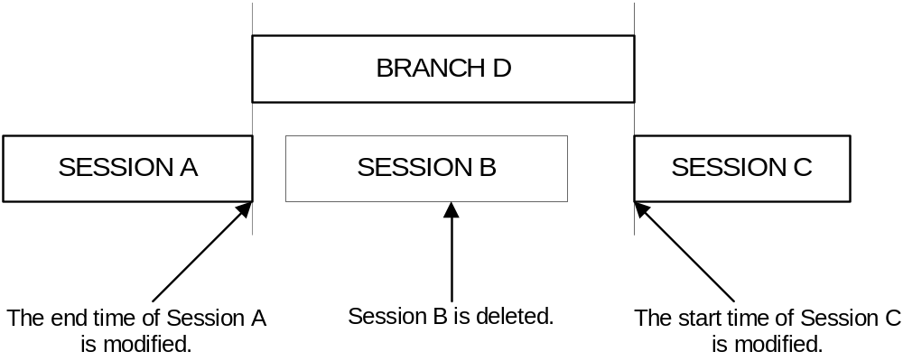

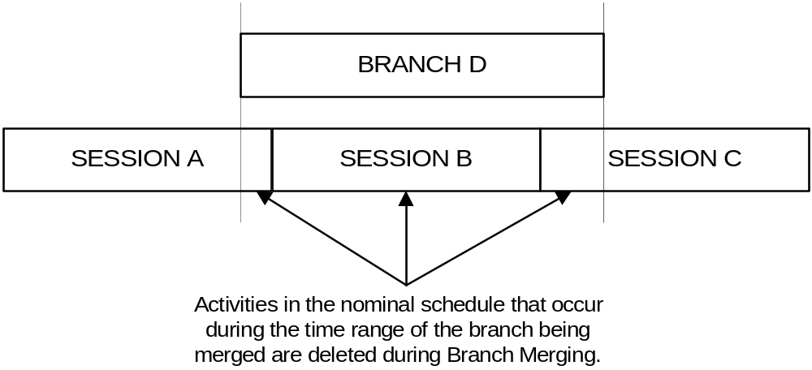

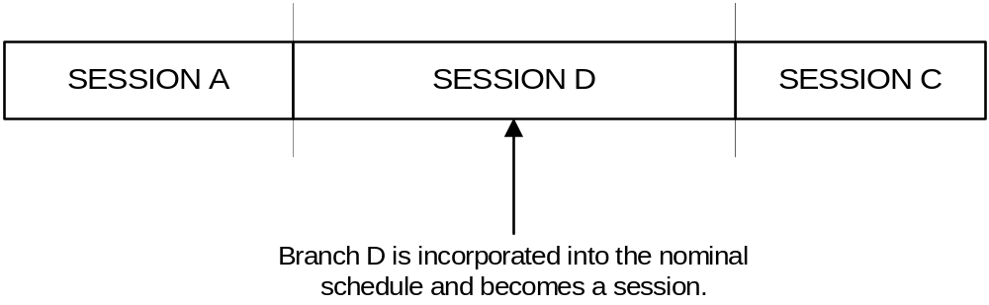
MPSS shall perform the following steps, in order, during branch merging.
- Identify the activities in the nominal schedule that overlap the start and stop boundaries of the branch.
- Unschedule the activities in the nominal schedule that overlap the start and stop boundaries of the branch.
- Store the activities in the nominal schedule that overlap the start and stop boundaries of the branch.
- Delete all data occurring in the nominal schedule that is contained within the branch boundaries.
- Move the branch schedule to the nominal schedule. Data to be moved includes scheduled activities, unscheduled activities and orbital events.
- Update overlapping session definitions by deleting sessions which are fully contained within the branch time window, setting the start time of any session that overlaps the stop time of the branch to be the branch’s stop time, setting the stop time of any session that overlaps the start time of the branch to be the branch’s start time and splitting a session into two if the branch occurs entirely within the time window of a session.
- Merge the unavailable times for the branch into the unavailable times for the nominal schedule.
- Re-schedule the nominal activities that overlapped the branch boundaries (the activities saved off in step 3).

Service Rules
Service rules are defined to maintain data integrity within the MPSS database. Each MPSS application generates a service rule request during start up. Service rules indicate application name, machine, username, branch, and time window of required data. Service rules are then checked against existing service rules. If a conflict is found, the offending application is not started.

The following table identifies the locking rules between MPSS applications.

 | WANTS TO RUN
RUNNING |  | ARLMGR | ARLRDONLY | BRANCHMERGE* | COLDSCHED* | EARSCHED* | HOTSCHED* | GANTTRDONLY | GENORBEVENTS | INGESTORBEVENTS | LOGDISP | PRODUCTGEN | PURGE | RESCONFIG* | RESCONFIGRDONLY | RTSREPORTGEN | SCHEDVALID* | SCHEDVIEW | SESSIONMGR* | SCHEDREPORTGEN | TRANSFERPG | TRANSEXTERNAL | TRANSFDF
 | ARLMGR | - |  | - | - |  |  |  |  |  |  |  | - |  |  |  |  |  | -
 | ARLRDONLY |  |  |  |  |  |  |  |  |  |  |  | -
 | BRANCHMERGE* | - |  | - | - | - | - | L |  | - |  | L | - | - |  | L | - | L | - | L
 | COLDSCHED* | - |  | - | - | - | - | L |  | G |  | L | - | - |  |  | - | L | - | L
 | EARSCHED* |  |  | - | - | - | - | L |  | G |  | L | - | - |  |  | - | L | - | L |  | -
 | HOTSCHED* |  |  | - | - | - | - | L |  | G |  | L | - | - |  |  | - | L | G | L
 | GANTTRDONLY |  |  | G | G | G | G |  |  | G |  |  | - |  |  |  | G |  | G
 | GENORBEVENTS |  |  |  |  |  |  |  | - | - |  |  | - | - |  |  |  |  |  |  |  |  | -
 | INGESTORBEVENTS |  |  | - | L | L | L | L | - | - |  | L | - | - |  |  | T | L | T
 | LOGDISP
 | PRODUCTGEN |  |  | G | G | G | G |  |  | G |  |  | - | - |  |  | G |  | G |  | -
 | PURGE | - | - | - | - | - | - | - | - | - |  | - | - | - | - | - | - | - | - | - | - | - | -
 | RESCONFIG* |  |  | - | - | - | - |  | - | - |  | - | - | - |  |  | - |  | - | -
 | RESCONFIGRDONLY |  |  |  |  |  |  |  |  |  |  |  | -
 | RTSREPORTGEN |  |  | G |  |  |  |  |  | T |  |  | - |  |  | - |  |  |  |  |  | -
 | SCHEDVALID* |  |  | - | - | - | - | L |  | G |  | L | - | - |  |  | - | L | T | L
 | SCHEDVIEW |  |  | G | G | G | G |  |  | T |  |  | - |  |  |  | G |  | G
 | SESSIONMGR* | - |  | - | - | - | L | L |  |  |  | L | - | - |  |  | T | L | - | L
 | SCHEDREPORTGEN |  |  | G | G | G | G |  |  |  |  |  | - | - |  |  | G |  | G | -
 | TRANSFERPG |  |  |  |  |  |  |  |  |  |  | - | - |  |  |  |  |  |  |  | -
 | TRANSEXTERNAL |  |  |  |  | - |  |  |  |  |  |  | - |  |  | - |  |  |  |  |  | -
 | TRANSFDF |  |  |  |  |  |  |  | - |  |  |  | - |  |  |  |  |  |  |  |  |  | -

Blank = OK to run at the same time.
T = Time Constraint (time ranges must not overlap).
L = Time Range must be less than current process time range.
G = Time Range must be greater than current process time range.
(-) = Cannot happen at all.
Processes with (*) can unschedule activities.

Appendix A
Internal Activity Structure

The following diagrams display the internal EUROPA structure of the FORMOSAT-5 activities.
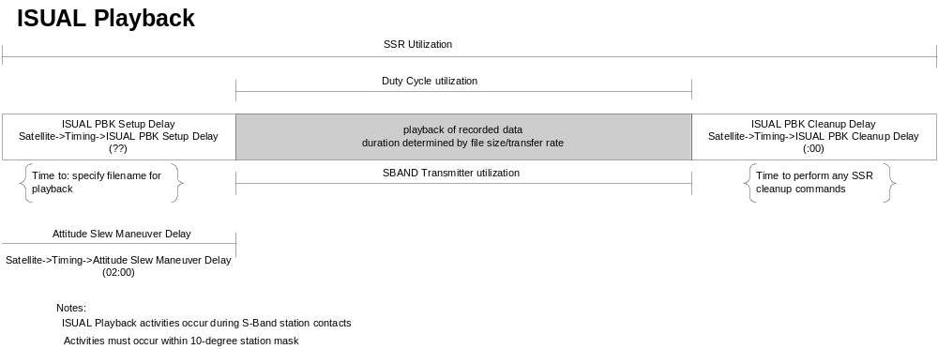

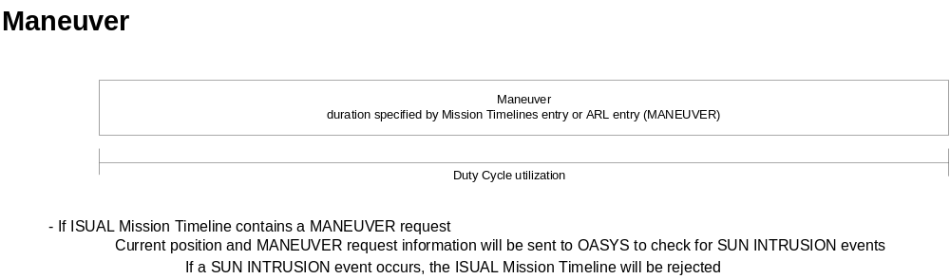
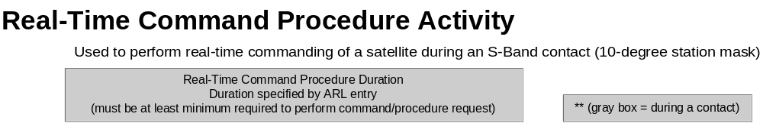

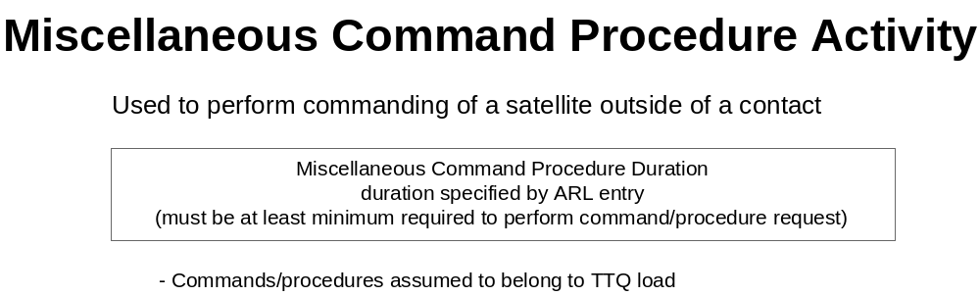

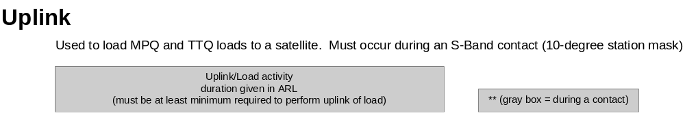

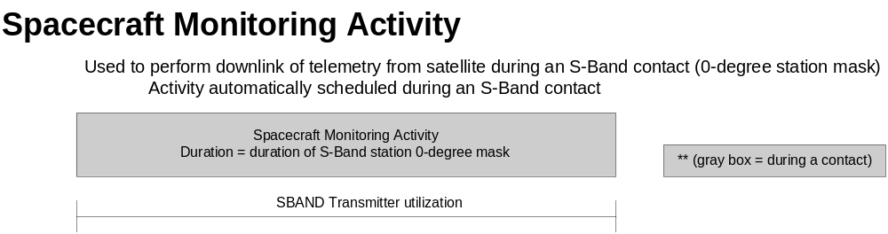

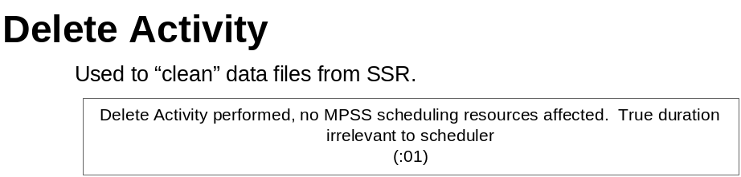

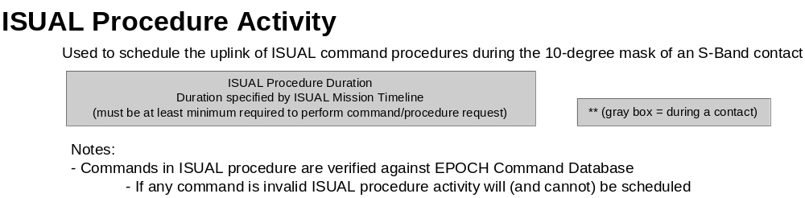

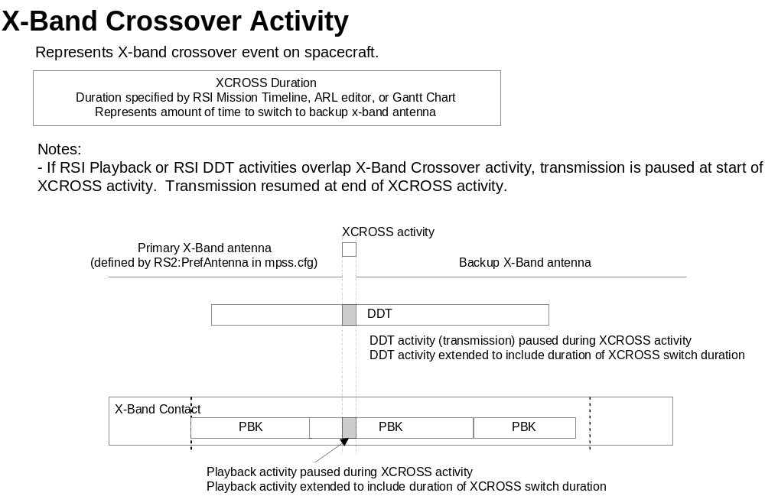
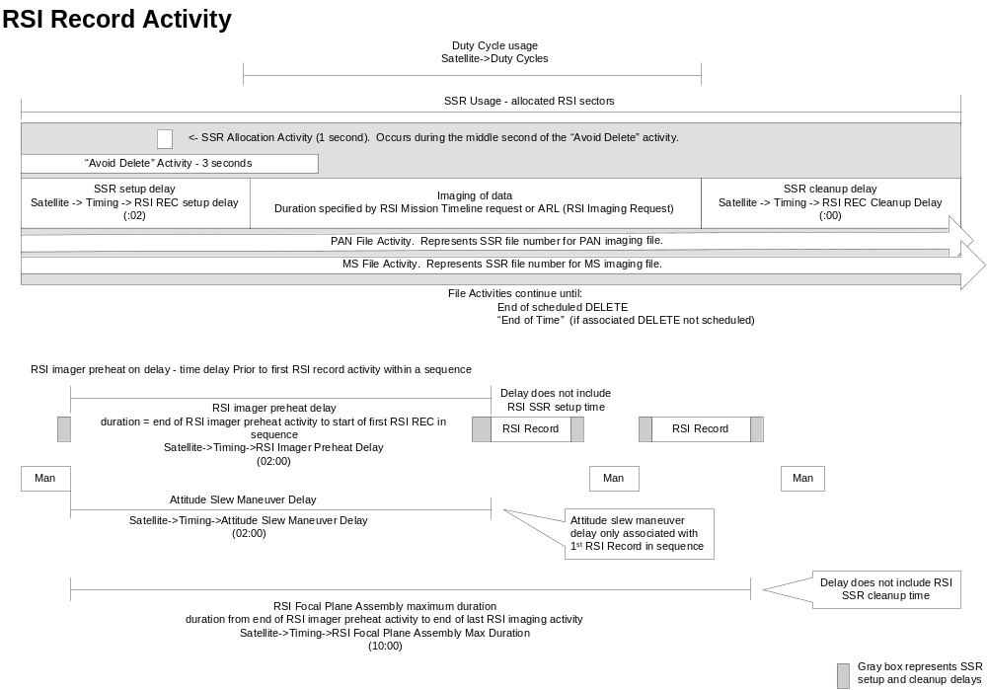
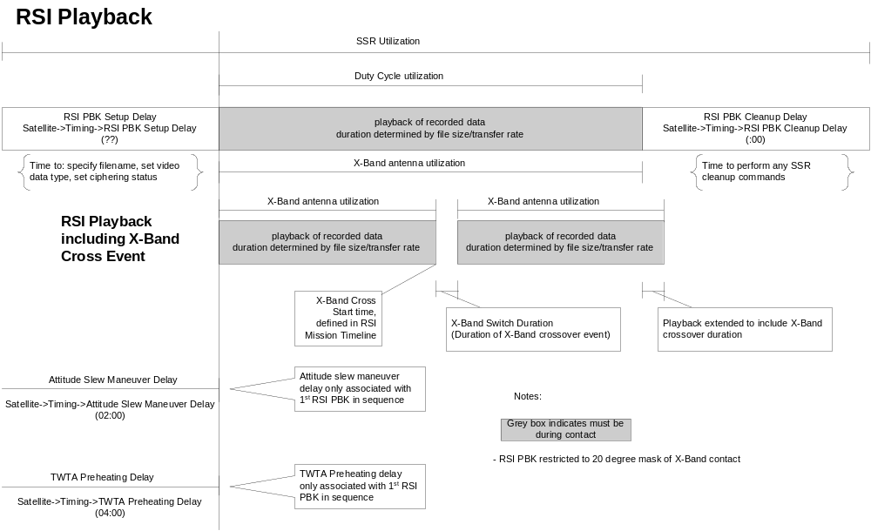

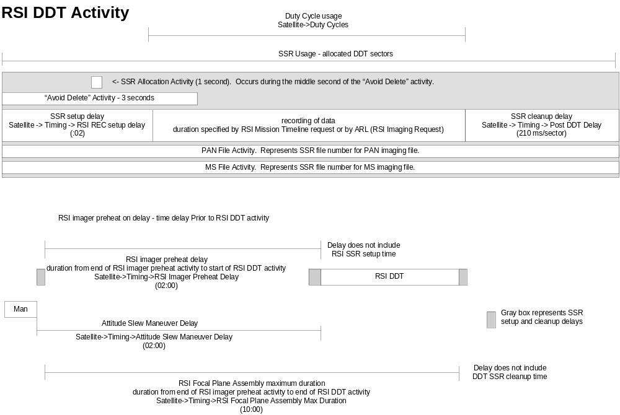

The following diagram shows the scheduling relationships between RSI Record and RSI Playback activities.
