

國家太空中心
衛星多重任務及星系操作系統整合軟體
系統架構程式與功能說明文件
文件編號：MCC-CDRL-009
Submitted by: |  |  | 
ACS 專案經理 彭一盟
Authenticated by:

CONTENT
1 Document Overview 4
1.1 Purpose 4
1.2 Scope 4
2 Applicable Documents 5
3 System Architecture 6
3.1 Overall Software Architecture 6
3.2 Hardware Architecture 7
3.3 Programming Request Manager (PRM) 12
3.4 Tasking Order Feasibility Assessor 13
3.5 MPSS (Mission Planning and Scheduling Subsystem) 14
3.6 Database Engine - Postgresql 16
3.6.1 Platforms 16
3.6.2 Features 17
3.7 GIS Engine - PostGIS 23
3.7.1 Features 23
4 Function Descriptions 25
4.1 MPSS Operational Processes 25
4.2 Resource Configuration 25
4.2.1 Global Data 26
4.2.2 Parameter Sets 26
4.2.3 Modifying the System Default PS Values 29
4.2.4 Modifying Global Data 30
4.2.5 Satellite Configuration 31
4.2.6 Site Configuration 48
4.2.7 Scheduling Parameters Configuration 52
4.3 Orbit Events 53
4.3.1 Orbit Event Request Generator 53
4.3.2 Orbit Event Ingest 57
4.4 RTS Schedule Request Generation 59
4.5 Session Management 60
4.5.1 Working with Sessions 61
4.5.2 Working with Branches 63
4.5.3 Selecting the Time Range 66
4.5.4 Selecting a Parameter Set 67
4.5.5 Selecting Satellites and Sites 67
4.5.6 ARL/Satellite Assignments 68
4.5.7 Session/Branch Description 69
4.6 Activity Request List Editor 69
4.6.1 Working with Activity Request List Editor 70
4.6.2 Editing an Activity Request Specification 72
4.6.3 Activity Request Specifications 73
4.7 Cold Scheduling 78
4.7.1 Overview 78
4.7.2 Cold Scheduling Preparation 79
4.7.3 Cold Scheduling User Specification Directions 79
4.7.4 Cold Scheduling Conclusion 88
4.8 External Activity Request Scheduler 89
4.8.1 Overview 89
4.8.2 Working with External Activity Request Scheduler (EARS) 89
4.8.3 Ingesting Mission Timelines 90
4.9 Gantt Chart 95
4.9.1 Overview 95
4.9.2 Hot Scheduling Preparation 96
4.9.3 Viewing the Schedule Graphically 96
4.9.4 Gantt Chart View and Configuration Options 99
4.9.5 Editing the Schedule (Hot Scheduling) 104
4.9.6 Hot Scheduling Troubleshooting 130
4.10 Schedule Validator 131
4.10.1 Overview 131
4.10.2 Schedule Selection 132
4.10.3 Schedule Verification 132
4.10.4 Results 133
4.11 Schedule Report Generator 137
4.11.1 Generating Reports 137
4.11.2 RSI Acquisition Schedule Report 138
4.11.3 ISUAL Acquisition Schedule Report 138
4.11.4 SSR Utilization Report 138
4.11.5 Duty Cycle Utilization Report 140
5 Package Descriptions 141
5.1 MPSS Packages 141
5.2 mpss.jpa package 141
5.3 mpss.dao package 143
5.4 mpss.ac package 144
5.5 mpss.oe package 145
5.6 mpss.mtl package 147
5.7 mpss.resources package 148
5.8 mpss.plan package 148
5.9 mpss.sched package 149

Document Overview

Purpose
The purpose of the MCC System Specification is to:
a. Document officially the top-level requirements that MCC will be required to meet.
b. Provide an overview of the MCC system for SOCC personnel and users.
c. Define the functional baseline for the MCC system.

Scope
The scope of this document is limited to system level specifications of the MCC system. The system level requirements address the following system characteristics: key system capabilities, functional requirements, high level architectural design. Subsequent design and development work will expand the system requirements to more detailed design specifications.

Applicable Documents
- NSPO-P-101080衛星多重任務及星系操作系統整合軟體 工作說明書

System Architecture

Overall Software Architecture
MCC software has a layered architecture that consists of PRM (Programming Request Manager, both RIA client and OGC-compliant web services) , TOFA (Tasking Order Feasibility Assessor) module and MPSS (Mission Planning and Scheduling Service) module.
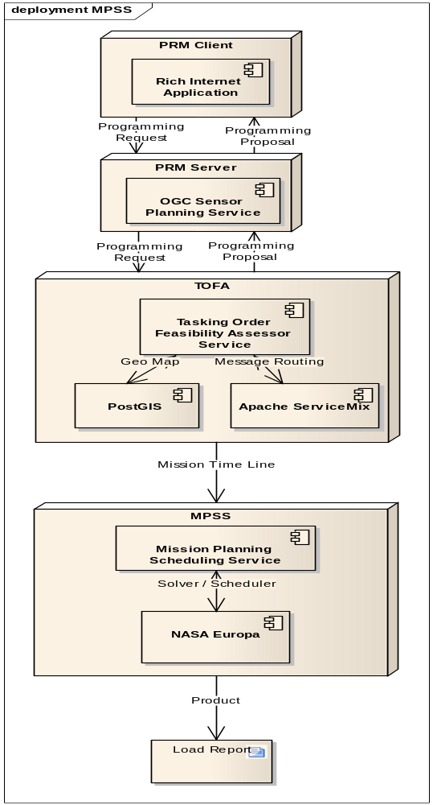

Hardware Architecture
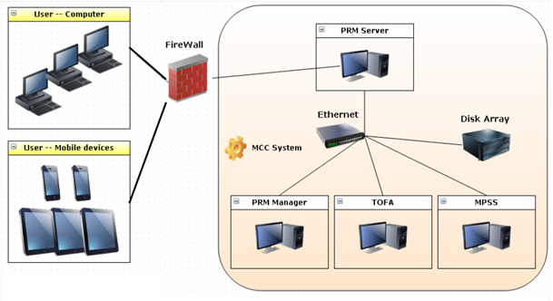
Detailed hardware specification is tabulated as follows.
項次 | 設備名稱 | 數量 | 規格
1 | 個人電腦(含螢幕) | 8
  1.CPU
  1-1.Intel Core i7 3.4GHz(含)以上。
  1-2.整體快取(cache)記憶體8MB(含)以上。
  1-3.處理器核心數(Cores)4個(含)以上，超執行緒(Hyper-Threading Technology)8個(含)以上，提供Turbo Boost(渦輪加速) Technology功能。
  1-4.內建HD Graphics 2000(含)以上繪圖顯示核心功能。
  2.主機版
  2-1.晶片組及顯示卡擴充槽：
  2-1-1.處理器：支援Intel Core i7 3.4GHz(含)以上。
  2-1-2.記憶體：支援雙通道(Dual Channel) DDR(Double Data Rate)3 1066(含)以上。
  2-1-3.記憶體容量：支援16GB(含)以上。
  2-1-4.USB擴充埠：支援6個(含)以上USB(Universal Serial Bus) 2.0(含)以上擴充埠
  2-1-5.顯示卡擴充槽：提供PCI(Peripheral Component Interface) Express 16倍slot一個(含)以上。
  2-1-6.SATA擴充埠：支援4個(含)以上Serial ATA 2.0(含)以上擴充埠，傳輸速率3Gb/s(300MB/s)(含)以上，及支援2個(含)以上Serial ATA 3.0(含)以上擴充埠，傳輸速率6Gb/s(600MB/s)(含)以上。
  3.記憶體:DDR3 1333 4GB(含)以上。
  4.硬碟:SATA 500GB(含)以上。
  5.24吋LED螢幕。
2 | 機櫃 | 1 | 19吋標準機櫃
3 | 機架式FC to SATA/SAS 磁碟陣列儲存系統 | 1 | 1-1.外型：主機本身標準19吋機架式，機架高度共可達2U(含)以上。  1-2.磁碟陣列控制器採用RISC或CISC運算處理器。  1-3.磁碟陣列組需提供雙控制器, 單一控制器記憶體容量4GB(含)以上; 雙控制器最大可支援到8GB(含)以上。  1-4.主機連接介面：提供4個(含)以上光纖通道(Fiber Channel)，每個光纖通道(Fiber Channel)傳輸速率可達8G(含)以上，各單一控制器需提供2個(含)以上光纖通道。  1-5.磁碟機陣列及硬碟  1-5-1.技術：提供硬體磁碟陣列技術支援RAID Level 0,1或1/0，及RAID Level 5,6，或硬體磁碟陣列技術支援RAID Level 6 或8  1-5-2.硬碟：提供轉數7200RPM(含)以上SATA/SAS(Nearline SAS) 2TB(含以上硬碟10顆，或3TB(含以上硬碟8顆，硬碟機具備即抽即換線上修復功能(hot swap)，並支援磁碟機自動檢測與備援修復功能(drive failure detection and rebuild)。  1-5-3.主機硬碟空間：獨立主機本身提供12顆Hot Swap硬碟盒(含)以上。  1-5-4.資料保護：提供資料快照功能(Snapshot或 FlashCopy)及複製功能(提供下列: Clone、Shadow Image、FlashCopy Cloning、Mirror、Volume Copy等任一種)，可手動或定時執行資料快照及複製功能，以保障資料損毀時，可快速回復資料。  1-6.伺服器光纖通道連接卡：提供2片1埠(含)以上PCI-X或PCI-Express光纖通道連接卡，傳輸速率可達8G(含)以上，可支援Windows及Linux，並提供2條5公尺光纖連接線。
4 | iPhone | 2 | 1.儲存容量 64GB  2.螢幕尺寸 4吋 960 x 640  3.處理器 A6雙核心處理器  4.作業系統 iOS 6.0  5.無線功能: WiFi +3G
5 | iPAD | 4 | 1.儲存容量: 64GB  2.螢幕尺寸: 9.7吋 2048 x 1536  3.處理器: A5X  4.作業系統: iOS 5.1  5.無線功能: WiFi +3G

Programming Request Manager (PRM)
The RPM will comply with OGC Sensor Planning Service (SPS) interface standard Earth Observation Satellite Tasking Extension.

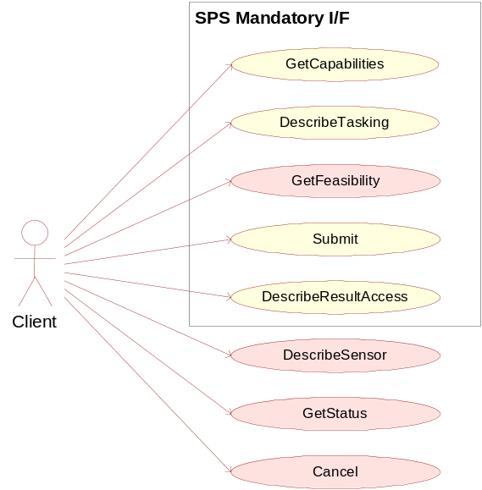
Key functions to aim at are:
- Determining the request and receive service metadata describing the abilities of the specific server implementation (GetCapabilities)
- Requesting information needed to send GetFeasibility and Submit requests (DescribeTasking)
- Determining the feasibility of an intended sensor planning request (GetFeasibility)
- Submitting such a request (Submit)
- Retrieving information about how and where data (produced by the sensor) can be accessed (DescribeResultAccess)
Earth Observation Satellite Tasking Extension will be considered:
- GetSensorAvailability
- Validate
- SubmitSegmentByID

An SPS framework will be provided to facilitate the work of an SPS development. The framework consists of three components: the AssetManager (AM), the ProfileManager (PM) and the Controller. Together they form the SPS.
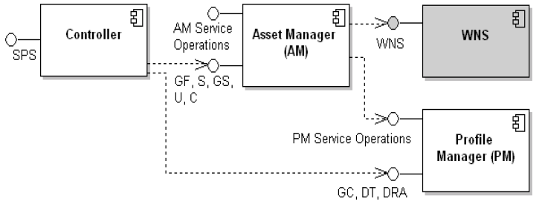
While the AM is responsible for the instance management of a sensor (registering, deregistering, delegating submits, etc), the PMs job is to handle the static meta information of the service and of each plugin. The Controller serves as frontend to these modules – the Controller represents the interface of the SPS specification.

Tasking Order Feasibility Assessor
The Tasking Order Feasibility Assessor (TOFA) is a standalone application that is used to convert Programming Requests (PRs are entered through the PRM) into Tasking Orders (TOs) and assess the TO’s feasibility. The TOFA also produces Programming Proposals (PPs) that are sent to the customers for approval. Communication with the FDF, MPSS and CWB are performed to acquire the necessary information to assess TO feasibility.
In other words, TOFA needs to orchestrate different services to complete its process workflow. Therefore, Apache ServiceMix will be proposed to create a SOA (service-oriented architecture) solution for TOFA applications.
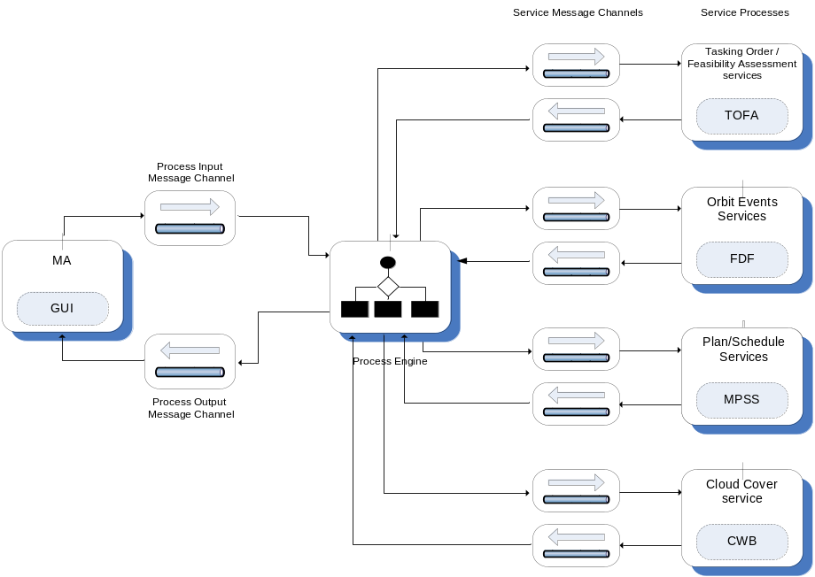
The main features of Apache ServiceMix include:
- reliable messaging with Apache ActiveMQ
- messaging, routing and Enterprise Integration Patterns with Apache Camel
- WS-\* and RESTful web services with Apache CXF
- complete WS-BPEL business process engine with Apache ODE
- OSGi-based server runtime powered by Apache Karaf

MPSS (Mission Planning and Scheduling Subsystem)
NASA EUROPA is a framework to model and tackle problems in Planning, Scheduling and Constraint Programming. EUROPA is typically embedded in a host application, so MPSS will be developed on top of this framework.
EUROPA is designed to be expressive, efficient, extendable and configurable. It includes:
- A Plan Database: The technology cornerstone of EUROPA for storage and manipulation of plans as they are initialized and refined. The EUROPA Plan Database integrates a rich representation for actions, states, objects and constraints with powerful algorithms for automated reasoning, propagation, querying and manipulation.
- A Problem Solver: A core solver to automatically find and fix flaws in the plan database. It can be configured to plan, schedule or both. It can be easily customized to integrate specialized heuristics and resolution operations.
- A Tool Box: Europa includes a debugger for instrumentation and visualization of applications. It also includes a very high-level, declarative modeling language for describing problem domains and partial-plans.
The modules of EUROPA and their interdependencies are set out as below . EUROPA is a highly modular architecture and modules can be developed, tested and applied quite independently.
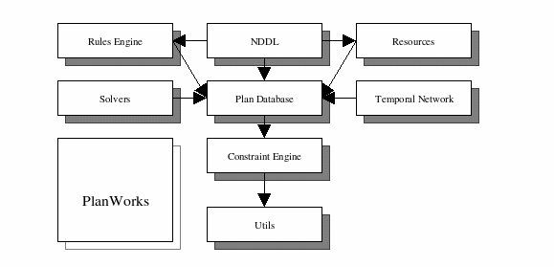
- The Utils module provides common C++ utility classes for error checking, smart pointers etc. It also includes a very useful debugging utility. Many common programming practices in EUROPA development are built on assets in this module.
- The Constraint Engine is the nexus for consistency management. It provides a general-purpose component-based architecture for handling dynamic constraint networks. It deals in variables and constraints. It includes an open propagation architecture making it straightforward to integrate specialized forms of local and global constraint propagation.
- The Plan Database adds higher levels of abstractions for tokens and objects and the interactions between them. This is the code embodiment of the EUROPA planning paradigm. It supports all services for creation, deletion, modification and inspection of partial plans. It maintains the dynamic constraint network underlying a partial–plan by delegation to the Constraint Engine and leverages that propagation infrastructure to maintain relationships between tokens and objects.
- The Solvers module provides abstractions to support search in line with the EUROPA planning approach. It includes a component-based architecture for Flaw Identification, Resolution and heuristics as well as an algorithm for chronological backtracking search. As additional search algorithms are implemented they will be added to this module.
- The Rules Engine module provides the inference capabilities based on domain rules described in the model. It is almost exclusively used to execute NDDL rules but can be extended for custom rule formats.
- The Resources module provides specialized algorithms and data structures to support metric resources (e.g. battery, power bus, disk drive).
- The Temporal Network module provides specialized algorithms and data structures to support efficient propagation of temporal constraints.
- The NDDL module provides a parser and compiler for NDDL (pronounced noodle) which is a very high-level, object-oriented, declarative domain and problem description language. This module defines the mapping from the language to the code and consequently interfaces to a number of key modules in the system.
- PlanWorks is a java application for visualization and debugging of plans and planning. It is loosely coupled to the other EUROPA modules through a JNI interface.

Database Engine - Postgresql
(from PostgreSQL wiki )
PostgreSQL is an object-relational database management system (ORDBMS) available for many platforms including Linux, FreeBSD, Solaris, Microsoft Windows and Mac OS X. It is released under the PostgreSQL License, which is an MIT-style license, and is thus free and open source software. PostgreSQL is developed by the PostgreSQL Global Development Group, consisting of a handful of volunteers employed and supervised by companies such as Red Hat and EnterpriseDB.It implements the majority of the SQL:2008 standard, is ACID-compliant, is fully transactional (including all DDL statements), has extensible data types, operators, index methods, functions, aggregates, procedural languages, and has a large number of extensions written by third parties.

Platforms
Instruction set architectures
PostgreSQL works on any of the following instruction set architectures: x86, x86-64, IA-64 Itanium, PowerPC, PowerPC 64, S/390, S/390x, SPARC, SPARC 64, Alpha, ARM, MIPS, MIPSel, M68k, and PA-RISC. It is also known to work on M32R, NS32k, and VAX. In addition to these, it is possible to build PostgreSQL for an unsupported CPU by disabling spinlocks.
Operating systems
PostgreSQL is available for the following operating systems: Linux (all recent distributions), Windows (Windows 2000 SP4 and later), FreeBSD, OpenBSD, NetBSD, Mac OS X, AIX, BSD/OS, HP-UX, IRIX, OpenIndiana, OpenSolaris, SCO OpenServer, SCO UnixWare, Solaris and Tru64 Unix. As of 2012, support for the following obsolete systems was removed: DG/UX, NeXTSTEP, SunOS 4, SVR4, Ultrix 4, and Univel. Most other Unix-like systems should also work.

Features
Procedural languages
Procedural languages (often called stored procedures) allow blocks of code to be executed by the database server, and can be written in programming languages other than SQL and C. Procedural languages can be used to create user-defined functions (subroutine, trigger, aggregates and window functions), and can also be used in ad hoc "DO" blocks. The following four procedural languages are provided by a standard PostgreSQL installation:
- PL/pgSQL, a built-in language that resembles Oracle's PL/SQL procedural language
- PL/Tcl, provides Tcl
- PL/Perl, provides Perl
- PL/Python, provides Python, either version 2 or 3
- Other non-standard procedural languages that have been developed outside the core distribution include (but are not limited to):
- PL/Java (Java)
- PL/Js (JavaScript)
- PL/LOLCODE (LOLCODE)
- PL/Lua (Lua)
- PL/OpenCL for GPU-accelerated functionality (OpenCL)
- PL/Parrot (Parrot)
- PL/PHP (PHP)
- PL/Proxy (wiki article)
- (SQL/PSM)
- PL/R (R)
- PL/Ruby (Ruby)
- PL/scheme (Scheme)
- PL/sh (any Unix-like shell)
- PL/V8 (implements V8 JavaScript engine)
Indexes
PostgreSQL includes built-in support for B+-tree, hash, generalized search trees (GiST) and generalized inverted indexes (GIN). In addition, user-defined index methods can be created, although this is quite an involved process. Indexes in PostgreSQL also support the following features:
Expression indexes can be created with an index of the result of an expression or function, instead of simply the value of a column.
Partial indexes, which only index part of a table, can be created by adding a WHERE clause to the end of the CREATE INDEX statement. This allows a smaller index to be created.
The planner is capable of using multiple indexes together to satisfy complex queries, using temporary in-memory bitmap index operations.
As of PostgreSQL 9.1, k-nearest neighbor (also referred to KNN-GiST) indexing provides efficient searching of "closest values" to that specified, useful to finding similar words, or close objects or locations with geospatial data. This is achieved without exhaustive matching of values.
In PostgreSQL 9.2 and above, index-only scans often allow the system to fetch data from indexes without ever having to access the main table.
Triggers
Triggers are events triggered by the action of SQL DML statements. For example, an INSERT statement might activate a trigger that checks if the values of the statement are valid. Most triggers are only activated by either INSERT or UPDATE statements.
Triggers are fully supported and can be attached to tables. In PostgreSQL 9.0 and above, triggers can be per-column and conditional, in that UPDATE triggers can target specific columns of a table, and triggers can be told to execute under a set of conditions as specified in the trigger's WHERE clause. As of PostgreSQL 9.1, triggers can be attached to views by utilising the INSTEAD OF condition. Views in versions prior to 9.1 can have rules, though. Multiple triggers are fired in alphabetical order. In addition to calling functions written in the native PL/PgSQL, triggers can also invoke functions written in other languages like PL/Python or PL/Perl.
Schemas
In PostgreSQL, all objects (with the exception of roles and tablespaces) are held within a schema. Schemas effectively act like namespaces, allowing objects of the same name to co-exist in the same database. Schemas are analogous to directories in a file system, except that they cannot be nested, nor it is possible to create a "symbolic link" pointing to another schema or object.
By default, databases are created with the "public" schema, but any additional schemas can be added, and the public schema isn't mandatory. A "search_path" determines the order in which schemas are checked on unqualified objects (those without a prefixed schema), which can be configured on a database or role level. The search path, by default, contains the special schema name of "$user", which first looks for a schema named after the connected database user (e.g. if the user "dave" were connected, it would first look for a schema also named "dave" when referring to any objects). If such a schema is not found, it then proceeds to the next schema. New objects are created in whichever valid schema (one that presently exists) is listed first in the search path.

MVCC
PostgreSQL manages concurrency through a system known as multiversion concurrency control (MVCC), which gives each transaction a "snapshot" of the database, allowing changes to be made without being visible to other transactions until the changes are committed. This largely eliminates the need for read locks, and ensures the database maintains the ACID (atomicity, consistency, isolation, durability) principles in an efficient manner.
Rules
Rules allow the "query tree" of an incoming query to be rewritten. One common usage is to implement views, including updatable views. Rules, or more properly, "Query Re-Write Rules", are attached to a table/class and "Re-Write" the incoming DML (select, insert, update, and/or delete) into one or more queries that either replace the original DML statement or execute in addition to it. Query Re-Write occurs after DML statement parsing, but, before query planning.
Data types
A wide variety of native data types are supported, including:
- Boolean
- Arbitrary precision numerics
- Character (text, varchar, char)
- Binary
- Date/time (timestamp/time with/without timezone, date, interval)
- Money
- Enum
- Bit strings
- Text search type
- Composite
- Arrays (variable length and can be of any data type, including text and composite types) up to 1 GB in total storage size.
- Geometric primitives
- IPv4 and IPv6 addresses
- CIDR blocks and MAC addresses
- XML supporting XPath queries (as of 8.3)
- UUID (as of 8.3)
In addition, users can create their own data types which can usually be made fully indexable via PostgreSQL's GiST infrastructure. Examples of these include the geographic information system (GIS) data types from the PostGIS project for PostgreSQL.
There is also a data type called a "domain", which is the same as any other data type but with optional constraints defined by the creator of that domain. This means any data entered into a column using the domain will have to conform to whichever constraints were defined as part of the domain.
User-defined objects
New types of almost all objects inside the database can be created, including:
- Casts
- Conversions
- Data types
- Domains
- Functions, including aggregate functions and window functions
- Indexes including custom indexes for custom types
- Operators (existing ones can be overloaded)
- Procedural languages
Inheritance
Tables can be set to inherit their characteristics from a "parent" table. Data in child tables will appear to exist in the parent tables, unless data is selected from the parent table using the ONLY keyword, i.e. select * from ONLY PARENT_TABLE. Adding a column in the parent table will cause that column to appear in the child table.
Inheritance can be used to implement table partitioning, using either triggers or rules to direct inserts to the parent table into the proper child tables.
As of 2010 this feature is not fully supported yet—in particular, table constraints are not currently inheritable. As of the 8.4 release, all check constraints and not-null constraints on a parent table are automatically inherited by its children. Other types of constraints (unique, primary key, and foreign key constraints) are not inherited.
Inheritance provides a way to map the features of generalization hierarchies depicted in Entity Relationship Diagrams (ERD) directly into the PostgreSQL database.
Replication
PostgreSQL, beginning from version 9.0, includes built-in binary replication, based on shipping the changes (write-ahead logs) to slave systems asynchronously.
Version 9.0 also introduced the ability to run read-only queries against these replicated slaves, where earlier versions would only allow that after promoting them to be a new master. This allows splitting read traffic among multiple nodes efficiently. Earlier replication software that allowed similar read scaling normally relied on adding replication triggers to the master, introducing additional load onto it.
Beginning from version 9.1, PostgreSQL also includes built-in synchronous replication[17] that ensures that, for each write transaction, the master waits until at least one slave node has written the data to its transaction log. Unlike other database systems, the durability of a transaction (whether it's asynchronous or synchronous) can be specified per-database, per-user, per-session or even per-transaction. This can be useful for work loads that don't require such guarantees, and may not be wanted for all data as it will have some negative effect on performance due to the requirement of the confirmation of the transaction reaching the synchronous standby.
There can be a mixture of synchronous and asynchronous standby servers. A list of synchronous standby servers can be specified in the configuration which determines which servers are candidates for synchronous replication. The first in the list which is currently connected and actively streaming is the one that will be used as the current synchronous server. When this fails, it falls to the next in line.
Synchronous multi-master replication is currently not included in the PostgreSQL core. Postgres-XC which is based on PostgreSQL provides scalable synchronous multi-master replication[18] and is licensed under the BSD license.
There are also several asynchronous trigger-based replication packages for PostgreSQL. These remain useful even after introduction of the expanded core capabilities, for situations where binary replication of an entire database cluster isn't the appropriate approach:
- Slony-I
- Skype’s Londiste (part of SkyTools)
- Backcountry.com’s Bucardo (multi-master replication)[19]
- Proxy (middleware) tools enable replication, failover or load management and balancing for PostgreSQL:
- PGPool-II
- Continuent Sequoia, also available for other database software
Asynchronous notifications
PostgreSQL provides an asynchronous messaging system that is accessed through the NOTIFY, LISTEN and UNLISTEN commands. A session can issue a NOTIFY command, along with the user-specified channel and an optional payload, to mark a particular event occurring. Other sessions are able to detect these events by issuing a LISTEN command, which can listen to a particular channel. This functionality can be used for a wide variety of purposes, such as letting other sessions know when a table has updated or for separate applications to detect when a particular action has been performed. Such a system prevents the need for continuous polling by applications to see if anything has yet changed, and reducing unnecessary overhead. Notifications are fully transactional, in that messages aren't sent until the transaction they were sent from is committed. This eliminates the problem of messages being sent for an action being performed which is then rolled back.
Many of the connectors for PostgreSQL provide support for this notification system (including libpq, JDBC, Npgsql, psycopg and node.js) so it can be used by external applications.
Security
Internal
Security within the database is managed on a per-role-basis. A role is generally regarded to be a user (a role that can log in), or a group (a role which other roles are members of). Permissions can be granted or revoked on any object down to the column level, and can also allow/prevent the creation of new objects at the database, schema or table levels.
The sepgsql extension (provided with PostgreSQL as of version 9.1) provides an additional layer of security by integrating with SELinux. This utilises PostgreSQL's SECURITY LABEL feature.
External
PostgreSQL natively supports a broad number of authentication mechanisms including:
- trust (no enforcement)
- password (either MD5 or plain-text)
- GSSAPI
- SSPI
- Kerberos
- ident (maps O/S user name as provided by an ident server to database user name)
- peer (maps local user name to database user name)
- LDAP
- RADIUS
- certificate
- PAM
The GSSAPI, SSPI, Kerberos, peer, ident and certificate methods can also use a specified "map" file that lists which users matched by that authentication system are allowed to connect as a specific database user.
These methods are specified in the cluster's host-based authentication configuration file (pg_hba.conf), which determines what connections are allowed. This allows control over which user can connect to which database, where they can connect from (IP address/IP address range/domain socket), which authentication system will be enforced, and whether the connection must use SSL.
Contrib modules
PostgreSQL comes with additional extensions, libraries and tools that are referred to as contrib modules.

GIS Engine - PostGIS
(from PostGIS wiki )
PostGIS is an open source software program that adds support for geographic objects to the PostgreSQL object-relational database. PostGIS follows the Simple Features for SQL specification from the Open Geospatial Consortium (OGC).

Features
- Geometry types for points, linestrings, polygons, multipoints, multilinestrings, multipolygons and geometrycollections.
- Spatial predicates for determining the interactions of geometries using the 3x3 Egenhofer matrix (provided by the GEOS software library).
- Spatial operators for determining geospatial measurements like area, distance, length and perimeter.
- Spatial operators for determining geospatial set operations, like union, difference, symmetric difference and buffers (provided by GEOS).
- R-tree-over-GiST (Generalised Search Tree) spatial indexes for high speed spatial querying.
- Index selectivity support, to provide high performance query plans for mixed spatial/non-spatial queries.
- For raster data, under development PostGIS WKT Raster (now integrated into PostGIS 2.0 and renamed PostGIS Raster)
The PostGIS implementation is based on "light-weight" geometries and indexes optimized to reduce disk and memory footprint. Using light-weight geometries helps servers increase the amount of data migrated up from physical disk storage into RAM, improving query performance substantially.

Function Descriptions

MPSS Operational Processes
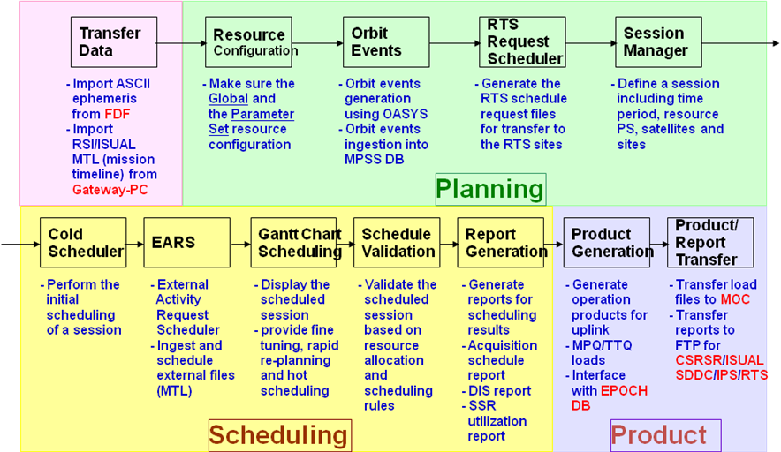

Resource Configuration
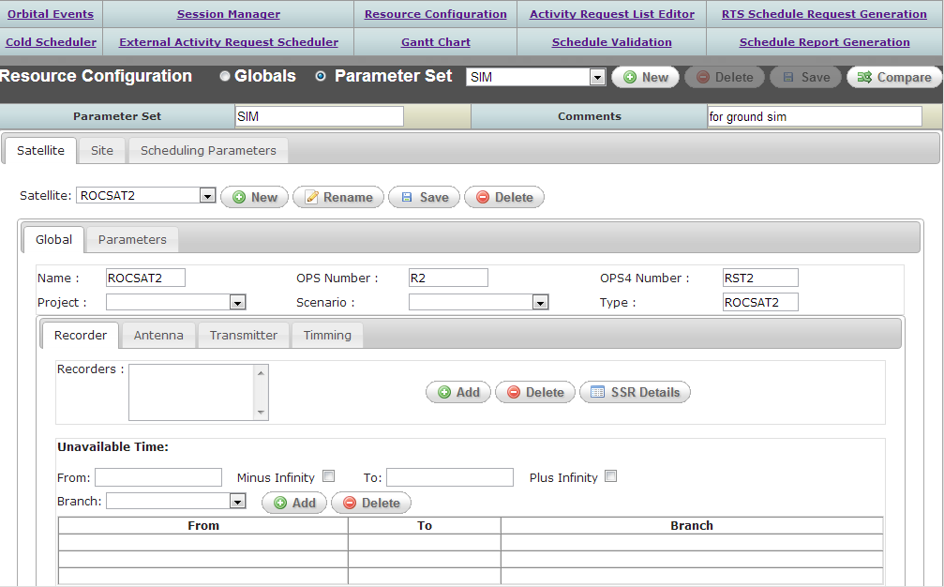
The Resource Configuration utility enables users to view and define static and dynamic attributes of the physical resources and scheduling parameters, and save these values to the MPSS database. The Resource Configuration data is divided into Global data and Parameter Set data. Global data encompasses the static attributes of the physical resources and scheduling parameters. Parameter Set data encompasses the dynamic attributes of the physical resources and scheduling parameters.
To initiate the Resource Configuration application from the MPSS Menu Bar as follows.
- Select the Resource Configuration… option.
- Note that if another process is running that conflicts with the Resource Configuration process, the user will be given the option to open the Resource Configuration utility in read-only mode.
Two buttons allow the user to modify either Global or Parameter Set values.
- Globals.
- Parameter Set.

Global Data
The single “Global” data set is used by every session/branch. The values that comprise the Global data set are static values that will rarely change. Modifications to the Global data set affect the entire schedule. Resource unavailable times are an exception to this; an unavailable time only affects the schedule/branch that it references.

Parameter Sets
A session/branch references only one Parameter Set (PS). One PS may be used by multiple sessions/branches. The values that comprise a PS are dynamic values that the user may want to change from one session to the next.

Under each tab, there are Global and Parameters tabs to allow the user to modify either global or parameter set values, depending on which button (Globals or Parameter Set) is selected at the top of the window. Note that parameter set values may not be modified when the Globals button is selected, and global values may not be modified when the Parameter Set button is selected.

Creating a Parameter Set
The user may create a new PS either by using the system’s Default PS values or by copying an existing PS. Copying an existing PS is useful when the user has already created a PS that contains the baseline operational values, but a certain value needs to be modified for a new session/branch. The user can copy this baseline PS into a new PS and modify only the necessary values, while all other values remain baselined. The user may document the changes made to the new PS in the Comments field.

Create a PS using Default PS Values
The user may create a PS using the Default PS values as follows.
- From the Resource Configuration utility, select button New.
- In the New Parameter Set window, enter a name for the new PS in the Name field. Keep the Create using data from existing Parameter Set flag off.
- Select OK.

Create a PS by Copying an Existing PS
The user may create a PS by copying an existing PS as follows.
- From the Resource Configuration utility, select button New.
- In the New Parameter Set window, enter a name for the new PS in the Name field.
- Set the Create using data from existing Parameter Set flag on and select the PS to be copied from the list.
- Select OK.

In the Resource Configuration utility, the user may then modify the necessary PS values.
If desired, the user may document these changes in the Comments field. This is a helpful way to keep track of the differences, for example, between a PS containing baseline values and a copy of this PS modified for a contingency or testing.

Modifying a Parameter Set
A PS can be modified unless it has been copied to create a new PS, or if it is assigned to a session/branch that is scheduled. When a PS is selected, from the Parameter Set list, that has been either copied or assigned to a scheduled session/branch, a message is receivied indicating that this PS may not be modified.
The user may modify a PS as follows.
- From the Resource Configuration utility, select the Parameter Set button.
- Select the PS to be modified from the Parameter Set list.
- Once the PS is displayed, select the tab corresponding to the resource to be modified.
- Under the resource tab, select the Parameters tab and modify the desired fields.

Comparing Two Parameter Sets
The user can display the differences between two PSs by using the compare tool of the Resource Configuration window. This tool is helpful, for example, when the user needs to quickly determine the difference between the PS that contains the baseline values and another PS.
The user may compare two PSs as follows.
- From the Resource Configuration utility, select the Parameter Set button.
- Select one of the two PSs from the Parameter Set list.
- Select button Compare.
- In the Compare Parameter Sets window, select the second PS from the Parameter Set 2 list.
Select OK.
In the Parameter Set Comparison Results window, select the Different tab to view the differences between the PSs; select the Consistent tab to view what values are identical between the PSs.

Deleting a Parameter Set
A PS can be deleted unless it has been copied to create a new PS, or if it is assigned to a session/branch (even if the session/branch has not been scheduled).
The user may delete a PS as follows.
- From the Resource Configuration utility, select the Parameter Set button.
- Select the PS to be deleted from the Parameter Set list.
- Select button Delete.
- A confirmation message will be received; select Yes in the message to delete the PS, No to cancel the deletion.

Modifying the System Default PS Values
The system default PS values, which are used to create a new PS when the Create using data from existing Parameter Set flag is off, may be modified. The new default PS values will be used when creating all future PSs (unless copying from an existing PS). Modifications to the default PS values do not affect existing PSs. Note that the “~~DEFAULT~~” PS (which contains the system default PS values) is a template for creating PSs and resources from scratch; it is not a PS that can be used for scheduling or deleted.
The user may modify the default PS values as follows.
- From the Resource Configuration utility, select the Parameter Set button.
- Select the PS “~~DEFAULT~~” from the Parameter Set list.
- Once the default PS values are displayed, select the tab corresponding to the resource to be modified. Note that all of the default resources will either be displayed as “~~” or “DEFAULT”.
- Under the resource tab, select the Parameters tab and modify the desired fields.
Select button Save to save changes to the default parameter set, or close the Resource Configuration utility and select No in the message received asking if changes should be saved to cancel the changes.

Modifying Global Data
The values in the global data set may be modified. Changes made to global values affect the entire schedule. One exception is the addition or modification of resource unavailable times, which affects only the schedule/branch to which the unavailable times are assigned. Note that if an unavailable time is added to a branch, it must fall within the timeframe of the branch.
The addition of unavailable times may result in the unscheduling of activities within the schedule/branch to which the unavailable time is assigned. When the user adds a resource unavailable time that overlaps scheduled activities that use this resource, the user is given the option of unscheduling the conflicting activities or canceling the addition of the unavailable time. If the user chooses to unschedule the conflicting activities, the unscheduling does not occur until the change is saved (File/Save).
The user is prevented from deleting resources that are “in use”. A resource is considered to be in use if:
- Schedule activities use the resource.
- An activity request (ARL) references the resource.
- A session/branch references the resource (even if the session/branch is not scheduled).

Other global value changes that may appear to conflict with the schedule are allowed and handled by the scheduling software.
The user may modify global values as follows.
- From the Resource Configuration utility, select the Globals button.
- Select the tab corresponding to the resource to be modified.
- Under the resource tab, select the Global tab and modify the desired fields.
- Select File/Save to save global changes, or close the Resource Configuration utility and select No in the message received asking if global changes should be saved to cancel the changes.

Satellite Configuration
The user may use the Resource Configuration utility’s Satellite tab to view or modify a satellite’s global or parameter set values.

Create a New Satellite
To add a new satellite to the MPSS system, the user must use the New button in the Resource Configuration utility. Using the Satellite/Global tab in the Resource Configuration utility, the user may add a satellite as follows.
From the Resource Configuration utility, select the Globals button.
Select the Satellite tab.
Select New.
- In the New Satellite GUI, enter the Name of the new satellite and select the satellite Type from the list. Satellite types include ROCSAT2 and ROCSAT3.
- Select OK to add the new satellite to the list of satellite resources, or Cancel to cancel the addition of the new satellite.
- If OK was selected in the New Satellite GUI, select File/Save to save the satellite to the database, or close the Resource Configuration window and select No in the message that is sent, asking if changes should be saved, to cancel the addition of the satellite.

Rename a Satellite
Using the Satellite/Global tab of the Resource Configuration utility, the user may rename an existing satellite as follows.
- From the Resource Configuration utility, select the Globals button.
Select the Satellite tab.
- Select the satellite to be edited from the Satellite list; the GUI will then be populated with this satellite’s values.
- Select Rename.
- In the Rename Satellite window, enter the new Name of the satellite.
- Select OK to accept the name change or Cancel to return the main window with no changes.
- Select File/Save to apply the changes to the satellite, or close the Resource Configuration window and select No in the message that is sent, asking if changes should be saved, to cancel the changes to the satellite.

Delete a Satellite
Using the Satellite/Global tab in the Resource Configuration utility, the user may delete an existing satellite as follows. Note that a satellite may not be deleted from the database until all schedules/contacts referencing the satellite have been purged.
- From the Resource Configuration utility, select the Globals button.
- Select the Satellite tab.
- Select the satellite to be deleted from the Satellite list; the GUI will then be populated with this satellite’s values.
- Select Delete. A message will be received asking for confirmation to delete this satellite.
  - Select Yes in the message to continue deleting the satellite thus removing it from the MPSS database.
  - Select No in the message to cancel the deletion of the satellite.

Edit Satellite Global Configuration
The user may edit global satellite values using the Satellite/Global tab in the Resource Configuration utility as follows.
- From the Resource Configuration utility, select the Globals button.
- Select the Satellite tab.
- Select the satellite to be edited from the Satellite list; the GUI will then be populated with this satellite’s values.
- Select the Global tab.
- Edit the attributes of the Satellite tab.
- Select the resource tabs, and make any needed changes.
- Select button Save to apply the changes to the satellite, or close the Resource Configuration window and select No in the message that is sent, asking if changes should be saved, to cancel the changes to the satellite.

Edit Satellite Global Recorders
The satellite recorder global values can be modified using the Satellite/Global/Recorders tab in the Resource Configuration utility.
Edit Global Recorders as follows.
- From the Resource Configuration utility, select the Globals button.
- Select the Satellite tab.
- Select the satellite to be edited from the Satellite list.
- Select the Global tab.
- Select the Recorders tab.
- In this tab, the user may Add or Delete a recorder, update SSR Details and edit Unavailable Times.
- Select File/Save to apply the changes to the satellite, or close the Resource Configuration window and select No in the message that is sent, asking if changes should be saved, to cancel the changes to the satellite.

Add Recorder Resource

To add a new recorder to a satellite:
- From the Resource Configuration utility, select the Globals button.
- Select the Satellite tab.
- Select the desired satellite from the Satellite list.
- Select the Recorders tab.
- Select Add.
- In the New Recorder GUI, enter the Name of the new recorder resource.
- Select OK to add the new recorder resource to the “Recorders” list, or Cancel to cancel the addition of the new satellite.
If OK was selected in the New Recorder GUI, select button Save to save the recorder to the database, or close the Resource Configuration window and select No in the message that is sent, asking if changes should be saved, to cancel the addition of the recorder.

Delete Recorder Resource

To delete a recorder from a satellite:
- From the Resource Configuration utility, select the Globals button.
- Select the Satellite tab.
- Select the desired satellite from the Satellite list.
- Select the Recorders tab.
- Select the desired recorder from the “Recorders” list to delete.
- Select Delete. A message will be received asking for confirmation to delete this recorder.
    - Select Yes in the message to continue deleting the recorder thus removing it from the MPSS database.
    - Select No in the message to cancel the deletion of the recorder.

Edit SSR Details
The SSR Details window provides the ability to specify solid-state recorder details specific for the ROCSAT2 recorder. The SSR details include the maximum number of files allowed by the recorder the maximum number of allowed files for each instrument, and the sector size.

To edit the SSR Details:
- From the Resource Configuration utility, select the Globals button.
- Select the Satellite tab.
- Select the desired satellite from the Satellite list.
- Select the Recorders tab.
- Select the desired recorder from the “Recorders” list to delete.
- Select SSR Details.
- In the File Size Configuration GUI, enter the desired solid-state recorder values.
- Select OK to accept the values and return to the main window, or Cancel to return to the main window.
- If OK was selected in the File Size Configuration GUI, select button Save to save the changes to the database, or close the Resource Configuration window and select No in the message that is sent, asking if changes should be saved, to cancel the SSR detail changes.

Edit Recorder Unavailable Times
Unavailable times indicate a time period where the recorder resource is unavailable for scheduling. This would be useful to indicate the recorder resource is inoperable. To edit recorder unavailable times:
- From the Resource Configuration utility, select the Globals button.
- Select the Satellite tab.
- Select the desired satellite from the Satellite list.
- Select the Recorders tab.
- Select the desired recorder from the “Recorders” list to edit.
- Add unavailable times for the recorder by entering the values in the time fields and selecting Add. The time field formats are yyyy/ddd/hh:mm:ss.
- If no branch is selected, the unavailable time is mapped to the nominal schedule; if a branch is selected; the unavailable time is mapped only to the branch and does not affect the nominal schedule. If “~” is selected, the unavailable time will be mapped to the nominal schedule.
- Delete unavailable times for the recorder by selecting the entry in the chart and selecting Delete.
- Select File/Save to apply the changes to the recorder, or close the Resource Configuration window and select No in the message that is sent, asking if changes should be saved, to cancel the changes to the recorder.

Edit Satellite Global Antennas
The satellite channel global values can be modified using the Satellite/Global/Antennas tab of the Resource Configuration utility.
Edit Global Antennas as follows.
- From the Resource Configuration utility, select the Globals button.
- Select the Satellite tab.
- Select the satellite to be edited from the Satellite list.
- Select the Global tab.
- Select the Antennas tab.
- In this tab, the user may Add or Delete an antenna and edit Unavailable Times.
- Select button Save to apply the antenna changes to the satellite, or close the Resource Configuration window and select No in the message, asking if changes should be saved, to cancel the changes to the satellite.

Add Antenna Resource
To add a new antenna to a satellite:
- From the Resource Configuration utility, select the Globals button.
- Select the Satellite tab.
- Select the desired satellite from the Satellite list.
- Select the Antenna tab.
- Select Add.
- In the New Antenna GUI, enter the Name of the new antenna resource.
- Select the Type of the antenna.
- Select OK to add the new antenna resource to the “Antennas” list, or Cancel to cancel the addition of the new satellite.
- If OK was selected in the New Antenna GUI, select button Save to save the antenna to the database, or close the Resource Configuration window and select No in the message that is sent, asking if changes should be saved, to cancel the addition of the antenna.

Delete Antenna Resource

To delete a antenna from a satellite:
- From the Resource Configuration utility, select the Globals button.
- Select the Satellite tab.
- Select the desired satellite from the Satellite list.
- Select the Antennas tab.
- Select the desired antenna from the “Antennas” list to delete.
- Select Delete. A message will be received asking for confirmation to delete this antenna.
  - Select Yes in the message to continue the deletion of the antenna thus removing it from the MPSS database.
  - Select No in the message to cancel the deletion of the antenna.

Edit Antenna Unavailable Times
Unavailable times indicate a time period where the antenna resource is unavailable for scheduling. This would be useful to indicate the antenna resource is inoperable. To edit antenna unavailable times:
- From the Resource Configuration utility, select the Globals button.
- Select the Satellite tab.
- Select the desired satellite from the Satellite list.
- Select the Antenna tab.
- Select the desired antenna from the “Antennas” list to edit.
- Add unavailable times for the antenna by entering the values in the time fields and selecting Add. The time field formats are yyyy/ddd/hh:mm:ss.
- If no branch is selected, the unavailable time is mapped to the nominal schedule; if a branch is selected; the unavailable time is mapped only to the branch and does not affect the nominal schedule. If “~” is selected, the unavailable time will be mapped to the nominal schedule.
- Delete unavailable times for the antenna by selecting the entry in the chart and selecting Delete.
- Select button Save to apply the changes to the antenna, or close the Resource Configuration window and select No in the message that is sent, asking if changes should be saved, to cancel the changes to the antenna.

Edit Satellite Global Transmitters
The satellite transmitter global values can be modified using the Satellite/Global/Transmitters tab of the Resource Configuration utility.
Edit Global Transmitters as follows.
- From the Resource Configuration utility, select the Globals button.
- Select the Satellite tab.
- Select the satellite to be edited from the Satellite list.
- Select the Global tab.
- Select the Transmitters tab.
- In this tab, the user may Add or Delete a transmitter and edit Unavailable Times for a transmitter.
- Select File/Save to apply the changes to the satellite, or close the Resource Configuration window and select No in the message that is sent, asking if changes should be saved, to cancel the changes to the satellite.

Add Transmitter Resource

To add a new transmitter to a satellite:
- From the Resource Configuration utility, select the Globals button.
- Select the Satellite tab.
- Select the desired satellite from the Satellite list.
- Select the Transmitter tab.
- Select Add.
- In the New Transmitter GUI, enter the Name of the new transmitter resource.
- Select OK to add the new transmitter resource to the “Transmitters” list, or Cancel to cancel the addition of the new satellite.
- If OK was selected in the New Transmitter GUI, select button Save to save the transmitter to the database, or close the Resource Configuration window and select No in the message that is sent, asking if changes should be saved, to cancel the addition of the transmitter.

Delete Transmitter Resource

To delete a transmitter from a satellite:
- From the Resource Configuration utility, select the Globals button.
- Select the Satellite tab.
- Select the desired satellite from the Satellite list.
- Select the Transmitter tab.
- Select the desired transmitter from the “Transmitter” list to delete.
- Select Delete. A message will be received asking for confirmation to delete this transmitter.
- Select Yes in the message to continue the deletion of the transmitter thus removing it from the MPSS database.
- Select No in the message to cancel the deletion of the transmitter.

Edit Transmitter Unavailable Times
Unavailable times indicate a time period where the transmitter resource is unavailable for scheduling. This would be useful to indicate the transmitter resource is inoperable. To edit transmitter unavailable times:
- From the Resource Configuration utility, select the Globals button.
- Select the Satellite tab.
- Select the desired satellite from the Satellite list.
- Select the Transmitter tab.
- Select the desired transmitter from the “Transmitters” list to edit.
- Add unavailable times for the transmitter by entering the values in the time fields and selecting Add. The time field formats are yyyy/ddd/hh:mm:ss.
- If no branch is selected, the unavailable time is mapped to the nominal schedule; if a branch is selected; the unavailable time is mapped only to the branch and does not affect the nominal schedule. If “~” is selected, the unavailable time will be mapped to the nominal schedule.
- Delete unavailable times for the transmitter by selecting the entry in the chart and selecting Delete.
- Select File/Save to apply the changes to the transmitter, or close the Resource Configuration window and select No in the message that is sent, asking if changes should be saved, to cancel the changes to the transmitter.

Edit Satellite Global Timing
The Global Timing window of the satellite specifies timing parameters or attributes that do not change significantly over time or not at all. Global satellite timing parameters can be modified using the Satellite/Global/Timing tab of the Resource Configuration utility.

To edit global Timing values:
- From the Resource Configuration utility, select the Globals button.
- Select the Satellite tab.
- Select the satellite to be edited from the Satellite list.
- Select the Global tab.
- Select the Timing tab.
Timing values include:
- Default Video Gain: Specifies default video gain to use when ingesting and scheduling RSI imaging requests from RSI Mission Timeline.
- Nominal Orbit: Orbit period of selected spacecraft. Format in HH:MM:SS.
- Max AN Drift: Maximum ascending node drift. Timing value used during orbital event ingest process. Indicates maximum delay between pre-existing orbit events and new overlapping events when determining if events are the same.
- Ephemeris Propagation Duration. Timing value used during ingest of the ISUAL Mission Timeline in the External Activity Request Scheduler. Specifies amount of time to propagate a maneuver request in order to search for Sun Intrusion events.

To save the global Timing values:
- Select File/Save to apply the changes to the satellite, or close the Resource Configuration window and select No in the message that is sent, asking if changes should be saved, to cancel the changes to the satellite.

Edit Satellite Parameter Set Configuration
The user may edit MPSS satellite parameter set values using the tabs under the Satellite/Parameters tab of the Resource Configuration utility.

Edit Satellite Parameter Set Timing
For a given PS, the user may edit satellite Timing values as follows.
From the Resource Configuration utility, select the Parameter Set button.
- Select the parameter set to be modified from the Parameter Set list.
- Select the satellite to be edited from the Satellite list; the window will then be populated with this satellite’s values.
- Select the Parameters tab.
- Select the Timing tab.
- Edit the desired fields described below:
  - TWTA Heating Delay: Represents the time needed to preheat the TWTA prior to the first RSI playback activity in a sequence.
  - Attitude Slew Maneuver Delay: Time delay from the end of the first maneuver activity in a sequence. RSI or ISUAL activities should not be scheduled within this time.
  - RSI Imager Preheat Delay: Time delay prior to the first RSI record activity in a sequence.
  - Max RSI Focal Plane Assembly: This is the maximum operation time limit for the RSI imager. The RSI imager shall not operate for longer than specified maximum RSI Focal Plane Assembly (RFPA) time.
  - Min RFPA Separation: This is the minimum time between two RFPA sequences. RSI record and/or DDT activities within same sequence cannot be scheduled outside of the minimum RFPA time range. In addition, an RSI Record or DDT activity cannot be scheduled if the start of the scheduled RSI record activity is within the minimum RFPA time range prior to the start of this activity.
  - RSI Record Cleanup Delay: Time required to perform SSR cleanup commands for an RSI Record activity. Delay added to end of RSI Record activity.
  - RSI Record Setup Delay: Time required to perform SSR setup commands prior to the start of an RSI Record activity.
  - RSI Playback Cleanup Delay: Time required to perform SSR cleanup commands for an RSI Playback activity. Delay added to end of RSI Playback activity.
  - RSI Playback Setup Delay: Time required to perform SSR setup commands prior to the start of an RSI Playback activity.
  - ISUAL Playback Cleanup Delay: Time required to perform SSR cleanup commands for an ISUAL Playback activity. Delay added to end of ISUAL Playback activity.
  - ISUAL Playback Setup Delay: Time required to perform SSR setup commands prior to the start of an ISUAL Playback activity.
  - Post DDT Delay Per Sector: Timing value used to calculate DDT cleanup delay. The value is multiplied by the number of sectors allocated to a DDT activity.
  - X-Band Switch Delay: Time delay required to perform the antenna switch command when an X-Band cross event occurs. During this delay, all data transmission is paused.
  - Priority: Satellite priority is used by MPSS to assign contacts to satellite with higher priority than lower priority.
  - RSI Playback Shift Delay: If the RSI record and playback start at the same time, this time delay is used to shift the playback forward.

Select button Save to apply the changes to the PS, or close the Resource Configuration window and select No in the message that is sent, asking if changes should be saved, to cancel the changes to the PS.

Edit Satellite Parameter Set Recorders
For a given PS, the user may edit satellite Recorder values as follows.
- From the Resource Configuration utility, select the Parameter Set button.
- Select the parameter to edit from the Parameter Set list.
- Select the satellite to edit from the Satellite list; the GUI will then be populated with this satellite’s values.
- Select the Parameters tab.
- Select the Recorders tab.
- In this tab, the user may modify the Recorder Capacities, specify RSI Input Rates, configure ISUAL File Parameters, and specify additional Recorder Attributes.
- Select button Save to apply the changes to the PS, or close the Resource Configuration window and select No in the message that is sent, asking if changes should be saved, to cancel the changes to the PS.

Edit Recorder Capacities
The recorder capacity values provide the user the ability to specify the total capacity of the recorder, in addition to allocating capacities to the RSI and ISUAL instruments. The user may also specify the maximum DDT sector allocation size within this window.
To edit recorder capacities:
- From the Resource Configuration utility, select the Parameter Set button.
- Select the parameter to edit from the Parameter Set list.
- Select the satellite to edit from the Satellite list; the GUI will then be populated with this satellite’s values.
- Select the Parameters tab.
- Select the Recorders tab.
- Select the recorder to edit from the Recorders list. The window will update with the values configured for that recorder.
- To modify the recorder capacities, select the Set Capacities button.
- In the Capacity Configuration window specify values for Total Capacity, RSI Capacity, and ISUAL Capacity.
Note, the sum of the RSI and ISUAL capacities is limited to the Total Capacity value.
- Click OK to accept the values and return to the window, or click Cancel to return with out changes.
- If OK was selected, Capacity group will update to reflect the new capacity values.
- The Maximum DDT Sector Allocation value limits the DDT sector allocation algorithm to the value specified. This value is not dependent on the Total or RSI capacity values. If the DDT sector allocation is greater than the RSI capacity allowed, the scheduling library will restrict the DDT sector allocation to the RSI capacity.
- Select button Save to apply the changes to the PS, or close the Resource Configuration window and select No in the message that is sent, asking if changes should be saved, to cancel the changes to the PS.

Edit RSI Input Rates
The Recorder PS window provides the ability to modify the recorder input rates for the different RSI instrument modes. The RSI imaging modes include:
- PAN (2.8)
- PAN+ (3.75)
- MS (1.7)
- MS+ (3.75)
To edit the RSI input rates:
- From the Resource Configuration utility, select the Parameter Set button.
- Select the parameter to edit from the Parameter Set list.
- Select the satellite to edit from the Satellite list; the GUI will then be populated with this satellite’s values.
- Select the Parameters tab.
- Select the Recorders tab.
- Select the recorder to edit from the Recorders list. The window will update with the values configured for that recorder.
- Select the desired Imaging Mode from the input rate table. The entry fields at the bottom of the table will update to reflect the selection.
- Update the input rate as desired. The input rate is in sectors/second.
- Select Replace to enter the changes into the input rate table.
- Select button Save to apply the changes to the PS, or close the Resource Configuration window and select No in the message that is sent, asking if changes should be saved, to cancel the changes to the PS.

Edit File ISUAL Parameters
The ISUAL instrument requires two files in the recorder to performing its imaging tasks. The Recorder PS window provides the ability to specify the size of the ISUAL files and the output rate related to the ISUAL files.

To edit the ISUAL file parameters:
- From the Resource Configuration utility, select the Parameter Set button.
- Select the parameter to edit from the Parameter Set list.
- Select the satellite to edit from the Satellite list; the GUI will then be populated with this satellite’s values.
- Select the Parameters tab.
- Select the Recorders tab.
- Select the recorder to edit from the Recorders list. The window will update with the values configured for that recorder.
- Enter a value for the ISUAL File Size. The value specified will correspond to each ISUAL imaging file. The value is limited to the ISUAL Capacity divided by two.
- Enter a value for Time to Read One Sector of ISUAL Data. This value corresponds to the ISUAL output data rate.
- Select button Save to apply the changes to the PS, or close the Resource Configuration window and select No in the message that is sent, asking if changes should be saved, to cancel the changes to the PS.

Edit Recorder Attributes
The Recorder PS window provides additional attributes that may be modified by the user. The File Sector Margin parameter is a “slop” value used when calculating RSI DDT and RSI Record sector allocations. The Output Data Rate is used to calculate downlink durations for RSI DDT and RSI Playback activities. The Bandwidth Allocation is used when calculating RSI DDT sectors when performing PAN+MS imaging.

To edit recorder attributes:
- From the Resource Configuration utility, select the Parameter Set button.
- Select the parameter to edit from the Parameter Set list.
- Select the satellite to edit from the Satellite list; the GUI will then be populated with this satellite’s values.
- Select the Parameters tab.
- Select the Recorders tab.
- Select the recorder to edit from the Recorders list. The window will update with the values configured for that recorder.
- Enter a value for the File Sector Margin. This parameter allows positive as well as negative values and is used to add “slop” to RSI Record and RSI DDT sector allocations.
- Enter a value for Output Data Rate. This value is used to calculate the downlink rate for RSI DDT and RSI Playback activities.
- Enter values for the Bandwidth Allocation parameters. The first parameter, VC1, corresponds to the PAN channel, while VC2 corresponds to the MS channel of the recorder.
- Select button Save to apply the changes to the PS, or close the Resource Configuration window and select No in the message that is sent, asking if changes should be saved, to cancel the changes to the PS.

Edit Satellite Parameter Set Duty Cycle
The scheduling algorithm uses duty cycles to handle power management. Duty cycles represent the number of minutes an orbit an “activity type” can be scheduled.

To edit Duty Cycle values:
- From the Resource Configuration utility, select the Parameter Set button.
- Select the parameter set to edit from the Parameter Set list.
- Select the satellite to edit from the Satellite list; the GUI will then be populated with this satellite’s values.
- Select the Parameters tab.
- Select the Duty Cycle tab.
- To add a duty cycle value, select the desired Activity Type, Activity Sub-Type and specify the Total Duty Cycles per Orbit, then click Add.
  - A duty cycle entry will be added to the table.
  - If an addition would result in multiple duty cycle values for the same Activity type/Sub-type combination an error will be recevied.
- To delete a duty cycle entry, simply select the entry from the table then select Delete.
- To modify a duty cycle entry, the entry must first be deleted, and then added again with the new values.
- Select button Save to apply the changes to the PS, or close the Resource Configuration window and select No in the message that is sent, asking if changes should be saved, to cancel the changes to the PS.

Site Configuration
The user may use the Resource Configuration utility’s Site tab to view or modify a site’s global or parameter set values.

Create a New Site
Using the Site/Global tab in the Resource Configuration utility, the user may add a new site as follows.
- From the Resource Configuration utility, select the Globals button.
- Select the Site tab.
- Select New.
- In the New Site window, enter the Name of the new site and select the site Type from the list. Site types include S-Band and X-Band.
- Select OK to add the new site to the list of site resources, or Cancel to cancel the addition of the new site.
- To specify the site as a remote tracking station, set the Remote Tracking Station flag “on”.
- Select File/Save to save the new site to the database, or close the Resource Configuration window and select No in the message that is sent, asking if changes should be saved, to cancel the addition of the new site.

Rename a Site
Using the Site/Global tab of the Resource Configuration utility, the user may rename an existing site as follows.
- From the Resource Configuration utility, select the Globals button.
Select the Site tab.
- Select the site to be edited from the Site list; the GUI will then be populated with this site’s values.
- Select Rename.
- In the Rename Site window, enter the new Name of the site.
- Select OK to accept the change and return to the main window, or Cancel to return without changes.
- Select button Save to apply the changes to the site, or close the Resource Configuration window and select No in the message that is sent, asking if changes should be saved, to cancel the changes to the site.

Delete a Site
Using the Site/Global tab of the Resource Configuration utility, the user may delete an existing site. Note that a site may not be deleted from the database until all schedules, contacts, and ARLs referencing the site have been purged and deleted.
- From the Resource Configuration utility, select the Globals button.
Select the Site tab.
- Select the site to be deleted from the Site list; the GUI will then be populated with this site’s values.
- Select Delete. A message will be received asking for confirmation to delete this site.
- Select Yes in the message to continue deleting the site; select No in the message to cancel the deletion of the site.
- If Yes was selected in the confirmation message, select button Save to delete the site from the database, or close the Resource Configuration window and select No in the message that is sent, asking if changes should be saved, to cancel the deletion of the site.

Edit Site Global Configuration
The user may edit MPSS global site values using the Site/Global tab in the Resource Configuration utility as follows.
- From the Resource Configuration utility, select the Globals button.
- Select the Site tab.
- Select the site to be edited from the Site list; the GUI will then be populated with this site’s values.
- Select the Global tab.
- Edit the attributes of the Site tab.
- Select button Save to apply the changes to the site, or close the Resource Configuration window and select No in the message that is sent, asking if changes should be saved, to cancel the changes to the site.

Edit Site Global Unavailable Times
Unavailable times indicate a time period where the site is unavailable for scheduling. This would be useful to indicate site maintenance periods or the reverse, site availability periods for RTS sites. To edit site unavailable times:
- From the Resource Configuration utility, select the Globals button.
- Select the Site tab.
- Select the site to be edited from the Site list.
- Select the Global tab.
- Select the Unavailable Time tab.
- In this tab, the user may add unavailable times for the site by entering the values in the time fields and selecting Add. The time field formats are yyyy/ddd/hh:mm:ss.
- If no branch is selected, the unavailable time is mapped to the nominal schedule; if a branch is selected, the unavailable time is mapped only to the branch and does not affect the nominal schedule. If “~” is selected, the unavailable time will be mapped to the nominal schedule.
- The user may also delete unavailable times for the site by selecting the entry in the chart and selecting Delete.
- Select button Save to apply the changes to the site, or close the Resource Configuration window and select No in the message that is sent, asking if changes should be saved, to cancel the changes to the site.

Edit Site Parameter Set Configuration
The user may edit Site parameter set values using the Site/Parameters tab in the Resource Configuration utility.
For a given PS, the user may edit the site PS value as follows.
- From the Resource Configuration utility, select the Parameter Set button.
- Select the parameter set edit from the Parameter Set list.
- Select the Site tab.
- Select the site to edit from the Site list; the GUI will then be populated with this site’s values.
- Select the Parameters tab.
- In this tab, the user may modify the Prepass Clean up Time, Postpass Cleanup Time, and Contact Turnaround field. These time fields are in hh:mm:ss format. The turnaround time is the time to be enforced between two contacts using the selected site, or between a contact and an external resource demand using the site. The Prepass and Postpass are the time needed before and after a contact uses the site.
- Select button Save to apply the changes to the PS, or close the Resource Configuration window and select No in the message that is sent, asking if changes should be saved, to cancel the changes to the PS.

Scheduling Parameters Configuration
The user may use the Resource Configuration utility’s Scheduling Parameters tab to view or modify the scheduling parameters global or parameter set values. These are general values used in cold and hot scheduling.

Edit Scheduling Parameters Global Configuration
The user may edit MPSS global scheduling parameters using the Scheduling Parameters/Global tab in the Resource Configuration utility as follows.
- From the Resource Configuration utility, select the Globals button.
- Select the Scheduling Parameters tab.
- Select the Global tab.
- Enter a value for the Cold Scheduling Time Limit. This value sets a time limit when scheduling a session or branch in the Cold Scheduling utility. If this time limit is reached the cold scheduling algorithm aborts and the schedule remains unchanged.
- Enter a value for the Hot Scheduling Time Limit. This value sets a time limit on the Re-Scheduling option in the Gantt Chart utility. If this time limit is reached the scheduling algorithm aborts and the schedule remains unchanged.
- Enter a value for Session Duration. This is the default session duration used by the Session Manager utility. This value is in days.
- Select button Save to apply the changes to the scheduling parameters, or close the Resource Configuration window and select No in the message that is sent, asking if changes should be saved, to cancel the changes to the scheduling parameters.

Orbit Events
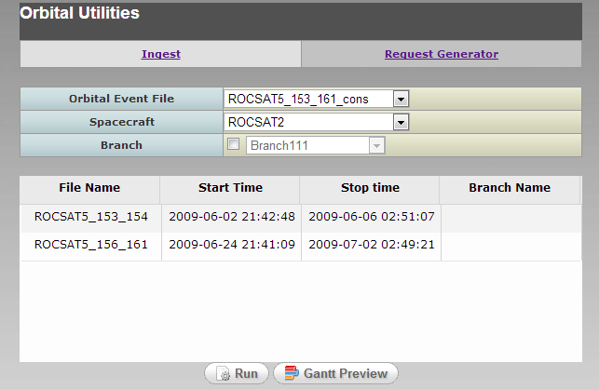
The MPSS Orbital Events utility provides operators the ability to generate orbital event data for scheduling periods and ingest orbit event data into the MPSS system. The orbit event data will be used as planning aides in generating multi-mission schedules.
To initiate the Orbital Events application from the MPSS Menu Bar as follows.
- Open the MPSS Menu Bar.
- Select the Planning… button to bring up the Planning Menu.
- Select the Orbital Events… button.
- Note that if another process is running that conflicts with the Orbital Events process, the user will be given the option to open the Orbital Events GUI in read-only mode.
The Orbit Events utility contains two “tabs”, Request Generator and Ingest, providing the option to generate orbit events or ingest orbit events. Each process is discussed in further detail below.

Orbit Event Request Generator

The Request Generator utility interfaces with OASYS to generate pre-defined orbit events. The MCC machines have a local instance of OASYS installed. Orbital events are requested from OASYS via the batch mode interface, oasyssrv. The Request Generator utility uses the necessary input files to initiate the OASYS orbit report generation process. The request generation process requires the following files:
- ASCII Ephemeris
- ROCSAT2.adb
- rev_rpt.adb
- pass_rpt.adb
- alias.adb

The MCC OASYS requires an ASCII Ephemeris file to generate the orbit events requested by the Orbit Events utility. An ASCII Ephemeris file must be generated from OASYS on the FDF machine. This ASCII Ephemeris file must then be retrieved from the FDF system and stored on the MCC machines. ASCII Ephemeris files are stored in the ELEMENTS directory under their associated satellite.
The ROCSAT2.adb file contains all the baseline database definitions required by the MCC/OASYS to properly function. In addition, the following items must be defined in the rocsat2.adb: ISUAL sensor definition, all ground sites that must be scheduled by the MCC, and the parameters and events required for MCC reporting. The only required parameter is the Orbit Number, which is a built-in parameter. The required events include Earth Eclipse of the Sun, Earth Eclipse of the Moon, Lunar Eclipse of the Sun, Sun in ISUAL FOV, and Station Contact events for each station that is required to be scheduled by MPSS. The eclipse events are standard built-in OASYS events, while the ISUAL and Station Contact events need to be defined by the user.
The FDF can create this file by saving the current FDF binary database as an ASCII database as rocsat2.adb and then transferring the ADB file to the MCC via ftp (in bin mode). This file must be stored in the OASYS_ADBS directory on the MCC machine.

The rev_rpt.adb file defines the required orbit events found in a satellite revolution or “rev”. The obit events defined in the rev_rpt.adb file include:
- Ascending Node (AN)
- Descending Node (DN)
- Orbit Number
This file must be generated by a member of the FDF personnel and stored in the OASYS_ADBS directory on the MCC machine.

The pass_rpt.adb file defines all the contact and eclipse events including:
- 0-degree Rise/Fade
- 10-degree Rise/Fade
- 20-degree Rise/Fade
- Maximum Elevation
- Maximum Elevation Time
- Sun/Moon Penumbra Enter/Exit
- Sun/Moon Umbra Enter/Exit
- Earth/Sun Penumbra Enter/Exit
- Earth/Sun Umbra Enter/Exit
- Earth/Moon Penumbra Enter/Exit
- Earth/Moon Umbra Enter/Exit
This file must be generated by a member of the FDF personnel and stored in the OASYS_ADBS directory on the MCC machine.

The alias.adb file contains aliases to OASYS report definitions. This file is pre-configured and should not be modified by MCC or FDF personnel.

To Generate Orbit Events
To initiate the request generation process:
- Select the Request Generator tab in the Orbital Utilities window.
- Specify a Start Time. The format of the time field is (yyyy/ddd/hh:mm:ss). This specifies the start time of the events to be generated.
- Specify a Stop Time. The format of the time field is (yyyy/ddd/hh:mm:ss). This specifies the start time of the events to be generated.
Note: The time window may overlap a previous event request, but it must begin at the end of the previous request as to maintain continuity.
- Enter a Result File Name (optional). This value is used as an “identifier” in the name of the output files generated by OASYS. The default result file name extracts the year and date information from the start and stop entries. An example of a default result file name, 2003_031_032
- Click Select to select the Satellites and associated Ephemeris files for the generation process.
A “Selection Dialog Box” window will be displayed on the screen. The window will contain two tabs, Satellites and Ephemeris. The Satellite tab will list the available satellite name(s) and the Ephemeris tab will list the available ASCII Ephemeris files retrieved from the FDF sub-system The ephemeris files must be selected in order to generate the orbital events. The operator can simply select the desired satellite and ephemeris files using the >, >>, <, and << buttons. Click OK to accept the selections and return to the Request Generator window or click Cancel to reject the selections and return.
- Click Run to initiate the orbit event generation process.
When the process has completed an HTML file will display the outputs and results of the generation process.

Request Generator Outputs
There are five output files generated by this application:
- Request Generation Log file. This html file contains hypertext links to the four different report files described below.
  - This file can be found in the GEN_LOG_FILES directory.
  - The default filename format is log_<result_file_name>.html.
- Rev Report Log file. This file contains the verbose output from OASYS while generating the orbit events specified in the rev_rpt.adb.
  - This file can be found in the GEN_REPORTS directory.
  - The filename format is <satellite name>_< result_file_name>_revs.rpt.
- Rev Report Data file: This is the output file containing orbit events generated by OASYS from the events listed in the rev_rpt.adb file.
  - This file can be found in the OASYS_OUTPUT directory.
  - The filename format is <satellite name>_< result_file_name>_revs.rpt.
- Contacts Report Log file: This file contains the verbose output from OASYS while generating the orbit events specified in the pass_rpt.adb.
  - This file can be found in the GEN_REPORTS directory.
  - The filename format is <satellite name>_< result_file_name>_cons.rpt.
- Contacts Report Data file: This is the output file containing orbit events generated by OASYS from the events listed in the pass_rpt.adb file.
  - This file can be found in the OASYS_OUTPUT directory.
  - The filename format is <satellite name>_< result_file_name>_cons.rpt.

Orbit Event Ingest
The Orbit Event Ingest utility is used to parse the orbit event file generated by OASYS and store the events into the MPSS database. The orbit event data may be ingested for nominal scheduling or branch scheduling. Orbit events that are ingested for branches will be stored separately from mission-level orbit events. Existing orbit event data that overlaps the time window of the new orbit event data will be replaced with the new corresponding set of orbit event.
This process uses the generated request files by Request Generator application to parse orbital events data to specified table in MPSS database. To ingest the request files user must select the Orbital events file, desired Satellite, and Branch.

To Ingest Orbit Events
To initiate the orbit ingest process:
- Select the Ingest tab in the Orbital Utilities window.
- Select an Orbital Event File. This selection is used to identify the rev and contact data files generated during the Request Generation process.
The rev and contact data files are located in the OASYS_OUTPUT directory.
- Select a Spacecraft. This is the satellite associated with the orbital event files specified above.
- Click Run to initiate the orbit event ingest process.
When the process has completed an HTML file will display the outputs and results of the generation process.
To ingest orbit events into a ‘what-if’ branch schedule (if a branch exists in the system):
- Click the Branch checkbox. This enables the selection of branch schedule.
- Select a Branch name. The orbit event data may be ingested for nominal scheduling or branch scheduling.
- Click Run to initiate the orbit event ingest process.
  - Orbit events ingested for branches will be stored separately from mission-level orbit events.
  - When the process has completed an HTML file will display the outputs and results of the generation process.

Ingest Outputs:
Ingest application generates three files:
- Orbit Ingest Log file. This html file contains hypertext links to the 2 different report files described below.
- This file can be found in the ING_LOG_FILES directory.
- The default filename format is log_<orbital_event_file identifier>.html. The <orbital_event_file identifier> will match the selection specified in the Orbital Event File field.
- Rev Report Data file. This is the output file generated by the ingest process which contains information about the objects written to the MPSS database.
  - This file can be found in the ING_REPORTS directory.
  - The filename format is <orbital_event_file identifier>_revs.rpt.
- Contacts Report Data file. This is the output file generated by the ingest process which contains information about the objects written to the MPSS database.
  - This file can be found in the ING_REPORTS directory.
  - The filename format is <orbital_event_file identifer>_cons.rpt.

RTS Schedule Request Generation
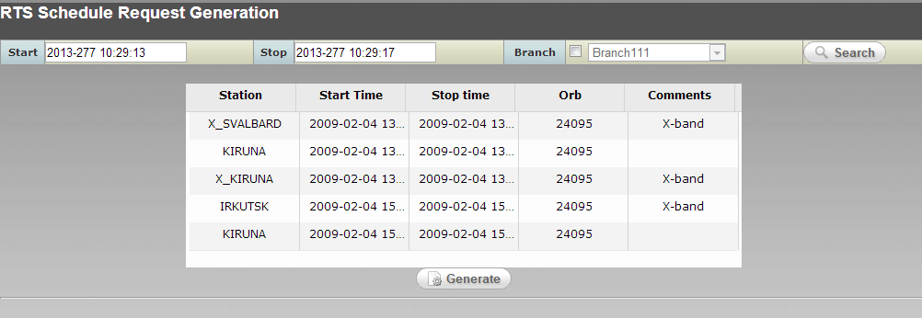
The Remote Tracking Station (RTS) Schedule Request utility enables the users to create an RTS schedule request. This utility provides the ability to specify the required scheduling request periods for each RTS site. Working with RTS Schedule Request Generation
Initiate the RTS Schedule Request Generation Application from the MPSS Menu Bar as follows.
- Open the MPSS Menu Bar.
- Select the Planning… option to bring up the Schedule Menu.
- Select the RTS Schedule Request Generation … button.
- Click the Select.. button to specify a time window to retrieve RTS contacts.
- In the RTS Request dialog window select the Start and Stop times (yyyy/ddd/hh:mm:ss).
- If requesting data from a “what-if” schedule, select the Branch button and select the desired branch from the branch list.
- Select OK to display RTS Schedule Requests for selected time range in the Table provided in the RTS Schedule Request Generator window.
- Select one or more desired remote sites by clicking on the check box located in the first column of the RTS Schedule Request Table.
- Add desired comments to the comment fields of selected RTS site.
- The File Name is optional and if it is not provided by user, the utility will generate one using the RTS_<request start time>_<request end time>_<Branch Name>.txt file name convention.
Select the Generate button. A prompt message will indicate the completion of the process and generated RTS request file name. The request file will be stored in the directory defined by the RTS_REQUESTS configuration value from the DIR section of MPSS configuration file.
The operator is responsible for transferring the RTS schedule request files to the RTS sites using the Transfer Data Utility.
The response to the RTS schedule requests must be entered manually into the Resource Configuration utility.

Session Management
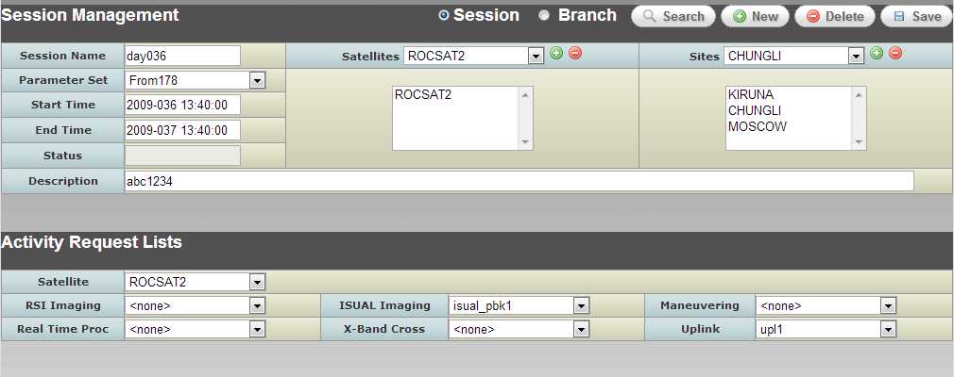
The Session Manager GUI enables the user to define a scheduling session. A session definition will include the scheduling time window, resource parameter set, defined in the MPSS Resource Management utility, the scheduling resources, satellites and sites, and sets of activity requests. The Session Manager utility will store the session and branch definitions in the MPSS database for use by other MPSS subsystems.

Working with Sessions
The following paragraphs describe how to create a session, open an existing session, save a session, or delete a session.

Creating a Session
Create a new session as follows.
- Select New… from the Session/Branch Management window. If the user has been editing a previous session or branch, and if that session or branch has not been saved, a question asks if the user would like to save the current session or branch before continuing to the next session or branch. If the user selects Yes, the current session or branch is saved, and the New Session/Branch Dialog window is displayed.
- Click the Session button.
- In the Name field, enter a name for the new session. This is a text field and is limited to 20 characters.
- Click OK.
Note that if the name entered matches the name of an existing session or branch, the user will be prompted to enter a different name.
The user also may create a new session by using data from an existing session. When this option is used, all satellite, site, and ARL information is copied from the existing session to the new session.
Create a new session from an existing session as follows.
- Select New… If the user has been editing another session or branch, and if that session or branch has not been saved, a question asks if the user would like to save the current session or branch and continue. If the user selects Yes, the current session or branch is saved, and the New Session/Branch Dialog window is displayed.
- Click the Session button.
- In the Name field, enter a name for the new session. This is a text field and is limited to 20 characters.
- Click the Create using data from existing Session checkbox.
- Select a session from the list.
- Click OK.
Note that if the name entered matches the name of an existing session, the user will be prompted to enter a different name.

Open an Existing Session
The user may open an existing session to view its definition or to modify its contents as follows.
- Select Search… If the user has been editing another session or branch, and if that session or branch has not been saved, a question asks if the user would like to save the current session or branch and continue. If the user selects Yes, the current session or branch is saved. The Open Session/Branch Dialog window is displayed.
- Click the Session button.
- Select the name of the session to open from the Select list.
- Click OK.

Saving a Session
Save a session as follows:
- In the Session/Branch Management GUI, select Save.
If the session being saved has been scheduled previously, a question prompt informs the user that saving the session will remove all activities from the schedule and asks if he wants to continue. If the user selects Yes, activities are removed, and the session is saved. If the user selects No, the session modifications will not be saved, and the schedule remains unchanged.

Deleting a Session
A user may delete a previously saved session. However, to keep sessions contiguous, the user may delete only the latest session, and must have that session open in the Session Manager. Delete the latest session as follows.
- Select Delete….
- If the session currently open in the Session Manager is not the latest session, an information prompt informs the user that the current session cannot be deleted because it is not the latest session.
- If the selected session has been previously scheduled and is the latest session, a question prompt informs the user that deleting the session will remove all activities from the schedule and asks if he wants to continue. If the user selects Yes, activities are removed, and the session is deleted. If the user selects No, the session will not be deleted, and schedule remains unchanged.

Working with Branches
Branches are “what-if” sessions. Branches are scheduled against their own ACQSUM and do not affect the nominal schedule in any way.

Creating a Branch
Create a new branch as follows.
- Select New… If the user has been editing another session or branch, and if that session or branch has not been saved, a question asks if the user would like to save the current session or branch and continue. If the user selects Yes, the current session or branch is saved. The New Session/Branch Dialog window is displayed.
- Click the Branch button.
- In the Name field, enter a name for the new branch. This is a text field and is limited to 20 characters.
- Click OK.
Note that if the name entered matches the name of an existing branch or session, the user will be prompted to enter a different name.
The user also may create a new branch by using data from an existing session. When this option is used, all satellite, site, and ARL information is copied from the existing session to the new branch.
To create a new branch from an existing session:
- Select New… If the user has been editing another session or branch, and if that session or branch has not been saved, a question asks if the user would like to save the current session or branch and continue. If the user selects Yes, the current session or branch is saved. The New Session/Branch Dialog window is displayed.
- Click the Branch button.
- In the Name field, enter a name for the new branch. This is a text field and is limited to 20 characters
- Click the Create using data from existing Session checkbox.
- Select a session from the list.
- Click OK.
Note that if the name entered matches the name of an existing branch or session, the user will be prompted to enter a different name.

Create a Branch from the Nominal Schedule
The user also may create a new branch by copying an existing session’s ACQSUM and schedule. Satellite, site, and ARL information is copied from the session to the branch. In addition, the ACQSUM data is copied to the branch, along with all scheduled and unscheduled activities related to the selected session. Creating a branch in this way allows the user to perform “what-if” changes on an already scheduled session.
To create a new branch from an existing session and copy ACQSUM and schedule information for that session:
- Select New… If the user has been editing another session or branch, and if that session or branch has not been saved, a question asks if the user would like to save the current session or branch and continue. If the user selects Yes, the current session or branch is saved. The New Session/Branch Dialog window is displayed.
- Click the Branch button.
- In the Name field, enter a name for the new branch. This is a text field and is limited to 20 characters.
- Click the Create using data from existing Session checkbox.
- Click the Copy existing Schedule checkbox.
- Select a session from the list.
- Click OK.
Note that if the name entered matches the name of an existing branch or session, the user will be prompted to enter a different name.
If the user wants to only copy a subset of the session into the new branch, the Start time of the branch can be increased (as long as it is still less than the original session Stop time) and the Stop time of the branch can be decreased (as long as it is still greater than the original session Start time). The schedule is copied into the new branch whenSave is selected.
If the user decreases the branch Start time, increases the branch Stop time, or modifies any of the other branch settings so that they differ from the original session’s settings, the session’s schedule will not be copied into the branch. If the user selects File/Save, a question message will be received indicating that the schedule will not be copied to the branch, and asks if the user would still like to save the branch. If the user selects Yes in the message, the branch is saved to the database; if the user selects No in the message, the branch is not saved to the database and the user can continue making changes to the branch settings.

Open an Existing Branch
The user may open an existing branch to view its definition or to modify its contents. Open a branch as follows.
- Select Search… If the user has been editing another session or branch, and if that session or branch has not been saved, a question asks if the user would like to save the current session or branch and continue. If the user selects Yes, the current session or branch is saved. The Open Session/Branch Dialog window is displayed.
- Click the Branch button.
- Select the name of the branch to open from the Select list.
- Click OK.

Saving a Branch
Save a branch as follows.
- In the Session/Branch Management GUI, select Save.
If the branch being saved has been scheduled previously, a question prompt informs the user that saving the branch will remove all activities from the schedule and asks if the user wants to continue. If the user selects Yes, activities are removed, and the branch is saved. If the user selects No, the branch will not be saved, and the branch schedule remains unchanged.

Deleting a Branch
A user may delete a previously saved branch. When a branch is deleted, all ACQSUM and schedule information is deleted, as well. To delete a branch, the user must open that branch in the Session Manager. Delete a branch as follows.
- Select Delete…
- If the selected branch has been previously scheduled, a question prompt informs the user that deleting the branch will remove all activities from the schedule and asks if the user wants to continue. If the user selects Yes, activities are removed, and the branch is deleted. If the user selects No, the branch will not be deleted, and the branch schedule remains unchanged.

Selecting the Time Range

Session Time Range
To keep sessions contiguous, the start time of a new session will be the stop time of the last session created, and the user will not be able to modify the start time. If, however, this is the first session created, the user will be able to enter session start and stop times (yyyy/ddd/hh:mm:ss); the start time of the first session in the database must not be earlier than the latest recorder checkpoint time in the database. The session stop time defaults to 7 days after the start time. The user may modify the stop time, if desired.

Branch Time Range
Since branches are “what-if” sessions, the start time of a branch must fall within the start time of the earliest session and the stop time of the latest session in the database. The branch stop time must be later than the branch start time and can extend past the end of the last session. By default, the branch start time is set to the earliest session's start, and the stop time is set to the stop time of the latest session.

Selecting a Parameter Set
A session defines which parameter set values are to be used during cold scheduling. A different parameter set may be used for each session, or many sessions may use the same parameter set. The Parameter Set field in the Session/Branch Management GUI defines the parameter set to be used when scheduling the session. Select the parameter set for the session as follows.
- In the Session/Branch Management GUI, click the combo box in the Parameter Set field.
- The list of possible parameter sets will be displayed.
- Select the desired Parameter Set from the list.

Selecting Satellites and Sites
A session defines which satellites and sites are to be used during cold scheduling. The Satellite/Site Selection group on the Session/Branch Management GUI summarizes the selected satellites and sites. Add or modify satellite and site selections as follows.
- Click the Select… button within the Satellite/Site Selection group. The Selection Dialog Box GUI will appear.
To add satellites:
Select the Satellite tab.
From the Available list, select the satellites to add.
Click the > button. This will move the selected satellites to the Selected list.
To select all satellites within the Available list, select the >> button.
To remove satellites:
Select the Satellite tab.
From the Selected list, select the satellites to remove.
Click the < button. This will move the selected satellites to the Available list.
To remove all selected satellites, click the << button.
To add sites:
Select the Site tab.
From the Available list, select the sites to add.
Click the > button. This will move the selected sites to the Selected list.
To select all sites within the Available list, click the >> button.
To remove sites:
Select the Site tab.
From the Selected list, select the sites to remove.
Click the < button. This will move the selected sites to the Available list.
To remove all selected sites, click the << button.
To accept the satellite and site selections, click OK to return to the Session/Branch Management GUI, or click Cancel to return to the original satellite and site settings.

ARL/Satellite Assignments
The ARL/Satellite Assignments group defines which activity requests to map to each satellite. These mappings will be used during cold scheduling to define the activities to be created for each satellite. Assign ARLs to satellites as follows.
- Select a satellite from the Satellite combo box.
- Select the ARL name for each of the ARL types: RSI Imaging, ISUAL Imaging, Maneuvering, Real Time Procedure, X-Band Cross, and Uplink. The selection <none> within any ARL type indicates that no ARL of that type has been selected for that satellite.
If errors were made when selecting the ARLs and if the session has not been saved, click the Reset button to reset all ARL assignments for the currently selected satellite.

Session/Branch Description
The Description field allows users to enter comments about the current session or branch. The user may save changes to this field for a scheduled or an unscheduled session.

Activity Request List Editor
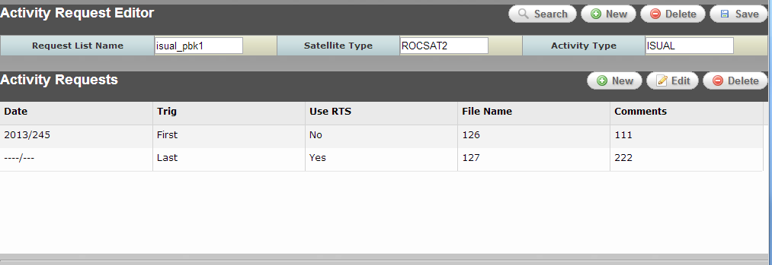
The Activity Request List (ARL) Editor utility enable users to create activity requests for RSI Imaging activities, ISUAL Imaging activities, Monitoring activities, Uplink activities, Real-Time Command activities, and X-Band Cross activities. Each activity type defines the timing frequency, and in some types, resources that are required when scheduling.
Activity requests may consist of one or more request specifications, identifying required activities at specific times and more general activity times. Users may create activity requests by copying existing ARLs and modifying needed specifications. The activity requests are not designed to be spacecraft specific, allowing one activity request to be used for scheduling multiple satellites.
The Activity Request editor will store the ARLs in the MPSS database for use by other MPSS subsystems.

Working with Activity Request List Editor
The following paragraphs describe how to create an ARL, open an existing ARL, save an ARL, or delete an ARL.

Creating a New ARL
Create a new activity request as follows.
- Select New… from the Activity Request Editor Window. If the user has been editing a previous ARL, and if that ARL has not been saved, a question asks if the user would like to save the current ARL before continuing to create the next activity request. If the user selects Yes, the current ARL is saved, and the New Request Dialog window is displayed.
- In the Name field, enter a name for the new ARL. This is a text field.
- Select the Satellite Type from the pulldown list.
- Select the Activity Type from the pulldown list.
- Click OK.
Note that if the name entered matches the name of an existing ARL, the user will be prompted to enter a different name.
The user also may create a new ARL by using data from an existing. When this option is used, all ARL information is copied from the existing ARL to the new ARL.
Copy a new activity request from an existing ARL as follows.
- Select New… If the user has been editing another ARL, and if that ARL has not been saved, a question asks if the user would like to save the current ARL and continue. If the user selects Yes, the current ARL is saved, and the New Activity Request Dialog window is displayed.
- In the Name field, enter a name for the new ARL.
- Select the Satellite Type from the pulldown list.
- Select the Activity Type from the pulldown list.
- Click the Copy from Available Request List checkbox.
- Select an activity request from the list.
- Click OK.
Note that if the name entered matches the name of an existing ARL, the user will be prompted to enter a different name.

Open an Existing ARL
The user may open an existing ARL to view its definition or to modify its contents as follows.
- Select Search… If the user has been editing another ARL, and if that ARL has not been saved, a question asks if the user would like to save the current ARL and continue. If the user selects Yes, the current ARL is saved. The Open Request Dialog window is displayed.
- Select the Satellite Type from the pulldown list.
- Select the Activity Type from the pulldown list.
- Select an ARL from the Available Activity Request list
- Click OK.

Saving an ARL
Save an ARL as follows:
  - In the ARL GUI, select Save.
If the ARL has been scheduled previously, a question prompt informs the user that user can save this ARL with different name and asks if user wants to continue. If the user selects Yes, then in the new dialog window user will be able to name the ARL and save the ARL. If the user selects No, the ARL modifications will not be saved, and ARL stay unchanged.

Deleting an ARL
A user may delete a previously saved ARL. However, the user is only allowed to delete an ARL that is not being used by a session. If user tries to delete an ARL that is used by a session, an error message will prompt indicating that this ARL cannot be deleted because it is being used by a session. If the ARL is not used by any session, a question prompt informs the user that deleting this ARL will remove this ARL and all of its entries. If the user selects Yes, ARL is removed. If the user selects No, the ARL will not be deleted.
Delete the ARL as follows.
- Select Delete

Editing an Activity Request Specification
The Activity Request Editor provides the ability to Add, Edit, Delete ARL specification to the existing ARLs or new ARLs. The ARL specifications are listed in the provided list in Activity Request Editor. The following sections describe details of adding a New ARL specification to an open or new ARL, Edit an existing ARL specification, and Delete an existing ARL specification.

Create a New Activity Request Specification
The Activity Request Editor provides the ability to Add ARL specification to existing ARLs or new ARLs. However, additional ARL specifications cannot be added to ARLs that have been used to generate a schedule. To modify ARLs that have been scheduled, the Activity Request Editor provides the ability to copy the contents of an ARL to a new ARL.
To create a new ARL specification:
- In the ARL utility, while an ARL is open, click on the New button on the lower right side of the Activity Request Editor window. This will prompt a dialog window that allows the user to create a new ARL specification to the open ARL.
- In the specification dialog window enter all the necessary data.
- Click OK to assign the specification to the open ARL, or Click Cancel to exit this dialog window without assigning this specification.

Edit an Existing Activity Request Specification
The Activity Request Editor provides the ability to modify specifications in ARLs. However, modifications to specifications cannot be performed if an ARL has been used to generate a schedule. To edit an ARL specification that has been already scheduled, the Activity Request Editor provides the ability to copy the contents of the open ARL to a new ARL. Modifications can then be performed on the specifications in the new ARL.
To Edit an ARL specification:
- Open an existing ARL
- Select an ARL specification and then click on the Edit button on the lower right side of the Activity Request Editor window. This will prompt a dialog window that allows the user to modify the specification.
- Modify the specification values as needed..
- Click OK to accept the changes and update the specification in the Activity Request List Editor window, or click Cancel to exit this dialog window without updating this specification.

Delete an Existing Activity Request Specification
The Activity Request Editor provides the ability to Delete specification from ARLs. However, modifications to specifications cannot be performed if an ARL has been used to generate a schedule.
To Delete an ARL specification:
- Open an existing ARL
- Select an ARL specification and then click on the Delete button on the lower right side of the Activity Request Editor window.
This deletion becomes final only when the ARL is saved.

Activity Request Specifications
Each ARL includes one or more ARL specifications with the same type and each specification is represented as an entry in the ARL Specification list. As described in the previous sections user can add, edit, and delete ARL specifications. The following sections describe detail information about different ARL specifications type and associated dialog window.

Maneuver Activity Request Specifications
The Maneuver Activity Request Specifications window provides data fields that are used in supporting spacecraft maneuver operations such as RSI, ISUAL or nominal spacecraft maneuvers. The scheduling algorithm uses Maneuver request data to determine the approximate time when a maneuver is to be performed and to ensure that this does not interfere with other satellite operations, such as imaging requests.
The following are the data field required to generate a maneuver request:
- Date: Date (YYYY/DOY) the maneuver is to be performed.
- Start Time: Start time (hh:mm:ss) of the maneuver activity.
- Duration: Duration (sss.mmmm) of the maneuver activity.
- Maneuver Type:
- Attitude: Attitude maneuver require four quaternion values. The quaternion parameters Q1, Q2, Q3, and Q4 values are ranged within –1.0000 to 1.0000 and represent the scaled vectors for axis rotation of the coordinate frames.
  - Orbit: FDF personnel plan and generator orbit maneuver plans. The orbit maneuver plans must be retrieved from the FDF using the Transfer Data utility. Using the orbit maneuver plan the operator must generate the associated orbit maneuver procedure. The orbit maneuver type requires a link to the orbit maneuver plan and associated procedure.
  - Go Home.
- Comments: The Comments field is a text field that can be used by user for any specific comments.

RSI Activity Request Specifications
The RSI Activity Request Specifications window provides data fields that are used in supporting RSI operations such as RSI record and DDT. These are the requests to collect (record and playback) imaging data for the RSI instrument. RSI imaging requests specify, at a minimum, the date/time and duration of the request, the corresponding orbit and elevation, the imaging mode, the imaging type, and the imaging range, the type of the imaging request. The following is the list of fields used in RSI Activity Request Specifications dialog window:
- Start Date: Date (YYYY/DOY) the activity is to be performed.
- Start Time: Start time (hh:mm:ss) of the activity
- Duration: Duration (in seconds) of the activity
- Station Information: optional fields to provide station location infomration
  - Station: Name of requesting station
  - Orbit: Corresponding orbit
  - Elevation: Elevation angle of satellite position viewed from receiving station at the point that sat start to take image.
  - Azimuth: Azimuth angle of satellite position viewed from receiving station at the point that satellite start to take image
- Mode: Imaging mode - MS, PAN, PAN+MS
- Type: Imaging types - Mono-strip, Multi-strip, Stereo mono-strip, Stereo multi-strip
- PAN Compression Ratio: Low/High/Default
- MS Compression Ratio: Low/High/Default
- Video Gains: Gain settings for PAN, MB1, MB2, MB3, and MB4.
- SSR Status: RSI imaging type – Record/DDT
- Imaging Grid: optional fields to specify RSI imaging grid information
  - Track GI: Track number of satellite. Integer value between 01..14.
  - Grid JS: Start of Grid J for imaging. Integer value between 001:999 or "NA"
  - Grid JE: End of Grid J for imaging. Integer value between 001:999 or "NA"
  - Grid K: Grid K for imaging. Integer value between 001:999 or "NA"
  - Start Latitude: Start latitude of imaging area. Integer value between –90.0..90.0
  - Stop Latitude: Stop latitude of imaging. . Integer value between –90.0..90.0
- Comments: The Comments field is a text field that can be used by user for any specific comments.

ISUAL Activity Request Specifications
The ISUAL Activity Request Specifications dialog window provides data fields that are used in supporting ISUAL playback operations. ISUAL imaging request are used to transmit ISUAL data that has been recorded on the SSR. The following is the list of fields provided in ISUAL Activity Request Specifications dialog window:
- Absolute Date: Provides ability to specify the date (YYYY/DOY) the activity is to be performed.
- Every Day: Provides ability to specify this activity should happen “every day”.
- ISUAL Filename: Filenames 126 and 127 are the only two assigned ISUAL file names on the SSR.
- Contact Occurrence: Specifies when to the playback occurs, FIRST or LAST contact of the specified day.
- Use Remote Tracking Station: Specifies if remote tracking stations can be used to schedule the activity.
- Comments: The Comments field is a text field that can be used by user for any specific comments.

Uplink Activity Request Specifications
The Uplink activity request provides the ability to specify when and what type of spacecraft load to schedule. The following is the list of fields provided by the Uplink Request specification window:
- Absolute Date: Provides ability to specify the date (YYYY/DOY) the activity is to be performed.
- Every Day: Provides ability to specify this activity should happen “every day”.
- Start Time: Approximate start time (hh:mm:ss) of the activity. This is not the actual start time of the uplink rather the start of the scheduling window.
- Duration: Duration (sss.mmmm) of the activity.
- Load Type: TTQ or MPQ.
- Comments: The Comments field is a text field that can be used by user for any specific comments.

Real-Time Command Activity Request Specifications

The Real Time Procedure Activity Type is used to specify a period of time to execute a real-time procedure. The Real Time Procedure Request window contains the following inputs:
- Start Date: Date (YYYY/DOY) the activity is to be performed.
- Start Time: Start time (hh:mm:ss) of the activity
- Duration: Duration (in seconds) of the activity
- Procedure: STOL procedure name to execute.
- Comments: The Comments field is a text field that can be used by user for any specific comments.

X-Cross Activity Request Specifications
The X-Band Cross Activity Request Specification window allows users to specify when an X-Band cross activity occurs. The X-Band cross activities are used to perform the antenna switch command while the transmission of data is paused. The X-Band Crossover request window contains the following inputs:
- Start Date: Date (YYYY/DOY) the activity is to be performed.
- Start Time: Start time (hh:mm:ss) of the activity
- Duration: Duration (in seconds) of the activity
- Station Information: optional fields to provide station location information
- Station: Name of requesting station
- Orbit: Corresponding orbit
- Elevation: Elevation angle of satellite position viewed from receiving station at the point that sat start to take image.
- Azimuth: Azimuth angle of satellite position viewed from receiving station at the point that satellite start to take image
- Comments: The Comments field is a text field that can be used by user for any specific comments.

Cold Scheduling

Overview
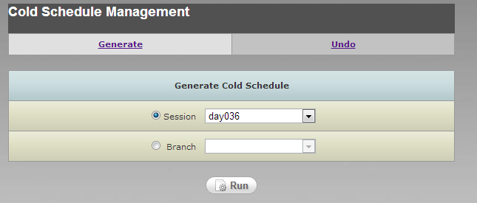
The Cold Scheduler is one of the MPSS core functions. The Cold Scheduler considers all of the contact data, session definitions, and ARL definitions. Given all of the resources and user-defined parameters, the Cold Scheduler generates a schedule that follows the rules defined in Rules Document. The Cold Scheduler will attempt to schedule as many activities as possible in the time allocated for Cold Schedule generation. The scheduler filters orbit data previously loaded into the MPSS database, which overlaps the session window. If a branch is scheduled, the orbit event data associated to the branch will be filtered. The filter criterion is based on selected satellites and site in session/branch, minimum contact maximum elevation requirement for cold scheduling, and minimum contact duration for cold scheduling.
The cold scheduling function works in the background to process the user’s requests and resource data to generate the schedule. The scheduling software automatically runs the following processes for the user.
- User data collection.
- Contact filtering.
- Activity generation.
- Schedule solution processing..
- Schedule saving.
The Cold Scheduler probably will not schedule every activity. Activities left unscheduled, due to the constraints of the rules and the impossibility of checking every possible arrangement of activities and resources, will be placed in an unscheduled activities window, viewable through the Gantt Chart. Via the Gantt Chart, the user can manipulate these unscheduled activities later. This process is known as “hot scheduling”. Most cold scheduling is performed for the user in the background. There is very little user input during the cold scheduling process. Sections 3.2.2 and 3.2.3 describe the user’s responsibilities.

Cold Scheduling Preparation
Before the Cold Scheduler is initiated, the user should:
- Generate contact data for the desired time period to be scheduled.
- Load the generated contact data into the database.
- Create new or edit existing ARLs.
- Create a parameter set defining the resource parameters to be used during scheduling.
- Create a session, and assign ARLs.
When these steps are completed, the session is ready to be cold scheduled.

Cold Scheduling User Specification Directions
Initiate the Cold Scheduling Application from the MPSS Menu Bar as follows.
- Open the MPSS Menu Bar.
- Select the Cold Scheduler… option.
- Select the Session or Branch button.
- Use the corresponding pulldown list to select an existing session or branch.
- Select the Run button.

The user can set the ‘Cold scheduling limit’ to define the amount of time that the scheduler will have to solve the schedule. This limit is a time that can be set by the user in the Resource Configuration utility under the Scheduling Parameters tab.
Once the user selects the Run button, a status window will appear. This window displays a progress bar and a text box. The progress bar illustrates the exact percentage of the ‘Cold scheduling limit’ that has been used. If the scheduling limit is reached before the schedule is solved, the Cold Scheduler will time-out and display a message. Note that the status bar does not represent the percentage of the schedule that is complete. As noted above, the bar represents the percentage of the ‘Cold scheduling limit’ that has already been used by the process. The text box area will display messages stating which scheduling process step is being executed at that time.
Once the schedule generation is completed, an information message box will appear. The message will state whether or not the scheduler completed successfully or aborted, and indicate the total number of activities generated, how many activities the scheduler was unable to schedule (these will appear in the Unscheduled Activities window when the timeline is opened). The message will also provide the name of the log file. Select OK to exit this message window.

Aborting a Schedule
The user may abort the cold scheduling process by selecting the Abort button on the Status Window. However, once the scheduler reaches the “Scheduler is saving solution…” point of the process, the user will not be allowed to abort the schedule. The abort process is not an instantaneous function. Note that the abort process may require the same amount of processing time already used prior to selecting the Abort button.

Schedule Undo
The user can undo any scheduled session or branch. The undo process “un-cold schedules” the session or branch; once the undo process has completed, the user may run cold scheduling on the session or branch again. Undo a scheduled session/branch as follows.
- Open the MPSS Menu Bar.
- Select the Cold Scheduler… option.
- Select the Undo tab.
- Select the Session or Branch button.
- Use the corresponding pulldown list to select the latest scheduled session or any scheduled branch to undo.
- Select the Run button.

Activity Generation
The scheduler generates activities by processing and expanding ARLs (Activity Request Lists). The ARLs act as general requests. The activities are assigned absolute time windows based on the ARL requests. The activities become the specific implementation of the requests. For instance, there may be an ARL for a uplink request for every day of the spacecraft. This single uplink ARL would generate many activities. The activity generator determines the exact number of activities that need to be generated from a given ARL. Usually more than one activity will be generated from a given ARL, unless the ARL is very specific.
The scheduler then checks previous activities for overlap from the last scheduled time period. Then, the scheduler considers all of the rules to ensure that the activities generated do not violate any of the scheduling rules.

Activities
Activity requests are generated by Activity Request Lists (ARLs) or instrument Mission Timelines. Activity requests result in the scheduling of activities translated subsequently into a combination of real-time ground directives and/or spacecraft commands. The following paragraphs will describe activity types as they are generated from the ARLs or Mission Timelines.

RSI Record Activity
RSI record activities are generated from RSI Imaging requests specifying an SSR_STATUS of “RECORD”. The RSI data may be recorded in Panchromatic (PAN), Multi-spectrum (MS), or PAN+MS imaging modes.
RSI Record activities contain three internal activities:
- SSR Setup: represents the amount of time to configure the SSR for the RSI imaging request. RSI Record Setup Duration value is used to specify the SSR setup activity duration. The activity occurs prior to the actual imaging window.
- Imaging: represents the actual RSI imaging window. The time and duration of the imaging activity is specified within the RSI Mission Timeline or ARL entry.
- SSR Cleanup: represents the amount of time to perform any SSR cleanup operations. RSI Record Cleanup Duration value is used to specify the SSR cleanup activity duration.
The imaging duration of an RSI Record activity, or sequence of RSI Record and/or RSI DDT activities, is limited by the RSI Focal Plane Assembly (RFPA) limit. The RFPA indicates the “on” duration of the RSI instrument.
The data recorded by an RSI Record activity is stored on the SSR. Each data type is allocated its own file on the SSR for storage. The imaging data is retained on the SSR as long as possible until space is required to store data for another RSI imaging request, either RSI Record or RSI DDT. At that point, an SSR Delete activity is scheduled which represents the “deletion” of the imaging file from the SSR.
The amount of space allocated for each imaging file is dependent on the type of data (PAN, MS, or PAN+MS), the duration of the record, and the compression ratio related to each imaging type. Each imaging data type has an associated SSR input ratio, which is defined in the Resource Configuration utility. Each data type also has an associated compression ratio (LOW, HIGH, or DEFAULT). The compression ratio indicates which SSR input ratio to use when allocating sectors for the RSI Record activity. The DEFAULT compression ratio is dependent on the imaging data type:
- DEFAULT compression ratio for PAN imaging is: LOW.
- DEFAULT compression ratio for MS imaging is LOW.
- DEFAULT compression ratio for PAN and MS during PAN+MS imaging is HIGH.
The RSI Record SSR allocation algorithm is the following:
- sectors = (Record duration * SSR input ratio) + file sector margin

RSI Playback Activity
In order to retrieve the data recorded during an RSI Record activity, an RSI Playback activity must be scheduled. RSI Playback activities represent the read/transmit of RSI data from the SSR to the ground X-Band antenna. RSI Playback activities can only be scheduled within the 20-degree mask of an X-Band contact.
RSI Playback activities contain three internal activities:
- SSR Setup: represents the amount of time to configure the SSR for the transmission of the RSI data. RSI Playback Setup Duration value is used to specify the SSR setup activity duration. The activity occurs prior to the actual imaging window.
- Transmission: represents the actual playback window. The time and duration of the transmission is based on the time window of the associated RSI Record activity and the X-Band contact times.
- SSR Cleanup: represents the amount of time to perform any SSR cleanup operations. RSI Playback Cleanup Duration value is used to specify the SSR cleanup activity duration.
RSI Record activities can have multiple RSI Playback activities. This represents the data recorded during the RSI Record activity is transmitted multiple times to the ground.
For each SSR file allocated during an RSI Record activity, an RSI Playback activity is generated to transmit the contents of the file to the ground. There is one exception however, if the RSI Record is performing PAN+MS imaging during an X-Band contact, only one RSI Playback activity is generated. This one RSI Playback activity transmits the contents of both SSR files at the same time.
The duration of an RSI Playback is dependent on the number of sectors allocated to its associated RSI Record activity, bandwidth allocation, SSR output data rate, and any overlapping X-Band Crossover activities. The playback duration is calculated as:
- For PAN or MS only data: (SSR sectors / output data rate) + “potential” X-Band crossover duration.
- For PAN+MS data, the duration must be calculated for each SSR file, taking into account the bandwidth ratio to interleave the data transmission. For the PAN file, the duration is calculated as (SSR sectors / (output data rate * VC1 bandwidth ratio)) + “potential” X-Band crossover duration. The MS file duration calculation is (SSR sectors / (output data rate * VC2 bandwidth ratio)) + “potential” X-Band crossover duration. The greater duration is the final duration of the RSI Playback activity.
- If an X-Band crossover activity starts during the RSI Playback activity, then the duration of the X-Band crossover activity is added to the total duration.

RSI DDT Activity
RSI DDT activities are generated from RSI Imaging requests specifying an SSR_STATUS of “DDT”. The RSI data may be recorded in Panchromatic (PAN), Multi-spectrum (MS), or PAN+MS imaging modes. Data recorded during an RSI DDT activity is not stored on the SSR recorder. Rather the SSR is used as a “buffer” to hold the data as it is recorded then transmitted to the ground. The data recorded during an RSI DDT activity is deleted from the SSR after the RSI DDT activity is completed.
RSI DDT activities contain three internal activities:
- SSR Setup: represents the amount of time to configure the SSR for the RSI imaging request. RSI Record Setup Duration value is used to specify the SSR setup activity duration. The activity occurs prior to the actual imaging window.
- Imaging/Transmission: represents the actual DDT window. The time and duration of the DDT is specified within the RSI Mission Timeline or ARL entry.
- SSR Cleanup: represents the amount of time to perform any SSR cleanup operations. The SSR cleanup activity is dependent on the number of sectors reserved for the DDT activity * Post DDT Delay Per Sector value.
The imaging duration of an RSI DDT activity, or sequence of RSI Record and/or RSI DDT activities, is limited by the RSI Focal Plane Assembly (RFPA) limit. The RFPA indicates the “on” duration of the RSI instrument.
The type of data recorded by the RSI DDT indicates the number of files required to use as a “buffer” on the SSR. PAN or MS data requires only one file, while PAN+MS data requires 2 separate SSR files.
The amount of space allocated for each imaging file is dependent on the type of data (PAN, MS, or PAN+MS), the duration of the DDT, the compression ratio related to each imaging type, and the duration of any overlapping X-Band crossover activities. Each imaging data type has an associated SSR input ratio, which is defined in the Resource Configuration utility. Each data type also has an associated compression ratio (LOW, HIGH, or DEFAULT). The compression ratio indicates which SSR input ratio to use when allocating sectors for the RSI Record activity. The DEFAULT compression ratio is dependent on the imaging data type:
- DEFAULT compression ratio for PAN imaging is: LOW.
- DEFAULT compression ratio for MS imaging is LOW.
- DEFAULT compression ratio for PAN and MS during PAN+MS imaging is HIGH.
The RSI DDT SSR sector allocation algorithm is the following:
- sectors = accumulation rate * (DDT duration – X-Band crossover duration) + (SSR input rate * X-Band crossover duration) + file sector margin
- accumulation rate = SSR input rate – (output data rate * bandwidth allocation ratio)
- If an X-Band crossover equals 0 unless an X-Band crossover activity starts during an RSI DDT activity.
- If performing PAN or MS imaging, then bandwidth allocation ratio defaults to 1.0.
- If performing PAN+MS imaging, then the bandwidth allocation ratio is based off the Resource Configuration values for VC1 and VC2.
The SSR has a restriction on the minimum and maximum sectors allowed for each DDT file. The minimum is specified in the mpss.cfg file as “MinDDTAllocation” while the maximum is configurable in the Resource Configuration utility as “Maximum DDT Sector Allocation.”

SSR Delete Activity
SSR Delete activities are used to delete data files stored on the SSR from an RSI Record. Each file allocated by an RSI Record activity has an associated SSR Delete activity. SSR Delete activities are automatically scheduled when space is required to schedule a new RSI Record activity.

ISUAL Playback Activity
These activities request the playback of ISUAL data during an S-Band contact. ISUAL playback activities do not have an associated ISUAL record activity. Since the ISUAL instrument records ISUAL data automatically, MPSS is unable to generate and schedule ISUAL record activities.
ISUAL Playback activities reference procedures that execute real-time during an S-Band contact. The duration of the ISUAL Playback activity must be at least the minimum required to perform the command/procedure request.

Maneuver Activity
A Maneuver activity is used to specify the time and duration of a spacecraft maneuver. Spacecraft maneuvers include Attitude, Go Home, and Orbit. Maneuver activities must not overlap any imaging or data transmission activities.

Real-Time Activity
These activities schedule the execution of one or more real-time command procedures. Real-time command procedures may contain a combination of ground directives and spacecraft commands to be executed during a spacecraft contact. The commands within a real-time procedure are assumed not to require any active resource allocation or conflict management. A real-time activity is restricted within a 10-degree S-Band station mask. The duration of a real-time activity must be at least the minimum required to perform command/procedure request.

Miscellaneous Activity
Miscellaneous activities are used to schedule the execution of one or more commands contained within an associated procedure. The miscellaneous procedure may contain a combination of commands to execute either out of the TTQ or MPQ loads. The commands within a miscellaneous procedure are assumed not to require any active resource allocation or conflict management. The duration of a miscellaneous activity must be at least the minimum required to perform the command/procedure request. A miscellaneous activity can occur anytime within the schedule because it does not conflict with any other activities.

Spacecraft Monitoring Activity
Spacecraft monitoring activities are scheduled to observe the health and safety of a spacecraft. They are generated and scheduled automatically by the MPSS scheduler whenever an available S-Band station contact occurs. Spacecraft monitoring activities start and end on the 0-degree S-Band station mask and do not require any spacecraft resources. These activities are written to TTQ loads and can occur during any other activity.

Uplink Load Activities
Uplink activity requests are used to schedule the uplink of one or more memory load files for a given spacecraft. Uplink activities specify the load type including Time Tagged Queues (TTQs) and Mission Plan Queues (MPQs). The duration of the uplink activity must be long enough to handle the uplink of the load to the spacecraft. The associated load file for the uplink activity is generated by the Product Generation utility. Uplink activities occur within the 10-degree S-Band station contact mask and cannot overlap Real-Time or ISUAL Procedure activities.

X-Band Crossover Activity
The X-Band Crossover activity represents the +X X-band 6db crossover event. X-Band crossover activities represent the switch duration between the +X and –X antennas onboard the ROCSAT2 spacecraft. The duration of the X-Band Crossover activity is specified in the Resource Configuration utility. RSI Playback activities and DDT activities that overlap the X-Band crossover activity are affected by the X-Band crossover activity to handle the SSR pause, switch X-Band antenna, then SSR resume. RSI Playback activity durations are extended to include the X-Band crossover activity. The number of sectors allocated to an RSI DDT activity is adjusted to include the additional sectors required to pause the transmission during an X-Band crossover activity.

Solution Search
When all activities are generated, a solution search begins. The activities are matched with available contacts and other resources. The rules are used to rank activities in order to schedule as many activities as possible. All unscheduled activities will be placed in the unscheduled window in the timeline and text schedule viewer.

Cold Scheduling Conclusion
The Cold Scheduler uses all of the user inputs and contact information to prepare a schedule that fits within the rules. The next step is for the user to manipulate and adjust the schedule based on human knowledge regarding the rules and specific situations. The tool used to manipulate the schedule is called the Gantt Chart. .

External Activity Request Scheduler

Overview
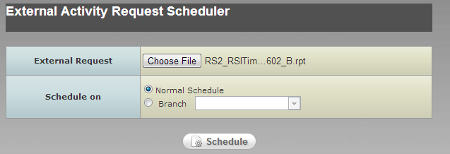
The External Activity Request Scheduler (EARS) provides the ability to ingest and schedule external requests. The EARS utility allows users to select Mission Timelines received from the PSF and the ISUAL SDDC. EARS processes and schedules the Mission Timelines selected by the user from the PSF and the ISUAL SDDC directory tree. The External Activity Request Scheduler will process the activity requests and store this information within the MPSS database. EARS can be run for the nominal schedule or branch schedule. The Mission Timelines files reside in the directory defined by the EARDATAELEMENTS configuration value from the EAR section of MPSS configuration file.

Working with External Activity Request Scheduler (EARS)
Initiate the External Activity Request Scheduler Application from the MPSS Menu Bar as follows.
- Open the MPSS Menu Bar.
- Select the External Activity Request Scheduler … option.
- Select the ISUAL_SDDC or PSF directory from the directory tree by clicking on the + sign.
- Select the desired external request file.
- Select nominal or Branch button. If branch button is selected, select a branch from the pulldown list.
- Select the Run button.

Ingesting Mission Timelines
In order to properly ingest a Mission Timeline, the following information must be in the header of the file:
- Spacecraft: Indicates which satellite the activity requests are to be scheduled on.
  - Options ROCSAT-2 and TBD
- Instrument: Indicates which instrument associated with the Mission Timeline.
  - Options – RSI or ISUAL
- Request_Window: Indicates time window of all activity requests contained within Mission Timeline. Includes start of first activity request to end of last activity request.
The ingest process parses each Mission Timeline file for the spacecraft, instrument, and time window. If the spacecraft or instrument is of unknown type, the Mission Timeline is rejected. The spacecraft, instrument, request window and filename are stored into the database as a reference to the Mission Timeline that was ingested.
The request window is read in from the file and 24 hours is added. This 24-hour period is added in order to load additional orbital data that may be required when scheduling the activity requests. The new time window is used to determine if a schedule has been generated (by Cold Scheduler utility) that encompasses the time period. This process is required to verify a parameter set has been defined for the schedulable resources during the time window of the Mission Timeline.

The ingest process does not allow Mission Timeline files to overlap, in time, with other Mission Timelines unless:
- They are associated with different satellites.
- They are associated with different instruments.
- The request window completely contains the request windows of the overlapping Mission Timelines.

RSI Mission Timelines
Each activity request within the RSI Mission Timeline is parsed and sorted by request type. Request types include:
- Attitude maneuver
- Sun-pointing maneuver
- RSI imaging
- X-Band crossover

Attitude Maneuver Request
The External Activity Request Scheduler generates a maneuver activity from the attitude maneuver request. The maneuver activity is of type ATTITUDE and stores the quaternion values specified within the request. Activity windows and durations within MPSS are rounded to the nearest second. In order to maintain maneuver activity durations in fractions of seconds, a second duration parameter (represented as a double) is used to store the actual maneuver duration. The maneuver duration is passed to the Product Generation utility to properly handle timing constraints within products.

Sun-pointing Maneuver Request
The External Activity Request Scheduler generates a maneuver activity from the sun-pointing maneuver request. The maneuver activity is of type, GO HOME. Activity windows and durations within MPSS are rounded to the nearest second. In order to maintain maneuver activity durations in fractions of seconds, a second duration parameter (represented as a double) is used to store the actual maneuver duration. The maneuver duration is passed to the Product Generation utility to properly handle timing constraints within products.

RSI Imaging Request
RSI imaging requests are used to specify two different RSI requests: record/transmit and direct data transmit (DDT). In order to determine the request type, the ingest process looks at the “SSR_STATUS” field.
- If the SSR_STATUS is DDT, then an RSI DDT activity is generated.
- If the SSR_STATUS is REC, then RSI Record, RSI Playback, and SSR Delete activities are generated.
  - The time window of the RSI Playback is dependent on the location of the RSI Record.
    - If the RSI Record starts outside an X-Band contact, then the RSI Playback window is set to the 0 degree site mask of the “next” X-Band contact based on the start of the RSI Record.
    - If the RSI Record occurs during an X-Band contact (starts and ends during the contact) then the time window of the RSI Playback starts at the 0 degree rise of the “current” X-Band contact and ends at the 0 degree fade of the “next” X-Band contact. The time window overlaps 2 X-Band contacts in case the scheduler needs to “push” the Playback to the next contact due to resource constraints.
  - If the RSI Record is performing PAN+MS imaging and occurs during an X-Band contact (starts and ends during the contact) only 1 RSI Playback activity is generated. The RSI Playback transmits both PAN and MS data.
  - If the RSI Record is performing PAN+MS imaging and starts outside an X-Band contact, then 2 RSI Playbacks are generated. One to transmit the PAN data file and the other to transmit the MS data file.
  - The SSR Delete activity is required to remove the data from the SSR that corresponds to the RSI Record activity. The SSR Deletes time window is from the end of the RSI record to the “end of time”. SSR Delete activities are scheduled as late as possible in order to retain the RSI data on the SSR as long as possible.

X-band Crossover Request
X-band crossover requests specify the event when the spacecraft must switch to the backup x-band antenna in order to maintain the downlink of data. The ingest process creates an XCROSS activity from the x-band crossover request.
The duration of an XCROSS activity is specified by the “X-Band Switch Delay” parameter in the Resource Configuration utility.
The XCROSS activities are generated prior to all other activity requests. RSI Playback and RSI DDT activities are affected by overlapping XCROSS activities. If an XCROSS starts during an RSI Playback, then the RSI Playback activity is extended to include the XCROSS activity duration. If an XCROSS overlaps an RSI DDT activity, then the XCROSS activity duration is used in the DDT sector allocation to reserve additional SSR space to handle the pause in the data transmission.

SUAL Mission Timelines
Each activity request within the ISUAL Mission Timeline is parsed and sorted by request type. Request types include:
- Attitude maneuver
- ISUAL command procedure
During an ISUAL Mission Timeline ingest, the operator is requested to select an ephemeris file to use to check for sun intrusion events. The ephemeris file MUST BE the same ephemeris file that was used to generate the orbital events that cover the time range of the ISUAL Mission Timeline.
If the ISUAL Mission Timeline references an ISUAL command procedures, the procedure must exist in the same directory as its associated ISUAL Mission Timeline, EXTERNAL_REQUESTS/ISUAL_SDDC. The commands contained within the ISUAL command procedures are validated against the EPOCH Database. If an ISUAL command procedure is referenced in the ISUAL Mission Timeline but not found, or commands within the ISUAL command procedure are invalid, an error message is received. The ingest process will continue, an ISUAL procedure activity is generated, but the activity is marked as “invalid for scheduling”.

Attitude Maneuver Request
An attitude maneuver request is detected when quaternion values are specified in the request entry. The External Activity Request Scheduler generates a maneuver activity from the attitude maneuver request. The maneuver activity is of type attitude and stores the quaternion values specified within the request. Activity windows and durations within MPSS are rounded to the nearest second. In order to maintain maneuver activity durations in fractions of seconds, a second duration parameter (represented as a double) is used to store the actual maneuver duration. The maneuver duration is passed to the Product Generation utility to properly handle timing constraints within products.
During the ingest process, the maneuver request is checked against OASYS to determine if it would cause a sun intrusion event. The External Activity Request Scheduler passes the maneuver request and the selected ephemeris file value to OASYS to check for any possible sun intrusion events. The ephemeris propagation duration (EPD) value, set in the Resource Configuration utility, tells OASYS how far into the future to propagate the maneuver request. OASYS will generate a sun intrusion event report that is parsed by the External Activity Request Scheduler. If the report contains a sun intrusion event, a warning message is received, however, the maneuver activity is still scheduled.

ISUAL Command Procedure Request
ISUAL command procedure requests are used to specify a time window to uplink the specified ISUAL procedure. The start time of the request specifies to the scheduling process that the activity must be scheduled on the next available s-band contact. The External Activity Request Scheduler creates an ISUAL Proc activity with a start window of that specified in the ISUAL request and the stop of the window 24 hours after the start. This allows the scheduling process to search for an appropriate s-band contact to schedule the ISUAL Proc activity.
The ingest process detects ISUAL command procedure requests by searching for entries that have NA for the quaternion values and a reference to a command procedure. An error message is retrieved if a request entry specifies NA for the quaternion values and is missing a command procedure value. In this case, all processing is stopped, and any prior ingested requests are deleted.
ISUAL command procedures are validated against the EPOCH database prior to scheduling. Warning messages are received when:
- The ISUAL command procedure does not exist or is not found.
- A request refers to an ISUAL procedure that does not contain any commands.
- The EPOCH database indicates a command within the ISUAL command procedure is invalid.
- The format of the ISUAL command procedure is incorrect.
ISUAL Proc activities are generated for all ISUAL command procedure requests. However, requests that have invalid command procedures will not be scheduled.

Gantt Chart

Overview
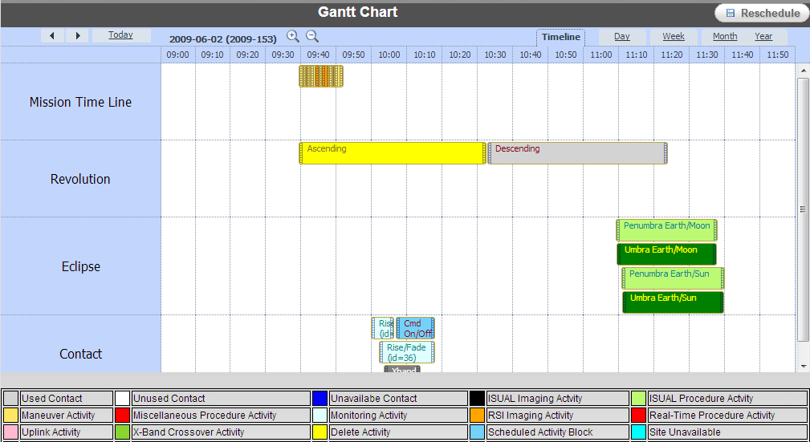
When MPSS completes the cold scheduling process, the user has a chance to manipulate the resulting schedule using a timeline display known as the Gantt Chart. The Gantt Chart allows the user to view the contacts and activities for a requested time period or session. All of the unscheduled activities can be viewed and manually scheduled by the user given the scheduling rules. The Cold Scheduler tool does most of the work for scheduling the time period. However, the Gantt Chart allows the user to make final decisions.
The Gantt Chart resides in the Summary window of the hot scheduling portion of MPSS. This timeline is color-coded and includes many detailed window options. Many configuration choices aid the user through the hot scheduling process.

Hot Scheduling Preparation
Prior to initiating the hot scheduling process, the cold scheduling steps described in section 3.2.3 should be completed.

Viewing the Schedule Graphically
Initiate the Gantt Chart from the MPSS Menu Bar as follows.
- Open the MPSS Menu Bar.
- Select the Gantt Chart… option and the Open Schedule Dialog window will be displayed.
- To view a scheduled session or branch, select the Schedule button. Then, choose the session or branch button and then select the available session or branch from the list box.
- To view a scheduled time period, select the Time Range button, and choose the time range. The Start Time and Stop Time are in yyyy/ddd/hh:mm:ss format. If a time range within a branch is to be viewed, select the Branch checkbox, select the Branch name from the pulldown list, and enter the time range.
- Select the OK button.
Note that if another process is running that conflicts with the Hot Scheduling process, the user will be given the option to open the Hot Scheduling GUI in read-only mode.
When the hot scheduling process is initiated, three windows will open at the same time:
- The MPSS Scheduler Summary Window.
- The MPSS Legend Window.
- The Unscheduled Activities window.

Once the MPSS Scheduler Summary Window is open, the schedule can be viewed and manipulated in a user-friendly manner. This graphical display is a timeline with which the user may perform hot scheduling. This MPSS Scheduler Summary Window allows the user to view the specified time ranges for the scheduled tasks for each satellite. This view can be reconfigured in multiple ways.
The MPSS Legend Window will open to the left of the MPSS Scheduler Summary Window. The MPSS Legend Window displays the color of each visual cue on the MPSS Scheduler Summary Window.

DEFINITION OF LEGEND WINDOW SCHEDULE ITEMS
Used Contact: Contact that has one or more scheduled activities
Unused Contact: Contact that is available for scheduling but has no scheduled activities
Unavailable Contact: Contact that is not available for scheduling
ISUAL Imaging Activity: Activities that are assigned ISUAL playback activity
ISUAL Procedure Activity: Activities that are assigned ISUAL procedure activity
Maneuver Activity: Activities that are assigned to Maneuver activity
Miscellaneous Activity: Activities that are assigned to Miscellaneous activity
Monitoring Activity: Activities that are assigned to Monitoring activity
RSI Imaging Activity: Activities that are assigned to RSI Playback, Record, and DDT activities
Real-Time Procedure Activity: Activities that are assigned to Real-Time activity
Uplink Activity: Activities that are assigned to Uplink activity
X-Band Crossover Activity: Activities that are assigned to X-Band Crossing activity
Delete Activity: Activities that are assigned to Delete activity
Scheduled Activity Block: Composite of scheduled activities assigned to a specific contact, gaps not identified
Site Unavailable: Period of time during which a site is not available for scheduling
SatRev: Start of a revolution of a satellite
Orbital Event: The orbital events request within selected rev
Out Of Locked Range: Any Schedule entity on the Summary Window that is not modifiable because it is partially or completely outside of the time range of the schedule being edited

Figure 5-9-3. MPSS Legend Window
The Unscheduled Activities window will open to the right of the MPSS Scheduler Summary Window. It gives a listing of all unscheduled activities during the timeframe for which the Gantt Chart is open. The unscheduled activities can be manipulated and set in place for hot scheduling by dragging and dropping items back and forth between the Unscheduled Activities window and the Gantt Chart.
There are human choices for unique cases that cannot be made by the scheduling software. This tool gives the user more freedom in creating the best possible schedule.

Gantt Chart View and Configuration Options
The MPSS Scheduler Summary Window can be viewed in multiple configurations to aid the user during the hot scheduling process. Some of the options are as follows:
- Switching the Y-axis.
- Configuring Color Selections.
- Filtering Schedule Items.
- Specifying Satellites/Sites.
- Specifying the number of Unused Contacts to display.
- Configuring Detail Popups.
- Zooming.
The next few paragraphs will discuss each of these options.

Switching the Y-Axis
The timeline view of the MPSS Scheduler Summary Window can be displayed in two ways. The default view displays the satellites on the Y-axis, the timeline on the X-axis, and the site contact information in the center portion. The second option displays the sites on the Y-axis, the timeline on the X-axis, and the satellite contact information in the center portion. The procedure for changing the axis is as follows:
- Select “Axis” from the menu bar in the MPSS Scheduler Summary Window.
- Select the “By Site” or “By Sat” option.
A check mark will appear by the selected option. The Gantt Chart will then refresh the display of the schedule in the requested format.

Configuring the Gantt Chart Colors
As discussed in section 3.4.3, the colors for the visual cues of the Gantt Chart can be changed to suit the user’s preference. Additionally, each user can customize their color settings and save them to a file.
To change the colors of items displayed in the Gantt Chart display:
- Click “Configure” from the menu bar in the MPSS Scheduler Summary Window.
- Select the “Configure colors…” choice to open the User Profile dialog window.
- Select the item for the color change from the “Configured Items” list box.
- Select the Edit button to initiate the Edit dialog window.
- Use the pulldown list to choose a new color value.
- Select the OK button to close the Edit dialog window.
- Choose the Save button in the User Profile window to store the color settings to the UserProfile.cfg file or choose the Reset button to return to the previous settings.
- Select the Close button to apply the changes.
The original system default colors can be reloaded at anytime by selecting the Load Defaults button. Once the Close button is selected, the Legend window and the Summary window will reflect the updated colors.

Schedule Item Filtering
This option provides the capability of filtering items in the schedule to simplify the display.. Selecting “View” from the menu bar on the MPSS Scheduler Summary Window can perform this option. The options that can be filtered are as follows:
- Unused Contacts.
- Unavailable Contacts.
- Activities.
- Non-Contact Activities.
- SatRevs.
- Orbital Events
Clicking on specific items in the list will toggle the options on and off. A check mark indicates that an item is selected. Multiple items can be filtered at the same time.

Selecting Satellites/Sites
There are times when the user may want to view only a certain subset of sites or satellites for a given scheduling time period or perhaps view the satellites or sites in a specific order down the Y-axis. The Summary window allows for this type of filtering/sorting as well. In order to access this option, the following steps need to be taken:
- Click “Configure” from the menu on the MPSS Scheduler Summary Window.
- Select the “Satellites/Sites” option from the pulldown menu and the Selection dialog box will open.
- Choose which Satellites and Sites will be included in the MPSS Scheduler Summary Window.
- Order the chosen Satellites or Sites in the manner in which they need to appear on the Y-axis.
- Select the OK button to refresh the MPSS Scheduler Summary Window with the new choices.
The default setting is to display all the satellites and sites for which contacts exist in the database for the selected time range. This option is the only way to show a subset or reordering of the satellites and sites. A good use of this feature would be in the case where the user needed to work on two sites that are not by default listed next to each other on the MPSS Scheduler Summary Window. The user could configure the Y-axis so that these two sites were listed on top of one another. This feature makes manipulating activities back and forth between the two sites more manageable.

Specifying the Number of Unused Contacts to Display
When viewing the MPSS Scheduler Summary Window, there may be a significant number of unused contacts displayed. In general, this can clutter up the display. The unused contacts that are considered to be the best are the longest. These are the ones that pose the greatest opportunity for being used to schedule some of the unscheduled activities. The method for limiting the number of unused contacts displayed is as follows:
- Click “Configure” from the menu bar on the MPSS Scheduler Summary Window.
- Select the “Best <n> Unused Contacts” option from the pulldown menu and the Integer Value dialog box will open.
- Enter the desired number of lines containing unused contacts to be displayed.
- Select the OK button to refresh the Summary window with the new choices.

Configuring the Detailed Popup Windows
The user may view a variety of popup detailed windows that textually describes the visual cues on the Gantt Chart.
Within each used contact on the MPSS Scheduler Summary Window, the user may double click and open a detailed layout of activities. More than one of these windows can be open at a time and can be moved around the GUI freely and resized.
Popup windows are available on both the Gantt Chart and the Detail window by right clicking on the desired item. The information displayed in these popup windows is configurable by doing the following:
- Click Configure from the menu bar on the top of the Summary window.
- Select the Configure Detail Popups option.
- Configure any of the following popup windows by clicking on the desired tab:
- Used Contact
- Unused Contact
- Unavailable Contact
- RSI Imaging Activity
- ISUAL Procedure Activity
- ISUAL Imaging Activity
- Maneuver Activity
- X-Band Crossover Activity
- Real Time Procedure Activity
- Monitoring Activity
- Delete Activity
- Unscheduled Activity
- Non-Contact Unscheduled Activity
- Activity Block
- Sat Rev
- Contact Bound
- Orbital Events.
- Use the arrow keys to modify the settings for each popup window.
- Select the Save button to save the changes to the user profile for future use, select the OK button to apply the settings to the current Gantt Chart, or Cancel to revert back to original settings.

Zooming the Gantt Chart View
The MPSS Scheduler Summary Window provides the ability to zoom the display along the
X-axis time line. Zooming in provides a more detailed view and zooming out provides a higher-level view. However, if the zooming exceeds the windows limitations, a warning will prompt indicating that the user must open the Gantt Chart for a smaller time range. To Change the level of the zoom function by:
- Click “Zoom” from the menu bar at the top of the MPSS Scheduler Summary Window.
- Select the desired zoom choice:
1. Zoom In.
2. Zoom out.
3. Zoom To in order to select the time interval.
The summary window will refresh to the requested view.
The “Zoom To” option has some limitations based on the zoom increment and the original time range of the Gantt Chart. The zoom increments are:
- 30 seconds
- 1 minute
- 5 minutes
- 15 minutes
- 30 minutes
- 1 hour
The zoom limitations are:
Time Range | Minimum Zoom Increment
Time range > 7 days | 30 minutes
7 days > time range > 2 days | 15 minutes
2 days > time range > 8 hours | 5 minutes
8 hours > time range > 3 hours | 1 minute
Time range < 3 hours | 30 seconds

Editing the Schedule (Hot Scheduling)
All of the options discussed in section 3.4.4 provide the user with configurable views of the schedule. The user can adjust the Gantt Chart view to best serve the nature of the particular scheduling need at hand. The next phase is known as Hot Scheduling. This is the point in the process where the user begins to manipulate the cold schedule via the Gantt Chart.
There are two options for editing the cold schedule through this Gantt Chart tool. The first option is Automatic Rescheduling, which provides the capability of attempting to automatically schedule all activities in the Unscheduled Activities window for a selected timeframe. The second method is the Manual Schedule method, which allows the user to edit and reschedule individual activities.

Automatic Rescheduling
This method enforces most of the rules used during the cold scheduling process, with the exception of the following.
- All contacts are considered; no minimum contact maximum elevation or minimum contact duration value filters are imposed.
- All satellites and sites are considered; no session satellite/site limitations are imposed.
The user can restrict the time period, sites and satellites used during the rescheduling process. The method for this bulk reschedule is relatively straightforward.
The user can initiate the Automatic Rescheduling process by doing the following:
- Click Edit from the menu bar on the MPSS Scheduler Summary Window.
- Select the Reschedule option.
- Edit the Reschedule dialog window to the desired settings.
- Select the Reschedule button to start the process or Cancel button to exit the process (from this point, the behavior mimics the cold scheduling process).
- Once the reschedule is complete the MPSS Scheduler Summary Window and Unscheduled Activities window will refresh with the new schedule information.

Manual Schedule Editing
The user can reschedule individual activities one at a time by dragging and dropping the unscheduled activities from the Unscheduled Activities window to the available time period on the Gantt Chart. It will usually be necessary to drag off activities that had been scheduled, in order to make room for other activities. Once the desired activities have a place on the schedule, the user can finish dropping the leftover unscheduled activities back on the Gantt Chart wherever they fit. If the activity does not fit where it gets dropped, an error message will appear and the activity will remain in the Unscheduled Activities window.
The Unscheduled Activities window can be sorted by any of its columns. To sort the window by a particular column, simply click on the column header. The window will sort itself accordingly.
There are four types of manual schedule editing functions that can be performed. They are:
- Scheduling and unscheduling of activities and activity blocks.
- Modifying contacts, scheduled activities, and unscheduled activities.
- Generating new activities.
- Editing Site Unavailability periods.

Scheduling/Unscheduling Activities and Activity Blocks
This type of manual scheduling allows the user to schedule an unscheduled activity. Once the user locates the target contact to attempt to schedule the activity, he/she should click on the activities in the Unscheduled Activities window and drag it to the target contact. Similarly, non-contact activities can be dragged from the Unscheduled Activities window to the corresponding satellite label on the Y-axis. It will take at least a few seconds to process this reschedule. If the reschedule is successful, the Summary and Unscheduled Activities windows will refresh accordingly. If the activity cannot be rescheduled, an error message will appear and the activity will return to the Unscheduled Activities window. The user may also reverse this process and remove a scheduled activity from the Summary window to the Unscheduled Activities window. Usually this would be done in order to make room for an activity that did not get scheduled. Activities can also be unscheduled directly from the Detail window. Scheduled activities can also be moved from one contact to another.
Note that in the case of the unscheduled RSI Imaging record activity, rescheduling the record activity will also schedule the associated playback and delete activities. The scheduler will schedule the playback activities after associated record activity and schedule the delete activities will be scheduled after associated playback activities.

Modifying Contacts, Scheduled Activities, and Unscheduled Activities
This type of manual editing allows the user to modify the schedule through different commands. Below is a list of available commands.

List of Available Commands on Schedule Items
Command | Applicable Object | Description
Cancel | Used or Unused Available Contact | Mark a contact as unavailable for scheduling consideration. If the object is a used contact, activities are unscheduled
Make Available | Unavailable Contact | Mark contact as available for scheduling consideration
Adjust Activities | Used Contact | Make all activities in the contact start after a specified time; if not all activities can be scheduled after the specified time, the activities are returned to their original times
Generate Contact Activities | Used or Unused Contact | Create new activity using the time window of the contact as the base start/stop times.
Edit | Unscheduled Activity | Modify the attributes of an unscheduled activity
Delete | Unscheduled Activity | Delete an unscheduled activity
Generate/Schedule Playback | Scheduled RSI Record Activity | Creates a new RSI Playback activity and links it to the selected RSI Record activity. RSI Playback activities time window is set to the NEXT x-band contact window that occurs after the RSI Record. The duration of the RSI Playback window is dependent on the duration of the RSI Record, imaging type, and compression ratio.  After new activity created, the scheduling software attempts to schedule the activity.
Move Activity | Scheduled SSR Delete Activity | Provides ability to “shift” Delete activities within the schedule. Must enter time to move activity to. Time is limited to the end of the associated RSI Record activity to the end time of the schedule opened in the Summary Window.
The directions for modifying a contact are as follows.
- Right click on site contact for a given satellite; a popup menu will appear.
- If there are commands available, the popup will contain a submenu.
- Select Commands at the bottom of the popup window.
- Select from the list of available commands. The site contact will refresh visually (through color) to reflect the contact’s new status.
The directions for modifying a scheduled activity are as follows.
- Right click on site contact for a given satellite; a popup menu will appear.
- Select Activities near the bottom of the popup window and select the activity to be modified.
- If there are commands available, the popup will contain a submenu.
- Select Commands at the bottom of the popup window.
- Select from the list of available commands.
The directions for modifying an unscheduled activity are as follows.
- Locate the unscheduled activity in the Unscheduled Activities window.
- Right click on the unscheduled activity.
- Move the cursor to the Commands.
- Select from the list of available commands. The Unscheduled Activities window will refresh to reflect any changes to the unscheduled activity.

Editing Site Unavailability Periods
The Gantt Chart provides the ability to create, modify or delete periods during which a site is unavailable. Editing this window is similar to other Unavailable Times widows described in previous sections. Directions for Editing Site Unavailable times are as follows:
- Select Edit from the menu bar on the MPSS Scheduler Summary Window.
- Select the Site Unavailable Times option.
- Select the site and enter the unavailable time information into the Site Unavailable dialog window.
- Select the desired site from the Name list.
- Select the Unavailable Time range using the From and To fields. Select the Add button to add selected unavailable times to the table.
- To change the Unavailable Time for a branch, click the Branch button and select the desired branch from the branch list
- To delete an Unavailable Time simply select the entry from the table and then click on the Delete button.
- Select the Save button.
- The Cancel button will reset all the entries.
- The Close button will close the window. If window has been modified, a prompt will ask users if he or she like to save the changes.
Note that if there are activities currently scheduled for a site during the newly entered unavailable time, these activities will automatically be unscheduled.

Generating New Activities
Activities are primarily generated from the activity request lists (ARLs) generated form the Activity Request List Editor or Mission Timelines ingested from the External Activity Request Scheduler. However, the Gantt Chart allows for post-cold scheduling activity generation. Once these activities are generated they get added to the Unscheduled Activities window. Create new activities as follows.
- Click Edit from the menu bar at the top of the MPSS Scheduler Summary window.
- Select the Generate Activities option.
- The Activity Generator dialog window will open.
- Enter desired activity information into the Activity Generator dialog window.
- Select the OK button.
Note:
- Activity windows are restricted to the opened time range of the Gantt Chart
- New activities are restricted to the satellites specified in the session or branch that corresponds to the opened time range.
The Activity Generator can also be initiated from the contact popup menu by selecting Generate Contact Activities. This option sets the start and stop times to the AOS and LOS of the selected contact.

Activity Generator
The Activity Generator window provides the ability to enter information for the following types of activities:
- ISUAL Procedure
- Miscellaneous Procedure
- Monitoring
- R/T Command Procedure
- RSI Imaging
- Spacecraft Maneuver
- Uplink
- Xband Crossover

For each activity the operator must specify:
Field | Purpose
Activity Name | Used as identifier
Activity Type | Activity types specified above
Activity Sub-Type | Provides further activity detail.  For example: DDT, Record, Playback
Satellite | Activities must be assigned to a satellite
Time Window | Specifies where to schedule activity.  Note: Miscellaneous Procedure activities do not require a time window. They are based on orbital events.
Activity Specific Information | Required input values based on selected activity type and sub-type.
Comments | Optional field for description of activity.

The following sections detail each activity type and their required inputs.

ISUAL Procedure Activity
The ISUAL Procedure activity provides the ability to generate and schedule a new ISUAL procedure request.
To generate a new ISUAL Procedure request:
- Enter activity name
- Select ISUAL Proc in Activity Type
- Select ROCSAT2 satellite.
- Specify scheduling window for activity. It is recommended to expand this window to include provide the ability to select multiple s-band contacts for scheduling.
- Specify duration of activity: amount of time required to uplink the ISUAL procedure. Format HH:MM:SS
- Specify ISUAL procedure.
  - The “…” button places the file browser in the mpss/data/external_requests/ISUAL_SDDC directory.
  - Note: ISUAL procedure files are not validated against the EPOCH database. It is recommended to only select ISUAL procedure files that were successfully validated by the External Activity Request Scheduler.
- Specify any Comments for the activity
- Click OK to close window and generate activity for scheduling. New ISUAL Proc activity will appear in the Unscheduled Activities window.
  - Click Cancel to close Activity Generator window without generating any new activities.
Miscellaneous Procedure Activity
The miscellaneous procedure activity provides the ability to generate and schedule miscellaneous procedures to occur during a particular orbital event. The format of a miscellaneous procedure is specified in section 4.3.1.1
Miscellaneous procedure activities can be generated for three types of events:
- GMT: Specify actual start time of activity
- Orbital: Specify orbit number and associated orbital event occurring during that orbit.
  - Activity may be offset (+/-) from orbital event time.
  - Events include:
    - AN (Ascending Node)
    - DN (Descending Node)
    - Earth/Moon Penumbra Enter
    - Earth/Moon Penumbra Exit
    - Earth/Moon Umbra Enter
    - Earth/Moon Umbra Exit
    - Earth/Sun Penumbra Enter
    - Earth/Sun Penumbra Exit
    - Earth/Sun Umbra Enter
    - Earth/Sun Umbra Exit
    - Moon/Sun Penumbra Enter
    - Moon/Sun Penumbra Exit
    - Moon/Sun Umbra Enter
    - Moon/Sun Umbra Exit
- Contact: Ability to create activity based on rise, mid-point, or fade of contact.
  - Contact events are only selectable when generating activities from contact menu.
  - Activity may be offset (+/-) from contact event.
To generate a miscellaneous procedure activity based on GMT event:
- Enter activity name
- Select Miscellaneous Proc in Activity Type
- Select ROCSAT2 satellite.
- Click GMT button.
- Enter start time for activity. Format: YYYY/DDD/HH:MM:SS
- Specify duration of activity: amount of time required to perform procedure. Format HH:MM:SS
- Specify miscellaneous procedure.
  - The “…” button places the file browser in the mpss/data/ROCSAT2/miscel_memory_procs directory.
- Specify any Comments for the activity
- Click OK to close window and generate activity for scheduling. A new miscellaneous procedure activity will appear in the Unscheduled Activities window.
  - Click Cancel to close Activity Generator window without generating any new activities.
To generate a miscellaneous procedure activity based on an Orbital event:
- Enter activity name
- Select Miscellaneous Proc in Activity Type
- Select ROCSAT2 satellite.
- Click Orbital button.
- Select desired orbital event.
- Select orbit number.
- Specify desired time offset from orbital event. Format: (+/-) HH:MM:SS
- Specify duration of activity: amount of time required to perform procedure. Format HH:MM:SS
- Specify miscellaneous procedure.
  - The “…” button places the file browser in the mpss/data/ROCSAT2/miscel_memory_procs directory.
- Specify any Comments for the activity
- Click OK to close window and generate activity for scheduling. A new miscellaneous procedure activity will appear in the Unscheduled Activities window.
  - If the desired orbital event does not occur during the orbit specified, an information message will be received asking the operator to make another selection.
  - Click Cancel to close Activity Generator window without generating any new activities.
To generate a miscellaneous procedure activity based on Contact event:
- In MPSS Scheduler Summary Window, right-click on desired contact.
- Select Commands->Generate Activities. This action will open the Activity Generator window. The Contact event will be selectable.
- Enter activity name
- Select Miscellaneous Proc in Activity Type
- Select ROCSAT2 satellite.
- Click Contact button.
- Select desired contact event.
- Specify desired time offset from orbital event. Format: (+/-) HH:MM:SS
- Specify duration of activity: amount of time required to perform procedure. Format HH:MM:SS
- Specify miscellaneous procedure.
  - The “…” button places the file browser in the mpss/data/ROCSAT2/miscel_memory_procs directory.
- Specify any Comments for the activity
- Click OK to close window and generate activity for scheduling. A new miscellaneous procedure activity will appear in the Unscheduled Activities window.
  - Click Cancel to close Activity Generator window without generating any new activities.

Monitoring Activity
A monitoring activity represents telemetry playback and SOH periods. Monitoring activities are scheduled on s-band contacts and are typically schedule for the full duration of the contact (AOS to LOS). Monitoring activities
To generate a monitoring activity:
- Enter activity name.
- Select Monitoring in Activity Type
- Select ROCSAT2 satellite.
- Specify scheduling window for activity. It is recommended to expand this window to include provide the ability to select multiple s-band contacts for scheduling.
- Specify any Comments for the activity
- Click OK to close window and generate activity for scheduling. New Monitoring activity will appear in the Unscheduled Activities window.
  - Click Cancel to close Activity Generator window without generating any new activities.
Real-Time Command Procedure Activity
Real-Time command activities provide the ability to generate and schedule a period of time during an s-band contact to execute a real-time procedure. Real-time procedures do not exist on the MPSS machine; therefore, the operator must type the exact name of the procedure in the window.
To generate a real-time command procedure activity:
- Enter activity name
- Select Real-Time Proc in Activity Type
- Select ROCSAT2 satellite.
- Specify scheduling window for activity. It is recommended to expand this window to include provide the ability to select multiple s-band contacts for scheduling.
- Specify duration of activity. The duration must provide enough time to complete the real-time procedure.
- Specify requestor. Optional parameter, used to link activity request to personnel or sub-system.
- Specify real-time procedure. As mentioned above, real-time procedures are not stored on the MPSS system. The operator must type the filename (and extension) of the real-time procedure.
- Specify any Comments for the activity
- Click OK to close window and generate activity for scheduling. New Monitoring activity will appear in the Unscheduled Activities window.
  - Click Cancel to close Activity Generator window without generating any new activities.
RSI Imaging Activity
The Activity Generator provides the ability to generate RSI imaging activities. RSI imaging activities are divided into two sub-types – DDT and Record. When generating an RSI DDT activity, the Activity Generator will verify the operator selected PAN+MS for imaging mode and it will also verify the RSI DDT request does not occur during the x-band contact within the Taiwan region. If the operator enters invalid inputs, an error message will be received, and the operator will have to update the input parameters.
The Activity Generator will verify the RSI Record activity is contained within the x-band contact within the Taiwan region. If the RSI Record is not fully contained within the x-band contact, an error message will be received and the user will have to update the time window.
When generating an RSI Record activity, the Activity Generator will also generate an RSI Playback and SSR Delete activity that are associated with the RSI Record activity.
The time window of the RSI Playback is dependent on the location of the RSI Record.
- If the RSI Record starts outside an X-Band contact, then the RSI Playback window is set to the 0 degree site mask of the “next” X-Band contact based on the start of the RSI Record.
- If the RSI Record occurs during an X-Band contact (starts and ends during the contact) then the time window of the RSI Playback starts at the 0 degree rise of the “current” X-Band contact and ends at the 0 degree fade of the “next” X-Band contact. The time window overlaps 2 X-Band contacts in case the scheduler needs to “push” the Playback to the next contact due to resource constraints.
- If the RSI Record is performing PAN+MS imaging and occurs during an X-Band contact (starts and ends during the contact) only 1 RSI Playback activity is generated. The RSI Playback transmits both PAN and MS data.
- If the RSI Record is performing PAN+MS imaging and starts outside an X-Band contact, then 2 RSI Playbacks are generated. One to transmit the PAN data file and the other to transmit the MS data file.
- The duration of the RSI Playback is dependent on the RSI Record duration, the associated imaging mode, and the compression ratio.
- The SSR Delete activity is required to remove the data from the SSR that corresponds to the RSI Record activity. The SSR Deletes time window is from the end of the RSI record to the “end of time”. SSR Delete activities are scheduled as late as possible in order to retain the RSI data on the SSR as long as possible.
To generate an RSI DDT activity:
- Enter activity name.
- Select RSI Imaging in Activity Type
- Select DDT from Sub-Type.
- Select ROCSAT2 satellite.
- Specify activity time window. This window is the actual time of RSI imaging.
- Select PAN+MS from Imaging Mode
- Select desired Imaging Type.
- Select PAN compression ratio. For DDT, DEFAULT is HIGH.
- Select MS compression ratio. For DDT, DEFAULT is HIGH.
- Enter Video Gain settings for PAN, MB1, MB2, MB3, MB4.
- If desired, Imaging Grid information may also be entered.
  - Select Imaging Grid button
  - Specify Start and Stop latitude
  - Specify imaging grid information, Track GI, Grid JS, Grid JE, Grid K
- If desired, Station information may also be entered
  - Select Station Information button
  - Enter Station name
  - Enter Orbit number
  - Enter station elevation and azimuth values
- Specify any Comments for the activity
- Click OK to close window and generate activity for scheduling. New RSI DDT activity will appear in the Unscheduled Activities window.
  - Click Cancel to close Activity Generator window without generating any new activities.
To generate an RSI Record activity:
- Enter activity name
- Select RSI Imaging in Activity Type
- Select REC from Sub-Type.
- Select ROCSAT2 satellite.
- Specify activity time window. This window is the actual time of RSI imaging.
- Select Imaging Mode. PAN or MS are valid values for RSI Record activities.
- Select desired Imaging Type.
- Select appropriate compression ratio. If recording PAN data, specify PAN compression ratio. If recording MS data, specify MS compression ratio. For both PAN and MS, DEFAULT is LOW.
- Enter Video Gain settings for PAN, MB1, MB2, MB3, MB4.
- If desired, Imaging Grid information may also be entered.
  - Select Imaging Grid button
  - Specify Start and Stop latitude
  - Specify imaging grid information, Track GI, Grid JS, Grid JE, Grid K
- If desired, Station information may also be entered
  - Select Station Information button
  - Enter Station name
  - Enter Orbit number
  - Enter station elevation and azimuth values
- Specify any Comments for the activity
- Click OK to close window and generate activities for scheduling. New RSI REC, RSI PBK, and DEL activities will appear in the Unscheduled Activities window.
- RSI Record activity will be generated based on inputs specified by operator
- RSI Playback activity information is dependent on RSI Record time window and duration.
- SSR Delete activity is dependent on RSI Record stop time.
  - Click Cancel to close Activity Generator window without generating any new activities.
Spacecraft Maneuver Activity
The Activity Generator provides ability to generate attitude maneuver, orbit maneuver, and sun-pointing maneuver. Attitude maneuvers inputs require associated quaternion values. Orbit maneuvers require the orbit maneuver plan generated by FDF and the orbit maneuver procedure. The operator must generate the orbit maneuver procedure. Sun pointing maneuvers do not require any special inputs.
To generate an attitude maneuver:
- Enter activity name.
- Select Maneuver in Activity Type
- Select ROCSAT2 satellite.
- Specify scheduling window for activity.
- Select Attitude button
- Enter quaternion values for Q1, Q2, Q3, and Q4.
- Enter maneuver duration. Activity Generator window will verify time window encompasses maneuver duration. If not, an error message is received.
- Specify any Comments for the activity
- Click OK to close window and generate activity for scheduling. New Maneuver activity will appear in the Unscheduled Activities window.
  - Click Cancel to close Activity Generator window without generating any new activities.
To generate an orbit maneuver:
- Enter activity name.
- Select Maneuver in Activity Type
- Select ROCSAT2 satellite.
- Specify scheduling window for activity.
- Select Orbit button
- Enter quaternion values for Q1, Q2, Q3, and Q4.
- Enter maneuver duration. Activity Generator window will verify time window encompasses maneuver duration. If not, an error message is received.
- Specify orbit maneuver plan.
  - The “…” button places the file browser in the mpss/reports/Orbit_Maneuver_Plans directory
- Specify orbit maneuver procedure.
  - The “…” button places the file browser in the mpss/data/ROCSAT2/maneuver_procs directory
- Click OK to close window and generate activity for scheduling. New Maneuver activity will appear in the Unscheduled Activities window.
  - Click Cancel to close Activity Generator window without generating any new activities.
To generate a sun-pointing maneuver:
- Enter activity name
- Select Maneuver in Activity Type
- Select ROCSAT2 satellite.
- Specify scheduling window for activity.
- Select Sun pointing button
- Enter maneuver duration. Activity Generator window will verify time window encompasses maneuver duration. If not, an error message is received.
- Click OK to close window and generate activity for scheduling. New Maneuver activity will appear in the Unscheduled Activities window.
  - Click Cancel to close Activity Generator window without generating any new activities.
Uplink Activity
The uplink activity is used to request uplinks periods for the TTQ and MPQ binary loads within s-band contacts. Each load type (TTQ and MPQ) requires its own uplink activity. At this point, the operator specifies the uplink time. The associated load file is created and assigned to the uplink period by the Product Generation utility.
To generate an uplink activity:
- Enter activity name
- Select Uplink in Activity Type
- Select ROCSAT2 satellite.
- Specify scheduling window for activity. It is recommended to expand this window to provide the ability to select multiple s-band contacts for scheduling.
- Select load type (MPQ or TTQ).
- Enter activity duration. Activity Generator window will verify time window encompasses activity duration. If not, an error message is received.
- Click OK to close window and generate activity for scheduling. New Uplink activity will appear in the Unscheduled Activities window.
  - Click Cancel to close Activity Generator window without generating any new activities.
X-Cross Activity
The Activity Generator provides the ability for an operator to specify when an x-band crossover event. The x-band crossover event is represented as an XCROSS activity within the MPSS system. The operator specifies when the event occurs and its duration.
Note: During cold scheduling and Mission Timeline scheduling, RSI Playback and RSI DDT activities that overlap an existing XCROSS activity have their durations extended to include the duration of the XCROSS activity. Generating XCROSS activities in the Activity Generator will not update RSI Record or RSI DDT activity windows that have been previously generated by the Cold Scheduler or External Activity Request Scheduler processes.
To generate an xcross activity:
- Enter activity name
- Select XBand Crossover in Activity Type
- Select ROCSAT2 satellite.
- Specify scheduling window for activity.
- If desired, Station information may also be entered
  - Select Station Information button
  - Enter Station name
  - Enter Orbit number
  - Enter station elevation and azimuth values
- Enter activity duration. Activity Generator window will verify time window encompasses activity duration. If not, an error message is received.
- Click OK to close window and generate activity for scheduling. New XCROSS activity will appear in the Unscheduled Activities window.
  - Click Cancel to close Activity Generator window without generating any new activities.

Editing Activity Information
The Gantt Chart provides the ability to modify certain properties of unscheduled activities. This can be useful when activities are unable to be scheduled based on resource conflicts or timing issues. The Gantt Chart provides the ability to modify the following activity types:
  - ISUAL Playback
  - ISUAL Procedure
  - Miscellaneous Procedure
  - Monitoring
  - Real-Time Command Procedure
  - RSI DDT
  - RSI Record
  - RSI Playback
  - Spacecraft Maneuver
  - Uplink
  - X-Band Crossover
SSR Delete activities are automatically generated by the scheduling software and are dependent on their activity settings. The user is unable to modify any properties of the SSR Delete activities.
To modify the properties of an activity:
- Select the desired activity in the Unscheduled Activities window.
  - Operator is not allowed to modify the properties of a Delete activity.
- Right-click on the activity and select Commands, Edit.
  - The Activity Generator window will display with the selected activities information entered into the window.
The following table defines the modifiable properties of each activity type.

Activity Type | Modifiable Parameters | Results
ISUAL Playback | Activity Name  Time Window  Filename: Filenames include 126 and 127.  Comments | New ISUAL Playback activity is added to Unscheduled Activities window. Activity can be identified by key: ISUAL.  Original activity is removed.
ISUAL Procedure | Activity Name  Time Window  Duration.  ISUAL Procedure  Comments | New ISUAL Procedure activity is added to Unscheduled Activities window. Activity can be identified by key: ISUALPROC.  Original activity is removed.
Miscellaneous Procedure | Activity Name  Event Trigger (GMT, Orbital, Contact)  Offset  Duration  Procedure  Comments | New Miscellaneous Procedure activity is added to Unscheduled Activities window. Activity can be identified by key: MISC  Original activity is removed.
Monitoring | Activity Name  Time Window  Comments | New Monitoring activity is added to Unscheduled Activities window. Activity can be identified by key: MON  Original activity is removed.
Real-Time Command Procedure | Activity Name  Time Window  Duration  Requestor  Procedure  Comments | New Real-Time Command Procedure activity is added to the Unscheduled Activities window. Activity can be identified by key: RTCMD  Original activity is removed.
RSI DDT | Activity Name  Time Window  Video Gains  Station Information  Imaging Information  Comments | New RSI DDT activity is added to the Unscheduled Activities window. Activity can be identified by the key: RSI/DDT/<mode>  Original activity is removed.
RSI Record | Activity Name  Time Window  Imaging Mode  Imaging Type  Compression Ratios  Video Gains  Station Information  Imaging Information  Comments | New RSI Record, RSI Playback and SSR Delete activities are generated based on new inputs. Activities can be identified by keys: RSI/REC/<mode>, RSI/PBK/<mode>, DEL  Original RSI Record, RSI Playback, and SSR Delete activities are removed from Unscheduled Activities window.
RSI Playback | Activity Name  Time Window  Video Gains  Station Information  Imaging Information  Comments | New RSI Playback activity is added to the Unscheduled Activities window. Activity can be identified by key: RSI/PBK/<mode>  Original activity is removed.
Spacecraft Maneuver | Activity Name  Time Window  Maneuver Type (Sun Pointing, Attitude, Orbit)  Quaternion (Q1, Q2, Q3, Q4)  Orbit Maneuver Plan  Orbit Maneuver Procedure  Duration  Comments | New Spacecraft Maneuver activity is added to the Unscheduled Activities window. Activity can be identified by key: MANEUVER  Original activity is removed
Uplink | Activity Name  Time Window  Load Type (TTQ or MPQ)  Duration  Comments | New Uplink activity is added to the Unscheduled Activities window. Activity can be identified by key: UPLINK/<load type>  Original activity is removed.
X-Band Crossover | Activity Name  Time Window  Station Information  Duration  Comments | New X-Band Crossover activity is added to the Unscheduled Activities window. Activity can be identified by key: XCROSS  Original activity is removed.

Hot Scheduling RSI Record Activities
When scheduling an RSI Record activity, the hot scheduler attempts to schedule all related activities at the same time. If the RSI Record activity cannot be scheduled, due to resource or timing conflicts, all related activities remain unscheduled also.
When an RSI Record activity is scheduled during hot scheduling, either drag/drop or using the Reschedule window, its associated SSR Delete activity is scheduled as early as possible. This is different than cold scheduling where the SSR Delete is scheduled as late as possible or not at all. The SSR Delete is scheduled as early as possible to handle possible SSR capacity overflows or filename conflicts.
The number and duration of RSI Record and DDT activities is limited by the RFPA duration. The scheduler assigns one RFPA window per orbit. All RSI Record and DDT activities scheduled during that orbit must be “contained” within that RFPA window. If an RSI Record does not fit within the RFPA window it remains unscheduled.
Multiple RSI Record activities can be scheduled at the same time as long as they are imaging different data types. For example, an RSI Record imaging PAN data can occur at the same time as an RSI Record imaging MS data. However, an RSI Record imaging PAN data is not allowed to overlap an RSI Record imaging PAN+MS data.

Hot Scheduling RSI Playback Activities
RSI Playback activities must be scheduled within the 20-degree site mask of an X-Band contact. Typical RSI Playback time windows include two possible X-Band contacts for scheduling. The user may select either contact for scheduling as long as the associated SSR Delete activity is scheduled later in the schedule.
The antenna resource assigned to the RSI Playback after scheduling is defined by the RS2:PrefAntenna parameter in the mpss.cfg file. However, if an XCROSS activity occurs prior to the RSI Playback activity, then it will be assigned the backup antenna resource. If an RSI Playback occurs during an XCROSS activity, the antenna resource remains the preferred antenna resource. The scheduling software cannot assign multiple antenna resources to one activity. However, the Product Generation utility handles the antenna resource change when creating the MPQ and TTQ loads.
If an RSI Playback activity is scheduled during an XCROSS activity, the XCROSS activity duration is added to the duration of the RSI Playback to handle the “pause” in the data transmission.

Hot Scheduling RSI DDT Activities
The number and duration of RSI DDT and Record activities is limited by the RFPA duration. The scheduler assigns one RFPA window per orbit. All RSI DDT and Record activities scheduled during an orbit must be “contained” within that RFPA window. If an RSI DDT does not fit within the RFPA window it remains unscheduled.
The antenna resource assigned to the RSI DDT after scheduling is defined by the RS2:PrefAntenna parameter in the mpss.cfg file. However, if an XCROSS activity occurs prior to the RSI DDT activity, then it will be assigned the backup antenna resource. If an RSI DDT occurs during an XCROSS activity, the antenna resource remains the preferred antenna resource. The scheduling software cannot assign multiple antenna resources to one activity. However, the Product Generation utility handles the antenna resource change when creating the MPQ and TTQ loads.
If an RSI DDT activity is scheduled during an XCROSS activity, the SSR file sectors are updated to handle the “pause” in the data transmission.

Hot Scheduling XCROSS Activities
XCROSS activities represent the event when a spacecraft switches from the +X antenna to the –X antenna. If this “switch” happens to occur during data transmission, the RF is disabled, transmission is paused for the duration of the switch, RF is enabled, and transmission is resumed. RSI transmission activities, RSI Playback and RSI DDT, are affected by the antenna switch commands.

Antenna Updates
Scheduling an XCROSS activity forces RSI transmission activities, occurring within the RFPA time after the XCROSS, to change their satellite antenna resource to the backup antenna. The primary antenna is configured in the mpss.cfg file by the parameter RS2:PrefAntenna. If the XCROSS overlaps an RSI Playback or RSI DDT activity, their antenna resources are not affected. The scheduling software cannot assign multiple antenna resources to one activity. However, the Product Generation utility handles the antenna resource change when creating the MPQ and TTQ loads.
When an XCROSS activity is unscheduled, any RSI transmission activity, occurring within the RFPA after the XCROSS, reverts back to the preferred antenna resource.

RSI Playback Updates
If an XCROSS activity is manually scheduled during an RSI Playback activity, the hot scheduler attempts to extend the RSI Playbacks duration to include the XCROSS duration. If the hot scheduler is successful, a message will indicate the RSI Playback was RESCHEDULED. If, after the RSI Playback duration is extended, the hot scheduler is not able to schedule the RSI Playback (due to resource conflicts, or timing issues), a message will indicate the RSI Playback remains UNSCHEDULED. The RSI Playback will then be added to the Unscheduled Activities Bin.
If an XCROSS activity is unscheduled and happened to overlap an RSI Playback activity, the hot scheduler attempts to remove the XCROSS extension from the RSI Playback duration. If the hot scheduler is successful, a message will indicate the RSI Playback was RESCHEDULED. If the hot scheduler is not able to re-schedule the RSI Playback (due to resource conflicts, or timing issues), a message will indicate the RSI Playback remains UNSCHEDULED. The RSI Playback will then be added to the Unscheduled Activities Bin.

RSI DDT Updates
If an XCROSS activity is manually scheduled during an RSI DDT activity, the hot scheduler attempts to reallocate sectors for the DDT activity to handle the “pause” associated with the XCROSS activity. If the hot scheduler is successful, a message will indicate the RSI DDT was RESCHEDULED. If, after the RSI DDT sector allocation is updated, the hot scheduler is not able to schedule the RSI DDT (due to resource conflicts, or timing issues), a message will indicate the RSI DDT remains UNSCHEDULED. The RSI DDT will then be added to the Unscheduled Activities Bin.
If an XCROSS activity is unscheduled and happened to overlap an RSI DDT activity, the hot scheduler attempts reallocate sectors for the DDT activity, removing the additional sectors caused by the XCROSS. If the hot scheduler is successful, a message will indicate the RSI DDT was RESCHEDULED. If the hot scheduler is not able to re-schedule the RSI DDT (due to resource conflicts, or timing issues), a message will indicate the RSI DDT remains UNSCHEDULED. The RSI DDT will then be added to the Unscheduled Activities Bin.

Hot Scheduling SSR Delete Activities
The scheduling software automatically handles the placement of the SSR Delete activities within the schedule. Since the scheduler decides where to schedule SSR Delete activities, the operator cannot manually schedule and unschedule SSR Delete activities. However, the Gantt Chart does provide the ability to “force” unscheduled SSR Delete activities into the schedule.
The Gantt Chart’s Reschedule interface provides the ability to schedule “all” SSR Delete activities listed in the Unscheduled Activities bin. However, unlike the Cold Scheduler, the SSR Delete activities will be scheduled as early as possible.
Scheduled SSR Delete activities may not be manually unscheduled however, they can be “moved” within the schedule. The hot scheduler may not allow SSR Delete activities to “move” to the desired time if the results would cause SSR capacity overflow or conflicts with SSR filenames.

Hot Scheduling Troubleshooting
The following is a guide to assist in the process of hot scheduling troubleshooting. The many schedule-editing features of the Gantt Chart make the hot scheduling process very flexible, but they can also complicate the user’s understanding of the process. Keep the following tips in mind when performing hot scheduling to eliminate some of this confusion.
- Hot scheduling (autoreschedule and manual reschedule) does not follow all of the cold scheduling rules.
- The scheduler does not unschedule already scheduled activities during autoreschedule or manual rescheduling. If there is a scheduled activity that is preventing an unscheduled activity from getting scheduled, the user must remove the conflicting activity before the unscheduled activity will get scheduled. The exception being the scheduling/unschedulig of XCROSS activities. If an XCROSS activity overlaps an RSI Playback or RSI DDT activity, the scheduler attempts to update their resources. If after updating the required resource the scheduler is unable to place the activity back into the schedule, that activity will remain unscheduled.
- When trying to schedule an activity that requires a specific resource, verify that the resource is not already in use (or unavailable) at the same time that the activity needs to be scheduled. For example, if a RSI playback needs to be scheduled, verify that there is an available X-Band contact for that time range. Similarly, if an RSI Record is performing PAN imaging, verify there isn’t an overlaping RSI Record performing PAN+MS or PAN imaging.
- Adjusting an activity’s start time causes the activity to become unscheduled before it is actually scheduled at the new time. As a result, the activity may be assigned different resources than had been assigned to it before the start time was adjusted.
- RSI Record and RSI DDT activities scheduled during the same orbit are limited to the RFPA window of that orbit. Only one RFPA window is allocated to an orbit.
- RSI Record activities within same sequence cannot be scheduled outside of the maximum RFPA duration (The default value for maximum RFPA is 8 minutes: 10 minutes RFPA minus the 2 minutes RSI Imager Preheat Delay).
- RSI DDT activities within same sequence cannot be scheduled outside of the maximum RFPA duration (The default value for maximum RFPA is 8 minutes: 10 minutes RFPA minus the 2 minutes RSI Imager Preheat Delay).
- X-Band contacts that overlap an orbit (SatRev) boundary may have scheduling issues for RSI Record and RSI DDT activities. RSI Record and RSI DDT activities are not allowed to overlap into the next orbit due to the RFPA limits for each orbit.

Schedule Validator

Overview
The Schedule Validator is used to validate any scheduled session or branch. The Schedule Validator verifies that all scheduled activities conform to all scheduling rules outlined in the ROCSAT Scheduling Rules. The validation criteria will be categorized into advisories and violations. Advisories will be identified as soft constraints, warnings that may be acceptable, such as unscheduled activities, turnaround time violations. Violations will be identified as hard constraints, serious problems that should be addressed, such as activities scheduled against a resource that is not available.
Schedule validation must be performed before Product Generation is performed.
Initiate the Schedule Validator from the MPSS Menu Bar as follows.
- Open the MPSS Menu Bar
- Select the Schedule Validation… option.

Schedule Selection
The user has the option of validating scheduled sessions or branches. Whichever selection the user chooses, the name and time range of the session/branch will be displayed on the Schedule Validator. After the selection is made user will be able to View Criterion, Validate, and View the list of Violation and Advisories. The next sections will describe these capabilities in detail.

Opening a Session or Branch
To validate a session or branch, user must first open the desired scheduled session or branch. To validate activities from a scheduled session or branch:
- Select File, then Open…
- Select the Session or Branch button on the Session/Branch Selection window. This will list the available branches or sessions.
- Select a session or branch from the list.
- Click OK.

Schedule Verification
Once the Schedule Validation window has been opened, the user may elect to view the Validation Criterion. To view validation criterion:
- Select Options, then View Criterion…
- The View Criterion GUI will appear displaying all advisories and violations against which scheduled activities will be verified when the process is run.

Advisories
Following is a list of advisories against which scheduled activities are verified:
- Unscheduled Activity. Indicates unscheduled activities.
- Site Turnaround Time. Verifies activities do not exceed the site turnaround time for handling 2 consecutive contacts – site specific parameter.

Violations
Following is a list of violations against which scheduled activities are verified:
- Site Availability. Verifies the site related to contact activities is available during the time range of the activity.
- Antenna Availability. Verifies the antenna related to contact activities is available during the time range of the activity.
- Recorder Availability. Verifies the recorder related to contact activities is available during the time range of the activity.
- Transmitter Availability. Verifies the transmitter related to contact activities is available during the time range of the activity.
- DDT Overlaps with RSI Imaging. Verify that no other RSI imaging activity (playback and record) overlaps with RSI DDT activities.
- Duty Cycles. Verifies the power already being used plus the power going to be used by this activity does not exceed total duty cycle.
- Recorder RSI Capacity. Verifies the RSI capacity already being used plus the RSI capacity going to be used by this activity does not exceed total capacity.
- Recorder ISUAL Capacity. Verifies the ISUAL capacity already being used plus the ISUAL capacity going to be used by this activity does not exceed total capacity.
- RFPA Interval. Verifies the RSI RECORD/DDT activities operational time windows are not within the minimum RFPA (RSI Focal Plan Assembly) separation time plus the preheat time interval.

Results
Once the validation process is complete, the status will change to “Validated.” At this point the number of Advisories and Violations will be displayed, and the user may view the advisories and violations. To view advisories and violations:
- In the Schedule Validator GUI, click the View Adv/Vio button, or
- Select Options, then View Adv/Vio.
The Validation Summary GUI displays all activities that caused an advisory or a violation. The activities are in the form:
Activity Type (id <id of scheduled activity>), Sat: XX: <advisory or violation>
If the activity was not scheduled, it is displayed in the advisories list as:
Activity Type [time window start – time window end], Sat: XXXXX: Not scheduled.

Viewing Individual Advisory, Violation
The user may display detailed information related to any activity entry within the advisory or violation list. If the activity entry indicates that it was not scheduled, the detailed information may display information on why the activity was not scheduled.
To display detailed information about an activity from the Validation Summary Window:
- Select an activity entry from either the Advisories or Violations list.
- Double-click on that activity. The Activity Information GUI will appear.

Unscheduling Activities
Activities that violate resource constraints are recommended to be unscheduled through the Schedule Validator. If any activity violates a resource constraint, an Unschedule Activities button appears on the Validation Summary GUI. Selecting the Unschedule Activities button will display an Unschedule Activity Information GUI with all the activities that have violated a resource constraint. The user has the choice of unscheduling all activities or canceling the operation. If the user cancels the unschedule operation, the activities and the related session/branch are unaffected. It is recommended that the user continue with the unschedule process of all activities. The user may then update the schedule through the Gantt Chart.
To unschedule all activities violating resource constraints:
- Select Unschedule Activities from Validation Summary GUI.
- Select OK from the Unschedule Activity Information GUI.
If the user elects to continue the unschedule process, all activities will be unscheduled, and the activities will be moved to the Advisories list. The new activity entry will look like the following:
Activity Type [time window start – time window end], Sat: XXXXX: User Unscheduled
The user may also unschedule certain activities individually through the Schedule Validator. If the user views detailed activity information and the Activity Information GUI contains an Unschedule button, the user is allowed to unschedule the displayed activity and other related activities. Selecting Unschedule will display another window confirming the unschedule action. The confirmation window will display the selected activity, and other related activities to unschedule. For example, if the user were unscheduling a playback activity, the related record activity would also be displayed.
If the user elects to continue the unschedule process, all activities in the Activity Information window will be unscheduled, and the activities will be moved to the Advisories list. The new activity entries will look like the following:
Activity Type [time window start – time window end], Sat: XXXXX: User Unscheduled

Accepting Advisories, Violations
When the validation process is completed, the user may accept all advisories and violations that have been found. To accept all advisories/violations:
- Select Accept All from the Schedule Validator main window. A confirmation window will be displayed informing the user of the number of advisories and violations related to the session/branch.
- At this point the user may select Yes to accept the status, or No to reject the validation. If the user selects No, the validation status of the session/branch will return to “Needs Validation.”

Rejecting Advisories, Violations
When the validation process is completed, the user may reject the validation, at which point the verification status of the session/branch will change to “Needs Validation.” To reject the validation:
- Select Reject All from the Schedule Validator main window. The validation status of the session/branch will return to “Needs Validation.”

Saving Advisories, Violations
When the validation process is completed, the user may save the advisories and violations to a file. To save the advisories/validations from the Scheduler Validator window:
Select File, then Save…
Enter the path and filename to which to save, and click OK.

Printing Advisories, Violations
When the validation process is completed, the user may print the advisories and violations to a file. To prnt the advisories/validations from the Scheduler Validator window:
Select File, then Print…
In the print Dialog window select the appropriate printer and select Print.

Schedule Report Generator
The Schedule Report Generator is used to generate resource and activity reports from schedules within MPSS. Reports can be generated for each satellite type within the MPSS system. The Schedule Report Generator generates the following reports:
- RSI Acquisition Schedule Report
- ISUAL Acquisition Schedule Report
- SSR Utilization Report
- Duty Cycle Utilization Report

Initiate the Schedule Report Generator from the MPSS Menu Bar as follows.
- Open the MPSS Menu Bar.
- Select the Schedule Report Generator… option.

Generating Reports
The Schedule Report Generator provides the ability to generate reports based on a specific time frame from the nominal schedule or a desired branch schedule.
To generate reports for ROCSAT 2 spacecraft:
- Select ROCSAT2 tab
- Select desired Acquisition Schedule Reports and Resource Reports.
  - Provides ability to specify optional filename for each report
- Select schedule type – Nominal or Branch
  - If branch, select branch schedule.
  - Note, branch must be scheduled in order to generate reports.
- Specify time range for reports.
- Select Generate

The following sections will discuss each report in greater detail.

RSI Acquisition Schedule Report
RSI Acquisition Schedule Reports contain the scheduling status of all RSI imaging activities within the selected time period and schedule. The format of the report is defined in the RGS ICD.
RSI Acquisition Schedule Reports are placed in the directory defined by the RS2_ACQUISITION_SCHED_REPORTS variable in the MPSS.cfg file.

ISUAL Acquisition Schedule Report
ISUAL Acquisition Schedule Reports contain the scheduling status of all ISUAL procedure and ISUAL related maneuver activities within the selected time period and schedule. The format of the report is defined in the RGS ICD.
RSI Acquisition Schedule Reports are placed in the directory defined by the RS2_ACQUISITION_SCHED_REPORTS variable in the MPSS.cfg file.

SSR Utilization Report
SSR Utilization Reports contain the status of the ROCSAT-2 solid-state recorder during the selected time period and schedule.
The SSR Utilization Report indicates the initial capacities for each SSR segment. SSR segments include RSI, DDT, and ISUAL. SSR capacities are configured using the Resource Configuration utility. .
All SSR related activities written to the report display the time they are scheduled, the type of the activity and the number of sectors used. SSR related activities include:
- RSI DDT
- RSI Record
- RSI Playback
- SSR Delete
- ISUAL Playback
The SSR Utilization reports displays the following information for each activity:
- Time. Start of activity
- Activity Name. Activity identifier.
- SSR Filename. File containing data on SSR.
- RSI Usage Write/Read. Number of RSI sectors used by RSI Record, RSI Playback, and SSR Delete activities.
  - RSI Record activities “use” SSR capacity, therefore they write data to the SSR. SSR values are positive.
  - RSI Playback activities read data from the SSR. However, they do no change the data on the SSR. RSI Playback SSR usage is always zero (0).
  - SSR Delete activities “produce” SSR capacity. SSR Delete activities remove data files written to the SSR by the RSI Record activities. SSR Delete SSR usage is always negative (-).
- RSI Available. Running total of RSI sectors available on the ROCSAT-2 SSR.
- RSI DDT Usage. Number of DDT sectors used by RSI DDT activities.
  - Since RSI DDT activities use the SSR as a buffer, they only “use” the SSR during their time window.
- ISUAL Usage. Number of ISUAL sectors used by ISUAL playback activities.
  - Since MPSS only handle ISUAL playback activities, the column reports the number of ISUAL sectors transmitted to the ground.
- ISUAL Available. Running total of ISUAL sectors available on the ROCSAT-2 SSR.
- Total SSR Available. Running total of all sectors (RSI, DDT, and ISUAL) available on the ROCSAT-2 SSR.
SSR Utilization Reports are placed in the directory defined by the RS2_SSR_REPORTS variable in the MPSS.cfg file.

Duty Cycle Utilization Report
Duty Cycle Utilization Reports contain the power utilization breakdown per activity type per orbit for the ROCSAT-2 spacecraft during the selected time period and schedule. Duty cycle values are defined in the Resource Configuration utility.
The Duty Cycle Utilization Report displays duty cycle information for each orbit contained within the specified time period. Duty Cycle information includes:
- Time. Start time of activity
- Duration. Total duration of activity, including any setup and cleanup times.
- Activity Type.
- Duty Cycles by Activity. Duration of activity that requires duty cycles.
  - This duration may not include setup and cleanup times.
- Total Duty Cycles Used. Total number of duty cycles used per Activity Type in current orbit.
- Duty Cycle Limit. Maximum duty cycle limit per orbit for associated Activity Type.
Duty Cycle Utilization Reports are placed in the directory defined by the RS2_DUTYCYCLE_REPORTS variable in the MPSS.cfg file.

Package Descriptions

MPSS Packages
The overall package structure of MPSS software is as follows:
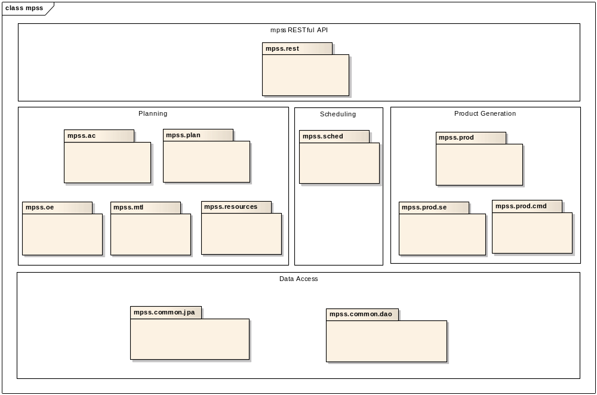

mpss.jpa package
Package mpss.jpa is used to provide an object/relational mapping (ORM) facility for the MPSS java application using a Java domain model to manage a relational database.
Package mpss.jpa consists of all persistence entities created in MPSS database tables.
A persistence entity is a lightweight Java class whose state is typically persisted to a table in a relational database. Instances of such an entity correspond to individual rows in the table. Entities typically have relationships with other entities, and these relationships are expressed through object/relational metadata. Object/relational metadata are specified directly in the entity class file by using annotations.

Subject area: Resources
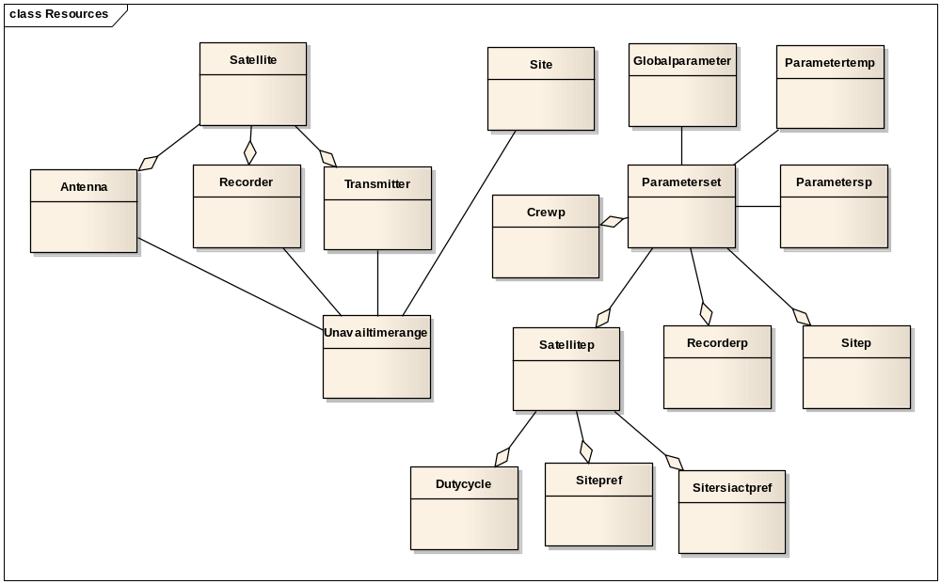

Subject area: Orbit events
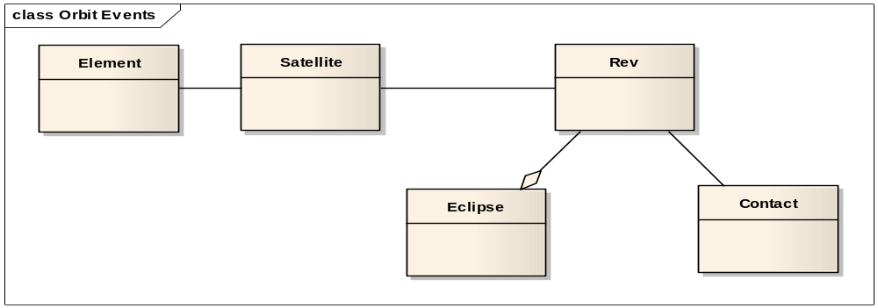

Subject area: Activity Requests
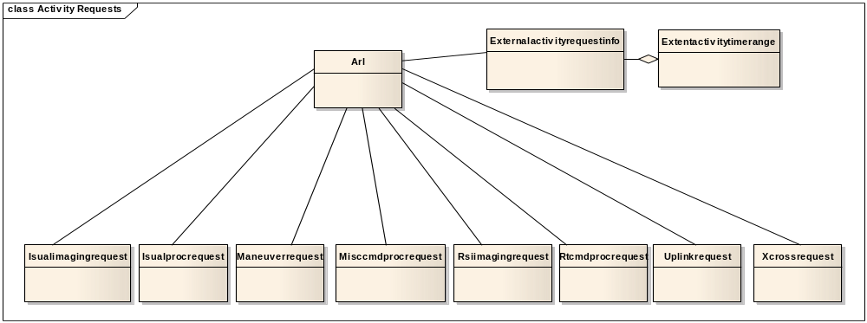
Subject area: Schedule
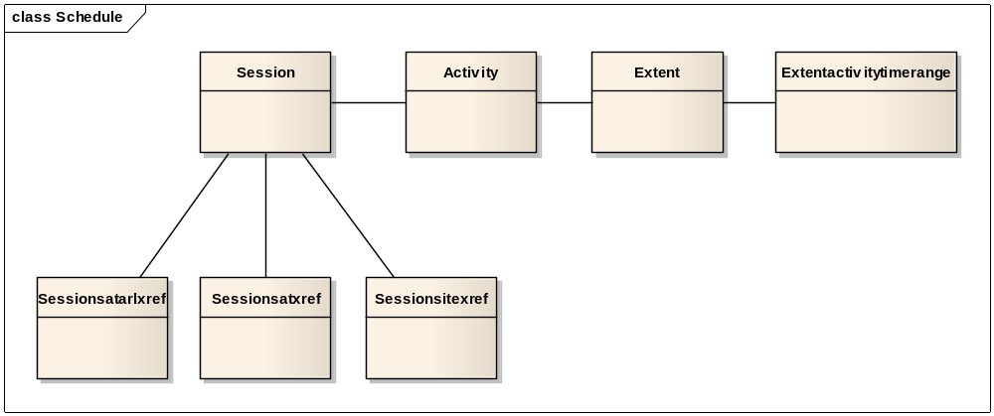

mpss.dao package
Package mpss.dao is used as Data Access Object (DAO) to abstract and encapsulate all access to the data source. The DAO manages the connection with the data source to obtain and store data.
The DAO implements the access mechanism required to work with the data source.

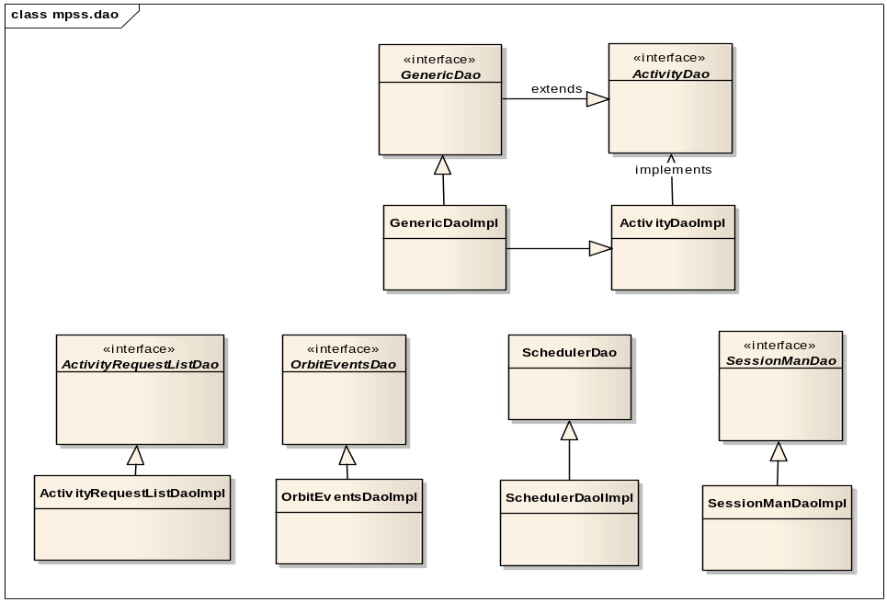
GenericDao
GenericDao generic object is the base abstraction of DAO to provide add, delete, update, save transactions upon JPA persistence entities.
Every JPA entity has a corresponding Dao class by wrapping in GenericDao.

ActivityRequestDao
Access to activity request list related information.

OrbitEventsDao
Access to orbit events related information, such as revolutions, eclipses and contacts.

SessionManDao
Access to session management related information.

SchedulerDao
Access to scheduling related information.

mpss.ac package
Package mpss.ac is used to provide planned activity creation services for a session.
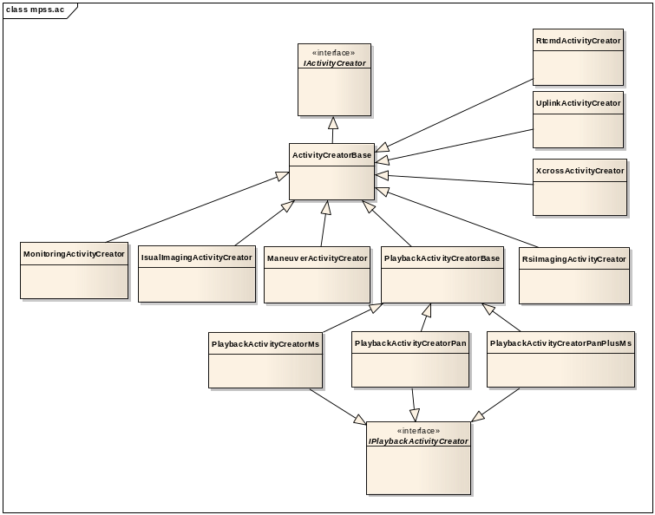
MonoitoringActivityCreator
Monitoring activity creator refers to available S band contacts to generate monitoring activities within a session.

ManeuverActivityCreator
Maneuver activity creator refers to Maneuver requests to generate maneuver activities within a session.

RsiImagingActivityCreator
Create Imaging activities based on RSI imaging request and recorder parameter set constraints.

IPlaybackActivityCreator
Create Playback activities by deriving from related RSI imaging request and recorder parameters.
Three types of activities may be created, which are MS, PAN or PAN plus MS.

RtcmdActivityCreator
Rtcmd activity creator refers to Rtcmd requests to generate real time command activities within a session.

UplinkActivityCreator
Create uplink activity based on Uplink request. Two types of activities will be created. One type is absolute time activity, and the other type is daily activity.

XcrossActivityCreator
Xcross activity creator refers to Xcross requests to generate X band crossover activities within a session.

mpss.oe package
Package mpss.oe is used to parse incoming rev files and cons files from FDF and store the results as orbit events in the database.
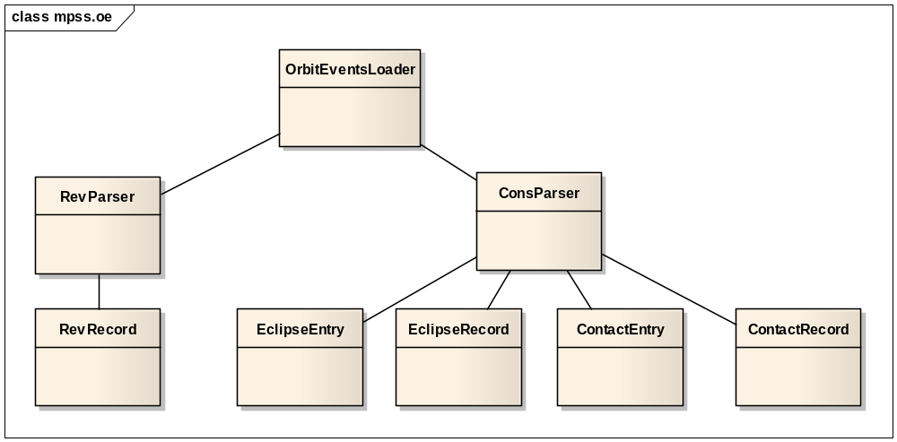

OrbitEventsLoader
Load incoming rev files and cons files from FDF and parse rev and cons files respectively. After completion, revolution (pass), eclipse and contact events will be generated and stored in the database tables.

RevParser
Parse rev file into revolution (pass) data.

RevRecord
Contain parsed revolution (pass) data.

ConsParser
Parse cons file into eclipse and contact data.

EclipseRecord
Contain parsed eclipse data.

EclipseEntry
Represent one line of eclipse data in the cons file.

ContactRecord
Contain parsed contact data.

ContactEntry
Represent one line of contact data in the cons file.

mpss.mtl package
Package mpss.mtl is used to parse incoming mission time line files from IPS and store the results as activity requests in the database.
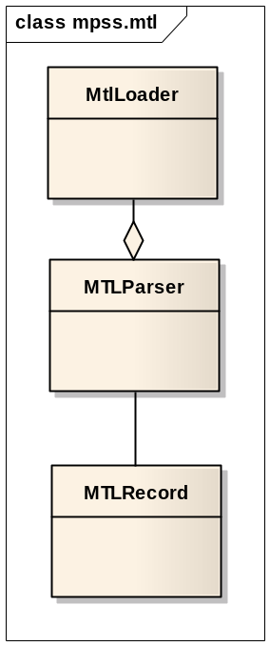

MtlLoader
Load incoming mission time line files from IPS. After completion, corresponding activity requests will be generated and stored in the database tables.

MtlParser
Parse mission time line file into activity request data.

MtlRecord
Contain parsed mission time line data.

mpss.resources package
Package mpss.resources is used to determine available resources such as contacts and satellite recorders to support scheduling decision.
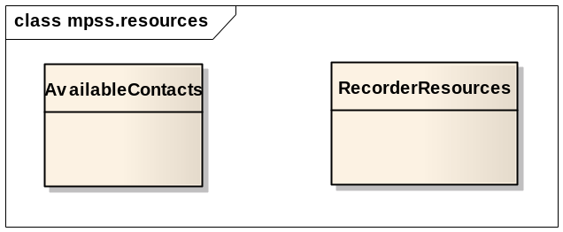

AvailableContacts
Provide S band and X band contacts within session period and filter out contacts that target to unavailable sites.

RecorderResources
Help to calculate number of sectors reserved for the duration of the imaging activity and imaging mode that is dependent on the record duration and the data rate for MS and PAN imaging.
Help to determine playback duration.

mpss.plan package
Package mpss.plan is the main entry of MPSS planning functions. It aggregates resource configuration, session management and activity request list services to provide the planning information for the scheduling task.
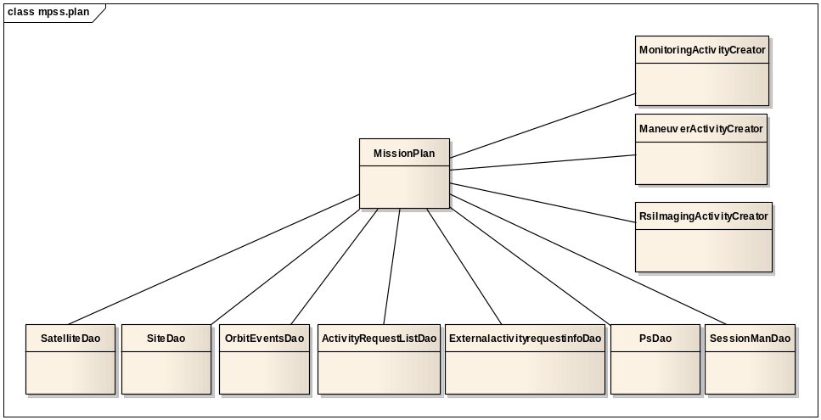

mpss.sched package
Package mpss.sched is the main entry of MPSS scheduling functions. It defines scheduling problem by turning planned activities into scheduling activities. This is done by combining resource and temporal constraints with the plan created in the session to form a Constraint Satisfaction Problem (CSP). The scheduler provides a solver (NASA EUROPA) to solve the scheduling problem by constraint processing algorithms. The scheduler provides a Gantt interface for front end to access the scheduling result time lines.
