

國家太空中心
衛星多重任務及星系操作系統
整合軟體
功能驗收與測試文件

文件編號：MCC-CDRL-015
Submitted by: |  |  | 
ACS 專案經理 鄭介棠
Authenticated by:
NSPO操控組組長 黃文莊

目錄

1. MPSS 功能測試 1
1.1. Orbital Events 1
1.2. Resource Configuration 4
1.3. Activity Request List Editor 27
1.4. Session Management 33
1.5. RTS Schedule Request Generation 49
1.6. Scheduling Overview 50
1.7. Cold Scheduling 51
1.8. External Activity Request Scheduler 54
1.9. Gantt Chart 56
1.10. Schedule Validator 64
1.11. Schedule Report Generator 68
1.12. Schedule Viewer 70
1.13. Product Generation 71
1.14. Purge Data 75

MPSS 功能測試

Orbital Events
The MPSS Orbital Events utility provides operators the ability to generate orbital event data for scheduling periods and ingest orbit event data into the MPSS system. The orbit event data will be used as planning aides in generating multi-mission schedules.
項目 | 功能說明 | 測試內容說明 | 測試結果 |  | 備註與  說明
項目 | 功能說明 |  | 通過 | 不通過 | 備註與  說明
 | Ingest Orbit Events | Ingest orbit event data into the MPSS database. |  |  | 1.1.1
 | Ingest Outputs | Ingest application generates three files:  - Orbit Ingest Log file.  - Rev Report Data file.  - Contacts Report Data file. |  |  | 1.1.2

備註與說明
1.1.1
- 點選Planning→Orbit Events→Ingest，選擇Orbital Event File、Spacecraft、Branch條件後，按Run
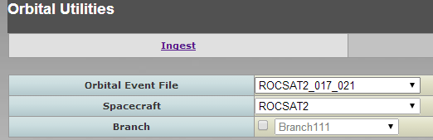
- 執行完若Ingest成功，則會出現下列視窗
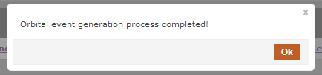
按下Ok則會出現Report Data，可看到產出的相關contacts, revs reports
- 在File清單裏會多一筆剛ingest 的資料
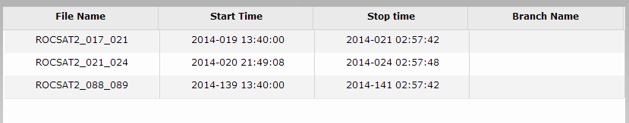

1.1.2
- 續1.1.1 – (2), 當Ingest成功後，按下Ok鍵，會產出相關報表。如:
Orbit Ingest Log file
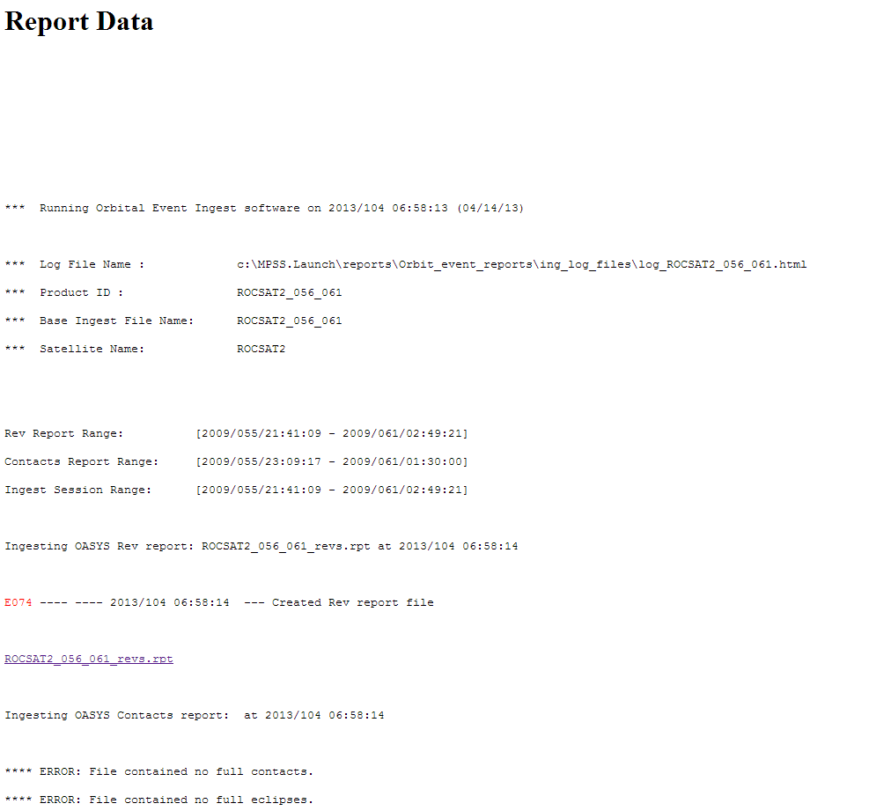

Rev Report Data file
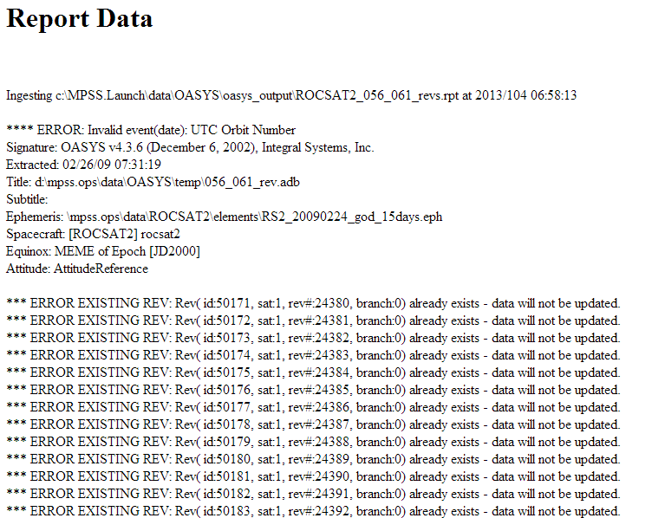

Contacts Report Data file
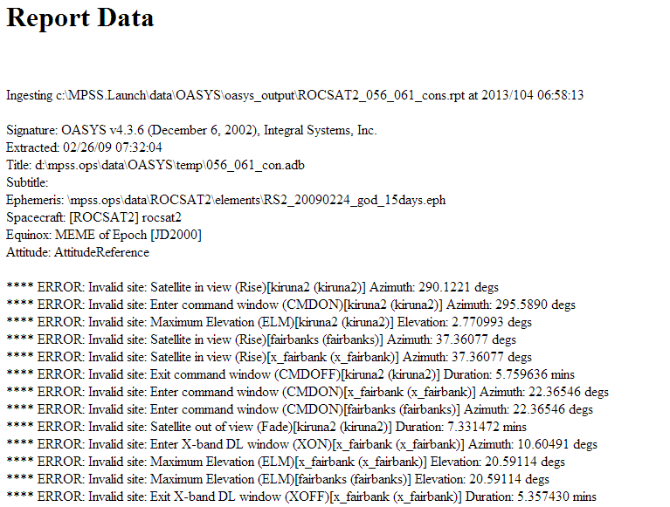

Resource Configuration
The Resource Configuration utility enables users to view and define static and dynamic attributes of the physical resources and scheduling parameters, and save these values to the MPSS database. The Resource Configuration data is divided into Global data and Parameter Set data. Global data encompasses the static attributes of the physical resources and scheduling parameters. Parameter Set data encompasses the dynamic attributes of the physical resources and scheduling parameters.

項目 | 功能說明 | 測試內容說明 | 測試結果 |  | 備註與  說明
項目 | 功能說明 |  | 通過 | 不通過 | 備註與  說明
 | Creating a Parameter Set
 | Create a PS using Default PS Values | 透過畫面檢視是否正確新增PS資料並寫入MPSS 資料庫相關表格中，其中包括：PARAMETERSET.  SATELLITEPS.  RECORDERPS.  DUTYCYCLE.  SITERSIACTPREF. |  |  | 1.2.1.1
 | Create a PS by Copying an Existing PS | 透過畫面檢視是否正確複製已存在的PS資料並寫入MPSS 資料庫相關表格中，其中包括：PARAMETERSET.  SATELLITEPS.  RECORDERPS.  DUTYCYCLE.  SITERSIACTPREF. |  |  | 1.2.1.2
 | Modifying a Parameter Set | 透過畫面檢視是否正確修改PS資料並寫入MPSS 資料庫相關表格中，其中包括：  PARAMETERSET.  SATELLITEPS.  RECORDERPS.  DUTYCYCLE.  SITERSIACTPREF. |  |  | 1.2.1.3
 | Deleting a Parameter Set | 透過畫面檢視PS資料是否從MPSS 資料庫相關表格中刪除，其中包括：  PARAMETERSET.  SATELLITEPS.  RECORDERPS.  DUTYCYCLE.  SITERSIACTPREF. |  |  | 1.2.1.4
 | Modifying the System Default PS Values | 透過畫面檢視是否正確修改系統預設的PS資料並寫入MPSS 資料庫相關表格中，其中包括：  PARAMETERSET.  SATELLITEPS.  RECORDERPS.  DUTYCYCLE.  SITERSIACTPREF. |  |  | 1.2.1.5
 | Modifying Global Data
 | Create a New Satellite | 透過畫面檢視是否正確寫入MPSS 資料庫SATELLITE表格中。 |  |  | 1.2.2.1
 | Rename a Satellite | 透過畫面檢視是否正確Rename a Satellite並寫入MPSS 資料庫SATELLITE表格中。 |  |  | 1.2.2.2
 | Delete a Satellite | 透過畫面檢視是否正確從SATELLITE表格中刪除資料。 |  |  | 1.2.2.3
 | Edit Satellite Global Configuration | 透過畫面檢視是否正確編輯資料並寫入SATELLITE表格中。 |  |  | 1.2.2.4
 | Add Recorder Resource | 透過畫面檢視是否正確新增資料並寫入RECORDER表格中。 |  |  | 1.2.2.5
 | Delete Recorder Resource | 透過畫面檢視是否正確從RECORDER表格中刪除。 |  |  | 1.2.2.6
 | Edit SSR Details | 透過畫面檢視是否正確編輯SSR資料並寫入RECORDER表格中。 |  |  | 1.2.2.7
 | Edit Recorder Unavailable Times | 透過畫面檢視是否正確編輯Recorder Unavailable times資料並寫入UNAVAILTIMERANGE表格中 |  |  | 1.2.2.8
 | Add Antenna Resource | 透過畫面檢視是否正確新增資料並寫入ANTENNA表格中。 |  |  | 1.2.2.9
 | Delete Antenna Resource | 透過畫面檢視是否正確從ANTENNA表格中刪除。 |  |  | 1.2.2.10
 | Edit Antenna Unavailable Times | 透過畫面檢視是否正確編輯Antenna Unavailable times資料並寫入UNAVAILTIMERANGE表格中 |  |  | 1.2.2.11
 | Add Transmitter Resource | 透過畫面檢視是否正確新增資料並寫入TRANSMITTER表格中。 |  |  | 1.2.2.12
 | Delete Transmitter Resource | 透過畫面檢視是否正確從TRANSMITTER表格中刪除。 |  |  | 1.2.2.13
 | Edit Transmitter Unavailable Times | 透過畫面檢視是否正確編輯Antenna Unavailable times資料並寫入UNAVAILTIMERANGE表格中 |  |  | 1.2.2.14
 | Edit Satellite Global Timing | 透過畫面檢視是否正確編輯資料並寫入SATELLITE表格中。 |  |  | 1.2.2.15
 | Edit Satellite Parameter Set Configuration | 透過畫面檢視是否正確編輯資料並寫入SATELLITEPS表格中。 |  |  | 1.2.2.16
 | Edit Satellite Parameter Set Duty Cycle | 透過畫面檢視是否正確編輯資料並寫入DUTYCYCLE表格中。 |  |  | 1.2.2.17
 | Edit Site Global Configuration
 | Create a New Site | 透過畫面檢視是否正確寫入SITE表格中。 |  |  | 1.2.3.1
 | Rename a Site | 透過畫面檢視是否正確Rename a Site並SITE表格中。 |  |  | 1.2.3.2
 | Delete a Site | 透過畫面檢視是否正確從SITE表格中刪除資料。 |  |  | 1.2.3.3
 | Edit Site Global Unavailable Times | 透過畫面檢視是否正確編輯Site Global Unavailable times資料並寫入UNAVAILTIMERANGE表格中 |  |  | 1.2.3.4
 | Edit Site Parameter Set Configuration | 透過畫面檢視是否正確編輯Site PS資料並寫入SITEPS表格中 |  |  | 1.2.3.5
 | Edit Scheduling Parameters Global Configuration | 透過畫面檢視是否正確編輯資料並寫入GLOBALPARAMETERS表格中 |  |  | 1.2.3.6

備註與說明
1.2.1.1
- 點選Planning→Resource Configuration，點選Parameter Set
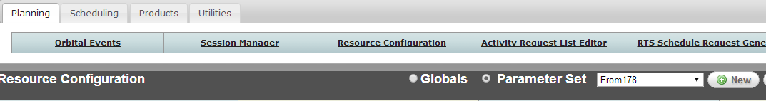
按下New的按鈕，輸入新的Parameter Set的Name
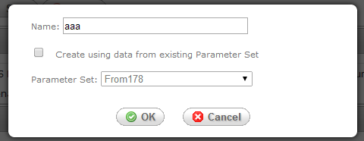
再按OK
- 輸入相關基本資料後，再按Save鍵，會出現ParameterSet Data Is Saved視窗。
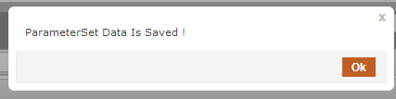

1.2.1.2
- 點選Planning→Resource Configuration，點選Parameter Set
按下New的按鈕，輸入新的Parameter Set的Name，並勾選Create using data from existing Parameter Set
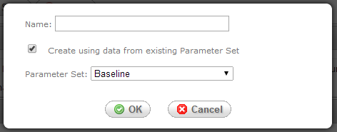
再按OK，若是copy現有的parameter set，此時comments會自動帶出for Baseline [copied from PS: xxx] 字樣 ( xxx 為 copy的 paramenter set的 name)。
- 輸入相關基本資料後，再按Save鍵，會出現ParameterSet Data Is Saved視窗

1.2.1.3
- 點選Planning→Resource Configuration，點選Parameter Set，在下拉選單中點選所要修改的名稱

- 若該parameter set 已被copy或已被schedule使用，則不能修改，系統會出現下列訊息
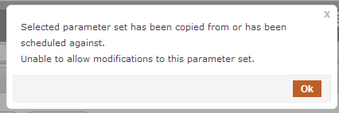
- 修改相關基本資料後，再按Save，會出現ParameterSet Data Is Saved視窗

1.2.1.4
- 點選Planning→Resource Configuration，點選Parameter Set，在下拉選單中點選所要刪除的名稱，再按下Delete
- 若刪除成功，會出現ParameterSet Data Is Deleted的畫面。
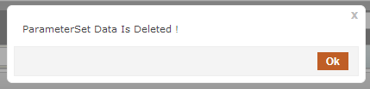

1.2.1.5
- 點選Planning→Resource Configuration，點選Parameter Set，在下拉選單中點選Default

- 在相關的Parameters的參數中作修改，修改完再按save。
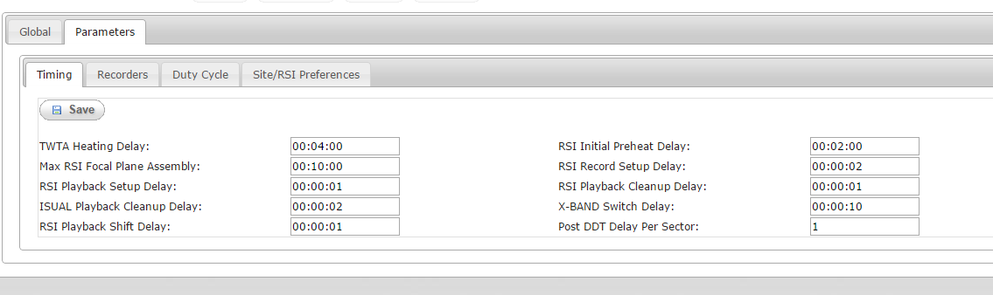

- 儲存成功會出現下列畫面
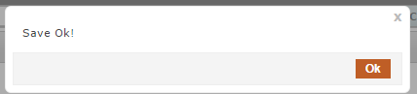

1.2.2.1
- 點選Planning→Resource Configuration，點選Globals
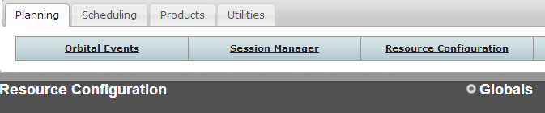

- 在Satellite頁籤，按下New
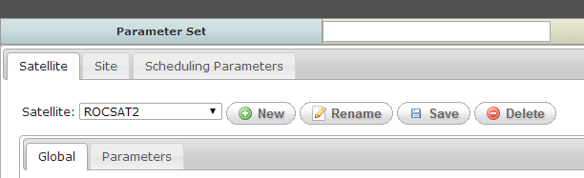
- 會彈出輸入畫面，輸入新的Satellite的Name
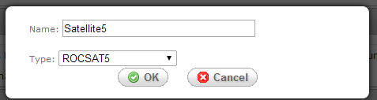

- 再輸入基本資料按下Save，
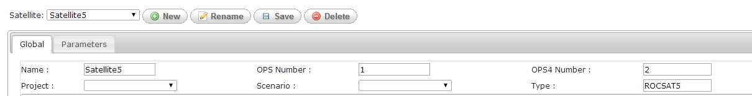
Save成功會出現下列畫面
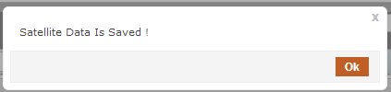

1.2.2.2
- 點選Planning→Resource Configuration，點選Globals

- 在Satellite頁籤，按下Rename
- 會彈出輸入畫面，輸入新的Satellite的Name
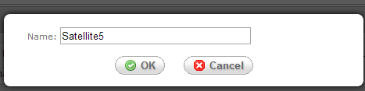

- 再輸入基本資料按下Save，
Save成功會出現下列畫面

1.2.2.3
- 點選Planning→Resource Configuration，點選Globals

- 在Satellite頁籤，下拉選單選擇要刪除的Satellite，按下Delete
- 若刪除成功，則出現下列訊息
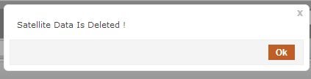

1.2.2.4
- 點選Planning→Resource Configuration，點選Globals

在Satellite頁籤，選擇要修改的satellite，修改完基本資料按Save

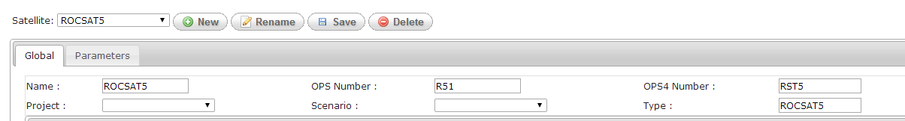

儲存成功，會出現下列畫面

1.2.2.5
- 選擇要修改的Satellite, 再點選Global→Recorder，再按下Add
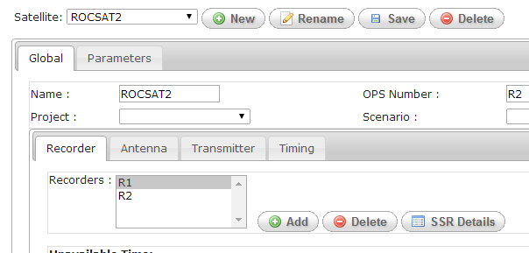

- 輸入Recorder name，再按OK
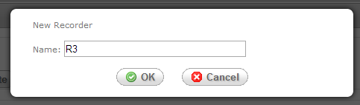

- 再輸入該Recorder 的SSR Details或Unavailable Time資料
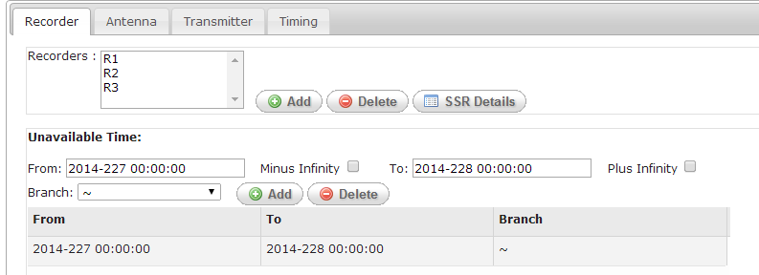
再按下Satellite 旁的Save鍵
儲存成功，會出現下列畫面

1.2.2.6
- 選擇要修改的Satellite, 再點選Global→Recorder，選擇要刪的Recorder，再按下Delete

- 再按下Satellite 旁的Save鍵
儲存成功，會出現下列畫面，即將該筆Recorder刪除

1.2.2.7
- 選擇要修改的Satellite, 再點選Global→Recorder，選擇要修改的Recorder，再按下SSR Details

- 修改SSR相關資料後按OK
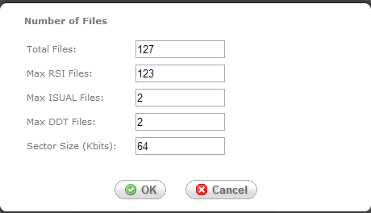
- 再按下Satellite 旁的Save鍵
儲存成功，會出現下列畫面，即將該筆SSR資料存檔

1.2.2.8
- 選擇要修改的Satellite, 再點選Global→Recorder，選擇要修改的Recorder
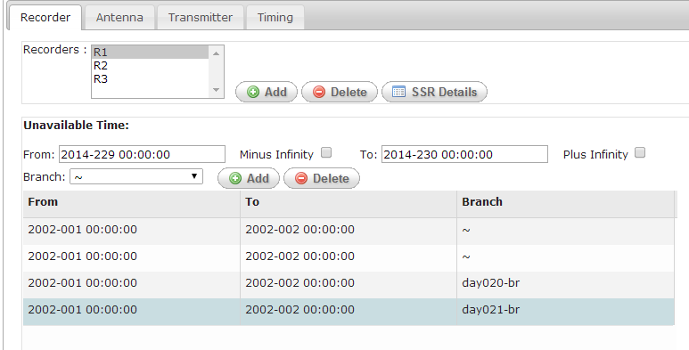

- 欲新增新的Unavailable Time，先輸入From, To, Branch 等欄位，再按Add，則會在列表中出現新增的資料。
- 若欲刪除Unavailable Time，先點選列表中欲刪的資料，再按Delete
- 再按下Satellite 旁的Save鍵
儲存成功，會出現下列畫面

1.2.2.9
- 選擇要修改的Satellite, 再點選Global→Antenna，再按下Add
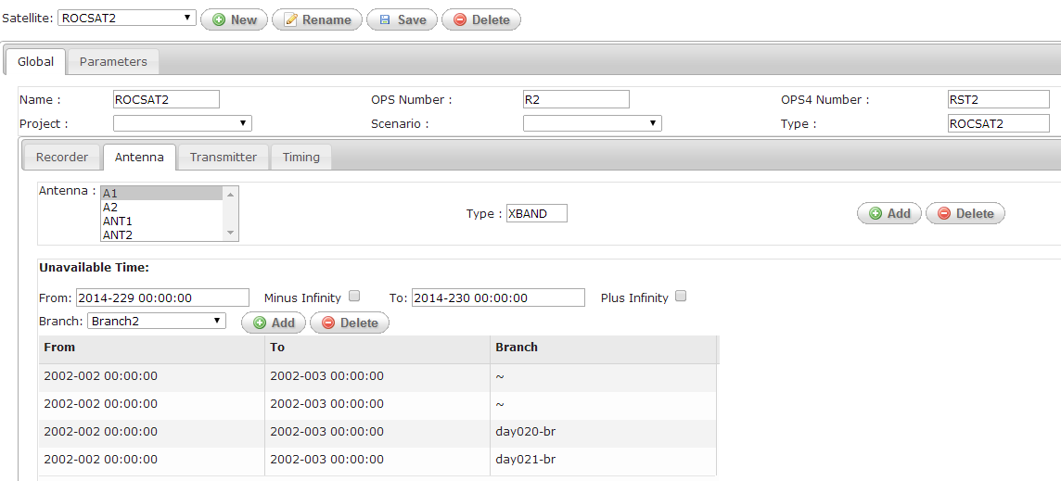

- 輸入Antenna Name、 Type，再按OK
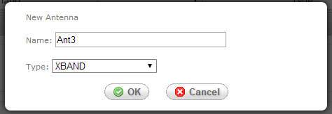

- 再按下Satellite 旁的Save鍵
儲存成功，會出現下列畫面

1.2.2.10
- 選擇要修改的Satellite, 再點選Global→Antenna，在Antenna的List中選擇要刪的那一筆，再按下Delete
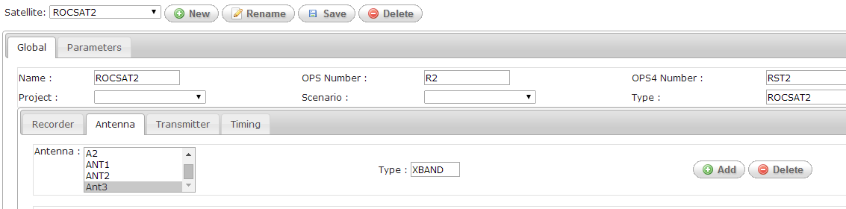
- 清單中的該筆Antenna消除後，再按下Satellite 旁的Save鍵
儲存成功，會出現下列畫面

1.2.2.11
- 選擇要修改的Satellite, 再點選Global→Antenna，選擇要修改的Antenna
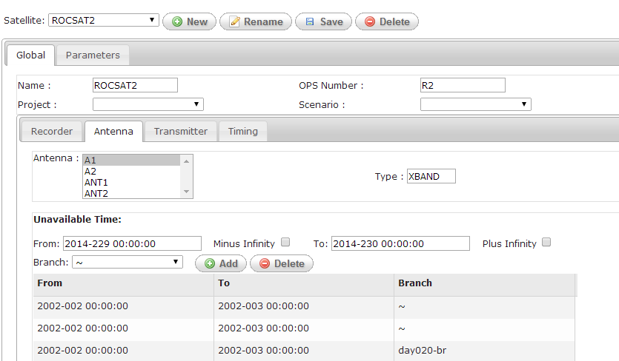

- 欲新增新的Unavailable Time，先輸入From, To, Branch 等欄位，再按Add，則會在列表中出現新增的資料。
- 若欲刪除Unavailable Time，先點選列表中欲刪的資料，再按Delete
- 再按下Satellite 旁的Save鍵
儲存成功，會出現下列畫面

1.2.2.12
- 選擇要修改的Satellite, 再點選Global→Transmitter，再按下Add
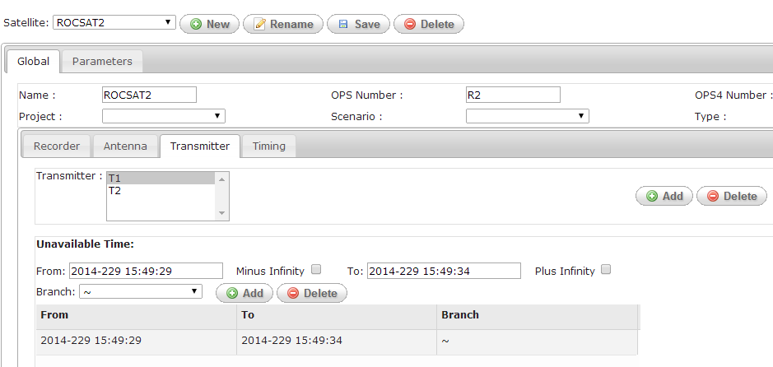

- 輸入Transmitter Name，再按OK
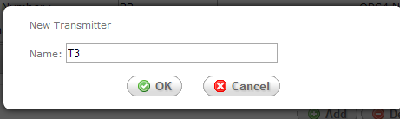

- 再按下Satellite 旁的Save鍵
儲存成功，會出現下列畫面

1.2.2.13
- 選擇要修改的Satellite, 再點選Global→Transmitter，在Transmitter的List中選擇要刪的那一筆，再按下Delete
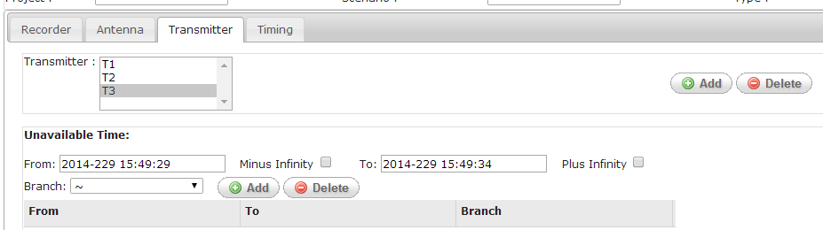
- 清單中的該筆Transmitter消除後，再按下Satellite 旁的Save鍵
儲存成功，會出現下列畫面

1.2.2.14
- 選擇要修改的Satellite, 再點選Global→Transmitter，選擇要修改的Transmitter

- 欲新增新的Unavailable Time，先輸入From, To, Branch 等欄位，再按Add，則會在列表中出現新增的資料。
- 若欲刪除Unavailable Time，先點選列表中欲刪的資料，再按Delete
- 再按下Satellite 旁的Save鍵
儲存成功，會出現下列畫面

1.2.2.15
- 選擇要修改的Satellite, 再點選Global→Timing
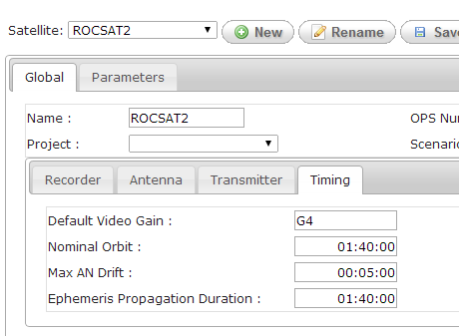

- 修改相關欄位後，再按下Satellite 旁的Save鍵
儲存成功，會出現下列畫面

1.2.2.16
- 點選Satellite→Parameters→Timing頁籤，再選擇要修改的Satellite + Parameters
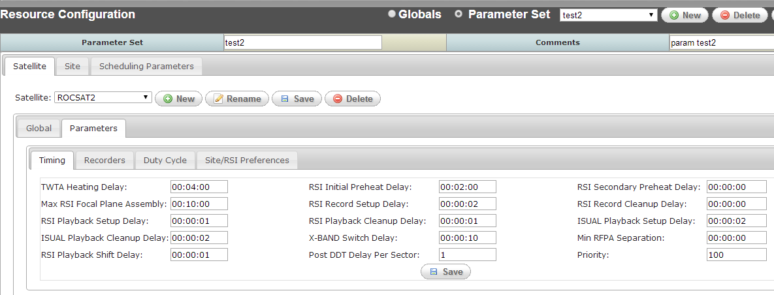

- 修改Timing頁籤中相關欄位後，再按下Save鍵，會出現下列畫面
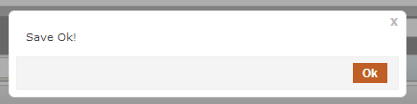

1.2.2.17
- 點選Satellite→Parameters→duty Cycle頁籤，再選擇要修改的Satellite + Parameters
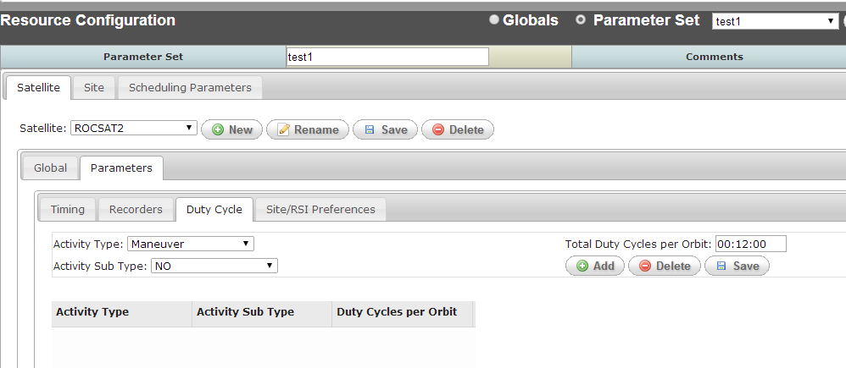

- 輸入Activity Type、Activity Sub Type，再按Add，會在下方清單出現一筆新增資料，若欲刪除列表中資料，則點選列表中的某一筆再按下Delete。修改完要存檔，則按下Save鍵，會出現下列視窗
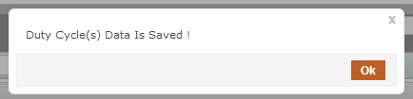

1.2.3.1
- 點選Site頁籤，按下New按鍵
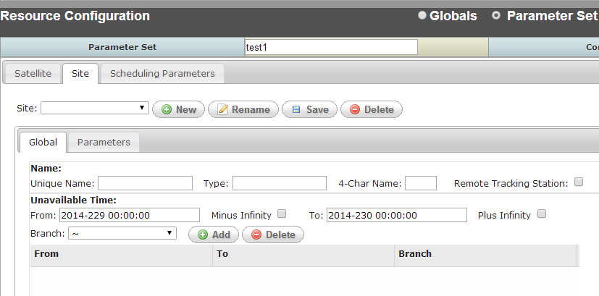
- 出現輸入畫面，輸入相關欄位後按OK
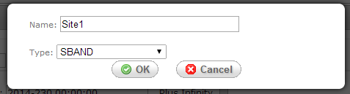
- 再輸入基本資料相關欄位按下Save
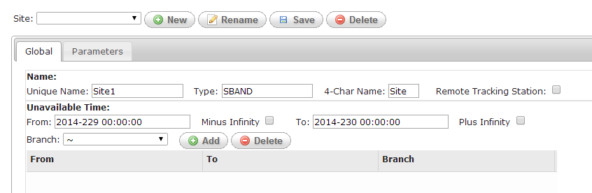
若成功，會出現下列視窗
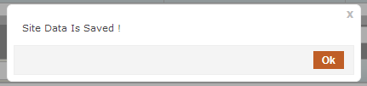

1.2.3.2
- 點選Site頁籤，在Site下拉選單選擇要改名的Site，按下Rename按鍵
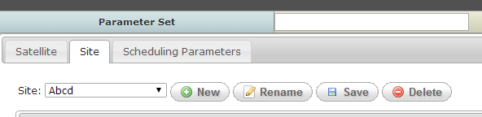
- 出現輸入畫面，輸入Name後按OK
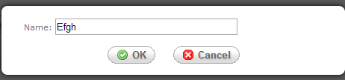
- 再按下Save，會出現下列視窗

1.2.3.3
- 點選Site頁籤，在Site下拉選單選擇要刪除的Site，按下Delete按鍵

- 會出現刪除確認畫面，若確定刪除後，會出現下列視窗
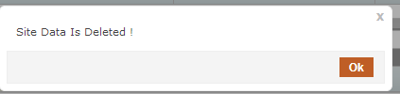

1.2.3.4
- 點選Site頁籤，在Site下拉選單選擇要修改的Site
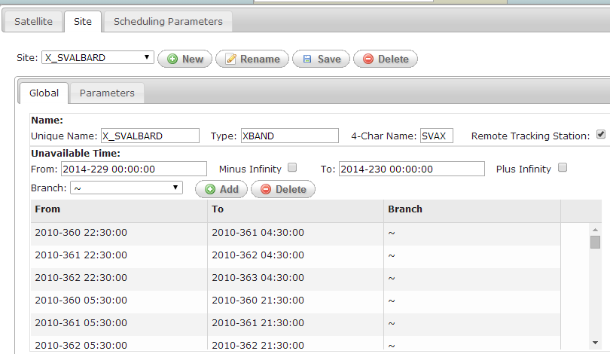

- 欲新增新的Unavailable Time，先輸入From, To, Branch 等欄位，再按Add，則會在列表中出現新增的資料。
- 若欲刪除Unavailable Time，先點選列表中欲刪的資料，再按Delete
- 再按下Site 旁的Save鍵
儲存成功，會出現下列畫面
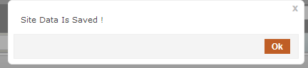

1.2.3.5
- 點選Site→Parameters頁籤，在Site下拉選單選擇要修改的Site
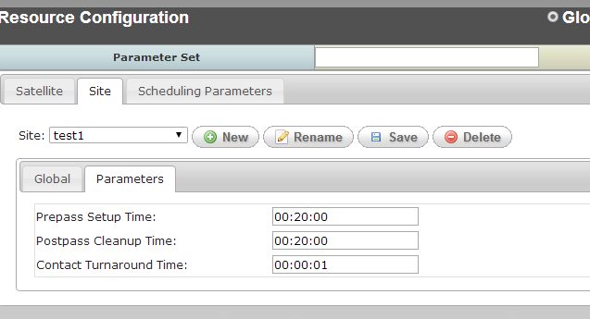
- 修改相關欄位後，按下Save，會出現下列畫面

1.2.3.6
- 點選Scheduling Parameters頁籤
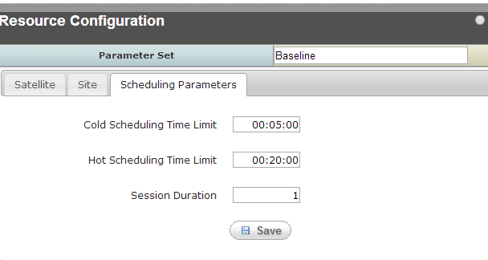
- 修改相關欄位後，按下Save，會出現下列畫面
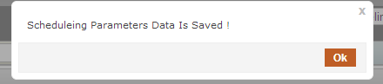

Activity Request List Editor
The Activity Request List (ARL) Editor utility enable users to create activity requests for RSI Imaging activities, ISUAL Imaging activities, Monitoring activities, Uplink activities, Real-Time Command activities, and X-Band Cross activities. Each activity type defines the timing frequency, and in some types, resources that are required when scheduling.
Activity requests may consist of one or more request specifications, identifying required activities at specific times and more general activity times. Users may create activity requests by copying existing ARLs and modifying needed specifications. The activity requests are not designed to be spacecraft specific, allowing one activity request to be used for scheduling multiple satellites.
項目 | 功能說明 | 測試內容說明 | 測試結果 |  | 備註與  說明
項目 | 功能說明 |  | 通過 | 不通過 | 備註與  說明
 | Working with Activity Request List Editor
 | Creating a New ARL | 透過畫面檢視是否正確寫入ARL表格中。 |  |  | 1.3.1.1
 | Open an Existing ARL | 透過畫面檢視是否正確從ARL/ ISUALIMAGINGREQUESTS/ MANEUVERREQUESTS/ RSIIMAGINGREQUESTS/ RTCMDPROCREQUESTS/ UPLINKREQUESTS/ XCROSSREQUESTS表格中讀取資料。 |  |  | 1.3.1.2
 | Saving an ARL | 透過畫面檢視是否正確將資料儲存到ARL/ ISUALIMAGINGREQUESTS/ MANEUVERREQUESTS/ RSIIMAGINGREQUESTS/ RTCMDPROCREQUESTS/ UPLINKREQUESTS/ XCROSSREQUESTS表格中。 |  |  | 1.3.1.3
 | Deleting an ARL | 透過畫面檢視是否正確從ARL/ ISUALIMAGINGREQUESTS/ MANEUVERREQUESTS/ RSIIMAGINGREQUESTS/ RTCMDPROCREQUESTS/ UPLINKREQUESTS/ XCROSSREQUESTS表格中刪除資料。 |  |  | 1.3.1.4
 | Editing an Activity Request Specification
 | Create a New Activity Request Specification | - 透過畫面檢視是否正確寫入ISUALIMAGINGREQUESTS/ MANEUVERREQUESTS/ RSIIMAGINGREQUESTS/ RTCMDPROCREQUESTS/ UPLINKREQUESTS/ XCROSSREQUESTS表格中。 |  |  | 1.3.2.1
 | Edit an Existing Activity Request Specification | 透過畫面檢視是否正確編輯資料並儲存到ISUALIMAGINGREQUESTS/ MANEUVERREQUESTS/ RSIIMAGINGREQUESTS/ RTCMDPROCREQUESTS/ UPLINKREQUESTS/ XCROSSREQUESTS表格中。 |  |  | 1.3.2.2
 | Delete an Existing Activity Request Specification | 透過畫面檢視是否正確從 ISUALIMAGINGREQUESTS/ MANEUVERREQUESTS/ RSIIMAGINGREQUESTS/ RTCMDPROCREQUESTS/ UPLINKREQUESTS/ XCROSSREQUESTS表格中刪除資料。 |  |  | 1.3.2.3

備註與說明
1.3.1.1
- 點選Planning→Activity Request List Editor頁籤 ，按下New
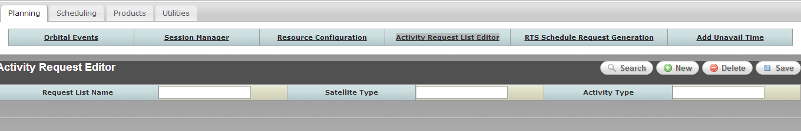
- 輸入基本相關欄位後，按OK
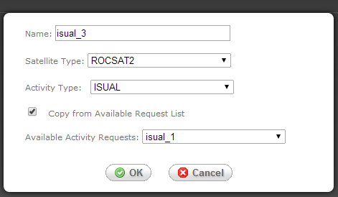
- 按下Save，會出現下列畫面
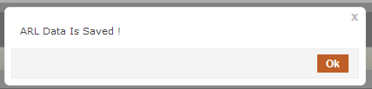
1.3.1.2
- 點選Planning→Activity Request List Editor頁籤 ，按下Search

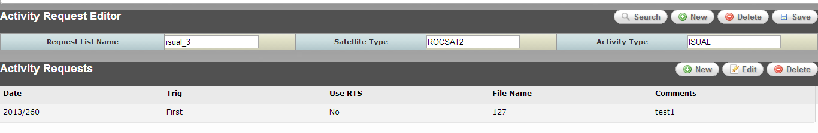
- 輸入Search條件，按下OK
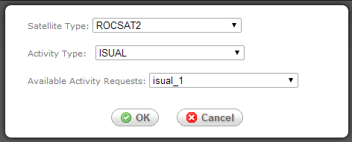
即可在畫面顯示查詢結果
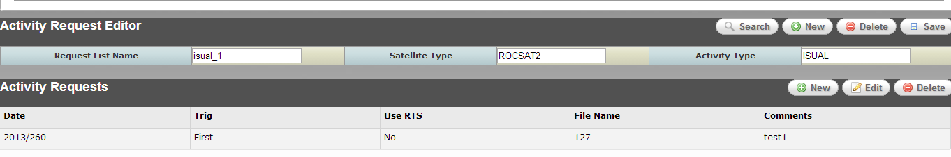

1.3.1.3
- 在Activity Requests的清單中，按下Edit

- 修改相關欄位，按下OK
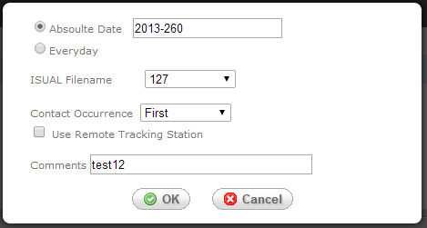
- 按下Save

儲存成功後有下列畫面
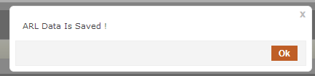

1.3.1.4
- 先Search出要刪的ARL，按下Delete
- 確認刪除後有下列畫面
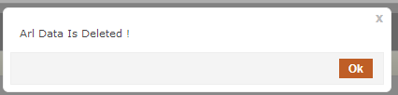

1.3.2.1
- 先Search出要編輯的ARL，在下方Activity Requests的清單中，按下New

- 輸入相關欄位，按下OK
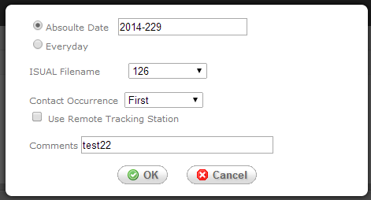

- 按下Save
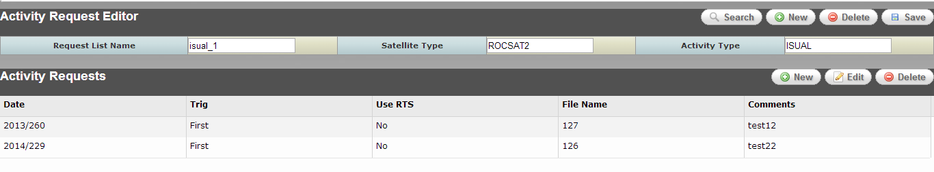
儲存成功後有下列畫面
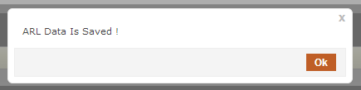

1.3.2.2
- 在Activity Requests的清單中先點選要修改的項目，按下Edit

- 修改相關欄位，按下OK
- 按下Save
儲存成功後有下列畫面

1.3.2.3
- 在Activity Requests的清單中，先點選要刪的項目，再按下Delete

- 該項目移除後，按下Save
儲存成功後有下列畫面

Session Management
The Session Manager GUI enables the user to define a scheduling session. A session definition will include the scheduling time window, resource parameter set, defined in the MPSS Resource Management utility, the scheduling resources, satellites and sites, and sets of activity requests. The Session Manager utility will store the session and branch definitions in the MPSS database for use by other MPSS subsystems.
項目 | 功能說明 | 測試內容說明 | 測試結果 |  | 備註與  說明
項目 | 功能說明 | 測試內容說明 | 通過 | 不通過 | 備註與  說明
 | Working with Sessions
 | Creating a Session | - Show New Session/Branch Dialog and List all sessions from SESSIONS database table.  - Select Session Option  - Sessin id is automatically generated, ID is generated from LASTNUMBER of IDTABLE.  - If Click the Create using data from existing Session checkbox and Select a session from the list  - Copy data from SESSIONS and insert into new record.  - Copy data from SESSIONSATXREF and insert into new record.  - Copy data from SESSIONSATARLXREF and isert into new record.  - Copy data from SESSIONSITEXREF and insert into new record.  - Show session management page and input session data.  - Select a parameter set from PARAMETERSET table and input PSID field.  - Input start time, may reference Session Time Range use case.  - Input stop time, may reference Session Time Range use case.  - The status field ,if COLDSCHEDULED = 1 then display scheduled else display nonscheduled.  - Select satellite from SATELLITE table and insert new record into SESSIONSATXREF table .  - Select satellite from SITE table and insert new record into SESSIONSITEXREF table .  - Select RSI imaging from ARL table then insert new record into SESSIONSATARLXREF table, related fields have ID, SATELLITEID , SESSIONID, ARLID,ARLTYPE. the ID is generated from LASTNUMBER of IDTABLE.  - Select ISUAL imaging from ARL table then insert new record into SESSIONSATARLXREF table, related fields have ID, SATELLITEID , SESSIONID, ARLID,ARLTYPE. the ID is generated from LASTNUMBER of IDTABLE.  - Select Manevering from ARL table then insert new record into SESSIONSATARLXREF table, related fields have ID, SATELLITEID , SESSIONID, ARLID,ARLTYPE. the ID is generated from LASTNUMBER of IDTABLE.  - Select Real Time Proc from ARL table then insert new record into SESSIONSATARLXREF table, related fields have ID, SATELLITEID , SESSIONID, ARLID,ARLTYPE. the ID is generated from LASTNUMBER of IDTABLE.  - Select X-Band Cross from ARL table then insert new record into SESSIONSATARLXREF table, related fields have ID, SATELLITEID , SESSIONID, ARLID,ARLTYPE. the ID is generated from LASTNUMBER of IDTABLE.  - Select Uplink from ARL table then insert new record into SESSIONSATARLXREF table, related fields have ID, SATELLITEID , SESSIONID, ARLID,ARLTYPE. the ID is generated from LASTNUMBER of IDTABLE.  - Save new session data, It may reference “Save a Seesion use case”. |  |  | 1.4.1.1
 | Open an Existing Session | - Show New Session/Branch Dialog and List all sessions from SESSIONS database table.  - Select Session Option  - Select Session Name from Sessions list.  - Show session management page and modify session data.  - Select a parameter set from PARAMETERSET table and update PSID field.  - modify stop time, may reference Session Time Range use case.  - The status field ,if COLDSCHEDULED = 1 then display scheduled else display nonscheduled.  - Select satellite from SATELLITE table and update satellite id of SESSIONSATXREF record .  - Select satellite from SITE table and update site id of the SESSIONSITEXREF record .  - Select RSI imaging from ARL table then update arl id of SESSIONSATARLXREF recoed.  - Select ISUAL imaging from ARL table then update arl id of SESSIONSATARLXREF recoed.  - Select Manevering from ARL table then update arl id of SESSIONSATARLXREF recoed.  - Select Real Time Proc from ARL table then update arl id of SESSIONSATARLXREF recoed.  - Select X-Band Cross from ARL table then update arl id of SESSIONSATARLXREF recoed.  - Select Uplink from ARL table then update arl id of SESSIONSATARLXREF recoed.  - Save session data, It may reference “Save a Seesion use case”. |  |  | 1.4.1.2
 | Saving a Session | - If the session being saved has been scheduled previously, a question prompt informs the user that saving the session will remove all activities from the schedule.  - Commit the change, include SESSIONS、SESSIONSATXREF、SESSIONSITEXREF、SESSIONSATARLXREF tables.  - Delete activities records from ACTIVITY according to the selected and scheduled session id. |  |  | 1.4.1.3
 | Deleting a Session | - If the session currently open in the Session Manager is not the latest session, an information prompt informs the user that the current session cannot be deleted because it is not the latest session.  - Check current session whether is a lastest session,Compare current session id with NAME, LASTNUMBER of IDTABLE.  - If the selected session has been previously scheduled and is the latest session, a question prompt informs the user that deleting the session will remove all activities from the schedule and asks if he wants to continue. If the user selects Yes, activities are removed, and the session is deleted. If the user selects No, the session will not be deleted, and schedule remains unchanged.  - Delete the selected session from SESSIONS.  - Delete satellite record from SESSIONSATXREF according to the selected session id.  - Delete site record from SESSIONSITEXREF according to the selected session id.  - Delete arl record from SESSIONSATARLXREF according to the selected session id.  - Delete activitie recoeds from ACTIVITY according to the selected session id. |  |  | 1.4.1.4
 | Renaming a Session | Update new name to NAME of SESSIONS table. |  |  | 1.4.1.5
 | Working with Branches
 | Creating a Branch | The Spec. description is same as Creating a Session exception of clicking the Branch Option button. |  |  | 1.4.2.1
 | Create a Branch from the Nominal Schedule | - Show New Session/Branch Dialog and List all sessions from SESSIONS database table.  - Select Branch Option.  - Input Branch Name and Check Session/Branch Name Whether being existed.  - Branch id is automatically generated, ID is generated from LASTNUMBER of IDTABLE. |  |  | 1.4.2.2
 | Open an Existing Branch | The Spec. description is same as Open a Session exception of clicking the Branch Option button. |  |  | 1.4.2.3
 | Saving a Branch | The Spec. description is same as Saving a Session exception of clicking the Branch Option button. |  |  | 1.4.2.4
 | Deleting a Branch | The Spec. description is same as Deleting a Session exception of clicking the Branch Option button. |  |  | 1.4.2.5
 | Renaming a Branch | The Spec. description is same as Renaming a Session exception of clicking the Branch Option button. |  |  | 1.4.2.6
 | Selecting the Time Range
 | Session Time Range | To keep sessions contiguous, the start time of a new session will be the stop time of the last session created, and the user will not be able to modify the start time. If, however, this is the first session created, the user will be able to enter session start and stop times (yyyy/ddd/hh:mm:ss); the start time of the first session in the database must not be earlier than the latest recorder checkpoint time in the database. The session stop time defaults to 7 days after the start time. The user may modify the stop time, if desired. |  |  | 1.4.3.1
 | Branch Time Range | Since branches are “what-if” sessions, the start time of a branch must fall within the start time of the earliest session and the stop time of the latest session in the database. The branch stop time must be later than the branch start time and can extend past the end of the last session. By default, the branch start time is set to the earliest session's start, and the stop time is set to the stop time of the latest session. |  |  | 1.4.3.2

備註與說明
1.4.1.1
- 點選Planning→Session Management頁籤，點選Session，再按下New
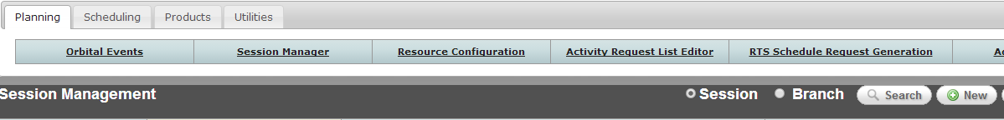
- 在彈出畫面中輸入Name，並選擇是否copy 現有的Session資料，再按OK
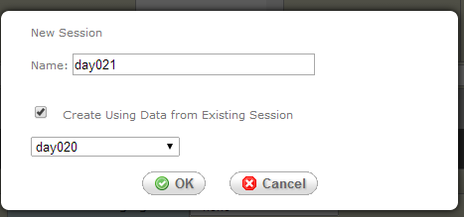
- 在基本資料欄任中，輸入相關資訊，輸入完後按Save
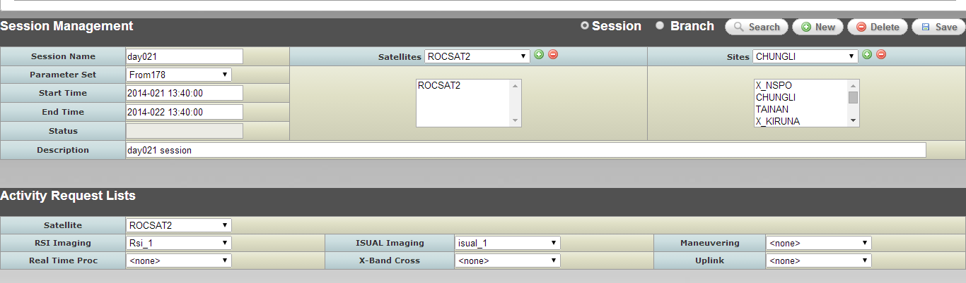

- 若儲存成功，有下列畫面
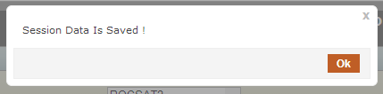

1.4.1.2
- 點選Planning→Session Management頁籤，按下Search
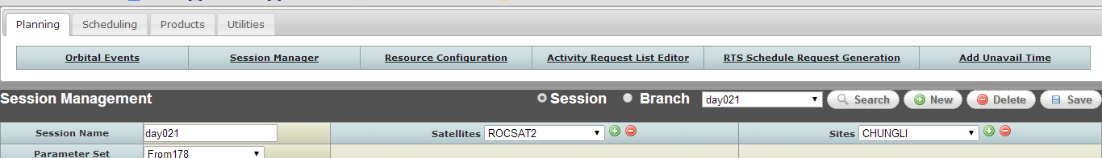
- 按下Search時，此時會出現session name的下拉選單，選擇要編輯的session，選完後下方會帶出該session的基本資料
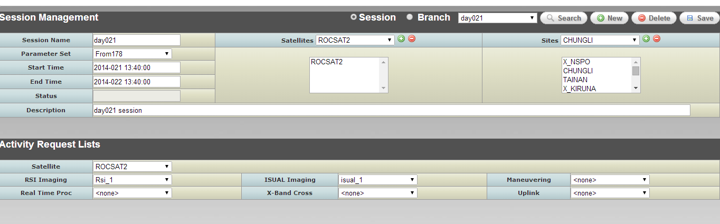

1.4.1.3
- 在1.4.1.2查詢出的基本資料欄位中，修改相關資訊，輸入完後按Save

- 若儲存成功，有下列畫面

1.4.1.4
- 點選Planning→Session Management頁籤，按下Search
- 按下Search時，此時會出現session name的下拉選單，選擇要delete的session
- 按下Delete鍵，在刪除確認視窗按下OK後，刪除成功會有下列畫面
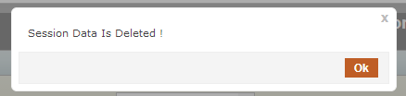

1.4.1.5
- 點選Planning→Session Management頁籤，按下Search
- 按下Search時，此時會出現session name的下拉選單，選擇要rename的session，選完後下方會帶出該session的基本資料
- 在Session Name欄位輸入新的name，再按下Save鍵，若儲存成功，有下列畫面

1.4.2.1
- 點選Planning→Session Management頁籤，點選Branch，再按下New
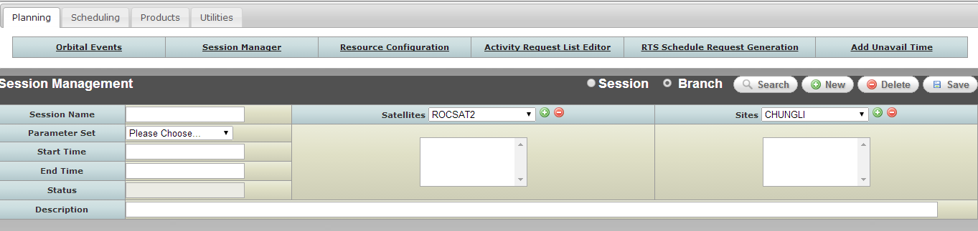
- 在彈出畫面中輸入Name，不勾選Create Using Data from Existing Session，再按OK
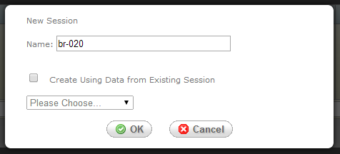
- 在基本資料欄位中，輸入相關資訊，輸入完後按Save
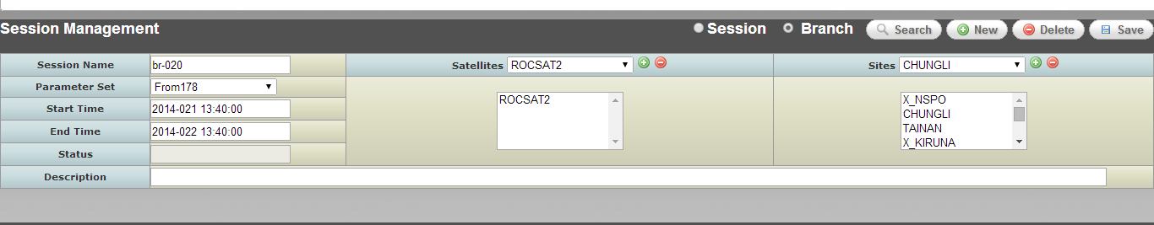

- 若儲存成功，有下列畫面

1.4.2.2
- 點選Planning→Session Management頁籤，點選Branch，再按下New
- 在彈出畫面中輸入Name，勾選Create Using Data from Existing Session，再按OK
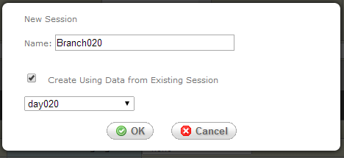
- 在基本資料欄位中，會先帶出所copy session的基本資料，可修改相關資訊，輸入完後按Save

- 若儲存成功，有下列畫面

1.4.2.3
- 點選Planning→Session Management頁籤，切換到Branch，按下Search
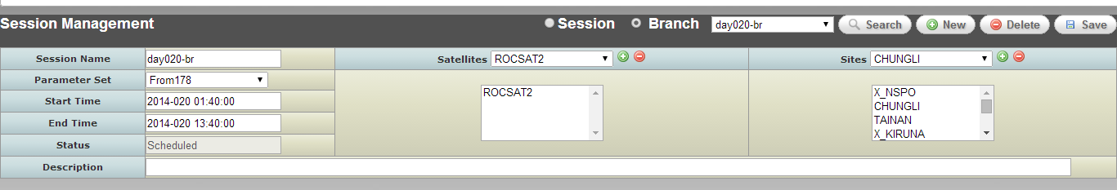
- 按下Search時，此時會出現branch name的下拉選單，選擇要編輯的branch，選完後下方會帶出該branch的基本資料

1.4.2.4
- 在1.4.2.3查詢出的基本資料欄位中，修改相關資訊，輸入完後按Save
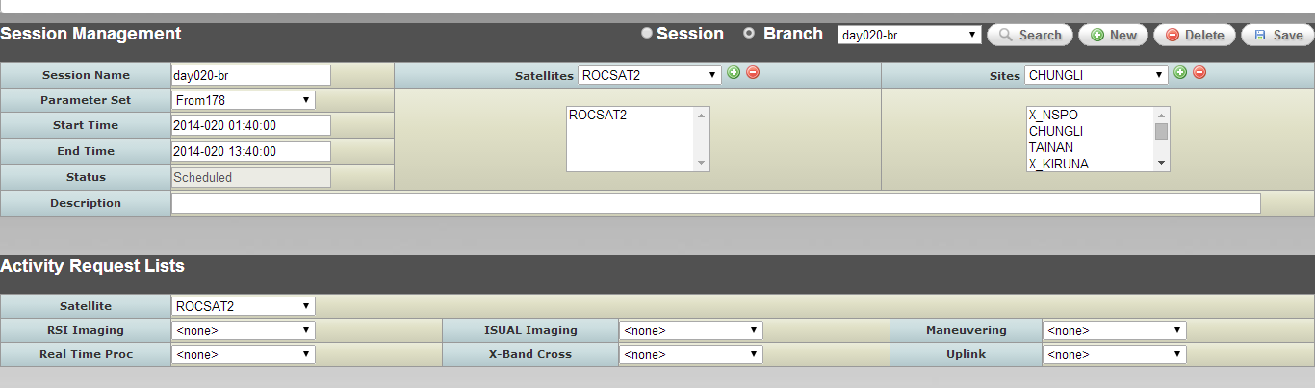

- 若儲存成功，有下列畫面

1.4.2.5
- 點選Planning→Session Management頁籤，切換到Branch，按下Search
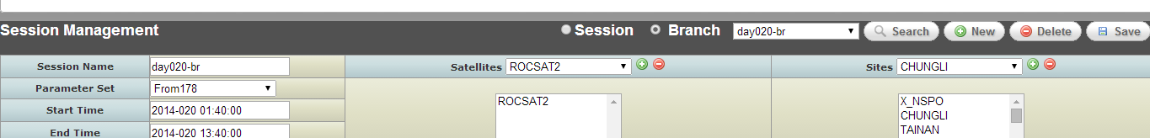
- 按下Search時，此時會出現branch name的下拉選單，選擇要delete的branch，選完後下方會帶出該branch的基本資料
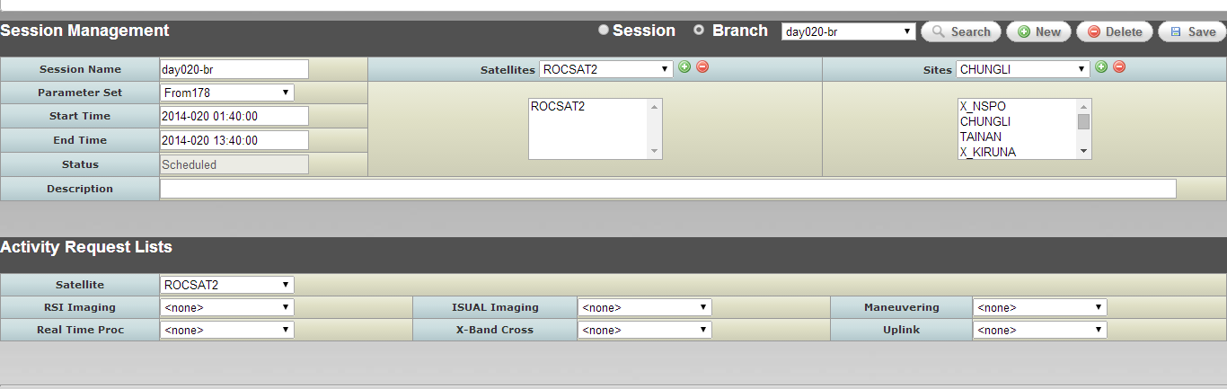
- 按下Delete鍵，在刪除確認視窗按下OK後，刪除成功會有下列畫面

1.4.2.6
- 點選Planning→Session Management頁籤，切換到Branch，按下Search

- 按下Search時，此時會出現branch name的下拉選單，選擇要rename的branch，選完後下方會帶出該branch的基本資料
- 在Session Name欄位輸入新的name，再按下Save鍵，若儲存成功，有下列畫面

1.4.3.1
- 點選Planning→Session Management頁籤，切換到Session，按下New
- 輸入session name，按下OK
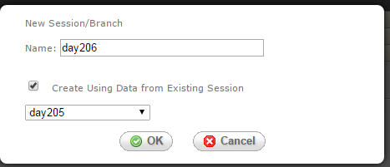
- 系統自動帶出new session的Start time時間為上一筆session的End Time
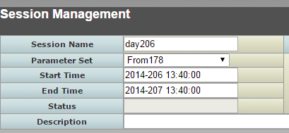

1.4.3.2
- 點選Planning→Session Management頁籤，切換到Branch，按下New
- 輸入branch name，按下OK
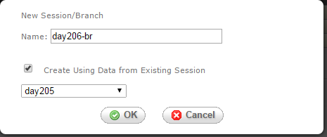
- 系統自動帶出new branch的Start time、End Time時間為最後一筆session的Start Time、End Time
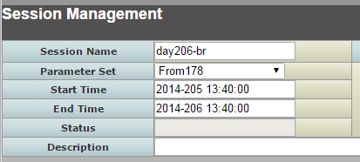

RTS Schedule Request Generation
The Remote Tracking Station (RTS) Schedule Request utility enables the users to create an RTS schedule request. This utility provides the ability to specify the required scheduling request periods for each RTS site.
項目 | 功能說明 | 測試內容說明 | 測試結果 |  | 備註與  說明
項目 | 功能說明 |  | 通過 | 不通過 | 備註與  說明
 | RTS Schedule Request Generation
 | create an RTS schedule request | - Select the RTS Schedule Request Generation … button.  - Click the Select.. button to specify a time window to retrieve RTS contacts.  - In the RTS Request dialog window select the Start and Stop times (yyyy/ddd/hh:mm:ss).  - If requesting data from a “what-if” schedule, select the Branch button and select the desired branch from the branch list.  - Select OK to display RTS Schedule Requests for selected time range in the Table provided in the RTS Schedule Request Generator window.  - Select one or more desired remote sites by clicking on the check box located in the first column of the RTS Schedule Request Table.  - Add desired comments to the comment fields of selected RTS site.  - The File Name is optional and if it is not provided by user, the utility will generate one using the RTS_<request start time>_<request end time>_<Branch Name>.txt file name convention. |  |  | 後續階段開發。

Scheduling Overview
The MCC Schedule subsystem is divided into lower level functions that aide in the planning of multi-mission schedules. The functions are categorized into schedule definition, schedule processing, schedule viewing, schedule validation and schedule report generation.
The schedule definition function includes an Activity Request List Editor and a Session Manager. The Activity Request Editor will allow spacecraft users the ability to create activity requests for State Of Health (SOH), Loads, Data Collection and Real-Time commands. The ARL (Activity Request List) editor is used to define the activity types, when the activities are to be accomplished, and, in some cases, what resources they require. The Session Manager provides the ability to define the resources and ARLs to schedule over a particular time range.
The schedule processing function includes a Cold Scheduling, External Activity Requests Scheduler (EARS), and Branch Merging. Cold Scheduling will utilize the orbit event data, resource profiles, scheduling information defined by the Session Manager to generate a conflict free schedule. Cold scheduling generates a schedule adhering to the rules defined by TBD Scheduling Rules, and attempts to schedule as many activities as available resources will support. Cold scheduling ends by providing the Scheduler with the total number of generated activities and the number of these activities that were left unscheduled, assuming that Schedulers will schedule these activities manually, if possible, by hot scheduling. Cold scheduling branches enable Schedulers to do ‘what if’ scheduling in the operational environment. Schedulers can create numerous branches off of the current schedule, perform cold scheduling, and check the outcome of each branch. If one branch generates a preferred schedule, this branch can be merged using Branch Merging process to become the nominal schedule. The Branch Merge process merges “what-if” scenarios to the nominal schedule. The External Activity Request Scheduler will process the Mission Timelines and attempt to schedule the activity requests.
The Schedule Viewing function includes a Gantt Chart Display and a Text Viewer. The Gantt Chart display will provide a graphical representation of the schedule. The Gantt Chart enables Schedulers to view a timeline that is a subset of the entire schedule. It also present a listing of unscheduled activities remaining from the Cold Scheduling process, and will allow for manual schedule editing. Schedulers can drag an unscheduled activity from the unscheduled list to the active schedule, or can move activities off of the schedule into the unscheduled list. These manual changes occur immediately. In addition, the Gantt Chart display provides the ability to manually modify existing schedules. Auto-Rescheduling can be used to reschedule a section of the schedule delimited by time, satellite(s), and available site(s). The time required to run Auto-Rescheduling depends on the resources and the time range selected. Branches also can be viewed using hot scheduling. Color-coding, text descriptions, and popup boxes visually represent the scheduled activities. Branch changes can be made using the timeline, and the branch can be rescheduled. The Text Viewer will be provided to view schedules textually. The Text Viewer will be a read-only view of a schedule.
The schedule validation function will provide the ability to validate a session or branch that has been cold scheduled or modified by Gantt Chart against the scheduling rules and constraints defined in the ROCSAT Rules Document. Schedules must be valid in order to generate products for loads and activity schedule reports.
The schedule report generation function will generate activity schedule reports, an SSR utilization report, and a power utilization report. The activity schedule reports will contain the final status of RSI and ISUAL instrument activity requests. These reports will be generated for the same time period that the current scheduled session was run.

Cold Scheduling
The Cold Scheduler is one of the MPSS core functions. The Cold Scheduler considers all of the contact data, session definitions, and ARL definitions. Given all of the resources and user-defined parameters, the Cold Scheduler generates a schedule that follows the rules defined in Rules Document. The Cold Scheduler will attempt to schedule as many activities as possible in the time allocated for Cold Schedule generation. The scheduler filters orbit data previously loaded into the MPSS database, which overlaps the session window. If a branch is scheduled, the orbit event data associated to the branch will be filtered. The filter criterion is based on selected satellites and site in session/branch, minimum contact maximum elevation requirement for cold scheduling, and minimum contact duration for cold scheduling.
項目 | 功能說明 | 測試內容說明 | 測試結果 |  | 備註與  說明
項目 | 功能說明 |  | 通過 | 不通過 | 備註與  說明
 | Cold Scheduling Preparation
 | Generate contact data for the desired time period to be scheduled. | Refer to Orbital Events.
 | Load the generated contact data into the database. | Refer to Orbital Events.
 | Create new or edit existing ARLs | Refer to ARL.
 | Create a parameter set defining the resource parameters. | Refer to Resource configuration.
 | Create a session, and assign ARLs. | Refer to Session Management.
 | Cold Scheduling User Specification Directions
 | Running a Schedule | An information message box will appear. The message will state whether or not the scheduler completed successfully or aborted, and indicate the total number of activities generated, how many activities the scheduler was unable to schedule. |  |  | 1.7.2.1
 | Schedule Undo | undo any scheduled session or branch. |  |  | 1.7.2.2
 | Activity Generation | - Generate RSI Record Activity  - Generate RSI Playback Activity  - Generate RSI DDT Activity  - Generate SSR Delete Activity  - Generate ISUAL Playback Activity  - Generate Maneuver Activity  - Generate Real-Time Activity  - Generate Miscellaneous Activity  - Generate Spacecraft Monitoring Activity  - Generate Uplink Load Activities  - Generate X-Band Crossover Activity |  |  | 1.7.2.3

備註與說明
1.7.2.1
- 點選 Scheduling→Cold Scheduler→Generate頁籤，在Session下拉選單選擇Session，然後按Run
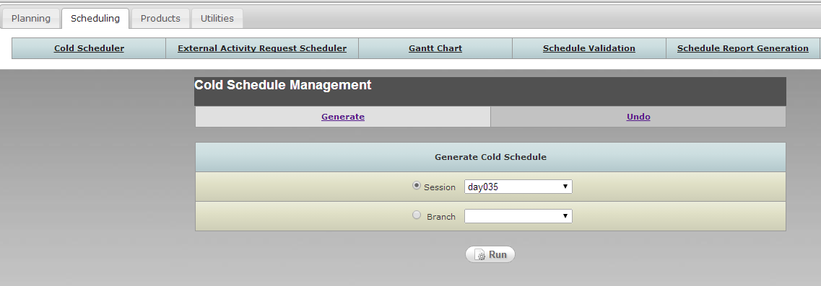
- 若執行完畢，會有下列訊息
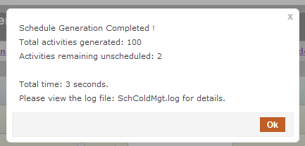

1.7.2.2
- 點選 Scheduling→Cold Scheduler→Undo頁籤，在Session下拉選單選擇Session，然後按Undo
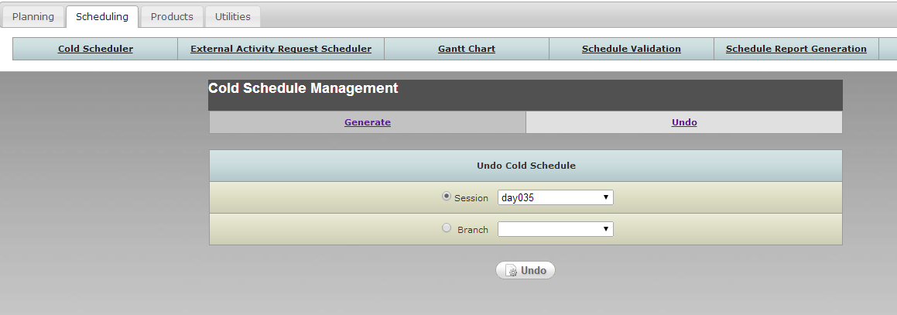
- 若執行完畢，會有下列訊息
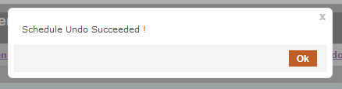

1.7.2.3
- 點選 Scheduling→Gantt Chart→Schedule頁籤，在Session下拉選單選擇Session，再按下Gantt
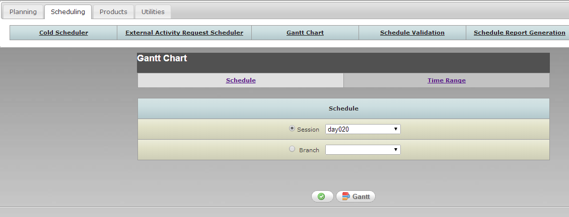
- 出現Gantt Chart，可依Activity 顏色的定義觀察出各種Activity是否產出
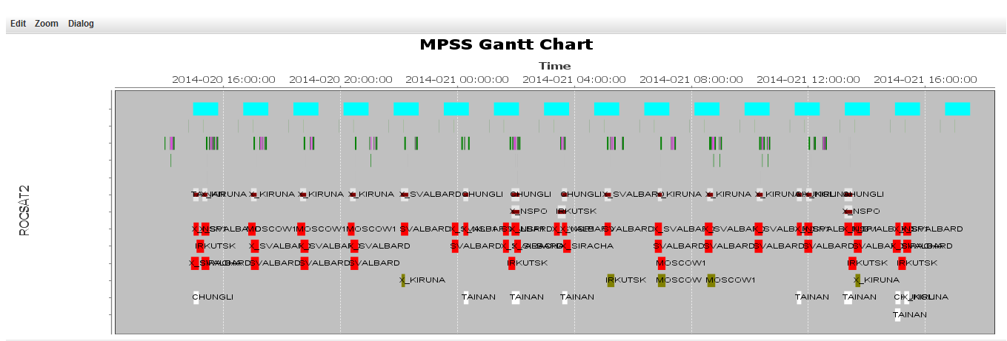

External Activity Request Scheduler
The External Activity Request Scheduler (EARS) provides the ability to ingest and schedule external requests. The EARS utility allows users to select Mission Timelines received from the PSF and the ISUAL SDDC. EARS processes and schedules the Mission Timelines selected by the user from the PSF and the ISUAL SDDC directory tree. The External Activity Request Scheduler will process the activity requests and store this information within the MPSS database. EARS can be run for the nominal schedule or branch schedule. The Mission Timelines files reside in the directory defined by the EARDATAELEMENTS configuration value from the EAR section of MPSS configuration file.

項目 | 功能說明 | 測試內容說明 | 測試結果 |  | 備註與  說明
項目 | 功能說明 |  | 通過 | 不通過 | 備註與  說明
 | Working with External Activity Request Scheduler (EARS)
 | Initiate the External Activity Request Scheduler. | Select Mission Timelines received from the PSF and the ISUAL SDDC. |  |  | 1.8.1.1
 | Ingesting Mission Timelines. | Process the activity requests and store this information within the MPSS database. |  |  | 1.8.1.2

備註與說明
1.8.1.1
- 點選 Scheduling→External Activity Request Scheduler頁籤，選擇External Request檔案及Schedule on種類。
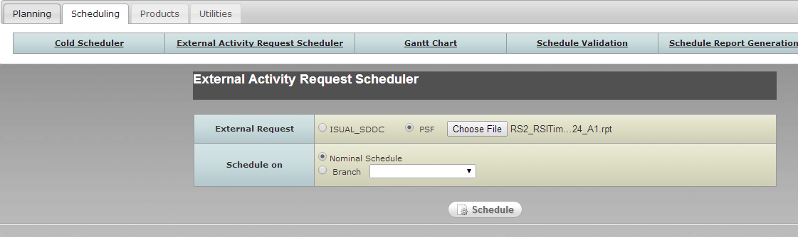
1.8.1.2
- 接續1.8.1.1，選擇External Request檔案及Schedule on種類，按下Schedule按鈕，開始Ingesting Mission Timelines，執行後會產生下列畫面
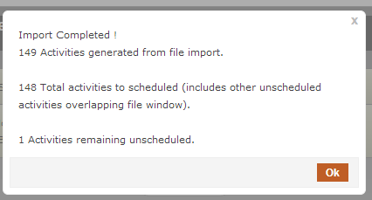

Gantt Chart
When MPSS completes the cold scheduling process, the user has a chance to manipulate the resulting schedule using a timeline display known as the Gantt Chart. The Gantt Chart allows the user to view the contacts and activities for a requested time period or session. All of the unscheduled activities can be viewed and manually scheduled by the user given the scheduling rules. The Cold Scheduler tool does most of the work for scheduling the time period. However, the Gantt Chart allows the user to make final decisions.
項目 | 功能說明 | 測試內容說明 | 測試結果 |  | 備註與  說明
項目 | 功能說明 |  | 通過 | 不通過 | 備註與  說明
 | Hot Scheduling Preparation
 | Initiating the hot scheduling process. | the cold scheduling steps described should be completed. |  |  | 同執行1.7及1.8的相關步驟
 | Viewing the Schedule Graphically
 | Viewing MPSS Scheduler Summary Window | MPSS Scheduler Summary Window allows the user to view the specified time ranges for the scheduled tasks for each satellite. |  |  | 1.9.2.1
 | Viewing MPSS Legend Window | displays the color of each visual cue on the MPSS Scheduler Summary Window. |  |  | 1.9.2.2
 | Viewing Unscheduled Activities window | listing of all unscheduled activities during the timeframe for which the Gantt Chart is open. The unscheduled activities can be manipulated and set in place for hot scheduling by dragging and dropping items back and forth between the Unscheduled Activities window and the Gantt Chart. |  |  | 1.9.2.3
 | Gantt Chart View and Configuration Options
 | Switching the Y-Axis | - The default view displays the satellites on the Y-axis, the timeline on the X-axis, and the site contact information in the center portion.  - The second option displays the sites on the Y-axis, the timeline on the X-axis, and the satellite contact information in the center portion. |  |  | 後續階段開發。
 | Configuring the Gantt Chart Colors | - The colors for the visual cues of the Gantt Chart can be changed to suit the user’s preference.  - Each user can customize their color settings and save them to a file.  - The original system default colors can be reloaded at anytime by selecting the Load Defaults button. |  |  | 1.9.3.2
 | Selecting Satellites/Sites | View the satellites or sites in a specific order down the Y-axis. |  |  | 後續階段開發。
 | Zooming the Gantt Chart View | Zooming in provides a more detailed view and zooming out provides a higher-level view. |  |  | 1.9.3.4
 | Editing the Schedule (Hot Scheduling)
 | Automatic Rescheduling | Once the reschedule is complete the MPSS Scheduler Summary Window and Unscheduled Activities window will refresh with the new schedule information. |  |  | 1.9.4.1。
 | Manual Schedule Editing | The desired activities have a place on the schedule, the user can finish dropping the leftover unscheduled activities back on the Gantt Chart wherever they fit. If the activity does not fit where it gets dropped, an error message will appear and the activity will remain in the Unscheduled Activities window. |  |  | 1.9.4.2

備註與說明
1.9.2.1
- 點選 Scheduling→Gantt Chart→Schedule頁籤，選擇Session 或Branch的名稱，再按下Gantt鍵
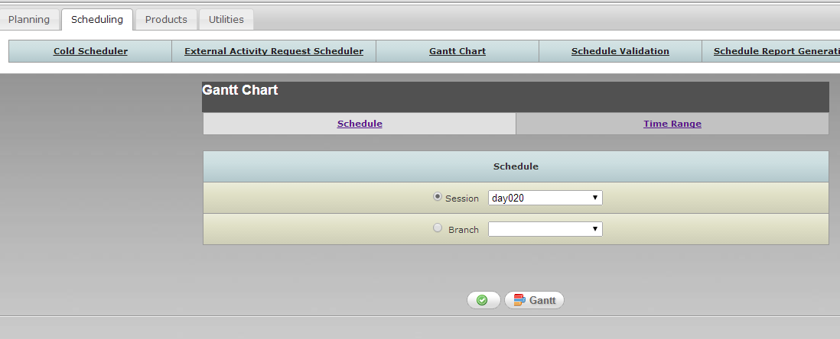
會出現一視窗顯示該Gantt Chart
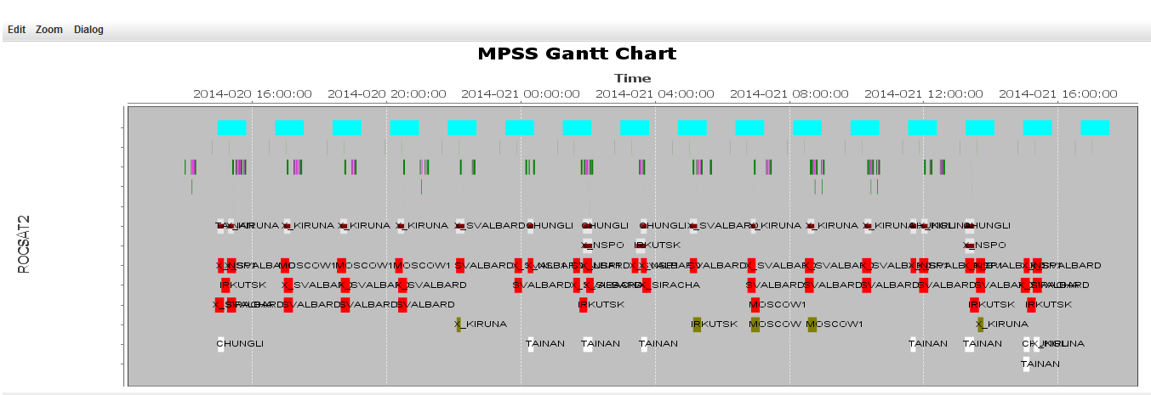

1.9.2.2
- 在GanttChart上方的MenuBar選擇 Dialog→ Color Legend
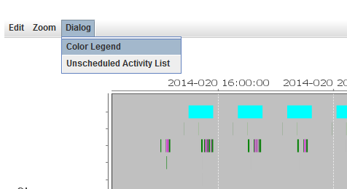

即會出現Color Legend如下：
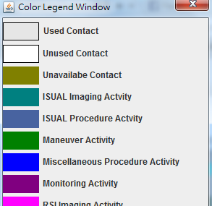

1.9.2.3
- 在GanttChart下方的有一Unscheduled Activities的List Box，會列出所有的unscheduled activities
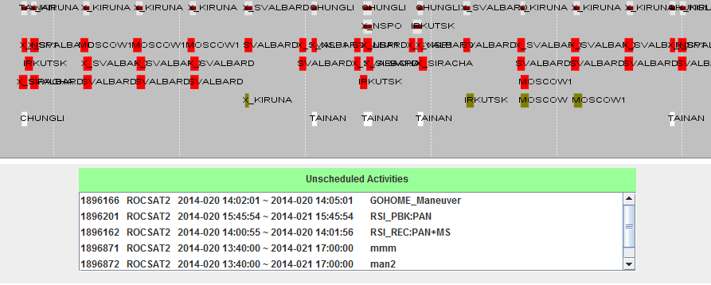
1.9.3.2
- 在GanttChart上方的MenuBar選擇 Configure→ Configure Color
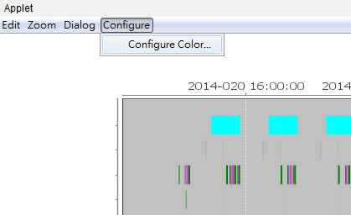
- 出現Color設定畫面，user可自行更改喜好顏色，也可以改回預設的顏色。
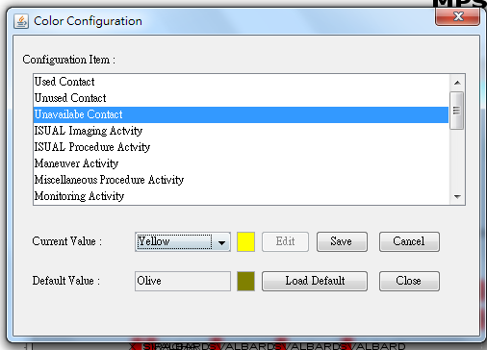

1.9.3.4
- User可以在Gantt Chart上欲Zoom in的地方往右拖拉，即可zoom in 該區域
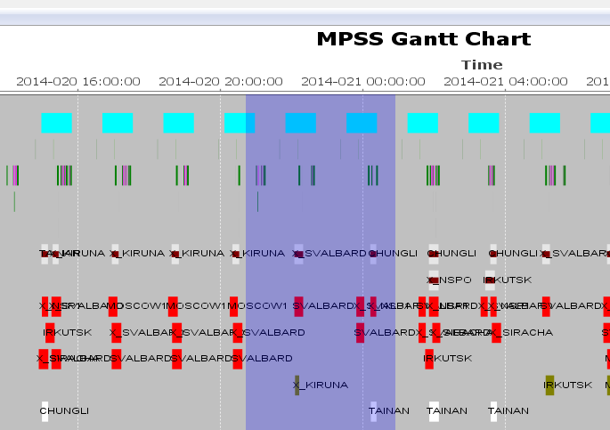
- zoom in 結果如下
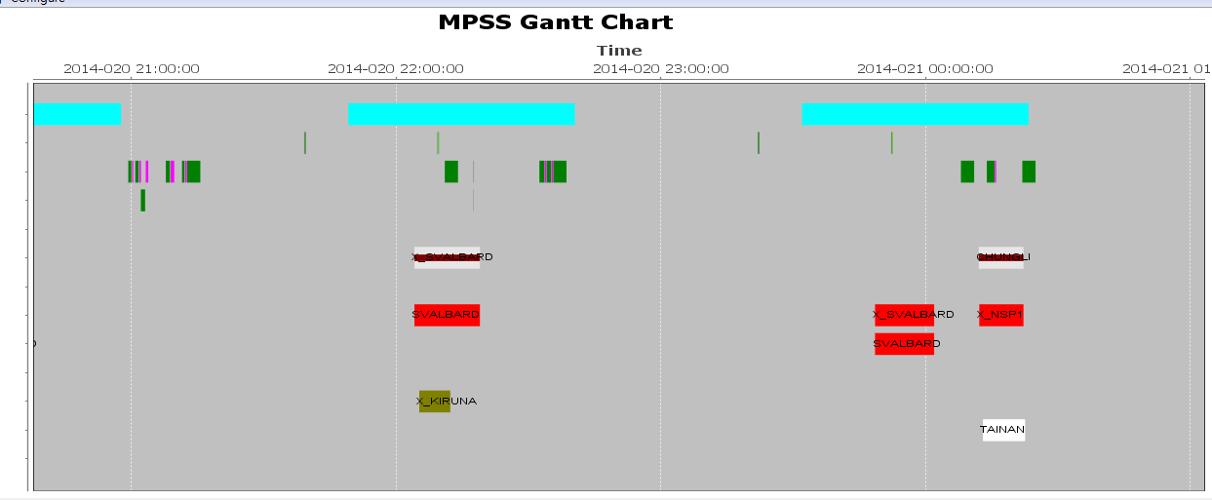

- 欲zoom out則在該區域由右往左拖拉
- 也在GanttChart上方的MenuBar選擇 Zoom→ Zoom To ，直接zoom到特定時間範圍
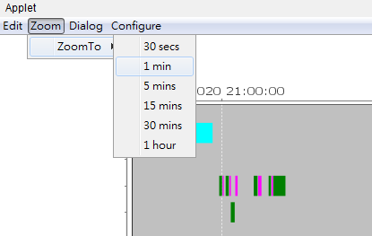

1.9.4.1
- User可以點選Gantt Chart上Menu bar→Edit→Reschedule
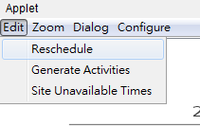
- 點選Filter Unschedule Activities按鈕，輸入Filter 條件
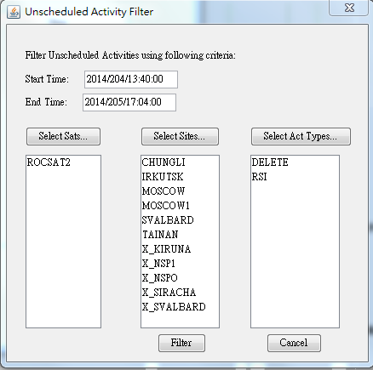
- 此時會列出可reschedule的activities，勾選不要重排的activities後，按下Update List重新整理，再按下Reschedule
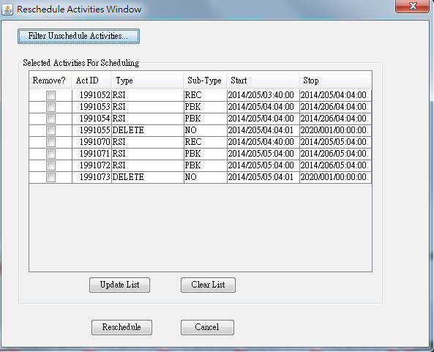
- 若重排成功有下列訊息
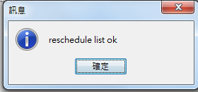
1.9.4.2
- User可以在Gantt Chart上某Activity按右鍵，選擇Activities→XXX→Set To Unscheduled Activity
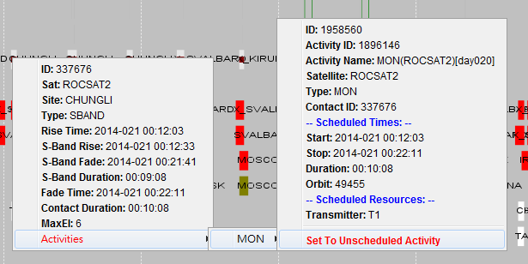
- 設完Unschedule之後，在Unscheduled Activities清單中會出現此筆Activity資料
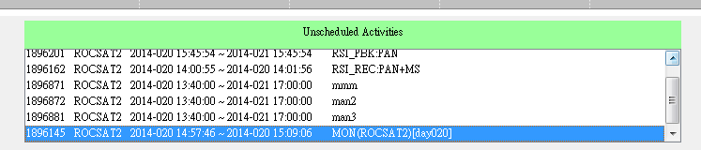
- 若欲將某Activity reschedule to Gannt Chart中，可在Unscheduled Activities List中點某一筆activity，拖拉至Gannt Chart
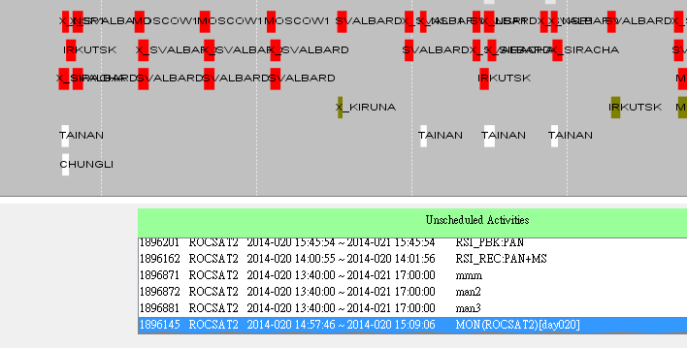

Schedule Validator
The Schedule Validator is used to validate any scheduled session or branch. The Schedule Validator verifies that all scheduled activities conform to all scheduling rules outlined in the ROCSAT Scheduling Rules. The validation criteria will be categorized into advisories and violations. Advisories will be identified as soft constraints, warnings that may be acceptable, such as unscheduled activities, turnaround time violations. Violations will be identified as hard constraints, serious problems that should be addressed, such as activities scheduled against a resource that is not available.

項目 | 功能說明 | 測試內容說明 | 測試結果 |  | 備註與  說明
項目 | 功能說明 |  | 通過 | 不通過 | 備註與  說明
 | Schedule Verification
 | Advisories | Following is a list of advisories against which scheduled activities are verified:  - Unscheduled Activity. Indicates unscheduled activities.  - Site Turnaround Time. Verifies activities do not exceed the site turnaround time for handling 2 consecutive contacts – site specific parameter. |  |  | 1.10.1.1
 | Violations | Following is a list of violations against which scheduled activities are verified:  - Site Availability. Verifies the site related to contact activities is available during the time range of the activity.  - Antenna Availability. Verifies the antenna related to contact activities is available during the time range of the activity.  - Recorder Availability. Verifies the recorder related to contact activities is available during the time range of the activity.  - Transmitter Availability. Verifies the transmitter related to contact activities is available during the time range of the activity.  - DDT Overlaps with RSI Imaging. Verify that no other RSI imaging activity (playback and record) overlaps with RSI DDT activities.  - Duty Cycles. Verifies the power already being used plus the power going to be used by this activity does not exceed total duty cycle.  - Recorder RSI Capacity. Verifies the RSI capacity already being used plus the RSI capacity going to be used by this activity does not exceed total capacity.  - Recorder ISUAL Capacity. Verifies the ISUAL capacity already being used plus the ISUAL capacity going to be used by this activity does not exceed total capacity.  - RFPA Interval. Verifies the RSI RECORD/DDT activities operational time windows are not within the minimum RFPA (RSI Focal Plan Assembly) separation time plus the preheat time interval. |  |  | 1.10.1.2
 | Results | Once the validation process is complete, the status will change to “Validated.” At this point the number of Advisories and Violations will be displayed, and the user may view the advisories and violations. |  |  | 1.10.1.3

備註與說明
1.10.1.1
- 點選 Scheduling→Schedule Validation頁籤，選擇Session 或Branch的名稱，再按下View Criterion鍵
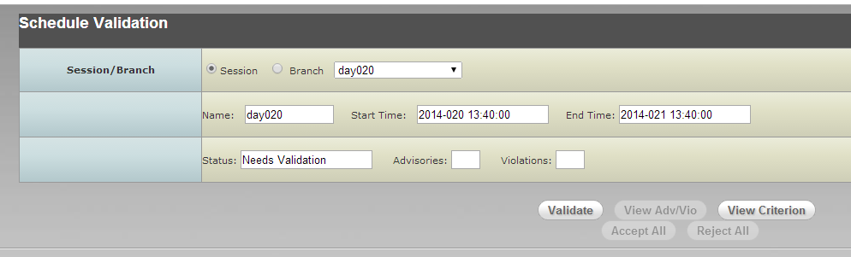
會出現Criterion視窗，可查詢Advisories Criterion的內容。
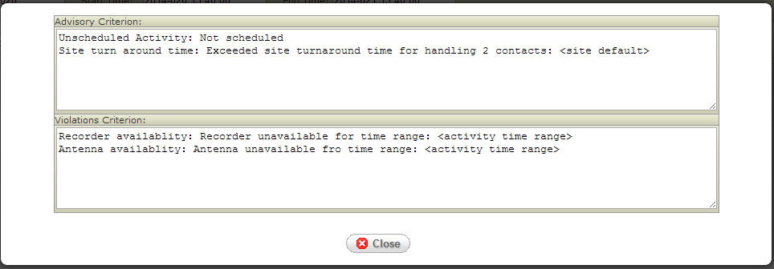

1.10.1.2
- 同1.10.1.1，出現Criterion視窗，可查詢Violations Criterion的內容。

1.10.1.3
- 點選 Scheduling→Schedule Validation頁籤，選擇Session 或Branch的名稱，再按下Validate鍵

- Validate完，Status欄位會變成Validated。
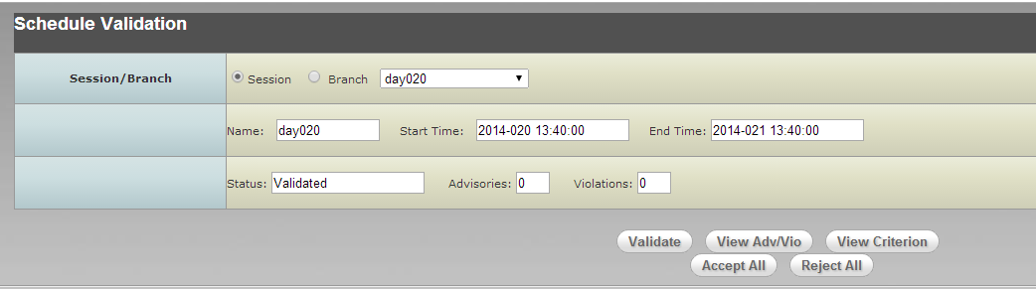
- user可按下View Adv/Vio ，查看Advisories /Violations 內容。
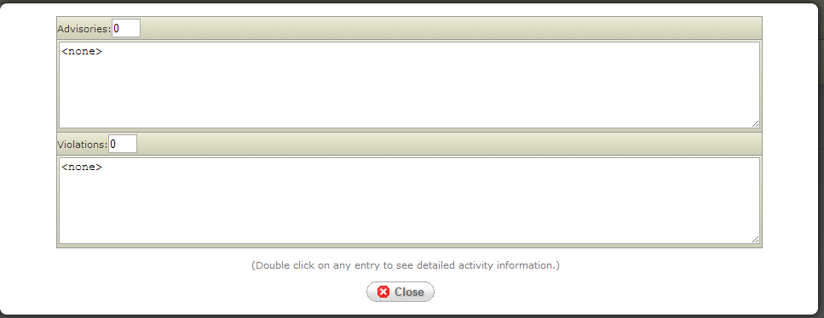

Schedule Report Generator
The Schedule Report Generator is used to generate resource and activity reports from schedules within MPSS. Reports can be generated for each satellite type within the MPSS system. The Schedule Report Generator generates the following reports:
- RSI Acquisition Schedule Report
- ISUAL Acquisition Schedule Report
- SSR Utilization Report
- Duty Cycle Utilization Report

項目 | 功能說明 | 測試內容說明 | 測試結果 |  | 備註與  說明
項目 | 功能說明 |  | 通過 | 不通過 | 備註與  說明
 | Generating Reports | Provides the ability to generate reports based on a specific time frame from the nominal schedule or a desired branch schedule. |  |  | 1.11.1
 | RSI Acquisition Schedule Report | RSI Acquisition Schedule Reports contain the scheduling status of all RSI imaging activities within the selected time period and schedule. |  |  | 1.11.2
 | SSR Utilization Report | SSR Utilization Reports contain the status of the ROCSAT-2 solid-state recorder during the selected time period and schedule. |  |  | 1.11.3
 | Duty Cycle Utilization Report | Duty Cycle Utilization Reports contain the power utilization breakdown per activity type per orbit for the ROCSAT-2 spacecraft during the selected time period and schedule. |  |  | 1.11.4
1.11.1
- 點選 Scheduling→Schedule Report Generation頁籤，即出現條件輸入畫面
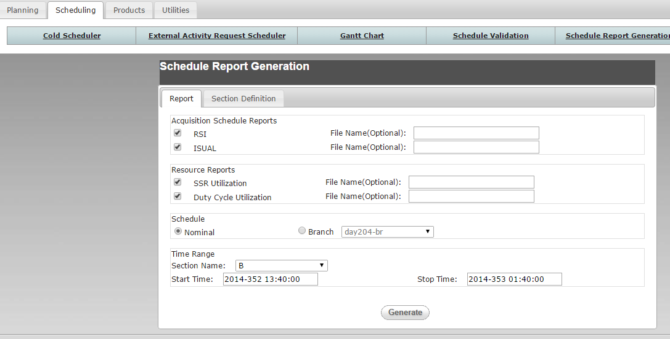

1.11.2
- 續1.11.1，勾選RSI選項，輸入Time Range，再按下Generate，若產生出Report會有ok訊息
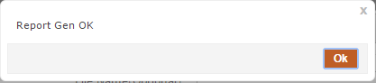
ASR report會產出在C:\MPSS.Launch\reports\ROCSATx\Acquisition_schedule_reports目錄中

1.11.3
- 續1.11.1，勾選SSR選項，輸入Time Range，再按下Generate，若產生出Report會有ok訊息
SSR report會產出在C:\MPSS.Launch\reports\ROCSATx\SSR_Util_reports
1.11.4
- 續1.11.1，勾選Duty Cycle Utilization選項，輸入Time Range，再按下Generate，若產生出Report會有ok訊息
Duty Cycle report會產出在C:\MPSS.Launch\reports\ROCSAT2\DutyCycle_Util_reports

Schedule Viewer
The Schedule Viewer, like the Gantt Chart Display, is used for viewing activities on the nominal schedule or a particular branch. The Schedule Viewer differs from the Gantt Chart as it displays activities and contacts in the schedule as event mnemonics.
項目 | 功能說明 | 測試內容說明 | 測試結果 |  | 備註與  說明
項目 | 功能說明 |  | 通過 | 不通過 | 備註與  說明
 | Schedule Selection | The Schedule Viewer window will display the session/branch time range or the time range entered by the user. |  |  | 1.12.1
 | Viewing Scheduled Events | The Schedule Viewer will display a listing of events in chronological order. |  |  | 後續階段開發。
 | Viewing Unscheduled Activities | If there were any unscheduled activities during the resulting time range, the Schedule Viewer displays them. |  |  | 後續階段開發。
 | Filtering Scheduled Events | The Schedule Viewer the filtering of Events by time range, satellite, or event mnemonic, or any combination. |  |  | 後續階段開發。
 | Saving Events/Unscheduled Activities to a File | The Schedule Viewer provides the ability to save the Events and Unscheduled Activities information to a file. |  |  | 後續階段開發。

備註與說明
1.12.1
- 點選 Scheduling→Schedule Viewer頁籤，使用者可選擇欲查看的條件
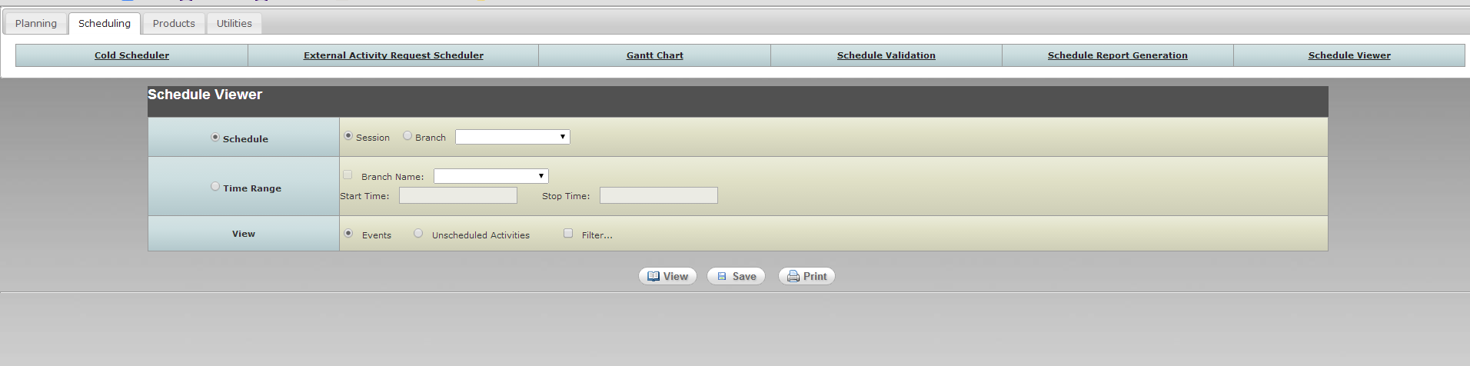

Product Generation
The MPSS PG subsystem will use pre-defined ASCII files for each satellite. This ASCII file is used as event templates during the product generation. The event templates are used to convert MPSS activity schedules into micro-events. These micro-events are spacecraft commands and/or ground directives, scheduled as part of activity schedules and command load files. The event template files need to be pre-defined for each event type with two exceptions; real time procedures, and stored command procedures. These types of events will be expanded using the corresponding user-defined procedure.

項目 | 功能說明 | 測試內容說明 | 測試結果 |  | 備註與  說明
項目 | 功能說明 |  | 通過 | 不通過 | 備註與  說明
 | PG Scheduler Setup Functions
 | Defining and Updating Miscellaneous (Memory) Procedures | - Miscellaneous Procedures are scheduled using the Activity Generator within the Gantt Chart by specifying the desired orbital event, offset, duration, and name of the Miscellaneous Procedure to be scheduled.  - The procedure must be created as an ASCII file in the appropriate satellite-specific (mpss\data\ROCSAT?\miscel_memory_procs) sub-folder using a standard text editor.
 | Orbit Maneuver Procedures | - Orbit Maneuver Procedures are scheduled using the Activity Request Editor or the Activity Generator within the Gantt Chart by specifying the desired start time, duration, orbit maneuver plan (received from FDF), and name of the Orbit Maneuver Procedure to be scheduled.  - An Orbit Maneuver Procedure is intended to be satellite specific. The procedure must be created as an ASCII file in the appropriate satellite-specific (mpss\data\ROCSAT?\maneuver_procs) sub-folder using a standard text editor.
 | Product Generation
 | Pass Plan | The final contents but minimally will include:  - Acquisition of Signal (AOS), Loss of Sight (LOS) of scheduled contacts.  - Real-time and memory commands that will be executed during pass.  - STOL procedures that will be executed before, during, after the pass.  - Orbit events during the pass.  - Additional comment fields.  The Pass Plan reports file generated by Product Generation GUI will be located in the directory defined by the RS2_PASSPLAN_REPORTS configuration value from the DIR section of MPSS configuration file. |  |  | 1.13.2.1
 | Resolved Acquisition Schedule Reports | - This report contains directives and spacecraft commands that can be executed by MOC (EPOCH), to automate the execution of real-time spacecraft and instrument activities during a contact.  - The generated reports (*.RPT) and procedure (*.PRC) files will be stored in the directory defined by the RS2_RASR_REPORTS configuration value from the DIR section of MPSS configuration file. |  |  | 同1.13.2.1說明
 | Ground Pass Initialization Reports | - This report contains commands and directives to automate the configuration of ground equipment for scheduled passes. The GPI report can be executed by MOC (EPOCH), to automate the execution of the ground equipment configuration.  - The generated reports (*.RPT) and procedure (*.PRC) files will be stored in the directory defined by the RS2_RASR_REPORTS configuration value from the DIR section of MPSS configuration file. |  |  | 同1.13.2.1說明
 | MPQ Load and Report Files | The Product Generation utility generates three separate binary files; Payload Data Management (PDM), Attitude and Orbit Control System (AOCS), and a combined PDM and AOCS load. |  |  | 同1.13.2.1說明
 | TTQ Loads | The Product Generation utility generates one TTQ file load file. |  |  | 同1.13.2.1說明
 | Integrated Reports | - Integrated Reports contain all spacecraft commands, ground directives, and orbit events that occur within a specified time period.  - The Integrated Report file is stored in the directory defined by the RS2_INTEGRATED_REPORTS configuration value from the DIR section of MPSS configuration file. |  |  | 同1.13.2.1說明
 | Product Transfer | This process will extract selected Pass Plan files and Integrated Reports based on the selected year and date (yyyyddd), spacecraft, and branch or nominal schedule. The Resolved Acquisition Schedule and Command Loads including MPQ and TTQ loads are extracted based on selected date (ddd), spacecraft, and branch or nominal schedule. |  |  | 後續階段開發。

備註與說明
1.13.2.1
- 點選 Products→Product Generation頁籤
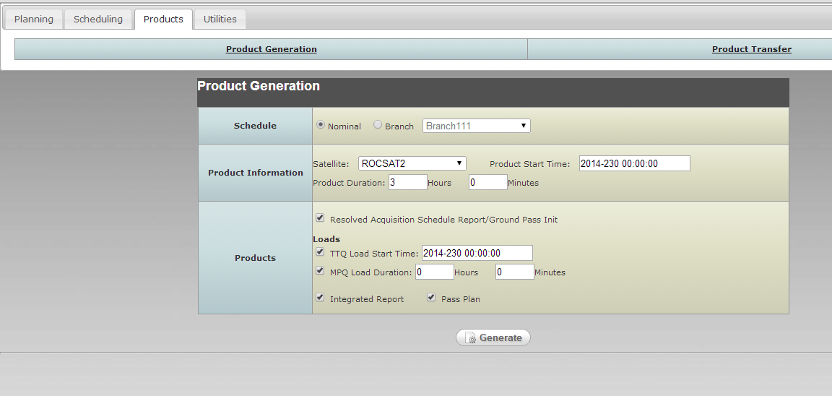
- 產出Product後，會有下列訊息
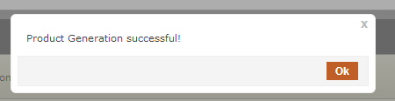
- 並有Report畫面如下：
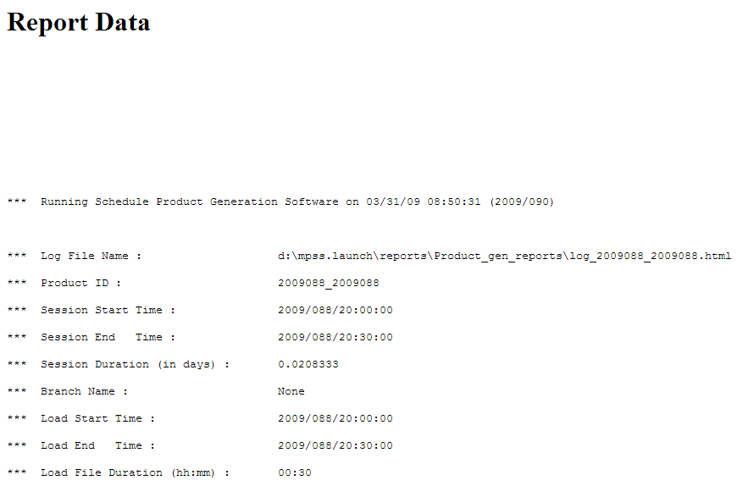
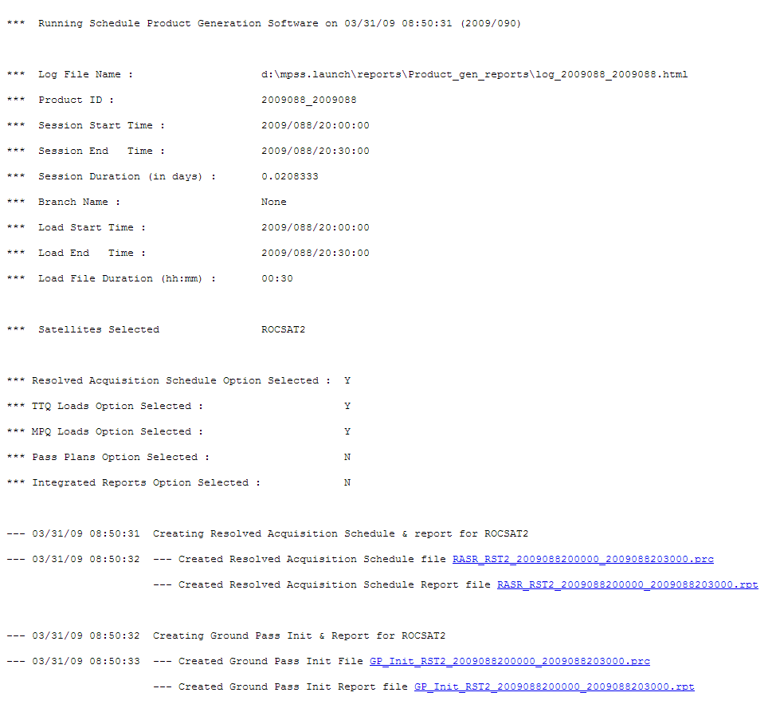

Purge Data
The Purge MPSS Data utility is used to remove data and report files, along with information contained within the MPSS database. The Purge utility allows the user to remove all data dated prior to a specified time. Data older than the specified number of days is removed.

項目 | 功能說明 | 測試內容說明 | 測試結果 |  | 備註與  說明
項目 | 功能說明 |  | 通過 | 不通過 | 備註與  說明
 | Purge Files | The Purge Data Files tab allows the user to specify which MPSS products to purge and how old the products must be to be purged. |  |  | 1.14.1
 | Purge Database | The MPSS database itself is backed up continually to a backup server. To enhance database performance, the user is allowed to specify a number of days prior to which all data older than the specified number of days will be purged. To maintain continuity in the database between sessions, the purge utility will keep the last complete session during or just before the purge date. The purge utility will indicate which sessions and branches will be purged within the window. Purge data includes contact activities, sessions, and branches. |  |  | 1.14.2
備註與說明
1.14.1
- 點選 Utilities→Purge Data→Files頁籤
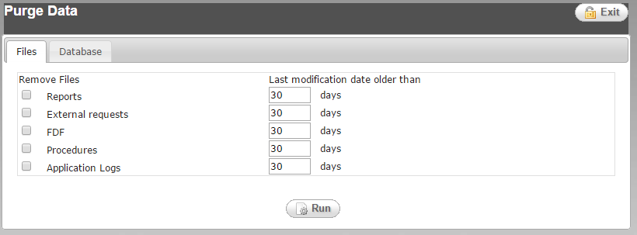
- 勾選欲remove的files型態及天數再按下Run，若執行成功則出現下列訊息
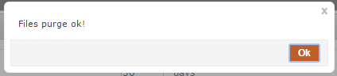

1.14.2
- 點選 Utilities→Purge Data→Database頁籤
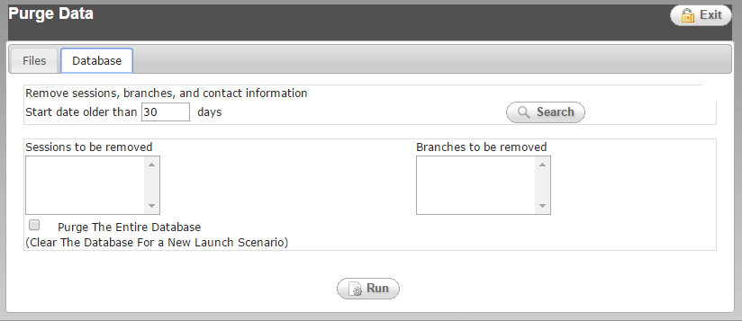
- 輸入欲remove的DB天數再按下Search，若要purge 整個DB，則勾選Purge The Entire Database，輸入完再按下Run，若執行成功則出現下列訊息

