

國家太空中心
衛星多重任務及星系操作系統整合軟體
系統設計文件

(最終版)

文件編號：MCC-CDRL-017
Submitted by: |  |  | 
ACS 專案經理 鄭介棠
Authenticated by:
NSPO操控組組長 黃文莊

CONTENT
1. Document Overview 1
1.1. Purpose 1
1.2. Scope 1
2. Applicable Documents 2
3. System Capability Requirements 3
3.1. Key Requirements 3
3.2. Functional Overview 4
3.3. MCC Software Requirement Specifications 5
3.3.1. Programming Request Manager 5
3.3.2. Tasking Order Feasibility Assessor 7
3.3.3. MCC Capability Requirements 11
3.3.3.1 Planning and Scheduling 12
3.3.3.2 Schedule Conflict Resolution 13
3.3.3.3 Data and Resource Management 14
3.3.3.4 Operations Product Generation 14
3.3.3.5 Coordination/Schedule Announcement 17
4. System Architecture 18
4.1. Overall Software Architecture 18
4.2. Hardware Architecture 19
4.3. Programming Request Manager (PRM) 24
4.4. Tasking Order Feasibility Assessor 26
4.5. MPSS (Mission Planning and Scheduling Subsystem) 27
4.6. Database Engine - Postgresql 29
4.6.1. Platforms 29
4.6.2. Features 29
4.7. GIS Engine - PostGIS 36
4.7.1. Features 36
5. Interface Requirements 37
5.1. Communication Interfaces 37
6. Security Requirements 39
6.1. SSL 39
6.2. Authentication and Authorization 39
7. General Requirements 39
7.1. Platform 39
7.2. Development Language 39

Document Overview

Purpose
The purpose of the MCC System Specification is to:
a. Document officially the top-level requirements that MCC will be required to meet.
b. Provide an overview of the MCC system for SOCC personnel and users.
c. Define the functional baseline for the MCC system.

Scope
The scope of this document is limited to system level specifications of the MCC system. The system level requirements address the following system characteristics: key system capabilities, functional requirements, high level architectural design. Subsequent design and development work will expand the system requirements to more detailed design specifications.

Applicable Documents
- NSPO-P-101080衛星多重任務及星系操作系統整合軟體 工作說明書

System Capability Requirements

Key Requirements
The System shall have the capability to control and manage the mission plans and schedules for the existing and future FORMOSAT-series satellites.
PRM (Programming Request Management)
- The RPM interface shall have the capability to follow the OGC format.
- The PRM shall have the capability to handle the image programming requests from customers.
TOFA (Tasking Order Feasibility Assessor)
- The TOFA shall have the capability to assess the feasibility of the image tasking orders for the FORMOSAT-series satellites
- The TOFA shall have the capability to generate programming proposals for customers
- The TOFA shall have the capability to generate mission timeline for MPSS
MPSS (Mission Planning and Scheduling Subsystem)
- The MCC shall use the information and data obtained from the science teams, the FDF, and the tasking list/mission timeline to generate short and long-range payload and spacecraft activity schedules
- The MCC shall have the capability to define pass plans for multi-mission operations.
- The MCC shall provide schedules and plans which are free of conflict and do not jeopardize any mission.
Requirement ID | Requirement Text | Verification Method
MCC000.01.01 | The MCC shall have the capability to handle the image programming requests from customers which follow the OGC (Open Geospatial Consortium) format. | DEMO
MCC000.02.01 | The MCC shall have the capability to control and manage the mission plans and schedules for the FORMOSAT-5 satellite and the existing FORMOSAT-series satellites | DEMO
MCC000.03.01 | The MCC shall have the capability to assess the feasibility of the image tasking orders for the FORMOSAT-5 payload. | DEMO
MCC000.04.01 | The MCC shall have the capability to generate programming proposals for customers | DEMO
MCC000.05.01 | The MCC shall use the information and data obtained from the science teams, the FDF, and the tasking list/mission timeline to generate short and long-range payload and spacecraft activity schedules and to define pass plans for multi-mission operations. | DEMO
MCC000.06.01 | The MCC shall provide schedules and plans which are free of conflict and do not jeopardize any mission. | DEMO
MCC000.07.01 | The PRM shall provide user account management for the website administrator | DEMO
MCC000.08.01 | The PRM shall provide user account management for the PR manager | DEMO

Functional Overview
The Functional Overview is divided into the following sections
The Programming Request Manager (PRM) Client
- Login securely to the PRM
- Managing Programming Requests (PRs)
- Managing Programming Proposals (PPs)
- Managing User Account Information
The Programming Request Manager (PRM) Server
- Authentication of Users
- Communication with the PRM/TOFA Database
- Communication with the PRM client
The Tasking Order Feasibility Assessor (TOFA)
- User Account Management
- Tasking Order Management
- Gain Data Management
- Cloud Cover Info.
- GIS Map Display
- Tasking Order Feasibility Assessment
- Managing Programming Proposals (PPs)
- Tasking Order List Management
- Generating Products
- Communication with External Processes/Entities
The Enhanced Mission Planning and Scheduling Subsystem
- Managing Satellite Resources & Constraints
- Managing Satellite Activities
- Exporting Resource Usage to TOFA
- Importing External Products
- Scheduling Satellite Activities
- Generating Satellite Operational Products
- Generating Satellite Operational Reports
- Exporting Satellite Products and Reports

MCC Software Requirement Specifications

Programming Request Manager
The Programming Request Manager (PRM) is a web based tool that allows customers to submit imaging requests (Programming Requests) via the internet. The primary functions of the PRM are:
- User Account Management.
- Programming Request Management.
- Programming Proposal Management.
- Log File Viewing.
Requirement ID | Requirement Text | Verification  Method
MCC001.01.01 | The MCC shall allow the users to submit their PRs through the Internet. | DEMO
MCC001.02.01 | The MCC shall authenticate the users of the PRM and TOFA independently of each other. | DEMO
MCC001.03.01 | The PRM shall exchange information with the users via a web browser. | DEMO
MCC001.04.01 | The PRM shall use secure socket layer (SSL) protocol to ensure the security of all transactions on the Internet | DEMO
MCC001.05.01 | The PRM shall record all access information in a log file. | DEMO
MCC001.06.01 | The PRM shall record all process information in a log file. | DEMO
MCC001.07.01 | The PRM shall provide user account management for the website administrator | DEMO
MCC001.08.01 | The PRM shall provide user account management for the PR manager | DEMO
MCC001.09.01 | The PRM shall provide user account management for the customer | DEMO
MCC001.10.01 | The PRM shall provide user account verification as part of user account management | DEMO
MCC001.11.01 | The PRM shall provide user account deletion as part of user account management | DEMO
MCC001.12.01 | The PRM shall provide user account modification as part of user account management. | DEMO
MCC001.13.01 | The PRM shall provide user account maintenance as part of user account management. | DEMO
MCC001.14.01 | The PRM shall provide user account creation as part of user account management. | DEMO
MCC001.15.01 | The PRM shall provide a utility to let the customers enter their preferred application fields for a PR. | DEMO
MCC001.16.01 | The PRM shall provide a utility to let the customers enter the optional service (standard, priority, urgent) for a PR. | DEMO
MCC001.17.01 | The PRM shall provide a utility to let the customers enter the survey period (taking the day as the unit) for a PR. | DEMO
MCC001.18.01 | The PRM shall provide a utility to let the customers enter the survey area (Area Of Interest, AOI) for a PR. | DEMO
MCC001.19.01 | The PRM shall provide a utility to let the customers enter the spectral mode for a PR. | DEMO
MCC001.20.01 | The PRM shall provide a utility to let the customers enter the survey method (viewing angle) for a PR. | DEMO
MCC001.21.01 | The PRM shall provide a utility to let the customers enter the validation criteria (cloud cover/snow & ice/haze & sand wind) for a PR. | DEMO
MCC001.22.01 | The PRM shall provide a utility to the customers to allow the modification of their proposed PRs before the PRs are confirmed. | DEMO
MCC001.23.01 | The PRM shall provide a utility to the customers to allow the cancellation of their proposed PRs before the PRs are confirmed. | DEMO
MCC001.24.01 | The PRM shall provide a utility to allow the customers to accept the Programming Proposal for a PR after they have received the Programming Proposal generated from the TOFA | DEMO
MCC001.25.01 | The PRM shall provide a utility to allow the customers to reject a Programming Proposal for a PR after they have received the Programming Proposal generated from the TOFA. | DEMO
MCC001.26.01 | The PRM shall provide the customer with statistical PR information including segment number and total imaging duration by week, month, quarter, season and year | DEMO
MCC001.27.01 | The PRM shall provide a utility for the PR managers to enter the customer’s Programming Request information into the PRM component if the customer proposes the PR by e-mail or FAX. | DEMO
MCC001.28.01 | The PRM shall provide a utility for the PR managers to accept a Programming Proposal for a PR after they receive the Programming Proposal generated from the TOFA, if the customer proposes the PR by e-mail or FAX. | DEMO

Tasking Order Feasibility Assessor
The Tasking Order Feasibility Assessor (TOFA) is a standalone application that is used to convert Programming Requests (PRs are entered through the PRM) into Tasking Orders (TOs) and assess the TO’s feasibility. The TOFA also produces Programming Proposals (PPs) that are sent to the customers for approval. Communication with the FDF, MPSS and CWB are performed to acquire the necessary information to assess TO feasibility. The primary functions of the TOFA are:

- User Account Management
- Tasking Order Management
- Tasking Order Feasibility Assessment
- Tasking Order List Management
- Programming Proposal Management
- Gain Data Management
- Product Generation
- External Product Ingestion
- Product and Log File Viewing
Requirement ID | Requirement Text | Verification Method
MCC002.01.01 | The TOFA shall have the capability for converting AOIs to several TOs | DEMO
MCC002.02.01 | The TOFA shall have the feasibility assessment capability for TO while receiving the further assessment application proposed by the PR manage | DEMO
MCC002.03.01 | The TOFA shall take into account the satellite constraints when determining TO feasibility. | DEMO
MCC002.04.01 | The TOFA shall take into account the validation criteria (cloud cover/ snow & ice/haze & sand wind) when determining TO feasibility. | DEMO
MCC002.05.01 | The TOFA shall take into account the TO List when determining TO feasibility. | DEMO
MCC002.06.01 | The TOFA shall take into account other limited resources when determining TO feasibility. | DEMO
MCC002.07.01 | The MCC shall authenticate the users of the PRM and TOFA independently of each other. | DEMO
MCC002.08.01 | The TOFA shall provide a utility for grid definition. | DEMO
MCC002.09.01 | The TOFA shall provide a utility for grid assessment. | DEMO
MCC002.10.01 | The TOFA shall provide a utility for segment definition | DEMO
MCC002.11.01 | The TOFA shall provide a utility for segment assessment. | DEMO
MCC002.12.01 | The TOFA shall allow two different units for the TOs,grids and segments. | DEMO
MCC002.13.01 | The TOFA shall provide GIS map machine database in order to facilitate the planning and assessment operation. | DEMO
MCC002.14.01 | The TOFA shall provide a utility for an AOI to be converted into TOs using the GIS map at the baseline. | DEMO
MCC002.15.01 | The TOFA shall provide the capability to convert the AOI to TOs. | DEMO
MCC002.16.01 | The TOFA shall maintain the relationship between the AOI and each TO. | DEMO
MCC002.17.01 | The TOFA shall provide the capability to assess the feasibility of TOs. | DEMO
MCC002.18.01 | The TOFA shall provide the capability to allow the TOFA managers to adjust the weight (inherit from the optional service of the PR) of the TOs. | DEMO
MCC002.19.01 | The TOFA shall provide the capability to allow the TOFA managers to adjust the survey periods of the TOs. | DEMO
MCC002.20.01 | The TOFA shall provide the capability to allow the TOFA managers to adjust the spectral mode of the TOs. | DEMO
MCC002.21.01 | The TOFA shall provide the capability to allow the TOFA managers to adjust the survey method (viewing angle) of the TOs. | DEMO
MCC002.22.01 | The TOFA shall provide the capability to allow the TOFA managers to adjust the validation criteria (cloud cover/ snow & ice/haze & sand wind) of the TOs. | DEMO
MCC002.23.01 | The TOFA shall provide the capability to allow the TOFA managers to adjust the preferred receiving station of the TOs. | DEMO
MCC002.24.01 | The TOFA shall allow the TOFA managers to properly assess the TOs after they have been modified | DEMO
MCC002.25.01 | The TOFA shall provide the capability to allow IQS (Imaging Quality Subsystem) team to update the status (open, closed,…) of the TOs on account of the results of the imaging quality. | DEMO
MCC002.26.01 | The TOFA shall provide the capability to assess the feasibility of TOs based on the current TO List | DEMO
MCC002.27.01 | The TOFA shall provide the capability to assess the feasibility of TOs based on the current satellite resources. | DEMO
MCC002.28.01 | The TOFA shall provide the capability to assess the feasibility of TOs based on the current ground station resources | DEMO
MCC002.29.01 | The TOFA shall provide the capability to simulate the entire on-orbit operations scenario including survey period to ensure satellite safety, image quality and prevent resource or schedule conflict. | DEMO
MCC002.30.01 | The TOFA shall provide the capability to simulate the entire on-orbit operations scenario including spectral mode to ensure satellite safety, image quality and prevent resource or schedule conflict. | DEMO
MCC002.31.01 | The TOFA shall provide the capability to simulate the entire on-orbit operations scenario including survey method to ensure satellite safety, image quality and prevent resource or schedule conflict. | DEMO
MCC002.32.01 | The TOFA shall provide the capability to simulate the entire on-orbit operations scenario including survey area to ensure satellite safety, image quality and prevent resource or schedule conflict | DEMO
MCC002.33.01 | The TOFA shall provide the capability to simulate the entire on-orbit operations scenario including validation criteria to ensure satellite safety, image quality and prevent resource or schedule conflict | DEMO
MCC002.34.01 | The TOFA shall provide the capability to simulate the entire on-orbit operations scenario including preferred receiving station to ensure satellite safety, image quality and prevent resource or schedule conflict. | DEMO
MCC002.35.01 | The TOFA shall provide the capability to simulate the entire on-orbit operations scenario including satellite position to ensure satellite safety, image quality and prevent resource or schedule conflict | DEMO
MCC002.36.01 | The TOFA shall provide the capability to simulate the entire on-orbit operations scenario including satellite attitude to ensure satellite safety, image quality and prevent resource or schedule conflict. | DEMO
MCC002.37.01 | The TOFA shall provide the capability to simulate the entire on-orbit operations scenario including data storage to ensure satellite safety, image quality and prevent resource or schedule conflict. | DEMO
MCC002.38.01 | The TOFA shall provide the capability to simulate the entire on-orbit operations scenario including power constraints to ensure satellite safety, image quality and prevent resource or schedule conflict. | DEMO
MCC002.39.01 | The TOFA shall provide the capability to simulate the entire on-orbit operations scenario including thermal constraints to ensure satellite safety, image quality and prevent resource or schedule conflict | DEMO
MCC002.40.01 | The TOFA shall provide the capability to simulate the entire on-orbit operations scenario including X-Band antenna switching to ensure satellite safety, image quality and prevent resource or schedule conflict. | DEMO
MCC002.41.01 | The TOFA shall incorporate and assess cloud cover information from CWB (Central Weather Bureau) or other weather prediction sources | DEMO
MCC002.42.01 | The TOFA shall provide the capability to import the feasible TOs into the TO List automatically after FA | DEMO
MCC002.43.01 | The TOFA shall provide the capability to allow the TOFA manager to delete TOs directly from the TO List. | DEMO
MCC002.44.01 | The TOFA shall provide the capability to generate Daily TO Reports from the TO List | DEMO
MCC002.45.01 | The TOFA shall provide the capability to generate Mission Timeline Reports from the TO List. | DEMO

MCC Capability Requirements
The major tasks of MCC are to perform and to conduct, at a minimum, the following：
- Planning and scheduling.
- Schedule Conflict Resolution.
- Data and Resource Management.
- Operations Product Generation.
- Coordination/Schedule Announcement.

Planning and Scheduling
The MCC shall use the MPSS to provide for the planning and scheduling of multi-mission operations. This shall include：
- Long-term and short-term planning and scheduling for normal mission operations.
- FORMOSAT-5 , FORMOSAT-2 and 3 activity scheduling.
- Instrument activity scheduling.
- Launch planning.
- Contingency planning and scheduling.
- Rapid Replanning.
Requirement ID | Requirement Text | Verification Method
MCC003.01.01 | The MCC shall have the capability to provide scheduling of multi-mission operations and long-term mission planning including launch planning. | DEMO
MCC003.02.01 | The MCC shall have the capability to provide scheduling of multi-mission operations and long-term mission planning including FORMOSAT-5,FORMOSAT-2 and 3 activity scheduling | DEMO
MCC003.03.01 | The MCC shall have the capability to provide scheduling of multi-mission operations and long-term mission planning including instrument activity scheduling. | DEMO
MCC003.04.01 | The MCC shall have the capability to provide scheduling of multi-mission operations and long-term mission planning including contingency planning and scheduling for anomaly phenomena. | DEMO
MCC003.05.01 | The MCC shall have the capability to provide scheduling of multi-mission operations and long-term mission planning including long-term schedule for normal mission operations. | DEMO
MCC003.06.01 | The MCC shall have the capability to provide scheduling of multi-mission operations and long-term mission planning including scheduling rules definitions. | DEMO
MCC003.07.01 | The MCC shall have the capability to provide scheduling of multi-mission operations and long-term mission planning including activity definitions | DEMO
MCC003.08.01 | The MCC shall have the capability to provide scheduling of multi-mission operations and long-term mission planning including rescheduling strategies. | DEMO
MCC003.09.01 | The MCC shall have the capability to provide scheduling of multi-mission operations and long-term mission planning including operations constraints. | DEMO
MCC003.10.01 | The MCC shall have the capability to provide scheduling of multi-mission operations and long-term mission planning including rapid re-planning. | DEMO
MCC003.11.01 | The MCC shall use a SQL database . | DEMO
MCC003.12.01 | The MCC shall allow the users to modify or re-implement the corresponding activity definitions. | DEMO
MCC003.13.01 | The spacecraft specialists shall provide the operations constraints. | DEMO
MCC003.14.01 | The MCC shall generate schedules that have been validated to not have any operational rule violations. | DEMO

Schedule Conflict Resolution
The MPSS shall use the rules and constraints defined in the FORMOSAT-series MPSS Rules Document, the resources available, and the list of requested activities to generate a conflict-free schedule. The MPSS will not generate a schedule that contains conflicts. If any activities could not be scheduled, due to conflicts of resources or rules, the MPSS will identify the unscheduled activities. The MPSS provides tools to assist the planners in deciding how to proceed with rescheduling of the unscheduled activities.
Requirement ID | Requirement Text | Verification Method
MCC003.15.01 | The MCC shall be capable of identifying schedule conflicts when there are overlapping resource allocations among multiple satellites. | DEMO
MCC003.16.01 | The MCC shall be capable of identifying schedule conflicts when there are operation rule violations. | DEMO
MCC003.17.01 | The MCC shall be capable of identifying schedule conflicts when there are scheduling rule violations. | DEMO
MCC003.18.01 | The MCC shall have the capability of merging individual event and activity schedules, analyzing schedule conflicts and resolving conflicts based on the rules and constraints defining priorities of satellite and ground activities. | DEMO
MCC003.19.01 | The MCC shall provide rescheduling tools to aid the users in resolving conflict. | DEMO
MCC003.20.01 | The MCC shall provide schedule editing tools to aid the users in resolving conflict. | DEMO

Data and Resource Management
The MCC shall provide resource management of specific ground and spacecraft resources. The resources to be managed are power/duty cycles, the Solid State Recorder (SSR) and the on-board TTQ/MPQ. The resource management shall provide the capability to predict base on the real condition of these specific spacecraft resource within MCC planning software.
Requirement ID | Requirement Text | Verification Method
MCC003.21.01 | The MCC shall provide a resource database to manage all ground and satellite resources electronically to facilitate planning including ground site selection, on-board command sequence management | DEMO
MCC003.22.01 | The MCC shall provide a GUI tool to update and modify the resource definitions as the mission requires. | DEMO
MCC003.23.01 | The MCC shall provide the ability to predict resource utilization within MCC planning software. | DEMO

Operations Product Generation
The MCC will generate operational products for FORMOSAT-series. These products will assist in the automation of mission operations and facilitate mission coordination. The products shall, at a minimum, include the following：
- Pass plan.
- Integrated report.
- Instrument operations plan (TBR).
- Executable files for MOC real-time operations.
- Executable files for ground equipment configuration setup.
- Command load ASCII and binary file.
- Branch Load ASCII and binary file.
- MPQ load ASCII and binary file.
Requirement ID | Requirement Text | Verification Method
MCC003.24.01 | The MCC shall be capable of generating operations products including Pass Plans for the FORMOSAT-5 satellites and the existing FORMOSAT-series satellites to automate mission operations and facilitate mission coordination. | DEMO
MCC003.25.01 | The MCC shall be capable of generating operations products including Integrated Reports for the FORMOSAT-5 satellites and the existing FORMOSAT-series satellites to automate mission operations and facilitate mission coordination. | DEMO
MCC003.26.01 | The MCC shall be capable of generating operations products including Instrument Operation Plans for the FORMOSAT-5 satellites and the existing FORMOSAT-series satellites to automate mission operations and facilitate mission coordination. | DEMO
MCC003.27.01 | The MCC shall be capable of generating operations products including executable files for MOC real-time operations for the FORMOSAT-5 satellites and the existing FORMOSAT-series satellites to automate mission operations and facilitate mission coordination. | DEMO
MCC003.28.01 | The MCC shall be capable of generating operations products including executable files for ground equipment configuration setup for the FORMOSAT-5 satellites and the existing FORMOSAT-series satellites to automate mission operations and facilitate mission coordination | DEMO
MCC003.29.01 | The MCC shall be capable of generating operations products including ASCII command loads for the FORMOSAT-5 satellites and the existing FORMOSAT-series satellites to automate mission operations and facilitate mission coordination. | DEMO
MCC003.30.01 | The MCC shall be capable of generating operations products including binary command loads (including FORMOSAT-5 payload command files) for the FORMOSAT-5 satellites and the existing FORMOSAT-series satellites to automate mission operations and facilitate mission coordination | DEMO
MCC003.31.01 | The MCC shall be capable of generating operations products including ACSII patch loads for the FORMOSAT-5 satellites and the existing FORMOSAT-series satellites to automate mission operations and facilitate mission coordination. | DEMO
MCC003.32.01 | The MCC shall be capable of generating operations products including binary patch loads for the FORMOSAT-5 satellites and the existing FORMOSAT-series satellites to automate mission operations and facilitate mission coordination. | DEMO
MCC003.33.01 | The MCC shall generate executable files for MOC real-time operations that are completely compatible (i.e.once the files are generated, no more post processing or conversion will be necessary for MOC normal operations) with the MOC EPOCH system. | DEMO
MCC003.34.01 | The MCC shall generate executable files for ground equipment configuration setup that are completely compatible (i.e. once the files are generated, no more post processing or conversion will be necessary for MOC normal operations) with the MOC EPOCH system. | DEMO
MCC003.35.01 | The MCC shall be capable of generating operations products including binary MPQ loads (including FORMOSAT-5 payload command files) for the FORMOSAT-5 satellites and the existing FORMOSAT-series satellites to automate mission operations and facilitate mission coordination | DEMO
MCC003.36.01 | The MCC shall be capable of generating operations products including ASCII MPQ loads (including FORMOSAT-5 payload command files) for the FORMOSAT-5 satellites and the existing FORMOSAT-series satellites to automate mission operations and facilitate mission coordination | DEMO

Coordination/Schedule Announcement
The MCC shall provide an interface to FDF, MOC, RTS, CSRSR, PSS, and ISUAL SDDC via GCN for gathering and disseminating information or data needed for conducting mission activities.
Requirement ID | Requirement Text | Verification Method
MCC003.37.01 | The MCC shall provide interface to FDF to gather information or data for coordination of conducting mission activities. | DEMO
MCC003.38.01 | The MCC shall provide interface to MOC to gather information or data for coordination of conducting mission activities | DEMO
MCC003.39.01 | The MCC shall provide interface to IPS (Image Processing System) to gather information or data for coordination of conducting mission activities. | DEMO
MCC003.40.01 | The MCC shall provide interface to CSRSR (Center for Space and Remote Sensing Research National Central University) to gather information or data for coordination of conducting mission activities. | DEMO
MCC003.41.01 | The MCC shall provide interface to SDDCs (Science Data Distribution Centers) to gather information or data for coordination of conducting mission activities. | DEMO
MCC003.42.01 | The MCC shall provide interface to RTS (Remote Tracking Station) sites scheduling office to gather information or data for coordination of conducting mission activities. | DEMO
MCC003.43.01 | The MCC shall provide the capability of receiving and automatically processing SDDC’s instrument schedule requests for the FORMOSAT-5 satellite and the existing FORMOSAT-series satellites. | DEMO
MCC003.44.01 | The MCC shall return the final integrated schedules to the SDDC. | DEMO
MCC003.45.01 | The MCC shall provide the capability to gather data detailed in operational products listed above that are required for NSPO to analyze in coordination of science communities and engineers to perform mission operations. | DEMO
MCC003.46.01 | The MCC shall have the capability to export operations reports in HTML format to selective websites once the schedule is approved, to announce the planned activity to the operations team and all concerned parties. | DEMO
MCC003.47.01 | The MCC shall have the capability to export operations reports in ASCII format to selective FTP sites once the schedule is approved, to announce the planned activity to the operations team and all concerned parties. | DEMO

System Architecture

Overall Software Architecture
MCC software has a layered architecture that consists of PRM (Programming Request Manager, both RIA client and OGC-compliant web services) , TOFA (Tasking Order Feasibility Assessor) module and MPSS (Mission Planning and Scheduling Service) module.
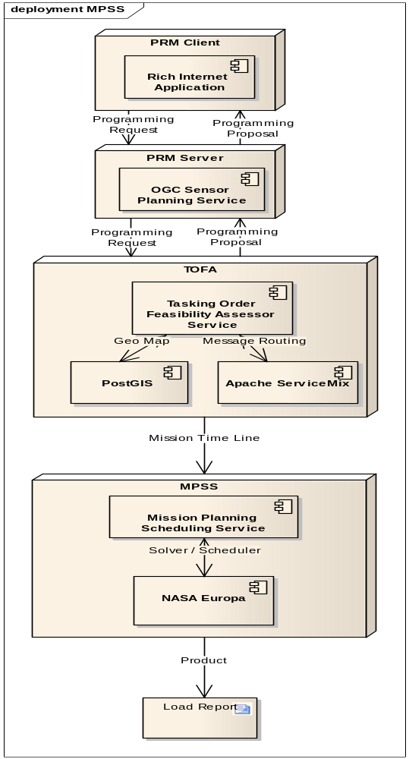

Hardware Architecture
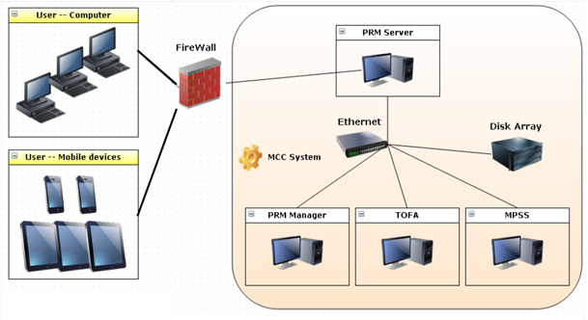
Detailed hardware specification is tabulated as follows.
項次 | 設備名稱 | 數量 | 規格
1 | 個人電腦(含螢幕) | 8
  1.CPU
  1-1.Intel Core i7 3.4GHz(含)以上。
  1-2.整體快取(cache)記憶體8MB(含)以上。
  1-3.處理器核心數(Cores)4個(含)以上，超執行緒(Hyper-Threading Technology)8個(含)以上，提供Turbo Boost(渦輪加速) Technology功能。
  1-4.內建HD Graphics 2000(含)以上繪圖顯示核心功能。
  2.主機版
  2-1.晶片組及顯示卡擴充槽：
  2-1-1.處理器：支援Intel Core i7 3.4GHz(含)以上。
  2-1-2.記憶體：支援雙通道(Dual Channel) DDR(Double Data Rate)3 1066(含)以上。
  2-1-3.記憶體容量：支援16GB(含)以上。
  2-1-4.USB擴充埠：支援6個(含)以上USB(Universal Serial Bus) 2.0(含)以上擴充埠
  2-1-5.顯示卡擴充槽：提供PCI(Peripheral Component Interface) Express 16倍slot一個(含)以上。
  2-1-6.SATA擴充埠：支援4個(含)以上Serial ATA 2.0(含)以上擴充埠，傳輸速率3Gb/s(300MB/s)(含)以上，及支援2個(含)以上Serial ATA 3.0(含)以上擴充埠，傳輸速率6Gb/s(600MB/s)(含)以上。
  3.記憶體:DDR3 1333 4GB(含)以上。
  4.硬碟:SATA 500GB(含)以上。
  5.24吋LED螢幕。
2 | 機櫃 | 1 | 19吋標準機櫃
3 | 機架式FC to SATA/SAS 磁碟陣列儲存系統 | 1 | 1-1.外型：主機本身標準19吋機架式，機架高度共可達2U(含)以上。  1-2.磁碟陣列控制器採用RISC或CISC運算處理器。  1-3.磁碟陣列組需提供雙控制器, 單一控制器記憶體容量4GB(含)以上; 雙控制器最大可支援到8GB(含)以上。  1-4.主機連接介面：提供4個(含)以上光纖通道(Fiber Channel)，每個光纖通道(Fiber Channel)傳輸速率可達8G(含)以上，各單一控制器需提供2個(含)以上光纖通道。  1-5.磁碟機陣列及硬碟  1-5-1.技術：提供硬體磁碟陣列技術支援RAID Level 0,1或1/0，及RAID Level 5,6，或硬體磁碟陣列技術支援RAID Level 6 或8  1-5-2.硬碟：提供轉數7200RPM(含)以上SATA/SAS(Nearline SAS) 2TB(含以上硬碟10顆，或3TB(含以上硬碟8顆，硬碟機具備即抽即換線上修復功能(hot swap)，並支援磁碟機自動檢測與備援修復功能(drive failure detection and rebuild)。  1-5-3.主機硬碟空間：獨立主機本身提供12顆Hot Swap硬碟盒(含)以上。  1-5-4.資料保護：提供資料快照功能(Snapshot或 FlashCopy)及複製功能(提供下列: Clone、Shadow Image、FlashCopy Cloning、Mirror、Volume Copy等任一種)，可手動或定時執行資料快照及複製功能，以保障資料損毀時，可快速回復資料。  1-6.伺服器光纖通道連接卡：提供2片1埠(含)以上PCI-X或PCI-Express光纖通道連接卡，傳輸速率可達8G(含)以上，可支援Windows及Linux，並提供2條5公尺光纖連接線。
4 | iPhone | 2 | 1.儲存容量 64GB  2.螢幕尺寸 4吋 960 x 640  3.處理器 A6雙核心處理器  4.作業系統 iOS 6.0  5.無線功能: WiFi +3G
5 | iPAD | 4 | 1.儲存容量: 64GB  2.螢幕尺寸: 9.7吋 2048 x 1536  3.處理器: A5X  4.作業系統: iOS 5.1  5.無線功能: WiFi +3G

Programming Request Manager (PRM)
The RPM will comply with OGC Sensor Planning Service (SPS) interface standard Earth Observation Satellite Tasking Extension.

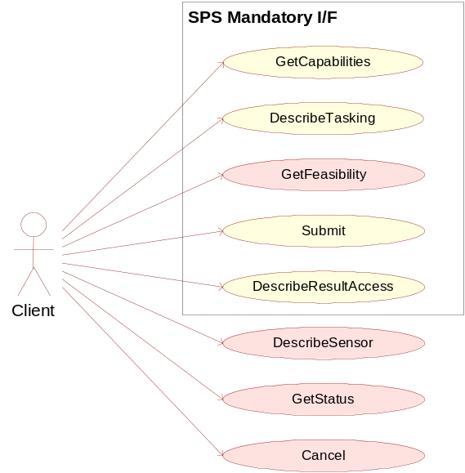
Key functions to aim at are:
- Determining the request and receive service metadata describing the abilities of the specific server implementation (GetCapabilities)
- Requesting information needed to send GetFeasibility and Submit requests (DescribeTasking)
- Determining the feasibility of an intended sensor planning request (GetFeasibility)
- Submitting such a request (Submit)
- Retrieving information about how and where data (produced by the sensor) can be accessed (DescribeResultAccess)
Earth Observation Satellite Tasking Extension will be considered:
- GetSensorAvailability
- Validate
- SubmitSegmentByID

An SPS framework will be provided to facilitate the work of an SPS development. The framework consists of three components: the AssetManager (AM), the ProfileManager (PM) and the Controller. Together they form the SPS.
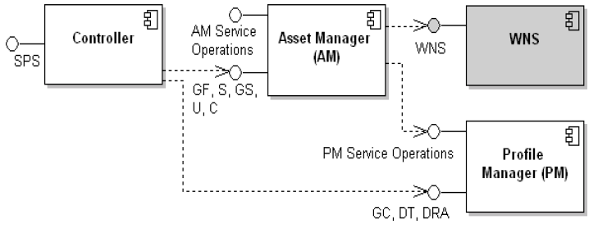
While the AM is responsible for the instance management of a sensor (registering, deregistering, delegating submits, etc), the PMs job is to handle the static meta information of the service and of each plugin. The Controller serves as frontend to these modules – the Controller represents the interface of the SPS specification.

Tasking Order Feasibility Assessor
The Tasking Order Feasibility Assessor (TOFA) is a standalone application that is used to convert Programming Requests (PRs are entered through the PRM) into Tasking Orders (TOs) and assess the TO’s feasibility. The TOFA also produces Programming Proposals (PPs) that are sent to the customers for approval. Communication with the FDF, MPSS and CWB are performed to acquire the necessary information to assess TO feasibility.
In other words, TOFA needs to orchestrate different services to complete its process workflow. Therefore, Apache ServiceMix will be proposed to create a SOA (service-oriented architecture) solution for TOFA applications.
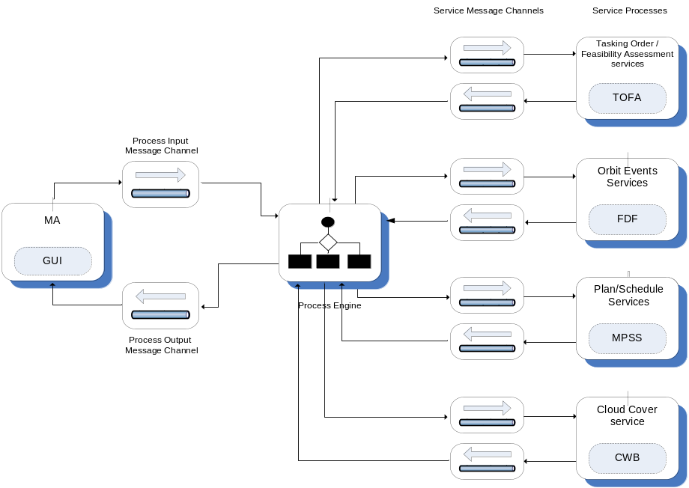
The main features of Apache ServiceMix include:
- reliable messaging with Apache ActiveMQ
- messaging, routing and Enterprise Integration Patterns with Apache Camel
- WS-\* and RESTful web services with Apache CXF
- complete WS-BPEL business process engine with Apache ODE
- OSGi-based server runtime powered by Apache Karaf

MPSS (Mission Planning and Scheduling Subsystem)
NASA EUROPA is a framework to model and tackle problems in Planning, Scheduling and Constraint Programming. EUROPA is typically embedded in a host application, so MPSS will be developed on top of this framework.
EUROPA is designed to be expressive, efficient, extendable and configurable. It includes:
- A Plan Database: The technology cornerstone of EUROPA for storage and manipulation of plans as they are initialized and refined. The EUROPA Plan Database integrates a rich representation for actions, states, objects and constraints with powerful algorithms for automated reasoning, propagation, querying and manipulation.
- A Problem Solver: A core solver to automatically find and fix flaws in the plan database. It can be configured to plan, schedule or both. It can be easily customized to integrate specialized heuristics and resolution operations.
- A Tool Box: Europa includes a debugger for instrumentation and visualization of applications. It also includes a very high-level, declarative modeling language for describing problem domains and partial-plans.
The modules of EUROPA and their interdependencies are set out as below . EUROPA is a highly modular architecture and modules can be developed, tested and applied quite independently.
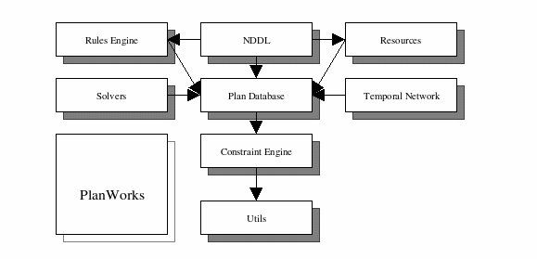
- The Utils module provides common C++ utility classes for error checking, smart pointers etc. It also includes a very useful debugging utility. Many common programming practices in EUROPA development are built on assets in this module.
- The Constraint Engine is the nexus for consistency management. It provides a general-purpose component-based architecture for handling dynamic constraint networks. It deals in variables and constraints. It includes an open propagation architecture making it straightforward to integrate specialized forms of local and global constraint propagation.
- The Plan Database adds higher levels of abstractions for tokens and objects and the interactions between them. This is the code embodiment of the EUROPA planning paradigm. It supports all services for creation, deletion, modification and inspection of partial plans. It maintains the dynamic constraint network underlying a partial–plan by delegation to the Constraint Engine and leverages that propagation infrastructure to maintain relationships between tokens and objects.
- The Solvers module provides abstractions to support search in line with the EUROPA planning approach. It includes a component-based architecture for Flaw Identification, Resolution and heuristics as well as an algorithm for chronological backtracking search. As additional search algorithms are implemented they will be added to this module.
- The Rules Engine module provides the inference capabilities based on domain rules described in the model. It is almost exclusively used to execute NDDL rules but can be extended for custom rule formats.
- The Resources module provides specialized algorithms and data structures to support metric resources (e.g. battery, power bus, disk drive).
- The Temporal Network module provides specialized algorithms and data structures to support efficient propagation of temporal constraints.
- The NDDL module provides a parser and compiler for NDDL (pronounced noodle) which is a very high-level, object-oriented, declarative domain and problem description language. This module defines the mapping from the language to the code and consequently interfaces to a number of key modules in the system.
- PlanWorks is a java application for visualization and debugging of plans and planning. It is loosely coupled to the other EUROPA modules through a JNI interface.

Database Engine - Postgresql
(from PostgreSQL wiki )
PostgreSQL is an object-relational database management system (ORDBMS) available for many platforms including Linux, FreeBSD, Solaris, Microsoft Windows and Mac OS X. It is released under the PostgreSQL License, which is an MIT-style license, and is thus free and open source software. PostgreSQL is developed by the PostgreSQL Global Development Group, consisting of a handful of volunteers employed and supervised by companies such as Red Hat and EnterpriseDB.It implements the majority of the SQL:2008 standard, is ACID-compliant, is fully transactional (including all DDL statements), has extensible data types, operators, index methods, functions, aggregates, procedural languages, and has a large number of extensions written by third parties.

Platforms
Instruction set architectures
PostgreSQL works on any of the following instruction set architectures: x86, x86-64, IA-64 Itanium, PowerPC, PowerPC 64, S/390, S/390x, SPARC, SPARC 64, Alpha, ARM, MIPS, MIPSel, M68k, and PA-RISC. It is also known to work on M32R, NS32k, and VAX. In addition to these, it is possible to build PostgreSQL for an unsupported CPU by disabling spinlocks.
Operating systems
PostgreSQL is available for the following operating systems: Linux (all recent distributions), Windows (Windows 2000 SP4 and later), FreeBSD, OpenBSD, NetBSD, Mac OS X, AIX, BSD/OS, HP-UX, IRIX, OpenIndiana, OpenSolaris, SCO OpenServer, SCO UnixWare, Solaris and Tru64 Unix. As of 2012, support for the following obsolete systems was removed: DG/UX, NeXTSTEP, SunOS 4, SVR4, Ultrix 4, and Univel. Most other Unix-like systems should also work.

Features
Procedural languages
Procedural languages (often called stored procedures) allow blocks of code to be executed by the database server, and can be written in programming languages other than SQL and C. Procedural languages can be used to create user-defined functions (subroutine, trigger, aggregates and window functions), and can also be used in ad hoc "DO" blocks. The following four procedural languages are provided by a standard PostgreSQL installation:
- PL/pgSQL, a built-in language that resembles Oracle's PL/SQL procedural language
- PL/Tcl, provides Tcl
- PL/Perl, provides Perl
- PL/Python, provides Python, either version 2 or 3
- Other non-standard procedural languages that have been developed outside the core distribution include (but are not limited to):
- PL/Java (Java)
- PL/Js (JavaScript)
- PL/LOLCODE (LOLCODE)
- PL/Lua (Lua)
- PL/OpenCL for GPU-accelerated functionality (OpenCL)
- PL/Parrot (Parrot)
- PL/PHP (PHP)
- PL/Proxy (wiki article)
- (SQL/PSM)
- PL/R (R)
- PL/Ruby (Ruby)
- PL/scheme (Scheme)
- PL/sh (any Unix-like shell)
- PL/V8 (implements V8 JavaScript engine)
Indexes
PostgreSQL includes built-in support for B+-tree, hash, generalized search trees (GiST) and generalized inverted indexes (GIN). In addition, user-defined index methods can be created, although this is quite an involved process. Indexes in PostgreSQL also support the following features:
Expression indexes can be created with an index of the result of an expression or function, instead of simply the value of a column.
Partial indexes, which only index part of a table, can be created by adding a WHERE clause to the end of the CREATE INDEX statement. This allows a smaller index to be created.
The planner is capable of using multiple indexes together to satisfy complex queries, using temporary in-memory bitmap index operations.
As of PostgreSQL 9.1, k-nearest neighbor (also referred to KNN-GiST) indexing provides efficient searching of "closest values" to that specified, useful to finding similar words, or close objects or locations with geospatial data. This is achieved without exhaustive matching of values.
In PostgreSQL 9.2 and above, index-only scans often allow the system to fetch data from indexes without ever having to access the main table.
Triggers
Triggers are events triggered by the action of SQL DML statements. For example, an INSERT statement might activate a trigger that checks if the values of the statement are valid. Most triggers are only activated by either INSERT or UPDATE statements.
Triggers are fully supported and can be attached to tables. In PostgreSQL 9.0 and above, triggers can be per-column and conditional, in that UPDATE triggers can target specific columns of a table, and triggers can be told to execute under a set of conditions as specified in the trigger's WHERE clause. As of PostgreSQL 9.1, triggers can be attached to views by utilising the INSTEAD OF condition. Views in versions prior to 9.1 can have rules, though. Multiple triggers are fired in alphabetical order. In addition to calling functions written in the native PL/PgSQL, triggers can also invoke functions written in other languages like PL/Python or PL/Perl.
Schemas
In PostgreSQL, all objects (with the exception of roles and tablespaces) are held within a schema. Schemas effectively act like namespaces, allowing objects of the same name to co-exist in the same database. Schemas are analogous to directories in a file system, except that they cannot be nested, nor it is possible to create a "symbolic link" pointing to another schema or object.
By default, databases are created with the "public" schema, but any additional schemas can be added, and the public schema isn't mandatory. A "search_path" determines the order in which schemas are checked on unqualified objects (those without a prefixed schema), which can be configured on a database or role level. The search path, by default, contains the special schema name of "$user", which first looks for a schema named after the connected database user (e.g. if the user "dave" were connected, it would first look for a schema also named "dave" when referring to any objects). If such a schema is not found, it then proceeds to the next schema. New objects are created in whichever valid schema (one that presently exists) is listed first in the search path.

MVCC
PostgreSQL manages concurrency through a system known as multiversion concurrency control (MVCC), which gives each transaction a "snapshot" of the database, allowing changes to be made without being visible to other transactions until the changes are committed. This largely eliminates the need for read locks, and ensures the database maintains the ACID (atomicity, consistency, isolation, durability) principles in an efficient manner.
Rules
Rules allow the "query tree" of an incoming query to be rewritten. One common usage is to implement views, including updatable views. Rules, or more properly, "Query Re-Write Rules", are attached to a table/class and "Re-Write" the incoming DML (select, insert, update, and/or delete) into one or more queries that either replace the original DML statement or execute in addition to it. Query Re-Write occurs after DML statement parsing, but, before query planning.
Data types
A wide variety of native data types are supported, including:
- Boolean
- Arbitrary precision numerics
- Character (text, varchar, char)
- Binary
- Date/time (timestamp/time with/without timezone, date, interval)
- Money
- Enum
- Bit strings
- Text search type
- Composite
- Arrays (variable length and can be of any data type, including text and composite types) up to 1 GB in total storage size.
- Geometric primitives
- IPv4 and IPv6 addresses
- CIDR blocks and MAC addresses
- XML supporting XPath queries (as of 8.3)
- UUID (as of 8.3)
In addition, users can create their own data types which can usually be made fully indexable via PostgreSQL's GiST infrastructure. Examples of these include the geographic information system (GIS) data types from the PostGIS project for PostgreSQL.
There is also a data type called a "domain", which is the same as any other data type but with optional constraints defined by the creator of that domain. This means any data entered into a column using the domain will have to conform to whichever constraints were defined as part of the domain.
User-defined objects
New types of almost all objects inside the database can be created, including:
- Casts
- Conversions
- Data types
- Domains
- Functions, including aggregate functions and window functions
- Indexes including custom indexes for custom types
- Operators (existing ones can be overloaded)
- Procedural languages
Inheritance
Tables can be set to inherit their characteristics from a "parent" table. Data in child tables will appear to exist in the parent tables, unless data is selected from the parent table using the ONLY keyword, i.e. select * from ONLY PARENT_TABLE. Adding a column in the parent table will cause that column to appear in the child table.
Inheritance can be used to implement table partitioning, using either triggers or rules to direct inserts to the parent table into the proper child tables.
As of 2010 this feature is not fully supported yet—in particular, table constraints are not currently inheritable. As of the 8.4 release, all check constraints and not-null constraints on a parent table are automatically inherited by its children. Other types of constraints (unique, primary key, and foreign key constraints) are not inherited.
Inheritance provides a way to map the features of generalization hierarchies depicted in Entity Relationship Diagrams (ERD) directly into the PostgreSQL database.
Replication
PostgreSQL, beginning from version 9.0, includes built-in binary replication, based on shipping the changes (write-ahead logs) to slave systems asynchronously.
Version 9.0 also introduced the ability to run read-only queries against these replicated slaves, where earlier versions would only allow that after promoting them to be a new master. This allows splitting read traffic among multiple nodes efficiently. Earlier replication software that allowed similar read scaling normally relied on adding replication triggers to the master, introducing additional load onto it.
Beginning from version 9.1, PostgreSQL also includes built-in synchronous replication[17] that ensures that, for each write transaction, the master waits until at least one slave node has written the data to its transaction log. Unlike other database systems, the durability of a transaction (whether it's asynchronous or synchronous) can be specified per-database, per-user, per-session or even per-transaction. This can be useful for work loads that don't require such guarantees, and may not be wanted for all data as it will have some negative effect on performance due to the requirement of the confirmation of the transaction reaching the synchronous standby.
There can be a mixture of synchronous and asynchronous standby servers. A list of synchronous standby servers can be specified in the configuration which determines which servers are candidates for synchronous replication. The first in the list which is currently connected and actively streaming is the one that will be used as the current synchronous server. When this fails, it falls to the next in line.
Synchronous multi-master replication is currently not included in the PostgreSQL core. Postgres-XC which is based on PostgreSQL provides scalable synchronous multi-master replication[18] and is licensed under the BSD license.
There are also several asynchronous trigger-based replication packages for PostgreSQL. These remain useful even after introduction of the expanded core capabilities, for situations where binary replication of an entire database cluster isn't the appropriate approach:
- Slony-I
- Skype’s Londiste (part of SkyTools)
- Backcountry.com’s Bucardo (multi-master replication)[19]
- Proxy (middleware) tools enable replication, failover or load management and balancing for PostgreSQL:
- PGPool-II
- Continuent Sequoia, also available for other database software
Asynchronous notifications
PostgreSQL provides an asynchronous messaging system that is accessed through the NOTIFY, LISTEN and UNLISTEN commands. A session can issue a NOTIFY command, along with the user-specified channel and an optional payload, to mark a particular event occurring. Other sessions are able to detect these events by issuing a LISTEN command, which can listen to a particular channel. This functionality can be used for a wide variety of purposes, such as letting other sessions know when a table has updated or for separate applications to detect when a particular action has been performed. Such a system prevents the need for continuous polling by applications to see if anything has yet changed, and reducing unnecessary overhead. Notifications are fully transactional, in that messages aren't sent until the transaction they were sent from is committed. This eliminates the problem of messages being sent for an action being performed which is then rolled back.
Many of the connectors for PostgreSQL provide support for this notification system (including libpq, JDBC, Npgsql, psycopg and node.js) so it can be used by external applications.
Security
Internal
Security within the database is managed on a per-role-basis. A role is generally regarded to be a user (a role that can log in), or a group (a role which other roles are members of). Permissions can be granted or revoked on any object down to the column level, and can also allow/prevent the creation of new objects at the database, schema or table levels.
The sepgsql extension (provided with PostgreSQL as of version 9.1) provides an additional layer of security by integrating with SELinux. This utilises PostgreSQL's SECURITY LABEL feature.
External
PostgreSQL natively supports a broad number of authentication mechanisms including:
- trust (no enforcement)
- password (either MD5 or plain-text)
- GSSAPI
- SSPI
- Kerberos
- ident (maps O/S user name as provided by an ident server to database user name)
- peer (maps local user name to database user name)
- LDAP
- RADIUS
- certificate
- PAM
The GSSAPI, SSPI, Kerberos, peer, ident and certificate methods can also use a specified "map" file that lists which users matched by that authentication system are allowed to connect as a specific database user.
These methods are specified in the cluster's host-based authentication configuration file (pg_hba.conf), which determines what connections are allowed. This allows control over which user can connect to which database, where they can connect from (IP address/IP address range/domain socket), which authentication system will be enforced, and whether the connection must use SSL.
Contrib modules
PostgreSQL comes with additional extensions, libraries and tools that are referred to as contrib modules.

GIS Engine - PostGIS
(from PostGIS wiki )
PostGIS is an open source software program that adds support for geographic objects to the PostgreSQL object-relational database. PostGIS follows the Simple Features for SQL specification from the Open Geospatial Consortium (OGC).

Features
- Geometry types for points, linestrings, polygons, multipoints, multilinestrings, multipolygons and geometrycollections.
- Spatial predicates for determining the interactions of geometries using the 3x3 Egenhofer matrix (provided by the GEOS software library).
- Spatial operators for determining geospatial measurements like area, distance, length and perimeter.
- Spatial operators for determining geospatial set operations, like union, difference, symmetric difference and buffers (provided by GEOS).
- R-tree-over-GiST (Generalised Search Tree) spatial indexes for high speed spatial querying.
- Index selectivity support, to provide high performance query plans for mixed spatial/non-spatial queries.
- For raster data, under development PostGIS WKT Raster (now integrated into PostGIS 2.0 and renamed PostGIS Raster)
The PostGIS implementation is based on "light-weight" geometries and indexes optimized to reduce disk and memory footprint. Using light-weight geometries helps servers increase the amount of data migrated up from physical disk storage into RAM, improving query performance substantially.

Interface Requirements

Communication Interfaces
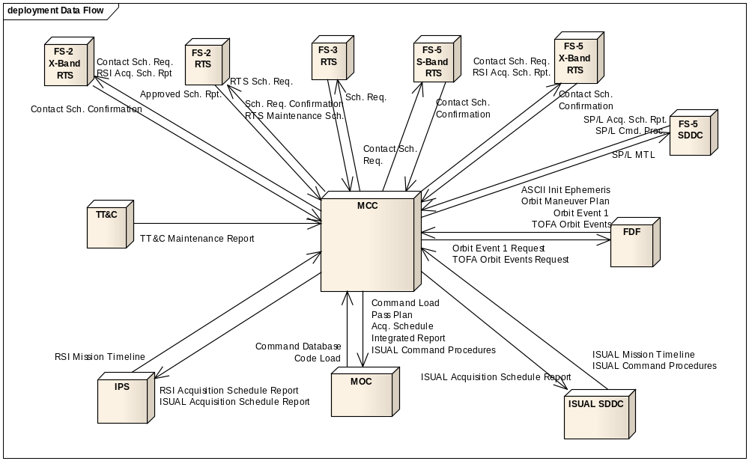
Item | System | Data | Direction
1 | MOC
1.1 |  | Command Database | In
1.2 |  | Code Load | In
1.3 |  | Command Load | Out
1.4 |  | Pass Plan | Out
1.5 |  | Acq. Schedule | Out
1.6 |  | Integrated Report | Out
1.7 |  | ISUAL Command Procedures | Out
2 | FDF
2.1 |  | ASCII Init Ephemeris | In
2.2 |  | Orbit Maneuver Plan | In
2.3 |  | Orbit Event 1 | In
2.4 |  | TOFA Orbit Events | In
2.3 |  | Orbit Event 1 Request | Out
2.5 |  | TOFA Orbit Events Request | Out
3 | RTS
3.1 |  | Contact Schedule Confirmation | In
3.2 |  | Contact Schedule Requests | Out
3.3 |  | RSI Acquisition Schedule Request (X-Band) | Out
4 | IPS
4.1 |  | RSI Mission Timeline | In
4.2 |  | RSI Acquisition Schedule Report | Out
4.3 |  | ISUAL Acquisition Schedule Report | Out
5 | ISUAL SDDC
5.1 |  | ISUAL Mission Timeline | In
5.2 |  | ISUAL Command Procedures | In
5.3 |  | ISUAL Acquisition Schedule Report | Out
6 | TT&C
6.1 |  | TT&C Maintenance Schedule | In
7 | FS-2 X-Band RTS
7.1 |  | Contact Schedule Confirmation | In
7.2 |  | Contact Schedule Request | Out
7.3 |  | RSI Acquisition Schedule Report | Out
8 | FS-2 RTS
8.1 |  | Approved Schedule Report | In
8.2 |  | RTS Schedule Request | Out
9 | FS-3 RTS
9.1 |  | Schedule Request Confirmation | In
9.2 |  | RTS Maintenance Schedule | In
9.3 |  | RTS Schedule Request | Out
10 | FS-5 S-Band RTS
10.1 |  | Contact Schedule Confirmation | In
10.2 |  | Contact Schedule Request | Out
11 | FS-5 X-Band RTS
11.1 |  | Contact Schedule Confirmation | In
11.2 |  | Contact Schedule Request | Out
11.3 |  | RSI Acquisition Schedule Report | Out
12 | FS-5 SDDC
12.1 |  | SP/L Acquisition Schedule Report | In
12.2 |  | SP/L Command Procedures | In
12.3 |  | SP/L Mission Time Line | Out

Security Requirements

SSL
The PRM shall use secure socket layer (SSL) protocol to ensure the security of all transactions on the Internet. (MCC001.04.01)

Authentication and Authorization
The MCC shall authenticate the users of the PRM and TOFA independently of each other. (MCC001.02.01)

General Requirements

Platform
The MCC system shall run on a Windows platform.

Development Language
All the software components of MCC shall use Java as the major programming language in addition to some C++.

