Zander Giuffrida
Partner: Kevin Chau
Station: 8
April 20, 2015
Lab 10: Analog to Digital and Digital to Analog Conversion

Prelab

1. Given the DAC in 10.2 has a resolution equal to 5 bits, how close to ideal must the resistor be?

The smallest change in the voltage is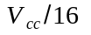, so the resistors are accurate to the point that the ratio between the feedback and 0-bit resistors are approximately to 6.

2. Assuming that the DAQ digital output high level is exactly 5V, what is the full scale value (largest output) of the DAC in this exercise?

5 + 5/2 + 5/4 + 5/8 + 5/16 = 9.6875V

Questions

1. We ran the program Sampling_Simulator. With filtering set to No Filter, we looked at the effects of the sample rate on Pure Sine and Square waves. We used both Flat Interpolation and Linear Interpolation.

i) We sample the circuit at 1Hz, phase 90 Sine wave at 4Hz. Do you get a reasonable facsimile of the original sine wave? Now change the phase. What happens? Do you still get a reasonable facsimile? Restore the phase to 90. What happens when you change the sample rate to 4.01? Can you account for the difference?

ii) Repeat these measurements with a Square wave, and record your answers.

iii) Using a 1Hz Sine wave, try some inadequate sampling rates, say 1.9, 1, 0.9, 0.5 and 0.47Hz. Can you account for the features you observe?

iv) Explore the effects of inadequate sampling rages on a Square wave.

v) What sample rate is necessary to give a reasonable facsimile of a sine wave, and what sample rate gives a reasonable facsimile of a square wave? Why are these frequencies different?

vi) Now find appropriate sample rates for the Two Tone, AM, and FM signals. Ironically, you may conclude that these signals can be sampled at a lower rate than the pure sine wave. This is probably because these signals are so complex that the sampling artifacts so clearly visible with the Sine signal are masked.

vii) Now try the Realistic Low Pass Filter with the Sine signal and various sample rates. Can you employ lower sample rates? Look at the amplitude as well as the form of the sampled and filtered signals. Is the amplitude sometimes incorrect even when the form is correct?

viii) Look at Square waves with the Realistic Low Pass Filter. What is the effect of the sample rate? Using the Expanded Time Axis, cycle between Realistic Low Pass Filter and No Filter. Note that the filter causes the rise and falls to be delayed. What is the size of the delay? Does it depend on the sample rate? Note that the realistic filter is a 3rd order Butterworth. Does this fact explain the delay?

ix) Look at the Two Tone, AM, and FM signals. Does the filter help?

x)Now go back to a 1Hz Sine wave, and set the sample rate to just above 2Hz, say 2.1Hz. Does any interpolation method produce a reasonable facsimile of the wave with the Realistic Low Pass Filter? (Hint: Ask what is reasonable?) Switch to the Ideal Low Pass Filter. Is it better? What do your signals look like for the different interpolations? Which one gets the amplitude correct? With Comb Interpolation, how low a sample frequency can you use? Try sample rates of 2.02 and 2.01Hz. In principle, you should be able to go down to 2.00Hz, but, in practice, 2.01Hz has problems. Can you explain why? (This is hard and is not obvious from the material covered in this writeup or in lecture.)

xi) Now go to a sample rate of 1.95Hz. Is the Ideal Low Pass Filter any better than the Realistic Low Pass Filter?

xii) With the Ideal Low Pass Filter and Comb Interpolation, explore sampling ranges above 2.00Hz for the Two Tone, AM, and FM signals. How good are the sampled signals? Try a Square Wave? Why is the sampled signal no good?

2. We built the following scaled resistor DAC and used the digital outputs of our DAQ card to drive the outputs. We corrected our prelab question calculation of the full scale voltage of the DAQ by measuring the actual high level output of the DAQ.
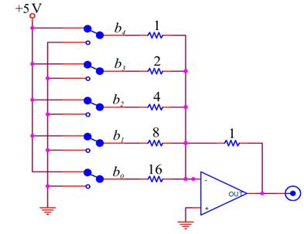

We constructed a LabVIEW program to convert the DAC output voltage to bits. First we rescale the voltage, which is between -9.6875 to 0 volts, to 0 to 31. We convert these values to a Boolean array and send the first five elements to the DAQ.

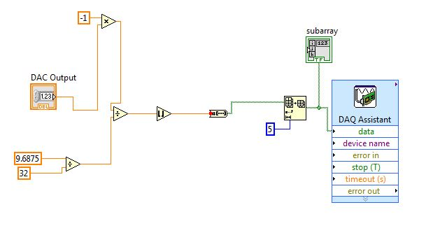

3. To test the DAC, we made the following LabVIEW program. The program loops through all 32 of the possible DAC output levels. We scale these values by -0.3121 to convert them back into the voltage range from -9.6875 to 0. With the vi from problem 2 we drove the DAC and used a stacked sequence structure to wait 20 ms for the DAQ to settle before reading the output.
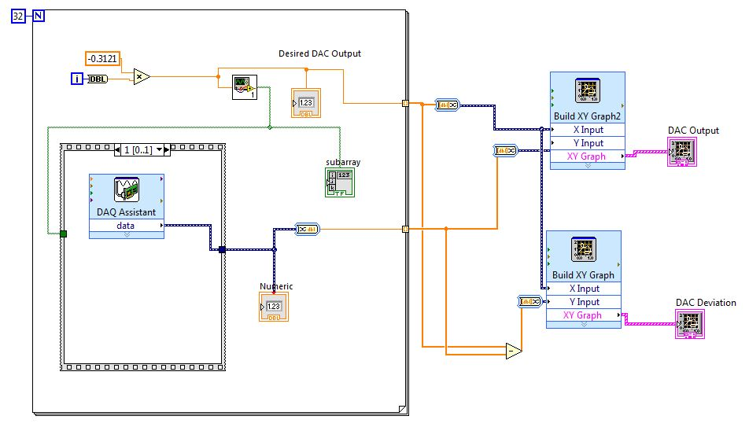

We display the actual output vs desired output (and deviation) on the XY plots shown below. Clearly our measured output is close to the desired output. The deviation has a sharp drop around -5V. Also note that the maximum error is -0.55 V.
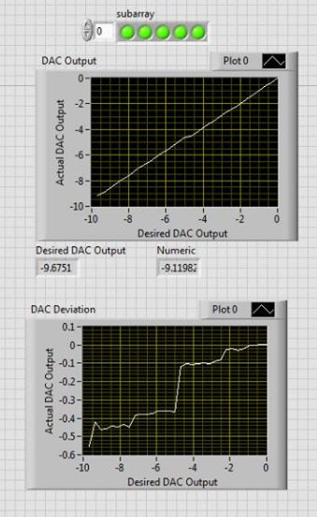

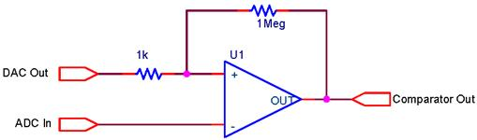
4. We constructed the following circuit. With the stacked sequence structure we made a VI which writes to the DAC, waits 10 ms for the DAC to settle, and compares the output to a fixed voltage.

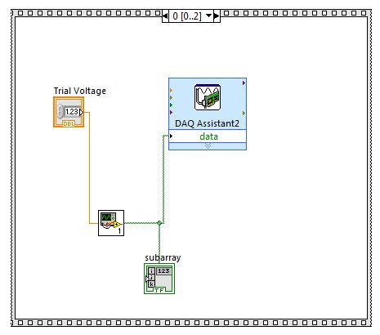
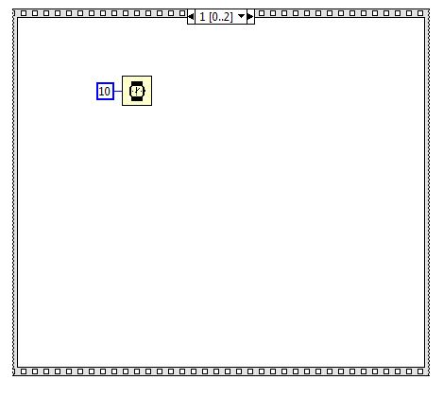

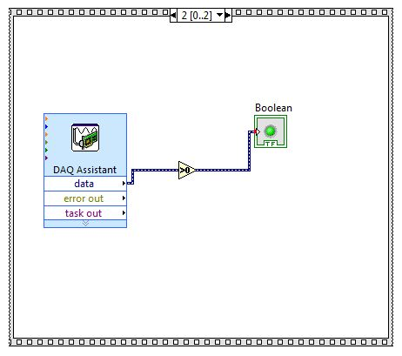

Next we constructed a VI which applies a binary search algorithm to guess the correct voltage.
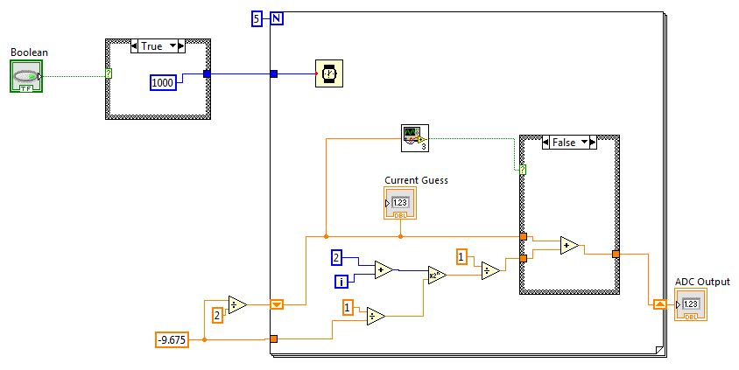

5. To test the ADC we constructed the following VI. To produce a continuous voltage ramp we produced 100 values evenly distributed between -9.6875 V and 0 V and fed them to the DAC. After waiting 20 ms, we obtain these values in the stack sequence structure. Plots of these values are shown in the two plots below. There is a large jump in the deviation at about -5.0 V. Note that the maximum deviation is about 0.35V.
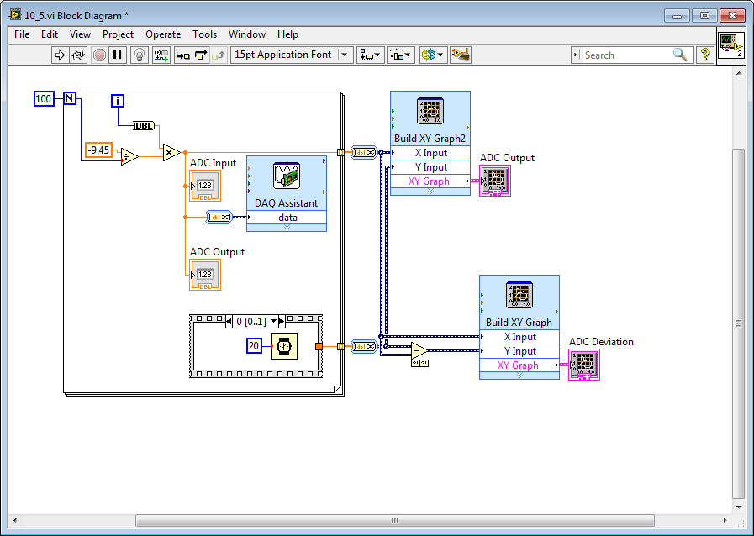

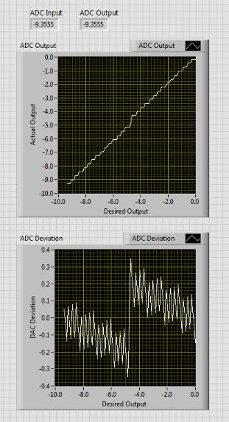

6. We ran Test DAQ ADC and DAC.vi which tests the DAC and ADC on the DAQ. After attaching the AO-0 output to the AI-7 input, we ran the routine to test the accuracy of the DAQ converters, with the corresponding output shown below.
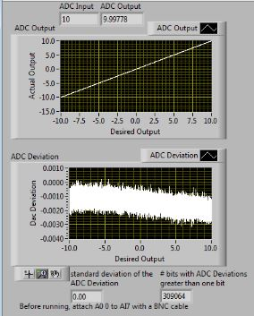

7. The program Sine_DAQ_Drive.vi was used to output a 5V sine wave on AO-0. The sample rate used was 10 kHz. At a frequency of 1000 Hz (shown below) it is reasonable to assume that the wave being sampled is a sine wave. However, with a frequency of 500 Hz (shown below) the signal is clearly a sine wave and thus acceptable.
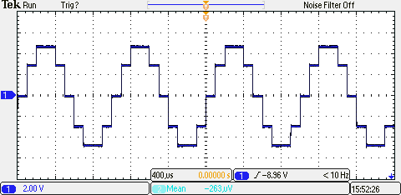

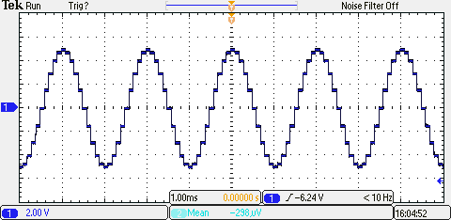

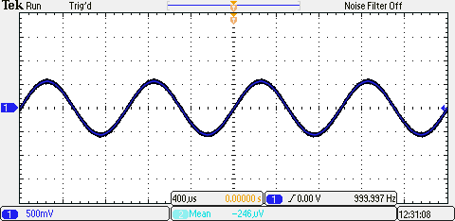
Using 3.3 k resistors (and since f = 1/RC using 30 nF and 300 nF capacitors) we constructed simple low pass filters with cutoff frequencies near 10 kHz and 1kHz. Note that in the top picture (where the frequency is 1 kHz) the signal is clearly acceptable, while in the bottom picture (where the sample frequency is 2 kHz) the signal is barely acceptable. In addition, note that due to the filters' capacitors the outputted waveforms have different phases and the 2 kHz wave has a smaller amplitude.

