Problem 2.1
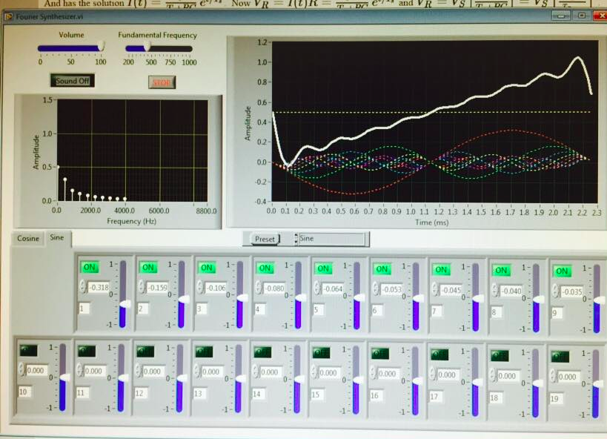

Sawtooth generated with Fourier coefficients

Problem 2.3
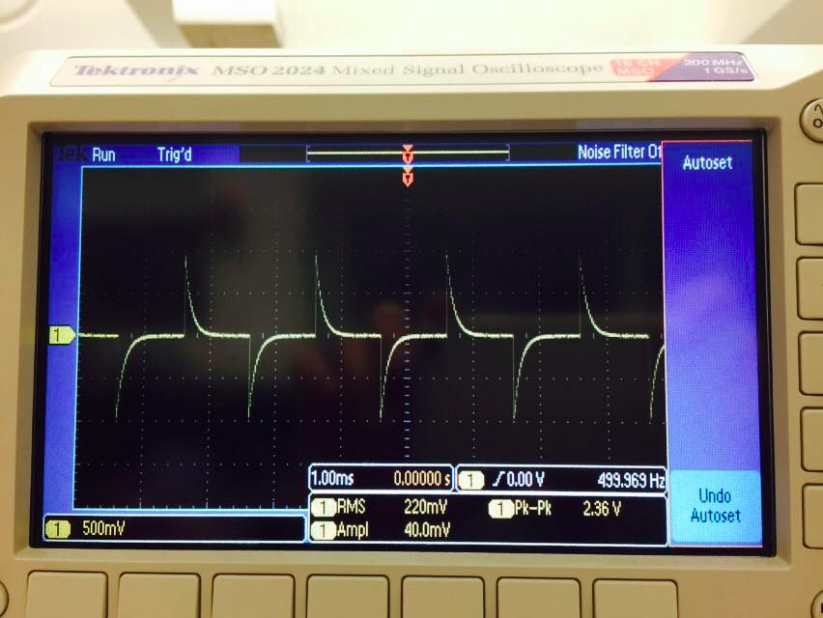

The high pass differentiates the input square wave.

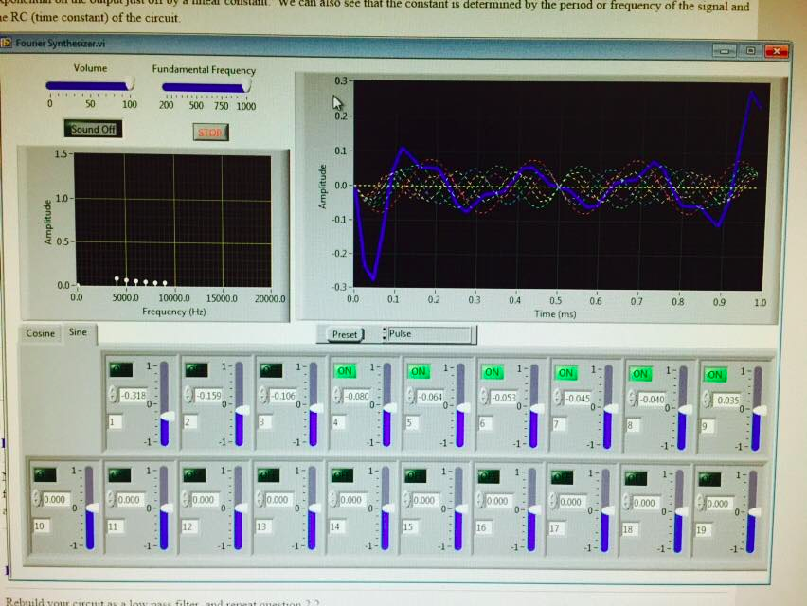

Turning off the harmonics in the Fourier synthesizer results in a similar wave form.

Problem 2.5

Problem 2.6

Problem 2.11
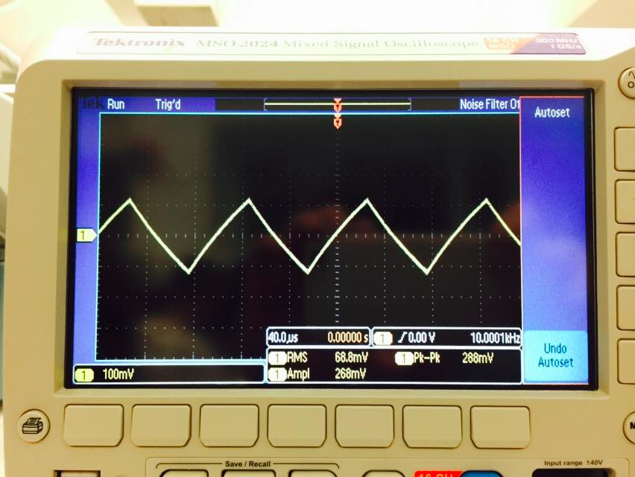
10kHz square wave get's integrated by the low pass behavior of the mock scope.

