CS61C Final Exam Study Guide
Kevin Chau
Six Great Ideas in Computer Architecture
    - Levels of Representation/Interpretation/Abstraction
    - Moore's Law
    - Principle of Locality/Memory Hierarchy
    - Parallelism
    - Performance Measurement and Improvement
    - Dependability via Redundancy
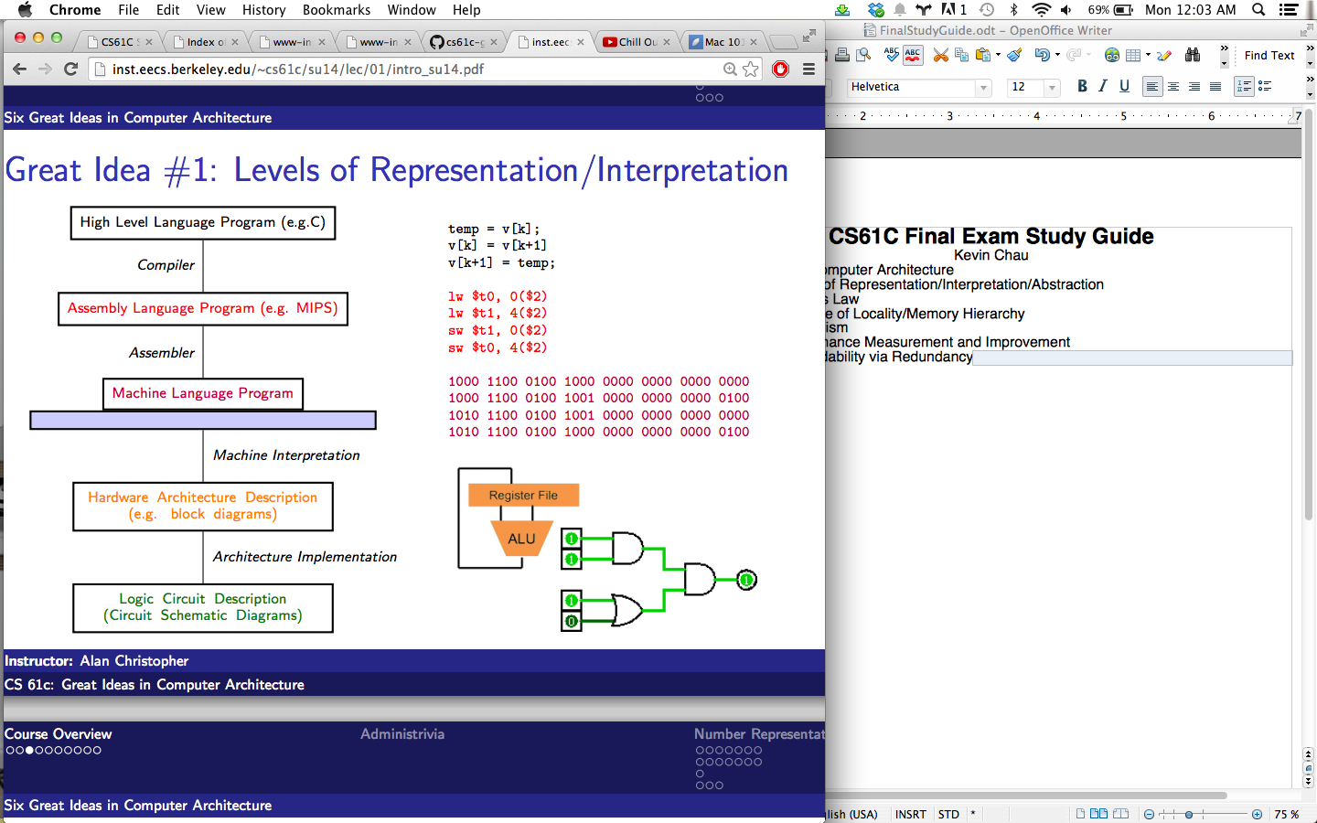
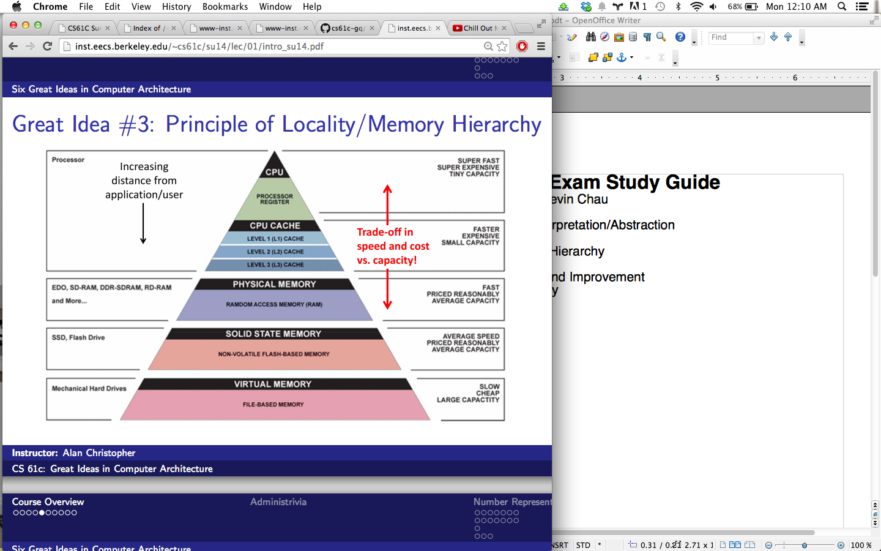
Number Representation
Decimal Binary Hex
Unsigned
0000 = 0
0001 = 1
. . .
0110 = 6
0111 = 7
1000 = 8
1001 = 9
. . .
1110 = 14
1111 = 15
Zero: 0000 (all zeros)
No negatives
Most+:
11..11=2^n-1

Sign and Magnitude
0000 = +0
0001 = +1
. . .
0110 = +6
0111 = +7
1000 = −0
1001 = −1
. . .
1110 = −6
1111 = −7
Zero: 0000,1000(two)
Most-:
1..1 = -(2^(n-1)-1)
Most+:
01..1= 2^(n-1)-1

Bias
0000 = −7
0001 = −6
. . .
0110 = −1
0111 = 0
1000 = +1
1001 = +2
. . .
1110 = +7
1111 = +8
Zero: 01..1
Most-:
0..0 = -(2^(n-1)-1)
Most+:
1..1= 2^(n-1)
0 0000 0
1 0001 1
2 0010 2
3 0011 3
4 0100 4
5 0101 5
6 0110 6
7 0111 7
8 1000 8
9 1001 9
10 1010 A
11 1011 B
12 1100 C
13 1101 D
14 1110 E
15 1111 F
One's Complement
0000 = +0
0001 = +1
. . .
0110 = +6
0111 = +7 (Negate
1000 = −7 by bit
1001 = −6flip)
. . .
1110 = −1
1111 = −0
Zero: 0..0,1..1 (+/-)
Most-:
10..0 = -(2^(n-1)-1)
Most+:
01..1= 2^(n-1)-1
Two's Complement
0000 = +0
0001 = +1
. . .
0110 = +6
0111 = +7 (Negate
1000 = −8 by bit
1001 = −7flip +1)
. . .
1110 = −2
1111 = −1
Zero: 0..0 (only 1)
Most-:
10..0 = -(2^(n-1))
Most+:
01..1= 2^(n-1)-1
Ex: n=5 bits → [-32,31]
Overflow: result is g.t. most+ or l.t. most-
Sign Extension: Sign/Mag—add 0s after sign bit
Ones/Two: copy leading bit
Ex: Sign and magnitude: 0b11 = 0b1001
Two’s comp: 0b11 = 0b1111

The C Programming Language (c99)
C Programming Concepts:
Compiler: Creates useable programs from C source code
Typed variables: Must declare the kind of data the variable will contain
Typed functions: Must declare the kind of data returned from the function
Head files(.h): Allows you to declare functions in files separate from their definitions
Structs: groups of related values
Enums: list of enumerated predefined values
Pointers: alias to other variables/ location in memory
-Compilation advantages: optimized (fast) for a given architecture, only recompiles modified files in larger projects
-Compilation disadvantages: must be recompiled/ported to other machines
Variable Types: types must be declared before use
int: signed integer (ex: 5, -12, 0)
short: smaller signed, bits depend on system
long: larger signed, bits depend on system
char: text character or symbol ( 'a', 'D', '?')
float: floating point rational (0.0f, 3.14159f)
double: greater precision float (0.0, 3.14)
-Types can be unsigned
-ints are normally 4 bytes (1 word, 32 bits), but depends on implementation
-sizeof() returns the size in bytes of a variables or data type
-chars are ascii coded (128 different characters; ex: 'a' = 97)
-both char c = 'a'; or char c = 97; are valid
-char takes up 1 byte
-typecasting is allowed in c
Functions in C
-must declare data type returned (void is okay)
-must declare argument data types
-must be declared before reference. Prototyping can happen in the .h file separate from def.
Structs
-ex: typedef struct songstr { int lengthInSeconds; int yearRecorded; } Song;
Song song1;
struct songstr song2;
song1.lenghtInSeconds = 213; song2.yearRecorded = 1994;
C operators
arithmetic: +, -, *, /, %
assignment: =, +=, - =, *=, /=, %=, &=, |=, ^=, <<=, >>=
bitwise: -, &, |, ^, >>, <<,
boolean: !, &&, ||, ==, !=, <, <=, >, >=, ? :
increment/decrement: ++,--
member selection: . , → (pointers)
Main() and command line args
void main(int arc, char *argv[])
-argc is the number of strings on command line, including executable name
-argv is an array of pointers to arguments as strings (0 index is the executable)
-ex: $ foo hello 87 ----> argv[0] = “foo”, arc =3
Booleans:
-no explicit boolean type (true/false)
- 0 and NULL evaluate to false, everything else is true
Control
if/if else/else, while/do, for, switch/case/break
Pointers
-address and value can be thought of as a single array
-an ADDRESS refers to a location in memory, the VALUE is what is stored in that spot.
-a pointer is a variable that contains an address, and it points to another val in mem.

syntax:
int *x;
-declares variable x to be the address of an int
x = &y;
-assigns address of y to x (& is the address operator)
z = *x;
-assigns the value AT x to z, (* is called the DEREFENCE operator)
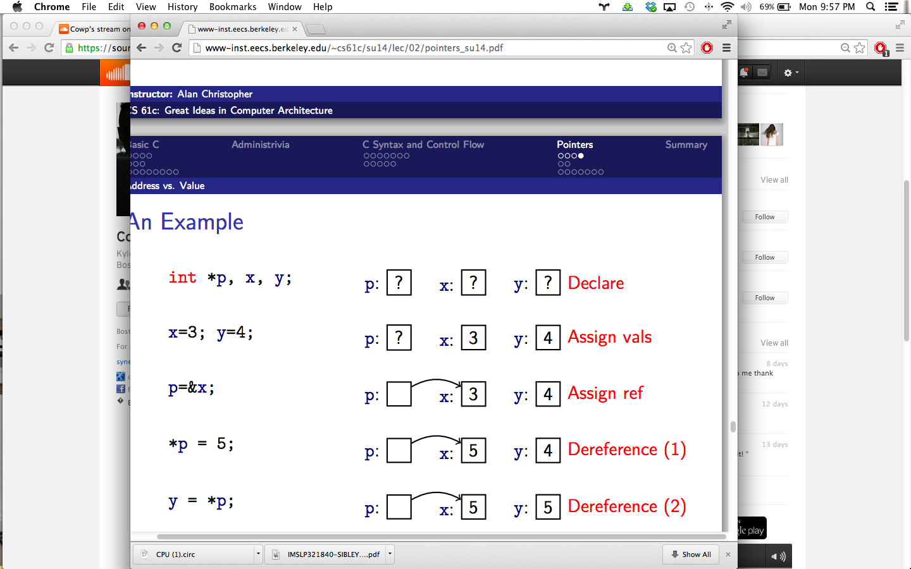
-pointers are data type specific (int, char, struct)
-pointers can point to pointers (int **h)
-functions can return pointers
-deference operator does not distribute, does not matter if next to type or var name
(int* x is the same as int *x)
-functions can change values of arguments by using pass by reference, in other words,
the function takes a POINTER argument. The function can modify value by deref.
-Parentheses can be used to specify order
-operators with greater precedence will evaluate first
-ex: equality binds more tightly than bool
X & 1 == 0
Means ---> X & (1==0)
-pre increment takes effect first (++x)
-post increment takes effect last (x++)
-for equal precedence, follow associativity
-ex: *p++ returns *p, then increments p; ++ binds to p before *, but takes effect last

*--p decrements p, returns whatever is at that address; -- binds to p before *, and takes effect first

++*p increments *p, then returns that value
* binds to ++ before *

(*p)++ returns *p, then increments in memory; * binds to p before ++, and takes effect first
void addOne (int *x) {
*x = *x + 1;
}
int y = 3;
addOne (&y); /* y == 4 */
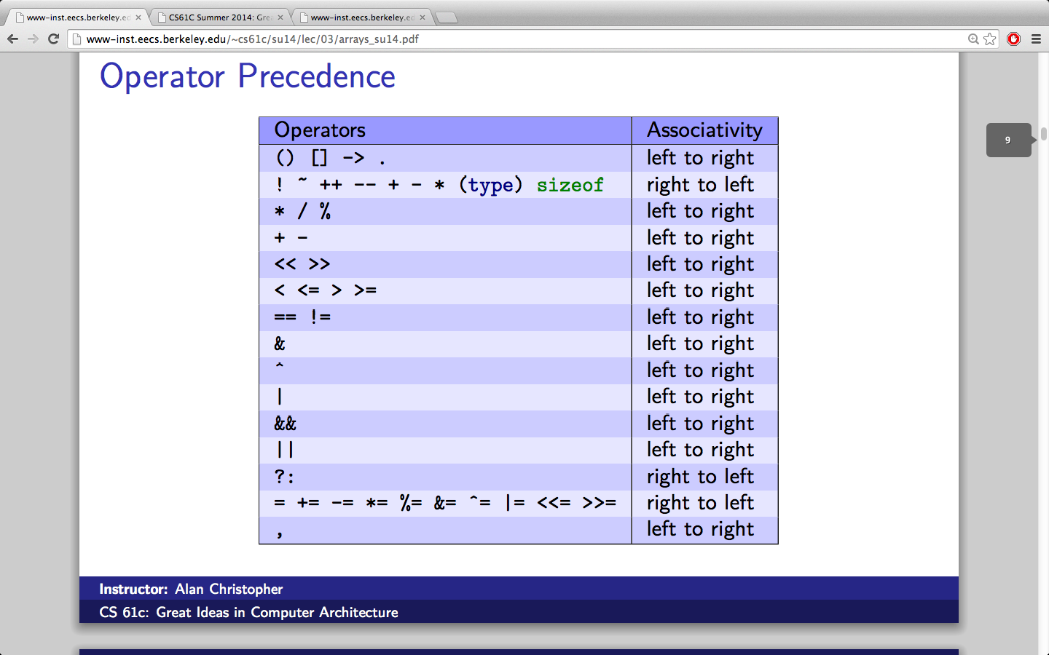
Precedence
Arrays
int ar[2]; declares a 2 element array
int ar[] = {1,2}; declares and initizlizes
ar[n] accesses the nth item in the array (0 indexed)
-C arrays do not know own length, or where the array bounds are (you can access past)
-arrays are nearly identical to pointers
-char *string and char string[] are identical declarations
-ar[0]==*ar; ar[2] == *(ar+2); ar[i] == *(ar+i)
-you cannot assign an array variable to anything
-arrays are passed to functions as pointers
-declared arrays only allocated while scope is valid (don't return an array that isnt malloced)
Strings
-strings are just null terminated char arrays; ie char string[] = “abc”; //4 bytes needed (1 for null term)
-null terminator '\0'==0. Need extra space in the array for the null terminator
-#include <string.h> → strlen(), strcmp() (0 if equal), strcpy(char * dst, char * src)
-ex: simple string cat:
void foo ( char *s, char *t) {
while (*s)
s++;
while (*s++ = *t ++);
}
Pointer Arithmetic
p+=1 increments p by sizeof(*p) (address is normally byte addressed)
ex: int *p; p = 100; p+1 = 104
-other valid pointer arithmetic: add integer to pointer, subtract two pointers in same array, compare pointers, compare pointer to NULL
-cannot add two pointers, multiply two pointers, subtract pointer from int
-pointer arithmetic allows us to walk through memory
-memory for pointers is NOT automatically allocated
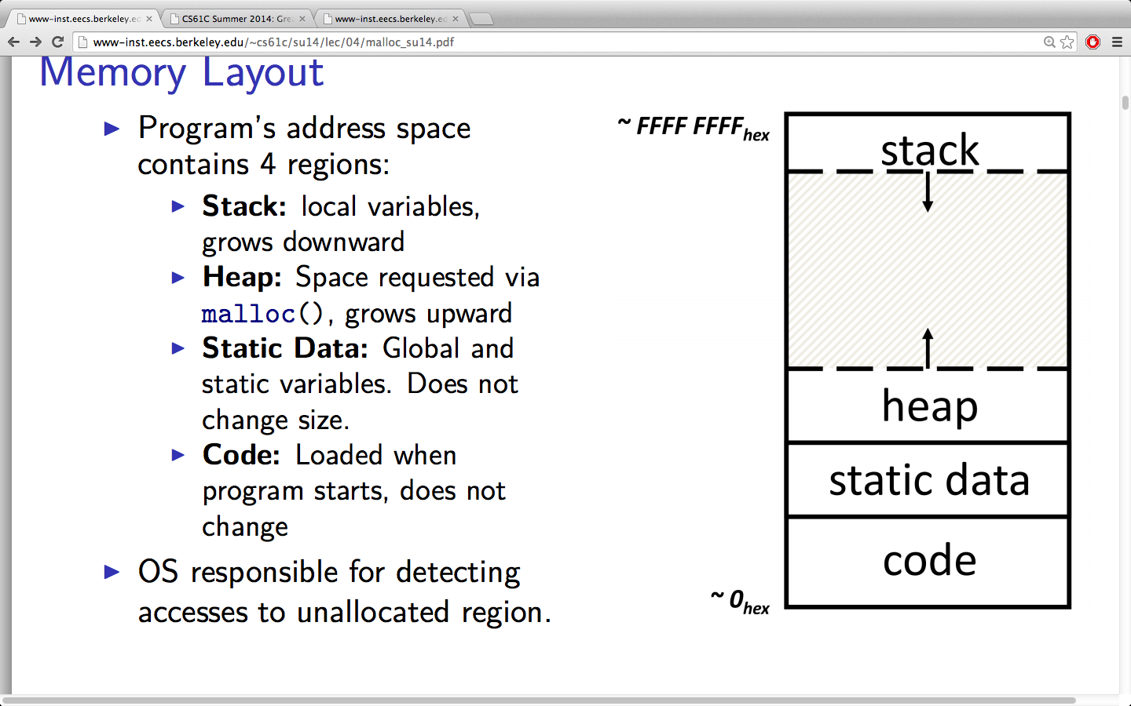
-a handle is a pointer to a pointer. Incrementing just one deference of the handle will move the pointer to the next spot in memory

Memory Layout
Stack: local variables, grows downward from top/last address
heap: space requested via malloc(); grows up
static data: global and static variables. Does not change size
code: loaded when program starts, does not change size
-variables in static are declared outside of functions
-stack variables declared inside functions (main() too), freed on return
-Heap variables must be dynamically and manual allocated with the malloc(size) functions
-stack contains contiguous blocks called FRAMES. Frames are pushed onto the stack when functions are called and popped off when they return
-frames include: location of caller, arguments, locals
-the STACK POINTER ($sp) tells where the lowest/current frame is
-static often holds string literals, globals. Size is constant, contents modifiable
-code is not meant to be modified, doing so usual breaks program execution
Dynamic Memory Allocation
-malloc(n) allocates a contiguous block of n bytes of uninitialized mem, returns pointer to beginning of block. Malloc will return null if the request fails (no more heap space)
-sizeof() allows portability of mallocs to different architectures. Good for structs
-NEVER increment a malloced pointer. You will lose original starting address
-calloc() does the same as malloc but initializes memory to zero
-realloc() will reallocate a pointer
-memory is released form the heap with free(p); frees the whole block that p points to (must be base of malloced block). Cannot call free on a block more than once
-a segmentation fault occurs when the program tries to access memory not allocated to it
-a bus error occurs when accessing a nonexistent device's physical addresses
-dynamically allocations allows for minimum memory overhead (vs garbage collection)
-can lead to fragmentation: many small chunks with not useful unallocated space between
-memory management strategies:
K&R section 8.7: linked list of free blocks
each list node holds its own size and pointer to the next block
free() adds block to the list, and combines with adjacent free blocks
malloc searches free list for block size that fits
-Best-fit: choose the smallest block that fits (reduces bad fragmentations)
-First-fit: choose first block that is large enough (start from beginning)
-Next-fit: choose next block that is large enough, starting from where we left off, fast and does not put a bunch of small blocks in the beginning
Linked Lists: typedef struct node { char *value; struct node *next;} node;

Assembly and Machine Language
-instruction: string of binary that the computer understands and can execute
-ISA: instruction set architecture. Set of all the instructions a computer/cpu understands.
Different computers use different ISAs, depending on application or functionality.\
Most common are intel x86 (i3, i5, i7), ARM (mobile devices), MIPS
-Assembly: lowest level language that gets translated into binary instructions.
Programming in assembly is useful for minimal applications, like embedded computers
-RISC: reduced instruction set computing. Complicated operations from composing basics
-CISC: complex instruction set computing. Add more instructions for new functions (x86)
-Risc design principles:
-fixed instruction length to simplify instruction fetch (same size everytime)
-smaller instruction memory required
-instruction set is smaller, which simplifies execution and data path control (hardware)
-few memory access instructions, which simplifies hardware
-compiler is suppose to do heavy translation of high level language
-ISA's have a small fixed number of variables/operands called REGISTERS
-values stored in hardware registers close to cpu, so very access (~1ns)
-small number means faster hardware, but typically cannot hold C data
-MIPS has 32 registers. Each register is 32bits wide (1 word)
-registers have no type, they are just binary words.
The operation determines number representation, etc.
-MIPS registers are denoted with $, referenced by actual reg number, or name
-MIPS has special conventions for names:
$s0-$s7 are 'saved' programmer variables (nonvolatile)
$t0-$t9 are (volatile) temporary variables
Mips Instructions
-syntax: opname dst, src1, src2
-one operation per instruction
-operation names that end in 'I' are called instructions for IMMEDIATES
-opi dst, src, imm (second source is just a numerical constant)
-operations that end in 'u' mean unsigned, they don't detect overflow, extension, cmp
-LOOK AT THE MIPS INSTRUCTION GREEN SHEET FOR MIPS SYNTAX DETAILS
Data Transfer
-specialized load and store instructions move data between memory and registers
-op reg, offest(reg w/ addr pointer) #offset is an immediate, in bytes
-word addresses are 4 bytes apart, no pointer arithmetic
Big Endian: most significant byte is at least address of word
Decision/Control:
beq src1, src2, label #go to label if src1 is equalt to src2
bne src1, src2, label
j label #jump to label
Pseudoins-tructions are other instructions that map directly to one or more MIPS instructions
-when breaking these into parts, assembler may need extra register ($at or $1 is assembler temporary, not safe to code with)

Calling Conventions:
    - put arguments into arg registers
    - transfer control to function (jump or jal)
    - function acquires local storage by pushing stack, save volatile regs into mem
    - function executes
    - put return value in return reg, restore saved values from mem/stack
    - control returned to caller with jump
register conventions:
$a0-$a3: argument registers
$v0-$v1: return value registers
$ra: return address which saves where a function is called from(next instr)
jal (jump and link): save location of following instruction to $ra, jump to label
used to call/invoke a function
jr (jump register): unconditionally jump to the address specified in src
PC: program counter holds the address of the current instruction (not accessible )
jal stores PC+4 into ra (instructions are a word long)
$sp pushed by subtraction multiples of 4
-Typical structure:
Prologue:
func_label :
addiu $sp , $sp , -framesize #push stack
sw $ra , <framesize - 4> ($sp ) # save other registers as needed
Body # whatever the function actually does
Epilogue
lw $ra , <framesize - 4> ($sp ) # restore other registers as needed
addiu $sp , $sp , framesize #pop stack
-saved registed must be restored to CALLER's values after a CALLEE uses them and before the function returns (save values on stack, use reg, reload values from stack)
-volatile registers may be used freely by the caller and callee
MIPS instruction format
-instructions are just binary data stored in memory. Instructions have addresses
-a program is really just an array of instructions, jump/branch logic is just pointer arith
-backwards compatible instruction sets can reuse old compiled binaries
-32 bit instructions are divided into fields (unsigned)
R-type: register type instructions
6,5,5,5,5,6 ----> | opcode | rs | rt | rd | shamt | funct |
opcode = 0 for all R types. Funct further specifies operation
rs = source (1st operand); rt = target (2nd operand); rd = destination (write reg)
each of the 32 registers fits in its 5bit instruction field
shamt is the shift amount if instr is a shift(cannot shift 32bit more than 31)
ex: R[rd]=R[rs]+R[rt] -> | 0 | 9 | 10 | 8 | 0 | 32 |=0x012A4020->add $8, $9, $10
NOP: 0x00000000 → sll $0, $0, 0 → does nothing
I-Type: instructions that use immediates, lw/sw (immediate offset), beq, bne
6,5,5,16 → | opcode | rs | rt | immediate |
I types have non-zero opcode (no funct though)
rs is a operand register, not always used in an I type
rt is the write/target register (NOT AN OPERAND LIKE IN R TYPE)
16 bit immediate is extended to 32 bits, signed vs unsigned ext based on instr.
2^16 immediates, load into register when larger constants needed
lui $at, 0xABAB # upper 16
ori $at, $at, 0xCDCD # lower 16, $at now == 0xABABCDCD
-lui does the same thing as ori and sll 16
branching instructions use an immediate to specify address (compare rs and rt)
-branches are PC relative addressing; use immediate as signed PC offset
-we can branch +/-2^15 addresses around PC
-immediate specifies word instead of byte, so we can drop 0b00 from end
-in total, we can branch +/- 2^15 words, so 2^16 instructions-> 2^18 bytes
-if branch taken: PC = PC+4 + IMM*4 (IMM is just # instructions to jump)
Loop : beq $9 , $0 , End
addu $8 , $8 , $10 # 0
addiu $9 , $9 , -1 # 1
j Loop # 2 beq → | 4 | 9 | 0 | 3 |
End : < some instr > # 3
J-type: j and jal (does not include jr)
- jump address is 26 bits wide, 2^26 addresses to jump to, drop 0b00 so in reality we have 28bits of address space. Then take the 4 highest order bits from PC. You can always stack jumps so limited distance not really an issue
- PC = {(PC+4)[31,28], ja, 0b00} {concatenate bits}
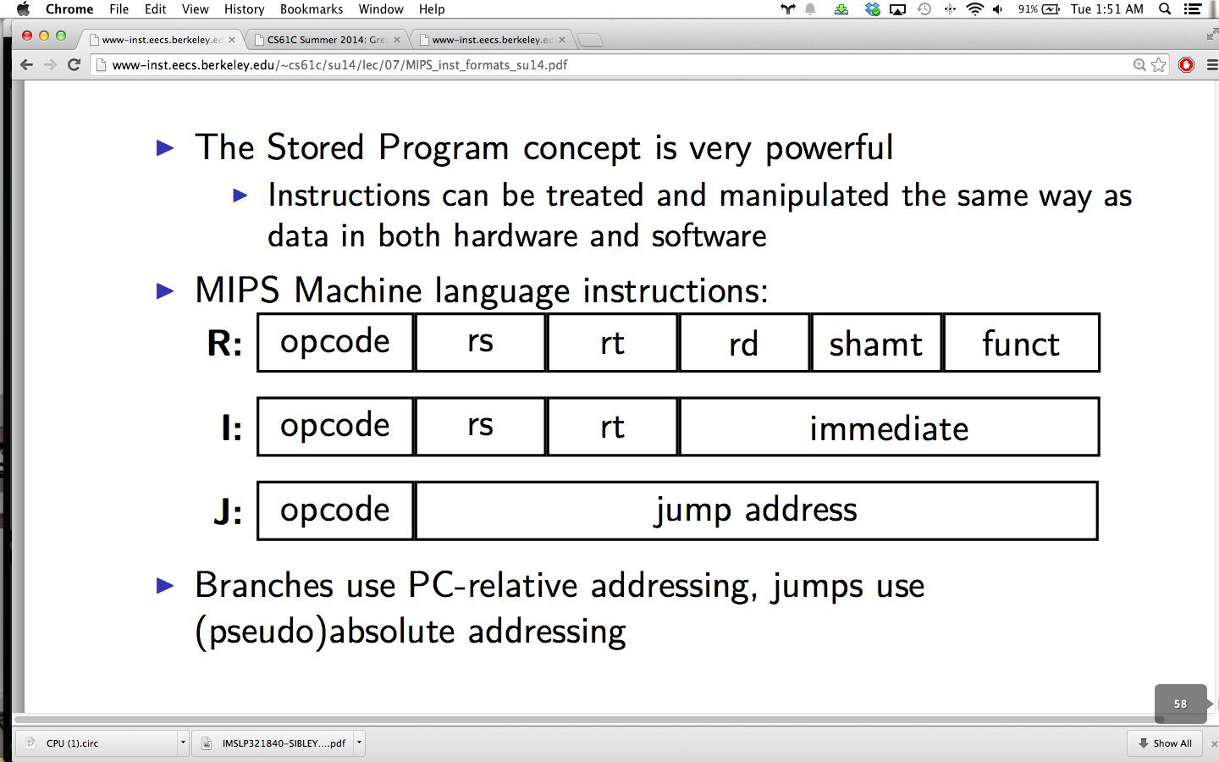
C.A.L.L: Compiling, Assembling, Linking, Loading
-Compiler optimizes code to be fast. Gcc -O# flag for optimization (0-3 levels)
-trade off between compilation speed and output file
-Assembler:
input: assembly language code (MAL code, like MIPS)
output: object code (TAL), information tables, (object files foo.o)
-reads and uses directives, translates pseudos, produces binary machine lang
-directives: .text (main code), .data (binary values), .asciiz (strings), .word (32bits), .globl sym (declares sym global, can reference in other files)
-after pseudo instructions are replaced, branch relative addresses are corrected
-two passes: first finds label positions, second generates label codes
-j and jal require absolute addresses, which cannot be determined until instruction loads into memory
-symbol table: items usable by other files; ie labels, .data
-relocation table: holds undetermined addresses
-labels (both internal and external), any piece of data (la instr)
-Object file format: header, text, data, relocation, symbol, debugging info
-Linker:

false sharing: two different threads sharing memory thats close together (may not actually be the same information/cache block), incurs a lot of caching overhead and MOESI cache invalidation

Parallelism:
Request level: handling many requests per second (use a data center)
Data level: operate on many piees of data at once; SIMD, MapReduce
Thread level: many processors split up work, same program or many programs
-for same program, need to deal with shared mem, data races, synchronization
-OpenMP: pragmas, shared vs private variables, some algorithm redesign
-parallel, for, critical, atomic, master, reduction
-synchronization needs hardware support
Instruction level: pipelining increases throughput by adding registers
-reduce critical path, increase max clock frequency
-allows you to work on multiple instructions at once by splitting work into separate stages
-hazards: data, structual, control. Use forwarding, delay slots, bubbling, branch prediction. Superscalar processors use more advanced prediction

Performance Measurement:
CPU time = instructions X cpi X clock period
AMAT, CPI_stall use hit time, miss rate, miss penalty (defined recursively by cache levels)
Amdahl's law: speedup = 1/ [(1-F) + F/S]
-make the common case fast, look for bottle necks, exceptions and edge cases won't speed up a process by much in most cases.

