CS61C Final Exam Study Guide
Kevin Chau
Six Great Ideas in Computer Architecture
    - Levels of Representation/Interpretation/Abstraction
    - Moore's Law
    - Principle of Locality/Memory Hierarchy
    - Parallelism
    - Performance Measurement and Improvement
    - Dependability via Redundancy
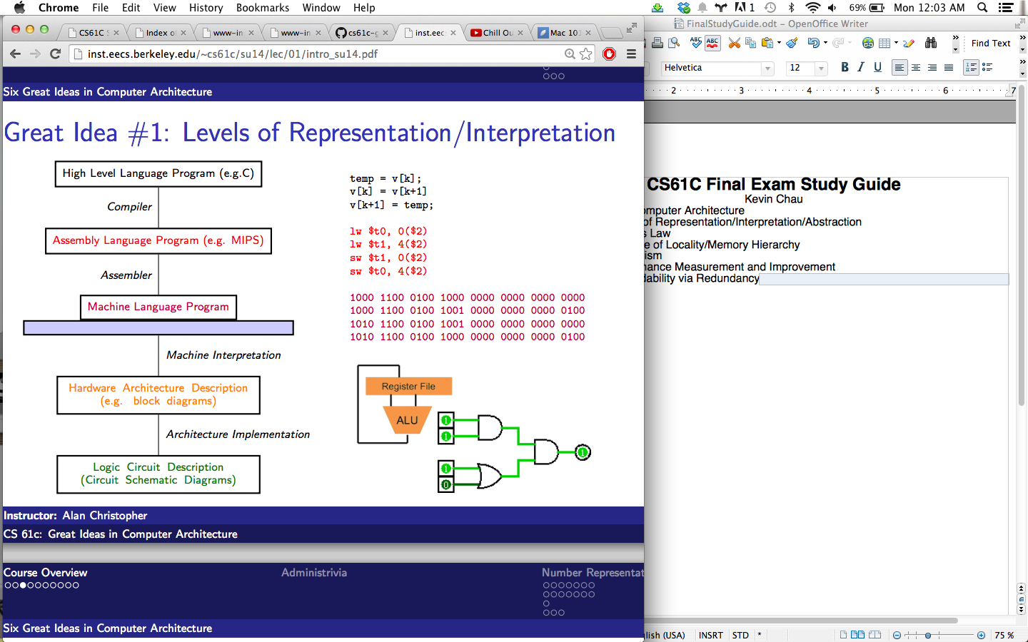
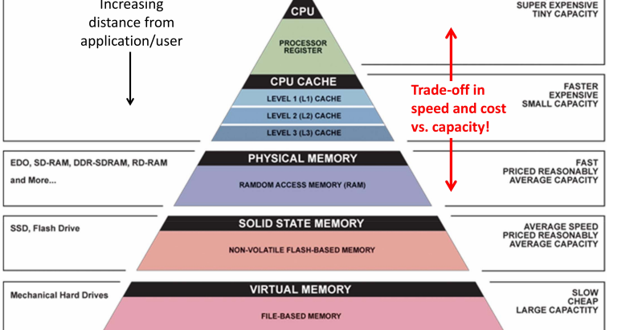
Number Representation
Decimal Binary Hex
Unsigned
0000 = 0
0001 = 1
. . .
0110 = 6
0111 = 7
1000 = 8
1001 = 9
. . .
1110 = 14
1111 = 15
Zero: 0000 (all zeros)
No negatives
Most+:
11..11=2^n-1

Sign and Magnitude
0000 = +0
0001 = +1
. . .
0110 = +6
0111 = +7
1000 = −0
1001 = −1
. . .
1110 = −6
1111 = −7
Zero: 0000,1000(two)
Most-:
1..1 = -(2^(n-1)-1)
Most+:
01..1= 2^(n-1)-1

Bias
0000 = −7
0001 = −6
. . .
0110 = −1
0111 = 0
1000 = +1
1001 = +2
. . .
1110 = +7
1111 = +8
Zero: 01..1
Most-:
0..0 = -(2^(n-1)-1)
Most+:
1..1= 2^(n-1)

0 0000 0

1 0001 1

2 0010 2

3 0011 3

4 0100 4

5 0101 5

6 0110 6

7 0111 7

8 1000 8

9 1001 9

10 1010 A

11 1011 B

12 1100 C

13 1101 D

14 1110 E

15 1111 F
One's Complement
0000 = +0
0001 = +1
. . .
0110 = +6
0111 = +7 (Negate
1000 = −7 by bit
1001 = −6flip)
. . .
1110 = −1
1111 = −0
Zero: 0..0,1..1 (+/-)
Most-:
10..0 = -(2^(n-1)-1)
Most+:
01..1= 2^(n-1)-1
Two's Complement
0000 = +0
0001 = +1
. . .
0110 = +6
0111 = +7 (Negate
1000 = −8 by bit
1001 = −7flip +1)
. . .
1110 = −2
1111 = −1
Zero: 0..0 (only 1)
Most-:
10..0 = -(2^(n-1))
Most+:
01..1= 2^(n-1)-1
Ex: n=5 bits → [-32,31]
Overflow: result is g.t. most+ or l.t. most-
Sign Extension: Sign/Mag—add 0s after sign bit
Ones/Two: copy leading bit
Ex: Sign and magnitude: 0b11 = 0b1001
Two’s comp: 0b11 = 0b1111

C Programming Concepts:
Compiler: Creates useable programs from C source code
Typed variables: Must declare the kind of data the variable will contain
Typed functions: Must declare the kind of data returned from the function
Head files(.h): Allows you to declare functions in files separate from their definitions
Structs: groups of related values
Enums: list of enumerated predefined values
Pointers: alias to other variables/ location in memory
-Compilation advantages: optimized (fast) for a given architecture, only recompiles modified files in larger projects
-Compilation disadvantages: must be recompiled/ported to other machines
Variable Types: types must be declared before use
int: signed integer (ex: 5, -12, 0)
short: smaller signed, bits depend on system
long: larger signed, bits depend on system
char: text character or symbol ( 'a', 'D', '?')
float: floating point rational (0.0f, 3.14159f)
double: greater precision float (0.0, 3.14)
-Types can be unsigned
-ints are normally 4 bytes (1 word, 32 bits), but depends on implementation
-sizeof() returns the size in bytes of a variables or data type
-chars are ascii coded (128 different characters; ex: 'a' = 97)
-both char c = 'a'; or char c = 97; are valid
-char takes up 1 byte
-typecasting is allowed in c
Functions in C

