CS61C Final Exam Study Guide
Kevin Chau
Six Great Ideas in Computer Architecture
    - Levels of Representation/Interpretation/Abstraction
    - Moore's Law
    - Principle of Locality/Memory Hierarchy
    - Parallelism
    - Performance Measurement and Improvement
    - Dependability via Redundancy
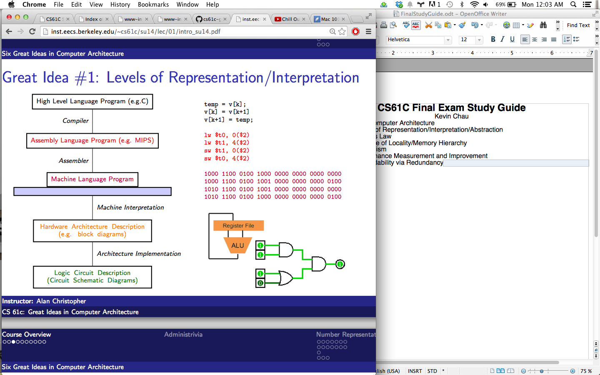
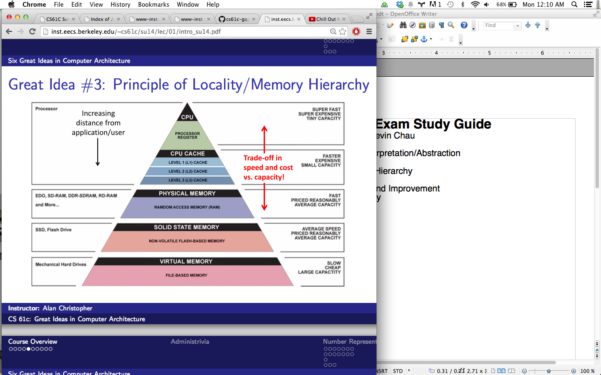
Number Representation
Decimal Binary Hex
Unsigned
0000 = 0
0001 = 1
. . .
0110 = 6
0111 = 7
1000 = 8
1001 = 9
. . .
1110 = 14
1111 = 15
Zero: 0000 (all zeros)
No negatives
Most+:
11..11=2^n-1

Sign and Magnitude
0000 = +0
0001 = +1
. . .
0110 = +6
0111 = +7
1000 = −0
1001 = −1
. . .
1110 = −6
1111 = −7
Zero: 0000,1000(two)
Most-:
1..1 = -(2^(n-1)-1)
Most+:
01..1= 2^(n-1)-1

Bias
0000 = −7
0001 = −6
. . .
0110 = −1
0111 = 0
1000 = +1
1001 = +2
. . .
1110 = +7
1111 = +8
Zero: 01..1
Most-:
0..0 = -(2^(n-1)-1)
Most+:
1..1= 2^(n-1)
0 0000 0
1 0001 1
2 0010 2
3 0011 3
4 0100 4
5 0101 5
6 0110 6
7 0111 7
8 1000 8
9 1001 9
10 1010 A
11 1011 B
12 1100 C
13 1101 D
14 1110 E
15 1111 F
One's Complement
0000 = +0
0001 = +1
. . .
0110 = +6
0111 = +7 (Negate
1000 = −7 by bit
1001 = −6flip)
. . .
1110 = −1
1111 = −0
Zero: 0..0,1..1 (+/-)
Most-:
10..0 = -(2^(n-1)-1)
Most+:
01..1= 2^(n-1)-1
Two's Complement
0000 = +0
0001 = +1
. . .
0110 = +6
0111 = +7 (Negate
1000 = −8 by bit
1001 = −7flip +1)
. . .
1110 = −2
1111 = −1
Zero: 0..0 (only 1)
Most-:
10..0 = -(2^(n-1))
Most+:
01..1= 2^(n-1)-1
Ex: n=5 bits → [-32,31]
Overflow: result is g.t. most+ or l.t. most-
Sign Extension: Sign/Mag—add 0s after sign bit
Ones/Two: copy leading bit
Ex: Sign and magnitude: 0b11 = 0b1001
Two’s comp: 0b11 = 0b1111

