Living Windows: a new material for storytelling

John Doe
User Interface Research Center
380 Gui Lane
Hillsville, NY 60292 USA
+1 555 321 7654
jdoe@uirc.com
Mary Smith
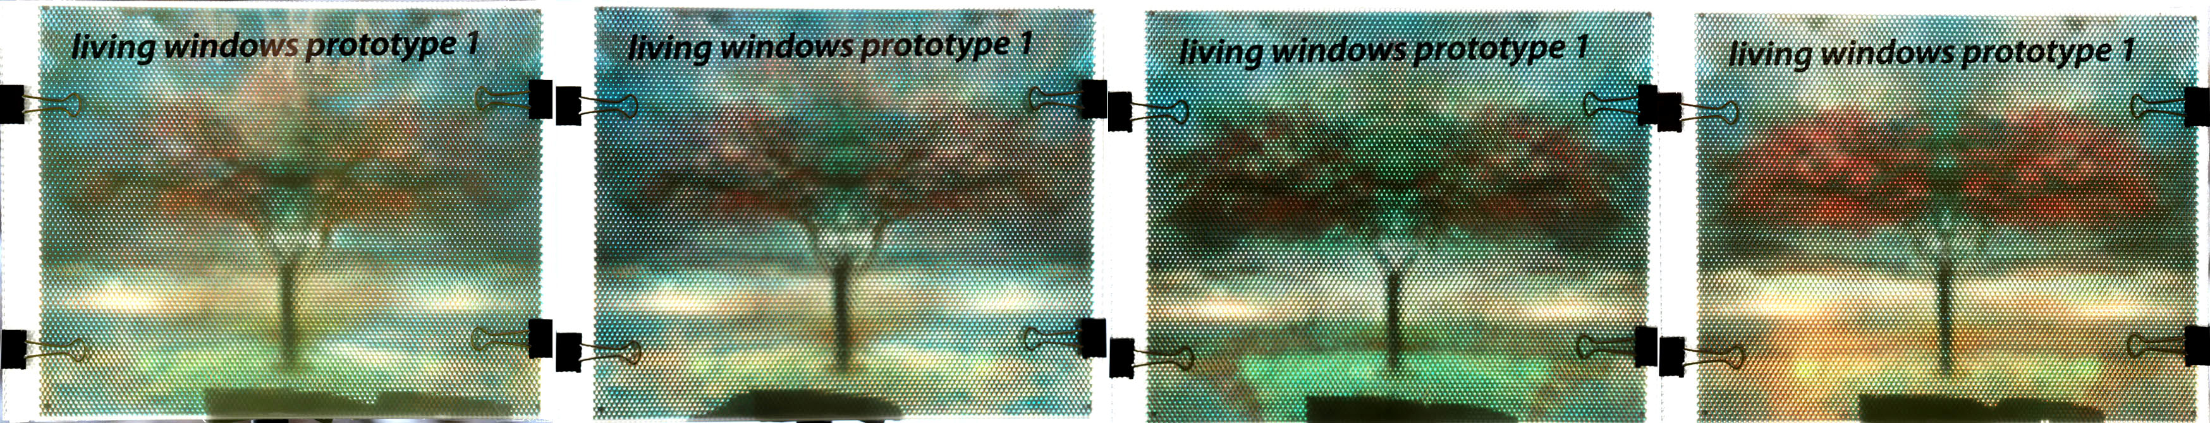Figure 1 Living Windows respond to the time of the day, the depicted tree blossoms during the day.

Computer Science Department
Vowel Technological Institute
Aeiou ZZ1 8BC UK
+44 1999 123456
msmith@vowel.ac.uk

ABSTRACT
We introduce a new material for dynamic storytelling. The material acts as a pixel-addressable display dependent on the environment lighting. Placed in a window, it conveys rich stories based on the time of the day or the season. Our material is completely passive and can be used in a similar fashion to stain glass windows.

Keywords
Storytelling, new materials for creativity, stained glass, windows

INTRODUCTION
Stained glass has a thousand year history in art and craft applications on windows of churches, buildings and people’s houses. Stained glass windows display both abstract and figurative narratives often drawn from the Bible, history or literature. A traditional narrative window has panels that relate a story.

LEAVE BLANK THE LAST 2.5 cm (1”) OF THE LEFT COLUMN ON THE FIRST PAGE FOR THE COPYRIGHT NOTICE.

Traditional stained glass windows depict 2D static images out of a patchwork of colored glass pieces. The glass pieces are put together with H profiles made out of lead and soldered into place. Details, as shown in figure 1, are painted on the glass. Painting glass evolved whereas it was less labor intense than creating a patchwork.
Stained glass storytelling takes place spatially over multiple panels, whereas in the last century pictorial storytelling in time emerged with motion pictures.

We introduce a new material that we call Living Windows, a see-through material that can change color over time, depending on the incoming light. The material consists of a sheet of microlenses that color the incoming light in a pre-computed way. Placed on a window, the picture can change throughout the day when the Sun moves from West to East, and over the year whereas the Sun’s elevation changes. 
Figure 1. A traditional stained glass window consists of colored glass and painted details.

Calculating the path of the sun on a specific geographical location and heading used to be quite an effort. However today’s cell-phones often include digital compasses and GPS, which makes determining the location and heading, and thereby the path of the Sun an easy task.

RELATED WORK
Microlenses and lenticular lenses have been around a while [2] used for depicting viewer dependent imagery. Fuchs et. al. [1] developed a 6D display. This display is viewer dependent and dependent on the incoming light.

TECHNOLOGY
Living Windows consist of a sheet of lenticular or microlenses and in each row, pixel a number of images are encoded in similar fashion to a traditional viewer dependent dynamic images. In contrary to viewer dependent displays, the lenses are back-facing the viewer and direct the light to a specific subpixel. A diffuser sheet colors the pixel with the specific subpixel.
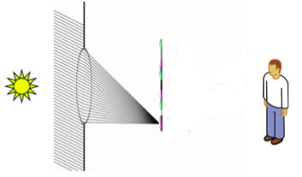
Figure 2. A microlens steers incoming light to a specific subpixel, and through a diffuser, colors the pixel.
For a specific geographical location we can calculate the path of the Sun over the year, as depicted in Figure 3. The lenses steer the incoming light within a 90 degree field of view and can encode both the time of the day and the time in the year. The time between the Summer and Winter equinoxes overlap.
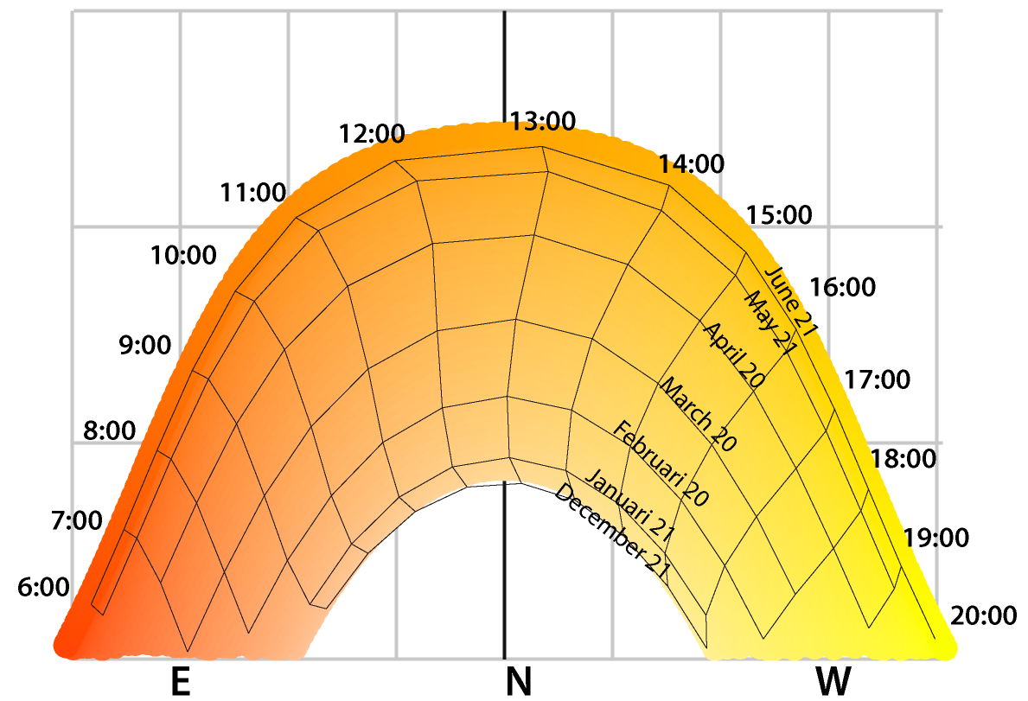
Figure 3. The path of the sun over a year calculated for a specific location. On the vertical axis the elevation and horizontally the heading.

MAKING
Our material comes in two variants. The simple variant consists of lenticular lenses that change color. On a north facing window, aligned horizontally will change color during the day, aligned vertically the color change will change with the season. On non-north facing windows the lenticular lenses should be rotated according to Figure 3.
The complex variant makes use of microlenses that encode the incoming light in 2 directions. Then based on a specific location/heading we can encode an image during the time of the day and season.
Our prototype is build with of-the-shelf sheets of microlenses and the image is printed on a transparency with a regular 300 DPI printer. The dot pitch of the lenses is 0.09 inch and we decode 24 by 24 images. Our diffuser consists of translucent drawing paper.
Our webservice allows people to upload images, and their geographical location and print out sheets.

EXAMPLES
Our example as shown in Figure 4. Shows a tree that blossoms over the time of the day. To overcome the relatively low resolution we can mix the dynamic images with a high res mask over the microlenses, in similar fashion as Figure 1. Other examples are displays that show special images during winter solstice or summer solstice.

DISCUSSION
The Living Window is an easy-to-use storytelling medium that brings the ancient art of stained glass windows into the modern world through windows that intelligently react to the light passing through them in novel ways. Living Windows can be easily deployed in a wide range of residential and commercial applications, including temporal art installations, passive digital sundials and calendars, light-adaptive passive lighting and many others.

Limitations
Printer resolution limits the number of subpixels one can fit beneath a given microlens pixel. The number of subpixels directly corresponds to the maximum number of possible views that pixel can present.
Printers with lower dot pitch provide less white space between dots, allowing for more continuous and more saturated images and typically higher resolution. Printers with higher dot pitch expose more white space between the subpixels, decreasing effective resolution.
The angle of the window determines the portion of the day that the microlenses accept incoming direct illumination from the Sun. In the northern hemisphere, during the time period starting on the Summer solstice and ending on Winter solstice, a north-facing window will accept angles plus and minus 45 degrees from north, but as windows face further away, they will from north will tend to receive, on average, less light throughout the year as well as lower light angles. A south-facing window in the same location may not receive any direct illumination. Changing the window direction also requires recalculating the subpixel arrangement.

ACKNOWLEDGMENTS
We thank CHI, PDC, CSCW volunteers, all publications support and staff who wrote and provided helpful comments on previous versions of this document.

REFERENCES
- Fuchs, M., Raskar, R., Seidel, H., and Lensch, H. P. 2008. Towards passive 6D reflectance field displays. In ACM SIGGRAPH 2008 Papers (Los Angeles, California, August 11 - 15, 2008). SIGGRAPH '08. ACM, New York, NY, 1-8.
- Oster, G., "Optical Art," Appl. Opt. 4, 1359-1369 (1965)

The columns on the last page should be of equal length.

