Kevin Christianson and Isaac Haseley

Today’s college ranking systems garner nothing but complaints for their misguided use of metrics by which to evaluate institutions. Why ask administrators to judge universities they’ve never stepped foot on? Why weight standardized test scores at 7.5% of an institution’s outcome? And where’s the quality of food metric? We can’t promise to fix that last one (yet), but our app will resolve common complaints by placing ranking metrics in the hands of its users. We’ll start humble and use the factors from our API (see mockup below).

The MVC design pattern is the pattern for us. Modeling Colleges and a list thereof (CollegeList) will allow us to reuse these classes upon future expansion of the user interface. Separating the design thusly will allow Kevin and me to work on different pieces of the project and reduce merge conflicts. When we begin reading resumes and our team expands, this conventional design pattern will be familiar to new recruits. Views will include nested AnchorPanes (or Regions or a close relative), buttons, text input fields, and text labels.

Potential mockup:

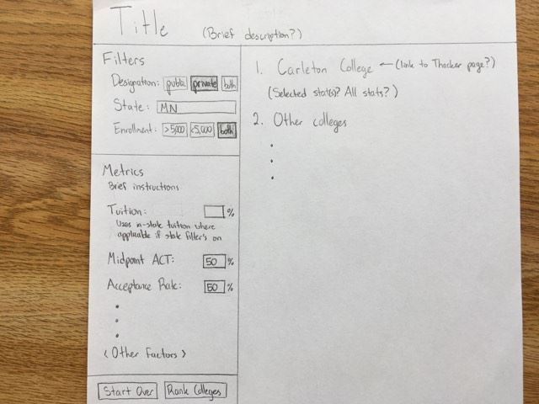

Models

* College
  + Instance variables for all attributes – We’ll grab this data from our API.
  + double totalWeightedOutcome – See example below. We’ll use this to sort.
  + Constructor will take in a dictionary, sets all instance variables
  + Getters for all instance variables
* AllColleges: either...
  + This is a simple class; the controller will handle all the filtering and sorting

Ranking algorithm: the following example assigns Carleton its totalWeightedOutcome metric, which we’ll use to sort all colleges in the user’s ranking list.

