SUPPLEMENTARY MATERIALS

First record of pyroplastic and partially burnt plastic litter along South African shores

Gerardo I. Zardi^{1,3}, Kevin Ma², Pierre William Froneman^{3,5}, Katy R. Nicastro^{3,4}
¹Normandie Université, UNICAEN, Laboratoire Biologie des Organismes et Ecosystèmes Aquatiques, UMR, 8067 BOREA, (CNRS, MNHN, UPMC, UCBN, IRD-207), CS 14032 14000, Caen, France

²Department of Ocean Sciences, Memorial University, St. John’s, Newfoundland and Labrador, Canada

³Department of Zoology and Entomology, Rhodes University, Grahamstown 6140, South Africa

⁴Univ. Lille, CNRS, Univ. Littoral Côte d’Opale, UMR 8187 – LOG – Laboratoire d’Océanologie et de Géosciences, F‐59000 Lille, France

⁵ Department of Biological Sciences, University of Cape Town, Rondebosch, 7700, South Africa

Fig. 1S. Pyroplastic pieces gathered during the study. This image displays all the samples collected, highlighting the diversity and characteristics of pyroplastic materials.

Polyethylene, PE (DU1)

Polypropylene, PP (DU4)

Polystyrene, PS (EL1)
Polyethylene terephthalate, PET (KS2)
Fig. 2S. Example of polymer spectra retrieved from the analyses.
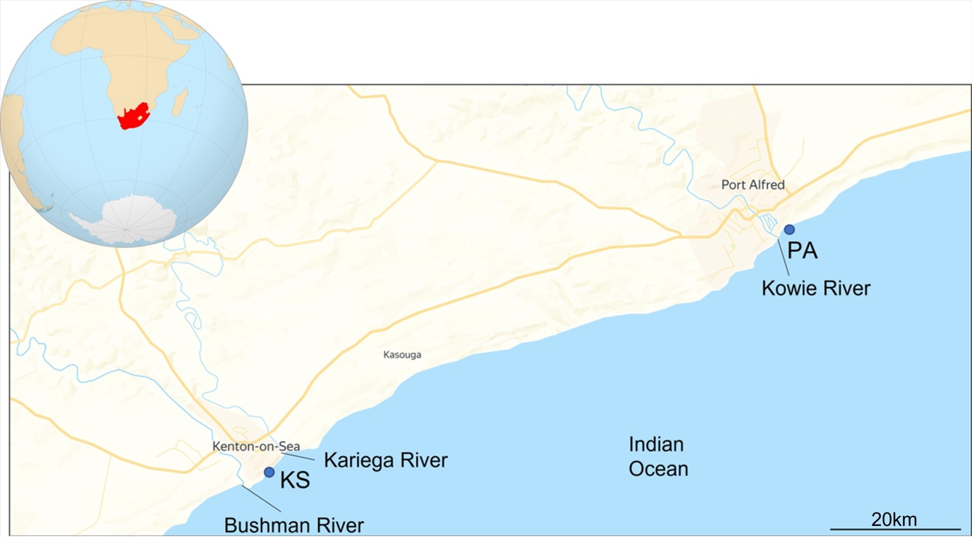
Fig. 3S. Rivers in proximity to Kenton on Sea (KS), including the Bushman River and Kariega River, and in proximity to Port Alfred (PA), featuring the Kowie River.

