Supplementary material

Detecting rare species with passive sampling tools: Optimizing the duration and frequency of sampling for benthic taxa

Kevin C. K. Ma^{1, 2}*, Christopher W. McKindsey^{1, 3}, Ladd E. Johnson¹

¹ Québec-Océan, Département de biologie, Université Laval, Québec, QC, G1V 0A6, Canada
² Department of Zoology and Entomology, Rhodes University, Grahamstown, 6139, Eastern Cape, South Africa
³ Fisheries and Oceans Canada, Institut Maurice-Lamontagne, Mont-Joli, QC, G5H 3Z4, Canada
* Corresponding author (e-mail): k.ma@ru.ac.za; kevinckma@gmail.com

Supplemental Table S1 — First day of observation of 22 benthic taxa and their optimal sampling durations (1, 2, 4, 8, 16, and 32 d) ranked according to (A) earliest day (day of plate retrieval) of species detection; (B) greatest proportion of colonized replicate plates; (C) highest density (recruits ⋅ plate^{–1}); and (D) highest rate (recruits ⋅ plate^{–1} ⋅ d^{–1}). Optimal sampling duration is bolded. Ties are shown with an equal sign (=).

Taxon | Authority | First day of observation | Ranking of sampling duration (d)
Taxon | Authority | First day of observation | (A) Earliest | (B) Least patchy | (C) Densest | (D) Highest rate
Ciliophora, Heterotrichea
Folliculina sp. | Lamarck, 1816 | July 6 | 4>1=2>9>16>32 | 4=8=16>32>2>1 | 16>8>32>4>2>1 | 8>16>4>32>1>2
Ochrophyta, Bacillariophyceae
Periphytic diatoms | — | July 2 | 1>2>4>8>16>32 | 1=2=4=8=16>32 | 8>4>16>1>2>32 | 1>2>4>8>16>32
Cnidaria, Anthozoa
Actiniaria | — | July 18 | 2=8>4=16>32 | 16>32>8=4=2 | 32>8>16>2=4 | 8>32>2=16>4
Cnidaria, Hydrozoa
Bougainvillia carolinensis | (McCrady, 1859) | July 16 | 8>16>4>32 | 4=8=16=32 | 8>4>16>32 | 4>8>16>32
Platyhelminthes, Turbellaria
Anaperus gardineri | (Graff, 1911) | July 5 | 1>2>4=8>16 | 4=8>1=2>16 | 8>4>1=2>16 | 1>2>8>4>16
Sterreria psammicola | (Sterrer, 1970) | July 12 | 8>2 | 8>2 | 8>2 | 2>8
Annelida, Polychaeta
Nereididae | Blainville, 1818 | July 16 | 8>16>32 | 32>16>8 | 32>8=16 | 32>8>16
Spionidae | Grube, 1850 | July 17 | 16>8>32 | 16=32>8 | 32>16>8 | 16>32>8
Arthropoda, Amphipoda
Gammarus sp. | Fabricius, 1775 | July 7 | 4>8>2>16>1>32 | 8>4=16>1=2=32 | 16>4>2>8>32>1 | 2>4>16>1>8>32
Mollusca, Bivalvia
Crassostrea virginica | (Gmelin, 1791) | July 20 | 1=2=4=8>16>32 | 1=2=4=8=16=32 | 8>4>16>32>2>1 | 8>4>2>1>16>32
Hiatella arctica | (Linnaeus, 1767) | July 12 | 4=8>1=2>16>32 | 4=8=16>32>2>1 | 8>16>32>4>2>1 | 8>16>1>32>2>4
Mytilus sp. | Linnaeus, 1758 | July 8 | 2>8>4>1>16>32 | 16=32>8>4>1=2 | 32>16>8>4>2>1 | 8>16>1>2>32>4
Mollusca, Gastropoda
Bittiolum alternatum | (Say, 1822) | July 19 | 2=4=8>16>1>32 | 16>8>2=4=32>1 | 32>16>8>4>2>1 | 2>16>1=8>4>32
Crepidula fornicata | (Linnaeus, 1758) | July 23 | 8>4>16 | 16>8>4 | 16>4=8 | 4>8>16
Lacuna vincta | (Montagu, 1803) | July 5 | 2>8>1>4>16>32 | 1=2=4=8=16=32 | 8>16>32>4>1>2 | 1>8>4>2>16>32
Littorina sp. | Férussac, 1822 | August 2 | 4=8=16=32 | 16=32>4=8 | 16>32>8>4 | 16>4>8>32
Tenellia fuscata | (Gould, 1870) | July 29 | 16>32 | 32>16 | 32>16 | 32>16
Echinodermata, Asteroidea
Asterias rubens | Linnaeus, 1758 | July 29 | 8=16>4>32 | 4=8=16=32 | 4=8=16=32 | 4>8>16>32
Bryozoa, Gymnolaemata
Amathia gracilis | (Leidy, 1855) | July 14 | 8>4>16>2>32 | 8=16>32>4>2 | 16>32>8>4>2 | 16>8>32>2=4
Conopeum tenuissimum | (Canu, 1908) | July 14 | 8>16>4>2>1>32 | 16=32>8>4>2>1 | 32>16>8>4>2>1 | 16>8>32>1=2=4
Crisularia turrita | (Desor, 1848) | July 18 | 8>16>4>32 | 16>8=32>4 | 16>32>4>8 | 4>16>8>32
Chordata, Ascidiacea
Botryllus schlosseri | (Pallas, 1766) | July 25 | 4=8>1=16>2>32 | 8=16>4>1=2=32 | 8>16>4>2>32>1 | 2=4=8>1>16>32
Supplemental Table S2 — Linear regressions modelled for nine benthic taxa and five plate day conditions (2, 4, 8, 16, and 32 d) on the relationship between log₁₀ (x + 0.01) transformed additive and cumulative recruitment rates. ND = no data. Statistically significant p values are bolded.

Taxon | 2-plate-days |  |  |  |  | 4-plate-days |  |  |  |  | 8-plate-days |  |  |  |  | 16-plate-days |  |  |  |  |  |  | 32-plate-days
 | slope | F _{(1,29)} | R² | p |  | slope | F _{(1,27)} | R² | p |  | slope | F _{(1,25)} | R² | p |  | slope | F _{(1,3)} | R² | p |  |  | slope |  | F | R² | p
Cnidaria, Hydrozoa
Bougainvillia carolinensis | — | — | — | ND |  | — | — | — | ND |  | 0.84 | 62.31 | 0.71 | < 0.001 |  | 0.79 | 46.83 | 0.94 | 0.006 |  |  | — |  | — | — | ND
Mollusca, Bivalvia
Crassostrea virginica | 1.08 | 230 | 0.89 | < 0.001 |  | 1.05 | 1606 | 0.98 | < 0.001 |  | 1.08 | 1172 | 0.98 | < 0.001 |  | 0.95 | 58.87 | 0.95 | 0.005 |  |  | — |  | — | — | ND
Hiatella arctica | 0.58 | 11.19 | 0.28 | 0.002 |  | 0.77 | 25.97 | 0.49 | < 0.001 |  | 0.58 | 5.99 | 0.19 | 0.022 |  | –0.32 | 0.88 | 0.23 | 0.417 |  |  | — |  | — | — | ND
Mytilus sp. | 0.50 | 14.13 | 0.33 | < 0.001 |  | 0.43 | 6.20 | 0.19 | 0.019 |  | 0.74 | 21.14 | 0.46 | < 0.001 |  | 1.16 | 3.35 | 0.53 | 0.165 |  |  | — |  | — | — | ND
Mollusca, Gastropoda
Lacuna vincta | 0.85 | 105 | 0.78 | < 0.001 |  | 1.10 | 96.66 | 0.78 | < 0.001 |  | 0.72 | 69.83 | 0.74 | < 0.001 |  | 1.82 | 32.19 | 0.91 | 0.011 |  |  | — |  | — | — | ND
Bryozoa, Gymnolaemata
Amathia gracilis | — | — | — | ND |  | –0.31 | 0.62 | 0.02 | 0.437 |  | 1.32 | 17.37 | 0.41 | < 0.001 |  | 1.99 | 368 | 0.99 | < 0.001 |  |  | — |  | — | — | ND
Conopeum tenuissimum | –0.13 | 0.21 | 0.01 | 0.651 |  | 0.48 | 5.54 | 0.17 | 0.026 |  | 0.32 | 2.22 | 0.08 | 0.149 |  | –0.32 | 0.19 | 0.06 | 0.693 |  |  | — |  | — | — | ND
Crisularia turrita | — | — | — | ND |  | — | — | — | ND |  | 0.52 | 4.86 | 0.16 | 0.037 |  | 1.09 | 23.06 | 0.88 | 0.017 |  |  | — |  | — | — | ND
Chordata, Ascidiacea
Botryllus schlosseri | 0.88 | 24.34 | 0.46 | < 0.001 |  | 1.32 | 53.75 | 0.67 | < 0.001 |  | 1.10 | 259 | 0.91 | < 0.001 |  | 0.98 | 23.80 | 0.88 | 0.016 |  |  | — |  | — | — | ND
 | slope | F _{(1,184)} | R² | p |  | slope | F _{(1,201)} | R² | p |  | slope | F _{(1,241)} | R² | p |  | slope | F _{(1,43)} | R² | p |  |  | slope |  | F _{(1,7)} | R² | p
All taxa | 0.94 | 731 | 0.80 | < 0.001 |  | 0.93 | 856 | 0.81 | < 0.001 |  | 0.92 | 663 | 0.73 | < 0.001 |  | 0.77 | 81.48 | 0.65 | < 0.001 |  |  | 0.98 |  | 25.08 | 0.78 | 0.002

Supplemental Table S3 — Logarithmic regressions modelled on the relationship between time elapsed and each of the 18 sampling strategies: a combination of sampling duration (1, 2, 4, 8, or 16 d) and frequency (1 [daily], 0.5 [every second day], 0.25 [every fourth day], or 0.125 sampling events ⋅ d^{–1} [every eighth day]). Statistically significant p values are bolded.

Duration (d) | Frequency (sampling events ⋅ d⁻¹) | Equation | F _{(df)} | R² | p
1 | 1 | y = –2.7 + 8.1 log₁₀ x | 164.5 _{(1,30)} | 0.85 | <0.001
1 | 0.5 | y = –1.7 + 6.5 log₁₀ x | 110.4 _{(1,30)} | 0.79 | <0.001
1 | 0.25 | y = –0.1 + 4.7 log₁₀ x | 69.3 _{(1,30)} | 0.70 | <0.001
1 | 0.125 | y = –1.1 + 3.5 log₁₀ x | 59.4 _{(1,30)} | 0.66 | <0.001
2 | 1 | y = –6.5 + 13.1 log₁₀ x | 269.5 _{(1,29)} | 0.90 | <0.001
2 | 0.5 | y = –4.6 + 11.0 log₁₀ x | 247.1 _{(1,29)} | 0.90 | <0.001
2 | 0.25 | y = –2.5 + 8.6 log₁₀ x | 164.9 _{(1,29)} | 0.85 | <0.001
2 | 0.125 | y = –0.02 + 5.8 log₁₀ x | 67.7 _{(1,29)} | 0.70 | <0.001
4 | 1 | y = –14.2 + 20.5 log₁₀ x | 321.4 _{(1,27)} | 0.92 | <0.001
4 | 0.5 | y = –12.2 + 18.4 log₁₀ x | 344.9 _{(1,27)} | 0.93 | <0.001
4 | 0.25 | y = –9.6 + 15.8 log₁₀ x | 197.1 _{(1,27)} | 0.88 | <0.001
4 | 0.125 | y = –5.8 + 12.6 log₁₀ x | 118.1 _{(1,27)} | 0.81 | <0.001
8 | 1 | y = –23.1 + 29.8 log₁₀ x | 755.6 _{(1,23)} | 0.97 | <0.001
8 | 0.5 | y = –20.5 + 27.4 log₁₀ x | 296.5 _{(1,23)} | 0.93 | <0.001
8 | 0.25 | y = –15.9 + 23.5 log₁₀ x | 162.0 _{(1,23)} | 0.88 | <0.001
8 | 0.125 | y = –10.1 + 19.0 log₁₀ x | 90.1 _{(1,23)} | 0.80 | <0.001
16 | 0.25 | y = –38.0 + 39.5 log₁₀ x | 27.2 _{(1,3)} | 0.90 | 0.014
16 | 0.125 | y = –19.0 + 25.7 log₁₀ x | 3.3 _{(1,3)} | 0.52 | 0.168

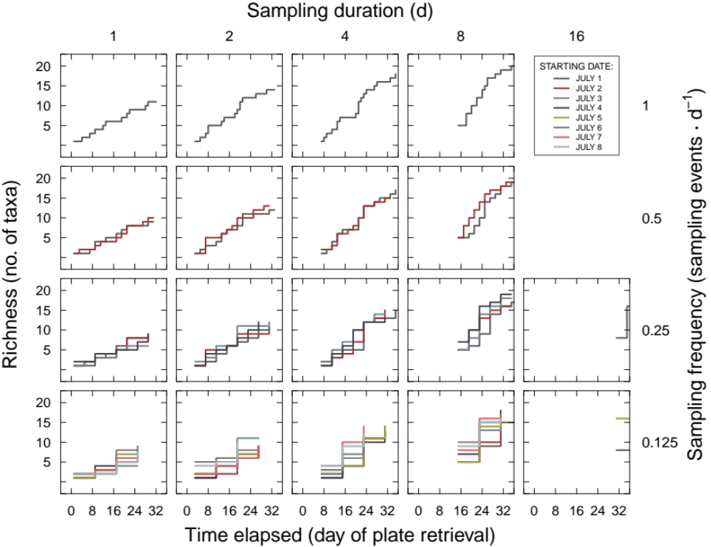

Supplemental Figure S1 — Richness as a function of time elapsed for 18 different sampling strategies, a combination of sampling duration (1, 2, 4, 8, or 16 d) and sampling frequency (1 [daily], 0.5 [every second day], 0.25 [every fourth day], or 0.125 sampling events ⋅ d^{–1} [every eighth day]).

Supplemental Figure S2 — Logarithmic regressions of richness and time elapsed for 18 different sampling strategies, a combination of sampling duration (1, 2, 4, 8, or 16 d) and sampling frequency. Frequencies: (A) 1 sampling event ⋅ d^{–1} (daily); (B) 0.5 sampling events ⋅ d^{–1} (every second day); (C) 0.25 sampling events ⋅ d^{–1} (every fourth day); (D) 0.125 sampling events ⋅ d^{–1} (every eighth day).

