Spatial and size distributions of early recruits of Cucumaria frondosa in a coastal nursery (Nunavut, Canadian Arctic)
Joséphine Pierrat^{1, *}, Kevin C. K. Ma¹, Jean-François Hamel²
and Annie Mercier¹

¹ Department of Ocean Sciences, Memorial University, St. John’s, Newfoundland and Labrador, Canada
² Society for the Exploration and Valuing of the Environment, St. Philips, Newfoundland and Labrador, Canada
* Corresponding author: jdpierrat@mun.ca

Supplementary materials
Supplementary Figure S1
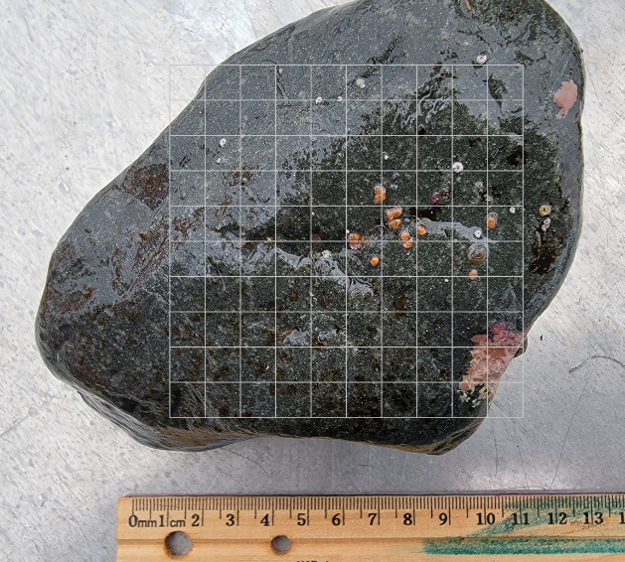
Illustration of the variance-to-mean ratio method, with a photo of a stone analysed using the superimposed 10 × 10 cm grid. The juvenile sea cucumbers (pinkish-orange) were counted in each square. Here the index of dispersion I = 1.63, meaning that the juveniles are aggregated.

Supplementary Figure S2
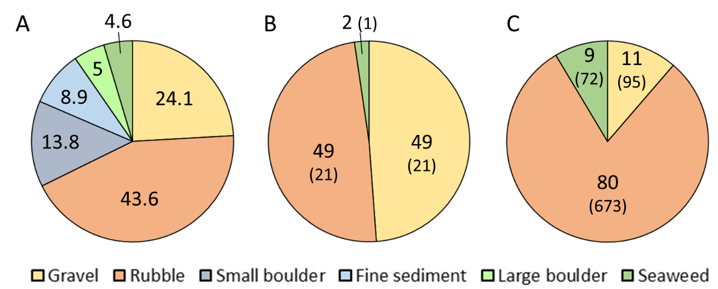
(A) Substrate composition (%) of the nursery habitat of Kataaluk (Qikiqtait, Nunavut, Canada) in October 2024: fine sediment (size <0.5 cm), gravel (>0.5‒8 cm), rubble (>8‒30 cm), small boulder (>30‒60 cm), large boulder (>60 cm) and seaweed. (B) The different stones (%) collected during the sampling with abundance of each substratum indicated in parenthesis. (C) Substratum utilisation (%) by juveniles of Cucumaria frondosa, with abundance of the juveniles on each substratum indicated in parenthesis.
Supplementary Figure S3
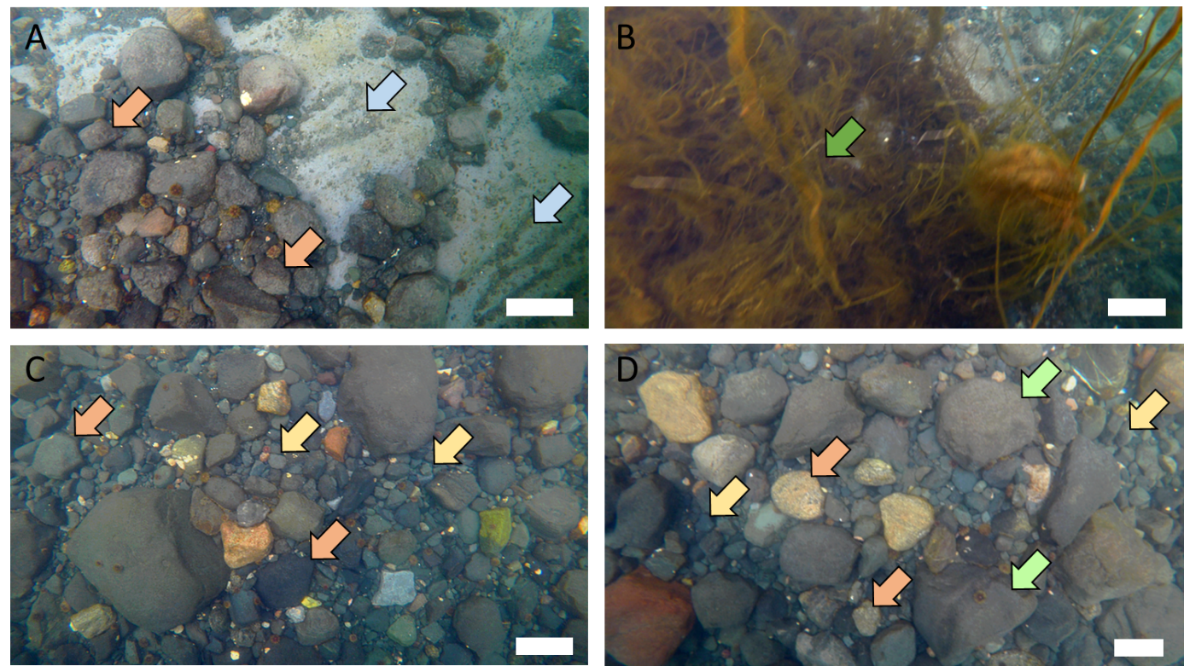
Extracted photo frames from ROV video footages at Kataaluk illustrating the different substrata found in the nursery: (A) Substratum dominated by fine sediment (<0.5 cm; light blue arrows) and rubbles (>8‒30 cm; orange arrows); (B) substratum dominated by seaweed (dark green arrow); (C) substratum dominated by gravels (>0.5‒8 cm; yellow arrows) and rubbles (orange arrows); and (D) substratum dominated by gravel (yellow arrows), rubbles (orange arrows) and small boulders (>30‒60 cm; light green arrows). Scale bars ~20 cm.
Supplementary Figure S4
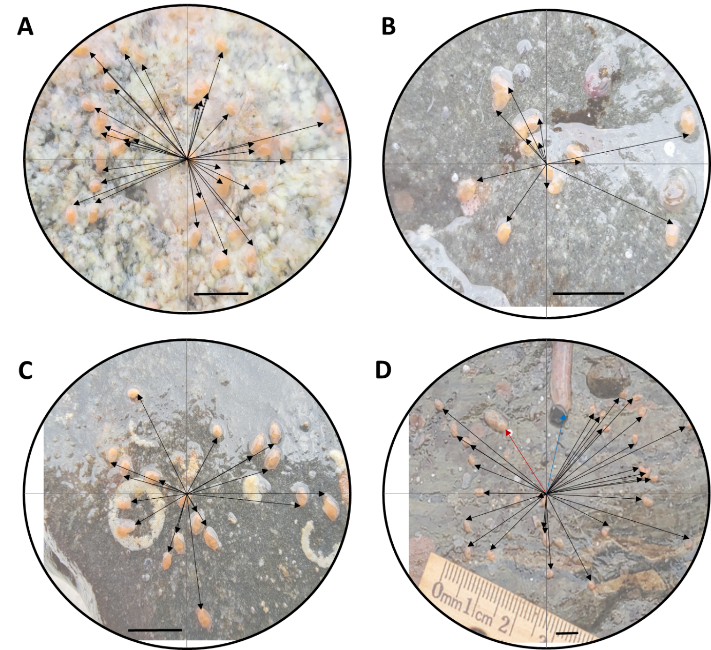
Examples of vectors of distance from a central early recruit to surrounding juveniles of Cucumaria frondosa. (A, C) Distances from early recruits found on flat surfaces of the underside of a stone; (B) distances from early recruits found in a shallow depression; and (D) distances from early recruits (black arrows), from juvenile of ˃2,000–6,000 µm (red arrow), and from juvenile >10,000 µm (blue arrow). Scale bar = 5 mm.

