Appendix: Table A1. List of 16 sites from range edge to range centre that were surveyed for Mytilus galloprovincialis on the rocky shore between 10 December 2019 and 16 November 2020; quadrat size: 25 × 25 cm.
Site number | Site name | Estimated distance from warm-edge range limit (km) | Number of quadrats | Total search time (minutes) | Number of mussels collected
1 | Tenza Beach | 0 | — | 136 | 1
2 | Mazeppa Bay | 17.0 | — | 118 | 2
3 | Seagulls | 50.0 | — | 138 | 2
4 | Kei Mouth | 57.0 | — | 209 | 19
5 | Morgans Bay | 63.5 | — | 158 | 21
6 | Haga Haga | 74.5 | — | 136 | 21
7 | Cintsa West | 91.5 | — | 44 | 3
8 | Glen Gariff | 99.0 | — | 204 | 33
9 | Kidd’s Beach | 153.0 | — | 171 | 170
10 | Hamburg | 180.5 | — | 58 | 291
11 | Old Woman’s River | 220.0 | 12 | — | 125
12 | Cannon Rocks | 288.5 | 6 | — | 214
13 | Schoenmakerskop | 430.5 | 3 | — | 513
14 | St Francisbaai | 513.0 | 3 | — | 720
15 | Nature’s Valley | 661.5 | 9 | — | 1078
16 | Mosselbaai | 846.5 | 9 | — | 899

Appendix: Table A2. Determination of mean effective shore levels (ESLs) ± one standard deviation (SD) based on sudden drops in temperature for five sites where submersible temperature data loggers were installed and the nearest maritime port associated with tidal predictions; ESLs were estimated using a modified method, which gradually raised the threshold until at least 10 drops were detected for a given site.
Data logger site | Nearest maritime port | Distance to  port (km) | Threshold  (°C·hr^{–1}) | No. of  sudden drops | Mean  ESL (m) | ± SD  ESL (m)
Port Edward | Durban | 154.5 | –3.9 | 11 | 1.200 | 0.383
Port Saint Johns | Durban | 246.1 | –9.7 | 11 | 1.260 | 0.137
Old Woman’s River | East London | 86.0 | –16.5 | 54 | 1.200 | 0.165
Nature’s Valley | Knysna | 49.4 | –16.5 | 12 | 0.943 | 0.143
Mosselbaai | Mosselbaai | 1.4 | –11.0 | 11 | 0.957 | 0.228

Appendix: Table A3. Results of post hoc two-component conditional model using the binomial error distribution and the logit link function on presence and absence data for the first component and the Poisson error distribution and the log link function on zero-truncated data for the second component to examine the relationship between shell length of Mytilus galloprovincialis (for a subset of data after removing shells that were > 4.0 cm in length) and the abundance of Chthamalus dentatus (barnacle) epibionts on mussel shells and, to compensate for surface area of shells, the relationship between shell length and the estimated densities of C. dentatus epibionts on shells; SE = standard error; statistically significant p values are in bold that have been adjusted using the Bonferroni correction to the alpha level of 0.025 because there are two ecological comparisons on the same data; df = degrees of freedom.
Component | Dependent variable | Source | Estimate | SE | test statistic (z) | p
First | Presence and absence of epibionts on shells | (intercept) | –5.28104 | 0.18578 | –28.43 | < 0.001
 | Presence and absence of epibionts on shells | Shell length | 1.58155 | 0.07126 | 22.20 | < 0.001
 |  | Null deviance | 3515.2 on 4061 df
 |  | Residual deviance | 2837.6 on 4060 df
 |  | Deviance explained | 0.19
Second | Zero-truncated abundance of epibionts on shells | (intercept) | –0.96128 | 0.10177 | –9.45 | < 0.001
 | Zero-truncated abundance of epibionts on shells | Shell length | 0.86993 | 0.03348 | 25.98 | < 0.001
 |  | Null deviance | 3736.1 on 632 df
 |  | Residual deviance | 3025.7 on 631 df
 |  | Deviance explained | 0.19
Second | Zero-truncated estimated densities of epibionts on shells | (intercept) | –1.04523 | 0.23511 | –4.45 | < 0.001
 | Zero-truncated estimated densities of epibionts on shells | Shell length | 0.23845 | 0.08272 | 2.88 | 0.004
 |  | Null deviance | 442.6 on 632 df
 |  | Residual deviance | 434.3 on 631 df
 |  | Deviance explained | 0.02

Appendix: Table A4. R script to estimate temperature thresholds and calculate effective shore levels (ESLs). Data associated with this script can be found archived in Dryad (https://doi.org/10.5061/dryad.h70rxwdmn).
#### The esl() function to estimate temperature thresholds and calculate effective shore levels ####

## START ##

esl <- function(temperatures, tide, thresholds, drops){

timestep <- median(diff(as.numeric(as.POSIXct(temperatures$datetime)))/60) # To calculate the time step of temperature data in minutes

if(timestep>60){print("CAUTION: the temporal resolution of temperature data is probably to coarse.")} # Suggestion to exclude temperature data if the temporal resolution is coarser than an hour

# Initialization

dropcounter <- 0 # To set zero drops before starting the screening
trythreshold <- 1 # A counter for the while loop (i.e., to try every threshold one by one)
print("Screening temperature thresholds...")
pb <- txtProgressBar(min=1, max=length(thresholds), initial=1) # To show the progression of the screening (it will stop before 100% if a solution is found)

# Screening

while(dropcounter<=drops & trythreshold<length(thresholds)+1){ # To screen until at least a number of 'sudden drops' is identified or until all potential thresholds are tested

threshold <- thresholds[trythreshold] # To select temperature threshold
ESLs <- NULL # To contain all effective shore levels if a suitable threshold is found
droptimes <- NULL # To contain the dates and times when sudden drops in temperature (during incoming tides) occurred
for(i in seq_along(unique(temperatures$logger))){ # To look for sudden drops in each logger's data

data <- temperatures[which(temperatures$logger==unique(temperatures$logger)[i]),] # To retrieve data for logger i
selecteddrops <- which(diff(data$temperature)<=-threshold) # To compute the difference between temperatures x+1 and x and to select the ones (if any) that are = or > to the magnitude of the threshold
if(any(selecteddrops)){ # To calculate effective shore levels if some drops are found

time <- data$datetime[selecteddrops+1] # To select the time when sudden drops occurred
for(t in seq_along(time)){ # To retrieve the closest tidal level for each sudden drop that is identified and to test if it occurred during an rising (incoming) tide

pos <- which.min(abs(as.numeric(as.POSIXct(time[t], tz="GMT0"))-as.numeric(as.POSIXct(tide$datetime, tz="GMT0")))) # To identify the position of the closest tidal level
risingtide <- tide$level[pos+1]-tide$level[pos] # Values are positive for rising (incoming) tides and negative for falling (outgoing) tides
if(risingtide>0){ # To keep the tidal level and the date and time when the drop in temperature occurred if the tide is rising (i.e., an incoming tide)

ESLs <- c(ESLs, tide$level[pos])
droptimes <- c(droptimes, time[t])
}
}
}
}

dropcounter <- length(ESLs) # To get the number of drops found during this cycle of the while loop
trythreshold <- trythreshold+1 # To add one to the counter (i.e., to go to the next cycle of the while loop)
setTxtProgressBar(pb,trythreshold) # To set the progress bar
}

close(pb) # To close the progress bar
if(dropcounter>=drops){ # To print and return the results if a suitable threshold is found

print(paste0("THRESHOLD FOUND: -", threshold, " DegC in ", timestep, " minutes (with ", length(ESLs), " drops counted).")) # To display the results
results <- list(-threshold, ESLs, droptimes) # To select the threshold and the vector containing effective shore levels
names(results) <- c("Threshold", "Effective Shore Levels", "Drops' date and time") # To label the list's components
return(results) # To return the results
}else{

print("WARNING: no threshold was found...")
print("Perhaps try again with a lower minimum number of drops or thresholds closer to zero.")
}
}

## END ##

#### The exposure() function to distinguish between emersed and immersed values ####

## START ##

exposure <- function(temperatures, tide, ESL, buffer){

assigned <- NULL # This will contain a data.frame with loggers' data and 2 additional columns: one (labeled 'tidelevel') that will contain tidal levels and another one (labeled 'exposure') that will contain emersed, immersed, or uncertain values.
loggers <- unique(temperatures$logger) # To identity each logger
tide$datetime <- as.POSIXct(tide$datetime, tz="GMT0") # To convert from character to POSIXct format
for(i in seq_along(loggers)){ # To merge emersion and immersion values for each logger

data <- cbind(temperatures[temperatures$logger==loggers[i],], data.frame(tidelevel=NA, exposure=NA)) # To add 2 columns: 'tidelevel' (to merged tidal level with temperature data), 'exposure' (whether temperatures occurred during emersion or immersion or uncertain)
timestep <- diff(as.numeric(as.POSIXct(data$datetime)))[1] # To calculate the time step of temperature data in seconds
breaks <- as.POSIXct(data$datetime, tz="GMT0") # To match dates in order to merge with tidal levels
breaks <- as.POSIXct(c(as.character(breaks), as.character(tail(breaks, n=1)+timestep)), tz="GMT0") # To add another one so that the 'aggregate' function does not return a NA at the tail of the time series
aggregatedtide <- aggregate(level~cut(datetime, breaks=breaks), data=tide, FUN=mean) # To calculate the mean tidal level within the logger's temporal resolution
data$tidelevel <- aggregatedtide$level[match(data$datetime, as.character(aggregatedtide[,1]))] # To merge aggregated tidal levels with temperature data
data$exposure[which(data$tidelevel<=(ESL-buffer))] <- "emersed" # To identify emersed temperature values, i.e., condition when tidal levels are lower than (or equal to) the lower limit of the buffer zone
data$exposure[which(data$tidelevel>=(ESL+buffer))] <- "immersed" # To identify immersed temperature values, i.e., condition when tidal levels are higher than (or equal to) the upper limit of the buffer zone
data$exposure[which(data$tidelevel>(ESL-buffer) & data$tidelevel<ESL)] <- "uncertain (likely emersed)" # To identify uncertain temperature values (but likely emersed) when tidal levels are lower than the mean effective shore level but higher than the lower limit of the buffer zone
data$exposure[which(data$tidelevel<(ESL+buffer) & data$tidelevel>ESL)] <- "uncertain (likely immersed)" # To identify uncertain temperature values (but likely immersed) when tidal levels are higher than the mean effective shore level but lower than the upper limit of the buffer zone
data$exposure[which(data$tidelevel==ESL)] <- "uncertain" # To identify uncertain temperature values when tidal levels are equal to the mean effective shore level
assigned <- rbind(assigned, data) # To arrange results of each logger end to end
}

return(assigned) # To return the results
}

## END ###

#### Example of how to use the esl() and the exposure() functions with a description of the required input data and the function's parameters ####

path <- getwd() # The user must specify its directory here

## Input data

site <- "OWR" # The site for which data will be imported. In this example, it could be MB (Mosselbaai), NV (Natures Valley), OWR (Old Woman's River), PSJ (Port Saint Johns), or PE (Port Edward).

# To load the data
load(file.path(path, "material.RData"))
temperatures <- temperature_data # To import all temperature data
temperatures <- temperatures[temperatures$code==site,] # To select temperature data for the specified site
tide <- tide_data # To import all tidal data
tide <- tide[tide$code==site,] # To select tidal data for the specified site

head(temperatures)
# 'temperatures' is a data frame with at least 3 columns that must be labeled as follows: 'datetime' (yyyy-mm-dd HH:MM:SS), 'temperature' (in degree Celsius), 'logger' (logger's label)
# It contains temperature time series of each logger placed end to end
# Ensure that the time step is continuous and the time zone is the same as in 'tide'

head(tide)
# 'tide' is a data frame with at least 2 columns that must be labeled as follows: 'datetime' (yyyy-mm-dd HH:MM:SS), 'level' (in metres)
# It contains tidal levels at the study site (ideally) or from the closest port
# Ensure that the time zone is the same as in 'temperatures'
# Ensure that the temporal resolution is the same as (or ideally finer than) the one in 'temperatures'

## Parameters for the esl() function

thresholds <- seq(16.5, 0.1, by=-0.1) # To select the range of thresholds to be screened (here from -16.5 to -0.1 degree Celsius per hour every 0.1 degrees)
drops <- 10 # To select the minimum number of drops in temperature that the threshold must be able to determine

## To run the esl() function

results <- esl(temperatures=temperatures, tide=tide, thresholds=thresholds, drops=drops)
# esl() returns a list with three components: 'Threshold' (the threshold found), 'Effective Shore Levels' (a vector containing tidal levels observed when sudden drops in temperature occurred), and 'Drops' date and time' (a vector containing the dates and times when the sudden drops in temperature occurred).

## To extract the outputs

threshold <- results[["Threshold"]]
drops_datetime <- results[["Drops' date and time"]]
ESLs <- results[["Effective Shore Levels"]]
ESL_mean <- mean(ESLs)
ESL_sd <- sd(ESLs)
ESL_n <- length(ESLs)

## Parameters for the exposure() function

ESL <- ESL_mean # Mean effective shore level (in metres) to distinguish between emersed and immersed (or uncertain) values
buffer <- ESL_sd # Buffer zone (in metres) to identify uncertain values (i.e., uncertain if tidal levels = ESL, uncertain but likely emersed if tidal levels > ESL-buffer & tidal levels < ESL, uncertain but likely immersed if tidal levels < ESL+buffer & tidal levels > ESL)

## To run the exposure() function

results <- exposure(temperatures=temperatures, tide=tide, ESL=ESL, buffer=buffer) # exposure() returns a data.frame with loggers' data and 2 additional columns: one (labeled 'tidelevel') that contains tidal levels and another one (labeled 'exposure') that contains emersed, immersed, or uncertain values. Uncertain values are subdivided in 3 categories (see description of the 'buffer' parameter for details): uncertain, uncertain (likely emersed), and uncertain (likely immersed).

## To extract the outputs

temperatures_emersed <- results[results$exposure=="emersed",]
temperatures_immersed <- results[results$exposure=="immersed",]
temperatures_uncertain <- results[which(results$exposure=="uncertain (likely immersed)" | results$exposure=="uncertain (likely emersed)" | results$exposure=="uncertain"),]
temperatures_withoutuncertainties <- results[which(results$exposure=="emersed" | results$exposure=="immersed"),]

Appendix: Figure A1. Barnacle epibionts on shells of M. galloprovincialis: (a) Amphibalanus amphitrite; (b) Chthamalus dentatus; (c) Octomeris angulosa; (d) Tetraclita serrata surrounded by C. dentatus; photographs by KCKM.
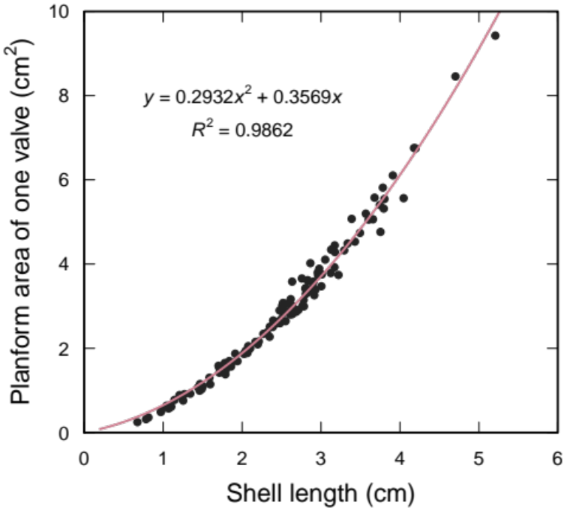
Appendix: Figure A2. Relationship between length and planform area of Mytilus galloprovincialis shells from the balanoid zone of intertidal rocky shores along the south coast of South Africa; solid pink line = quadratic function with the intercept set to zero fitted to the data; shell lengths ranged from 0.674 to 5.208 cm (n = 125 valves).

Appendix: Figure A3. Temperature data from loggers deployed on the rocky shores in the vicinity of mussel beds: (a) South African distribution of the five sites where loggers were deployed in relation to the 16 sites where Mytilus galloprovincialis were detected; (b) local regression (LOESS, 15% smoothing span) on immersed temperature data from each of the five sites; (c) mean monthly immersed temperature (± one standard deviation for data from loggers) in February 2020 (austral summer) and August 2020 (austral winter) from each of the five sites and interpolated inshore temperature data extracted from the literature, i.e., Smit et al. (2013), for the corresponding months of February and August; PE = Port Edward (subtropical waters); PSJ = Port Saint Johns (subtropical waters); OWR = Old Woman’s River (warm temperate waters); NV = Nature’s Valley (warm temperate waters); MB = Mosselbaai (warm temperate waters).
Appendix: Figure A4. Temperature data from loggers deployed on the rocky shores in the vicinity of mussel beds (points) and local regression (LOESS, 15% smoothing span) on the data (lines) under emersed and immersed conditions for the five South African sites where loggers were deployed: (a) Port Edward (n = 1 logger); (b) Port Saint Johns (n = 2 loggers); (c) Old Woman’s River (n = 3 loggers); (d) Nature’s Valley (n = 3 loggers); (e) Mosselbaai (n = 3 loggers); (f) mean annual immersed temperature (± one standard deviation) for each of the 12 loggers; PE = Port Edward (subtropical waters); PSJ = Port Saint Johns (subtropical waters); OWR = Old Woman’s River (warm temperate waters); NV = Nature’s Valley (warm temperate waters); MB = Mosselbaai (warm temperate waters).

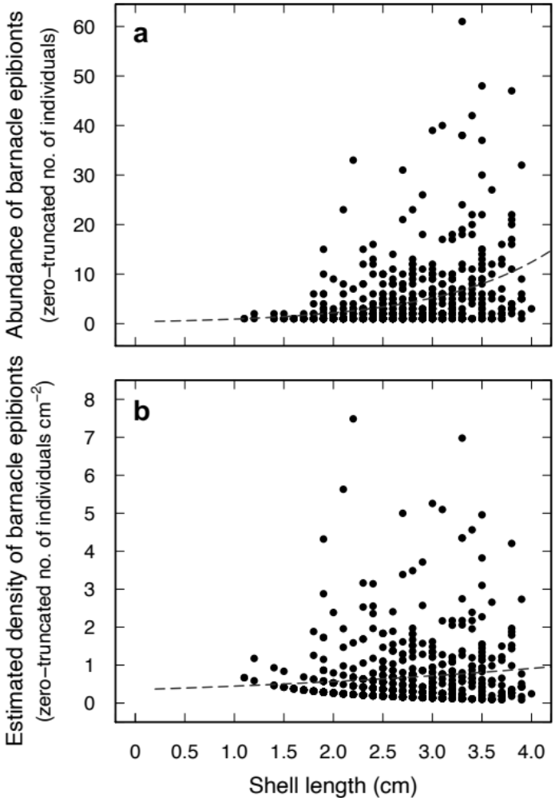
Appendix: Figure A5. Relationships (a) between shell length of Mytilus galloprovincialis (for a subset of data after removing shells that were > 4.0 cm in length) and zero-truncated abundance of Chthamalus dentatus (barnacle) epibionts on mussel shells and (b) between shell length of M. galloprovincialis (> 4.0 cm in length) and zero-truncated estimated densities of C. dentatus epibionts on shells; dashed line = predicted values of the second component of the post hoc two-component conditional model (i.e., generalised linear model using the Poisson error distribution and the log link function).

