Supplementary material

Larval supply is a limited determinant of settlement at mesoscales across an anthropogenic seascape

Kevin C. K. Ma^{1,2}*, Christopher W. McKindsey³, Ladd E. Johnson¹

¹Québec-Océan, Département de biologie, Université Laval, Québec, QC, G1V 0A6, Canada
²Department of Zoology and Entomology, Rhodes University, Grahamstown, 6139, Eastern Cape, South Africa
³Pêches et Océans Canada, Institut Maurice-Lamontagne, Mont-Joli, QC, G5H 3Z4, Canada
Author e-mails: k.ma@ru.ac.za (KCKM), chris.mckindsey@dfo-mpo.gc.ca (CWM), ladd.johnson@bio.ulaval.ca (LEJ)
*Corresponding author

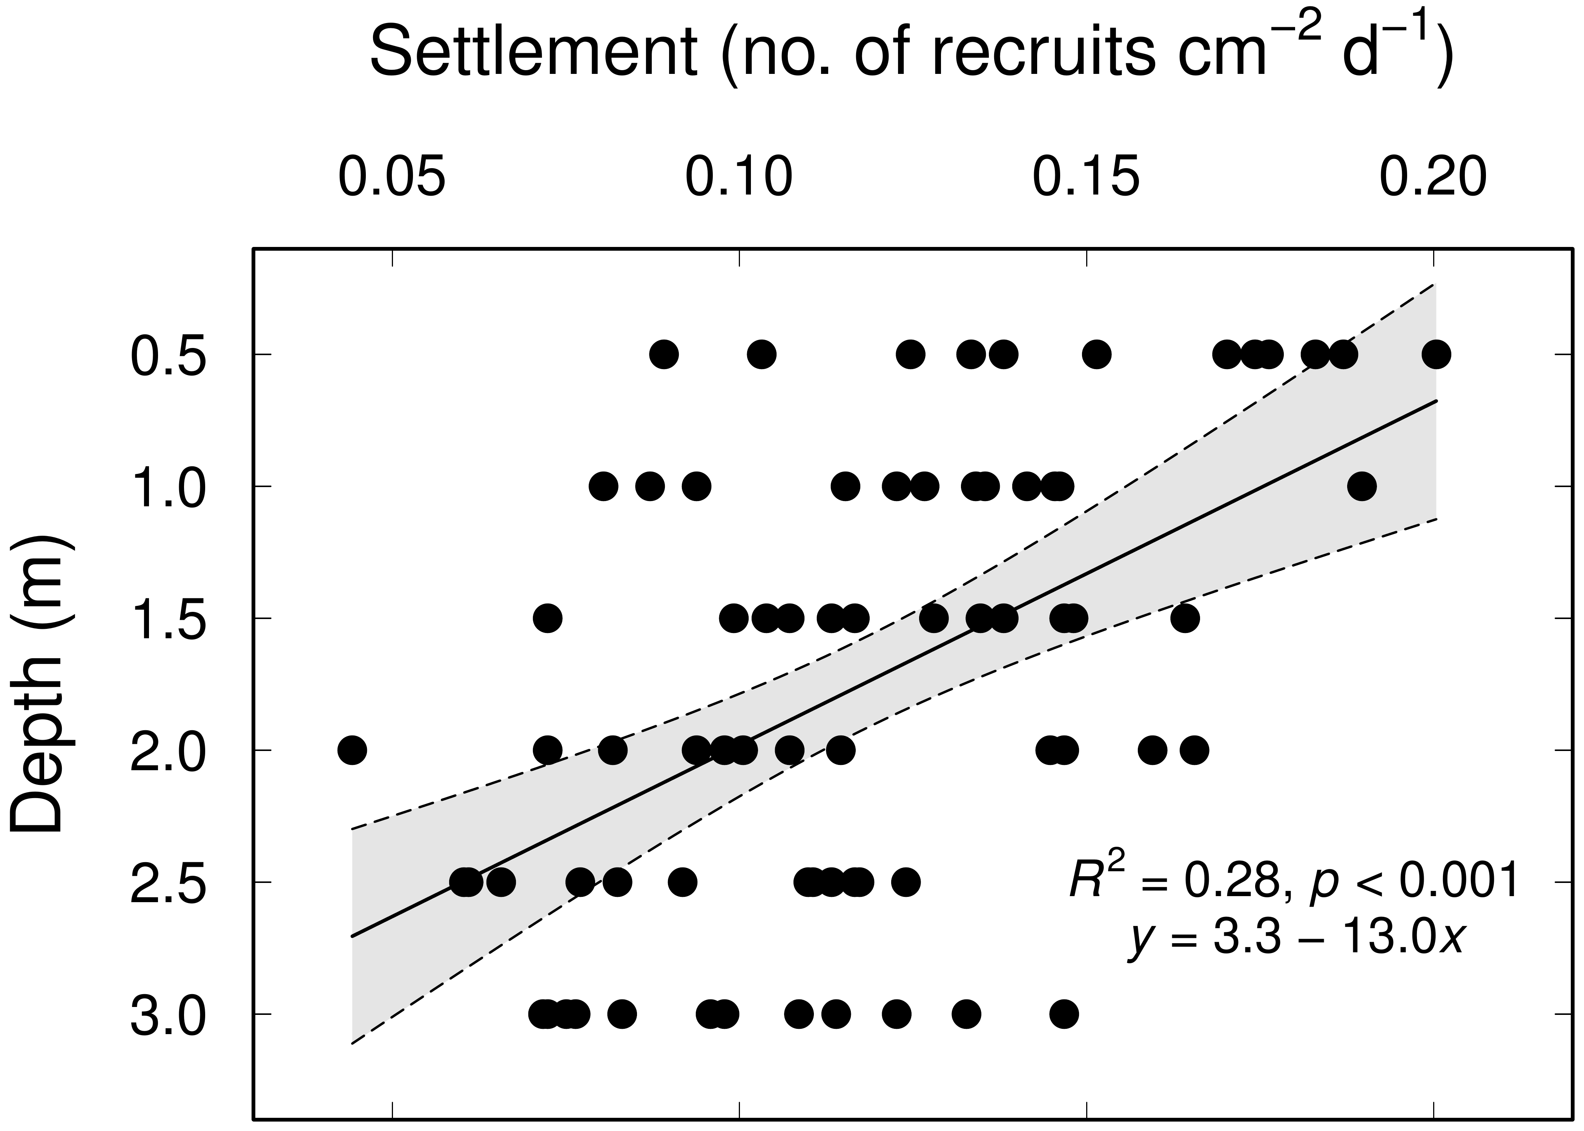

Supplemental Fig. S1 Vertical distribution of Botryllus schlosseri settlement at six depths; solid line = linear regression (N = 72); dashed line = 95% confidence limits of the linear regression

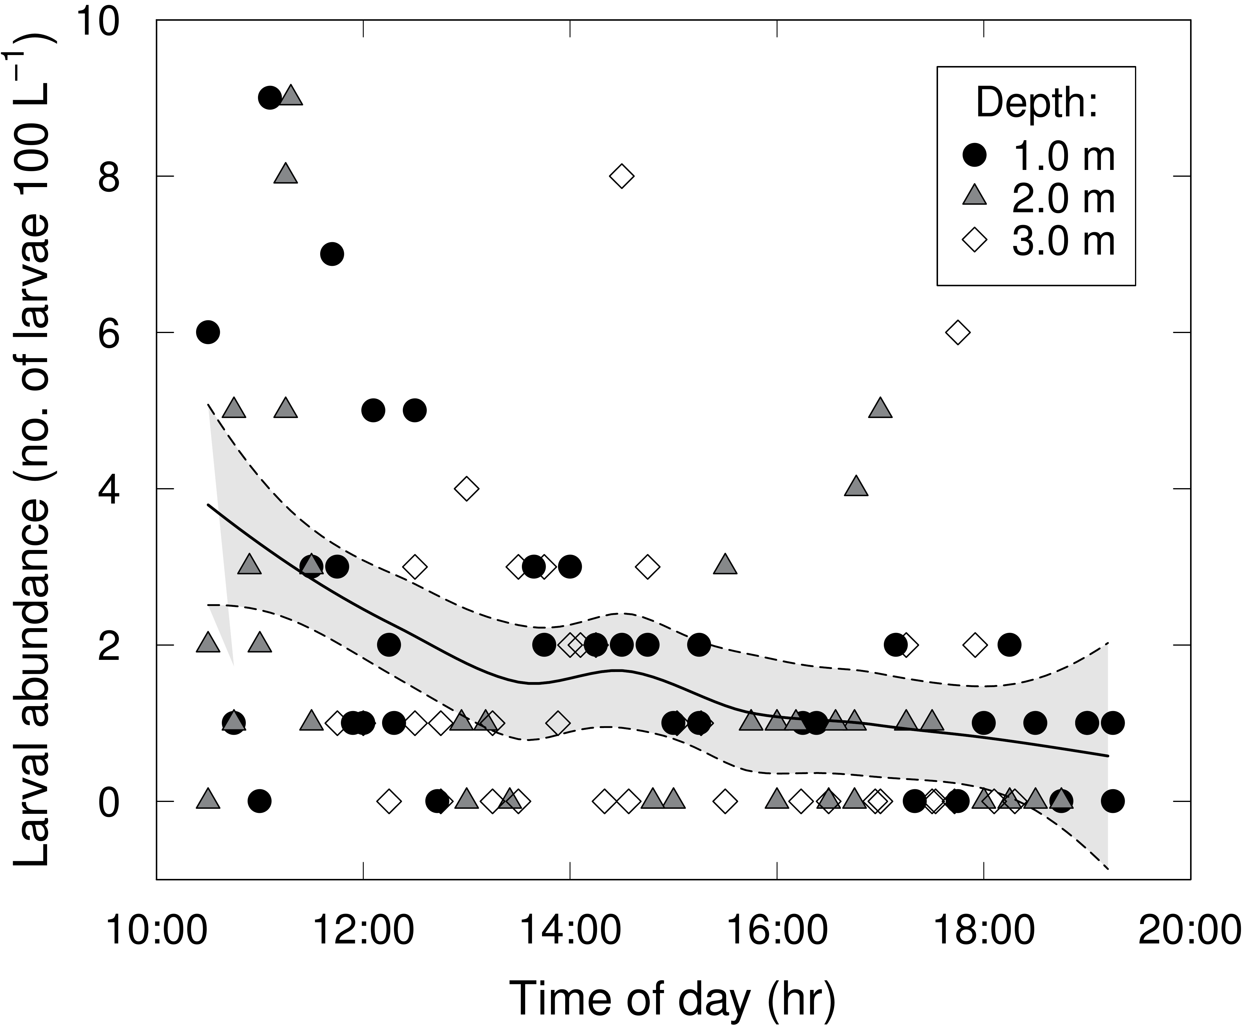

Supplemental Fig. S2 Botryllus schlosseri larval abundance as a function of time of day; solid line = local regression (LOESS, span = 0.7) curve to show temporal trends in larval abundance (data pooled from all three depths and from all three consecutive days of sampling; n = 108); dashed line = 95% confidence limits of the LOESS curve

Supplemental Fig. S3 Botryllus schlosseri larval abundance as a function of time of day for different days (Day 1, 2, and 3) and for different depths (1.0 m, 2.0 m, 3.0 m, and all depths); solid line = local regression (LOESS, span = 0.7) curve to show temporal trends in larval abundance

Supplemental Fig. S4 Horizontal distributions of (a) depth‑corrected settlement rates, (b) larval abundance (mean over three days), and (c) adult colonies (semi-quantitative values of percent cover on surveyed dock structures and berthed boats) of Botryllus schlosseri inside the Ben Eoin Marina, Nova Scotia, Canada. (a) n = 72 sampling stations (＋); (b) n = 36 sampling stations (＋); (c) n = 20 dock sections (＋); n = 20 recreational boats (○)

