**PRISONS REGISTRATION SYSTEM**

**(A Case Study of Shimo la Tewa Prison, Mombasa)**

**MOSES KIBUGA**

**BIT-1-7102-1/2015**

A PROJECT PROPOSAL SUBMITTED TO THE INSTITUTE OF COMPUTING AND INFORMATICS FOR THE PARTIAL FULFILMENT OF THE REQUIREMENT FOR THE AWARD OF DEGREE OF BACHELOR OF BUSINESS INFORMATION TECHNOLOGY OF KENYA METHODIST UNIVERSITY

**November, 20****20**

# DECLARATION

I declare that this is my own original work and has not been submitted in any other institution of higher learning for academic or any other purpose.

**NAME**: MOSES KIBUGA **REG NO**: BIT-1-7102/2015 SIGN……………

This project has been submitted for examination with my approval as University supervisor

**LECTURER**: MR. JOEL CHARO **SIGN**…………………………….

# DEDICATION

To my Dad Samuel Thirata, my Mum Esther Thirata, my siblings Douglas and Sally.

# ACKNOWLEDGEMENT

Much regards first, to the almighty God for the good health, guidance and sustenance. I would also like to thank my dear parents and generous friends for their tireless support throughout my course and seeing to it that my project is a success. I am grateful to my project Supervisor Dr.Mvurya Mgala for his unending support, prowess and cooperation during the entire project development.

# ABSTRACT

The main objective of this study is to develop a Sacco society transaction system. The transaction system comprises of a web based mobile application that will enable Sacco members to access services offered by the Sacco society and the web based interface where the admin can approve of the transaction/ services that a member request for. This services are; new member registration, loan application, erroneous deduction refund application, spouse and next of kin nomination, share variation deduction application and withdrawal from Sacco application. The study is based on the existing problem of how Sacco members consume a lot of time and money to travel from different parts of the country to come fill up forms for different services application. Sometimes, the application is processed and it turns out that the member doesn’t qualify. For instance a normal loan application takes a span of two weeks to complete processing. If at the end of these two weeks the member is not qualified for the loan, then it becomes devastating for the member to come back to apply afresh. Adoption of this proposed Sacco mobile application will ensure that members can apply for any Sacco service at the convenience of their mobility provided they have a smartphone that is connected to a network. The methodology that will be used in solving this problem is the Rapid Application Development methodology. The methodology best suits this problem since deliverables will be made in prototypes and several new changes can be easily accommodated by the system. Java, PHP, MySQL programming languages incorporating JavaScript scripting language will be used to develop this application. The expected results of this study is to have a working online Sacco society mobile application that will enable the Sacco to offer services over the mobile application while enabling customers to get products ,through the internet. I recommend that in future all services of the Sacco to be automated in that they can even offer online cheque in the mobile application

# TABLE OF CONTENTS

DECLARATION ii

DEDICATION iii

ACKNOWLEDGEMENT iv

ABSTRACT v

TABLE OF CONTENTS vi

LIST OF FIGURES AND TABLES viii

CHAPTER ONE 1

INTRODUCTION 1

1.0 Introduction 1

Background of the study 1

1.2 Statement of the research problem 2

1.3 Objectives 3

1.3.1 General objectives 3

1.3.2 Specific objectives 3

1.4 Justification 3

1.5 Significance of the Study 4

1.6 Scope of the study 4

1.7 Target Users 5

CHAPTER TWO 6

LITERATURE REVIEW 6

2.0 Introduction 6

2.1 Theoretical Review 6

2.2 System review 7

2.2.1 Case study of Msacco+ 7

2.2.2 Case study of Hazina Sacco 9

2.2.3 Case study of Stima.sacco.com 10

2.3 System Critique 11

2.3.1 Case study of MSacco+ 11

2.3.2 Case study of Hazina Sacco 11

2.3.3 Case study of Stima Sacco 12

2.4 Conclusion 12

CHAPTER THREE: RESEARCH METHODOLOGY 13

3.1 Introduction 13

3.2 System Design 13

3.2.1 System development methodology 13

3.3 Justification of the Methodology to be used 15

3.4 Fact Finding Approach 16

3.4.1 Interviews 17

3.4.2 Questionnaires 17

3.4.3 Observations 17

3.5 Research Design 17

3.6 Requirement Analysis 18

3.6.1 Functional requirement 18

3.6.2 Nonfunctional requirements. 18

3.7 Logical Design 19

3.7.1 Use Case diagrams 19

3.7.2 Activity Diagrams 20

3.8 Specific platforms 21

3.8.1 Device requirements 21

References 21

APPENDICES 22

# LIST OF FIGURES AND TABLES

**Figure 2.1** Msacco+ mobile application welcome page………………………………………….8

**Figure 2.2** Hazina sacco webpage interface……………………………………………………...9

**Figure 2.3** Stima sacco webpage interface……………………………………………………...10

**Figure 3.1** RAD development approach………………………………………………………...14

**Figure 3.2** Use case Diagram……………………………………………………………………19

**Figure 3.3** Activity diagram for member………………………………………………………. 20

**Figure 3.4** Sacco member sequence diagram……………………………………………………21

**Table 3.1** Project schedule………………………………………………………………………23

**Table 3.2** Project proposal budget………………………………………………………………24

# CHAPTER ONE

INTRODUCTION

## **1.0 Introduction**

This chapter lays its basis on the background of the study, problem statement, and the purpose of the study, research objective and research questions, significance of the study, justification of the study, the scope and the conceptual framework. Over years, people have been consuming a lot of time and money travelling from different parts of the country to the Sacco offices to be able to access Sacco services. They also stand on long queues at the cashier to be able to access these services. For years since the evolution of technology, milestones have been made in the banking sector to try and solve these problems. All in all the software and applications developed have not been able to fully incorporate solutions to the Sacco. This is yet to change hence, having the need of an Sacco society transaction system.

Background of the study

A SACCO is an acronym for Savings and Credit Cooperative Organizations. It is owned, governed and managed by its members who have the same common bond: they may be working for the same employer, belonging to the same church, labour union, social fraternity or living/working in the same community. The operations of a Sacco are similar to those of a bank. The difference is the management and the group of people it serve. The first Sacco in the world the pioneer of modern cooperation was started in 1840s and its second generation in 1860s (Mwakajumilo, 2013). In Africa saccos were introduced in 1955 in Ghana (Mwakajumilo, 2013).51013 credit unions in the world exist having a total of 196,498,738 members and a penetration rate of 7.8% penetration rate is calculated by dividing the total number of saccos members by the economically active population (WOCCU, 2012)**.**In Africa, Kenya to be precise, the number as per December 31st 2011 total sacco members were 4,183,220 (WOCCU, 2012)Such a great number of users is not to be ignored. Over years and still to this day, we see long queues of people in saccos who want to be served. Services offered in saccos include saving, applicatiions for loans, buying shares, withdrawal services, among others. Saccos have always been a highly information intensive activity that should rely heavily on information technology (IT) to acquire information, and deliver services to all its relevant members. IT is not only critical in the processing information; it provides a way for the saccos to differentiate their products and service in the market. Therefore, it is needed for Sacco’s to adapt, constantly innovate and update their information technology to retain their demanding and discerning customers. This is to ensure that they can provide convenient, reliable and expedients services and to also capture a larger share of the banking market (Subramanian, 2011). The benefits of e-commerce include reduction in cost, increasing business opportunities, reducing lead time and providing a more personalized service to the consumers (Turban, 2008). This is what all Sacco’s should aim to achieve.

## 1.2 Statement of the research problem

Over years Sacco members consume a lot of time and money to travel from different parts of the country to come fill up forms for different services application. Sometimes, the application is processed and it turns out that the member doesn’t qualify. For instance a normal loan application takes a span of two weeks to complete processing. If at the end of these two weeks the member is not qualified for the loan, then it becomes devastating for the member to travel back to the premises for reapplication.

* 1. Objectives

### **1.3.1 General objectives**

To develop a Sacco transaction system that will enable members of the Sacco society to request services offered by the Sacco from a mobile application on their phones and enable system administrator to receive their request and approve of them.

### **1.3.2 Specific objectives**

1. To gather requirements of the system for Magereza Sacco.
2. To design a web based mobile application that will enable member of the Sacco society to access services offered by the Sacco on their mobile phones.
3. To design a web based interface for admin to approve members’ request.
4. To develop the mobile application.
5. To develop the web based interface.
6. To test the transaction system with some Sacco staff.

## 1.4 **Justification**

Currently in the world of IT, integration of organizations’ processes and activities with the internet leading to the term online, has been the emerging trend. Ease of access and convenience associated with accessing services, meeting the concerned entities of an activity, gaining feedback as well as conducting researches and surveys has led to a diversified use of the online based systems, where hand held gadgets e.g. mobile phones, iPad and iPhone can be utilized to supplement laptops and desktops in accessing the online-based systems which remotely run and access integrated organizations’ activities. . People carry their hand held gadgets almost everywhere they go. It then becomes convenient if they can be able to access Sacco services and do transactions at the convenience of their mobility. This will solve the problem of having to travel, line up at the Sacco premises, and consume a lot of time to fill up the forms to be able to access services. Developing a Sacco transaction system will ensure that anytime ones is in need of any service from the Sacco for example a loan, they can apply for it over phone and the application is processed real time.

## 1.5 Significance of the Study

This study is of great significance in ensuring timeliness, effectiveness and efficiency of accessing the Sacco services. The Sacco society will immeasurably benefit from the development of the system, the cost of the form papers, the wear and tear factor of the papers and having a lot of people lining at the Sacco premises will be done away with through embracing of this system. The customers will also benefit a big deal in that they will save the time and money they would have used to go to the Sacco premises to access the services.

## 1.6 Scope of the study

This study aims in having a Sacco society transaction system that will enable members to access services online. The same study will also ensure that the members request are received and processed in appropriate time. The data from the members’ application will be going to the system database and this data can be auto generated or generated by the system administrator and help in decision making and improving quality of services offered.

## 1.7 Target Users

The proposed Magereza Sacco transaction system is to be used by any registered Sacco members who wish to access Sacco services online provided they have a smart phone. The Sacco employees will also receive application made from the mobile application by members.

**1.8 Limitation**

One cannot use the mobile application unless they have a smart phone connected to a network.

# CHAPTER TWO

# LITERATURE REVIEW

## 2.0 Introduction

This chapter provides literature review to related studies on existing online Sacco society’s mobile applications, their design, and application. The chapter covers both theoretical and system reviews of the systems, their strengths and weaknesses over the proposed system. The sources are merely taken from books, articles, journals and other sources from The Internet.

## 2.1 Theoretical Review

This section surveys the theories linked with the online sacco society mobile application. The following aspects can be viewed as the respective theories. The aim for developing any system should be based on having a usable system with good interfaces and tools. The online sacco society mobile application should also impress its users who are mainly registered sacco members in this case.

The one consistent disadvantage to the current situation at Magereza sacco is how time and money resources are wasted as members come to apply for sacco services. Having a mobile application with good, usable and attractive interfaces could solve this issue. Service application does not change when completed via mobile application rather than on paper work.

The services that meet customer requirements should be simple, compatible and personalized (Boonsiritomachai, 2017). Simplicity comes in whereby the mobile application can be used by any registered member despite of their education level. This is because the mobile application will be user friendly, easy to use and navigate just like most mobile application in the market today. Compatibility comes in in that all the services offered physically at the Sacco are the same offered on the mobile application. Interaction with the mobile application feels like one is in the Sacco premises. The member applying for the services from the application will not have to stand in a line, they will feel like they are the only ones being served, hence, the aspect of personalization. They will also be able to request services as per their desires and not a set limit for everyone.

## 2.2 System review

This section examines the current system at the case study of Magereza sacco society. The sections also looks on the current similar systems that have been out in place and how they differ from the proposed system. A critique of the systems shall also be part of this chapter whereby the systems weaknesses and faults are criticized and a conclusion on how to rectify the weaknesses also documented.

### 2.2.1 Case study of Msacco+

Msacco is a mobile application that has been designed and modeled to provide registered M-Sacco members access to M-Sacco services and other functions using their mobile phones. This application is developed to be used by any registered sacco member regardless of which sacco they are in. The application functions on Android platform only. The features of M-Sacco are My Account, Balance inquiry, M-Poa loan access, withdrawal of funds, mini statement, funds transfer and loans calculator. A user can be able to view their account details, check their account balance, apply for different type of loans from their sacco among other things. The functionality of Msacco+ app that can be incorporated in the proposed system is the loan calculator. This will allow a member to calculate the interest they are going to pay if they apply for a certain amount of loan.

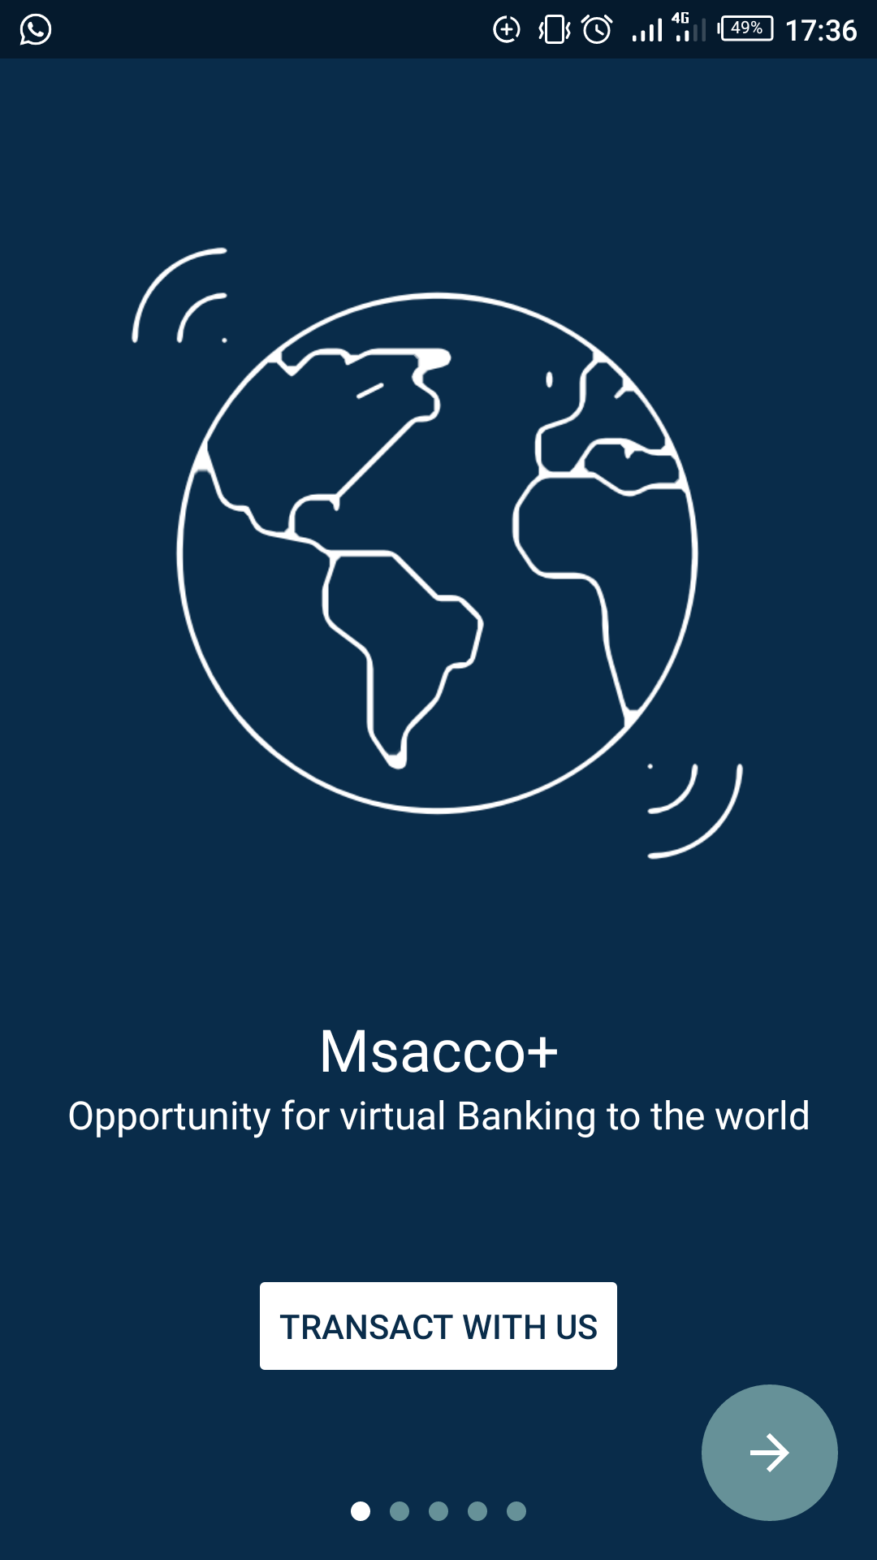

**Figure 2.1** Msacco+ mobile application welcome page

### 2.2.2 Case study of Hazina Sacco

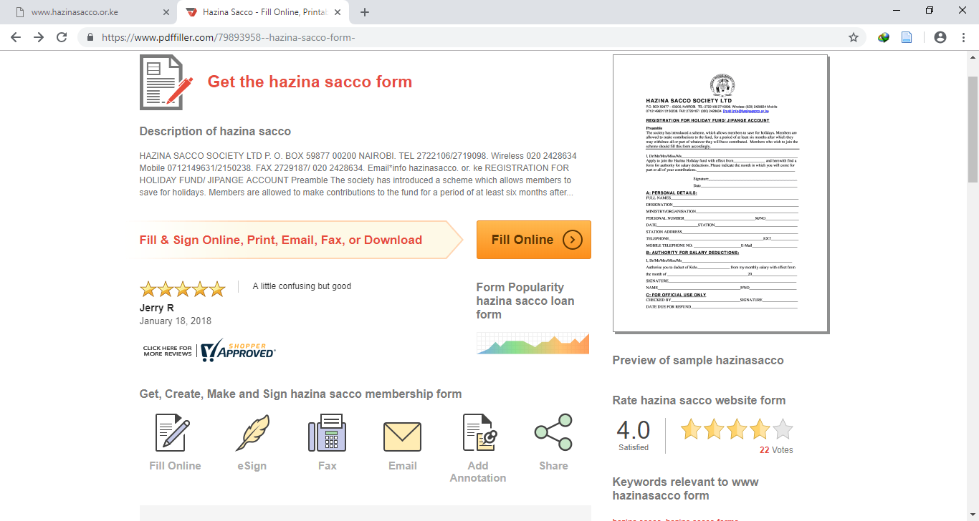

**Figure 2.2** Hazina sacco webpage interface

Hazina sacco is a nationwide sacco whose main objective is to afford its members an opportunity to accumulate their savings thereby creating a source of loanable funds (Kimani, 2018). Wwwhazinasacco.or.ke is a link to hazina sacco website. The functions this website meet are advertisement, loan calculator, ability to make a call to one of hazina agents. On this website an hazina sacco member is able to download a loan application form so that they may fill it and thereafter take it to the sacco premises for processing. Loan calculator is a functionality that can be incorporated in the proposed system.

### 2.2.3 Case study of Stima.sacco.com

It is a website of Stima sacco. Stima sacco facilitates savings and provides affordable credit to employees of the kenya power and lighting company. This websites provides a platform of advertising whereby an interested member can learn about them. The different interfaces on the website are; home, about us, product and services, web portals among others as in the image below

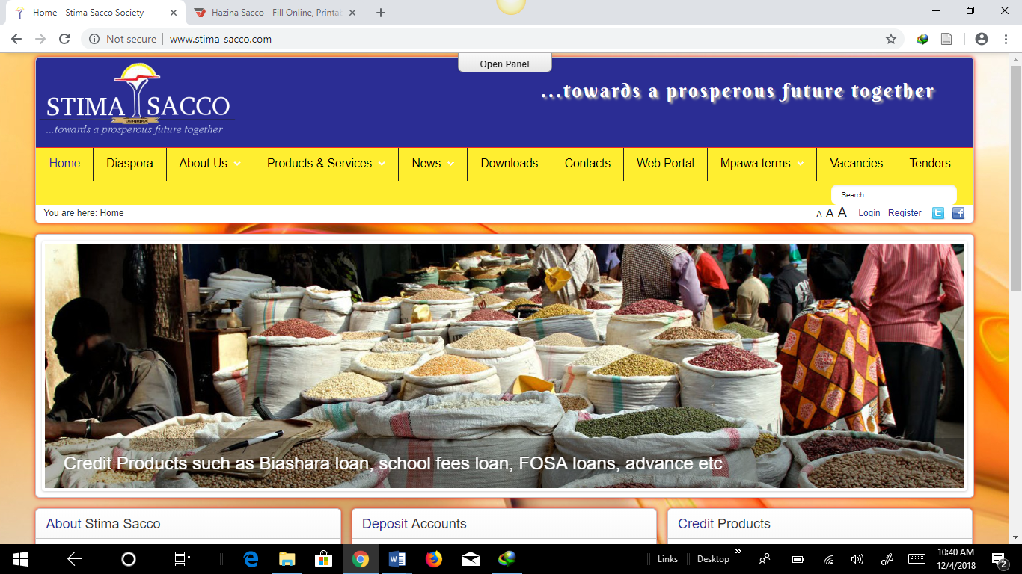

**Figure 2.3** Stima sacco webpage interface

## 2.3 System Critique

In this section the three systems reviewed in the system review are criticized and solutions issued on how the proposed system will fill the available gaps.

### 2.3.1 Case study of MSacco+

The problem with Msacco+ application is that it is not user friendly. A person has to navigate through multiple interfaces every time they open the application before arriving at the exact service they are looking for. Any mobile application should be straight forward and easy to use so as to serve the interest of all people including naive users. User friendliness is a feature that Magereza sacco transaction system is going to emphasis on. This application is also designed for use by any registered sacco member regardless of what sacco they are from. This is a problem in that it is not constrained to a particular sacco services, culture and mode of operation. It offers a general overview of what saccos provide.

### 2.3.2 Case study of Hazina Sacco

On the Hazina sacco website, functionalities are not well defined. If one clicks on the loan calculator, locate us button or the online agent call, they are redirected to a webpage that’s cannot open. This is an indication that those functionalities are not working. If a member wants to apply for a loan, they download a loan form from the internet (Hazina, 2017), print it, fill it and take it to the sacco premises which are in Nairobi physically. This is no difference from the situation at Magereza sacco since in both cases, a member has to travel to the sacco premises. This is a problem that cannot be ignored hence the need for the proposed sacco transaction system.

### 2.3.3 Case study of Stima Sacco

Stima’s website is just used as a means to advertise the sacco. Apart from knowing about the sacco, it does not solve any problem that a member experiences. It is beneficial to the saccos side and not the customers side whereas we know that a customer is the most important asset of any organization. Customer’s satisfaction should be the number one priority. Therefore, adoption of the proposed sacco transaction system, is something even Stima sacco should consider.

## 2.4 Conclusion

Based on the above review, Msacco+ application has functionalities close to the proposed sacco transaction system. Most of this features, therefore, are going to be adopted. Adoption of the proposed sacco transaction system will offer a solution to all the above mentioned short comings. Sacco members will not have to travel to the sacco premises to make an application since they can easily do that at their mobile phones convenience. The sacco will save a lot of money that is currently being used in printing application forms and members on the other hand, will save time and money used to travel to sacco premises.

## 

# CHAPTER THREE: RESEARCH METHODOLOGY

## 3.1 Introduction

This chapter on research methodology is based on the development approach, system design, and system design method, justification of system design method, fact finding approach, research design, requirements analysis, functional requirements, non-functional requirements, research design, logical design, specific platform, and hardware and software specifications.

## 3.2 System Design

### 3.2.1 System development methodology

During the development of the online Sacco society mobile application, the RAD system development approach will be used.

#### 3.2.1.1 Rapid Application Development

Rapid application development RAD is a software development methodology that uses minimal planning in favor of rapid prototyping (Liang, 2011). A prototype is a working model that is functionally equivalent to a component of the product. In RAD model the functional modules are developed in parallel as prototypes and are integrated to make the complete product for faster product delivery. Since there is no detailed preplanning, it makes it easier to incorporate the changes within the development process. RAD projects follow iterative and incremental model and have small teams comprising of developers, domain experts, customer representatives and other IT resources working progressively on their component or prototype. The most important aspect for this model to be successful is to make sure that the prototypes developed are reusable (Liang, 2011).

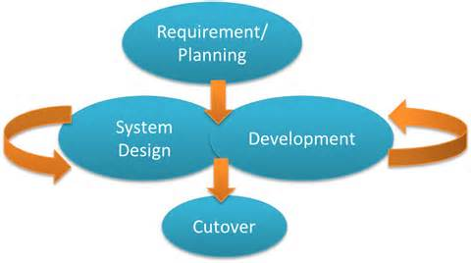

**Figure 3.1** RAD development approach

#### 3.2.1.2 Phases of RAD

RAD model distributes the analysis, design, build, and test phases into a series of short, iterative development cycles. Following are the phases of RAD Model (Liang, 2011):

**Business Modeling**: The business model for the product under development is designed in terms of flow of information and the distribution of information between various business channels. A complete business analysis is performed to find the vital information for business, how it can be obtained, how and when is the information processed and what are the factors driving successful flow of information. In this phase Magereza sacco is analyzed to find out the kind of services they offer and how they offer them. An analysis of the customer is also done to know how they apply and access the services offered by the sacco. What exactly would they want improved in the service rendering process.

**Data Modeling:** The information gathered in the Business Modeling phase is reviewed and analyzed to form sets of data objects vital for the business. The attributes of all data sets is identified and defined. The relation between these data objects example; data obtained from the customer and that from the sacco are established and defined in detail in relevance to the business model.

**Process Modeling:** The data object sets defined in the Data Modeling phase are converted to establish the business information flow needed to achieve specific business objectives as per the business model. The process model for any changes or enhancements to the data object sets is defined in this phase. Process descriptions for adding, deleting, retrieving or modifying a data object are given. In our case for instance, the flow of activity for the member and the admin will have to be established. For example, the member will use the mobile application to register, the admin will then approve of their registration and give them a membership number which they will then use together with the password they had initially given to log in to the mobile app and request for the service of their preference.

**Application Generation:** The actual system is built and coding is done by using automation tools to convert process and data models into actual prototypes. In this case, the mobile app is developed and the web based interface for the admin is also developed.

**Testing and Turnover**: The overall testing time is reduced in RAD model as the prototypes are independently tested during every iteration.

## 3.3 Justification of the Methodology to be used

The following reasons are why RAD fits well in the development of the online Sacco society mobile application.

Changing requirements can be accommodated. In case a user changes their mobile phone they can just login with the new phone and everything continues as normal since RAD takes the aspects of changing requirements.

Progress can be measured. During the development of the system the stake holders can be able to know on the progress taken if RAD approach will be used.

RAD approach ensures Productivity with fewer people in short time. RAD approach ensures maximum use of the human resource available.

Reduced development time. The phases in RAD are few and well defined hence minimizing on time used to produce the proposed mobile application.

Increases reusability of components. RAD ensures that several software components such as classes, objects are re- used, since a prototype produced its code can be used to produce another different prototype.

## 3.4 Fact Finding Approach

During the data collection stage of the development of the online Sacco society mobile application the following methods of data collection shall be used.

1. Interviews
2. Observation
3. Questionnaires

### 3.4.1 Interviews

Interviews will be carried out on Sacco members on how they view the current way of accessing services, what would they love improved and what would they want included in the mobile application. Interviews will also be carried out on Sacco stakeholders and employees on the same. Conclusions will be made on findings and implemented on the proposed mobile application.

### 3.4.2 Questionnaires

Questionnaires will be issued to a sample of Sacco members who own smartphones and a sample of others who don’t to find out what they think of the current mode of operation at the Sacco and what they would want improved.

### 3.4.3 Observations

Observations will be made on the general running of activities at the Magereza Sacco society with the permission of the Sacco administration.

## 3.5 Research Design

The type of research that will be adapted in development of the proposed system is the Survey research. This kind of research applies here since it is easy to get information from Sacco employees and members.

## 3.6 Requirement Analysis

### 3.6.1 Functional requirement

These are the functions that the system will do for the users. This is how the software system will respond or address the user’s needs. The online Sacco society mobile application ensures the following functional requirements:

**Mobile application:-**

In the mobile application; the Sacco member can be able to apply for services offered by the Sacco. These includes new member registration, loan application, erroneous deduction application, spouse and next of kin nomination, share variation deduction application and withdrawal from Sacco application.

### **3.6.2 Nonfunctional requirements**.

This will major on how the system works. They are quality attribute, designs implementation constraints and external interfaces that the online Sacco society mobile application must have. They include:

* Performance
* Availability
* Usability
* Security
* Reliability

## 3.7 Logical Design

This sections describes the several tools and techniques used for describing the system design of the proposed system. These tools and techniques are: Data flow diagrams (DFD), use case diagrams and activity diagrams.

### 3.7.1 Use Case diagrams

The use diagrams show the relationship between the users and the system.

admin

Sacco member

## 

**Figure 3.2** Use case

Diagram

### 3.7.2 Activity Diagrams

It is a diagram that represents the flow form one activity to another activity in a system.

**Figure 3.3** Activity diagram for member

Member makes application of their preference

Database verification successful. Member logged on

Is login details correct?

Sacco member opens mobile app and enters login details

## 3.8 Specific platforms

### 3.8.1 Device requirements

1. An android mobile phone

# References

Boonsiritomachai, W. &. (2017, 10 005). *Determinants affecting mobile banking adoption by generation Y based on the Unified Theory of Acceptance and Use of Technology Model modified by the Technology Acceptance Model concept*. Retrieved from Kasetsart Journal of Social Sciences: https://doi.org/10.1016/j.kjss.2017.10.005

Hazina. (2017). *loan form*. Retrieved from info@hazinasacco.or.ke

Kimani. (2018). *ZAKENYA*. Retrieved from Services And Products Of Hazina Sacco Society Ltd: www.zakenya.com/finance/services-and-products-of-hazina-sacco-society-ltd.html

Liang, S. (2011). *SDLC-RAD model*. Retrieved from tutorialspoint: http://www.tutorialspoint.com/sdlc/sdlc_rad_model.htm

Mwakajumilo. (2013, November). *UK Essays*. Retrieved from History of Saccos in Kenya : https://www.ukessays.com/essays/economics/history-of-saccos-in-kenya-economics-essays.php?.Vref=1

Subramanian, G. (2011, September). Retrieved from Mobile banking: studentrepo.um.edu

Turban, E. R. (2008). *Scirp*. Retrieved from A managerial perspective electonic commerce: m.Scirp.org

WOCCU. (2012). *statistical report.* World Council Of Credit Unions.

# 

# APPENDICES

**Appendix 1.1: Project Schedule**

The Gantt chart below illustrates the activities that will be carried out in the project and their respective time-frame.

**Table 3.1** Project schedule

|  |  |  |  |  |  |  |
| --- | --- | --- | --- | --- | --- | --- |
| **Month** | **November** | **December** | **January** | **February** | **March** | **April** |
| **Project proposal & research** |  |  |  |  |  |  |
| **System Analysis** |  |  |  |  |  |  |
| **System Design** |  |  |  |  |  |  |
| **System Coding/Testing** |  |  |  |  |  |  |
| **Documentation** |  |  |  |  |  |  |
| **Implementation** |  |  |  |  |  |  |

**Appendix 1.2:** **Project proposal budget**

**Table 3.2** Project proposal budget

|  |  |  |
| --- | --- | --- |
| Hardware facilities | Example | Estimated cost |
| Computer | 8gb RAM  3.0 ghz Core I5 and above. | Available |
| Storage devices | Server / hard disk | Available |
| Mobile phone | Android Smart phone | Available |
| Application software | Apache  Android studio  chrome | Available |
| Anti-virus software | Mc Afee | Kshs.1000 |
| Operating System | Windows 8, android | Available |