**PRISONS REGISTRATION SYSTEM**

**(A Case Study of Shimo la Tewa Prison, Mombasa)**

**MOSES KIBUGA**

**BIT-1-7102-1/2015**

A PROJECT PROPOSAL SUBMITTED TO THE INSTITUTE OF COMPUTING AND INFORMATICS FOR THE PARTIAL FULFILMENT OF THE REQUIREMENT FOR THE AWARD OF DEGREE OF BACHELOR OF BUSINESS INFORMATION TECHNOLOGY OF KENYA METHODIST UNIVERSITY

**November, 20****20**

# DECLARATION

I declare that this is my own original work and has not been submitted in any other institution of higher learning for academic or any other purpose.

**NAME**: MOSES KIBUGA **REG NO**: BIT-1-7102/2015 SIGN……………

This project has been submitted for examination with my approval as University supervisor

**LECTURER**: MR. JOEL CHARO **SIGN**…………………………….

# DEDICATION

To my Dad Samuel Thirata, my Mum Esther Thirata, my siblings Douglas and Sally.

# ACKNOWLEDGEMENT

Much regards first, to the almighty God for the good health, guidance and sustenance. I would also like to thank my dear parents and generous friends for their tireless support throughout my course and seeing to it that my project is a success. I am grateful to my project Supervisor Dr.Mvurya Mgala for his unending support, prowess and cooperation during the entire project development.

# ABSTRACT

The main objective of this study is to develop a Prison Registration system. The system comprises of a web based application that will enable Prisons to be able to manage prisoner information from one pool of data easily, and get reports of different type based on the search criteria and input by the system users. These services include and are not limited to; user registration, adding prisoners, keeping track of the types of crimes committed by the prisoners using report filtering, storing next of kin information for prisoners etc. The study is based on the existing problem of how Shimo La Tewa prison manages its prisoner data, which is done manually thus making data retrieval quite cumbersome and costly. For instance retrieving information for a prisoner who had been imprisoned a couple of years back, will mean that the prison staff will have to go through piles of papers and files to be able to get that information, which at times leads to data being lost or the involved parties forced to pay money for the search to be done, which in normal cases should be free of charge. Adoption of this system will ensure that data irrespective of when it was inputted into the system, can be retrieved within a matter of seconds by using the required filters i.e. prisoner names, crimes, dates etc. The methodology that will be used in solving this problem is the Rapid Application Development methodology. The methodology best suits this problem since deliverables will be made in prototypes and several new changes can be easily accommodated by the system. PHP (Codeigniter Framework), HTML and JavaScript will be used to develop this application MySQL will be used for data storage. The expected results of this study is to have a working Prison Registration System that will enable the prison staff to work effectively and efficiently managing prisoner data and information.

# TABLE OF CONTENTS

DECLARATION ii

DEDICATION iii

ACKNOWLEDGEMENT iv

ABSTRACT v

TABLE OF CONTENTS vi

CHAPTER ONE 1

INTRODUCTION 1

1.0 Introduction 1

1.1 Background of the study 1

1.2 Statement of the research problem 3

1.3 Objectives 3

1.3.1 General objectives 3

1.3.2 Specific objectives 4

1.4 Justification 4

1.5 Significance of the Study 4

1.6 Scope of the study 5

1.7 Target Users 5

CHAPTER TWO 6

LITERATURE REVIEW 6

2.0 Introduction 6

2.1 Theoretical Review 6

2.2 System review 7

2.2.1 Case study of Netopia Prison Management System 7

2.2.2 Case study of Prison-Secure System 9

2.2.3 Case study of Prison Inmate Information System 10

2.3 System Critique 11

2.3.1 Case study Netopia Prison Management System 12

2.3.2 Case study of Prison-Secure System 12

2.3.3 Case study of Prison Inmate Information System 12

2.4 Conclusion 13

CHAPTER THREE: RESEARCH METHODOLOGY 14

3.1 Introduction 14

3.2 System Design 14

3.2.1 System development methodology 14

3.3 Justification of the Methodology to be used 16

3.4 Fact Finding Approach 17

3.4.1 Interviews 17

3.4.2 Questionnaires 18

3.4.3 Observations 18

3.5 Research Design 18

3.6 Requirement Analysis 19

3.6.1 Functional requirement 19

3.6.2 Nonfunctional requirements. 19

3.7 Logical Design 20

3.7.1 Use Case diagrams 20

3.7.2 Activity Diagrams 21

3.8 Specific platforms 22

3.8.1 Device requirements 22

References 22

APPENDICES 23

# CHAPTER ONE

INTRODUCTION

## **1.0 Introduction**

This chapter lays its basis on the background of the study, problem statement, and the purpose of the study, research objective and research questions, significance of the study, justification of the study, the scope and the conceptual framework. Over the years data retrieval more so in the prison industry has been hectic to manage even more when it is data that was enters years back. This has made court hearings and judgments delay well over years, since much time is used in trying to retrieve the necessary files to be used. This end up eating up tax payer’s money and time. All this will change with the introduction and implementation of a Prison Registration System were all the prison data of a specific prison are stored together and can be retrieved on the click of a button by the system user.

## **1.1 Background of the study**

The Nigerian Prison Service, Yola Provincial Prison was established in the year 1914 which derived its operational powers from CAP 366 laws of the Federal Republic of Nigeria 1990 to perform the following functions:

• Take into lawful custody all those certified to be so kept by courts of competent jurisdiction.

• Produce suspects in court as and when due.

• Identify the causes of their antisocial dispositions.

• Set in motion mechanisms for their treatment and training for eventual reintegration into society as normal law abiding citizens on discharge.

• Administer Prisons farms and industries for this purpose and in the process generate revenue for the Government.

The Prison service in Nigeria is a Federal phenomenon. That is to say, the Prison is exclusively a Federal Government concern, which means that no state for now has the power in law to operate or maintain Prisons. According to the official website of the Nigerian Prison Service, the following Prisons and Prison related Institutions are spread across the length of Nigeria

1. A total of one hundred and forty five (145) Convict Prisons.
2. Eighty three (83) Satellite Prison Camps.
3. Twelve (12) Major Farm Centers
4. Nine (9) Subsidiary Farms
5. Nine (9) Cottage Industries
6. One Hundred and Twenty-Four (124) Market Gardens
7. Three (3) Borstal Institution
8. One (1) Open Prison Camp
9. One (1) Staff College, and
10. Four (4) Training School

The conventional Convict Prisons are for the remand of both the convicted and awaiting trial inmates. There are two major types of convict Prisons operational in Nigeria today. These are the maximum and the medium security Prisons.

The maximum security Prisons take into custody all classes of Prisoners including condemned convicts; lifers, long term Prisoners etc. Even though, we have an unofficial classification of these maximum security Prisons in terms of heightened security. This explains why a high risk Prisoner could be sent to one maximum security Prison as against another. The medium security Prison on the other hand also takes into custody both remands inmates and convicts. However, short term convicts constitute the bulk of the inmates that should ordinarily be found in the medium Prison. The satellite Prisons can be described as intermediate Prisons camps setup mainly in areas with courts that are far from the main Prisons. They serve the purpose of providing Remand Centers especially for those whose cases are going on in courts within the areas.

When convicted, long term Prisoners could be moved to appropriate convict Prisons to serve their terms. The Farm Centers are Agricultural Prison camps setup to train inmates in Agro-based vocations so that when they are discharged they will have Agro-based skills to depend upon. The convicts are expected in addition to be taught to appreciate the dignity of labour. The farm centers are large mechanized farms that are located in the food-producing areas of the different geopolitical regions of the country.

This is what all Prison Registration Systems should aim to achieve.

## 1.2 Statement of the research problem

Over years many prisoners have had their cases drag for too long, main reason being the cumbersomeness of retrieving vital documents and/or information which would have been used to free them earlier or get their sentences shortened.

This is due to the reason of the manual system of data storage in files and paper which is quite ineffective when trying to find specific information for a person. This also makes the work of the prison staff quite hard, searching through the piles of papers and files with the hope of finding the requested documents.

* 1. Objectives

### **1.3.1 General objectives**

To develop a Prison Registration system that will enable the prison staff to be able to handle prisoner information efficiently and also shorten the period for determining prisoner sentences by quickening the time for retrieving prisoner data and information.

It will also make easy for the users to generate reports.

### **1.3.2 Specific objectives**

1. To gather requirements of the system for Prison Registration System.
2. To design a web based application that will enable users of the Prison to access services prisoner information easily.
3. To design a web based mobile interface for mobile usage.
4. To test the system with dummy data and eventually real-time prisoner data.

## 1.4 **Justification**

Currently in the world of IT, integration of organizations’ processes and activities with the internet leading to the term online, has been the emerging trend. Ease of access and convenience associated with accessing services, meeting the concerned entities of an activity, gaining feedback as well as conducting researches and surveys has led to a diversified use of the online based systems, where hand held gadgets e.g. mobile phones, iPad and iPhone can be utilized to supplement laptops and desktops in accessing the online-based systems which remotely run and access integrated organizations’ activities. . People carry their hand held gadgets almost everywhere they go. It then becomes convenient if they can be able to access prison services and do transactions at the convenience of their mobility. This will solve the problem of having to travel, i.e. from the court room to the prison in case of data retrieval. It will lead to real-time information at the fingertips of the user.

## 1.5 Significance of the Study

This study is of great significance in ensuring timeliness, effectiveness and efficiency of accessing the Prison services. The Prison(s) society will immeasurably benefit from the development of the system, the cost of the form papers, the wear and tear factor of the papers and having a lot of people lining at the Prison premises will be done away with through embracing of this system. The prisoners will also benefit a big deal in that they will save the time and money they would have used for following up on their cases.

## 1.6 Scope of the study

This study aims in having a Prison Registration System that will enable users to access services online. The same study will also ensure that the users’ requests are received and processed in appropriate time. The data from the registration will be going to the system database and this data can be auto generated or generated by the system administrator and help in decision making and improving quality of services offered.

## 1.7 Target Users

The proposed Prisons Registration System is to be used by Prison Staff who want to register or retrieve prisoner information from the system. Implementation can also be made for public to view specific information regarding the prison data.

**1.8 Limitation**

One cannot use System unless they are connected to the Prison Network and eventually the Internet.

# CHAPTER TWO

# LITERATURE REVIEW

## 2.0 Introduction

This chapter provides literature review to related studies on existing online Prison Registration Systems and applications, their design, and application. The chapter covers both theoretical and system reviews of the systems, their strengths and weaknesses over the proposed system. The sources are merely taken from books, articles, journals and other sources from The Internet.

## 2.1 Theoretical Review

This section surveys the theories linked with the Prison Registration System. The following aspects can be viewed as the respective theories. The aim for developing any system should be based on having a usable system with good interfaces and tools. The online Prison Registration System should also impress its users.

The one consistent disadvantage to the current situation at Shimo La Tewa Prison is how time, money and other resources are wasted for data/information storage and retrieval. Having a system application with good, usable and attractive interfaces could solve this issue. Service application does not change when completed via online Registration application but rather than on paper work.

The services that meet customer requirements should be simple, compatible and personalized (Boonsiritomachai, 2017). Simplicity comes in whereby the system can be used by any registered user despite of their education level. This is because the system will be user friendly, easy to use and navigate just like most mobile application in the market today. Compatibility comes in in that all the services offered physically at the Shimo La Tewa Prison are the same offered on the system. Interaction with the system feels like one is in the Shimo La Tewa Prison premises. The user using the services from the system will not have to stand in a line, they will feel like they are the only ones being served, hence, the aspect of personalization. They will also be able to request services as per their desires and not a set limit for everyone.

## 2.2 System review

This section examines the current system at the case study of Shimo La Tewa Prison. The sections also looks on the current similar systems that have been out in place and how they differ from the proposed system. A critique of the systems shall also be part of this chapter whereby the systems weaknesses and faults are criticized and a conclusion on how to rectify the weaknesses also documented.

### 2.2.1 Case study of Netopia Prison Management System

A complete solution designed with the aim of enabling fluid and forward-looking prison management.

Concretely, with this system, it is a matter of having a global and clear view of prison staff, stocks of food and medicine available in real time, statistics on categories of prisoners, as well as identity and fingerprints. Detainees, arrival and departure dates, below the main sections and functionalities of the solution:

Identification of detainees by Acquisition & verification of:

* Identity data.
* Biometric data
* Generation of the Unique Identifier

Integration and Acquisition of judicial files:

* Automatic sentence calculation.
* Monitoring of the complete judicial history
* General Call Management.
* End of sentence alerts
* Management of pre-trial detention.
* Conditional release
* Management of temporary exit authorizations.
* State of inputs &amp; outputs.
* Movement of transfers.
* Escape management
* Royal grace management
* Correspondence management

Integration and Acquisition of judicial files:

* General Call Management.
* End of sentence alerts.
* Management of pre-trial detention.
* Conditional release
* Management of temporary exit authorizations.
* State of inputs &amp; outputs.
* Movement of transfers.
* Escape management
* Thanksgiving management
* Correspondence management

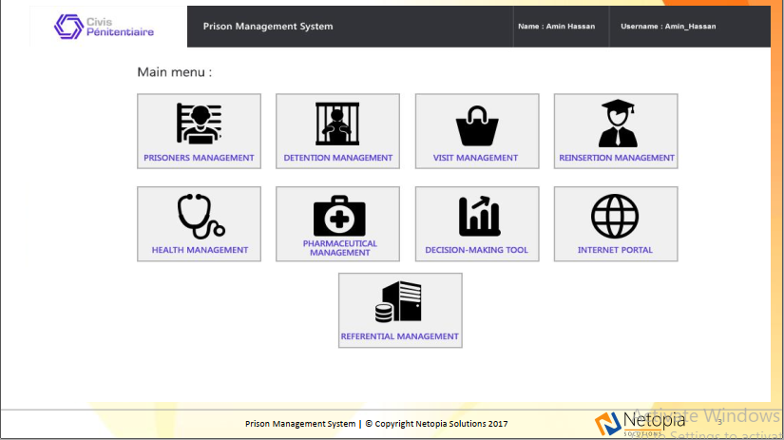

**Figure 2.1** Netopia Prison Management System welcome page

### 2.2.2 Case study of Prison-Secure System

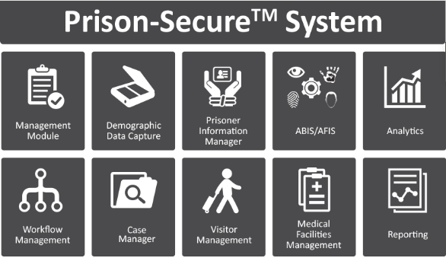

**Figure 2.2** Prison-Secure System webpage interface

Prison-Secure™ jail and prisoner management system provides a modern solution by which the Jail Authority, Public Safety Departments, and Governments can safely and securely manage prisoner identities. PrisonSecure™ is the only solution which can predict prisoner identities individually by Machine Learning Technology/Artificial Intelligence (AI) based on detailed analytical calculations.

### 2.2.3 Case study of Prison Inmate Information System

It is a Prison Management system for the Yola central Prison Nigeria. Captures information for all inmates with regards to date of incarceration, crime and date of release with related files i.e. evidence.

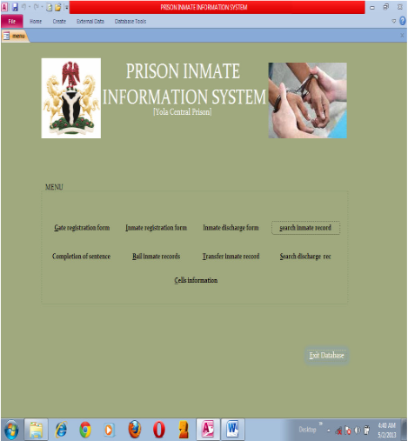

**Figure 2.3** Prison Inmate Information system interface

## 2.3 System Critique

In this section the three systems reviewed in the system review are criticized and solutions issued on how the proposed system will fill the available gaps.

### 2.3.1 Case study Netopia Prison Management System

The problem with Netopia Prison Management System is that it is not user friendly. A person has to navigate through multiple interfaces every time they open the application before arriving at the exact service they are looking for. Any System/Application should be straight forward and easy to use so as to serve the interest of all people including naive users. User friendliness is a feature that Prison Registration System is going to emphasize on. This application is also designed for use by any registered user irrespective of their location. This is a problem in that it is not constrained to particular prison services, culture and mode of operation. It offers a general overview of what prisons provide.

### 2.3.2 Case study of Prison-Secure System

On the Prison-Secure System website, functionalities are not well defined. This is an indication that those functionalities are not working. For some of the services and tasks, user has to move to a different department/office to be able to get certain information. This is a problem that cannot be ignored hence the need for the proposed Prison Registration System.

### 2.3.3 Case study of Prison Inmate Information System

Prison Inmate Information System’s website is just used as a means to advertise the system. Apart from that, it does not solve any problem that a member experiences. It is beneficial to the prison side and not the users’ side whereas we know that a user is the most important asset of any organization. Users’ satisfaction should be the number one priority. Therefore, adoption of the proposed Prison Registration System, is something even Prison Inmate Information System should consider.

## 

## 2.4 Conclusion

Based on the above review, Netopia Prison Management System has functionalities close to the proposed Prison Registration System. Most of this features, therefore, are going to be adopted. Adoption of the proposed Prison Registration System will offer a solution to all the above mentioned short comings. Users will not have to travel to the prison premises to make an application since they can easily do that at their mobile phones or laptops and computers convenience. The prison will save a lot of money that is currently being used in printing application forms and users on the other hand, will save time and money used to travel to prison premises when the need arises.

## 

# CHAPTER THREE: RESEARCH METHODOLOGY

## 3.1 Introduction

This chapter on research methodology is based on the development approach, system design, and system design method, justification of system design method, fact finding approach, research design, requirements analysis, functional requirements, non-functional requirements, research design, logical design, specific platform, and hardware and software specifications.

## 3.2 System Design

### 3.2.1 System development methodology

During the development of the Prison Registration System, the RAD system development approach will be used.

#### 3.2.1.1 Rapid Application Development

Rapid application development RAD is a software development methodology that uses minimal planning in favor of rapid prototyping (Liang, 2011). A prototype is a working model that is functionally equivalent to a component of the product. In RAD model the functional modules are developed in parallel as prototypes and are integrated to make the complete product for faster product delivery. Since there is no detailed preplanning, it makes it easier to incorporate the changes within the development process. RAD projects follow iterative and incremental model and have small teams comprising of developers, domain experts, customer representatives and other IT resources working progressively on their component or prototype. The most important aspect for this model to be successful is to make sure that the prototypes developed are reusable (Liang, 2011).

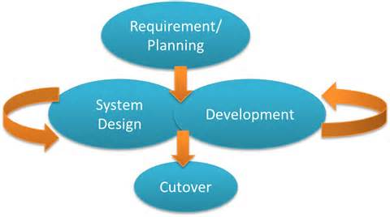

**Figure 3.1** RAD development approach

#### 3.2.1.2 Phases of RAD

RAD model distributes the analysis, design, build, and test phases into a series of short, iterative development cycles. Following are the phases of RAD Model (Liang, 2011):

**Business Modeling**: The business model for the product under development is designed in terms of flow of information and the distribution of information between various business channels. A complete business analysis is performed to find the vital information for business, how it can be obtained, how and when is the information processed and what are the factors driving successful flow of information. In this phase Shimo La Tewa Prison is analyzed to find out the kind of services they offer and how they offer them. An analysis of the user is also done to know how they apply and access the services/tasks offered by the Prison Registration System. What exactly would they want improved in the service rendering process.

**Data Modeling:** The information gathered in the Business Modeling phase is reviewed and analyzed to form sets of data objects vital for the business. The attributes of all data sets is identified and defined. The relation between these data objects example; data obtained from the user and that from the Prison Registration System are established and defined in detail in relevance to the business model.

**Process Modeling:** The data object sets defined in the Data Modeling phase are converted to establish the business information flow needed to achieve specific business objectives as per the business model. The process model for any changes or enhancements to the data object sets is defined in this phase. Process descriptions for adding, deleting, retrieving or modifying a data object are given. In our case for instance, the flow of activity for the user and the admin will have to be established. For example, the user will use the system to register, the admin will set restrictions with regards to how the normal user can interact with the system.

**Application Generation:** The actual system is built and coding is done by using automation tools to convert process and data models into actual prototypes. In this case, the mobile app is developed and the web based interface for the admin is also developed.

**Testing and Turnover**: The overall testing time is reduced in RAD model as the prototypes are independently tested during every iteration.

## 3.3 Justification of the Methodology to be used

The following reasons are why RAD fits well in the development of the Prison Registration System.

Changing requirements can be accommodated. User can access system from any device as long as they have the correct login credentials since RAD takes the aspects of changing requirements.

Progress can be measured. During the development of the system the stake holders can be able to know on the progress taken if RAD approach will be used.

RAD approach ensures Productivity with fewer people in short time. RAD approach ensures maximum use of the human resource available.

Reduced development time. The phases in RAD are few and well defined hence minimizing on time used to produce the proposed mobile application.

Increases reusability of components. RAD ensures that several software components such as classes, objects are re- used, since a prototype produced its code can be used to produce another different prototype.

## 3.4 Fact Finding Approach

During the data collection stage of the development of the Prison Registration System, the following methods of data collection shall be used.

1. Interviews
2. Observation
3. Questionnaires

### 3.4.1 Interviews

Interviews will be carried out on Prison Staff on how they view the current way of accessing services, what would they love improved and what would they want included in the registration system. Interviews will also be carried out on prisoners and next of kin of the prisoners on the same. Conclusions will be made on findings and implemented on the proposed Prison Registration System.

### 3.4.2 Questionnaires

Questionnaires will be issued to a sample of Shimo La Tewa Prison staff who own smartphones and a sample of others who don’t to find out what they think of the current mode of operation at the prison and what they would want improved.

### 3.4.3 Observations

Observations will be made on the general running of activities at the Shimo La Tewa Prison with the permission of the prison administration.

## 3.5 Research Design

The type of research that will be adapted in development of the proposed system is the Survey research. This kind of research applies here since it is easy to get information from prison employees and members.

## 3.6 Requirement Analysis

### 3.6.1 Functional requirement

These are the functions that the system will do for the users. This is how the software system will respond or address the user’s needs. The Prison Registration System ensures the following functional requirements:

**Online System:-**

In the Prison Registration System the users are able to perform the tasks and services which are offered by Shimo La Tewa. These includes new prisoner registration, data and document retrieval, daily/monthly/yearly reporting etc.

### **3.6.2 Nonfunctional requirements**.

This will major on how the system works. They are quality attribute, designs implementation constraints and external interfaces that the Prison Registration System must have. They include:

* Performance
* Availability
* Usability
* Security
* Reliability

## 3.7 Logical Design

This sections describes the several tools and techniques used for describing the system design of the proposed system. These tools and techniques are: Data flow diagrams (DFD), use case diagrams and activity diagrams.

### 3.7.1 Use Case diagrams

The use diagrams show the relationship between the users and the system.

admin

System User

## 

**Figure 3.2** Use case

Diagram

### 3.7.2 Activity Diagrams

It is a diagram that represents the flow form one activity to another activity in a system.

**Figure 3.3** Activity diagram for member

User makes application of their preference

Database verification successful. Member logged on

Is login details correct?

System user opens system and enters login details

## 3.8 Specific platforms

### 3.8.1 Device requirements

1. Smartphone, Laptop or Computer

# References

<https://www.capterra.com/jail-management-software/>

<https://www.m2sys.com/jail-and-prisoner-management-system-prison-secure/>

<http://services.lovelycoding.org/priso-management-system/>

<https://nairaproject.com/projects/776.html>

Boonsiritomachai, W. &. (2017, 10 005). Determinants affecting mobile banking adoption by generation Y based on the Unified Theory of Acceptance and Use of Technology Model modified by the Technology Acceptance Model concept. Retrieved from Kasetsart Journal of Social Sciences: https://doi.org/10.1016/j.kjss.2017.10.005

Liang, S. (2011). SDLC-RAD model. Retrieved from tutorialspoint: http://www.tutorialspoint.com/sdlc/sdlc_rad_model.htm

Turban, E. R. (2008). Scirp. Retrieved from A managerial perspective electronic commerce: m.Scirp.org

# APPENDICES

**Appendix 1.1: Project Schedule**

The Gantt chart below illustrates the activities that will be carried out in the project and their respective time-frame.

**Table 3.1** Project schedule

|  |  |  |  |  |  |  |
| --- | --- | --- | --- | --- | --- | --- |
| **Month** | **November** | **December** | **January** | **February** | **March** | **April** |
| **Project proposal & research** |  |  |  |  |  |  |
| **System Analysis** |  |  |  |  |  |  |
| **System Design** |  |  |  |  |  |  |
| **System Coding/Testing** |  |  |  |  |  |  |
| **Documentation** |  |  |  |  |  |  |
| **Implementation** |  |  |  |  |  |  |

**Appendix 1.2:** **Project proposal budget**

**Table 3.2** Project proposal budget

|  |  |  |
| --- | --- | --- |
| Hardware facilities | Example | Estimated cost |
| Computer | 8gb RAM  3.0 ghz Core I5 and above. | Available |
| Storage devices | Server / hard disk | Available |
| Mobile phone | Android Smart phone | Available |
| Application software | Apache  Android studio  chrome | Available |
| Anti-virus software | Mc Afee | Kshs.1000 |
| Operating System | Windows 8, android | Available |