WEB-BASED PATIENT APPOINTMENT BOOKING SYSTEM

PRESENTED BY
CHRISTINE CHONI MWARUMBA
admission number
course

A RESEARCH PROPOSAL SUBMITTED IN PARTIAL FULFILMENT OF THE REQUIREMENT FOR THE AWARD OF A BACHELORS DEGREE IN BUSINESS INFORMATION TECHNOLOGY AT KENYA METHODIST UNIVERSITY

OCTOBER 2021

DECLARATION
I Christine Choni Mwarumba solemnly declare that this research proposal is my original work and has not been presented in any other University or college for any award.

Admission No: ……………………….
Signature:……………………………
Date:…………………………………

This research proposal has been submitted by Christine Choni Mwarumba with the approval of the student’s Supervisor.

Name:
Signature:……………………………
Date:…………………………………

DEDICATION
I dedicate this proposal to my family members for the immense support they have given me throughout my life even unto this point in my education.

ACKNOWLEDGEMENT
I acknowledge my supervisor Mr. Joel Charo for the support he has accorded me throughout my stay in Kenya Methodist University and also the guidance with which I used to write this proposal.
I also thank my classmates and friends who have been supportive in all ways possible in making this proposal a success.

ABBREVIATIONS AND ACRONYMS
WBPAS – Web-based Patient Appointment System
B2B – Business to Business
B2C – Business to Consumer
Table of contents
DECLARATION 2
DEDICATION 3
ACKNOWLEDGEMENT 4
ABBREVIATIONS AND ACRONYMS 5
CHAPTER ONE: INTRODUCTION 8
1 PREAMBLE 8
1.1 PROBLEM DESCRIPTION 8
1.2 PROJECT OBJECTIVE 8
1.3 PROJECT SCOPE 9
1.3.1 Scope 9
1.3.2 Target User 9
1.3.3 Specific Platform 9
1.4 CONSTRAINTS 10
1.5 PROJECT STAGES 11
1.6 SIGNIFICANCE OF THE PROJECT 11
1.7 SUMMARY 12
CHAPTER TWO: LITERATURE REVIEW 13
2 INTRODUCTION 13
2.1 SYSTEM REVIEW 13
2.1.1 Existing Products 13
2.1.2 Advantages 14
2.1.3 Disadvantages 15
2.2 SYSTEM ADAPTATION 16
CHAPTER THREE: ANALYSIS AND DESIGN 17
3 INTRODUCTION 17
3.1 DEVELOPMENT APPROACH 17
3.2 REQUIREMENT SPECIFICATION 17
3.2.1 Functional Requirements 17
3.2.2 Non Functional Requirements 18
3.3 LOGICAL DESIGN 19
3.3.1 ACTIVITY DIAGRAM 19
3.3.2 DATA FLOW DIAGRAM 21
3.4 DATABASE DESIGN 21
3.5 INTERFACE DESIGN 21
CHAPTER FOUR: SYSTEM IMPLEMENTATION 22
4 INTRODUCTION 22
4.1 SYSTEM INTEGRATION 22
4.2 SYSTEM OUTPUT 23
4.2.1 Administrator 23
4.2.2 User 28
4.3 SYSTEM TESTING 30
4.3.1 Test Plan 30
4.3.2 Enhancement 30
CHAPTER 5 CONCLUSION 31
5 SYSTEM REQUIREMENTS 31
5.1 SYSTEM CONSTRAINT 31
5.2 FUTURE ENHANCEMENT 31
5.3 CONCLUSION 31
6 Chapter Six : Conclusion and Recommendations 32
6.1 Appendices 32
6.1.1 Time Schedule 32
6.1.2 Budget 32
6.1.3 Code (HTML and PHP) 33
7 CHAPTER SEVEN: REFERENCES 61

CHAPTER ONE: INTRODUCTION

PREAMBLE

The MEPHI Health services is a private Hospital in Kilifi County, it offers medical services including outpatient services and inpatient services.
Most of the services include
The MEPHI Health services has a staff capacity of 40 and a workload off 250 outpatient clients and 50 inpatient clients. Daily outpatient appointments are done mostly at patient arrival or via a telephone conversation for the new clients. For special clinics appointments are given every time the patient visits the hospital for clinical reviews.
The records department at MEPHI Hospital is responsible for managing the patient’s appointments. That is every visit a patient come for consultation when the consultant documents the next appointment on the patient card and after service delivery, the patient presents the card to the record person in the record department to schedule on the appointment book.
This department then is responsible for reminding the patient to come for the next appointment when it’s due.

PROBLEM DESCRIPTION
Give the workload of 250 patients in the outpatient alone documentation of register and cards becomes a challenge.
60% of the records on the registers were not accurate, due to poor documentation.
Retrieving of records of the past few years was a challenge due to missing old registers and miss handling of registers.

PROJECT OBJECTIVE
The main purpose of the online booking system is to generally to reduce a lot of paper work, when the booking is computerized it is even easy to manage due to the reduction of the paper work.
Most of the benefits of computerized system over a paper-based system are:
Making work easier
Improved confidentiality of patient records
Ability to store and reserve information for a long duration of time without losing
Fast and effective way of retrieving information
The other object of the online booking system is to increase the market population, to reach out to the people who can access the internet it becomes easier for them to book online instead.
With the current emerging of technology most people would prefer online platforms.

PROJECT SCOPE

Scope
With the advancement in technology and engineering capabilities, online booking and appointment platforms have been greatly enhanced giving rise to multiple on line registration health services.
The scope of this project is to develop an online Booking and Appointment web system for MEPHI Hospital Kilifi. This system will ease the cumbersome routine of clients/patient having to visit the hospital premise to inquire for information or seek services which they would have easily performed at the comfort of their homes. This will save them time and money.

Target User
The appointment booking system is specially design for the Records department at MEPHI hospital, the record department is responsible for handling patient records. One of the most important activity that this department handle is the appointment for every client who walks in the MEPHI hospital.
Basically, when a client is done with the doctor’s consultation, the clients presents themselves to the records person for the details to recorded in the appointment register and another appointment is hence generated. I.e. this routine is for the existing client
For the new client mostly, they make a phone call to the facility and request for an appointment.
Both the new and the existing clients of the facility will be able to access the appointment booking system, clients will be able to do their appointment at their own comfort.
The record person will be able to also use the system for planning purposes and managing the workflow.

Specific Platform
- Creating a system that will enable users to book appointments without having to physically visit the Hospital.
- To be able to easily save money and time with commuting to the Hospital when booking for a different date/time.
- Improve customer confidence and trust by building a reliable system in terms of service and customer care.
- Thoroughly test the system before deploying to ensure that the consumers get their money's and time worth when using the system.
- Ensuring that the returns from the system co-relate with the time and effort put into the system itself.
.

System Requirements
- Laptop/Dekstop 2GHZ 500GB Hard disk and at least 4GB RAM.
- PHP 5 and above
- Server for Hosting
- MySQL for database.

CONSTRAINTS
With the development and implementation of the online Appointment System in mind, there are some limitation which might cause the implementation to take longer than expected.
Time - the time required for effective study of the proposed system and the market is greater as compared to the time the researcher needs to complete the research, development and implementation of the system. This can be seen that during the day the researcher is at work and in the evenings a part time student so adequate time for research will be hard to come by.
Finances - for the implementation of an efficient system money will be required to purchase a good system and other hardware for adequate simulation for a real system. Transportation will also be taken into consideration since Kilifi County is large yet the researcher will have to traverse the whole of it to get the required data for implementation of the system.
New Technology - new technology will enable the developer to create the system more quickly and effectively, but this also means that the developer must learn these new skills which mean that more time will again be spent in learning the new techniques.
Information - It will be an uphill task to get adequate information from the hospital and other hospitals since most of them are secretive concerning their operations. This will require appointments with the management who in turn will want proof of the intention of the researcher wanting to get access to their information.

PROJECT STAGES
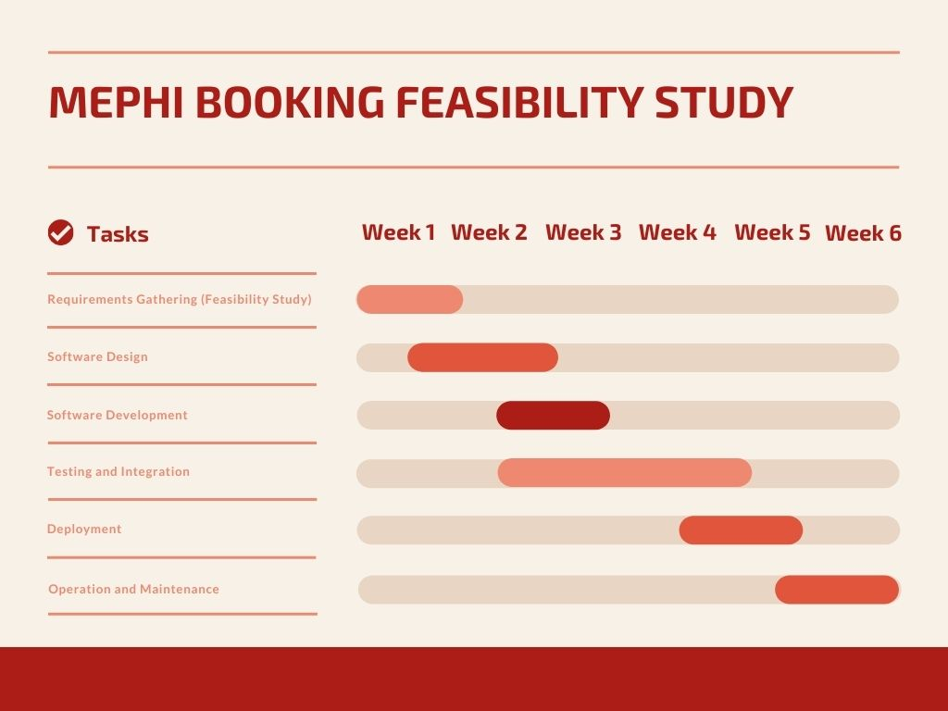

SIGNIFICANCE OF THE PROJECT
The Online system will improve customer experience i.e. ability to compare multiple prices of the same commodity from different shops and select the one that is most suitable in terms of price and quality. This will be done from the comfort of the consumers’ home or office using most probably a hand held device i.e. an internet enabled mobile phone or a tablet. This will reduce the hustle of moving from different shopping stores physically to compare the price of commodities, thus saving on time and other resources i.e. fuel.
It will also help in the reduction of users having to transact with physical cash i.e. notes and coins since they will be using credit cash payment or M-Pesa or other forms of Electronic payments (Electronic wallets).
On the developer's (me) side it will provide me with a platform for building other similar E Commerce websites for different customers, thus improving my skills in web development.

SUMMARY
With the development and implementation of the Appointment Booking System in mind, there are some limitation which might cause the implementation to take longer than expected.
Time - the time required for effective study of the proposed system and the market is greater as compared to the time the researcher needs to complete the research, development and implementation of the system. This can be seen that during the day the researcher is at work and in the evenings a part time student so adequate time for research will be hard to come by.
Finances - for the implementation of an efficient system money will be required to purchase a good system and other hardware for adequate simulation for a real system. Transportation will also be taken into consideration since Kilifi County is large yet the researcher will have to traverse the whole of it to get the required data for implementation of the system.

CHAPTER TWO: LITERATURE REVIEW

INTRODUCTION
Health care is changing with a new emphasis on patient-centeredness. Fundamental to this transformation is the increasing recognition of patients' role in health care delivery and design. online patient booking system, as the starting point of most non-urgent health care services, is undergoing major developments to support active involvement of patients. By using the Internet as a medium, patients are given more freedom in decision making about their preferences for the appointments and have improved access.
Objective: The purpose of this study was to identify the benefits and barriers to implement online patient booking system under the current health care environment.
Most of the practices have positive changes in some metrics after adopting online patient booking system, such as reduced no-show rate, decreased staff labor, decreased waiting time, and improved satisfaction, and so on. Cost, flexibility, safety, and integrity are major reasons discouraging providers from switching to online patient booking system. Patients' reluctance to adopt online patient booking system is mainly influenced by their past experiences using computers and the Internet as well as their communication preferences.
The findings of this review suggest that there are benefits to a variety of patient outcomes from online patient booking system.

SYSTEM REVIEW

Existing Products
At the moment patient appointment is done manually. Patient has to be physically present at the medical facility to book the appointment.
The patient will then be issued with an appointment made which will have the patient’s appointment date.
On the medical facility side, this information will be stored in a book or if it’s a technology savvy facility, the record will be stored in a computer.
Some of the existing systems include but not limited to;

Patient Appointment Card
With this, patient comes to hospital premise and purchases the appointment card, which is then filled with information regarding the appointment visit.

Appointment Register
Still a book which is filled for the different patients with information regarding the appointment. This is filled when patient reports on the premise.

SimplyBook
SimplyBook is an online booking system specifically designed for service-based companies. You can integrate SimplyBook with your existing website, or you can create a custom booking page within the platform. They also have social media integrations that allow you to accept bookings directly from Facebook and Instagram.

Innova
Centralized Hospital Appointment System matches physician services and patient demands, regulating hospital procedures. The system aims to regulate all procedures and consolidate second and third tier hospital appointments from a single outlet. The result is better resource planning for hospitals at ministry level and higher quality services for citizens.

Qless
The Qless hospital queue management app is a program that lets your patients schedule their hospital appointments through an online system via your company’s website, an app on their mobile device, or by using a physical kiosk in your waiting room. The system is fully automated and will follow up with them as their appointment draws near. Notifications will be sent to patients’ cell phones asking them to confirm whether they will be able to attend their appointment or if they need to reschedule. This confirmation process reduces no-shows and walk-aways by up to 75%.

Advantages

SimplyBook
- There is a free Tier
- It has social media integrations which enable user to book from different social media platforms.
- Friendly user interface.

Innova
- The applicant is free to make an appointment at his / her own will and most suitable date and time, avoiding long waits in line.
- Hospital Information Management Systems are fully compliant with ministry applications and valuable data arising from this integration is used to refine procedures and processes.

Qless
- Reduced Wait Time and Less Crowded Waiting Rooms
- Flexible appointments
- Direct Communication Between Staff and Patients
- Advanced Metrics
- Improved Patient Experiences Build a Stronger Business.

Disadvantages
- Cost expense. The price ranges are between 1000 Ksh and 6000 Ksh per month.
- Another issue is that the systems are not modularized in that you will have to purchase the whole system even though there are some bits which you will not be using.
- Users will need to be trained on how to use the system which means extra incurred costs.
- User will need to have access to internet, which might be inconveniencing for clients who do not have smartphones.

SYSTEM ADAPTATION
The development and implementation of the Appointment Booking System will help patients in that they will be able to acquire high quality services, worth their money and time which at the same time will be pocket friendly within the shortest time possible. This will be because by the time they are leaving their houses or places of work heading to the health facility, they already know what to expect and at what specific times.
In matters of diagnosis, patient can send information to the health facility which will be analyzed and reports prepared by the time patient is arriving at the health facility. This will improve on efficiency and time.

CHAPTER THREE: ANALYSIS AND DESIGN

INTRODUCTION
In this chapter we describe the current system which is in place and the requirements of the proposed system as obtained from the research. It describes the current system using unified modelling language, use case diagrams and sequence diagrams.

DEVELOPMENT APPROACH
In this chapter we deal with how the research was conducted to collect the primary data up to the conclusion of the research and also the methods, techniques and tools that were to be used in collecting primary data of the proposed system (WBPCS).
The main purpose of the research is to collect data and analyze it; this in turn will help in deriving factors which influence online consumer behaviours e.g. quality of website, consumer trust factor i.e. with regards to delivery and return of goods and services purchased, culture, technology awareness etc.
The survey (research) was performed in order to collect data about online shopping in Kenya and implementation of an online shop (WBPCS).

REQUIREMENT SPECIFICATION

Functional Requirements
These are requirements that describe how a system will function based on the user’s perspective. It allows a walk through the system to view the entire system aspects of how it works before its development.
It shall be possible for a user to perform the following functions: signing up; this is where the users can register themselves as members of the system and be able to login after the registration.
Other functional requirements include:
- Business Rules – this is how the system is supposed to work as per the laid down rules regarding the functionality of similar systems.
- Transaction corrections, adjustments and cancellations – these are the responses expected when an action that was not expected by the user takes place.
- Administrative functions – these are the laid down tasks of the site administrator.
- Authentication – process of ensuring that all processes and transactions are verified to be true and coming from a trustworthy source.
- Authorization levels – ensuring that not all processes can be performed by anyone i.e. restricting delicate processes to management level only.
- Audit Tracking – keeping track of the processes from beginning to end keeping in mind the resources used.
- Reporting Requirements – integrating reporting tools for summarizing transactions and system data and information.
- Historical Data – keeping records of previous transaction for future reference i.e. making frequent backups.
- Legal or Regulatory Requirements – acquiring the much needed documents to ensure that the system is legal.

Non Functional Requirements
They specify criteria that judge the operation of a system, rather than specific behaviours.
- Usability: Usability will describe the ease with which the new proposed system can be learned or used. A typical usability requirement might state: the proposed system should allow novice users to install and operate it with little or no training, the end user shall be able to place and the end user shall be able to access any page.
- Reliable – Reliability describes the degree to which the system must work for users. Specifications for reliability typically refer to availability, mean time between failures, and mean time to repair, accuracy, and maximum acceptable bugs. Reliability specifies the capacity of the system to maintain its performance over time
- Scalable – The proposed WBPCS will have the ability to integrate with any added functionality in future and respond to users’ queries and providing requested information
- Performance – Performance specifications typically will refer to response time, transaction throughput, and capacity. For example: While executing a search, the system must be able to display the maximum number of results per page in the shortest time possible.
- User authentication – Only authorized administrators shall be permitted to access all the database information and only authorized user will access the system.
- Error handling – the system shall handle expected and non-expected errors in ways that prevent loss in information and long downtime period.
- Performance Requirements – The system shall accommodate high number of bookings/appointments and users without any fault. Responses to view information shall take no longer than 5 seconds to appear on the screen. Safety Requirements: System use shall not cause any harm to human users.

LOGICAL DESIGN

ACTIVITY DIAGRAM

Activity Diagram

START

User has account?

NO
YES

LOGIN

Correct
Login credentials?
CREATE
ACCOUNT
NO
YES

BOOK APPOINTMENT

LOGOUT

Use case Diagram
to the shopping cart without user authentication.

Booking Appointment System
Check for available dates
Authentification

View found items
Make booking
New User Registration
System Maintenance
Registered User
Web User
New User
Identity Provider
Booking/Scheduling utilities

View found Items here the user views

DATA FLOW DIAGRAM

DATABASE DESIGN

INTERFACE DESIGN

CHAPTER FOUR: SYSTEM IMPLEMENTATION

INTRODUCTION
In this chapter we describe the current system which is in place and the requirements of the proposed system as obtained from the research. It describes the current system and the newly implemented systems and its functionalities.
Modified for both mobile and computer view/display.

SYSTEM INTEGRATION
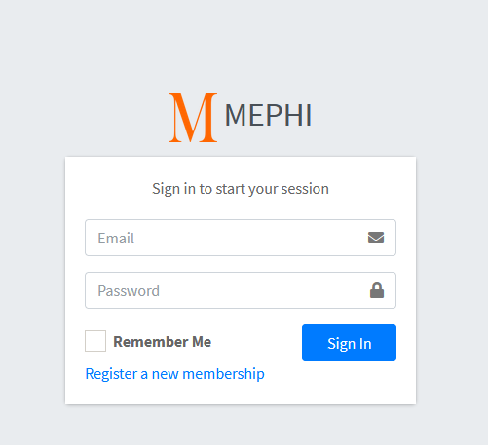

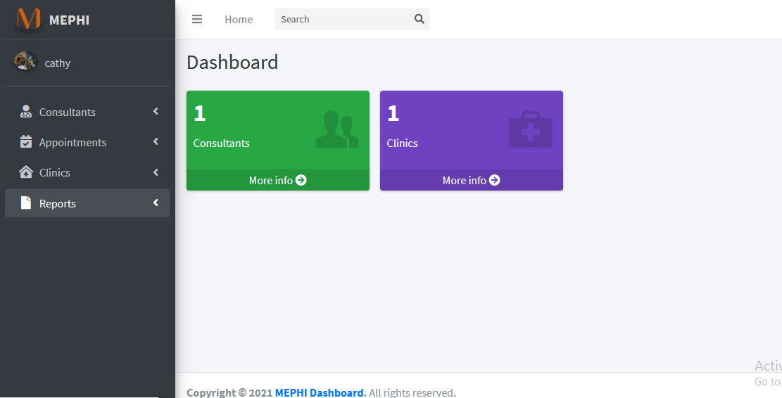

Here we have the landing page of the appointment application in Admin View.
Admin has a summary of all the happenings within the system when they log in i.e. number of users, patient registrations consultants, appointments, clinics etc.

SYSTEM OUTPUT

Administrator

Dashboard
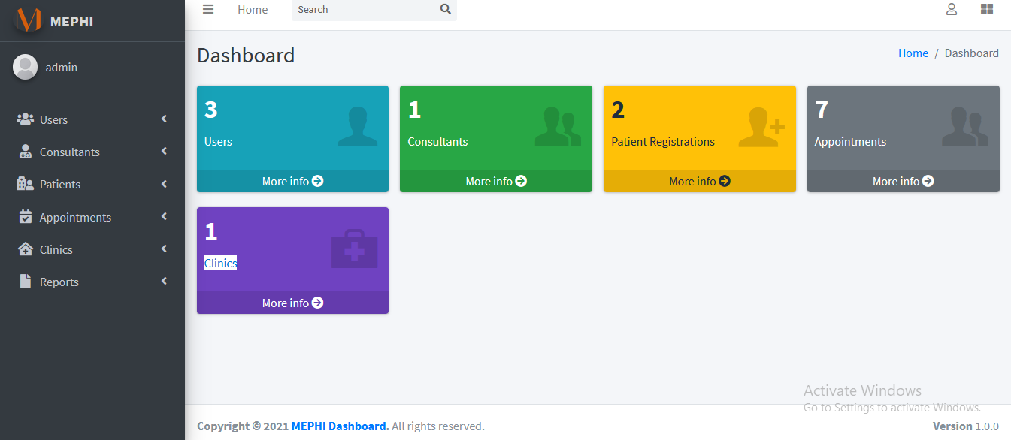

Users

Add Users
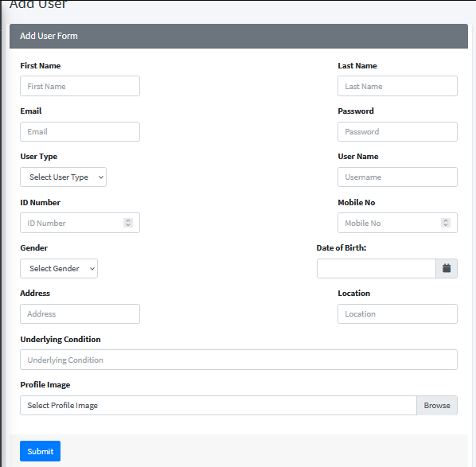

View Users
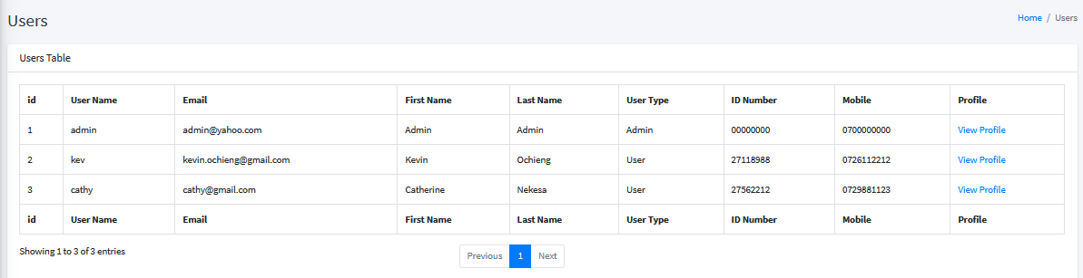

Patients

Add Patients
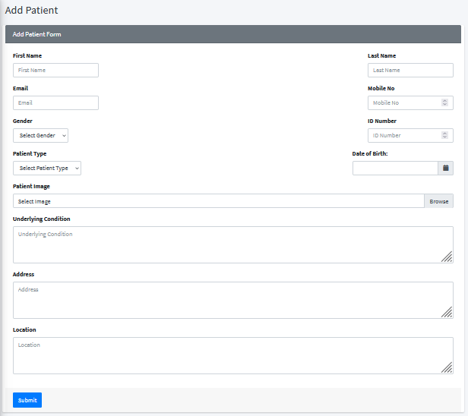

View Patients
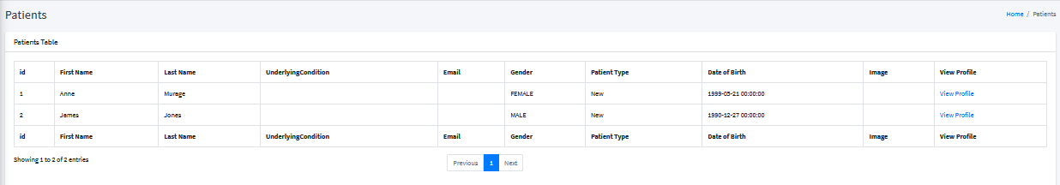

Appointments View
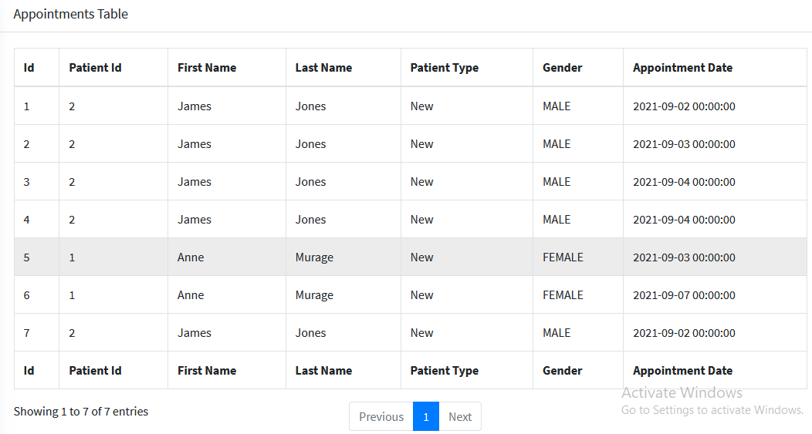

Add Consultants
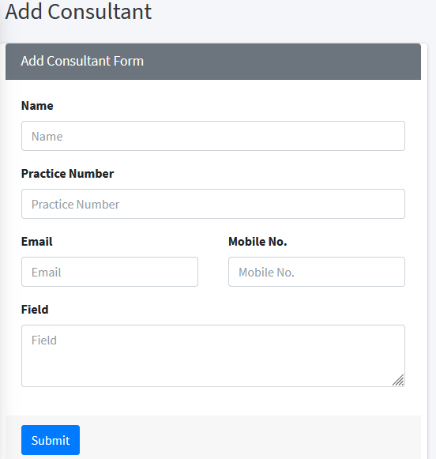

Add Clinics
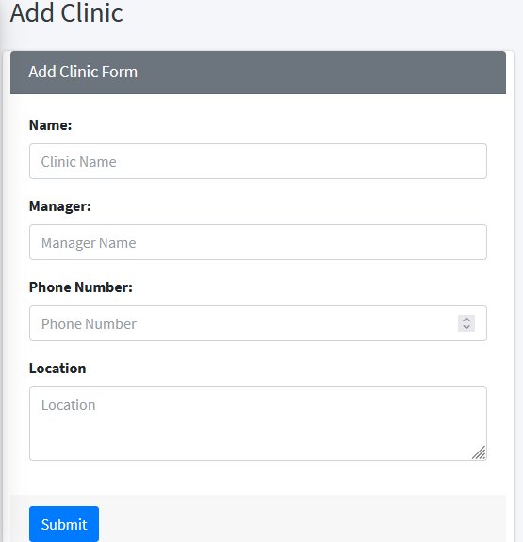

User

Dashboard
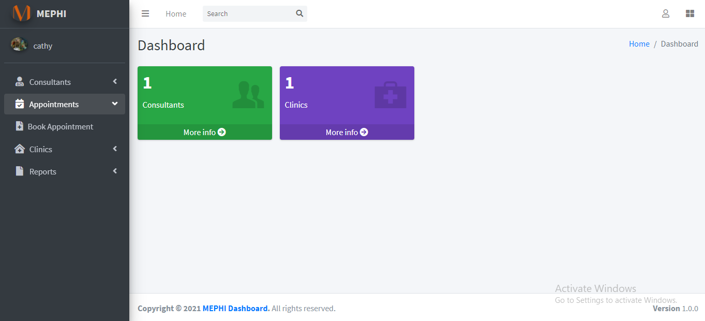

View Consultants
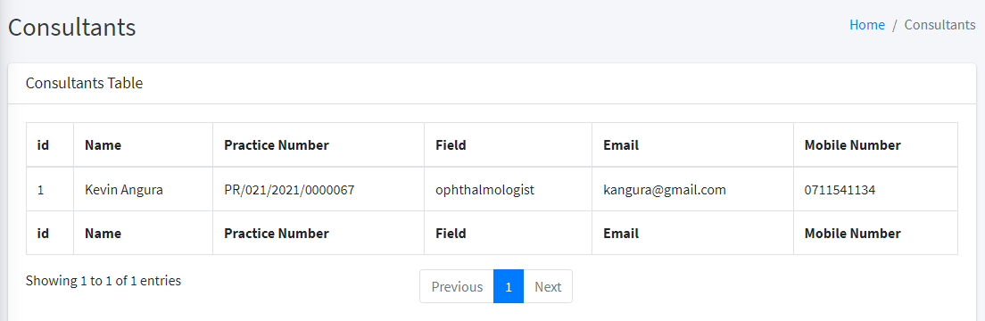

Book Appointments
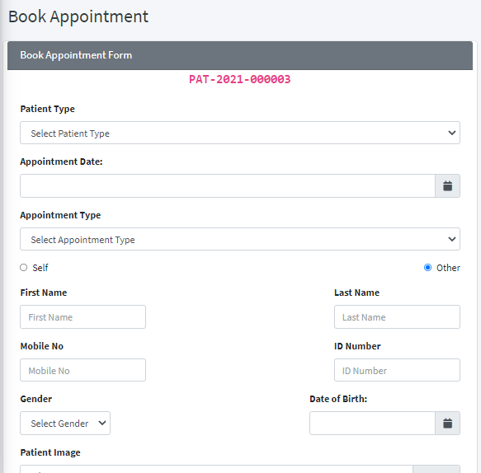

View Clinics
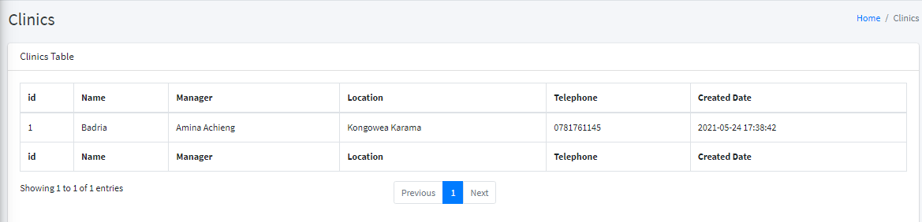

SYSTEM TESTING

Test Plan
A Test Plan is a detailed document that describes the test strategy, objectives, schedule, estimation, deliverables, and resources required to perform testing for a software product. Test Plan helps us determine the effort needed to validate the quality of the application under test. The test plan serves as a blueprint to conduct software testing activities as a defined process, which is minutely monitored and controlled by the test manager.

Test Plan Steps

Analyze the product
Who will use the website?
What is it used for?
How will it work?
What are software/ hardware the product uses?

Design the Test Strategy
Define Scope of Testing
Identify Testing Type
Document Risk and Issues
Create Test Logistics

Define the Test Objectives
Here we try to find as many defects of the system as possible.
- List all the software features (functionality, performance, GUI…) which may need to test.
- Define the target or the goal of the test based on above features

Define Test Criteria
Test Criteria is a standard or rule on which a test procedure or test judgment can be based. There’re 2 types of test criteria as following.
Suspension Criteria - Specify the critical suspension criteria for a test. If the suspension criteria are met during testing, the active test cycle will be suspended until the criteria are resolved.
Exit Criteria - It specifies the criteria that denote a successful completion of a test phase. The exit criteria are the targeted results of the test and are necessary before proceeding to the next phase of development. Example: 95% of all critical test cases must pass.

Resource Planning

Plan Test Environment

Schedule & Estimation

Determine Test Deliverables

Enhancement

CHAPTER 5 CONCLUSION

SYSTEM REQUIREMENTS
The system documentation entails a description of the Web based Price Comparison (Catalogue) system with screenshots of the system’s interface through which the users interact with the application. It will also contain the source code (written in php and HTML).
The purpose of this chapter is to give an overall explanation on how the system works and its transition from code into a working application.

SYSTEM CONSTRAINT

FUTURE ENHANCEMENT

CONCLUSION

Chapter Six : Conclusion and Recommendations
The system can be improved to be of more help to the consumer. For example right now all the commodities are put together. This can be improved by grouping the commodities with regards to where they fall e.g. House Appliance Radios, TV Sets, DVD’s etc, Kitchen Appliances Fridges, Cookers, Ovens, etc.
Also the system owners encourage frequent users usage to get feedback on what can be improved on.

Appendices

Time Schedule
Time Expenditure | Period Week
Choosing the area of study | 0-3 weeks
Formulating objective | 2-3 weeks
Literature review | 3-4 weeks
Writing proposal | 5-7 weeks
Defending proposal | 10-12 weeks
Data collection | 7-9 weeks
Data interpretation and reporting | 9-11 weeks
Typing and photocopying | 11-13 weeks
Binding and submission | 13-15 weeks

Budget
Description | Expenditure (KES)
Printing and Photocopy  Internet  Binding Spiral and Hard Cover  Miscellaneous | 5600  3000  2250  5000
Total | 15850

Code (HTML and PHP)

Controllers

Login.php
<?php

class Login extends CI_Controller {

function index()
{
$data['main_content'] = 'login_form';
$this->load->view('includes/template', $data);
}

function validate_credentials()
{
$this->load->model('membership_model');
$query = $this->membership_model->validate();

if($query) // if the user's credentials validated...
{
$data = array(
'username' => $this->input->post('username'),
'is_logged_in' => TRUE
);
$this->session->set_userdata($data);

redirect('shopping/index');
//redirect('site/members_area');
}
else // incorrect username or password
{
echo "<script>alert('You are not yet registered. Create account.')</script>";
$this->signup();
}
}

function signup()
{
$data['main_content'] = 'signup_form';
$this->load->view('includes/template', $data);
}

function create_member()
{
$this->load->library('form_validation');

// field name, error message, validation rules
$this->form_validation->set_rules('first_name', 'Name', 'trim|required');
$this->form_validation->set_rules('last_name', 'Last Name', 'trim|required');
$this->form_validation->set_rules('email_address', 'Email Address', 'trim|required|valid_email');
$this->form_validation->set_rules('username', 'Username', 'trim|required|min_length[4]');
$this->form_validation->set_rules('password', 'Password', 'trim|required|min_length[4]|max_length[32]');
$this->form_validation->set_rules('password2', 'Password Confirmation', 'trim|required|matches[password]');

if($this->form_validation->run() == FALSE)
{
$this->load->view('signup_form');
}

else
{
$this->load->model('membership_model');

if($query = $this->membership_model->create_member())
{
$data['main_content'] = 'signup_successful';
$this->load->view('includes/template', $data);
}
else
{
$this->load->view('signup_form');
}
}

}

function logout()
{
$this->session->sess_destroy();
$this->index();
}

}

Shopping.php
<?php if (!defined('BASEPATH')) exit('No direct script access allowed');

class Shopping extends CI_Controller {
public function __construct()
{
parent::__construct();
//load model
$this->load->model('billing_model');
$this->load->library('cart');

}

public function index()
{
//$username = $this->session->userdata('username');
$is_logged_in = $this->session->userdata('is_logged_in');

if($is_logged_in == 1)
{
//Get all data from database
$data['products'] = $this->billing_model->get_all();
//send all product data to "shopping_view", which fetch from database.
$this->load->view('shopping_view', $data);
}
else{
redirect('login/index');
}
}

public function aboutus()
{
$this->load->view('aboutus_view');
}

public function userhaspriviledges($username)
{
$userhaspriviledges = FALSE;
if(strtolower ($username) == 'admin')
{
$userhaspriviledges = TRUE;
}
return $userhaspriviledges;

}

public function productsreport()
{
$this->load->library('pagination');
$this->load->library('table');
$this->load->model('billing_model');

$config['base_url'] = base_url().'shopping/productsreport';
//$config['total_rows'] = $this->db->get('products')->num_rows();
$config['total_rows'] = $this->billing_model->getproductstotalrows();
$config['per_page'] = 10;
$config['num_links'] = 20;
$config['full_tag_open'] = '<div id="pagination">';
$config['full_tag_close'] = '</div>';

$this->pagination->initialize($config);

//$data['records'] = $this->db->get('products', $config['per_page'], $this->uri->segment(3));
$data['records'] = $this->billing_model->getproductsrecords($config);

$this->load->view('products_report_view', $data);
}

public function ordereditemsreport()
{
$this->load->library('pagination');
$this->load->library('table');

$username = $this->session->userdata('username');
$userhaspriviledges = $this->userhaspriviledges($username);

if($userhaspriviledges)
{
$sql = 'SELECT '
. ' products.serial AS Products_Serial, '
. ' products.name AS Products_Name, '
. ' products.description AS Products_Description, '
. ' order_detail.orderid AS OrderDetail_OrderId, '
. ' orders.customerid AS Orders_Customer, '
. ' orders.date AS Orders_Date, '
. ' customers.name AS Customer_Name, '
. ' customers.email AS Customer_Email, '
. ' customers.address AS Customer_Address, '
. ' customers.phone AS Customer_Phone '
. ' FROM products '
. ' INNER JOIN order_detail ON products.serial = order_detail.productid '
. ' INNER JOIN orders ON order_detail.orderid = orders.serial '
. ' INNER JOIN customers ON orders.customerid = customers.serial';

$this->table->set_heading('Product_Serial', 'Product_Name', 'Product_Description', 'Order_Detail_OrderId', 'Order_CustomerId', 'Order_Date', 'Customer_Name', 'Customer_Email', 'Customer_Address', 'Customer_Phone');
$config['base_url'] = 'http://localhost/webbasedpricecatalogue/shopping/ordereditemsreport';

$config['total_rows'] = $this->db->query($sql)->num_rows();
$config['per_page'] = 10;
$config['num_links'] = 20;
$config['full_tag_open'] = '<div id="pagination">';
$config['full_tag_close'] = '</div>';

$this->pagination->initialize($config);

$data['records'] = $this->db->query($sql)->result_array();

$this->load->view('ordered_items_report_view', $data);
} else {
echo "<script>alert('$username You do not have permission to view this Report.')</script>";
$this->index();
}
}

public function customerreport()
{
$this->load->library('pagination');
$this->load->library('table');

$username = $this->session->userdata('username');
$userhaspriviledges = $this->userhaspriviledges($username);

if($userhaspriviledges)
{
$config['base_url'] = 'http://localhost/webbasedpricecatalogue/shopping/customerreport';
$config['total_rows'] = $this->db->get('customers')->num_rows();
$config['per_page'] = 10;
$config['num_links'] = 20;
$config['full_tag_open'] = '<div id="pagination">';
$config['full_tag_close'] = '</div>';

$this->pagination->initialize($config);

$data['records'] = $this->db->get('customers', $config['per_page'], $this->uri->segment(3));

$this->load->view('customer_report_view', $data);
} else {
echo "<script>alert('$username You do not have permission to view this Report.')</script>";
$this->index();
}

}

public function add()
{
// Set array for send data.
$store_price = $this->input->post('stores');
$collItems = explode('-', $store_price);
$price = ((double)($collItems[1]));
$store = $collItems[0];

$insert_data = array(
'id' => $this->input->post('id'),
'store' => $store,
'name' => $this->input->post('name'),
'price' => $price,
'qty' => 1
);

// This function add items into cart.
$this->cart->insert($insert_data);

// This will show insert data in cart.
redirect('shopping');
}

function remove($rowid) {
// Check rowid value.
if ($rowid==="all"){
// Destroy data which store in session.
$this->cart->destroy();
}else{
// Destroy selected rowid in session.
$data = array(
'rowid' => $rowid,
'qty' => 0
);
// Update cart data, after cancle.
$this->cart->update($data);
}

// This will show cancle data in cart.
redirect('shopping');
}

function update_cart(){

// Recieve post values,calcute them and update
$cart_info = $_POST['cart'] ;
foreach( $cart_info as $id => $cart)
{
$rowid = $cart['rowid'];
$price = $cart['price'];
$amount = $price * $cart['qty'];
$qty = $cart['qty'];

$data = array(
'rowid' => $rowid,
'price' => $price,
'amount' => $amount,
'qty' => $qty
);

$this->cart->update($data);
}
redirect('shopping');
}
function billing_view(){
// Load "billing_view".
$this->load->view('billing_view');
}

public function save_order()
{
// This will store all values which inserted from user.

$customer = array(
'name' => $this->input->post('name'),
'email' => $this->input->post('email'),
'address' => $this->input->post('address'),
'phone' => $this->input->post('phone')
);
// And store user imformation in database.
$cust_id = $this->billing_model->insert_customer($customer);

$order = array(
'date' => date('Y-m-d'),
'customerid' => $cust_id
);

$ord_id = $this->billing_model->insert_order($order);

if ($cart = $this->cart->contents()):
foreach ($cart as $item):
$total_price = $item['qty'] * $item['price'];
$order_detail = array(
'orderid' => $ord_id,
'productid' => $item['id'],
'quantity' => $item['qty'],
'price' => $item['price'],
'total_price' => $total_price,
'store' => $item['store']
);

// Insert product imformation with order detail, store in cart also store in database.

$cust_id = $this->billing_model->insert_order_detail($order_detail);
endforeach;
endif;

// After storing all imformation in database load "billing_success".
$this->load->view('billing_success');
}
}

Site.php
<?php

class Site extends CI_Controller
{
function __construct()
{
parent::__construct();
$this->is_logged_in();
}

function members_area()
{
$this->load->view('logged_in_area');
}

function another_page() // just for sample
{
echo 'good. you\'re logged in.';
}

function is_logged_in()
{
$is_logged_in = $this->session->userdata('is_logged_in');
if(!isset($is_logged_in) || $is_logged_in != true)
{
echo 'You don\'t have permission to access this page. <a href="../login">Login</a>';
die();
//$this->load->view('login_form');
}
}

}

Models

Billing_model.php
<?php if (!defined('BASEPATH')) exit('No direct script access allowed');

class Billing_model extends CI_Model {

// Get all details ehich store in "products" table in database.
public function get_all()
{
$query = $this->db->get('products');
return $query->result_array();
}

// Insert customer details in "customer" table in database.
public function insert_customer($data)
{
$this->db->insert('customers', $data);
$id = $this->db->insert_id();
return (isset($id)) ? $id : FALSE;
}

// Insert order date with customer id in "orders" table in database.
public function insert_order($data)
{
$this->db->insert('orders', $data);
$id = $this->db->insert_id();
return (isset($id)) ? $id : FALSE;
}

// Insert ordered product detail in "order_detail" table in database.
public function insert_order_detail($data)
{
$this->db->insert('order_detail', $data);
}

public function getcustomers()
{
$query = $this->db->get('customers');
//$query = $this->db->field_data('customers');
return $query->result();
}

public function getproductstotalrows()
{
$query = $this->db->get('products')->num_rows();
return $query;
}

public function getproductsrecords($config)
{
$query = $this->db->get('products', $config['per_page'], $this->uri->segment(3));
return $query;
}
}

Membership_model.php
<?php

class Membership_model extends CI_Model {

function validate()
{
$this->db->where('username', $this->input->post('username'));
$this->db->where('password', md5($this->input->post('password')));
$query = $this->db->get('membership');

if($query->num_rows == 1)
{
return true;
}

}

function create_member()
{

$new_member_insert_data = array(
'first_name' => $this->input->post('first_name'),
'last_name' => $this->input->post('last_name'),
'email_address' => $this->input->post('email_address'),
'username' => $this->input->post('username'),
'password' => md5($this->input->post('password'))
);

$insert = $this->db->insert('membership', $new_member_insert_data);
return $insert;
}
}

Views

Aboutus_view.php
<html>
<head>
<title>About Us</title>
<link href='http://fonts.googleapis.com/css?family=Raleway:500,600,700' rel='stylesheet' type='text/css'>
<link rel="stylesheet" type="text/css" href="<?php echo base_url(); ?>css/style.css">
<link rel="shortcut icon" type="image/icon" href="<?php echo base_url(); ?>images/aboutus.ico" />
</head>
<body>
<div id='about_us'>
<div id='content'>
<div id='tag'>
<img src="<?php echo base_url(); ?>images/head.png"/>
</div>

<h2>"You need it? We have Priced It...!!"
<b style='float:right;'><?php echo '<b id="username_style">'. $this->session->userdata('username') .'</b>'; echo ' '.anchor('shopping','Home');?></b>
</h2>
<p style="font-size: 30">What is Web Based Price Catalogue?</p>
<p style="font-size: 30">
We are an E-Commerce Company that enables users to compare the prices of commodities they
intend to purchase without having to physically visit the stores or supermarkets from
which they want to purchase the items from.
</p>
<p style="font-size: 30">
Our target is the whole of Kenya but for starters we are dealing with Mombasa County first.
Our intention is to make the consumers work easier when they want to purchase a commodity whose
price they are not sure about and want to get the best offer available.
</p>
<p style="font-size: 30">
It compares product prices for the Four major supermarkets in Mombasa County namely;
<ol style="font-size: 30">
<li>Nakumatt Supermarket</li>
<li>Uchumi Supermarket</li>
<li>Naivas Supermarket</li>
<li>Tusky's Supermarket</li>
</ol>
</p>
<p>
<h2>Contact us</h2>

<div id='about_us_table'>
<table>
<tr>
<td>
Telephone
</td>
<td>
+254725036299
</td>
</tr>
<tr>
<td>
Email
</td>
<td>
<a href="mailto:webbasedpricecatalogue@gmail.com">webbasedpricecatalogue@gmail.com</a>
</td>
</tr>
<tr>
<td>
Website
</td>
<td>
<?php echo anchor('shopping','www.webbasedpricecomparison.com');?>
</td>
</tr>
<tr>
<td>
</td>
<td>
Mombasa, Kenya
</td>
</tr>
</table>
</div>

</p>
<?php $this->load->view('page_footer'); ?>
</div>

</div>

</body>
</html>

Billing_success.php
<html>
<head>
<title>Order Successful..!!</title>
<link href='http://fonts.googleapis.com/css?family=Raleway:500,600,700' rel='stylesheet' type='text/css'>
<link rel="stylesheet" type="text/css" href="<?php echo base_url(); ?>css/style.css">
<link rel="shortcut icon" type="image/icon" href="<?php echo base_url(); ?>images/billing.ico" />
</head>
<body>
<div id='result_div'>
<?php
// this will show you thank you message.
echo "<h1 align='center'>Thank You! your order has been placed!</h1>";
echo "<span id='go_back'><a class='fg-button teal' href=" . base_url() . "index.php/shopping>Go back</a></span>";
?>
</div>
</body>
</html>

Billing_view.php
<?php
$grand_total = 0;
// Calculate grand total.
if ($cart = $this->cart->contents()):
foreach ($cart as $item):
$grand_total = $grand_total + $item['subtotal'];
endforeach;
endif;
?>
<html>
<head>
<title>Billing Information</title>
<link href='http://fonts.googleapis.com/css?family=Raleway:500,600,700' rel='stylesheet' type='text/css'>
<link rel="stylesheet" type="text/css" href="<?php echo base_url(); ?>css/style.css"/>
<link rel="shortcut icon" type="image/icon" href="<?php echo base_url(); ?>images/billing.ico" />
</head>
<body>
<div id="bill_info">

<?php // Create form for enter user imformation and send values 'shopping/save_order' function?>
<form name="billing" method="post" action="<?php echo base_url() . 'index.php/shopping/save_order' ?>" >
<input type="hidden" name="command" />
<div align="center">
<h1 align="center">Billing Info</h1>
<table border="0" cellpadding="2px">
<tr><td>Order Total:</td><td><strong>KES <?php echo number_format($grand_total, 2); ?></strong></td></tr>
<tr><td>Your Name:</td><td><input type="text" name="name" required=""/></td></tr>
<tr><td>Address:</td><td><input type="text" name="address" required="" /></td></tr>
<tr><td>Email:</td><td><input type="text" name="email" required="" /></td></tr>
<tr><td>Phone:</td><td><input type="text" name="phone" required="" /></td></tr>
<tr><td><?php
// This button for redirect main page.
echo "<a class ='fg-button teal' id='back' href=" . base_url() . "index.php/shopping>Back</a>"; ?>
</td><td><input type="submit" class ='fg-button teal' value="Place Order" /></td></tr>

</table>
</div>
</form>
</div>
</body>
</html>

Customer_report_view.php
<html>

<head>
<title>Customer Report</title>
<link href='http://fonts.googleapis.com/css?family=Raleway:500,600,700' rel='stylesheet' type='text/css'>
<link rel="stylesheet" type="text/css" href="<?php echo base_url(); ?>css/style.css">
<link rel="shortcut icon" type="image/icon" href="<?php echo base_url(); ?>images/report.ico" />

<style type="text/css" media="screen">
#customer_container {
width: 979px;
margin: auto;
font-family: helvetica, arial;
}

table {
width: 979px;
margin-bottom: 10px;
}

td {
border-right: 1px solid #aaaaaa;
padding: 1em;
}

td:last-child {
border-right: none;
}

th {
text-align: left;
padding-left: 1em;
background: #cac9c9;
border-bottom: 1px solid white;
border-right: 1px solid #aaaaaa;
}

#pagination a, #pagination strong {
background: #e3e3e3;
padding: 4px 7px;
text-decoration: none;
border: 1px solid #cac9c9;
color: #292929;
font-size: 13px;
}

#pagination strong, #pagination a:hover {
font-weight: normal;
background: #cac9c9;
}
</style>
</head>

<body>
<div id='content'>
<div id='printablearea'>
<div id='tag'>
<img src="<?php echo base_url(); ?>images/head.png"/>
</div>

<h2>Customer's Report
<b style='float:right;'><?php echo '<b id="username_style">'. $this->session->userdata('username') .'</b>'; echo ' '.anchor('shopping','Home');?></b>
</h2>
<div id="customer_container">
<?php echo $this->table->generate($records); ?>
<?php echo 'page: '; ?>
<?php echo $this->pagination->create_links(); ?>
</div>
</br>
</div>

<button class = 'fg-button teal' onclick="printreport()">Print Report</button>

<script>
function printreport() {
window.print();
}
</script>
<?php $this->load->view('page_footer'); ?>
</div>

<script src="<?php echo base_url(); ?>jquery/jquery.js" type="text/javascript" charset="utf-8"></script>

<script type="text/javascript" charset="utf-8">
$('tr:odd').css('background', '#e3e3e3');
$('tr:even').css('background', '#a3e7e3');
</script>

</body>
</html>

Login_form.php
<?php $this->load->view('includes/header'); ?>

<div id="login_form">

<h1>Login</h1>
<?php
echo form_open('login/validate_credentials');
echo form_input('username', 'Username');
echo form_password('password', 'Password');
echo form_submit('submit', 'Login');
echo anchor('login/signup', 'Create Account');
echo form_close();
?>

</div><!-- end login_form-->

<?php //$this->load->view('includes/tut_info'); ?>

<?php //$this->load->view('includes/footer'); ?

Ordered_items_report_view.php
<html>

<head>
<title>Ordered Items Report</title>
<link href='http://fonts.googleapis.com/css?family=Raleway:500,600,700' rel='stylesheet' type='text/css'>
<link rel="stylesheet" type="text/css" href="<?php echo base_url(); ?>css/style.css">
<link rel="shortcut icon" type="image/icon" href="<?php echo base_url(); ?>images/report.ico" />

<style type="text/css" media="screen">
#customer_container {
width: 1200px;
margin: auto;
font-family: helvetica, arial;
}

table {
width: 1200px;
margin-bottom: 10px;
}

td {
border-right: 1px solid #aaaaaa;
padding: 1em;
}

td:last-child {
border-right: none;
}

th {
text-align: left;
padding-left: 1em;
background: #cac9c9;
border-bottom: 1px solid white;
border-right: 1px solid #aaaaaa;
}

#pagination a, #pagination strong {
background: #e3e3e3;
padding: 4px 7px;
text-decoration: none;
border: 1px solid #cac9c9;
color: #292929;
font-size: 13px;
}

#pagination strong, #pagination a:hover {
font-weight: normal;
background: #cac9c9;
}
#footer_bottom {
background-color: #08BBB7;
padding-top: 13px;
padding-bottom: 17px;
margin-top:70px;
width: 1540px;
}
</style>
</head>

<body>
<div id='content'>
<div id='printablearea'>
<div id='tag'>
<img src="<?php echo base_url(); ?>images/head.png"/>
</div>

<h2>Ordered Items Report
<b style='float:right;'><?php echo '<b id="username_style">'. $this->session->userdata('username') .'</b>'; echo ' '.anchor('shopping','Home');?></b>
</h2>
<div id="customer_container">
<?php echo $this->table->generate($records); ?>
<?php echo 'page: '; ?>
<?php echo $this->pagination->create_links(); ?>
</div>
</br>
</div>

<button class = 'fg-button teal' onclick="printreport()">Print Report</button>

<script>
function printreport() {
window.print();
}
</script>
<?php $this->load->view('page_footer'); ?>
</div>

<script src="<?php echo base_url(); ?>jquery/jquery.js" type="text/javascript" charset="utf-8"></script>

<script type="text/javascript" charset="utf-8">
$('tr:odd').css('background', '#e3e3e3');
$('tr:even').css('background', '#a3e7e3');
</script>

</body>
</html>

Page_footer.php
<div id="footer_bottom" class="footer-bottom">
<div class="container">
<div class="row">
<div class="col-md-12">
<div class="copyright">2015 © PrimeTime Technologies </br>
Contact information: <a href="mailto:ptimetechnologies@gmail.com">ptimetechnologies@gmail.com</a> All rights reserved.
</div>
</div>
</div>
</div>
</div>
</body>
</html>

Products_report_view.php
<html>

<head>
<title>Products Report</title>
<link href='http://fonts.googleapis.com/css?family=Raleway:500,600,700' rel='stylesheet' type='text/css'>
<link rel="stylesheet" type="text/css" href="<?php echo base_url(); ?>css/style.css">
<link rel="shortcut icon" type="image/icon" href="<?php echo base_url(); ?>images/report.ico" />

<style type="text/css" media="screen">
#customer_container {
width: 979px;
margin: auto;
font-family: helvetica, arial;
}

table {
width: 979px;
margin-bottom: 10px;
}

td {
border-right: 1px solid #aaaaaa;
padding: 1em;
}

td:last-child {
border-right: none;
}

th {
text-align: left;
padding-left: 1em;
background: #cac9c9;
border-bottom: 1px solid white;
border-right: 1px solid #aaaaaa;
}

#pagination a, #pagination strong {
background: #e3e3e3;
padding: 4px 7px;
text-decoration: none;
border: 1px solid #cac9c9;
color: #292929;
font-size: 13px;
}

#pagination strong, #pagination a:hover {
font-weight: normal;
background: #cac9c9;
}
</style>
</head>

<body>
<div id='content'>
<div id='printablearea'>
<div id='tag'>
<img src="<?php echo base_url(); ?>images/head.png"/>
</div>

<h2>Products Report
<b style='float:right;'><?php echo '<b id="username_style">'. $this->session->userdata('username') .'</b>'; echo ' '.anchor('shopping','Home');?></b>
</h2>
<div id="customer_container">
<?php echo $this->table->generate($records); ?>
<?php echo 'page: '; ?>
<?php echo $this->pagination->create_links(); ?>
</div>
</br>
</div>

<button class = 'fg-button teal' onclick="printreport()">Print Report</button>

<script>
function printreport() {
window.print();
}
</script>
<?php $this->load->view('page_footer'); ?>
</div>

<script src="<?php echo base_url(); ?>jquery/jquery.js" type="text/javascript" charset="utf-8"></script>

<script type="text/javascript" charset="utf-8">
$('tr:odd').css('background', '#e3e3e3');
$('tr:even').css('background', '#a3e7e3');
</script>

</body>
</html>

Shopping_view.php
<html>
<head>
<title>Price Comparison WBPCS</title>
<link href='http://fonts.googleapis.com/css?family=Raleway:500,600,700' rel='stylesheet' type='text/css'>
<link rel="stylesheet" type="text/css" href="<?php echo base_url(); ?>css/style.css">
<link rel="shortcut icon" type="image/icon" href="<?php echo base_url(); ?>images/favicon.ico" />

<script type="text/javascript">
// window.history.forward();

// To conform clear all data in cart.
function clear_cart() {
var result = confirm('Are you sure want to clear all bookings?');

if (result) {
window.location = "<?php echo base_url(); ?>index.php/shopping/remove/all";
} else {
return false; // cancel button
}
}
</script>
<script src="<?php echo base_url(); ?>jquery/jquery.js" type="text/javascript" charset="utf-8"></script>

</head>
<body>
<?php
$this->output->set_header('Last-Modified:'.gmdate('D, d M Y H:i:s').'GMT');
$this->output->set_header('Cache-Control: no-store, no-cache, must-revalidate');
$this->output->set_header('Cache-Control: post-check=0, pre-check=0',false);
$this->output->set_header('Pragma: no-cache');
?>
<div id='content'>
<div id='tag'>
<!-- Formget Fugo logo image -->
<img src="<?php echo base_url(); ?>images/head.png"/>
</div>
<div id="cart" >
<div id = "heading">
<h2 align="">Products Available for Ordering
<b style='float:right;'><?php echo '<b id="username_style">'. $this->session->userdata('username') .'</b>'; echo ' '.anchor('login/logout','Logout');?></b>
<?php
$format = "D d M Y";
$time = date("h:i:sa");
echo date($format);//, $time.'');
?>
</h2>
<h2>
<?php
echo anchor('shopping/aboutus','About Us') . ' | ';
echo anchor('shopping/customerreport','Customer Report') . ' | ';
echo anchor('shopping/productsreport','Products Report') . ' | ';
echo anchor('shopping/ordereditemsreport','Ordered Items Report') . ' | ';
echo anchor('shopping','Home') . ' | ';
?>
</h2>
</div>
<div id="text">
<?php $cart_check = $this->cart->contents();

// If cart is empty, this will show below message.
if(empty($cart_check)) {
echo 'To add Products to your Order List, select Store/Price from drop down list and click on "Add Order" Button';
}
?>
</div>

<table id="table" border="0" cellpadding="6px" cellspacing="1px">
<?php
// All values of cart store in "$cart".
if ($cart = $this->cart->contents()): ?>
<tr id= "main_heading">
<td>Serial</td>
<td>Store</td>
<td>Name</td>
<td>Price</td>
<td>Quantity</td>
<td>Amount</td>
<td>Cancel Product</td>
</tr>
<?php
// Create form and send all values in "shopping/update_cart" function.
echo form_open('shopping/update_cart');
$grand_total = 0;
$i = 1;

foreach ($cart as $item):
// echo form_hidden('cart[' . $item['id'] . '][id]', $item['id']);
// Will produce the following output.
// <input type="hidden" name="cart[1][id]" value="1" />

echo form_hidden('cart[' . $item['id'] . '][id]', $item['id']);
echo form_hidden('cart[' . $item['id'] . '][store]', $item['store']);
echo form_hidden('cart[' . $item['id'] . '][rowid]', $item['rowid']);
echo form_hidden('cart[' . $item['id'] . '][name]', $item['name']);
echo form_hidden('cart[' . $item['id'] . '][price]', $item['price']);
echo form_hidden('cart[' . $item['id'] . '][qty]', $item['qty']);
?>
<tr>
<td>
<?php echo $i++; ?>
</td>
<td>
<?php echo $item['store']; ?>
</td>
<td>
<?php echo $item['name']; ?>
</td>
<td>
KES <?php echo number_format($item['price'], 2); ?>
</td>
<td>
<?php echo form_input('cart[' . $item['id'] . '][qty]', $item['qty'], 'maxlength="3" size="1" style="text-align: right"'); ?>
</td>
<?php $grand_total = $grand_total + $item['subtotal']; ?>
<td>
KES <?php echo number_format($item['subtotal'], 2) ?>
</td>
<td>

<?php
// cancle image.
$path = "<img src='http://localhost/webbasedpricecatalogue/images/cart_cross.jpg' width='25px' height='20px'>";
echo anchor('shopping/remove/' . $item['rowid'], $path);
?>
</td>
<?php endforeach; ?>
</tr>
<tr>
<td>
<b>Order Total: KES <?php echo number_format($grand_total, 2); ?></b>
</td>
<td>
<b></b>
</td>
<?php // "clear cart" button call javascript confirmation message ?>
<td colspan="5" align="right"><input type="button" class ='fg-button teal' value="Clear Order" onclick="clear_cart()">

<?php //submit button. ?>
<input type="submit" class ='fg-button teal' value="Update Order">
<?php echo form_close(); ?>

<!-- "Place order button" on click send "billing" controller -->
<input type="button" class ='fg-button teal' value="Place Order" onclick="window.location = 'shopping/billing_view'"></td>
</tr>
<?php endif; ?>
</table>

</div>

<div id="products_e" align="center">

<h2 id="head" align="center">Products</h2>
<?php

// "$products" send from "shopping" controller,its stores all product which available in database.
foreach ($products as $product):
$id = $product['serial'];
$name = $product['name'];
$description = $product['description'];
$nakumatt_price = $product['nakumatt_price'];
$tuskys_price = $product['tuskys_price'];
$uchumi_price = $product['uchumi_price'];
$naivas_price = $product['naivas_price'];
?>

<div id='product_div'>
<div id='image_div'>
<img src="<?php echo base_url() . $product['picture'] ?>"/>
</div>
<div id='info_product'>
<div id='name'><?php echo $name; ?></div>
<div id='desc'> <?php echo $description; ?></div>
<?php
// Create form and send values in 'shopping/add' function.
echo form_open('shopping/add');
echo form_hidden('id', $id);
echo form_hidden('name', $name);
//echo form_hidden('stores', $price2);
//echo form_hidden('price2', $price2);
//echo form_hidden('price3', $price3);
//echo form_hidden('price4', $price4);
$options = array(
'Nakumatt-'.$nakumatt_price => 'Nakumatt-'.$nakumatt_price,
'Tuskys-'.$tuskys_price => 'Tuskys-'.$tuskys_price,
'Uchumi-'.$uchumi_price => 'Uchumi-'.$uchumi_price,
'Naivas-'.$naivas_price => 'Naivas-'.$naivas_price,
);
echo form_dropdown('stores', $options);
?>
</div>

<div id='add_button'>
<?php
$btn = array(
'class' => 'fg-button teal',
'value' => 'Add Order',
'name' => 'action'
);

// Submit Button.
echo form_submit($btn);
echo form_close();
?>

</div>

</div>

<?php endforeach; ?>
</div>

</div>

</body>
</html>

Signup_form.php
<?php $this->load->view('includes/header'); ?>
<h1>Create an Account</h1>
<fieldset>
<legend>Personal Information</legend>
<?php
echo form_open('login/create_member');
echo form_input('first_name', set_value('first_name', 'First Name'));
echo form_input('last_name', set_value('last_name', 'Last Name'));
echo form_input('email_address', set_value('email_address', 'Email Address'));
?>
</fieldset>

<fieldset>
<legend>Login Info</legend>
<?php
echo form_input('username', set_value('username', 'Username'));
echo form_input('password', set_value('password', 'Password'));
echo form_input('password2', 'Password Confirm');
echo form_submit('submit', 'Create Acccount');
?>

<?php echo validation_errors('<p class="error">'); ?>
</fieldset>

<?php //$this->load->view('includes/tut_info'); ?>

<?php $this->load->view('includes/footer'); ?>

Signup_successful.php
<h1>Congrats!</h1>
<p>Your account been created.
<?php echo anchor('login', 'Login Now');?>
</p>

Style.css
body{
background-color:#E0E0E0;
margin:0 auto;
font-family: 'Raleway', sans-serif;
}
#content{
width:979px;
margin:0 auto;

}
#result_div {
background-color: #FFF;
width: 640px;
height: 175px;
margin: 0 auto;
margin-bottom: 10px;
margin-left: 445px;
margin-top: 300px;
}
h1{
padding:20px;
background-color:#333333;
width: 600px;
color:#FFF;
}
#products_e{
background-color: #FFFFFF;
width: 979px;
position: absolute;
margin-top: 10px;

}
#cart{
width:979px;
height:auto;
margin-top: -20px;
position:relative;
background-color:#FFFFFF;
}
h2{
font-family: 'Raleway', sans-serif;
padding:20px;
background-color:#333333;
color:#FFF;
}

#product_div{
width: 310px;
height:500px;
background: #fff;
position: relative;
float: left;
padding: 5px;
margin: 2px;
border: 1px solid #E0E0E0;

}
div#image_div {
width: 300px;
height: 250px;

}
div#info_product {
height: 165px;
}
tr {
background: white;
}
#bill_info{
background-color:#FFF;
width:640px;
margin:0 auto;
margin-bottom:10px;
}
h1{
padding:20px;
background-color:#333333;
color:#FFF;
}
div#text {
color: #08BBB7;
margin-left: 0 auto;
margin-top: -19px;
margin-bottom: 10;
font-family: 'Calibri';
font-size:15px;
}

#heading{
padding-bottom:10px;
}
#heading, a{
text-decoration: none;
color: white;
font-family: calibri;
}
#table{
font-size:15px;
background-color:#E1E1E1;
width:100%;
}
tr{
bgcolor:#FFFFFF;
}
#main_heading{
font-weight:bold;
bgcolor:#FFFFFF;
}
div#name {
font-weight: 700;
font-size: 17px;
margin-bottom: 10px;
}
div#desc {
font-size: 15px;
margin-bottom: 11px;
min-height: 105px;
line-height: 1.4;
}
div#add_button {
margin-top: 23px;
}
span#go_back {
margin-left: 245px;
}

.fg-button{
position: relative;
top: 0;
font-size: 18px;
text-decoration: none;
cursor: pointer;
border-bottom-width: 3px;
outline: none;
-webkit-transition: 0.3s background;
-moz-transition: 0.3s background;
transition: 0.3s background;
-moz-border-radius: 1em;
border: 2px solid #a1a1a1;
padding: 5px 4px;
border-radius: 22px;
}

.fg-button:active{
top: 2px;
}

.fg-button.teal{
color: #fff;
border-color: #04A5A1;
background-color:#08BBB7;
-moz-border-radius: 1em;
}

.fg-button.teal:hover{
background: #0ACFCB;
}

.fg-button.teal:active{
background: #09cbc7;
top: 2px;
border-bottom-width: 1px;
}
#about_us
{

}
#about_us_table tr
{
background-color:#b0c4de;
}

@media print {
a{
display: none;
}
body * {
visibility: hidden;
}
#printablearea, #printablearea * {
visibility: visible;
}
#printablearea {
position: absolute;
left: 0;
top: 0;
}
}
#username_style{
color: green;
padding-right: 1em;
}

#footer_bottom {
background-color: #08BBB7;
padding-top: 13px;
padding-bottom: 17px;
margin-top:70px;
}
//tr:nth-child(even) {background: #65B1D1}
//tr:nth-child(odd) {background: #E8933A}

CHAPTER SEVEN: REFERENCES
Pollitz, J., & Christie, A. (2006). The high cost of textbooks: A convergence of academic libraries, campus Bookstores, publishers? Electronic Journal of Academic and Special Librarianship, 7, 2.
Malone, T., JoAnne, Y., & Benjamin, R, (1987). Electronic markets and electronic hierarchies. Communications of the ACM, 30(6), 484-497.
http://www.marxists.org/history/erol/periodicals/theoretical-review/
A Review of Theoretical and Empirical Literature— Unresolved Issues – http://www.calpro-online.org/eric/docs/taylor/taylor_03.pdf
https://student.portal.chalmers.se/en/contactservice/studysupport/writing-guide/theory_literature_review/Pages/default.aspx
http://www.ogcio.gov.hk/en/infrastructure/methodology/oom/
Wikipedia, the free Wikipedia http://en.wikipedia.org/wiki/Videotex
http://www.open.edu/openlearn/money-management/management/business-studies/history-online-retail
http://en.wikipedia.org/wiki/Comparison_shopping_website
http://www.wagvegas.com/shopping/the-advantages-of-price-comparison-websites
Bettman J.R (1986): Consumer Psychology - Annual review of Psychology.
Bhatnagar, A. and Ghose, S. (2004): Segmenting consumers based on the benefits and risks of internet shopping. Journal of Business Research
http://www.conceptdraw.com/examples/example-of-diagram
https://www.lucidchart.com/pages/class-diagram-for-online-shopping-system-UML

