Installation & Configuration Guide

# Raspberry Pi Installation

## Requirements

* A Laptop with Git, Java and IntelliJ / Eclipse EE
  + <https://git-scm.com/>
  + <http://www.oracle.com/technetwork/java/javase/downloads/jdk8-downloads-2133151.html>
  + <https://www.jetbrains.com/idea/>
  + <https://www.eclipse.org/downloads/packages/eclipse-ide-java-ee-developers/oxygen3a>
* A Raspberry Pi 3 or newer with the latest version of Raspbian (Git and Java are already pre-installed)
  + <https://www.raspberrypi.org/downloads/raspbian/>



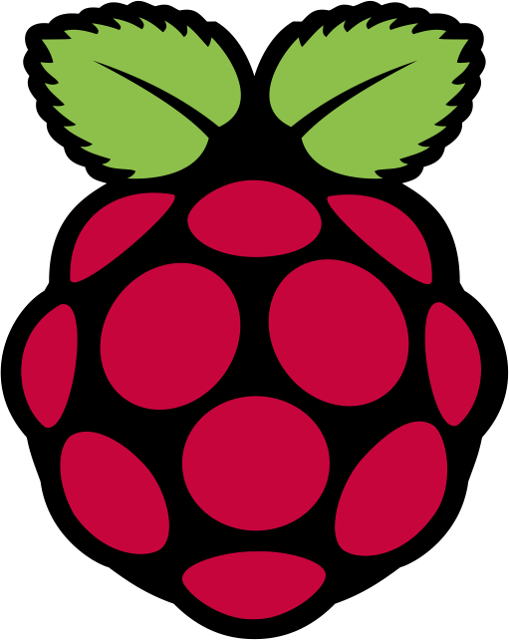

## Cloning Repository

To clone the repository to the laptop or the Raspberry Pi open a terminal and navigate to a folder you wish to clone the repository into. Then type the following command

git clone <https://github.com/kevind992/3rd-Year-Project.git>

You should now be able to open the repository from either the file explorer on your laptop or Raspberry Pi.

## Raspberry Pi Set-up

To run the application on the raspberry pi you need to have the *raspberrypi-0.0.1-SNAPSHOT.jar* on the Raspberry Pi within a folder. Create a folder by typing the following command

mkdir obdApplication

You now need to place the *raspberrypi-0.0.1-SNAPSHOT.jar* within the obdApplication folder. Once the jar file is in place all that is left to do is set up the OBDII dongle. Open a new terminal and type the following command and replacing mac address with your OBDII dongle’s mac address

sudo rfcomm connect OBDII AA:BB:CC:DD:EE:FF

A message should follow after completing the command indicating that the connection was successful.

You now need to set up the Raspberry pi to automatically run the *raspberrypi-0.0.1-SNAPSHOT.jar* applicationwhen the pi boots up. To do this you need to make two configurations to your Raspberry Pi. First you need to make sure a terminal opens after boot up. Open a terminal and type

nano ~/.config/lxsession/LXDE-pi/autostart

Go to the bottom of the file and add the following line of code @lxterminal

To exit from Nano press ‘Ctrl + X’ and then press ‘Shift + Y’ to save the file.

Secondly you need to change a startup script to that a terminal command is executed. To do this type the following into a terminal window

sudo nano /home/pi/.bashrc

Once the text editor is opened, navigate to the bottom on the file and add the following

echo Running at boot

sudo java -jar /home/pi/obdApplication/raspberrypi-0.0.1-SNAPSHOT.jar

Like before to exit from Nano press ‘Ctrl + X’ and then press ‘Shift + Y’ to save the file.

All that is left to do is reboot the Raspberry pi and you are now ready to run the application. To reboot type the following into your terminal window

sudo reboot

# Ionic Framework Installation

## Requirements

* A computer with Git, NodeJS, Cordova and Ionic:
  + <https://git-scm.com/>
  + <https://nodejs.org/en/>
  + <https://cordova.apache.org/>

You can run ionic on most operating systems, however in order to build and run on iOS you will need to be running Mac OS X or greater.

## Node JS

First you must install Node JS, a JavaScript Runtime. Follow the link to download

* 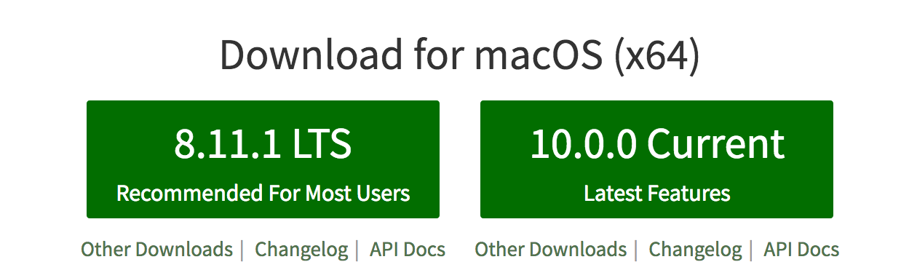<https://nodejs.org/en/>

## Cordova

The next step is to install Cordova

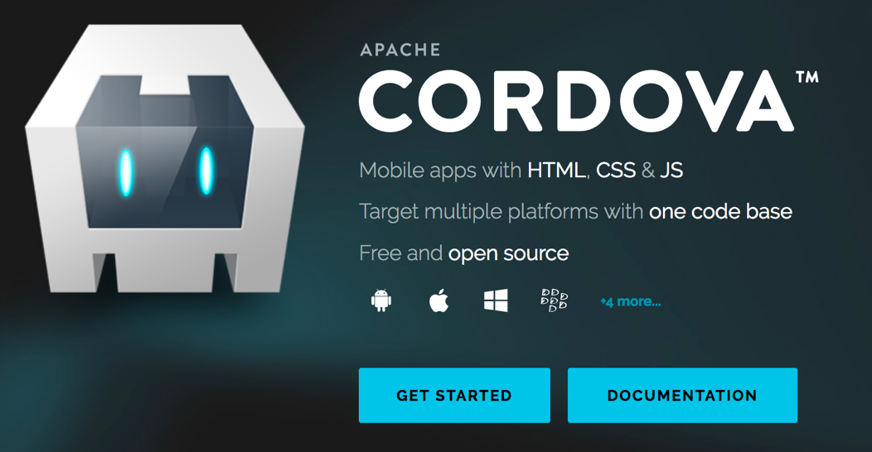 sudo npm install -g cordova

## Ionic

Finally, to install Ionic, run

sudo npm install -g ionic