**1)The Museum of Natural History of El Salvador**

The Museum of Natural History of El Salvador (MUHNES) is a scientific institution whose purpose is to investigate the biological and paleontological diversity of the country - national natural cultural heritage - administer the National Collections of Natural History, as well as transmit and share knowledge about the natural wealth of El Salvador.

For this, it has three permanent exhibition halls: Rocks and Minerals, Paleontology, and Ecosystems. They show the current and past natural heritage, through findings made by both Salvadoran and foreign biologists and paleontologists.

The museum is composed of the following units:

• Natural History Collections Unit, which manages and manages the collection pieces to generate information and knowledge.

• Educational Services and Mesography Unit, through which it provides assistance to the various users of MUHNES, through the production of educational materials, the dissemination of the country's biological and paleontological diversity, as well as the assembly of permanent and temporary exhibitions.

• Specialized Workshops Unit, which develops restoration, conservation and monitoring of specimens and pieces of natural history collections, in order to ensure their conservation and allow research.

The museum manages and manages the National Collections of Natural History, which safeguard samples, copies and pieces that become the record of Salvadoran natural heritage. The collections correspond to mastozoology, ornithology, herpetology, ichthyology, malacology, entomology, rocks and minerals, paleontology and botany. He is also responsible for the National Herbarium of El Salvador. From these resguardos is exhibited the Piece of the Month, a temporary sample that, due to its rarity or scientific importance, is exposed to the public with its technical, scientific and photographs.

The services that the museum has are the following:

• Permanent, temporary and itinerant exhibitions

• Guided visits

• Playful activities for girls, boys and young people

• Educational talks

• Taxonomic identification of biological and paleontological materials

• Paleontological and botanical inspections

• Attention to specialists and students in the process of graduation

• Training in paleontology, botany and zoology

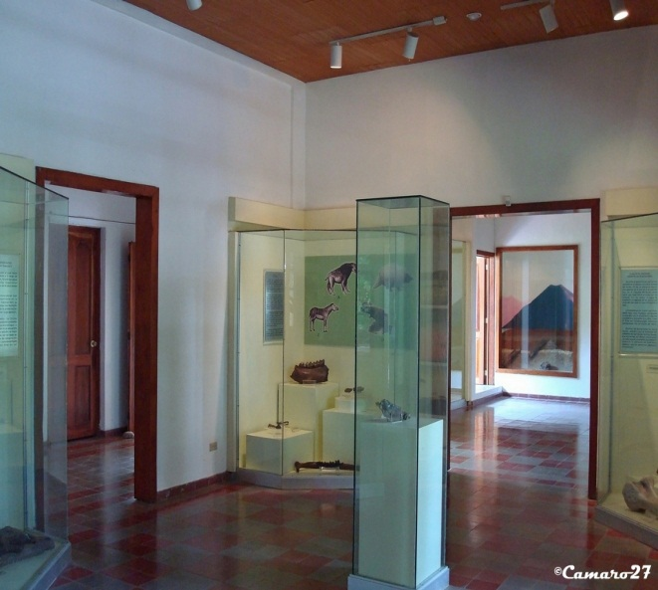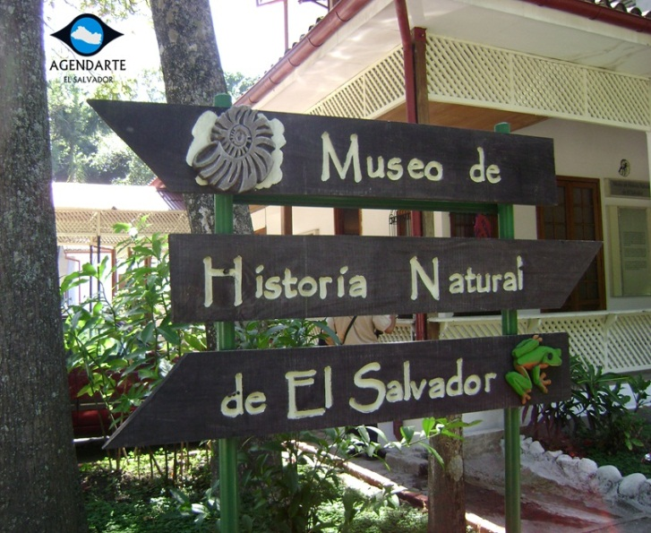

**2)EL ZAPOTE MUSEUM**

Oponed in 2002 in the old facilities of the Zapote barracks, the municipality of San Jacinto, the Military History Museum opened its doors to the public to permanently expose historical passages of the Salvadoran Army Force, from its foundation to the present.

The building was erected in 1865, which retains the original facade and floors. The museum consists of twelve rooms that expose military vestiges from the nineteenth century, portraits, artifacts and pieces that were used in different battles that carried out the Armed Forces over the years.

Every visitor can travel the rooms distributed in chronological order and with a particular meaning:

Room 1 Captain General Gerardo Barrios

Room 2 General Maximiliano Hernández Martínez

Room 3 General Fidel Sánchez Hernández

Room 4 Lieutenant Colonel Art. DEM Domingo Monterrosa and Room 5 Myr. Art. DEM Armando Azmitia Melara

Room 5 Support Weapons.

Room 6 General Francisco Menéndez

Room 7 Atlacatl

Room 8 Batallón Cuscatlán

Room 9 Cap. PA. Guillermo Reynaldo Cortez

Room 10 Rulers of El Salvador: Distinguished Military

Room 11 Papal Vehicle

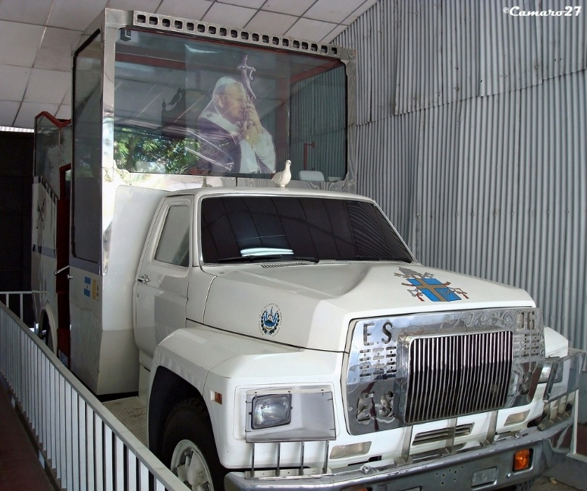Memorial Square to National Sovereignty

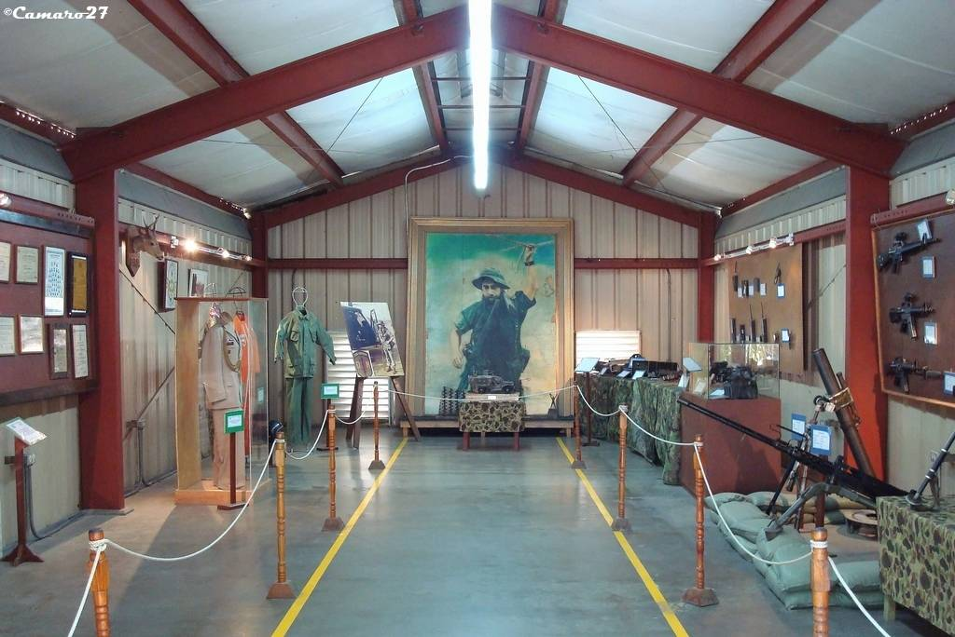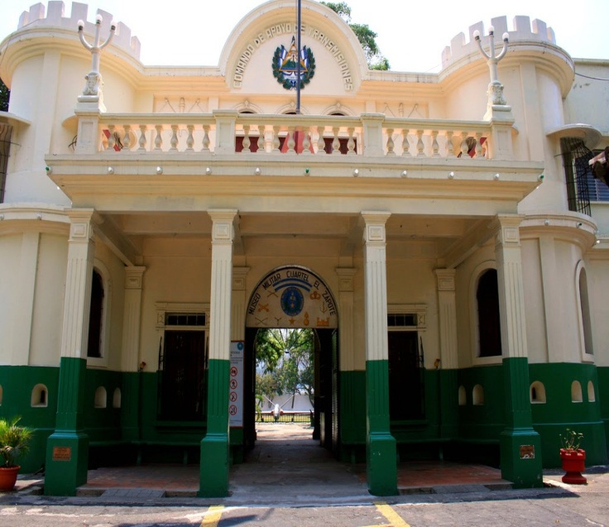

**3)Mortgage bank museum.**

The Mortgage Bank Museum of El Salvador is located in the city of San Salvador, El Salvador. It was inaugurated on November 20, 2015 and is located on the third floor of the bank branch of the historic center of the same city.

The museum was born as an initiative of the authorities of the bank in the framework of the 80th anniversary of the entity, and for its realization the support of the School of Anthropology of the Technological University of El Salvador was requested.

The collection contains historical documents such as the legislative decree establishing the bank, office tools, photographs, typewriters and furniture, among others, apart from a chronological tour of the institution. It also highlights a gallery with portraits of its presidents and other works of national and international artists.

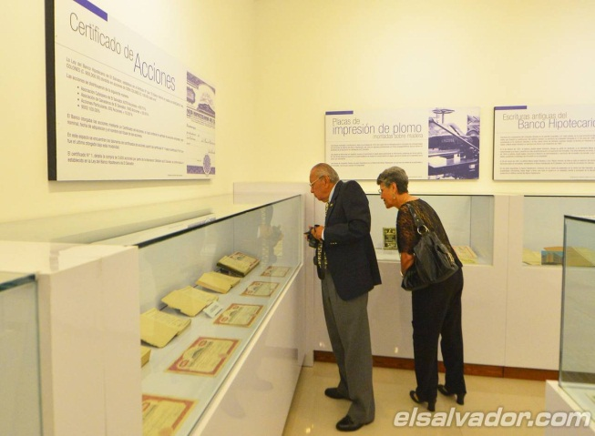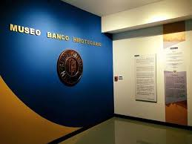The museum has gained a lot of popularity with respect to its short existence because it is the first in San Salvador to introduce the museum-café concept. In addition to offering a historical tour

**4)museum of anthropology DAVID J. GUZMAN**

DR. DAVID J. GUZMÁN

Facade of the MUNA. The National Museum of Anthropology Dr. David J. Guzmán is dedicated to administer and promote a collection of objects created by cultures in the national territory, in order to provide this legacy as a cultural heritage of past, current and future generations.

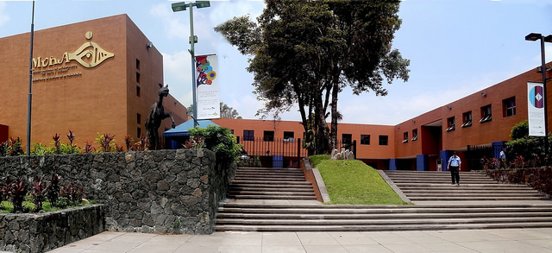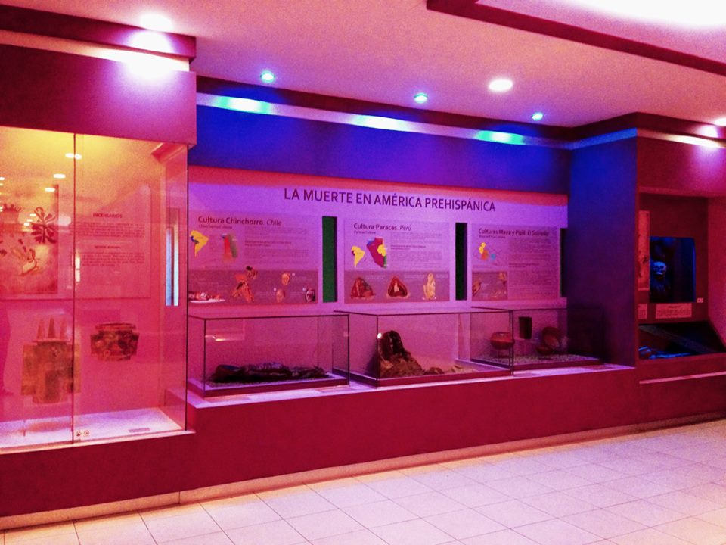The National Museum is conceived as a means of permanent education for all social sectors of the country, given that its mission is to promote the rapprochement and reflection of Salvadorans to their identity and cultural diversity, through permanent exhibitions, itinerant and temporary , as well as research, publications and didactic programs in the fields of Archeology, Anthropology and History, as a testimony of the social processes of the different

**5)MARTE Museum**

The Art Museum of El Salvador (MARTE) is a private, non-profit institution that began its functions on May 22, 2003, with the inauguration of its building. In the short time and thanks to the work developed, it has become an obligatory reference in the cultural life of the Central American area.

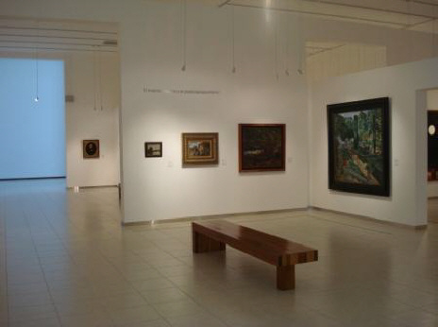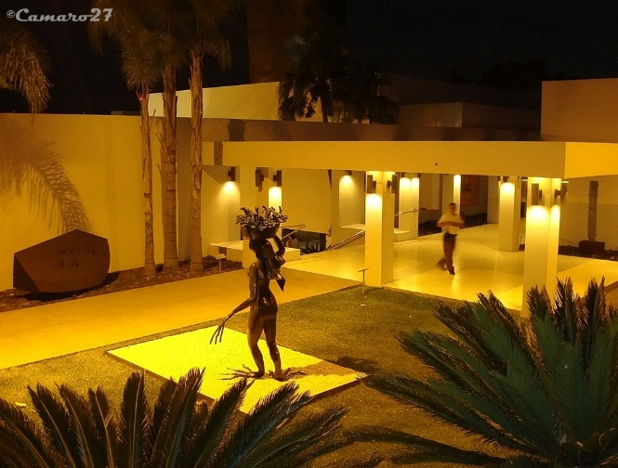MARTE exhibits a sample of Salvadoran art based on its permanent collection, private collections and the national collection. It presents a representative view of art from the mid-nineteenth century to the contemporary era. In the same way, a program of

important temporary exhibitions is maintained, which have allowed El Salvador to show

works by the great masters of universal art. Its exhibition activities

**6)Museum of the word and the image**

The Museum of the Word and the Image is a citizen initiative dedicated to the investigation, rescue, preservation and diffusion of the historical and cultural heritage of El Salvador.

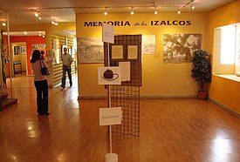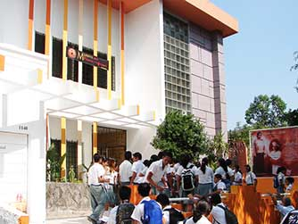The MUPI has an exceptional collection represented in manuscripts, photos, audio, film, video, posters, objects, publications and newspapers. It maintains a permanent accompaniment to the indigenous and peasant communities in the establishment of their historical memory. The museum was part of the Committee that erected the Monument to the Civil Victims of Violations of Human Rights, located in the Cuscatlán Park, in the capital. It is headquartered in the Salvadoran capital and conducts traveling exhibitions, talks, workshops and film forums on culture, memory and human rights in the most remote parts of the country.

**7)TRAIN MUSEUM**

The wagons and machinery of old trains welcome visitors to the Railway Museum, a new cultural space that rises in the center of San Salvador.

In this place there are more than 133 years of the railway history of the country, and in its rooms there is a series of historical pieces that show the evolution of this means of transport.

When you travel back in time, you will be transported to past centuries, where the train was an important means of communication and development for El Salvador.

See the photo gallery of the current exhibition at the following link: A trip to the past at the Railway Museum

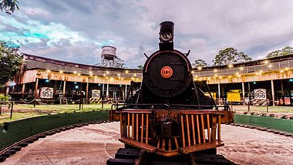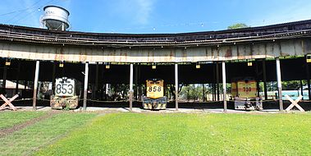When you go through each of the rooms you appreciate important pieces of the printing press, and you also know how the wagons of that old era were.

**8)COIN MUSEUM.**

Starting the month of March, the Luis Alfaro Durán Museum and Library welcomed a group of 25 students from the San Salvador International School, who during the visit had the opportunity to take a guided tour of the facilities of this museum, located in the Historic Center of San Salvador.

After appreciating each of the exhibition halls, they received a talk about the History of the Currency, with which they learned about the evolution of money in the world and in our country. This talk is part of the Financial Education Program, where the Central Reserve Bank provides support to the education of children and young people in our country.

The LAD Museum and Library offers public and private educational centers, guided visits and talks about the Savings and family budget, History of currency and security measures of dollar bills

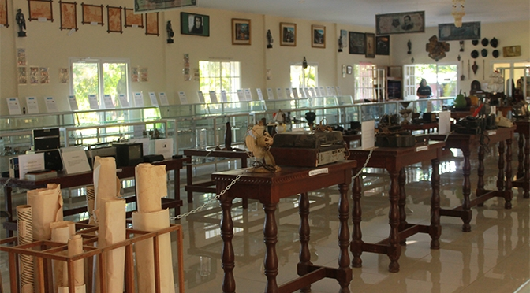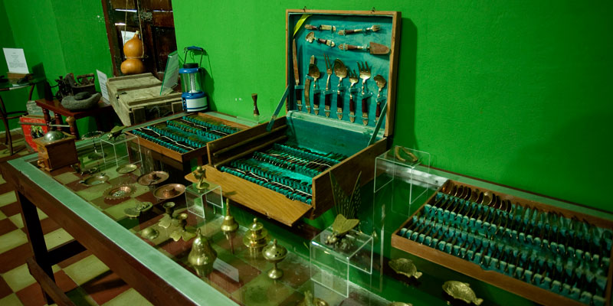

**9)UNIVERSITY MUSEUM UTEC**

Consecrated as a Protected Cultural Property, the University Museum of Anthropology (MUA) houses numerous treasures of Salvadoran identity. This is located in a house belonging to an important family of the country during the first years of the last century and which was completed in 1929.

Since 2006, the idea of ​​the museum was taking shape by collecting archaeological pieces belonging to the pre-Columbian era of our country.

It is distributed in five permanent exhibition halls, among which the persistence of the past and Salvadoran ethnography stands out, where it will appreciate more than 114 pieces of mud, obsidian, jade and other materials from the late pre-classic period (400 BC -250 d) C), classic (360-420 AD) elaborated by the indigenous tribes that populated Mesoamerica and, especially, El Salvador.

You will also find an extensive explanation of the movements, transfers and even elements of the daily life of the indigenous settlements, among them the close long-distance trade relations among the Mesoamericans that influenced the customs that characterized and, at the same time, differentiated each tribe.

**10)The Salvadoran Aviation Museum**

The Salvadoran Aviation Museum

Its objective is the acquisition, custody and conservation of movable and immovable property that constitute a historical patrimony of national aviation, for public knowledge of the most relevant aeronautical deeds. It has a collection of combat, transport and training airplanes, helicopters of great significance for the national historical set, remaining intact, according to the time in which they served.

About the museum: The antiquity of the building where the museum is located tells a lot about the history of Salvadoran aviation and the work that the Air Force has done in the country.

Due to the imposing infrastructure, its origin and the antiquity of it, it has been considered Cultural Heritage of El Salvador.

The Salvadoran Aviation Museum was inaugurated in 2001 at the initiative of a senior military officer. The museum is located in the old International Airport of El Salvador which was the main terminal area of ​​the country until the end of the seventies. It is considered Cultural Heritage of El Salvador.

Among the attractions of this museum are paintings and aeronautical drawings, scale models, military uniforms, tours on the history of different wars in which the Salvadoran Air Force participated, cabins area, an outdoor area of ​​restored combat aircraft, transportation and training, helicopters and many other things.

Attractions of Interest:

Library specialized in aeronautics.

Exhibition of scale models

Guided tours to teachers, students, tourists and the general public

Aircraft display

Art and photography galleries

Display of uniforms, costumes and flight equipment

