# AUDIT

|  |  |
| --- | --- |
| User Name: ……………………………………………. | Trainer Name: Ruchira Ariyasinghe |
| User Sign. : ……………………………………………. | Trainer Sign. : ……………………………………………. |

**SAMPLE AUDIT**

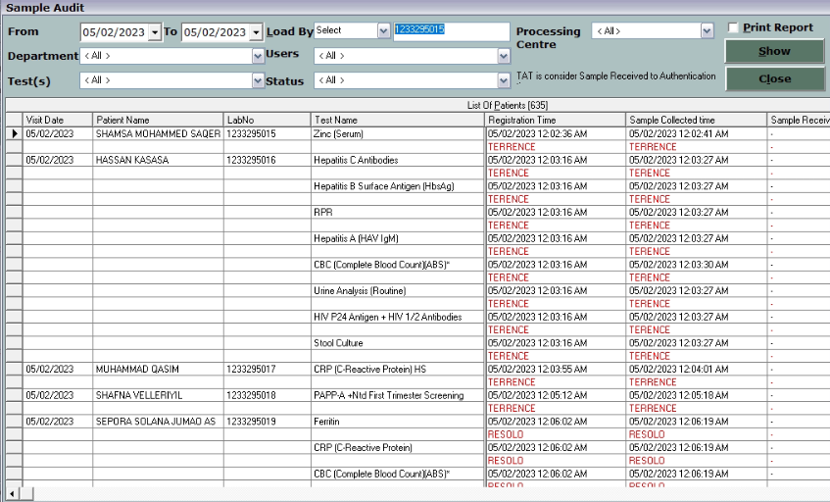

* Select the date criteria
* User can select department, users, tests and status to see sample track
* Click on Show button to load the sample track.

**RESULT AUDIT**

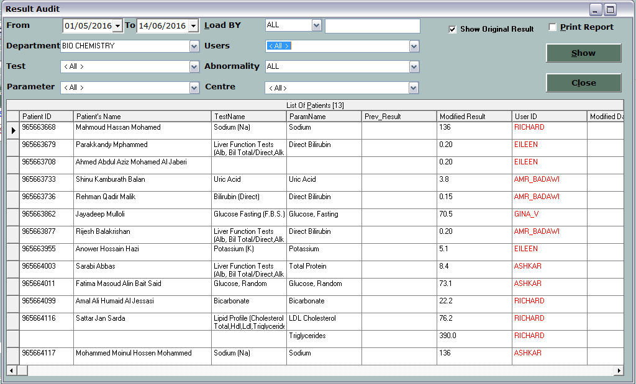

* This option is use to know result modification by users
* Select the date criteria
* Select the criteria like tests, parameters, abnormality and users.
* Click on Print report to print the report.