## DOCTOR

|  |  |
| --- | --- |
| User Name: ……………………………………………. | Trainer Name: Ruchira Ariyasinghe |
| User Sign. : ……………………………………………. | Trainer Sign. : ……………………………………………. |

### DOCTOR

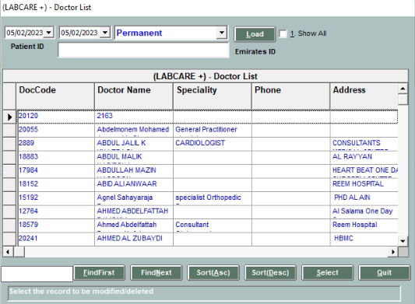

* By selecting the status for doctor like “Permanent” or “Temporary” user can see the doctor between selected date ranges.
* From this screen user can change the doctor information like “Address”, “SPECIALITY”.
* User can change the Doctor Status like “Permanent” to “Temporary”.
* User cannot delete the doctor.