## DOCTOR WISE COLLECTION

|  |  |
| --- | --- |
| User Name: ……………………………………………. | Trainer Name: Ruchira Ariyasinghe |
| User Sign. : ……………………………………………. | Trainer Sign. : ……………………………………………. |

**DOCTOR WISE COLLECTION**

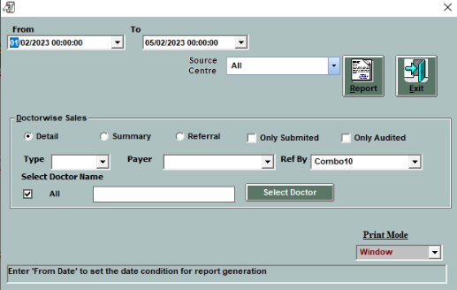

#### Go to Account main menu and select doctor wise collection.

* Select the date criteria
* Click on”All” option to get report for all Doctor
* Click on”select” to select the particular Doctor.
* Click on ”Detail” to get detailed report as shown below
* Click on”summary” for summary report.

