## E-CLAIM

|  |  |
| --- | --- |
| User Name: ……………………………………………. | Trainer Name: Ruchira Ariyasinghe |
| User Sign. : ……………………………………………. | Trainer Sign. : ……………………………………………. |

Open Eclaim.exe application from desktop.

**E-CLAIM SUBMISSION**



Go to E Claim to open the e claim option.

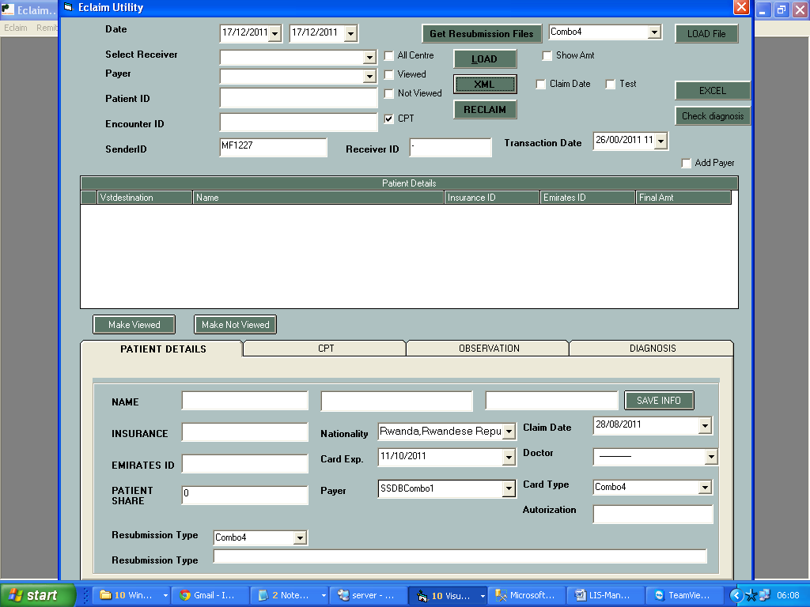

* Select the date criteria.
* Select the receiver id from box.
* Select the payer in case of TPA.
* Click on LOAD button to load the patient for selected date and insurance company.
* Double click on patient to get details down
* Check all details like demography and click on save info.
* Check the CPT codes for patient.
* Check the observation.
* Check the diagnosis in case if missing diagnosis reenter the diagnosis
* CPT codes and Observation will come automatically from Result entry part of **LABCARE** software.
* Click on e claim button to generate XML file.
* Click on Add Payer to add new payer.

**REMITTANCE**

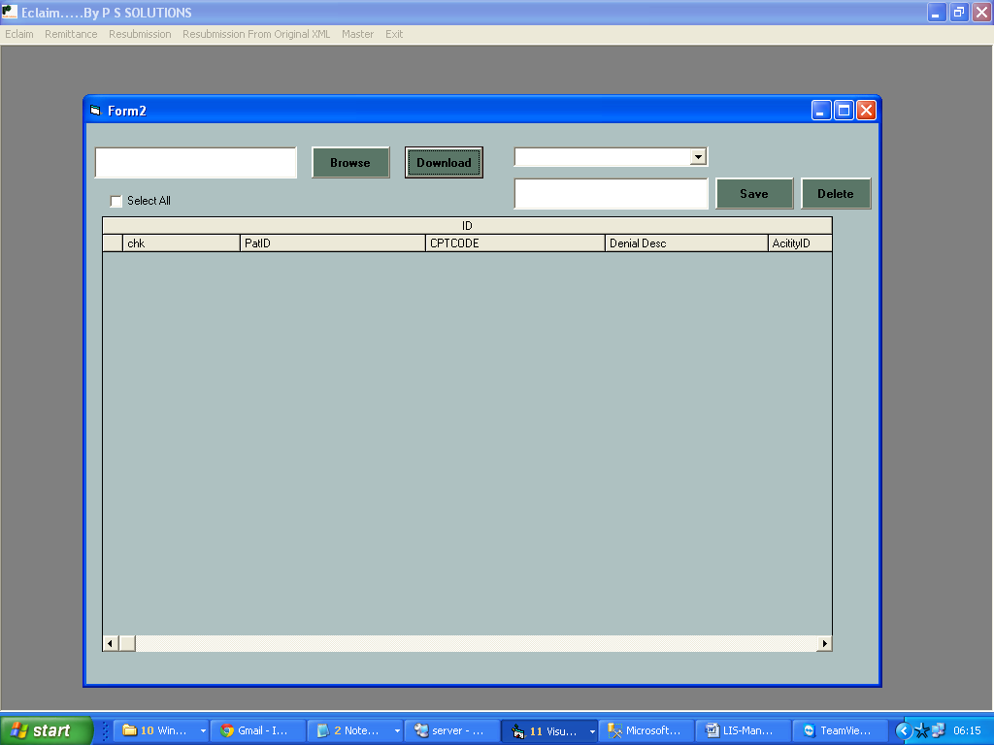

* Browse the file for remittance
* Click on Download button to download the file
* Enter the file name and click on save button to save the remittance file.
* For Resubmission go to main e claim form.
* In case of Resubmission ,select remittance file and then click on Load file to get the patients
* Enter the resubmission type and comment and authorization number.
* Click on Reclaim button to generate xml file.

**WORKFLOW**

**Patient Demographics, Investigation Details After Sample collection**

**Sample Flow / Track**

**Semi Automated**

**Manual Processing**

**Fully Automated**

**Rejections**

**Rejections**

**Un-directional transfer of data**

**Bi-directional transfer of data**

***First level of authentication***

***by technologist***

***Data Ready for Authentication***

**Rerun the sample if required**

***Final Report Generation***

***Report Dispatch***

***Interfacing***

**This module has built-in intelligence to communicate with device with RS 232 outputs & transfer the information in meaningful format to LABCARE**

***QUALITY ASSURANCE***

***Data from multiple equipments can be viewed at one place***

***Final Authentication***